Endurance of TiAlSiN coatings: Effect of Si and bias on wear and adhesion
D. Philippon (a), V. Godinhoa (b), P.M. Nagyb (c), M.P. Delplancke-Ogletree (b),
A. Fernández (a)

a Instituto de Ciencia de Materiales de Sevilla CSIC-US, c /Americo Vespucio, n° 49, 41092 Isla de la Cartuja, Sevilla, Spain
b Université Libre de Bruxelles, Matiéres et matériaux, Avenue F.D. Roosevelt, 50 (CP165/163), 1050 Bruxelles, Belgium
CRC-HAS, Department of Surface Modification and Nanostructures, 1025 Budapest, Pusztaszeri u. 59-67, Hungary
Abstract
In this work, the endurance of TiAlSiN nanocomposite thin films subjected to tribological solicitation is studied. These coating were deposited on M2 steel substrate by magnetron sputtering. Dry sliding experiments were conducted at ambient temperature against WC–Co ball. Coefficients of friction, wear rates and endurances were correlated with the composition, microstructure, mechanical properties, residual stress and adhesion of the coatings. The hardness and elastic modulus were found dependent not only on the composition but also on the residual stress induced by the deposition process. Friction coefficient was found to be independent on Si content while the wear rate is strongly reduced for higher Si contents. The formation of a nanocomposite microstructure, the amount of amorphous Si-based phase and both, wear resistance and adhesion are shown as the critical factors to determine the endurance of the coating.
Keywords
Nanocomposite Ti–Al–Si–N coatings; Residual stress; Adhesion; Wear rate; Endurance
1. Introduction
In the last decades microstructural design of nanocomposite thin films have been widely used to improve multifunctional coatings. The possibility of combining hard phases such as nanocrystalline TiAlN with improved oxidation resistance, with Si3N4 amorphous phase achieving superhardness, has allowed to increase the tools lifetime in cutting devices [1], [2], [3] and [4].
Many studies have been done to improve the performance of these coatings. A good compromise between microstructure and composition is needed. The influence of deposition conditions on microstructure, composition namely Al and Si content as well as other minor impurities (oxygen, carbon, hydrogen) seem to be critical to the good performance of these coatings [4].
The tribological response of hard coatings is often complex [5] and [6]. The classical theories of wear usually point hardness as the property controlling the wear resistance [7]. Many experimental studies demonstrate that the TiAlSiN nanostructured materials have enhanced the mechanical properties such as hardness [8], [9], [10], [11], [12], [13] and [14]. However, only few authors show experimentally the impact on the tribological properties of this nanocomposite structure. Moreover, in some case, there is a strong discussion if the enhanced hardness is due to the nanocomposite structure or can result also from high compressive residual stress generated by the deposition conditions. The macrostress generated also affects the adhesion of the coating to the substrate, limiting strongly the coatings functionality and reliability [15]. The appearance of new nanocomposite materials with improved hardness and elasticity makes imperative to re-think the way how the mechanical properties influence the coatings durability [5].
Some authors report on tribological properties (in particular the friction coefficient) of TiAlSiN thin films [13], [16], [17], [18], [19] and [20]. Friction reduction from 0.9 to 0.5 with the increase of Si content, between steel balls and TiAlSiN thin films at room temperature have been recently published [16] and [17]. These authors suggest that self-lubricating SiO2 and SiOH tribo-layers, which are formed by reaction of Si3N4 phase in the coating and H2O during friction test, are responsible of the reduction of friction, as it has been previously observed for Si3N4 ceramics [21]. Carvalho et al. [13] report on the friction coefficient of coatings with different Si content using Si3N4 balls. On their case, high friction and no direct correlation was found between the increase of Si content and the different friction values observed (0.7–1.0). When WC–Co balls are used, for similar Si content a high friction coefficient is also observed [18] indicating that no tribochemical reactions occur.
Even though the influence of Si on the friction and mechanical properties has been described in the previous papers, few studies report the correlation between wear resistance and the mechanical properties for different Si contents. In addition to our knowledge no study reported the durability of TiAlSiN thin films, in particular the effect of composition and residual stress in wear, adhesion and coating lifetime.
In this work the influence of composition on microstructure and mechanical properties is investigated. The effects of deposition conditions are related to mechanical properties and stress state of the films. Finally, the endurance of the thin films is discussed in terms of wear resistance and adhesion in correlation with the Si content and deposition conditions.
2. Experimental details
2.1. Samples preparation
TiAlSiN thin films with different Si content were co-deposited by magnetron sputtering from commercial targets: Ti–Al alloy (75/25, 99.8% purity) and pure Si (99.999% purity). Table 1 resumes the deposition conditions.
A 400 W dc power was applied to the TiAl target; while an increasing rf power, from 250 to 400 W, was applied to the Si target. For the same power supplied, the coatings were deposited at floating potential and with substrate bias. An rf bias was applied by controlling the power supplied (25 W) which corresponds to approximately 300 V.
Samples were labelled as SX-Y-Z where X, Y and Z indicating the applied power to the TiAl (dc) target, Si (rf) target and biased substrate respectively.
The base pressure before deposition was less than 1.5 × 10−4 Pa. In order to improve the adhesion strength between the TiAlSiN film and the substrate, a thin TiAl adhesion layer with a typical thickness of 200 nm, was deposited with pure argon (at 6.65 Pa) prior to the TiAlSiN coating deposition. The TiAlSiN coatings were deposited in a pure N2 atmosphere of 1.33 Pa.
The rotational substrate holder was located at 10 cm from each target. AISI M2 steel, Si wafer and NaCl substrates were used for the different analyses. Before each deposition, the substrates were sputtered-cleaned at 100 V at an argon atmosphere for 1 h.
2.2. Microstructure and composition
Thickness and morphology of coatings deposited on Si substrates were studied in fractured cross-section by scanning electron microscopy performed in a high resolution field-emission gun (FEG) microscope, using a Hitachi S4800 instrument.
The thickness was confirmed using a Mahr “stylus” profilometer (conic stylus dimension of 2 μm with a lateral resolution of 0.76 nm) by measuring the difference in height of the step between an uncoated part and a coated part on Si substrate, provided by the profile scan.
The microstructure of the coatings was investigated by grazing incidence X-ray diffraction analysis (GIXRD). Also transmission electron microscopy observations (Philips CM200 microscope) and selected area electron diffraction (SAED) were used to investigate the microstructure on samples grown on NaCl substrate and then floated off in water and supported on a grid.
Surface composition of the TiAlSiN thin films deposited on the Si substrate was determined by X-ray photoelectron spectroscopy (XPS, Leybold Heraus Spectrometer) with Al Kα X-ray source (hν = 1486.6 eV). XPS photoelectron peaks were fitted with a Shirley background subtraction, and the quantification was made using the sensitivity factors supplied by the instrument manufacturer. The samples were argon etched (2 × 10−3 Pa, 3.5 kV, 6 mA, 4 min) in order to clean surfaces before analysis.
The composition of the TiAlSiN thin films deposited onto the steel substrate was determined by energy dispersive spectroscopy (EDS) inside the SEM-FEG.
2.3. Tribological and mechanical properties

The tribological properties (wear and friction) were studied using a ball-on-disk rotating tribometer (CSEM).

Most of the published results that compare the tribological performance of TiAlSiN coatings with different Si content were obtained using steel or Si3N4 counterparts [13] and [17] which may form tribolayers affecting the friction coefficient. In this work a WC-6% Co ball (diameter 6 mm) was used as counterpart. To our knowledge no studies were performed for different Si content using WC–Co counterparts. The sliding tests were conducted with a sliding speed of 0.1 m/s under a load of 1 N at ambient temperature with a relative humidity of 40%. The sliding distance ranged from 100 m to 1000 m (equivalent 2000–25,000 cycles – different track diameters were used). For each sample, several tests at increasing sliding distance up to 1000 m – or until coating failure – were conducted, to determine the average friction coefficient, wear rate and to evaluate coating durability. The wear volume was calculated by multiplying the mean wear area of the track, determined by profilometry, by the scar ring circumference according to each track diameter.
Optical and scanning electron microscopy were employed to observe the morphology of the wear track after the tribological experiments. EDS was used to determine the composition of the wear track.
The hardness and the elastic modulus were measured by nanoindentation technique (using a Hysitron triboindenter) with a trigonal shaped Berkovitch indenter and calculated from the loading–unloading curves. The Berkovitch tip area function was estimated with the Oliver–Pharr method [22].
2.4. Stress and adhesion evaluation
Profilometry tests were used to evaluate the residual stress of the film on Si substrate according to the Stoney equation [23].
The adhesion evaluation was carried out with a Micro Scratch-tester Millenium 200 (CSM Instrument) equipped with a diamond tip (Rockwell C, radius 200 μm). The coatings were scratched with an increasing normal load until a maximum of 100 N (loading rate of 50 N/min and scratching speed of 10 mm/min). Acoustic emission (AE) was measured simultaneously and recorded for each test. Critical loads were determined based on specific damages observed by optical microscopy and AE changes.
3. Results and discussion
3.1. Microstructure and composition
The major point of this work is to investigate the effect of silicon on the tribological properties of Ti1−xAlxSiyN coatings. Table 2 presents the chemical composition of the coatings as given by XPS after short argon bombardment for surface cleaning.
As it was expected, the increase of the power supplied to the Si target results in an increase of the Si content in the films. The Ti and Si contents vary from 13 to 24 at.% and 7 to 15 at.%, respectively. In all cases the Ti/Al ratio of the target (Ti/Al = 3) was maintained in the coatings. The bulk composition of these coatings was also evaluated by EDS (Table 2). Similar values of Al, Ti and Si content (in at.%) to the ones given by XPS were found. Oxygen contamination due to the low O2 residual pressure in the chamber during deposition was also observed.

The high values of oxygen obtained by XPS correspond most probably to a high post-deposition surface oxidation. Longer sputter cleaning periods were not considered due to preferential sputtering of oxygen that can deteriorate the chemical and compositional information obtained by this technique.
The EDS values are taken as a better estimation of the oxygen in the coatings.
The morphology of TiAlSiN thin films deposited on Si substrate was observed by SEM-FEG as illustrated in Fig. 1. The thin films prepared without bias exhibit columnar structure while the coatings prepared with bias present dense structure. The columnar structure is typical of coatings grown under low energetic ion bombardment and limited adatom mobility. It is also possible to see the voids between the columns, characteristic of zone 1 of Thornton's model [24]. Application of substrate bias increases the adatom mobility. Also re-sputtering effects during the deposition can eliminate the open voids between the columns resulting in a dense structure [25]. The structure of the coatings largely influences their final properties, in particular the mechanical properties. The columnar structure is in general more brittle and can increase the surface oxidation of the coatings. It is also possible to distinguish in Fig. 1 the TiAl adhesion layer.
The thicknesses of the coatings and of the underlayer were measured by cross-sectional SEM views. The adhesion layer of TiAl has a typical thickness of 200 nm. The total thickness measured (coating + adhesion layer) displayed in Fig. 1, was confirmed by mechanical profilometry.
The microstructure of the coatings was investigated by GIXRD at 1°. Fig. 2 presents the diffraction pattern of the different samples and of the steel substrate as well as peak positions for cubic TiN and Ti3AlN. With the increase in Si content the coatings became more amorphous. When substrate bias is applied, the peaks become broader. Broadening of diffraction peaks can result from grain size refinement [13]. For low silicon content and in absence of bias, the peaks can be ascribed to c-(Ti,Al)N, namely planes (1 1 1), (2 0 0) and (2 2 0) were identified.
Fig. 3 shows TEM micrographs and the corresponding selected area electron diffraction pattern. The indexed planes correspond to c-(Ti,Al)N phase. As in the XRD data the samples with low silicon content present better defined rings corresponding to more crystalline samples. It can be noted also a decrease of the grain size when the Si content is increased.
The formation of silicon nitride phases was confirmed by XPS analyses. These phases are amorphous and were not detected by XRD or SAED. Fig. 4 shows the Si 2p core level for 7 and 15 at.% Si content thin films deposited with and without substrate bias. The width of the peaks (>2 eV) indicates that apart from the main contribution of silicon nitride also a contribution of a oxinitride phase is present [26] and [27]. The peaks of non biased samples are displaced to higher binding energy corresponding to higher oxidation, as it was expected from the results on Table 2. The results are in good agreement with theoretical studies by Hao et al. [28]. They investigated the incorporation of oxygen in nc-TiN/a-Si3N4 coatings; in nitrogen rich deposition conditions as the coatings in the present work, oxygen is predicted to diffuse to the silicon nitride phase and occupy nitrogen sites [28].
Based on XPS and diffraction data it seems that the coatings have a nanocomposite coating structure based on c-(Ti,Al)N crystals embedded in an amorphous silicon (oxy)nitride intergranular phase. The formation of TiAl oxide phases in minor quantity cannot be completely excluded from our results.
3.2. Tribological and mechanical properties
The typical friction curves for the different films against WC–Co counterface are represented in Fig. 5. For each coating, several tests at different sliding distances were conducted. The mean friction coefficient values are reported on Table 3. The friction coefficient behaviour is characterized by a rapid increase at the beginning of the test (10–40 m), followed by a stabilized value between 0.74 and 0.82 depending on the coating (Fig. 5 and Table 3). This short run-in stage with very low friction coefficient can be due to the adventitious surface contamination.
Coatings with 7 and 15 at.% of silicon present very similar friction behaviour (Table 3). Other coatings prepared under different conditions with similar composition (not presented in this work) showed the same results.
From these results one can conclude that WC–Co counterparts allow studying the tribological properties of coatings with different silicon content, without the interference of tribochemical reactions that may reduce the friction coefficient.
Fig. 6 shows the SEM images (and corresponding EDS analyses) of wear tracks on both disk and ball. It has been observed that there is no transferred material on the wear tracks. The generated wear debris were mainly accumulated on the border of the tracks. EDS analyses and mappings confirm that there is no transfer from the ball to the disk (no W detected) and from the disk to the ball (no Ti, Al and Si detected). Elemental mapping of the track shows how the steel substrate is revealed when the test is conducted until coating failure. W was also not detected in the wear debris, which confirms that counterface wear was very small (see also ball wear rates presented in Table 3).
The morphology of the wear track and the absence of transfer film indicate that abrasive wear was the dominant mechanism in the wear process. The wear rate (K) was calculated by Eq. (1):
(1)
V=KFd
where V is the wear volume (mm3), K the wear rate (mm3/Nm), F the normal load (N) and d the sliding distance (m). The wear volume (V) was measured at different sliding distances (d), for not failed tests or at least in an undamaged zone, by profilometry and reported in Fig. 7. As predicted by the Archard model [7], the wear volume increases linearly with the sliding distance that confirms that no tribochemical reactions occur during the friction test.
As shown in Fig. 7, the wear rate is affected by the Si content. Independently of substrate polarisation, the wear resistance is three times higher for 15 at.% Si content than for 7 at.% (Table 3). Substrate bias induces a slight reduction of the wear. Similar observation was made for TiAlN thin films [30]. As all the coatings present similar friction coefficient, the wear resistance of the coatings seems to be controlled by its mechanical properties.
The values of hardness (H) and reduced elastic modulus (E*) determined by nano-indentation are reported in Table 3. Both hardness and elastic modulus are dependent on the Si content and on the residual stress of the film. On the one hand, increasing the silicon content produces grain refinement which will lead to Hall–Petch hardening effects [31], and an increase of the intergranular amorphous phase in the nanocomposite leads to a certain improvement of the mechanical properties. On the other hand, high-energy ion bombardment will develop residual stresses in the coatings that can also contribute to an increase in the measured hardness. The average residual stress was determined using Stoney's method [23] by measuring the curvature of the TiAlSiN thin films deposited on a Si wafer with a tactile profilometer. The values of the compressive residual stress (shown in Table 3) vary from 0.1 to 2.3 GPa. Both Si content and deposition conditions influence the value of residual stress. The development of high compressive residual stress due to substrate bias is prevented when the Si content is increased (effect of the amorphous phase). Then, as it is the case for S400-250-25, for low Si content, applying bias induces a strong increase of the compressive residual stress. This can explain the significant increase of the hardness for this sample.
Classical theories of wear [7] relate the hardness (H) to the wear resistance of a surface. It is often the case that a hard material has also high wear resistance. Some authors have also suggested the importance of the elastic modulus (E) on the wear behaviour [5]. It was pointed out that the wear of a material is related with the material's elastic strain limit that characterizes the ability of a material to deform elastically and recover, without undergoing permanent (plastic) deformation [5]. An experimental measure of the elastic limit of strain is the H/E ratio. This approach has been applied to coated surfaces [5] and the elastic strain to failure has been related to the H/E* ratio. Also the H3/E*2 ratio, called the plastic resistance parameter, is an indicator of the coating's resistance to plastic flow [32]. Therefore, H/E* and H3/E*2 ratios play an important role to the coating wear resistance. Table 3 reports the values of H/E* and H3/E*2. Considering the coatings deposited without bias, the increase of H, H/E* and H3/E*2 are well correlated with the increase of wear resistance. However, when substrate bias is applied, in particular for low Si content, the previous correlation is not more conclusive. The hardness enhancement due to the macrostress developed in the film is not beneficial for wear resistance improvement. It suggests that it is essential to distinguish the improvement of the mechanical properties resulting from the microstructure of the material to those derived from the deposition process. The role of Si content on the mechanical properties and wear has two purposes. Firstly, increasing the Si content affects the microstructure, improving the mechanical properties and the wear resistance. Secondly, increasing the Si content (and thus the amount of amorphous phase) reduces the development of high residual compressive stress leading to better performance.
3.3. Cohesion and adhesion

The adhesive and cohesive properties of the thin films were evaluated by scratch test (Fig. 8). Table 3 summarizes the critical loads determined during the scratch test by both optical observation and integrated acoustic emission measurement.
The low thickness of the adhesion layer allied with the low critical load values and the presence of residual stress in the coatings makes very difficult to distinguish between the adhesion of the coating to the TiAl adhesion layer and the adhesion of this layer to the substrate. In that sense, LC1 represents the crack initiation load or the “crack initiation resistance” [33] and [34] (cohesive strength), LC2 corresponds to flake off and chipping and LC3 to the total failure of the coating and underlayer with exposure of the substrate (adhesive strength). All the coatings present a similar LC1 (first crack) however the LC2 (flake/chipping) and LC3 (exposed substrate) vary from one coating to the other. Critical loads can be used directly to quantify the “scratch toughness” of thin films [35]. As it has been defined by Zhang et al. [33] and [34], difference between LC1 and LC2/LC3 is representative of the capacity of the coating to survive after a crack is initiated before catastrophic failure occurs. Thus, toughness, which is the ability of the material to absorb energy during deformation up to fracture, is proportional to the difference between lower critical load and upper critical loads.
As shown in Table 3, there is strong relation between the evolution of the compressive residual stress and the adhesive strength of the thin film. By decreasing the residual stress, adhesion of the coating to the substrate increases (LC3).
For high Si contents, the critical adhesion load (LC3) is increased, independently of the bias application. Similar results are found in the literature for TiSiN nanocomposite thin films [36] and [37] with various Si content.
The optical micrographs in Fig. 8a reveal different failure modes. No flaking or chipping (LC2) before delamination (LC3) is observed for coatings prepared without bias. The failure of the coating is caused by semi-circular cracks within the scratch track (see Fig. 8b). These tensile cracks are parallel to the stylus and their density increases until substrate is revealed. Sample S400-400-0 (15 at.% of Si) present the best adhesive strength (79 N) where the substrate is progressively reached. On the contrary, sample S400-250-0 (7 at.% of Si), where the substrate is suddenly reached, has a lower adhesive strength (40 N). Bias application largely affects the adhesive strength since coatings prepared with substrate bias have a lower adhesive strength (LC3) and present severe flaking or delamination (characterized by LC2) before the substrate is revealed. Sample S400-250-25 presents the worst adhesive properties (LC < 14 N).
The wear behaviour of sample can be correlated with the values of critical load. Thin films deposited with bias show a better crack initiation resistance (higher LC1). It is well correlated with the better resistance to plastic deformation of these coatings (higher values of H/E* and H3/E*2 ratios). However, once a crack is initiated, it propagates rapidly (low toughness) and failure occurs (LC2 and low LC3). Due to the rapid failure, wear debris are produced rapidly after crack initiation and wear is increased. On the contrary, thin films deposited without bias have a lower crack initiation resistance but a better toughness.

The toughness of the thin films is increased by increasing the Si content. Thus, the propagation of crack is inhibited and the wear resistant is promoted. As previously seen, bias application generates residual stress enhancing the hardness. However, the toughness is largely reduced. This explains why biased samples with better resistance to plastic deformation, have a similar wear behaviour than non-biased samples presenting a better toughness. The increase in Si content seems to compensate the introduction of residual stress (and the “loss” of toughness) in the films due to bias through the incorporation of a higher amount of amorphous phase (sample S400-400-25).
3.4. Coatings durability
The durability (or endurance) of the coating is defined by the number of cycles of ball-on-disk sliding wear before reaching the substrate. Due to the progressive wear, the coating becomes thinner and the cyclic stress imposed to the substrate/coating interface is increased [38]. Depending on the adhesion between the coating and the substrate, below a critical coating thickness (or a threshold stress value), a rapid decohesion of the film will be activated leading to a general failure.
The endurance of the films was characterized by determining the number of cycles before reaching the substrate. The coating failure was determined, when it was possible, by a friction discontinuity, and post test microscopic observation of the wear track.
The points drawn in Fig. 9 correspond to the wear depth as a function of the number of cycles for the different coatings. As in Fig. 7, a linear relation between the wear depth and the number of revolutions is observed for the different Si contents. Coatings with high Si content presenting lower wear rate also have lower wear depth extension. The failure of the coating can be predicted according to its thickness and it can be translated in number of cycles for the given tribological conditions. Taking into account the coatings thickness and the dependence of the wear depth on the number of cycles, the theoretical number of cycles (Nth) at which the substrate is reached can be known. These predicted values are represented in Fig. 9, and compared with the experimental number of cycles (Nexp). In that sense a critical thickness hc can be determined by the following relation:
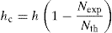
where h is the thickness of the coating (see Table 3). The zero critical thickness represents number of cycles at which the theoretical and experimental coincide. This means that a pure wear process is the responsible for the coating consumption, representing a good adhesion of the film to the substrate. It is the case for sample S400-400-0.
From the values in Table 3 a good relation is found between the critical thickness, the residual stress and the adhesion of the coatings. Coatings with high residual stress present high critical thickness and withstand lower critical loads.

All coatings are initially characterized by a pure wear process controlled by the mechanical properties and the cohesive strength. The progressive thinning of the coating leads to two possible failure modes. For coatings with good adhesion, the pure wear process goes on until the substrate is progressively reached. For coatings with bad adhesion, due to the development of higher compressive residual stress, the failure is then controlled by an adhesive wear process, characterized by rapid spallation at some critical coating wear depth.
4. Conclusions
TiAlSiN coatings with different silicon content were deposited under different conditions by reactive magnetron sputtering. The microstructure of the coatings revealed the formation of nanocrystalline c-(Ti,Al)N phase in an amorphous silicon nitride (oxynitride) phase.
The mechanical properties of the thin films have been studied by nanoindentation. The hardness and the elastic modulus are not only dependent on the nanocomposite formation but also on the residual stress induced by the deposition process, in particular by the substrate bias. Higher Si content produces grain size refinement and allows the achievement of slightly higher hardness. Bias application produced a strong increase of the hardness, in particular when the amount of amorphous phase is not sufficient to accommodate the compressive stress induced by the high energetic bombardment conditions.
The tribological properties of the coatings have been investigated regarding the influence of Si content and deposition conditions. The friction coefficient against a WC–Co ball counterface was found stable between 0.7 and 0.8 and independent of the Si amount in the film. On the contrary, the wear rate was reduced by increasing the Si content that is also correlated with better mechanical properties and cohesive strength. The compressive residual stress developed by the substrate negative electrical bias deteriorates the cohesive and adhesive strength.
The endurance of the coatings is a determinant parameter for industrial application. It represents the reliability of the films. In this work, the role of the Si content on tribological behaviour of TiAlSiN thin films has been detailed. In the literature, Si content of coatings from the TiAlSIN system have been correlated with mechanical properties, in particular the hardness enhancement [8], [9], [10], [11], [12], [13] and [14]. Generally, authors infer that the wear resistance is improved when hardness is increased (Archard model) but they did not justify it experimentally. Many studies report the friction behaviour of TiAlSiN thin films for different counterparts reporting the wear behaviour as a function of the Si content [19]. However these counterparts favour the formation of tribochemical reactions masking the “real” tribological behaviour of the coatings. In this work WC–Co balls were used which proved not to form tribochemical reactions.
Indeed, as shown in this work, wear resistance is not only correlated with the mechanical properties, it is also affected by stress state and the toughness of the coating. High energetic ion bombardment increases the residual macrostress and the hardness of the coating but without enhancing the wear resistance of the films (S400-250-25) due to the toughness loss.

Finally, it has been shown here that the Si content does not modify the friction coefficient as described in the literature for TiAlSiN/ceramic tribo-contacts (TiAlSiN/Si3N4, TiAlSiN/WC–Co) [13], [18] and [19]. However, increasing the Si content enhanced the mechanical properties and the wear resistance. Higher Si content also leads to tougher coating due to the higher amount of amorphous phase. It results in a better adhesion of the coating to the substrate and suppression of the detrimental effects of high compressive residual stress induced by substrate bias application.
The failure mode is then strongly influenced by the Si content and the deposition conditions. With high Si content a pure wear process seems to be operative due to higher amount of amorphous phase that can compensate the effect of stress, introduced during bias application, on coating adhesion. For low Si content, the effect of bias is clearly shown. In spite of the hardness increase, the higher residual stress strongly deteriorates the performance of the coating due to rapid spallation.
The evaluation of a critical wear depth for coating spallation can be a good way to predict the adhesion of coating to the substrate.
Nanocomposite coatings, constituted by a nanocrystalline phase in an amorphous matrix are complex systems where mechanical and tribological properties can be modulated. Carefully studies to fully understand their behaviour are needed.
Acknowledgements
Authors thank the financial support from EC (project NoE EXCELL and CA NANOINDENT), Spanish Ministry MICINN (CONSOLIDER FUNCOAT) and Junta de Andalucía.

References

[1] J. Patscheider, T. Zehnder, M. Diserens
Structure–performance relations in nanocomposite coatings
Surface and Coatings Technology, 146–147 (2001), pp. 201–208
[2] R. Hauert, J. Patscheider
From alloying to nanocomposites—improved performance of hard coatings
Advanced Engineering Materials, 2 (2000), pp. 247–259
[3] S. Veprek, S. Reiprich
A concept for the design of novel superhard coatings
Thin Solid Films, 268 (1995), pp. 64–71
[4] S. Veprek, H.D. Männling, P. Karvankova, J. Prochazka
The issue of the reproducibility of deposition of superhard nanocomposites with hardness of >50 GPa
Surface and Coatings Technology, 200 (2006), pp. 3876–3885
[5] A. Leyland, A. Matthews
On the significance of the H/E ratio in wear control: a nanocomposite coating approach to optimised tribological behaviour
Wear, 246 (2000), pp. 1–11
[6] P.W. Shum, W.C. Tam, K.Y. Li, Z.F. Zhou, Y.G. Shen
Mechanical and tribological properties of titanium–aluminium–nitride films deposited by reactive close-field unbalanced magnetron sputtering
Wear, 257 (2004), pp. 1030–1040
[7] J.F. Archard
Contact and rubbing of flat surfaces
Journal of Applied Physics, 24 (1953), p. 981
[8] A. Miyamura, M. Yamaguchi
Ti–Al–Si–N films for superhard coatings deposited by reactive cosputtering using Ti, Al, and Si targets
Journal of Vacuum Science Technology A, 25 (2007), pp. 1103–1107
[9] D. Rafaja, A. Poklad, V. Klemm, G. Schreiber, D. Heger, M. Sima
Microstructure and hardness of nanocrytalline Ti1−x−yAlxSiyN thin films
Materials Science and Engineering A, 462 (2007), pp. 279–282
[10] H.C. Barshilia, B. Deepthi, K.S. Rajam
Deposition and characterization of TiAlN/Si3N4 superhard nanocomposite coatings prepared by reactive direct current unbalanced magnetron sputtering
Vacuum, 81 (2006), pp. 479–488
[11] I.W. Park, S.R. Choi, M.H. Lee, K.H. Kim
Effects of Si addition on the microstructural evolution and hardness of Ti–Al–Si–N films prepared by the hybrid system of arc ion plating and sputtering techniques
Journal of Vacuum Science Technology A, 21 (2003), pp. 895–899
[12] N. Jiang, Y.G. Shen, H.J. Zhang, S.N. Bao, X.Y. Hou
Superhard nanocomposite Ti–Al–Si–N films deposited by reactive unbalanced magnetron sputtering
Materials Science and Engineering B, 135 (2006), pp. 1–9
[13] S. Carvalho, L. Rebouta, A. Cavaleiro, L.A. Rocha, J. Gomes, E. Alves
Microstructure and mechanical properties of nanocomposite (Ti, Si, Al)N coatings
Thin Solid Films, 398–399 (2001), pp. 391–396
[14] S.K. Kim, P.V. Vinh, J.H. Kim, T. Ngoc
Deposition of superhard TiAlSiN thin films by cathodic arc plasma deposition
Surface and Coatings Technology, 200 (2005), pp. 1391–1394
[15] V. Teixeira
Mechanical integrity in PVD coatings due to the presence of residual stresses
Thin Solid Films, 392 (2001), pp. 276–281
[16] D. Yu, C. Wang, X. Cheng, F. Zhang
Microstructure and properties of TiAlSiN coatings prepared by hybrid PVD technology
Thin Solid Films, 517 (2009), pp. 4950–4955
[17] I.-W. Park, S.R. Choi, J.H. Suh, C.-G. Park, K.H. Kim
Deposition and mechanical evaluation of superhard Ti–Al–Si–N nanocomposite films by a hybrid coating system
Thin Solid Films, 447–448 (2004), pp. 443–448
[18] C.L. Chang, J.W. Lee, M.D. Tseng
Microstructure, corrosion and tribological behaviors of TiAlSiN coatings deposited by cathodic arc plasma deposition
Thin Solid Films, 517 (2009), pp. 5231–5236
[19] E. Ribeiro, A. Malczyk, S. Carvalho, L. Rebouta, J.V. Fernandes, E. Alves, A.S. Miranda
Effects of ion bombardment on properties of dc sputtered superhard (Ti, Si, Al)N nanocomposite coatings
Surface and Coatings Technology, 151–152 (2002), pp. 515–520
[20] G.S. Kim, B.S. Kim, S.Y. Lee, J.H. Hahn
Effect of Si content on the properties of TiAl–Si–N films deposited by closed field unbalanced magnetron sputtering with vertical magnetron sources
Thin Solid Films, 506–507 (2006), pp. 128–132
[21] J. Takadoum, H. Houmid-Bennami, D. Mairey
The wear characteristics of silicon nitride
Journal of European Ceramic Society, 18 (1998), pp. 553–556
[22] W.C. Oliver, G.M. Pharr
An improved technique for determining hardness and elastic modulus using load and displacement sensing indentation experiments
Journal of Materials Research, 7 (1992), pp. 1564–1583
[23] G. Stoney
The tension of metallic films deposited by electrolysis
Proceedings of the Royal Society of London Series A, 82 (1909), p. 172
[24] J.A. Thornton
High rate thick film growth
Annual Review of Materials Science, 7 (1977), pp. 239–260
[25] Y. Tanaka, N. Ichimiya, Y. Onishi, Y. Yamada
Structure and properties of Al–Ti–Si–N coatings prepared by the cathodic arc ion plating method for high speed cutting applications
Surface and Coatings Technology, 146–147 (2001), pp. 215–221
[26] C.D. Wagner, J.F. Moulder, L.E. Davies, W.M. Riggs
Handbook of X-ray Photoelectron Spectroscopy
Perking-Elmer Corporation, Physical Electronics Division (1979) p. 190
[27] O. Benkherourou, J.P. Deville
X-ray photoelectron spectroscopy of silicon oxynitride layers obtained by low-energy ion implantation
Applied Physics A, 46 (1988), pp. 87–90
[28] S. Hao, B. Delley, C. Stampfl
Role of oxygen in TiN(1 1 1)/SixNy/TiN(1 1 1) interfaces: implications for superhard nanocrystalline nc-TiN/a-Si3N4 nanocomposites
Physical Review B, 74 (2006), p. 035424
[29] J. Prochazka, P. Karvankova, M.G.J. Veprek-Heijman, S. Veprek
Conditions required for achieving superhardness of ≥45 GPa in nc-TiN/a-Si3N4 nanocomposites
Materials Science and Engineering A, 384 (2004), pp. 102–116
[30] K. Chu, P.W. Shum, Y.G. Shen
Substrate bias effects on mechanical and tribological properties of substitutional solid solution (Ti, Al)N films prepared by reactive magnetron sputtering
Materials Science and Engineering B, 131 (2006), pp. 62–71
[31] A.H. Chokshi, A. Rosen, J. Karch, H. Gleiter
On the validity of the hall–petch relationship in nanocrystalline materials
Scripta Metallurgica, 23 (1989), pp. 1679–1683
[32] P.H. Mayrhofer, C. Mitterer, J. Musil
Structure–property relationships in single- and dual-phase nanocrystalline hard coatings
Surface and Coatings Technology, 174–175 (2003), pp. 725–731
[33] D.S.S. Zhang, Y. Fu, H. Du
Effect of sputtering target power on microstructure and mechanical properties of nanocomposite nc-TiN/a-SiNx thin films
Thin Solid Films, 447–448 (2004), pp. 462–467
[34] S. Zhang, D. Sun, Y. Fu, H. Du
Toughness measurement of thin films: a critical review
Surface and Coatings Technology, 198 (2005), pp. 74–84
[35] A.A. Voevodin, J.S. Zabinski
Supertough wear-resistance coatings with “chameleon” surface adaptation
Thin Solid Films, 370 (2000), pp. 223–231
[36] F. Vaz, L. Rebouta, M. Andritschky, M.F. da Silva, J.C. Soares
The effect of the addition of Al and Si on the physical and mechanical properties of titanium nitride
Journal of Materials Processing Technology, 92–93 (1999), pp. 169–176
[37] F. Vaz, L. Rebouta, P. Goudeau, J. Pacaud, H. Garem, J.P. Rivière, A. Cavaleiro, E. Alves
Characterization of Ti1−xSixNy nanocomposite films
Surface and Coatings Technology, 133–134 (2000), pp. 307–313
[38] P.K. Gupta, J.A. Walowit
Contact stress between an elastic cylinder and a layered elastic solid
Journal of Lubrication Technology, 79 (1974), pp. 250–257

Figure captions

Figure 1. SEM cross-section and planar views of the TiAlSiN thin films.
Figure 2. XRD diffraction pattern of the different coatings and the steel substrate. Peak positions for c-TiN and c-Ti3AlN are included for comparison.
Figure 3. TEM micrographs and corresponding SAED pattern. Indexed planes correspond to the c-(Ti,Al)N phase.
Figure 4. Si 2p XPS core level of sample with 7 and 15 at.% Si deposited with and without substrate bias. SiNx[20], [26] and [29] and SiO2[27] references are included for comparison.
Figure 5. Friction curves of the TiAlSiN films against a WC–Co ball, after 200 m.
Figure 6. SEM images showing the wear track morphology. EDS analysis inside the track and EDS mapping.
Figure 7. Wear rate of TiAlSiN films as function of the sliding distance.
Figure 8. (a) Micro-scratch test damage of the samples for the different Si content. (b) Detail of sample with 15 at.% Si.
Figure 9. Wear depth extension of TiAlSiN films indicating the coating failure. The open symbols correspond to the not failed coating, the filled symbols to the predicted failure (estimated with the coating thickness) and the crossed symbol to the failed coating.

Table 1

Table 1. Deposition conditions for the studied samples.
Deposition parameters | Adhesion layer | Coating
Working pressure (Pa) | 6.67 Ar | 1.33 N₂
Target composition | TiAl (75–25 at.%) (99.8% purity) | TiAl (75–25 at.%) (99.8% purity) Si 99.999%purity)
Substrate bias | −100 V dc | 0/25 W(∼300 V) rf
Magnetron power supply | TiAl (rf) 250 W | TiAl (dc) 400 W | Si (rf) 250/400 W
Deposition time (h) | 1 | 2.5

Table 2

Table 2. Comparative composition of TiAlSiN thin films given by XPS and EDS.
Coating | Composition at.% XPS |  |  |  |  |  | Composition at.% EDS
 | Al | Ti | Si | N | O | C | Al | Ti | Si | N | O
S400-250-0 | 7 | 20 | 7 | 31 | 26 | 9 | 7 | 19 | 6 | 47 | 21
S400-250-25 | 7 | 24 | 7 | 44 | 14 | 4 | 7 | 19 | 6 | 62 | 6
S400-400-0 | 5 | 17 | 15 | 35 | 24 | 4 | 7 | 18 | 10 | 55 | 10
S400-400-25 | 5 | 13 | 15 | 36 | 25 | 5 | 7 | 18 | 13 | 56 | 6

Table 3

Table 3. Mechanical, tribological and adhesion characteristics of the TiAlSiN films and its relationship with residual stress (σ_{c}) and critical depth (h_{c}).
Si at.% | Mechanical properties |  |  |  | Tribological characteristics |  |  | σ_{c} (GPa) | h_{c} (nm) | Adhesion
 | E* (GPa) | H (GPa) | H/E* | H³/E*² | μ | Wear rate disk (mm³/Nm) | Wear rate ball (mm³/Nm) |  |  | L_{C1} (N) | L_{C2} (N) | L_{C3} (N)
15  (S400-400-0) | 222 | 17.1 | 0.077 | 0.101 | 0.82 | 5.3 × 10⁻⁶ | 4.1 × 10⁻⁸ | −0.11 | 0 | 5 | – | 79
15  (S400-400-25) | 223 | 19.1 | 0.085 | 0.139 | 0.75 | 5.2 × 10⁻⁶ | 3.1 × 10⁻⁸ | −0.93 | 900 | 10 | 19 | 41
7  (S400-250-0) | 206 | 13.8 | 0.067 | 0.062 | 0.74 | 1.5 × 10⁻⁵ | 5.2 × 10⁻⁸ | −0.76 | 400 | 5 | – | 40
7  (S400-250-25) | 213 | 20.4 | 0.096 | 0.187 | 0.74 | 1.2 × 10⁻⁵ | 5.5 × 10⁻⁸ | −2.29 | 1300 | 7 | 11 | 14

Figure 1

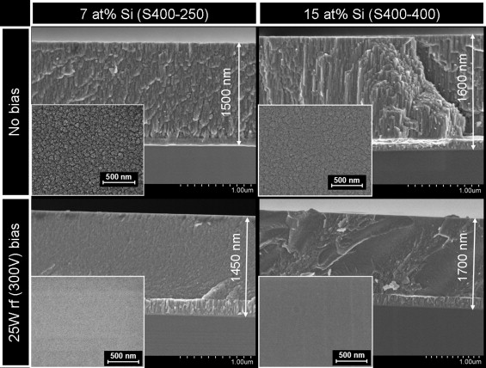

Figure 2

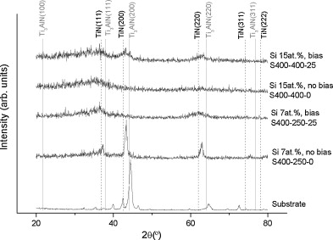

Figure 3

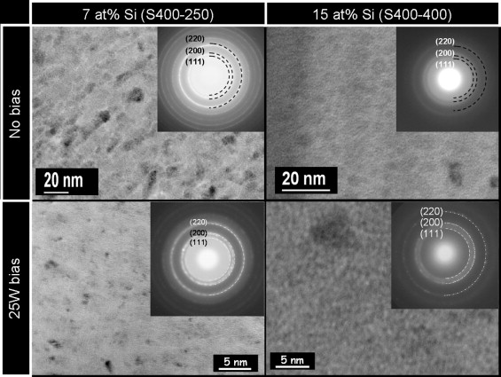

Figure 4
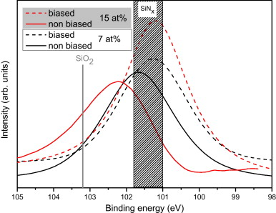

Figure 5

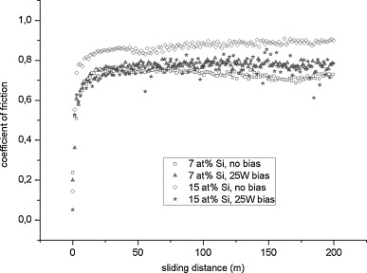

Figure 6

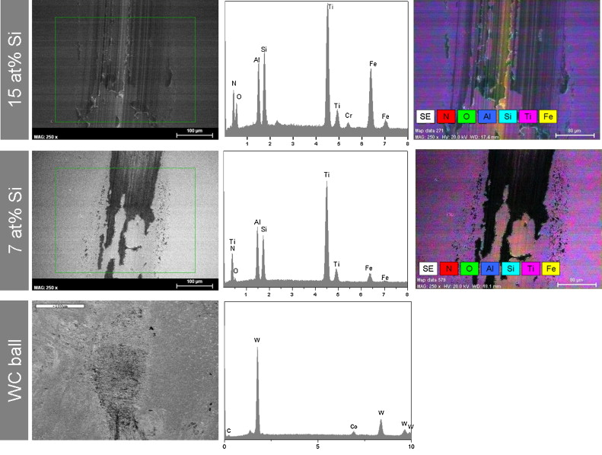

Figure 7
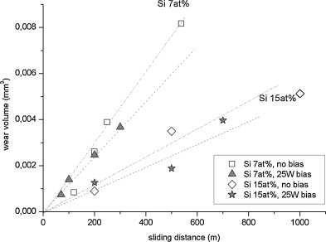

Figure 8

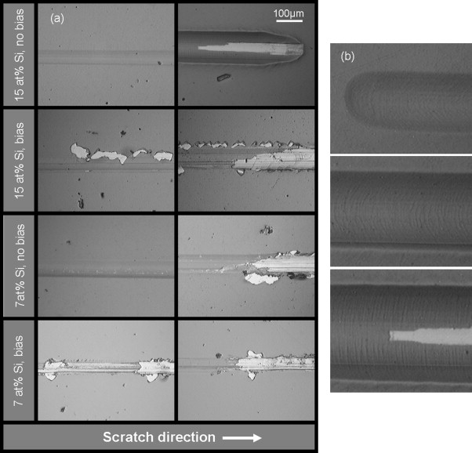

Figure 9
