SUPPLEMENTARY INFORMATION

Low-temperature Sintering and Enhanced Stability of Fluorine-modified BaZr_{0.8}Y_{0.2}O_{3-δ} Synthesised by a Sol-Gel Alkoxide Route

A. Triviño-Peláez, J. Mosa, D. Pérez- Coll, M. Aparicio, G.C. Mather
Instituto de Cerámica y Vidrio (CSIC), Campus de Cantoblanco, 28049, Madrid, Spain

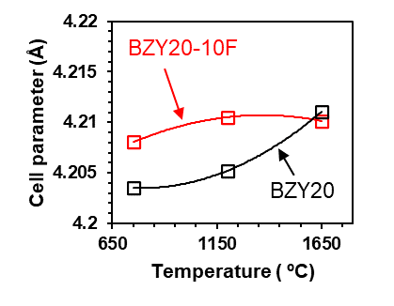

Fig. S1. Cell parameters determined by refinement with internal lattice-parameter standard (CaF₂) plotted against final treatment temperature for BZY20-10F (red open-squares) and halogen-free BZY20 (black open-squares). Thermal treatments were performed in Ar at 750 ºC and air at 1200 and 1650 ºC.

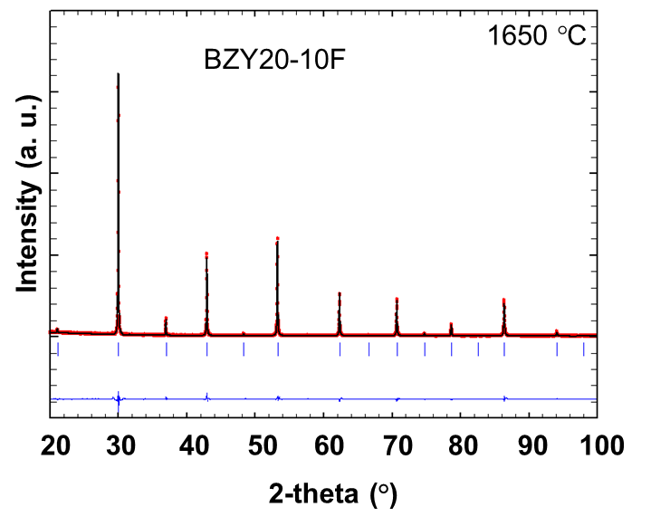
Fig. S2. XRD Rietveld refinement plot of BZY20-10F sintered at 1650 °C showing observed (red circles), calculated (continuous black line) and difference (continuous blue line at bottom) diffraction profiles.
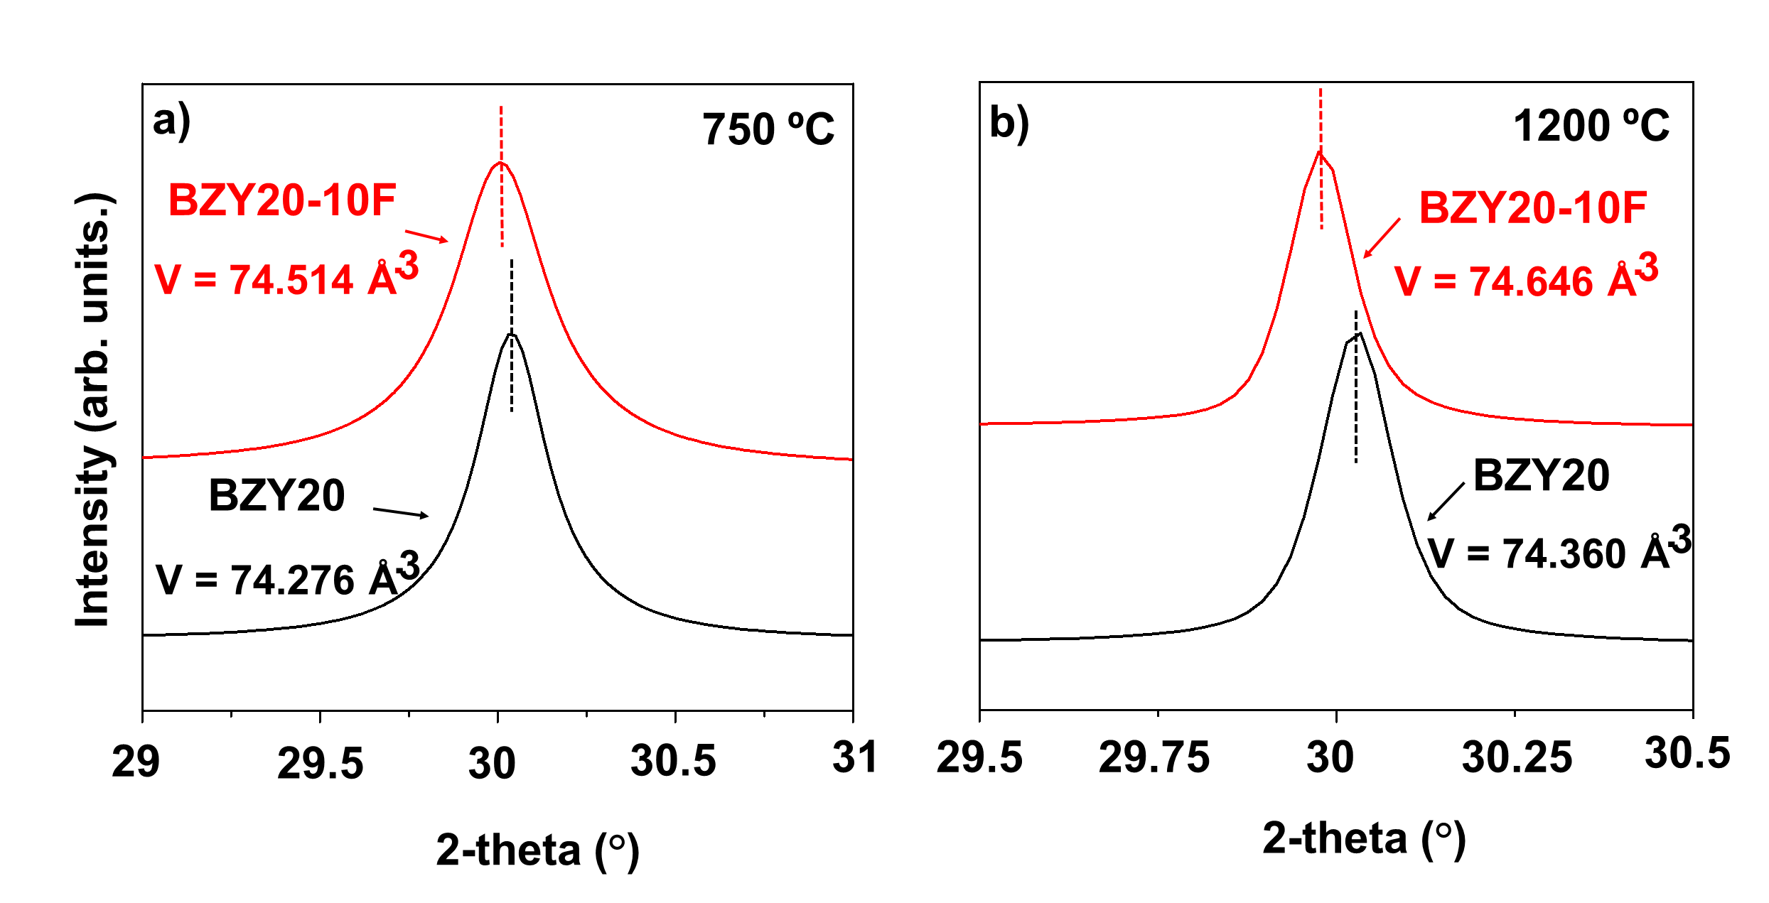
Fig. S3. Comparison of the (1 1 0) peak displacement for BZY20-10F and BZY20 at a) 750 ºC and b) 1200 ºC.

