**USING INTEGRATIVE SAMPLERS TO ESTIMATE THE REMOVAL OF PHARMACEUTICALS AND PERSONAL CARE PRODUCTS IN A WWTP AND BY SOIL AQUIFER TREATMENT ENHANCED WITH A REACTIVE BARRIER**

Adrià Sunyer-Caldú1, Bárbara Benedetti2, Cristina Valhondo3,4, Lurdes Martínez-Landa3, Jesús Carrera3, Marina Di Carro2, Emanuele Magi2, M. Silvia Díaz-Cruz*1

1Environmental Chemistry Department, Institute of Environmental Assessment and Water Research (IDAEA), Severo Ochoa Excellence Center, Spanish Council for Scientific Research (CSIC), Jordi Girona 18-26, 08034 Barcelona, Spain.

2 Department of Chemistry and Industrial Chemistry, University of Genova, Via Dodecaneso 31, 16146 Genova, Italy.

3GHS (UPC-CSIC) Geosciences Department, Institute of Environmental Assessment and Water Research (IDAEA), Severo Ochoa Excellence Center of the Spanish Council for Scientific Research (CSIC), Jordi Girona 18-26, 08034 Barcelona, Spain.

4Géosciences Montpellier, Université de Montpellier, CNRS, 300 avenue Emile Jeanbrau, CC MSE, 34095, Montpellier, France.

*Corresponding author: M. Silvia Diaz-Cruz; [silvia.diaz@idaea.csic.es](mailto:silvia.diaz@idaea.csic.es)

**Section S1. Figures**

Figure S1: Installation of the POCIS at the outlet of the T4 SAT system.

Figure S2: Appearance of the POCIS once transported to the laboratory and dismantled for subsequent cleaning and extraction.

Figure S3. Total amounts of the different chemical classes detected by POCIS sampling in the various steps of wastewater treatment (ST: secondary treatment; TT: tertiary treatment).

**Section S2. Tables**

Table S1: Selected compounds and their major physico-chemical properties. logKow, octanol-water partition constant; pKa dissociation constant.

Table S2: Limits of detection (LOD) and limits of quantification (LOQ) of each compound analysed, in picograms (pg).

Table S3: Concentrations of the single detected CECs in the deployed POCIS, expressed as ng/POCIS ± standard deviation.

**Section S1. Figures**

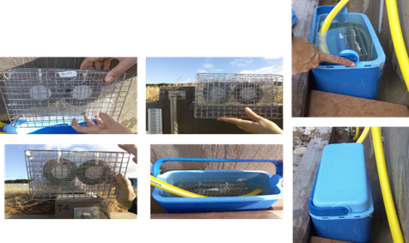

Figure S1: Installation of the POCIS at the outlet of the SAT system T4.



Figure S2: Appearance of the POCIS once transported to the laboratory and dismantled for subsequent cleaning and extraction.

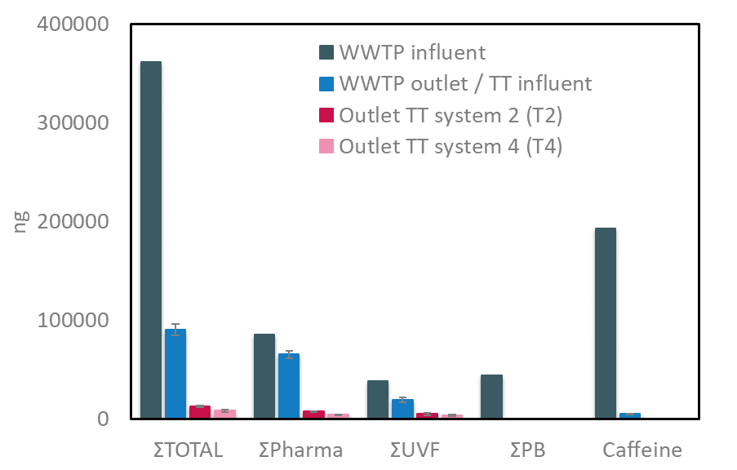

Figure S3. Total amounts of the different chemical classes detected by POCIS sampling in the various steps of wastewater treatment (ST: secondary treatment; TT: tertiary treatment).

**Section S2. Tables**

Table S1: Selected compounds and their major physico-chemical properties. Kow, octanol-water partition constant; pKa dissociation constant.



Table S1: continued.



Table S1: continued.



Table S1: continued.



Table S1: continued.



Table S2: Limits of detection (LOD) and limits of quantification (LOQ) of each compound analysed, in picograms (pg).



Table S3: Concentrations of the single detected CECs in the deployed POCIS, expressed as ng/POCIS ± standard deviation.

