Development of anacardic acid-loaded zein nanoparticles: physical chemical characterization, stability and antimicrobial improvement
Jennifer Thayanne Cavalcante de Araujoª, Manuel Martin-Pastor^{b}, Loures Pérez^{c}, Aurora Pinazo^{c}, Francisco Fabio Oliveira de Sousa^{a*}
ª Graduate Program on Pharmaceutical Sciences, Federal University of Amapa, Macapa, Brazil
^{b} Unidade de Resonancia Magnetica, RIAIDT, University of Santiago de Compostela, Santiago de Compostela, Spain
^{c} Department of Surfactants and Nanobiotechnology, IQAC-CSIC, Barcelona, Spain.
*Corresponding author: Francisco F. Oliveira de Sousa. School of Pharmacy, Department of Biological and Health Sciences, Federal University of Amapá, Rod. Juscelino Kubitscheck, KM-02, S/N, 68903-419. E-mail: fabio@unifap.br

Abstract
Anacardic acid (AA) has gained interest regarding its extraordinary antimicrobial activity. Nanotechnology based delivery systems are a modern approach to improve both pharmacological and functional properties of therapeutic agents. In this paper we aimed to design and characterize AA loaded-zein nanoparticles and evaluate its antimicrobial efficiency in vitro using microdilution and antibiofilm assays. AA nanoparticles were spherical, stable, with an average size of 381.6 nm and negative zeta potential. The saturation transfer difference-NMR analysis demonstrated the association of zein and AA in two different conformations, enlightening its enhanced pharmacological activity. Bacteriostatic concentrations were 0.05 and 3.12 µg/ml for Staphylococcus aureus and Pseudomonas aeruginosa, while bactericide activity was observed only for S. aureus at 0.2 µg/ml. Fungistatic/fungicide concentrations for Candida rugosa were 1.17/2.34 µg/ml, for Candida albicans and Candida parapsilosis 2.34/4.69 µg/ml and for Candida tropicalis, Candida jardinii, Candida glabratta and Candida auris 4.69/4.69 µg/ml. Furthermore, nanoencapsulated AA was more efficient in reducing S. aureus and C. albicans biofilms viability than AA solution, while they presented a similar inhibition against P. aeruginosa biofilm. Therefore, AA loaded-zein nanoparticles could represent an alternative for potential applications where the low concentrations of this phytochemical are useful to prevent or treat bacterial and fungical infections.

Keywords: Anacardium occidentale L; nanotechnology; zein; nanoparticles; anacardic acid; antimicrobial.

- Introduction
Nanoencapsulation has been used to reach specific targets, controlled release and reduce side effects [1]. Likewise, natural bioactive based formulations also benefit from the increased stability and improved pharmacological activities [2].
Corn protein zein is a hydrophobic prolamine, soluble in alkaline and hydroethanolic solutions [3,4]. Zein can encapsulate hydrophilic and hydrophobic molecules [5,6]. This biopolymer, classified in the GRAS (Generally Recognized as Safe) list [7], has been previously used in nanoparticles to encapsulate and promote controlled release of some active ingredients [3,8].
Anacardic acid (AA) is the major constituent of the resin oil, also popularly known as the cashew nut shell liquid (CNSL), extracted from the mesocarp of bark shells of Anacardium occidentale L. [9]. The mixture of AA (C₂₂H₃₀O₃) has the structure of a salicylic acid substituted by a long hydrocarbon chain (15-17 carbons), containing up to three unsaturation (Fig. 1), whose are closely related to the potentiation of some biological properties [10,11]. The resin is extracted with cold solvents to avoid its decarboxylation [11]. Finally, AA is isolated from the resin oil as calcium anacardate by precipitation, which is further acidified and extracted with organic solvents [11,12].
AA has demonstrated some important biological activities such as antioxidant [12], gastroprotective [13], anti-inflammatory [14], anticancer [15], larvicide [12] and antimicrobial, especially against Gram-positive bacteria [16,17]. Therefore, it has been eligible as an alternative against microorganisms resistant to multiple drugs [9].
Fungal infections are rare compared with bacterial infections, while their diagnosis and control are challenging, resulting in increased mortality [18]. Candida spp are present in the natural microbiota of healthy individuals, but can become an opportunistic pathogen from the host's immunological imbalance [19]. A virulence characteristic of this yeast is the factors that contribute to adhesion on surfaces and the formation of biofilms, and the inhibition of these processes are considered targets of antifungal drugs [20]. Moreover, in the recent years other opportunistic pathogens such as Candida albicans, Candida rugosa, Candida tropicalis, Candida glabratta, Candida parapsilosis and more recently the worrisome Candida auris have emerged, leading to important implications for diagnosis and management, as they have been turning aggressive and rapidly developing resistance to different classes of antifungal agents [21–23], representing a serious concern for the healthcare systems.
Due to the spreading of multidrug resistance microorganisms, there is a strong need to search for new alternatives to inhibit their growth and reduce their virulence. Accordingly, this work aimed to design and characterize anacardic acid loaded-zein nanoparticles and evaluate the impact of the nanoencapsulation in the antimicrobial activity.

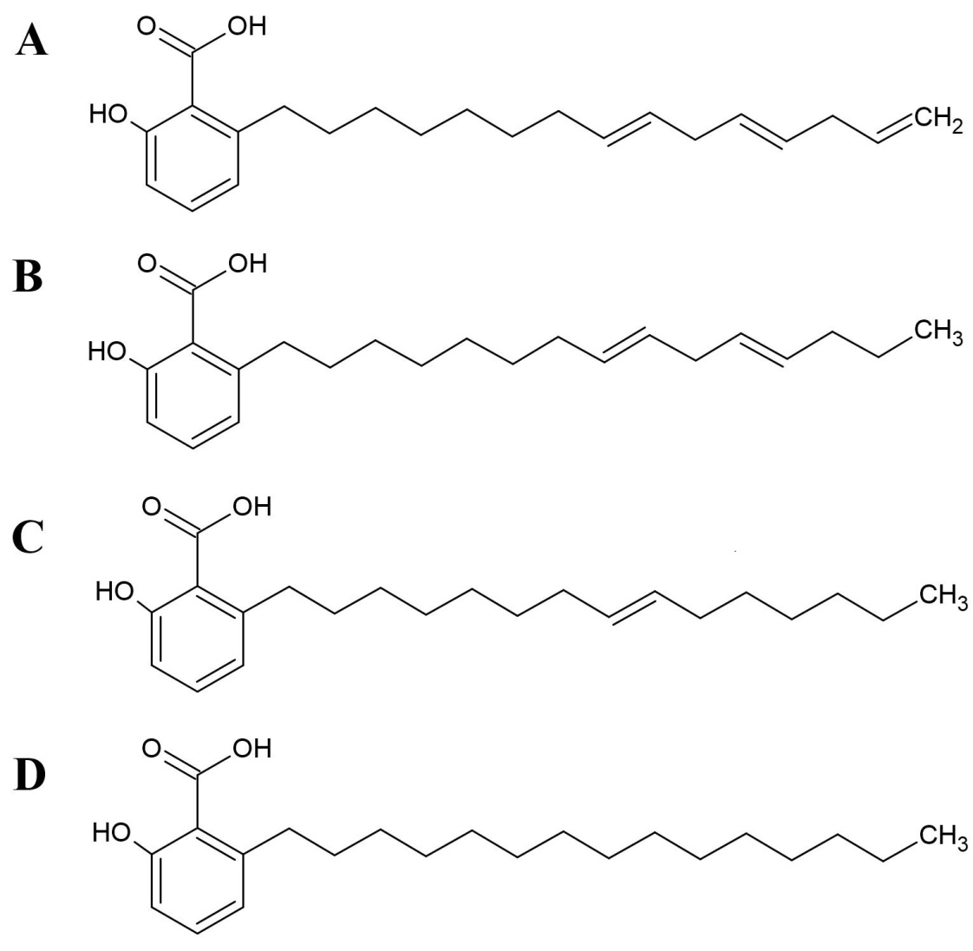

Fig 1. Chemical structures of the compounds present in the resin oil obtained from the cashew nut shell of Anacardium occidentale L. A) Anacardic acid C15:3; B) Anacardic acid C15:2; C) Anacardic acid C15:1 and D) Anacardic acid C15:0.

- Materials and methods
  - Materials
Zein, chlorhexidine gluconate and amphotericin B were purchased from Sigma-Aldrich® (St. Louis, MO, USA). Dimethylglyoxime was purchased from Dinamica® LTDA (São Paulo, Brazil). Purified AA mixture was kindly donated from the Chemistry Department of Federal University of Ceara, Brazil. It was obtained by cold solvent extraction from dried cashew shells of A. occidentale, according to the methodology proposed by Trevisan et al. [11] and characterized by Nuclear Magnetic Resonance (NMR). Brain Heart Infusion (BHI) broth and Muller-Hinton agar were obtained from Kasvi® (São Jose dos Pinhais, PR, Brazil). Deuterated solvents D₂O 99.9 % and CD₃OD 99.8 % were purchased from Eurisotop (Saint-Aubin, France). All the other reagents were analytical grade and used as received.
  - Preparation of zein nanoparticles
The nanoparticles were prepared by nanoprecipitation [24]. The nanoprecipitation is an economical, green, low-energy and scale-up reproducible method. This method allows obtaining small and homogeneous droplets by increasing the surface area through the disruption in the semipolar solvent containing the polymer and the aqueous interphase [25,26]. Zein concentrations ranged from 0.02 to 0.2 % (w/v), while AA was incorporated at concentrations ranging from 0.0009 to 0.0018 % (w/v). First, zein was dissolved in 70 % (v/v) ethanol, which was thereafter gently diluted with ultra-pure water to promote the nanoparticles formation. Separately, AA was solubilized in 96 % ethanol containing 0.108 % (w/v) dimethylglyoxime (DMG), providing a long-lasting stability to the loaded-nanoparticles. The pre-formed nanoparticles were added dropwise under constant stirring until complete homogenization, resulting in AA-loaded zein nanoparticles (ZA), which were evaluated in order to select the best formulation for the microbiological assays. Blank nanoparticles were prepared in the same manner, except for absence of drug (ZD). For control purposes, pure blank zein nanoparticles (ZE) prepared under the same procedure (without DMG) were also obtained. The formulations prepared are listed in Table 1.

  - Nanoparticles characterization
The nanoparticles were characterized in terms of size (nm), zeta (ζ) potential (mV) and polydispersity index (pdI) using a dynamic light analyzer (Zetasizer® Nano-ZS90, Malvern Instruments). Subsequently, they were also observed morphologically by transmission electronic microscopy (TEM) (JEOL JEM-2010, Electron Microscope).
  - Stability evaluation
The formulations were stored under two different conditions: room temperature (25 ± 2ºC) and refrigerator (4 ± 2ºC) and evaluated at predetermined time intervals (0, 1, 7, 30, 90 days) in terms of visual inspection, particle size, pdI and ζ potential. This analysis permits to indicate the best storage condition for the nanoparticles.

  - Saturation Transfer Difference (STD) by ¹H NMR
The binding interaction between AA and zein was assessed by STD-NMR analysis. Samples were dissolved and homogenized in CD₃OD:D₂O 90:10 (v/v). The concentration of zein was fixed at 8 mM, while AA was dissolved at 400 mM, based in our previous study [6]. ¹H NMR spectra were measured at 25 ºC using a 17.6 T Bruker NEO-750 NMR spectrometer (750 MHz proton frequency). One-dimensional ¹H spectra were measured for each individual component and for the mixture AA-zein [6,27] . The saturation time was set as 2 s and the STD-off saturation was applied at 20 ppm. The STD-on saturation was applied at two different points for AA-zein mixture (1.77 ppm and 7.05 ppm), corresponding to regions where ¹H signals of the protein (and not of AA) are expected. The STD-on and STD-off were measured in alternate scans and subtracted by the phase cycling, providing the so-called STD^{off-on} spectrum. The spectra were processed with MestraNova® software version 12.0.

  - Antimicrobial activity
    - Microdilution method
For the antimicrobial evaluation, ZA₃, ZD, ZE nanoparticles (Table 1) and AA solution 9.375 μg/mL (prepared in the same manner as ZA₃) were used. ZA₃ was chosen among the loaded-nanoparticles based on their stability and favorable physicochemical properties: size stability, uniformity (pdI) and zeta potential. Ethanol (EtOH) in the same concentration of the nanoparticles and sterile saline solution were used as negative controls, while chlorhexidine gluconate at 2 % (CHX) and Amphotericin B at 2 μg/mL (AMB) were used as positive controls for bacteria and yeasts, respectively.
The American Type Culture Collection (ATCC) Staphylococcus aureus (ATCC 6538P) and Pseudomonas aeruginosa (ATCC 9027) were used as representative of Gram-positive and Gram-negative bacterial strains, respectively. Candida tropicalis (ATCC 7349), Cyberlindnera jardinii (ATCC 60459), Candida rugosa (ATCC 10571), Candida albicans (ATCC 90028), Candida parapsilosis (ATCC 22019), Candida glabratta (ATCC 66032) and Candida auris (TSM 21092) were the yeast used. They were preserved according to the specific conditions [28]. The inoculum for the tests was prepared by culturing the bacterial strains in sterile BHI (Brain Heart Infusion) broth and yeasts in SB (Saboraud) broth at 37 ºC and adjusting to 1.5 x 10⁸ colony forming units per ml (CFU/ml) (equivalent to 0.5 in the McFarland scale). The antimicrobial activity was determined using the microdilution method to determine the minimum inhibitory concentration (MIC) and minimal biocide concentration (MBC) in accordance with the CLSI guidelines [28]. Serial dilutions from the tested substances (4.69 – 0.02 µg/mL) were made in the respective sterile broth in a 96-well sterile plate and the inoculum added resulting in a final concentration of approximately 10⁶ CFU/mL. MIC was defined as the lowest concentration able to inhibit the inoculum growth. To determine the MBC, aliquots of 10 µL obtained from the 3 wells just above the MIC were individually seeded over Mueller-Hinton (for bacteria) and SB (for yeasts) agar plates and incubated for 48 hours at 37 ± 2 ºC. MBC was defined as the minimum concentration eliminating most (≥99.9 %) viable microorganisms, identified by the absence of colonies on the agar surface. All assays were performed in triplicate under strictly aseptic conditions.

    - Antibiofilm activity
The antibiofilm activity was determined using the crystal violet assay [29]. This assay can be performed quickly and directly, not disrupting the biofilm and is commonly used as a preliminarily assessment.
The inoculum for the tests was prepared in the same manner as in the microdilution assay. For the bacterial biofilm formation, BHI broth supplemented with 0.5 % (w/v) glucose containing each individual inoculum adjusted to the MacFarland scale were transferred to a 96-well microplate. For the yeasts, RPMI 1640 buffered with 0.165M MOPS was used.
Biofilms were formed on the bottom of the wells after 24 hours at 37°C. After this period, the plates were stirred at 200 rpm for 5 minutes in an orbital lab shaker (Shaker 20E; Labner International, Edison, N.J.) to remove the non-adherent cells. The adherent bacterial biofilm was individually treated in each well with the testing formulations ZA₃ (MIC and 2x MIC), AA solution at 9.375 μg/mL and CHX (positive control group) for 1 minute, and immediately washed out 3 times with sterile saline solution to remove the non-adherent bacteria. The yeasts biofilms were treated over 24 hours, while the positive control used was AMB 2 μg/mL [30].
After the incubation period, the biofilms were fixed with methanol, stained with crystal violet 0.1 % (w/v) and dried at room temperature for 30 minutes. The non-adhered dye was removed by washing three times with sterile saline solution. Ethanol-acetone mixture (4:1) was used to dissolve the adhered biofilm. The absorbance of the obtained solution was determined in a microplate reader (Biotek, USA) at λ=570 nm. The mean absorbance value of inoculum free wells was used for background correction. The percentage of viability was calculated according to the following equation:

$$\% Cytotoxicity=100-(\frac{O.D.SS-O.D sample}{O.D. SS} x 100 )$$

Where: O.D._{SS}. is the optical density of saline solution after background correction O.D_{.sample} is the optical density of the samples after background correction.
Data were expressed as means ± standard deviation, submitted to one-way analysis of variance (ANOVA) test followed by Tukey's multiple comparison. The statistical significance for all tests was set at p<0.05, using the GraphPad Prism 5.0 software.

- Results and discussion
  - Nanoparticles characteristics
In preliminary preparations of nanoparticles containing solely zein and AA in different concentrations, particles´ precipitation occurred instantly. In order to shield the colloidal system, DMG was used to provide long-lasting stability to the loaded-nanoparticles. DMG is an organic complexing agent, mainly used in the analysis of nickel, copper, cobalt and palladium [31]. For instance, its complex with copper (II) is capable of promoting increased stability [32]. DMG has also been associated with poly-ε-caprolactone for the detection of nickel by colorimetric reaction in contaminated waters [31] and nanoparticles of clinoptilolite for Ni removal in waters [33].
The stability found in the AA loaded-zein nanoparticles may result from the hydrogen bonding between OH groups of DMG to non-bonding electrons [33], such as N found in the primary structure of zein or OH group(s) present in anacardic acid (Fig. 1) . This may explain in part the negative charge of the loaded-nanoparticles in contrast to the positive zeta potential found in the blank ones (Table 1). When comparing the blank nanoparticles ZE (only zein) to ZD (containing DMG), it is notorious that the addition of DMG decreased the zeta potential to almost half of its original value (Table 1). Moreover, keeping a fixed concentration of DMG, it was possible to observe that the amount of AA also conditioned the zeta potential in the formulations. For instance, ZA₂ and ZA₃ presented similar negative zeta potential, while for ZA₁ the zeta potential was inferior, despite the higher AA content (Table 1). This aspect reinforces the influence of zein in the zeta potential magnitude and DMG as being crucial on its stabilization. Hence, unlike its little usage in nanoformulations, the addition of DMG was found to be an useful strategy to stabilize the zein nanoparticles and keep anacardic acid encapsulated. Although DMG applicability is solely analytical, and some concerns are related to its therapeutic usage, its reported oral toxicity in vivo in rats is over 250 mg/kg [34], while the concentration used (1.08 mg/ml) as stabilizing agent (Table 1) is very low.
ZA₃ was the most stable formulation, maintaining the characteristics of the colloidal system, with particle size of 381.6 ± 2.12 nm, ζ potential of -15.9 mV and pdI of 0.215 (Table 1). When the concentration of zein was doubled, maintaining constant all the other adjuvants, such as in ZA₁, aggregation and precipitation occurred within 24 hours (Table 1). The size of this formulation increased substantially (534.6 nm). This formulation also presented a ζ potential of -12.0, which may also have contributed to this aspect, as it is in the limit to the instability. The higher the ζ potential, the higher is the stability of the colloidal systems [35]. Skin and mucous tissues are negatively charged. Positive nanoparticles are known to bind more extensively to these tissues [36]. Therefore, the negative charged AA nanoparticles are likely to be more biocompatible to this environment in topical applications, where the binding is undesirable for immediate the antimicrobial effect.

Table 1
Composition and key physical-chemical parameters of anacardic acid-loaded zein nanoparticles. Results are expressed as mean (± SD).

Samples | Zein  (% w/v) | DMG (% w/v) | AA  (% w/v) | Mean particle size (nm) | pdI | Zeta potential (mV) | pH
ZA₁ | 0.1424 | 0.108 | 0.00093 | 534.6 | 0.229 | -12.0 | -
ZA₂ | 0.0712 | 0.108 | 0.0018 | 642.7 | 0.353 | -16.1 | -
ZA₃ | 0.0712 | 0.108 | 0.00093 | 381.6 | 0.215 | -15.9 | 4.9
ZD | 0.0712 | 0.108 | - | 376.5 | 0.137 | +6.56 | 5.6
ZE | 0.0712 | - | - | 392.5 | 0.191 | +11.4 | 5.6
ZA, anacardic acid-dimethylglyoxime-loaded zein nanoparticles; ZD, Blank zein nanoparticles containing Dimethylglyoxime; ZE, zein nanoparticles; DMG, dimethylglyoxime; AA, anacardic acid; pdI, polydispersity index.

By doubling the AA concentration, such as in the formulation ZA₂, an increment in size and pdI were observed (Table 1) and could incurs in the disruption of these systems in a long-term. Bigger particles are easier to form bigger aggregates and flocculate/precipitate [35,37].
In our previous study, the encapsulation of tetracycline and indomethacin in zein nanoparticles increased the particle size comparatively to the blank nanoparticles, obtaining sizes of 380.0, 501.5 and 288.0 nm, respectively. The blank nanoparticles (ZE) obtained in this work had a particle size (392.5 nm) similar to that found in the best nanoparticles containing AA (ZA₃) (381.6 nm) and the positive ζ potential was consistent with that obtained by Sousa et al. [6], conditioned by zein conformation within the colloidal systems. Taking into account that colloidal systems tend to be non-homogeneous with pdI values greater than 0.3 [35], it is expected that ZA₂ could become unstable. Although the ζ potential was not altered compared to ZA_{3,} size increased substantially in ZA₂ (642.7 nm) and was therefore a key factor to disrupt the colloidal system.
In view of the most satisfactory characteristics, the composition ZA₃ was selected from the loaded-nanoparticles and used together with the controls ZD and ZE in the following tests.

  - TEM morphological appreciation
TEM images showed that ZA₃ nanoparticles presented an irregular spherical surface, presenting a shaded coating layer, displayed in Fig. 2A. This coating could be attributed to the presence of anacardic acid adsorbed on the surface of zein nanoparticles, as this aspect was not evident in none of the blank-nanoparticles (ZD and ZE) images (Fig. 2B and Fig. 2C).

Fig. 2. TEM images of the nanoparticle formulations. A) ZA₃, Anacardic acid-loaded zein nanoparticles; B) ZD, Blank zein-dimethylglyoxime nanoparticles; C) ZE, Blank zein nanoparticles. The arrow indicates the coating found in ZA₃ nanoparticles.

Based on the TEM images, ZA₃ nanoparticles size ranged between 350-490 nm, while the diameter of both control nanoparticles ranged from 100-400 nm. Both results are in agreement with the dynamic light scattering measurements displayed in Table 1. Similar results were obtained by Li and cols. [35]. These authors prepared zein nanoparticles using the same procedure and their TEM observation also indicated that the aggregates had spherical shape with a diameter of 165-470 nm.

  - Stability evaluation
After the initial physicochemical characterization, ZA₁ and ZA₂ formulations were discharged due to the instability issues observed. The formulations ZA_{3,} ZD and ZE were evaluated over 90 days under room temperature and refrigerator, the most common storage conditions. ZA₃ nanoparticles remained stable at 25 ± 2 °C, keeping the nanometric size (323.8 nm) after 90 days storage (Fig. 3A). Both control groups presented instability between 7 and 30 days, with clusters and precipitate formation. After 7 days, the blank-nanoparticles ZD and ZE stored at room temperature collapsed, resulting in size disruption (4,514 nm and 1,732 nm, respectively) forming big aggregates and sedimentation, visually noticeable, as the colloidal aspect changed from slightly bluish to transparent (Fig. 3A).
When stored at 4 ± 2 °C, the size of ZA₃ nanoparticles was kept unaltered over 90 days (Fig. 3B). The blank-nanoparticles ZE did not experience any size alterations after 7 days, although after 30 days both control formulations (ZD and ZE) disrupted and size increased substantially (Fig. 3B). ZA₃ nanoparticles stored at 4°C (378.0 nm) presented a similar value to the freshly obtained ones (381.6 nm), indicating that even if both conditions would be feasible for their preservation, 4°C would keep more strictly their original characteristics after 90 days.
After 90 days ZD and ZE formulations presented a severe reduction in particle size (ZD: 316.5 nm and ZE: 784.8 nm), resultant from the precipitation observed. Similar results were obtained in the encapsulation of glimepiride in zein nanoparticles, whose physical-chemical instability [5] was related to the acidic medium pH (4.4 – 4.7), where zein tends to form bigger nanoparticles and aggregates [37].
The higher the zeta potential in a system, the better the physical-chemical stability, preventing aggregation between particles [38]. Unlike the positive charged control nanoparticles (ZE = +11.4 mV and ZD = +6.56 mV), the incorporation of anacardic acid to zein nanoparticles resulted in negative ζ potential (-15.9 mV) (Table 1), which could be related to the presence of OH groups found in anacardic carboxylic and DMG. By doubling zein in the amount of zein in the formulation (ZA₁), the ζ potential reduced to -12.0, due to the positive influence of the protein charged surface. Although, the increment of AA to the composition (ZA₂) did not alter the ζ potential, what could possibly indicate a saturation of the nanoparticles surface with DMG and/or AA molecules. Positively charged zein nanoparticles could interact electrostatically to electrically negative molecules and reverse the surface charge [11]. Our findings are in agreement with the study of Sousa et al. [6] where the ζ potential of blank zein nanoparticles was +17.1 mV, while the addition of tetracycline and indomethacin decreased this parameter to +9.1 and +13.9 mV, respectively.
The zeta potential of ZA₃ nanoparticles stored at 25 ± 2 ºC (Fig. 3c) varied slightly along 90 days, although more than those stored at 4 ± 2 ° C (Fig. 3d). Contrariwise, the control groups ZD and ZE (Fig. 2C and Fig. 2D) were more unstable, oscillating and even inverting the zeta potential charge after 7 days, resulting in collapse and precipitation in both storage conditions, such as aforementioned.

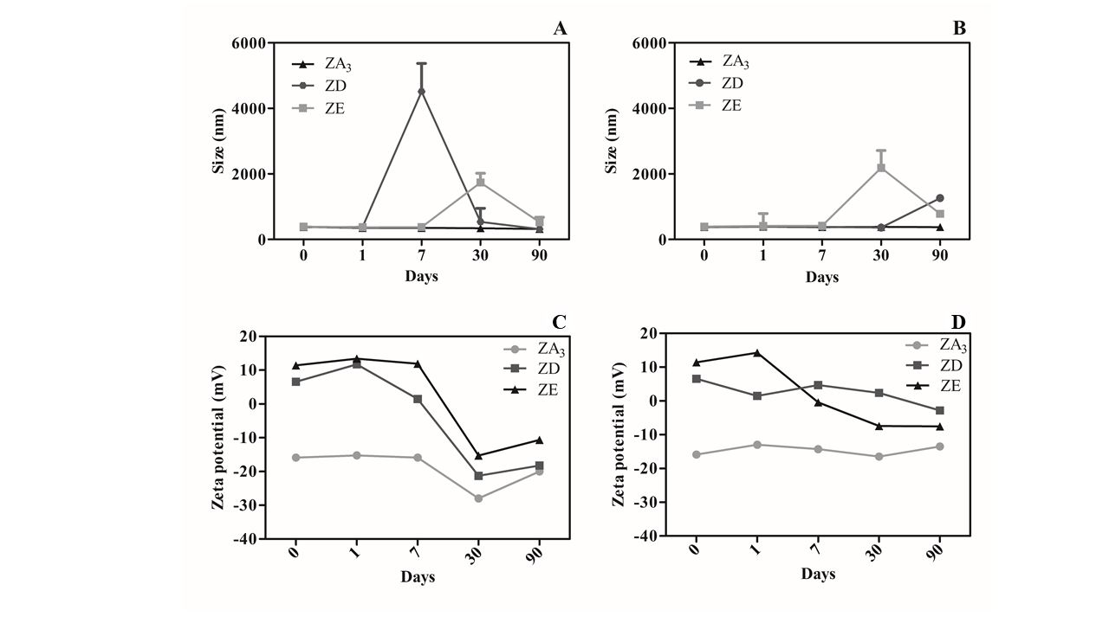Fig. 3. Stability of the blank and anacardic acid- loaded zein nanoparticles over 90 days. Size stability: A) Temperature 25 ± 2 ° C; B) Temperature 4 ± 2 ° C. Zeta potential stability: C) Temperature 25 ± 2 ° C; D) Temperature 4 ± 2 ° C. ZA₃, anacardic acid-dimethylglyoxime-loaded zein nanoparticles; ZD, Blank zein-dimethylglyoxime nanoparticles; ZE, Blank zein nanoparticles.

  - STD-NMR characterization of AA-zein interactions
The ¹H STD-NMR spectra for AA solely and mixed in solution with zein (zein-AA) is shown in Figure 4. In the first spectrum (Fig. 4A) the ¹H spectrum of AA is shown together with the signal assignment, confirming the solely presence of this bioactive in the material used to prepare the nanoparticles. In the purified mixture used, the molecules that contain monoene (Fig. 1C) and diene (Fig. 1B) in the aliphatic chain were predominant.
The STDwg^{on-off} spectra show the responses of certain signals of AA after applying the on-saturation over a region of the spectrum containing only zein protons either in the aliphatic (Fig. 4B, on-saturation at 1.77 ppm) or aromatic region of the spectrum (Fig. 4C, on-saturation at 7.05 ppm). The presence of STD responses, noticeable by the peaks intensification after the saturation, proves the formation of a complex between zein and AA. Although the complete structure of AA could interact to zein, the stronger association occurs in the aromatic protons, as these responses were appreciated in both spectra of Fig. 4B and Fig. 4C in which the saturation is applied in the aliphatic and aromatic region, respectively. The affinity of zein for phenolic structures has already been evidenced in other studies [39,40] and could be a result of the aromatic amino acids present on its primary structure and the binding to other aromatic groups to protect these groups in polar environments.

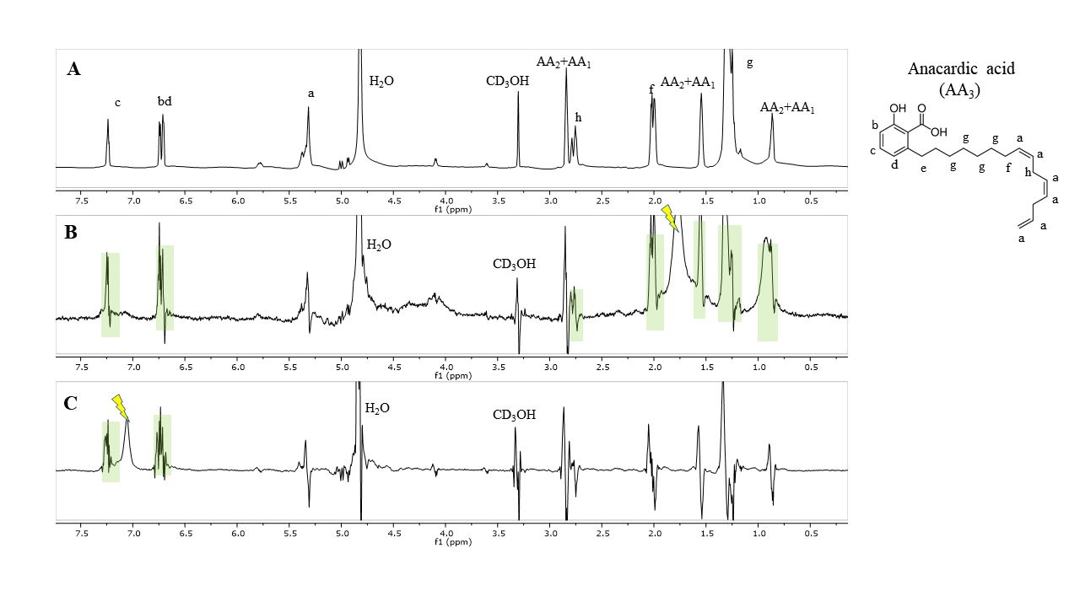
Fig. 4. NMR spectra of zein and AA. A) ¹H spectrum of anacardic acids. The proton signal assignment is indicated with letters that corresponds to the scheme of the molecule that is shown on the right. B) STDwg^{off-on} spectrum of the mixture zein-AA aliphatic with the on-saturation applied over a signal of zein at 1.77 ppm (indicated with a ray symbol). C) STDwg^{off-on} spectrum of the mixture zein-AA aromatic with the on-saturation applied over a signal of zein at 7.05 ppm (indicated with a ray symbol). In B) and C) the STD responses of AA are highlighted in both.

  - Minimal inhibitory and biocide concentrations
Nanoencapsulated anacardic acid (ZA₃) inhibited the Gram-positive bacteria S. aureus in half the concentration (0.05 µg/ml) of its solution (0.10 µg/ml). In addition, it was also able to inhibit the microbial growth of the Gram-negative bacteria P. aeruginosa, while AA in solution did not cause any effect to this bacteria (Table 2).
A bactericide effect against S. aureus was also observed for ZA₃ and AA, while none of the tested formulations were bactericide against P. aeruginosa under the experimental conditions used. The bactericidal concentration for ZA₃ against S. aureus was double the AA in solution (Table 2), demonstrating that nanoparticles loaded with anacardic acid present more pronounced bacteriostatic than bactericidal activity in the planktonic form. ZA₃ nanoparticles also showed fungistatic and fungicide activities against the yeasts of C. tropicalis, C. jardinii, C. albicans, C. rugosa, C. parapsilosis, C. glabratta and C. auris, the last considered a multidrug resistant strain [41] (Table 2). MICs against C. albicans, C. rugosa and C. parapsilosis for the nanoencapsulated AA was half of that found for AA solution, demonstrating the enhancement on its antifungal activity when loaded to zein-based nanoparticles. Neither ZD nor ZE blank-nanoparticles present inhibitory activity against the strains tested, indicating that the antimicrobial activity observed was attributed exclusively to AA. Finally, the positive control CHX 2% was bactericide against both bacterial strains and AMB 2 μg/mL fungicide against the yeasts tested (Table 2), validating our experimental protocol.

Table 2
Inhibitory (MIC) and biocide (MBC) concentrations of blank, anacardic acid loaded-zein nanoparticles and anacardic acid in solution against bacteria and yeasts.

Strains | Formulations
 | ZA₃ |  | ZD |  |  | ZE |  |  |  | AA |  |  | CHX |  |  | AMB
 | MIC | MBC | MIC |  | MBC |  | MIC | MBC | MIC |  | MBC |  |  | 0.12% | 2µg/mL
Staphylococcus aureus | 0.05 | 0.20 | - |  | - |  | - | - | 0.10 |  | 0.10 |  |  | -
Pseudomonas aeruginosa | 3.12 | - | - |  | - |  | - | - | - |  | - |  |  | -
Candida tropicalis | 4.69 | 4.69 | 4.69 |  | 4.69 |  | 4.69 | 4.69 | 4.69 |  | 4.69 |  |  |  | -
Candida jardinii | 4.69 | 4.69 | 4.69 |  | 4.69 |  | 4.69 | 4.69 | 4.69 |  | 4.69 |  |  |  | -
Candida albicans | 2.34 | 4.69 | 4.69 |  | 4.69 |  | 4.69 | 4.69 | 4.69 |  | 4.69 |  |  |  | -
Candida rugosa | 1.17 | 2.34 | 1.17 |  | 1.17 |  | 1.17 | 1.17 | 2.34 |  | 2.34 |  |  |  | -
Candida parapsilosis | 2.34 | 4.69 | - |  | - |  | - | - | 4.69 |  | 4.69 |  |  |  | -
Candida glabratta | 4.69 | 4.69 | - |  | - |  | - | - | 4.69 |  | 4.69 |  |  |  | -
Candida auris | 4.69 | 4.69 | - | - |  | - |  | - |  | 4.69 |  | 4.69 |  |  | -

AA has previously shown inhibitory activity against S. aureus (25 μg/mL) [9] and against its methicillin resistant strain (MRSA) (6.25 μg/mL) [42], in their molecular conformation C_{15:0} and C_{15:3} [10,42]. Conversely, AA does not present good activity against Gram-negative bacteria [43], confirmed in our study with the limited bactericidal response against P. aeruginosa. Nevertheless, when loaded to zein nanoparticles, an inhibitory effect was observed at 3.12 µg/mL, demonstrating that the coupling with this biopolymer as a nanocarrier was able to modulate and improve the pharmacological activity of this bioactive [39] in comparison to the non-encapsulated form.
In our previous studies, the antibacterial activity of anacardic acid-loaded nanoparticles has been observed against others Gram-positive bacteria in the planktonic form, obtaining inhibition/bactericide concentrations of 0.36 µg/mL against Streptococcus mutans [17] and inhibition/bactericide concentrations of 0.042/0.083 µg/mL for Enterococcus faecalis [44]. AA has already demonstrated antifungal activity against Magnaporthe oryzae, Saccharomyces cerevisiae, through apoptosis induction [45,46]. High concentrations were needed to inhibit Candida utilis [47]. Fungistatic and fungicidal concentration of 0.2567 and 0.5167 mg/mL were found against Trychophyton rubrum for the AA_{15:1}, attributing the lipophilicity of the molecule to the potentiation of antifungal activity [10]. Some studies reported the ineffectiveness of AA at 200 μM and cashew gum crude at 60 mg/mL against C. albicans, however, the ethanol extract of A. occidentale flowers showed a fungicidal concentration of 20 mg/mL against strains of C. albicans and C. tropicalis [48,49]. Hence, the antifungal activity of AA in natura against Candida spp is dependent on high concentrations, while the incorporation to zein nanoparticles (ZA₃) resulted in fungistatic and fungicidal activity over Candida spp. in extremely low concentrations (Table 2).
The formation of zein-AA complex (Fig. 4A) and the exposition of the pharmacophore groups improved the antimicrobial activity of AA, as the unsaturation present in the aliphatic groups are pointed as the major responsible for antimicrobial activity of this bioactive [10]. As such, the higher aromatic binding of AA to the zein nanostructure, confirmed by STD-NMR experiments, resulted in an increased exposition of the pharmacophore groups present in the aliphatic chain to the outer environment, enhancing the antimicrobial performance.
When analyzing the performance of ZA₃ nanoparticles at MIC, 2x MIC and AA solution (9.375 μg/mL) against S. aureus pre-formed biofilms, a consistent performance to that obtained in the microdilution assay was found, demonstrating that the higher the nanoparticles concentration (2x MIC) the higher the antimicrobial activity. The cell viability within the biofilms was 100 %, 36 %, 23 %, 67 % and 69 % for negative control, MIC ZA₃, 2x MIC ZA₃, AA and positive control, respectively (Fig. 5A). Regardless, the encapsulation of AA substantially improved the efficiency of this bioactive (p<0.05) against the S. aureus biofilm compared to its non-encapsulated form.
Sajeevan et al. [16] evaluated the ability of AA on removing S. aureus preformed biofilms from catheters, and found that at 250 µg/ml it reduced almost 100% of the biofilm adhesion, however the lowest concentration tested (2 µg/mL) limited its ability to 40%. In any case, that concentration was much higher than ZA₃ MIC (0.049 µg/mL), which was able to eliminate 64% of the S. aureus biofilm.
In our previous study [17], anacardic acid loaded-zein nanoparticles were able to fully inhibit the cariogenic biofilm of S. mutans equally to CHX gluconate at 0.12%.
In the P. aeruginosa antibiofilm assay, the bacterial viability was 100 %, 71 %, 51 %, 44 % and 83 % for the negative control, MIC ZA₃, 2x MIC ZA₃, AA and positive control treatments, respectively (Fig. 5B). Regardless of AA in solution (at 9.375 µg/ml) being more effective in reducing the bacterial viability of P. aeruginosa, and yet in a concentration higher than 2xMIC ZA₃ of 6.25 µg/ml, no statistical significance was found (p > 0.05). Nonetheless, in the microdilution assay, AA tested at 3.125 µg/ml did not inhibit the bacterial growth, while ZA₃ nanoparticles was effective in the same concentration (Table 2).
Regarding the C. albicans antibiofilm assay, the ZA₃ nanoparticles demonstrate better inhibition than AA in solution, consistent with the results found in the microdilution assay. The cell viability was 100 %, 77%, 68 %, 80 % and 84 % for negative control, MIC ZA₃, 2xMIC ZA₃, AA and positive control, respectively (Fig. 5C). Also, AA in solution presented good inhibition in comparison to the positive control AMB.

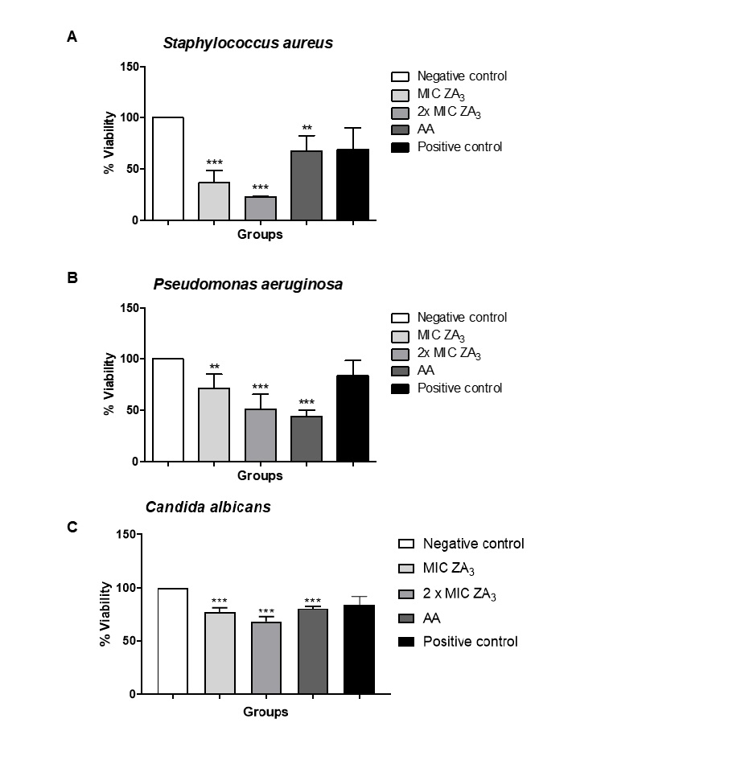Fig. 5. Cell viability of Staphylococcus aureus (A), Pseudomonas aeruginosa (B) and Candida albicans (B) biofilms eradicated by MIC (0.05 and 3.12 µg/mL, respectively), 2x MIC of ZA₃ (0.01, 6.24 and 4.69 µg/mL, respectively) and AA solution (9.375 µg/mL). ***p <0.001 2x MIC ZA₃ and AA lower cell viability compared to negative control; **p <0.01 MIC ZA₃ lower cell viability compared to negative control. Positive control: chlorhexidine gluconate 2% (for bacteria) and amphotericin-B 2µg/ml (yeast).

Some authors have proposed that through the enzymatic polymerization of AA, the new conformation could promote the biofilm inhibition of S. aureus and P. aeruginosa by modulating the pharmacological response [43] and in this assay, yet no enzymatic polymerization has been proposed, the nanoencapsulation of this bioactive in zein nanoparticles improved largely its antibacterial activity. Moreover, all the tested formulations used (AA in solution or nanoencapsulated) were more effective than the positive control chlorhexidine digluconate at 2% on reducing the bacterial viability of S. aureus and P. aeruginosa. Chlorhexidine is a synthetic cationic bis-guanide base, with broad antimicrobial spectrum [50], conventionally used as antiseptic and antibacterial agent in several applications.
C. albicans is the most prevalent yeast found in oral and dermic candidiasis, with resistance to several antifungals. ZA₃ and AA in solution were effective on reducing the C. albicans biofilm similarly to AMB at 2 µg/mL, used as a potent antifungal agent commonly used in resistant infections.
Different mechanisms have been attributed to the antimicrobial activity of AA, such as the ability to disrupt the bacterial membrane, acting as a surfactant, the inhibition of the bacterial respiratory chain, chelating Fe²⁺ and Cu²⁺ ions and the enzymatic inhibition, such as β-lactamase [9,10,15–17,42]. Further studies are expected to examine and attribute the mechanistic to both AA in solution and coupled to zein nanoparticles. In overall, its antimicrobial activity has benefited from the nanoencapsulation in zein nanoparticles.

- Conclusion
The encapsulation of anacardic acid in zein nanoparticles was successfully accomplished. The long-term stability up to 90 days was confirmed. The nanoparticles obtained were sized below 400 nm and preserved both size and negative zeta potential as a monodisperse system throughout. Dimethylglyoxime has been assayed satisfactorily for the very first time as a stabilizer agent in drug delivery systems, contributing both for the particles´ long-lasting stabilization and anacardic acid encapsulation. STD-NMR analysis demonstrated that zein was able to associate with anacardic acid in two different patterns, by the aromatic and aliphatic portions, and the first mode was responsible for the increment in the antimicrobial response, attributed to the pharmacophore disposal. The nanoencapsulation of anacardic acid doubled its inhibitory activity against Staphylococcus aureus and even made it active against Pseudomonas aeruginosa and Candida auris. In addition, it demonstrated very low fungistatic and fungicide concentrations for the Candida spp. tested. AA-loaded nanoparticles were able to reduce more effectively the cell viability in Staphylococcus aureus and Candida albicans biofilms than AA in solution and chlorhexidine digluconate and presented an equal inhibition as that of amphotericin B. Regarding Pseudomonas aeruginosa biofilm, the nanoparticles were equally effective as AA in solution, and both more active than the chlorhexidine gluconate. Furthermore, the inhibitory, bactericide/fungicide and antibiofilm active concentrations of AA nanoparticles against Staphylococcus aureus, Pseudomonas aeruginosa and Candida spp. were very low, representing a potential new antimicrobial agent.

Acknowledgements
This study was financed in part by the Coordenação de Aperfeiçoamento de Pessoal de Nível Superior - Brasil (CAPES) - Finance Code 001. The present work was accomplished with the support of the National Program of Cooperation in the Amazon – PROCAD/Amazon of Coordination of Superior Level Staff Improvement – CAPES/Brazil. We would like to thank Fundação de Amparo à Pesquisa do Estado do Amapá (FAPEAP) and CNPq for the support (EDITAL PRONEM, grant # 95/2018). This research also received financial support from Federal University of Amapá (UNIFAP) (PAPESQ and International mobility programs). This research was also funded by the Ministerio de Economia y Competitividad, Spain (grant # CTQ 2017 – 88948 – P) and Fondo Europeo de Desarollo Regional (FEDER). We thank the Research Laboratory of Drugs (LPFar) of Federal Universty of Amapa for the physicochemical characterization measurements and Prof. Otero-Espinar for the TEM images acquisition.
References
[1] M. Goldberg, R. Langer, X. Jia, Nanostructured materials for applications in drug delivery and tissue engineering, J. Biomater. Sci. Polym. Ed. 18 (2007) 241–268. https://doi.org/10.1163/156856207779996931.
[2] B.-L. Ma, C. Yin, B.-K. Zhang, Y. Dai, Y.-Q. Jia, Y. Yang, Q. Li, R. Shi, T.-M. Wang, J.-S. Wu, Y.-Y. Li, G. Lin, Y.-M. Ma, Naturally occurring proteinaceous nanoparticles in Coptidis Rhizoma extract act as concentration-dependent carriers that facilitate berberine absorption, Sci. Rep. 6 (2016) 20110. https://doi.org/10.1038/srep20110.
[3] J. Liang, H. Yan, X. Wang, Y. Zhou, X. Gao, P. Puligundla, X. Wan, Encapsulation of epigallocatechin gallate in zein / chitosan nanoparticles for controlled applications in food systems, Food Chem. 231 (2017) 19–24. https://doi.org/10.1016/j.foodchem.2017.02.106.
[4] H. Zhang, W. Zhang, Y. Zhou, Y. Jiang, S. Li, Dual Functional Mesoporous Silicon Nanoparticles Enhance the Radiosensitivity of VPA in Glioblastoma, Transl. Oncol. 10 (2017) 229–240. https://doi.org/10.1016/j.tranon.2016.12.011.
[5] O.A.A. Ahmed, A. Zidan, M. Khayat, Mechanistic analysis of Zein nanoparticles/PLGA triblock in situ forming implants for glimepiride, Int. J. Nanomedicine. 11 (2016) 543. https://doi.org/10.2147/IJN.S99731.
[6] F.F.O. Sousa, A. Luzardo-Álvarez, J. Blanco-Méndez, F.J. Otero-Espinar, M. Martín-Pastor, I. Sández Macho, Use of 1H NMR STD, WaterLOGSY, and Langmuir monolayer techniques for characterization of drug–zein protein complexes, Eur. J. Pharm. Biopharm. 85 (2013) 790–798. https://doi.org/10.1016/j.ejpb.2013.07.008.
[7] S. Hu, T. Wang, M.L. Fernandez, Y. Luo, Development of tannic acid cross-linked hollow zein nanoparticles as potential oral delivery vehicles for curcumin, Food Hydrocoll. 61 (2016) 821–831. https://doi.org/10.1016/j.foodhyd.2016.07.006.
[8] S. Chen, Y. Han, C. Sun, L. Dai, S. Yang, Y. Wei, L. Mao, F. Yuan, Y. Gao, Effect of molecular weight of hyaluronan on zein-based nanoparticles: Fabrication, structural characterization and delivery of curcumin, Carbohydr. Polym. 201 (2018) 599–607. https://doi.org/10.1016/j.carbpol.2018.08.116.
[9] M. Hemshekhar, M. Sebastin Santhosh, K. Kemparaju, K.S. Girish, Emerging Roles of Anacardic Acid and Its Derivatives: A Pharmacological Overview, Basic Clin. Pharmacol. Toxicol. 110 (2012) 122–132. https://doi.org/10.1111/j.1742-7843.2011.00833.x.
[10] S. Morais, K. Silva, H. Araujo, I. Vieira, D. Alves, R. Fontenelle, A. Silva, Anacardic Acid Constituents from Cashew Nut Shell Liquid: NMR Characterization and the Effect of Unsaturation on Its Biological Activities, Pharmaceuticals. 10 (2017) 31. https://doi.org/10.3390/ph10010031.
[11] M.T.S. Trevisan, B. Pfundstein, R. Haubner, G. Würtele, B. Spiegelhalder, H. Bartsch, R.W. Owen, Characterization of alkyl phenols in cashew (Anacardium occidentale) products and assay of their antioxidant capacity, Food Chem. Toxicol. 44 (2006) 188–197. https://doi.org/10.1016/j.fct.2005.06.012.
[12] M.S.C. Oliveira, S.M. de Morais, D.V. Magalhães, W.P. Batista, Í.G.P. Vieira, A.A. Craveiro, J.E.S.A. de Manezes, A.F.U. Carvalho, G.P.G. de Lima, Antioxidant, larvicidal and antiacetylcholinesterase activities of cashew nut shell liquid constituents, Acta Trop. 117 (2011) 165–170. https://doi.org/10.1016/j.actatropica.2010.08.003.
[13] T.C. Morais, N.B. Pinto, K. Maria, M.B. Carvalho, J.B. Rios, N. Maria, P.S. Ricardo, M. Teresa, S. Trevisan, V.S. Rao, F.A. Santos, Chemico-Biological Interactions Protective effect of anacardic acids from cashew ( Anacardium occidentale ) on ethanol-induced gastric damage in mice, Chem. Biol. Interact. 183 (2010) 264–269. https://doi.org/10.1016/j.cbi.2009.10.008.
[14] S.K. Mamidyala, S. Ramu, J.X. Huang, A.A.B. Robertson, M.A. Cooper, Bioorganic & Medicinal Chemistry Letters Efficient synthesis of anacardic acid analogues and their antibacterial activities, Bioorg. Med. Chem. Lett. 23 (2013) 1667–1670. https://doi.org/10.1016/j.bmcl.2013.01.074.
[15] M. Legut, D. Lipka, N. Filipczak, A. Piwoni, A. Kozubek, J. Gubernator, Anacardic acid enhances the anticancer activity of liposomal mitoxantrone towards melanoma cell lines – in vitro studies, Int. J. Nanomedicine. 9 (2014) 653–668.
[16] S.E. Sajeevan, M. Chatterjee, V. Paul, G. Baranwal, V.A. Kumar, C. Bose, A. Banerji, B.G. Nair, B.P. Prasanth, R. Biswas, Impregnation of catheters with anacardic acid from cashew nut shell prevents Staphylococcus aureus biofilm development, J. Appl. Microbiol. 125 (2018) 1286–1295. https://doi.org/10.1111/jam.14040.
[17] R.A. Lima, S.L.X. de Souza, L.A. Lima, A.L.X. Batista, J.T.C. de Araújo, F.F.O. Sousa, J.P.M.L. Rolim, T.D.J.P.G. Bandeira, Antimicrobial effect of anacardic acid–loaded zein nanoparticles loaded on Streptococcus mutans biofilms, Brazilian J. Microbiol. (2020). https://doi.org/10.1007/s42770-020-00320-2.
[18] D.D. Garbee, S.S. Pierce, J. Manning, Opportunistic Fungal Infections in Critical Care Units, Crit. Care Nurs. Clin. North Am. 29 (2017) 67–79. https://doi.org/10.1016/j.cnc.2016.09.011.
[19] S.A. Mosaddad, E. Tahmasebi, A. Yazdanian, M.B. Rezvani, A. Seifalian, M. Yazdanian, H. Tebyanian, Oral microbial biofilms: an update, Eur. J. Clin. Microbiol. Infect. Dis. 38 (2019) 2005–2019. https://doi.org/10.1007/s10096-019-03641-9.
[20] S. Silva, M. Negri, M. Henriques, R. Oliveira, D.W. Williams, J. Azeredo, Candida glabrata, Candida parapsilosis and Candida tropicalis: Biology, epidemiology, pathogenicity and antifungal resistance, FEMS Microbiol. Rev. 36 (2012) 288–305. https://doi.org/10.1111/j.1574-6976.2011.00278.x.
[21] M.D. Richardson, Changing patterns and trends in systemic fungal infections, J. Antimicrob. Chemother. 56 (2005) 5–11. https://doi.org/10.1093/jac/dki218.
[22] E.S. Spivak, K.E. Hanson, Candida auris: an Emerging Fungal Pathogen, J. Clin. Microbiol. 56 (2018) 1–10. https://doi.org/10.1128/JCM.01588-17.
[23] N. Martins, I.C.F.R. Ferreira, L. Barros, S. Silva, M. Henriques, Candidiasis: Predisposing Factors, Prevention, Diagnosis and Alternative Treatment, Mycopathologia. 177 (2014) 223–240. https://doi.org/10.1007/s11046-014-9749-1.
[24] C.I.C. Crucho, M.T. Barros, Polymeric nanoparticles: A study on the preparation variables and characterization methods, Mater. Sci. Eng. C. 80 (2017) 771–784. https://doi.org/10.1016/j.msec.2017.06.004.
[25] Y. Farrag, W. Ide, B. Montero, M. Rico, S. Rodríguez-Llamazares, L. Barral, R. Bouza, Preparation of starch nanoparticles loaded with quercetin using nanoprecipitation technique, Int. J. Biol. Macromol. 114 (2018) 426–433. https://doi.org/10.1016/j.ijbiomac.2018.03.134.
[26] E. Lepeltier, C. Bourgaux, P. Couvreur, Nanoprecipitation and the “Ouzo effect”: Application to drug delivery devices, Adv. Drug Deliv. Rev. 71 (2014) 86–97. https://doi.org/10.1016/j.addr.2013.12.009.
[27] A. Bhunia, S. Bhattacharjya, S. Chatterjee, Applications of saturation transfer difference NMR in biological systems, Drug Discov. Today. (2012). https://doi.org/10.1016/j.drudis.2011.12.016.
[28] CLSI, Methods for Dilution Antimicrobial Susceptibility Tests for Bacteria That Grow Aerobically : Approved Standard, 7th ed. Wayne, PA: Clinical and Laboratory Standards Institute; 2006., 2006. https://doi.org/10.1093/cid/ciw353.
[29] S. Stepanovic, I. Cirkovic, L. Ranin, M. Svabic-Vlahovic, Biofilm formation by Salmonella spp. and Listeria monocytogenes on plastic surface, Lett. Appl. Microbiol. 38 (2004) 428–432. https://doi.org/10.1111/j.1472-765X.2004.01513.x.
[30] M.A. Pfaller, M. Bale, B. Buschelman, M. Lancaster, A. Espinel-Ingroff, J.H. Rex, M.G. Rinaldi, C.R. Cooper, M.R. McGinnis, Quality control guidelines for National Committee for Clinical Laboratory Standards recommended broth macrodilution testing of amphotericin B, fluconazole, and flucytosine, J. Clin. Microbiol. (1995). https://doi.org/10.1128/jcm.33.5.1104-1107.1995.
[31] T. Poltue, R. Rangkupan, S.T. Dubas, L. Dubas, Nickel (II) ions sensing properties of dimethylglyoxime/poly(caprolactone) electrospun fibers, Mater. Lett. 65 (2011) 2231–2234. https://doi.org/10.1016/j.matlet.2011.04.012.
[32] H. Bougherra, O. Berradj, A. Adkhis, T. Amrouche, Synthesis, characterization, electrochemical and biological activities of mixed ligand copper(II) complexes with dimethylglyoxime and amino acids, J. Mol. Struct. 1173 (2018) 280–290. https://doi.org/10.1016/j.molstruc.2018.06.088.
[33] A. Nezamzadeh-ejhieh, M. Kabiri-samani, Effective removal of Ni ( II ) from aqueous solutions by modification of nano particles of clinoptilolite with dimethylglyoxime, J. Hazard. Mater. 260 (2013) 339–349. https://doi.org/10.1016/j.jhazmat.2013.05.014.
[34] G.S. Management, Safety Data Sheet, in: Mater. Saf. Data Sheet, 2012: pp. 8–10. https://beta-static.fishersci.com/content/dam/fishersci/en_US/documents/programs/education/regulatory-documents/sds/chemicals/chemicals-d/S25301.pdf.
[35] F. Li, Y. Chen, S. Liu, J. Qi, W. Wang, C. Wang, R. Zhong, Z. Chen, X. Li, Y. Guan, W. Kong, Y. Zhang, Size-controlled fabrication of zein nano/microparticles by modified anti-solvent precipitation with/without sodium caseinate, Int. J. Nanomedicine. Volume 12 (2017) 8197–8209. https://doi.org/10.2147/IJN.S143733.
[36] X. Wu, K. Landfester, A. Musyanovych, R.H. Guy, Disposition of charged nanoparticles after their topical application to the skin, Skin Pharmacol. Physiol. (2010). https://doi.org/10.1159/000270381.
[37] B. Zhang, Y. Luo, Q. Wang, Effect of acid and base treatments on structural, rheological, and antioxidant properties of α-zein, Food Chem. 124 (2011) 210–220. https://doi.org/10.1016/j.foodchem.2010.06.019.
[38] J.F.B. Bruniera, Y.T.C. Silva-sousa, G.M. Lara, A. Pitondo-silva, A.M. Marcaccini, C.E.S. Miranda, Development of Intracanal Formulation Containing Silver Nanoparticles, Braz. Dent. J. 25 (2014) 302–306. https://doi.org/dx.doi.org/10.1590/0103-6440201302431.
[39] W. de S. Tavares, M. Martin‐Pastor, A.G. Tavares, F.F.O. Sousa, Biopharmaceutical Activities Related to Ellagic Acid, Chitosan, and Zein and Their Improvement by Association, J. Food Sci. 83 (2018) 2970–2975. https://doi.org/10.1111/1750-3841.14369.
[40] F.F.O. Sousa, A. Luzardo-Álvarez, J. Blanco-Méndez, M. Martín-Pastor, NMR techniques in drug delivery: Application to zein protein complexes, Int. J. Pharm. 439 (2012) 41–48. https://doi.org/10.1016/j.ijpharm.2012.09.046.
[41] D. Sears, B.S. Schwartz, Candida auris: An emerging multidrug-resistant pathogen, Int. J. Infect. Dis. 63 (2017) 95–98. https://doi.org/10.1016/j.ijid.2017.08.017.
[42] F.B. Hamad, E.B. Mubofu, Potential Biological Applications of Bio-Based Anacardic Acids and Their Derivatives, Int. J. Mol. Sci. 16 (2015) 8569–8590. https://doi.org/10.3390/ijms16048569.
[43] R. Chelikani, Y.H. Kim, D. Yoon, D. Kim, Enzymatic Polymerization of Natural Anacardic Acid and Antibiofouling Effects of Polyanacardic Acid Coatings, (2009) 263–277. https://doi.org/10.1007/s12010-008-8284-2.
[44] I.G. Borges, J.T.C. de Araújo, F.F.O. de Sousa, Bactericidal and Antibiofilm Activity of Anacardic Acid Loaded-Zein Nanoparticles Against Enterococcus faecalis Ex Vivo, J. Comput. Theor. Nanosci. 17 (2020) 1–7. https://doi.org/10.1166/jctn.2020.9270.
[45] S. Muzaffar, C. Bose, A. Banerji, B.G. Nair, B.B. Chattoo, Anacardic acid induces apoptosis-like cell death in the rice blast fungus Magnaporthe oryzae, Appl. Microbiol. Biotechnol. 100 (2016) 323–335. https://doi.org/10.1007/s00253-015-6915-4.
[46] S. Muzaffar, B.B. Chattoo, Apoptosis-inducing factor (Aif1) mediates anacardic acid-induced apoptosis in Saccharomyces cerevisiae, Apoptosis. 22 (2017) 463–474. https://doi.org/10.1007/s10495-016-1330-6.
[47] J.L. Gellerman, N.J. Walsh, N.K. Werner, H. Schlenk, Antimicrobial effects of anacardic acids, Can. J. Microbiol. 15 (1969) 1219–1223.
[48] R. Amaral, S.A. Liberio, F.M.M. Amaral, F. Raquel, L. Maria, B. Torres, V.M. Neto, R. Nassar, M. Guerra, S. Luis, Antimicrobial and antioxidant activity of Anacardium occidentale L . flowers in comparison to bark and leaves extracts, J. Biosci. Med. 4 (2016) 87–99.
[49] M. Tscherner, K. Kuchler, A histone acetyltransferase inhibitor with antifungal activity against CTG clade Candida species, Microorganisms. 7 (2019). https://doi.org/10.3390/microorganisms7070201.
[50] F.F.O. Sousa, J.S. Nojosa, C.A.A. Alencar, A.P.M. Pires, R.S. Araújo, M. Yamauti, L.K.A. Rodrigues, Design and characterization of digluconate and diacetate chlorhexidine loaded-PLGA microparticles for dental applications, J. Drug Deliv. Sci. Technol. 141 (2021) 102361. https://doi.org/10.1016/j.jddst.2021.102361.

