Electronic Supplementary Material

Biomarker responses and metabolism in Lumbricus terrestris exposed to drugs of environmental concern, an in vivo and in vitro approach.

M. Solé¹, N. Montemurro², S. Pérez²

¹ Renewable Marine Resources Department, Institute of Marine Sciences (ICM‐CSIC), Barcelona, Spain.
² ENFOCHEM, Department of Environmental Chemistry, IDAEA-CSIC, Jordi Girona 18-26, 08034 Barcelona, Spain

Table of contents:
Chemicals and methodological details.
High purity reference standards cocaine (COC), benzoylecgonine (BEG), cocaethylene (COET) fipronil (FIP), fipronil desulfinyl (FIP-des), fipronil sulfone (FIP-sulfone), lamotrigine (LMG), N2-Methyl-Lamotrigine (LMG-met), lamotrigine-N2-oxide (LMG-N2-oxide), 5-Desamino 5-Oxo-2,5-dihydro lamotrigine) and isotopically labelled compounds (IS) (Cocaine-d5, fipronil-(pyrazole-13C3, cyano-13C) and, lamotrigine-13C3) were high purity (mostly 90%) and were obtained from Sigma-Aldrich (St. Luis, MO, USA) or Toronto Research Chemicals (Toronto, ON, Canada). For preparation of the EDTA-McIIvaine buffer (pH=4), Di-Sodium hydrogen phosphate dehydrate (Na2HPO4·2H2O) Citric acid monohydrate (C6H8O7·H2O) and EDTA (≥99%) were supplied by Sigma-Aldrich (St. Luis, MO, USA). LC-MS grade acetonitrile (≥99.9%), methanol (≥99.9%), HPLC water, hexane and formic acid (98%) were purchased from Merck (Darmstadt, Germany). Ammonium fluoride was bought from Fisher Chemical (Fisher Scientific SL, Madrid, Spain). The Original non-buffered (OR) QuEChERS extraction salts kit (4g MgSO4 + 1g NaCl) was obtained from BEKOlut GmbH & Co. KG (Hauptstuhl, Germany). Individual stock standard solutions (concentration of 1000 µg mL–1) and isotopically labelled compounds stock solution (1000 µg mL–1) used as internal standard (IS) was prepared in methanol and stored at -20 °C. Working solutions mixture (2 µg mL-1) and IS working solution (2 µg mL-1), for analysis and calibration purposes, were prepared by diluting adequate volumes of the individual stock solutions with methanol. All the solutions were stored at -20 °C.
Chromatographic separation was performed on a reverse phase Hibar® HR Purospher® STAR RP-C18 column (100 mm x 2.1 mm i.d., 2 µm particle size, Merck, Darmstadt, Germany), maintained at 40 °C in the column oven. For the positive electrospray ionization, mobile phases consisting of ACN and water (5 mM ammonium acetate + 0.1% formic acid), while for the negative ionization, ACN and water (2 mM ammonium fluoride). The flow rate of 0.5 mL/min for a total chromatographic run time of 12 min. The injection volume was 10 µL and the auto-sampler temperature was maintained at 8 °C. The fast elution was carried out using as mobile phases consisting of ACN and water (5 mM ammonium acetate + 0.1% formic acid) for the positive electrospray ionization and ACN and water (2 mM ammonium fluoride) for the negative ionization, at a flow rate of 0.5 mL/min. High resolution (HR) data were acquired in positive and negative electrospray ionization using SWATH® acquisition consisting of a TOF-MS survey (100-950 Da for 120 ms of Accumulation time (AT)) looped with 10 SWATH® MS/MS experiments (more details as in supplementary material Fig. S1). More details of the methodology are reported elsewhere (Montemurro et al., 2021).

Table S2. Metabolites or transformation products for COC and FIP previously reported in the literature were manually compiled by consulting the integrated SCIEX NIST-2017 spectral library included in the SCIEX OS™ software
Name | Chemical Formula | Adduct/Charge | Precursor ion (m/z) | Fragment ion (m/z) | Estimated RT (min)
3',4',5'-Trimethoxycocaine (NIST) | C20H27NO7 | [M+H]+ | 394,186 | 182,1176 | 7,6
3',4',5'-Trimethoxytropacocaine (NIST) | C18H25NO5 | [M+H]+ | 336,1806 | 124,1121 | 3,5
4-Fluorotropacocaine (NIST) | C15H18FNO2 | [M+H]+ | 264,1394 | 124,1122 | 6,85
Cocaethylene (NIST) | C18H23NO4 | [M+H]+ | 318,17 | 196,1334 | 5,76
Cocaine (NIST) | C17H21NO4 | [M+H]+ | 304,1543 | 182,1177 | 4,92
Isopropylcocaine (NIST) | C19H25NO4 | [M+H]+ | 332,1856 | 105,0417 | 4,68
m-Hydroxycocaine (NIST) | C17H21NO5 | [M+H]+ | 320,1493 | 182,1206 | 2,95
Norcocaine (NIST) | C16H19NO4 | [M+H]+ | 290,1387 | 136,0759 | 5
p-Fluorococaine (NIST) | C17H20FNO4 | [M+H]+ | 322,1449 | 182,1175 | 2,95
trans-3,4,5-Trimethoxycinnamoylcocaine (NIST) | C22H29NO7 | [M+H]+ | 420,2017 | 221,0809 | 3,97
trans-Cinnamoylcocaine (NIST) | C19H23NO4 | [M+H]+ | 330,17 | 182,1176 | 2,95
Tropacocaine (NIST) | C15H19NO2 | [M+H]+ | 246,1489 | 124,1121 | 6,85
Name | Chemical Formula | Adduct/Charge | Precursor (Q1) Mass (Da) | Fragment (Q3) Mass (Da) | Retention Time (min)
Fipronil (NIST) | C12H4Cl2F6N4OS | [M-H]- | 434,9314 | 329,96 | 8,93
Fipronil desulfinyl (NIST) | C12H4Cl2F6N4 | [M-H]- | 386,9644 | 143,0074 | 9,06
Fipronil sulfide (NIST) | C12H4Cl2F6N4S | [M-H]- | 418,9365 | 316,9857 | 9,22
Fipronil sulfone (NIST) | C12H4Cl2F6N4O2S | [M-H]- | 450,9263 | 414,953 | 9,25
Fipronil Amide (NIST) | C12H6Cl2F6N4O2S | [M-H]- | 452,942 | 303,9557 | 7,9

Variable SWATH acquisition windows size were optimized using the SCIEX Variable Window Calculator 1.1. The software automatically calculates the best Q1 window size for the earthworm matrix using the TOF-MS m/z distribution of precursors. Number of variable windows, accumulation time, total cycle time as well as the optimal number of points across the eluting sample peak (>10 points across each peak for optimal quantitation) were adapted from elsewhere (Montemurro et al., 2020) Ref: Journal of Chromatography A 2020; 1631: 461566.
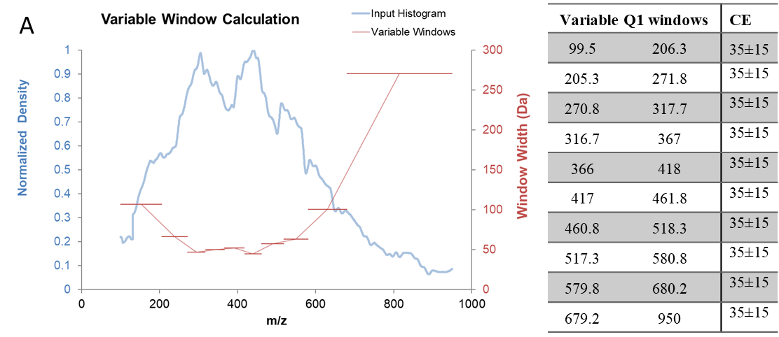
A: Earthworm tissues Positive

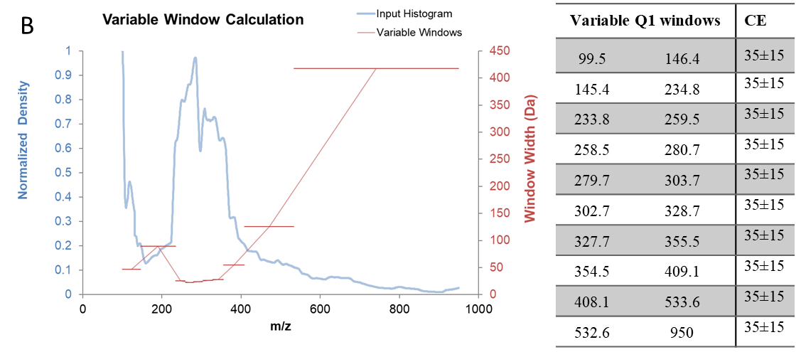
A: Earthworm tissues Negative
Figure S1. Variable Q1 Window Widths for SWATH Acquisition in positive (A) and negative (B) ionization. Depending on the complexity of the matrices as in the case of tissues of earthworms, the SCIEX Variable Window Calculator automatically generates small Q1 windows in very dense m/z regions where the number of precursors is greater, while larger Q1 windows in the presence of a smaller number of precursors. The m/z density histograms obtained from the TOF-MS data for the compounds of interest (blue line) can be used to define the variable size windows (red line), where the precursor density in each of the isolation windows is normalized across the m/z interval.

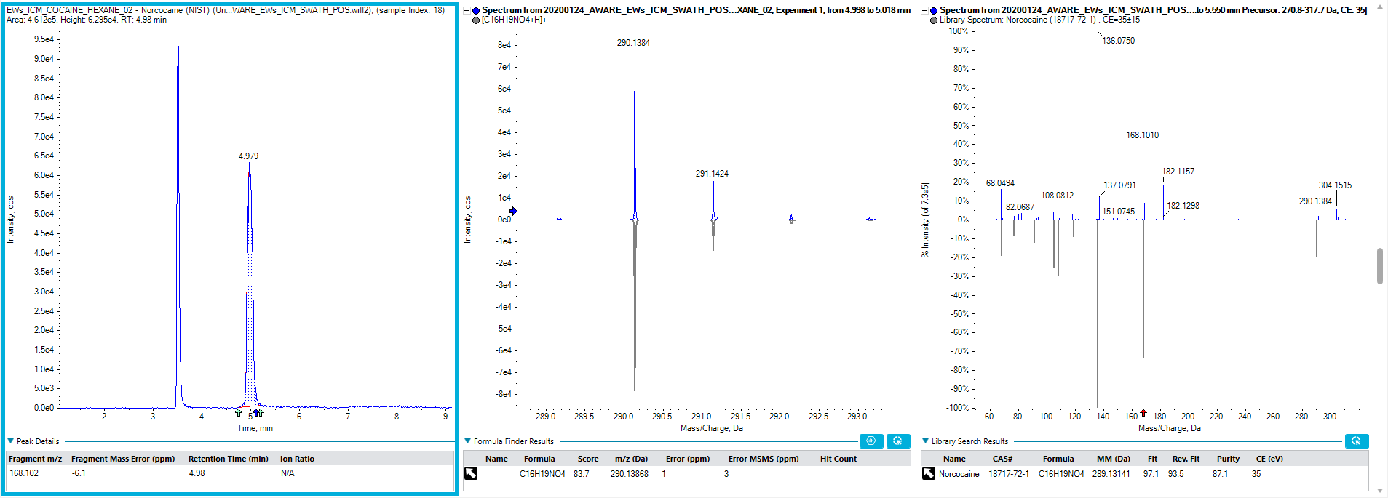
A)
A)

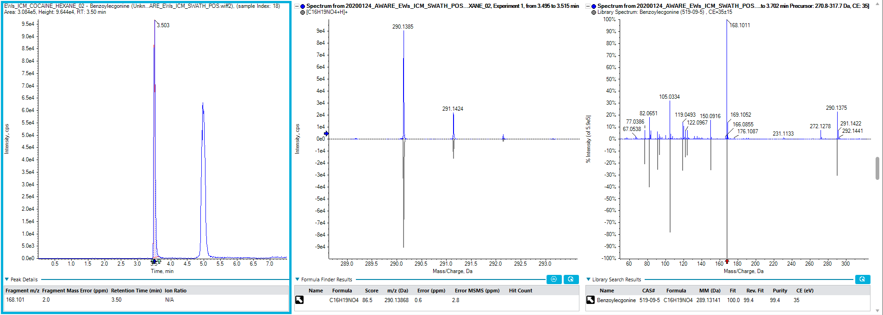
B)
Figure S2. Discrimination of isobaric compounds using SCIEX built-in spectral library: A) Norcocaine C16H19NO4 290.1386 (m/z) RT: 5.0 and B) Benzoylecgonine C16H19NO4 290.1386 (m/z) RT: 3.5.

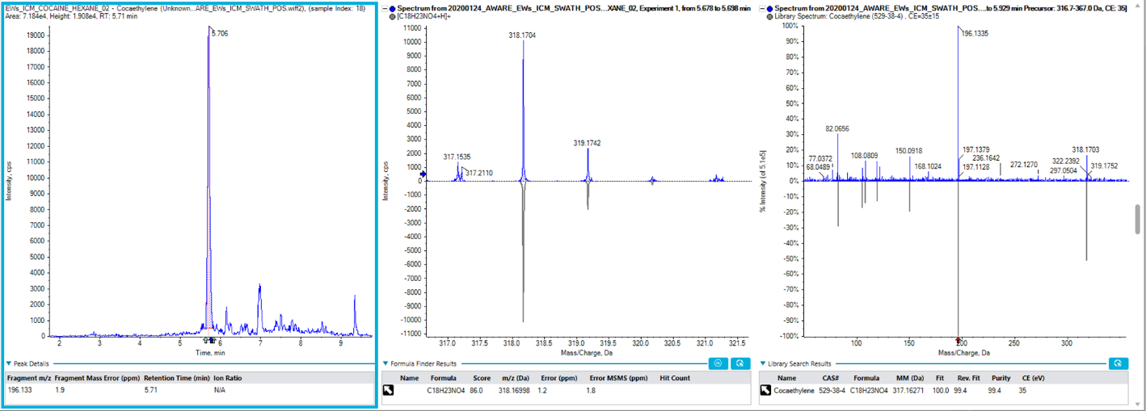

Figure S3. Target identification of Cocaethylene using reference standard and SCIEX built-in spectral library

