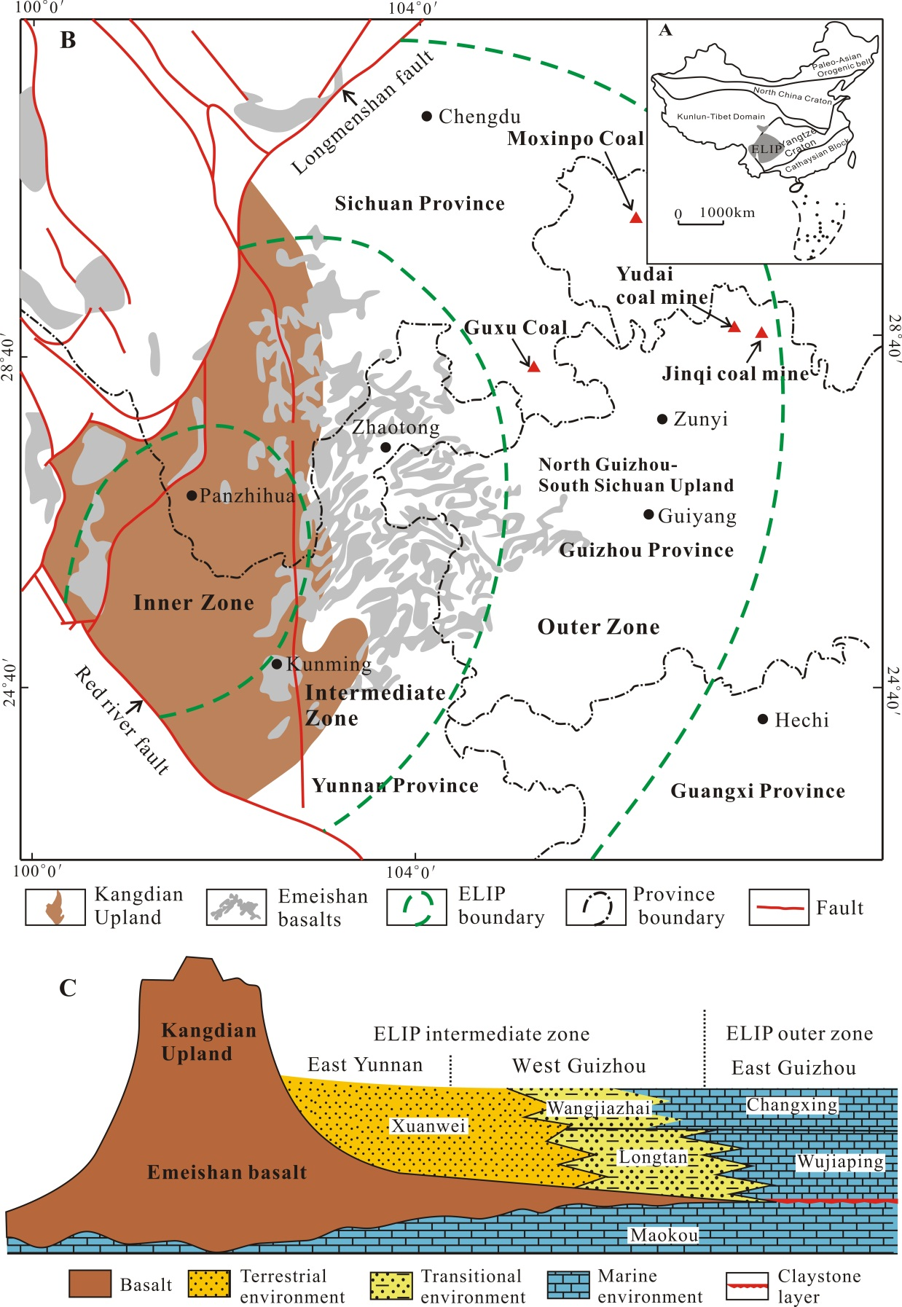
Fig. 1. Geological maps of the study area: (A) Map of China showing the location of Eemeishan Large Igneous Province (ELIP) (Shellnutt, 2014). (B) Regional distribution of the ELIP showing the concentric zones (dashed green lines) as well as locations of the Kangdian Upland and sampling sites (Yudai and Jinqi coal mines) (modified from Coal Geology Bureau (1996) and He et al. (2003). (C) Schematic paleogeography during Late Permian period and the Late Permian coal-bearing sequence in SW China (modified from He et al. (2003).

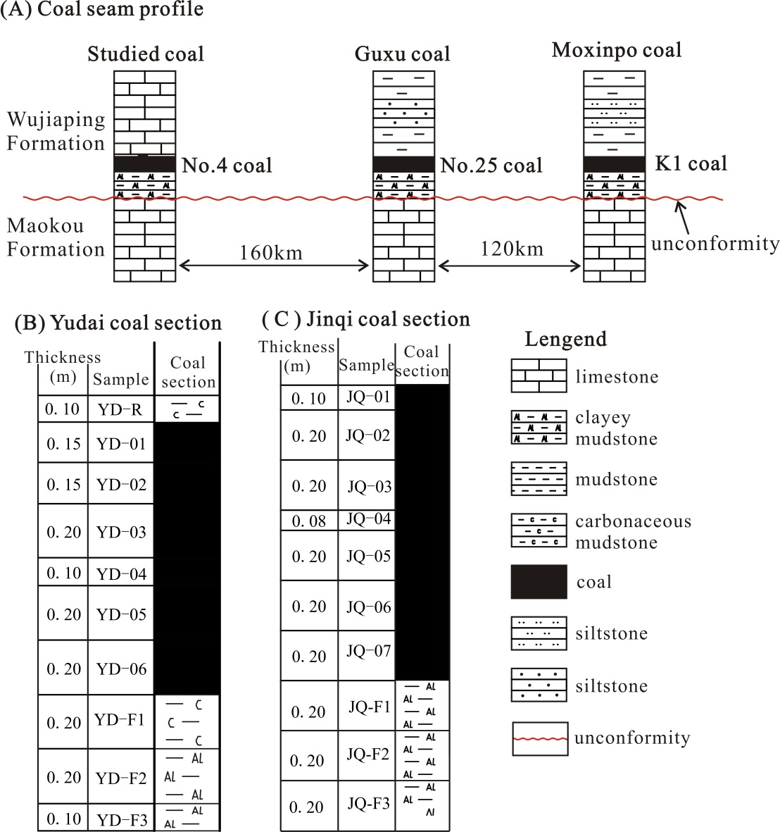
Fig. 2. (A) A correlation of the No. 4 coal to the No. 25 coal in the Guxu Coalfield (Dai et al., 2016b) and the K1 coal in the Moxinpo Coalfield (Dai et al., 2017a). (B) Yudai coal section. (C) Jinqi coal section.

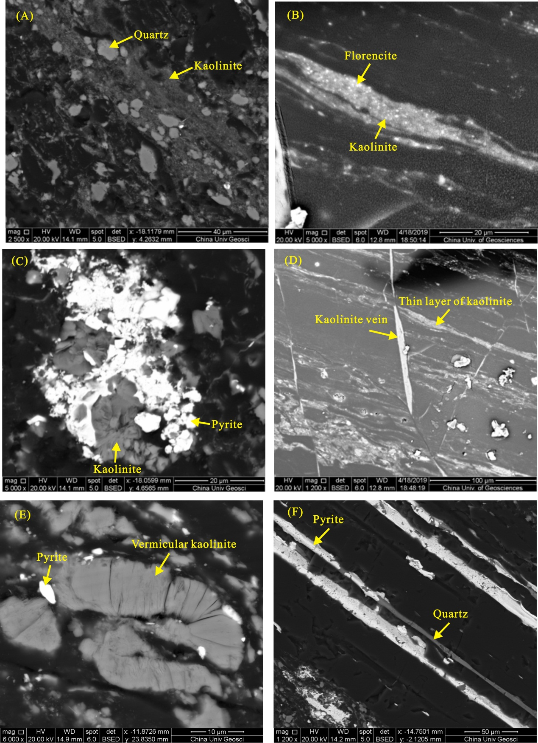
Fig. 3. Scanning electron microscope (SEM) back-scattered electron images of minerals in the studied coals. A dispersed quartz grains (sample JQ-02). B Thin layer of kaolinite and the impregnation of possibly florencite (sample JQ-07). C Cavity-filling pyrite and kaolinite (sample JQ-02). D Thin layers of kaolinite and kaolinite veins (sample JQ-07). E Vermicular kaolinite (sample YD-04). F Fracture-filling quartz and pyrite (sample JQ-02).

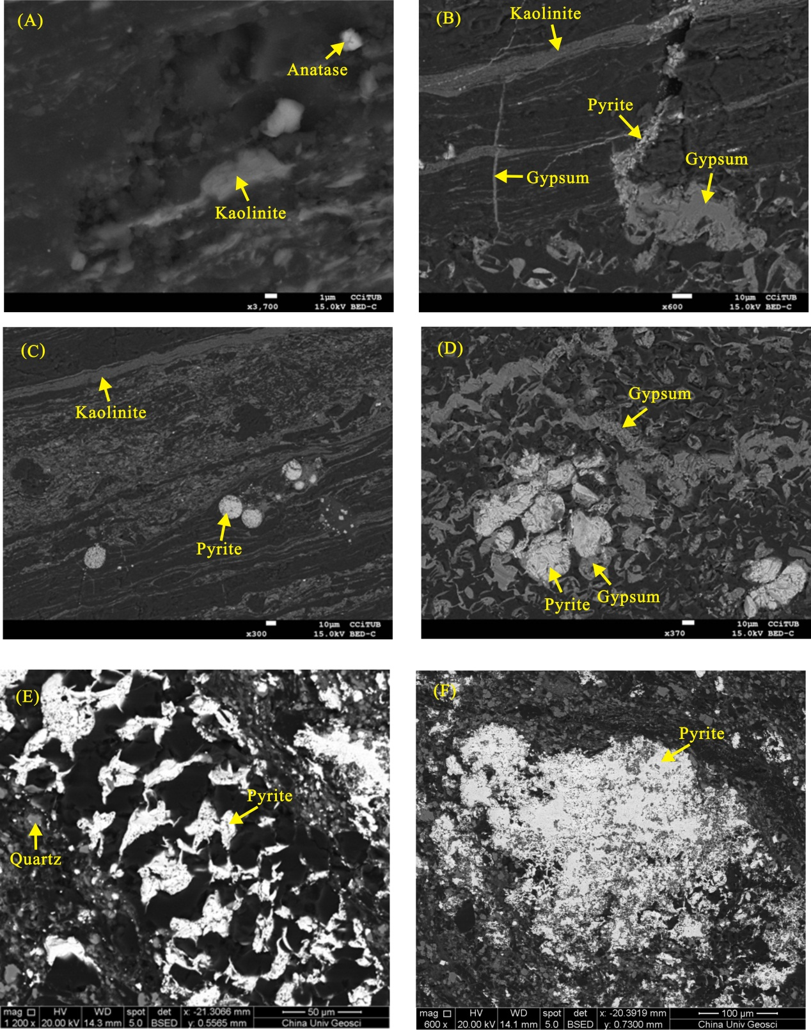
Fig. 4. SEM back-scattered electron images of minerals in the coal samples (sample YD-06 for A-D, sample JQ-02 for E-F). A Dispersed kaolinite and anatase particles into organic matter. B Pyrite and gypsum veins and thin layers of kaolinite. C Thin layers of kaolinite and framboidal pyrite aggregates. D Gypsum veins and pore-filling pyrite and gypsum. E Pyrite as cell infillings and dispersed quartz grains. F Massive pyrite.

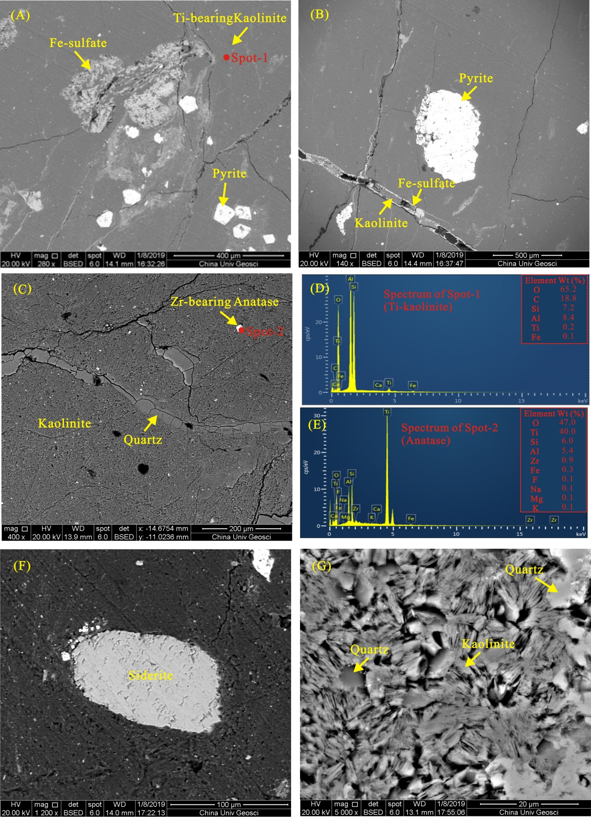
Fig. 5. SEM back-scattered electron images of minerals in the noncoal samples and energy-dispersive X-ray spectrometer (EDS) analysis of selected minerals. A Fracture-filling Fe-sulfate, euhedral pyrite, and Ti-bearing kaolinite matrix (sample YD-F2). B Massive pyrite particles and fracture-filling Fe-sulfate within kaolinite matrix (sample YD-F2). C Quartz veins and Zr-bearing anatase within kaolinite matrix (sample JQ-F3). D EDS spectrum showing traces of Ti within kaolinite. E EDS spectrum showing traces of Zr within anatase. F Siderite nodule in kaolinite matrix (sample YD-F3). G Quartz as cavities infillings of tabular kaolinite aggregates (sample JQ-F3).

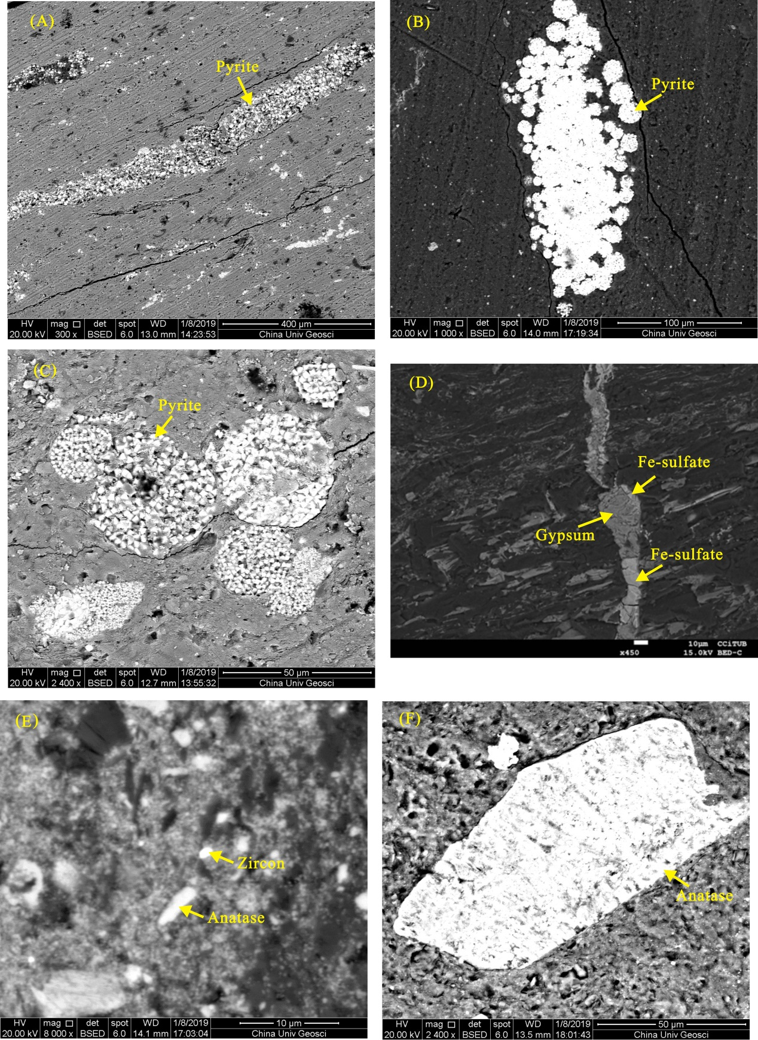
Fig. 6. SEM back-scattered electron images of minerals in the samples. A Pyrite as cavities infillings of kaolinite matrix (sample YD-R). B Framboidal pyrite aggregates (sample YD-F2). C Framboidal pyrite aggregates (sample YD-R). D Fe-sulfate and gypsum veins (sample YD-06). E Zircon and anatase particles (sample JQ-04). F Anatase grains with corroded edges (sample JQ-F3).

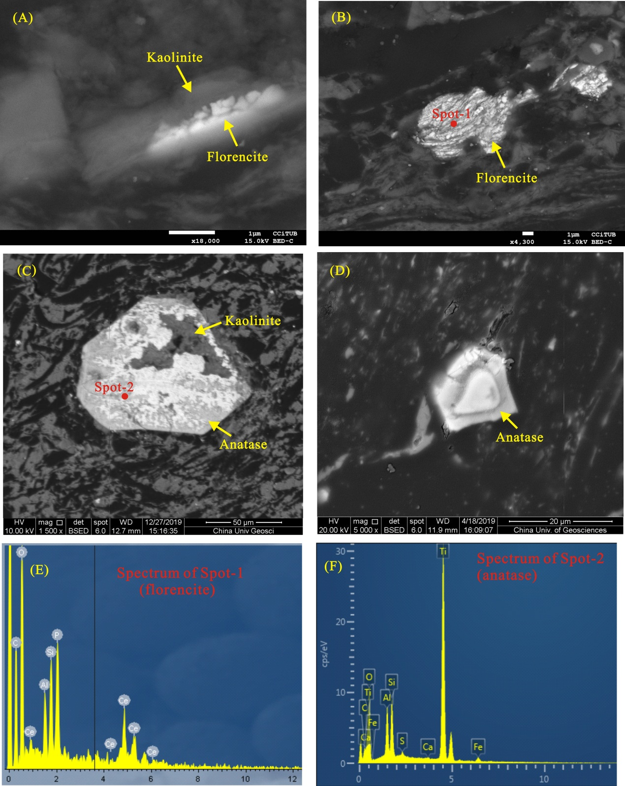
Fig. 7. SEM back-scattered electron images of minerals in the coal samples and EDS analysis of selected minerals. A REY-bearing florencite within kaolinite matrix (sample YD-05). B Florencite within organic matter (sample YD-05). C Euhedral anatase grains within organic matter (sample JQ-04). D Euhedral anatase grains within organic matter (sample YD-04). E EDS spectrum of florencite containing trace amounts of Ce. F EDS spectrum of anatase.

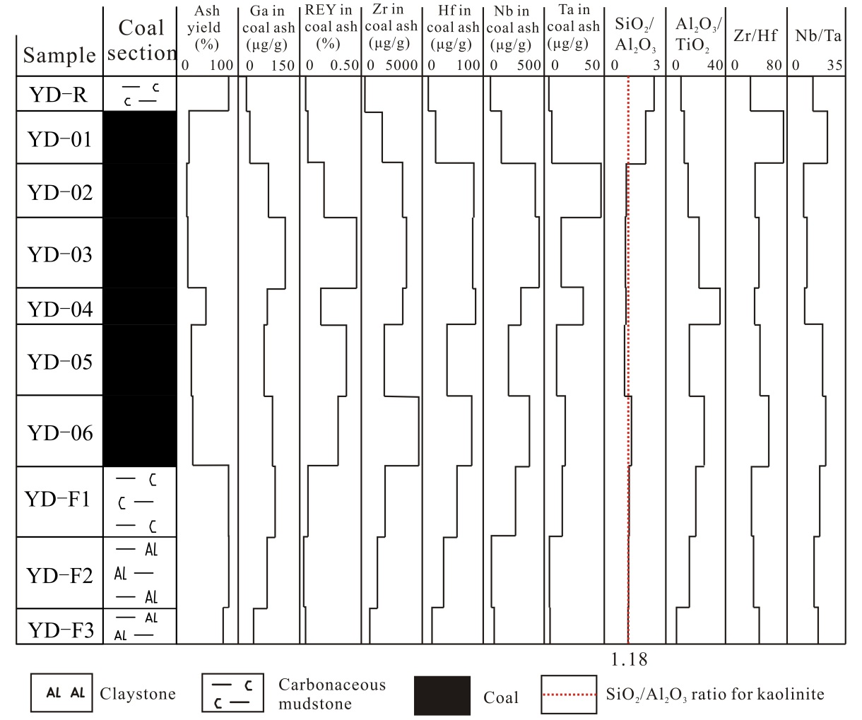
Fig. 8 Vertical distribution of ash yield, selected elements, and elements ratios throughout the Yudai coal profile

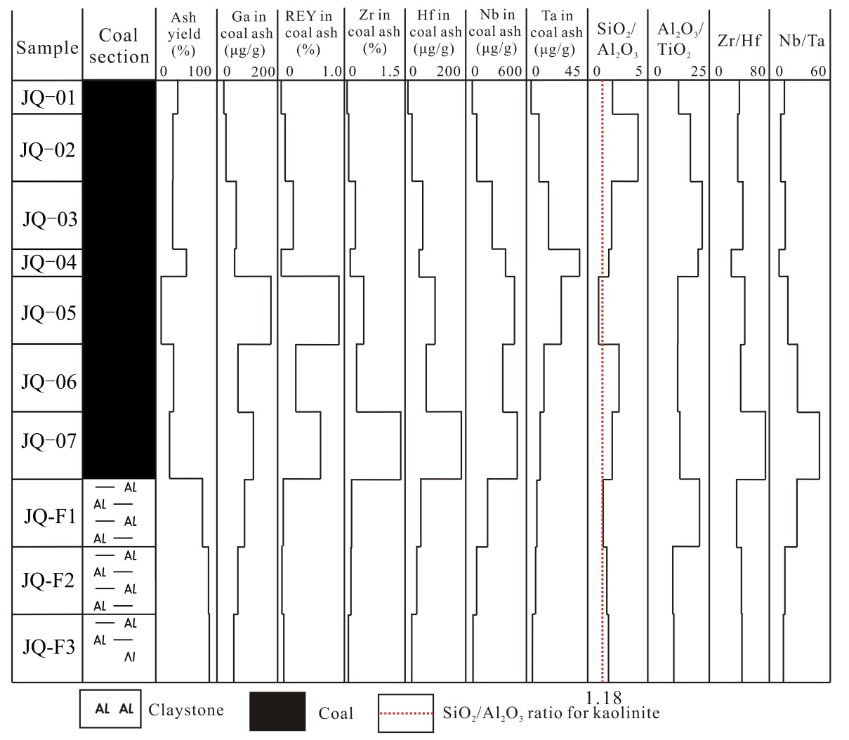
Fig. 9 Vertical distribution of ash yield, selected elements, and elements ratios throughout the Jinqi coal profile

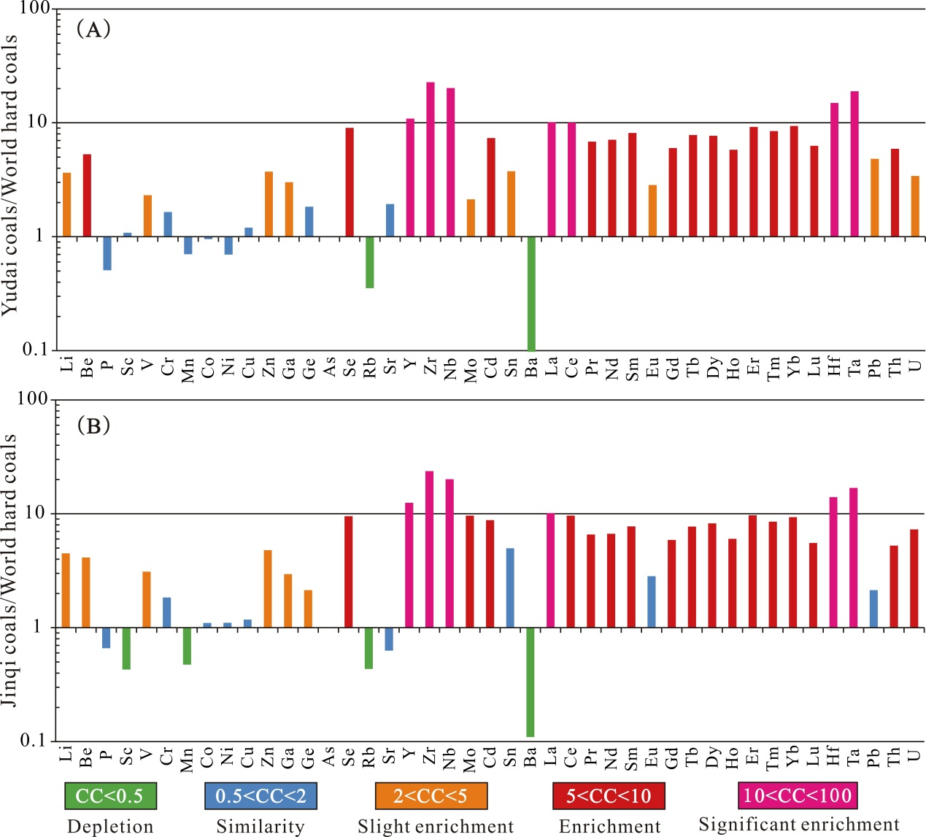
Fig. 10. Concentration coefficient (CC) of trace elements in the Yudai coals (A) and Jinqi coals (B), normalized to the respective average of world hard coals (Ketris and Yudovich, 2009).
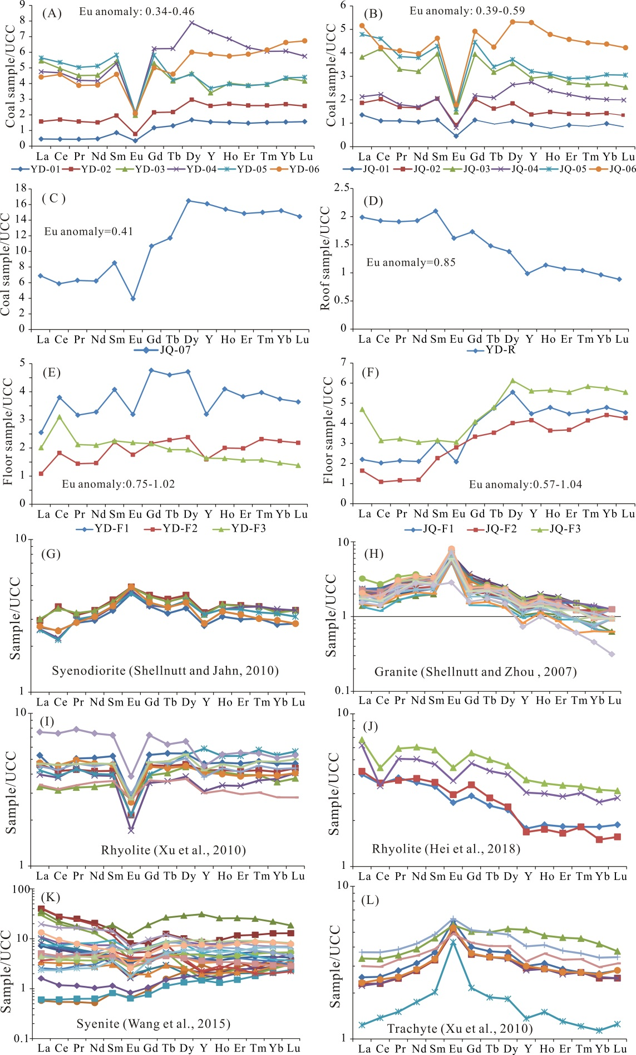
Fig. 11. Distribution patterns of rare earth elements and yttrium (REY) in the Yudai coals (A), Jinqi coals (B), sample JQ-7 (C), roof rock from the Yudai coal profile (D), floor rocks from the Yudai coal profile (E), floor rocks from the Jinqi coal profile (F), syenodiorite (G), granite (H), rhyolite (I and J), syenite (K), and trachyte (L). REY are normalized to Upper Continental Crust (UCC; Taylor and McLennan, 1985).
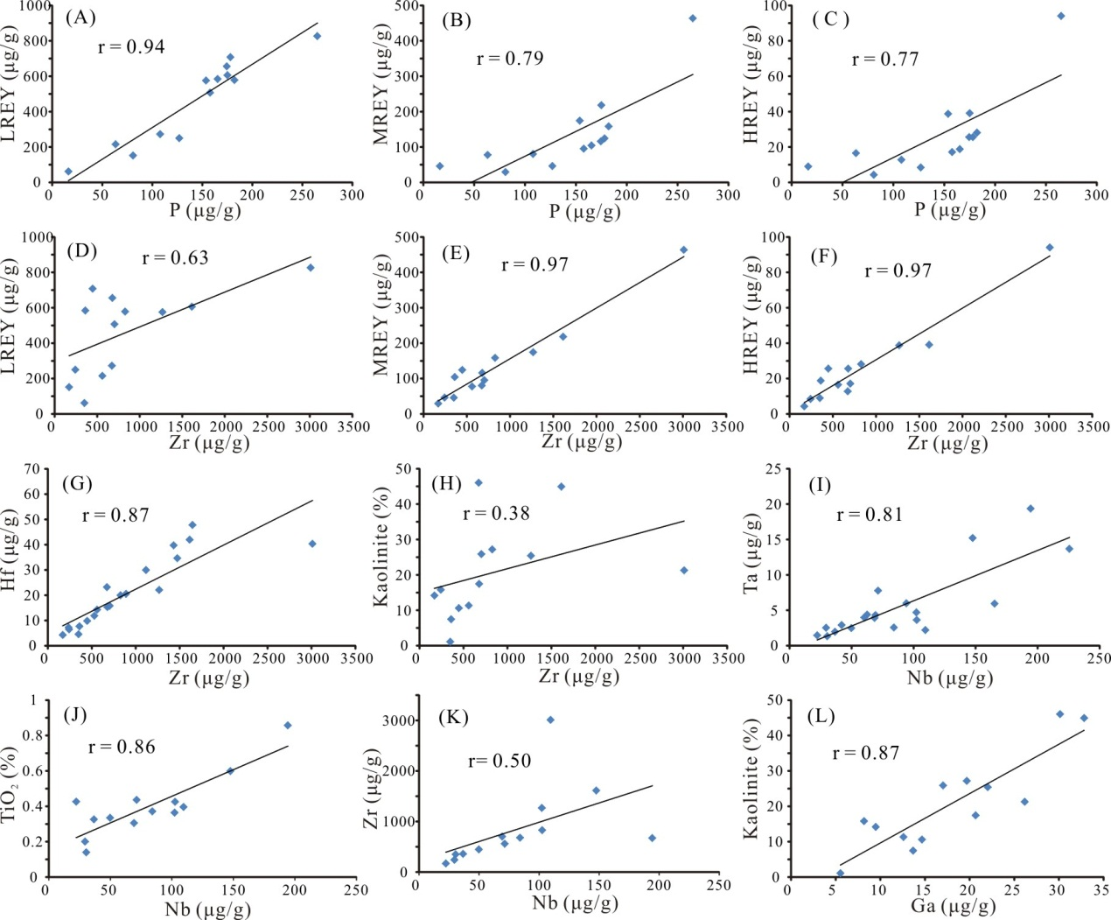
Fig. 12. Relationship between selected elements and kaolinite with P, Zr, Nb, and Ga

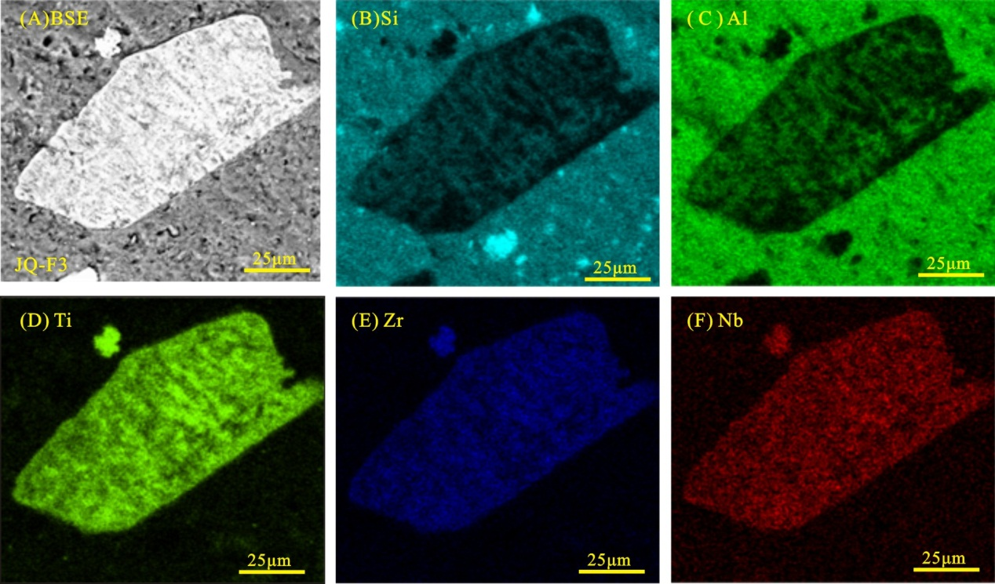
Fig. 13. SEM-EDS mappings showing the distribution of Si, Al, Ti, Zr, and Nb (sample JQ-F3).

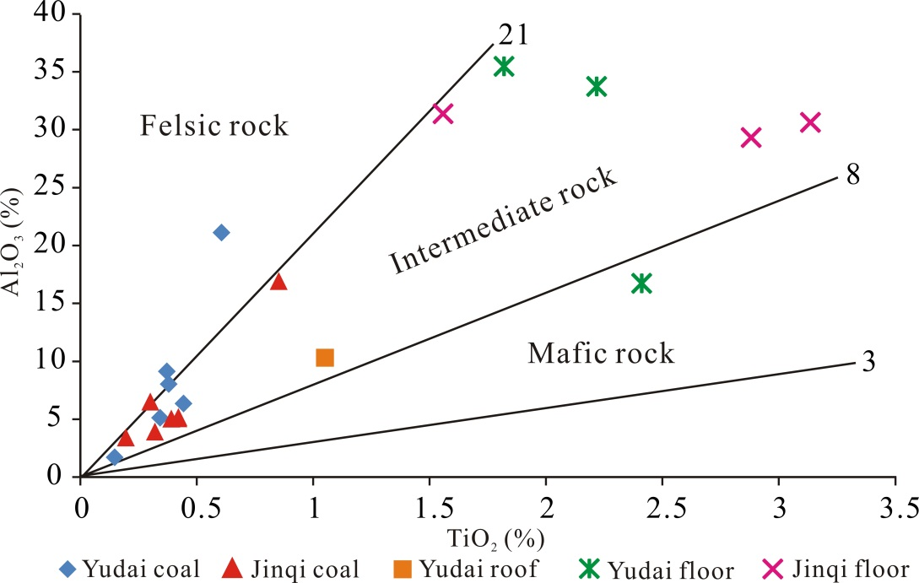
Fig. 14. The plot of TiO₂ versus Al₂O₃ contents for the coal and noncoal samples.

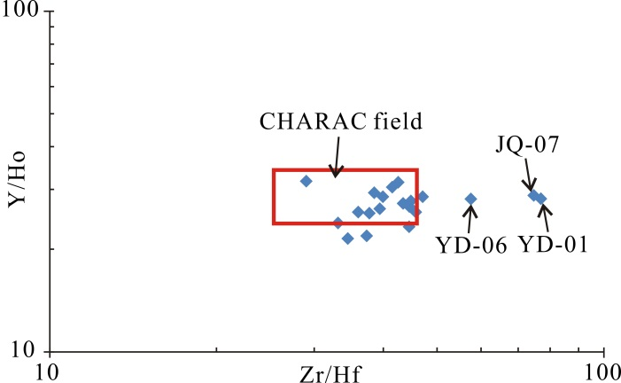
Fig. 15. The plot of Y/Ho versus Zr/Hf ratios for the studied coals. The CHARAC field is from Bau (1996).

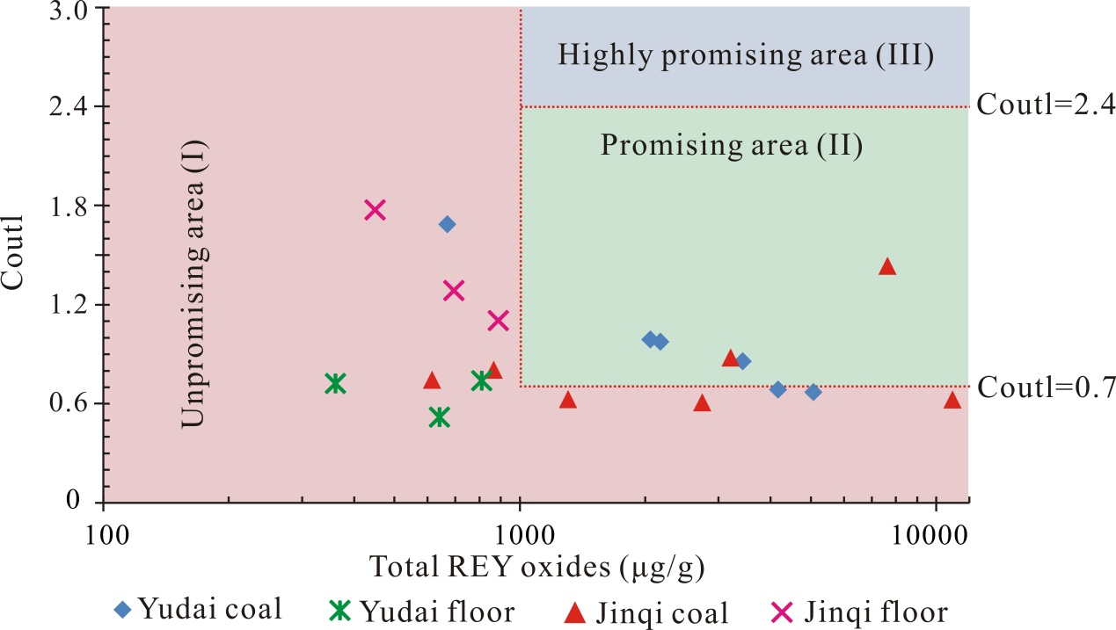
Fig. 16. Evaluation of REY in coal ash and noncoal rocks from the Qiandongbei Coalfield.

