Supplementary Information for manuscript entitled:
Constructed wetlands operated as bioelectrochemical systems for the removal of organic micropollutants

Marco Hartl^{a,b}, María Jesús García-Galánª, Victor Matamoros^{c}, Marta Fernández-Gatellª, Diederik P.L. Rousseau^{b}, Gijs Du Laing^{b}, Marianna Garfíª, Jaume Puigagut^{a,*}

ª GEMMA - Environmental Engineering and Microbiology Research Group, Department of Civil and Environmental Engineering, Universitat Politècnica de Catalunya·BarcelonaTech, c/ Jordi Girona 1-3, Building D1, E-08034 Barcelona, Spain.
^{b} Department of Green Chemistry and Technology, Faculty of Bioscience Engineering, Ghent University. Coupure Links 653, 9000 Gent, Belgium.
^{c} Department of Environmental Chemistry, IDAEA-CSIC, c/ Jordi Girona, 18-26, E-08034, Barcelona, Spain.
* Corresponding author:

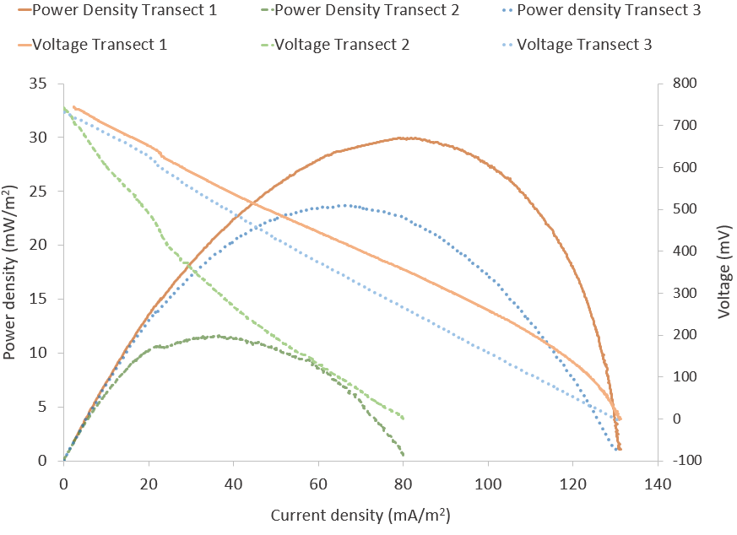
Figure S1. Power density and polarization curves for each transect of one of the closed-circuit CW-MFC replicates measured during sampling week 4.

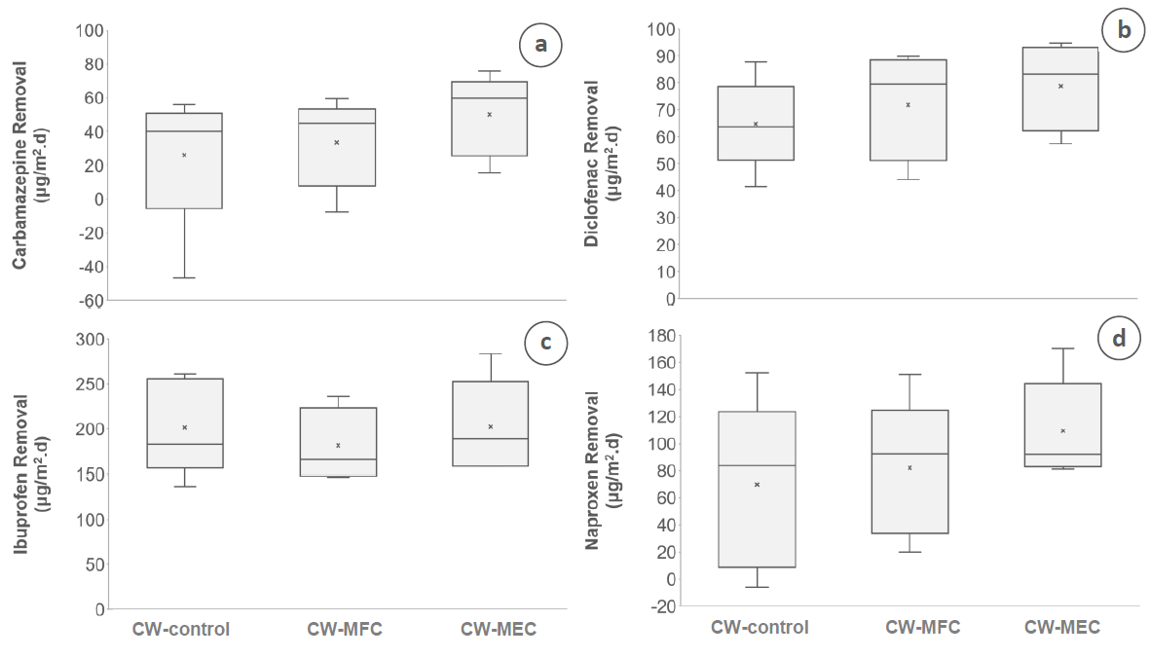
Figure S2. Specific removal from influent to effluent for all four OMPs (a; CBZ, b; DCF, c; IBU and d; NPX) comparing CW control, CW-MFC and CW-MEC treatments (n=5). The box- and whisker plots show the minimum and maximum (lower and upper whiskers), first and third quartile (lower and upper end of box), median (horizontal line in box) and average (marked as an “x”) values.

Table S1. Chemical structure and characteristics of the selected OMPs used in this study and their respective hydrophobicity and charge states estimated from the compound's Log D and pK_{a}, respectively (relative to the experimental pH of 7 – 7.5). Log K_{ow} describes the octanol-water partition coefficient which is a compound´s measure of the ratio of concentrations in octanol and water (Schwarzenbach et al., 2003). Log D is the partition coefficient for a compound at a specified pH
Compound | Structure ª | Classification | Log K_{ow} |  | Log D (pH 6.6-7.6)^{c} | Hydro-phobicity | pK_{a}^{b} | Charge state
Carbamazepine | 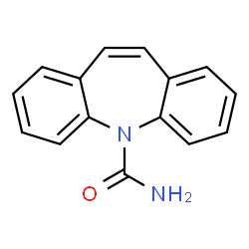 | Anticonvulsant | 2.45 ^{b} |  | 2.77 | hydrophilic | 13.90 | neutral
Diclofenac | 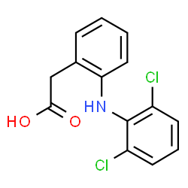 | Anti-inflammatory | 4.51 ^{d} |  | 1.70 to 1.04 | hydrophilic | 4.15 | negative
Ibuprofen | 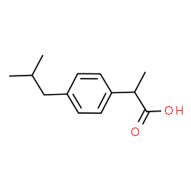 | Anti-inflammatory |  | 3.97 ^{b} | 2.10 to 1.16 | hydrophilic | 5.30 | negative
Naproxen | 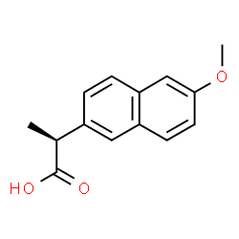 | Anti-inflammatory | 3.18 ^{b} |  | 0.61 to  -0.18 | hydrophilic | 4.15 | negative
ª chemspider.com
^{b} https://pubchem.ncbi.nlm.nih.gov
^{c} chemicalize.com (data has been obtained from the empirical model)
^{d} Avdeef et al. (1998)

Table S2. Results for pH for CW control, CW-MFC and CW-MEC systems during the OMP spiking and sampling weeks at the influent, after first transect, after second transect and effluent as well as overall average.
 |  | Influent | 1/3 | 2/3 | Effluent | Average
pH  (-) | CW control | 7.50±0.00 | 7.35±0.05 | 7.35±0.00** | 7.70±0.01 | 7.48±0.02
 | CW-MFC | 7.45±0.05 | 7.09±0.02 | 7.05±0.07** | 7.66±0.07 | 7.32±0.05
 | CW-MEC | 7.54±0.07 | 6.69±0.09** | 6.60±0.05** | 7.15±0.03* | 7.00±0.06
** very significant difference (p < 0.01)

Table S3. Post-hoc Tukey HSD pairwise comparison results for pH in CW-control, CW-MFC and CW-MEC systems during the OMP spiking and sampling weeks after first transect, after second transect and effluent.
pH (-)
Tukey HSD results
 | 1/3 |  |  | 2/3 |  |  | Effluent
Pair | Q statistic | p-value | Inference | Q statistic | p-value | Inference | Q statistic | p-value | Inference
CW-control vs CW-MFC | 4.1187 | 0.06 | insignificant | 13.39 | 0.001 | ** p<0.01 | 0.586 | 0.9 | insignificant
CW-control vs CW-MEC | 10.6203 | 0.001 | ** p<0.01 | 33.51 | 0.001 | ** p<0.01 | 7.633 | 0.004 | ** p<0.01
CW-MFC  vs CW-MEC | 6.5016 | 0.009 | ** p<0.01 | 20.12 | 0.001 | ** p<0.01 | 7.047 | 0.006 | ** p<0.01
* significant difference (p < 0.05)
** very significant difference (p < 0.01)

Table S4. Post-hoc Scheffé pairwise comparison results for pH in CW-control, CW-MFC and CW-MEC systems during the OMP spiking and sampling weeks after first transect, after second transect and effluent.
pH (-)
Scheffé results
 | 1/3 |  |  | 2/3 |  |  | Effluent
Pair | TT-stats | p-value | Inference | TT-stats | p-value | Inference | TT-stats | p-value | Inference
CW-control vs CW-MFC | 2.9124 | 0.071 | In-significant | 9.468 | 2E-04 | ** p<0.01 | 0.414 | 0.919 | In- significant
CW-control vs CW-MEC | 7.5097 | 9E-04 | ** p<0.01 | 23.7 | 1.18E-06 | ** p<0.01 | 5.398 | 0.005 | ** p<0.01
CW-MFC  vs CW-MEC | 4.5973 | 0.011 | * p<0.05 | 14.23 | 2.39E-05 | ** p<0.01 | 4.983 | 0.007 | ** p<0.01
* significant difference (p < 0.05)
** very significant difference (p < 0.01)

Table S5. One-factor ANOVA (with replication) results for the comparison of conventional wastewater parameters between the electric connections during the sampling period, for the total system from inlet to outlet and each of the three transects separately (statistically significant different if p-value < 0.05).
One-factor ANOVA |  | p-value  Comparing Electric Connections
 |  | Inlet-Outlet | Transect 1 | Transect 2 | Transect 3
COD | F (2, 8) | 0.37 | 0.84 | 0.42 | 0.97
NH₄ -N | F (2, 7) | 0.20 | 0.21 | 0.93 | 0.99
SO₄²⁻ | F (2, 6) | 0.97 | 0.98 | 0.16 | 0.36
PO₄ -P | F (2, 6) | 0.96 | 0.76 | 0.57 | 0.20

Table S6. One-factor ANOVA (with replication) results for the comparison of the four tested OMPs between the electric connections during the sampling period, for the total system from inlet to outlet and each of the three transects separately (statistically significant different if p-value < 0.05).
One-factor ANOVA |  | p-value  Comparing Electric Connections
 |  | Inlet-Outlet
Carbamazepine (CBZ) | F (2, 5) | 0.48
Diclofenac (DCF) | F (2, 5) | 0.48
Ibuprofen (IBU) | F (2, 5) | 0.75
Naproxen (NPX) | F (2, 5) | 0.47

