Journal of Geophysical Research: Atmospheres
Supporting Information for
Revising the Ozone Depletion Potentials Metric for Short-Lived Chemicals such as CF₃I and CH₃I
Authors: Jun Zhang¹, Donald J. Wuebbles¹*, Douglas E. Kinnison², Alfonso Saiz-Lopez³
Affiliations:
1Department of Atmospheric Science, University of Illinois at Urbana-Champaign, Champaign, IL, 61801, USA.
2Atmospheric Chemistry Observations & Modeling Laboratory, National Center for Atmospheric Research, Boulder, CO, 80305, USA.
3Department of Atmospheric Chemistry and Climate, Institute of Physical Chemistry Rocasolano, CSIC, Serrano 119, 28006 Madrid, Spain.
*Corresponding author: Donald J. Wuebbles (wuebbles@illinois.edu)

Contents of this file

Figures S1 to S4
Tables S1

Introduction
Supporting information includes table and figures to support the discussion in main article.

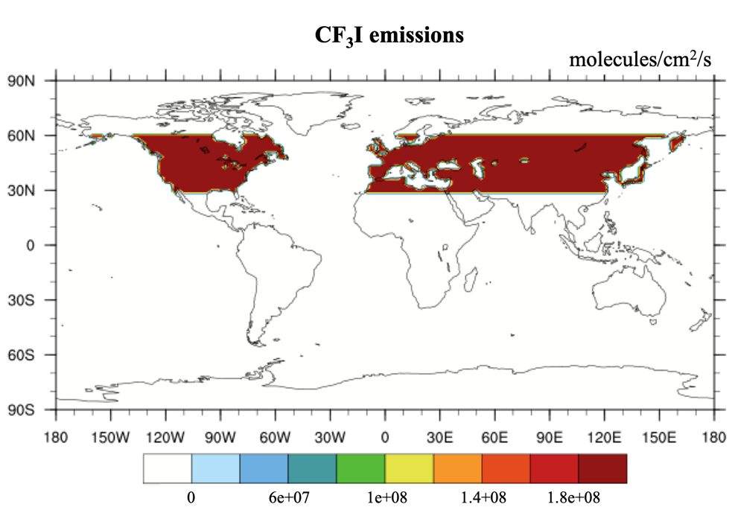

Figure S1. Land-based surface emission fluxes of CF₃I over 30ºN to 60ºN in the unit of molecules cm⁻² s⁻¹. These are the emissions used in Youn et al. (2010). These postulated emissions are inputs to the CF₃I ODP perturbation model run.
Table S1. Iodine chemistry scheme in CAM4-Chem (adopted from Saiz-Lopez et al. (2014) and Saiz-Lopez et al. (2015)).
Reaction types | Reactions
Bimolecular, thermal decomposition and termolecular reactions | I+O3 →IO+O2  IO+O3 →OIO+O2  I+HO2 →HI+O2  IO + NO → I + NO2  IO+HO2 →HOI+O2  IO + IO → OIO + I  IO + IO → I2O2  IO + OIO → I2O3  OIO + OIO → I2O4  I2 + O → IO + I  IO + O → I + O2  IO + OH → HO2 + I  I2O2 →OIO+I  I2O2 →IO+IO  I2O4 → 2 OIO  I2 + OH → HOI + I  I2 + NO3 → I + IONO2  I+NO3 →IO+NO2  OH + HI → I + H2O  I + IONO2 → I2 + NO3  HOI+OH→IO+H2O  IO + DMS → DMSO + I  INO2 →I+NO2  IONO2 → IO + NO2  INO + INO → I2 + 2NO  INO2 + INO2 → I2 + 2NO2  OIO + NO → IO + NO2  HI+NO3 →I+HNO3  IO + BrO → Br + I + O2  IO + BrO → Br + OIO  I + BrO → IO + Br  IO + ClO → I + OClO  IO + ClO → I + Cl + O2  IO + ClO → ICl + O2  IO + Br → I + BrO  IO+NO3 →OIO+NO2  IO+CH3O2 →CH2O+I+HO2  CH3I+OH→I+H2O+HO2  I+NO2 (+M)→INO2 (+M)  IO+NO2 (+M)→IONO2 (+M)  I+NO(+M)→INO(+M)  OIO+OH(+M)→HOIO2 (+M)
Photochemical reactions | CH3I + hν → CH3O2 + I  CH2I2+hν→2I  CH2IBr+hν→Br+I  CH2ICl+hν→Cl+I  I2+hν→2I  IO + hν → I + O  OIO + hν → I + O2  INO + hν → I + NO  INO2 +hν→I+NO2  IONO2 +hν→I+NO3  HOI + hν → I + OH  IBr + hν → I + Br  ICl + hν → I + Cl  I2O2 +hν→I+OIO  I2O3 +hν→IO+OIO  I2O4 +hν→OIO+OIO
Heterogeneous reactions  (on sea salt aerosols and ice crystals) | IONO2 → 0.5 IBr + 0.5 ICl  INO2 → 0.5 IBr + 0.5 ICl  HOI → 0.5 IBr + 0.5 ICl  I2O2 →  I2O3 →  I2O4 →
Recycling reactions  (ice-particles) | HOI + HI →I₂ + H₂O  HOI + HCl → ICl + H₂O  HOI + HBr →IBr + H₂O  IONO₂ → HOI + HNO₃

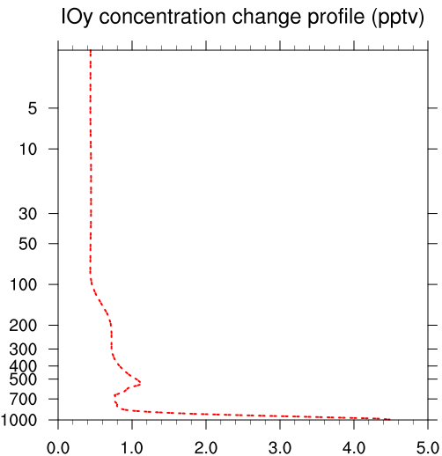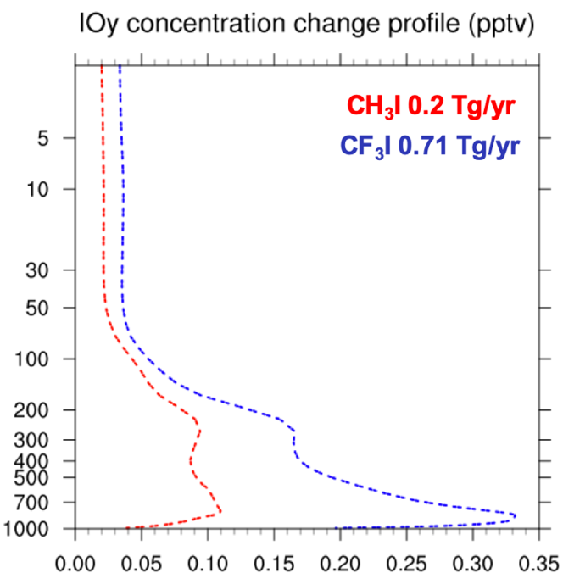
(a) (b)

Figure S2. Vertical distribution of IOy mixing ratio (pptv) averaging within the tropics (20°S–20°N) (a) from reference background simulation and (b) from delta change relative to the reference run (perturbation – reference) for CF₃I and CH₃I emission Scenario 1. Blue dashed line is for CF₃I perturbation while red dashed line is for CH₃I perturbation.

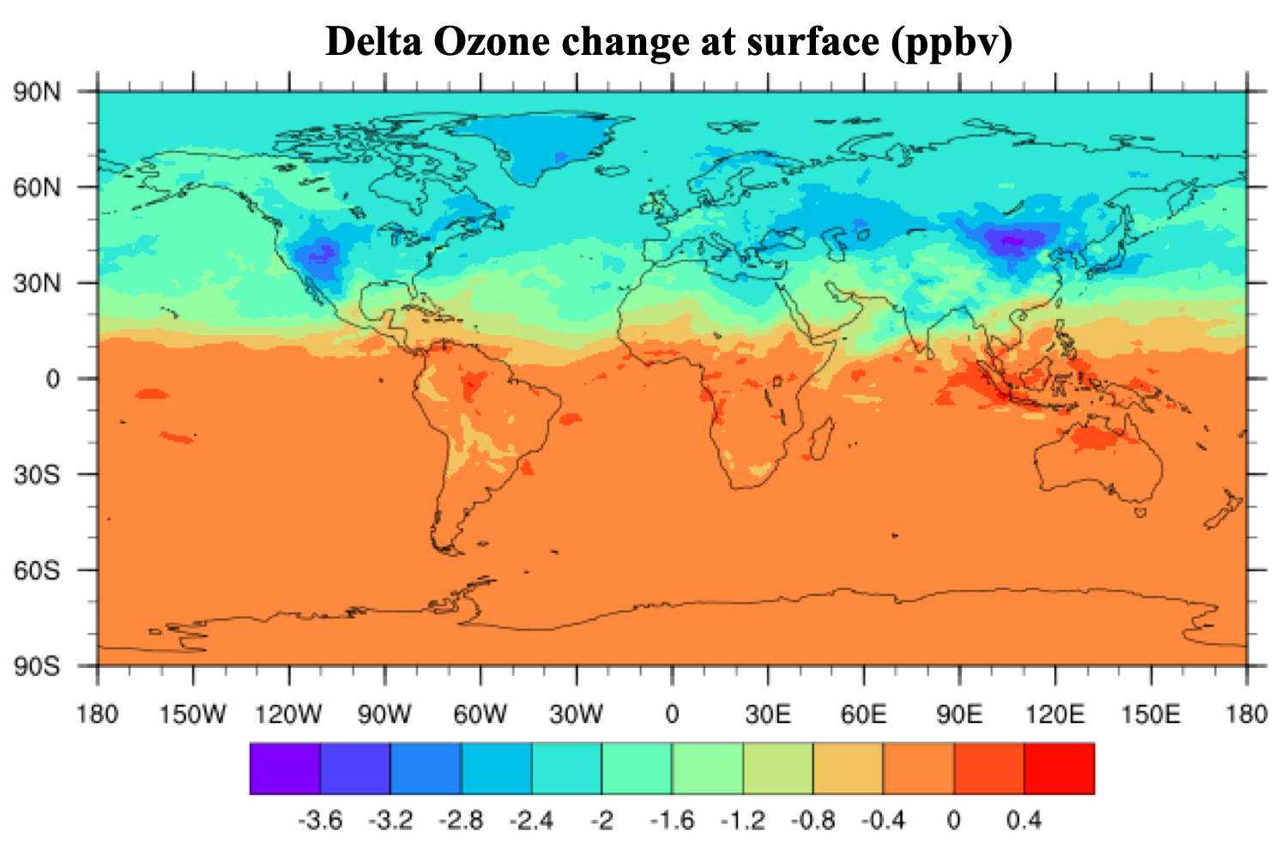
Figure S3. Annual average distribution of delta ozone changes from CF₃I emission Scenario 1 at the surface (992.5 hPa) in units of ppbv.

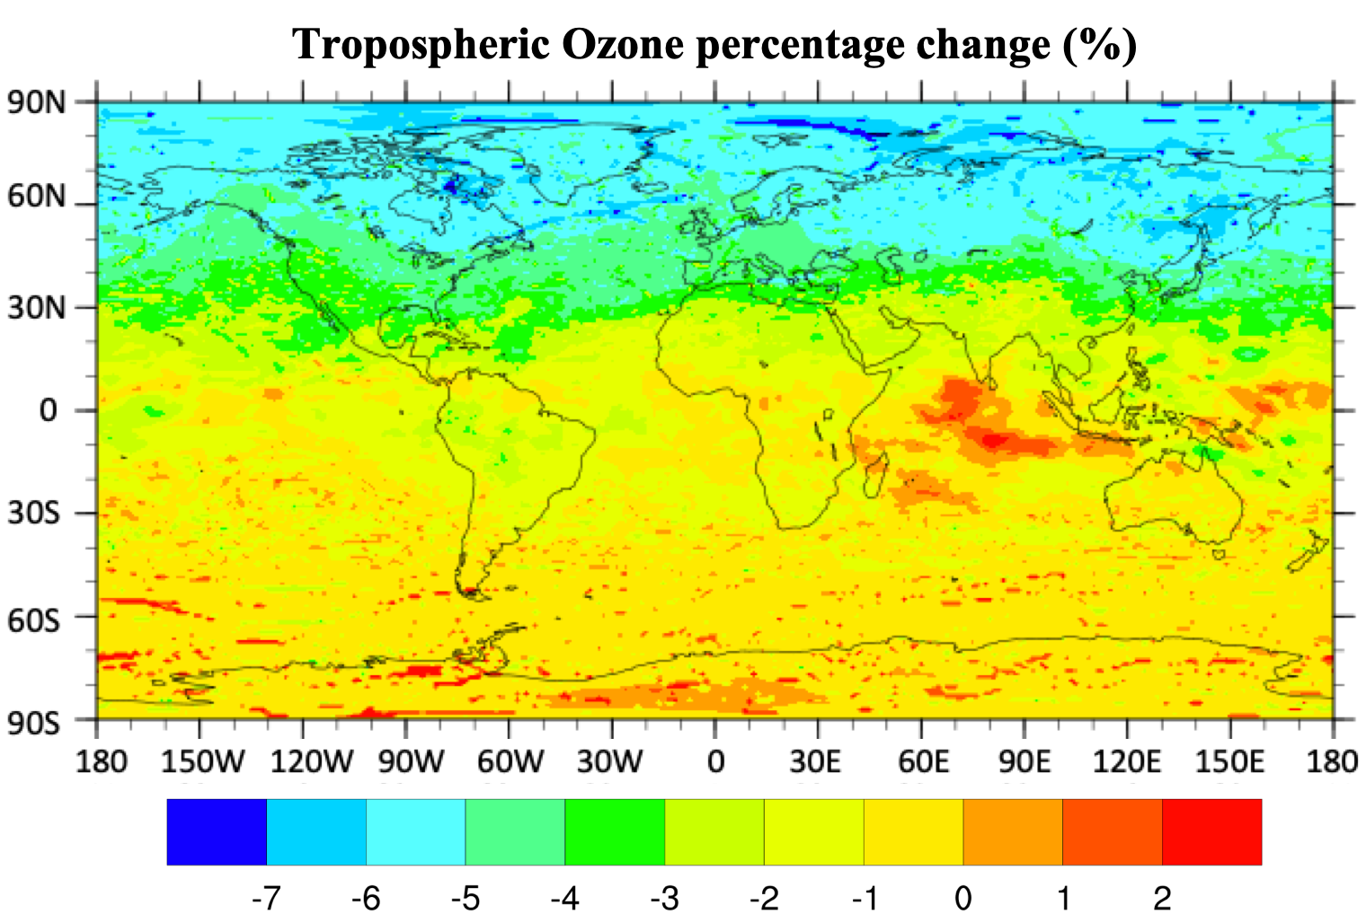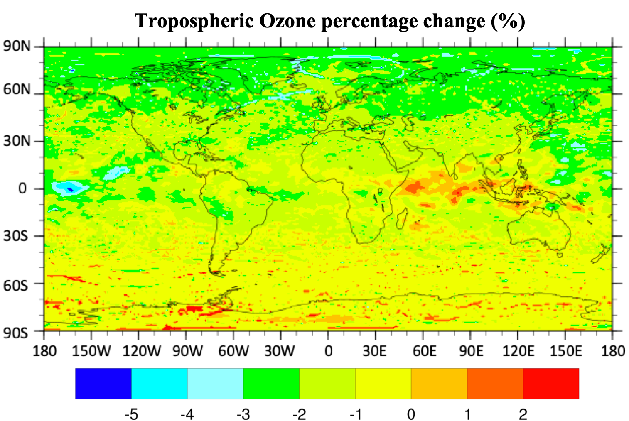
- (b)
Figure S4. Annual average distribution of (a) tropospheric integrated column ozone percentage change from CF₃I emission Scenario 1; (b) is the same but for CH₃I emission Scenario 1.

