**Supplementary Materials**

**Anisotropy engineering of soft thin films in the undulated magnetic state**

*Elena H. Sánchez, Gabriel Rodriguez-Rodriguez, Rodrigo Aragón, Miguel A. Arranz, Esther Rebollar, Marta Castillejo and Jose M. Colino \**

**I. Magneto-optical transmission experiments**

In order to characterize the magneto-optical effects of ripple films in transmission geometry, the same experimental setup as for the Kerr effect was modified according to the Voigt configuration,[1] e.g. the laser beam shed perpendicularly to the sample. A Glann-Thompson polarizer was used to orient the polarization plane of incident radiation. The external magnetic field $\vec{H}$ was applied in the sample plane to typically ± 25 mT at 13 Hz, it thus probes quasi-static magnetization.The transmitted light was separated into parallel and perpendicular components, T║ and T⊥, relative to $\vec{H}$. Both signals were recorded with two fast photodiodes and a differential amplifier circuit. Once the external magnetic field is applied, the Voight rotation of the polarization plane, θK, can be obtained by the formula sin(2θK) = (T║-T⊥)/T0, where T0 is the intensity of the incident light. This configuration allows us to investigate the in-plane magnetization, M(H), being particularly sensitive to its different reversal mechanisms under an alternating magnetic field. Statistical noise was further reduced by averaging 128 measurements at fixed conditions with a digital oscilloscope.

To investigate the uniaxial magnetic anisotropy (UMA) with the magnetooptical effect in transmission configuration, some considerations were taken into account. Due to the strong birefringence effect of the undulated PET substrates,[2] the polarization plane of the incoming beam was kept always parallel to the ripples axis. Thus, the split of the emerging light into ordinary and extraordinary rays was avoided by focusing only on the magnetic effect. The direction of $\vec{H}$ was fixed either parallel or perpendicular to the ripple direction. In both cases the Voigt effect should be also vanishing, assuming the occurrence of UMA. Finally, the sample plane was misaligned intentionally, tilting the ripple axis around 2 deg. relative to the electric field of the incident light, $\vec{E}$. In this way, the in-plane magnetization yields a small projection along the light path and, consequently, a rotation angle of $\vec{E}$. This Faraday rotation arising from such misalignment could be recorded at the twin photodiodes. Magnetization loops ML(H)/MS with field applied across the pattern are thus obtained from the Voight effect for Permalloy (Py) films on LIPSS, which develop complete uniaxial magnetic anisotropy, with a thickness ranging from 10 nm up to 30 nm (see Figure S1.1). Ripple Py film of 50 nm thickness developed just partial uniaxial anisotropy. Films thicker than 50 nm could not be measured in transmission geometry because of the metallic Py film is then sufficiently opaque and yields a too low signal at the photodiodes (red laser penetration depth is ~15 nm for Fe-Ni films[3]). In a previous publication[2] we have checked semi-transparency of this same set of films with the measure of optical transparency in the visible range up to 34% (10 nm thin film).

**Figure S1.1**: Normalized longitudinal magnetization ML/MS of Py uniaxial films with thickness 10 nm (left panel) or 30 nm (right panel) grown onto LIPPS PET as measured from Voight effect. Black and red curves correspond to easy axis (E.A.) and hard axis (H.A.), i.e. in-plane field along or across the pattern, respectively.

These results further support the existence of complete uniaxial anisotropy in this system as these measurements probe the whole Permalloy film across its thickness. The critical fields obtained by measuring that modified magnetooptical Voigt effect in all samples are consistent with those from the MOKE measurements.

**II. On the coercive force and easy-axis reversal**

Easy axis (E.A.) reversal of Py films grown on flat polymer foils corresponds to an isotropic magnetization process, as we mentioned in the manuscript, i.e. does not show any preferred field direction. We checked this point by means of angular studies of in-plane field and longitudinal MOKE. Figure S2.1 plots a few normalized loops measured with different field directions, relative to one of the square foil sides, which are nearly identical. The microscopic origin of E.A. domain nucleation in flat magnetic layers grown on polymers has not drawn attention in the scientific literature to our knowledge.

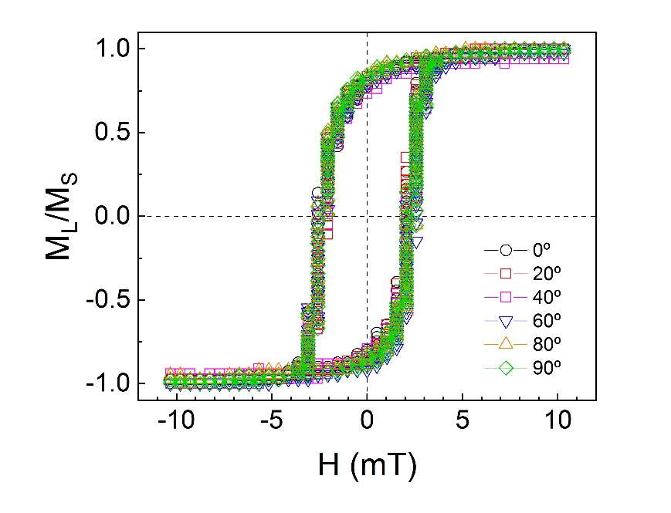

**Figure S2.1**: Normalized MOKE loops of longitudinal magnetization measured for a 15 nm thick Py film grown on flat PET foil with the field applied along a few in-plane directions, according to the legend, relative to the sample square side.

Due to the undulated surface of ripple films very few magnetic microscopy studies have been published and these are focused on remnant states.[4,5] Our attempts to study easy-axis reversal with MOKE imaging (EVICO microscope) have been unsuccessful. As there is no microscopy imaging study – to our knowledge – that specifically targets E.A. magnetization reversal showing either nucleation (single or multiple) or pinning of domains in large-area ripple uniaxial films, we can just claim that some pattern defects drive magnetization reversal, based on the following two evidences.

1. Correlation of easy-axis coercive force with induced anisotropy field of ripple films as reported in the scientific literature. The following Figure S2.2 is a summary of reversal field published values for sets of large-area ripple films. These films were made by different techniques and pattern dimensions though a clear trend relates HC (αH = 0º) to HK.



**Figure S2.2**: Easy-axis coercive force dependence on the uniaxial anisotropy field for a sets of ripple films from different authors: Py films on PET LIPSS (this work), cobalt films on ripple silicon made by IBS,[6] cobalt films on ripple silicon made by IBS,[7] cobalt films on ripple silicon made by IBS,[8] and FeGa films on wrinkled PDMS.[9]

1. Dependence of easy-axis coercive force with ripple pattern dimensions. In a previous article we presented a clear correlation between the value of easy-axis HC(0º) and the amplitude/depth of ripple patterns made by IBS: Figure 2 in the article by Arranz et al.[10] showed an increasing HC(αH = 0º) values with the peak-to-peak pattern amplitude. This evidence is independent from the previous point A) because it was obtained without varying any parameters other than the pattern amplitude (with fixed residual thickness and ripple spacing).

Furthermore, we can find out which reversal mechanisms play a role by means of angular studies of remanence and reversal fields. A complete angular study of remnant magnetization (MR) and critical fields (HC and HS) from MOKE loops, measured at different field angles (αH), of the 30 nm thick Py film grown on LIPSS is summarized in Figure S2.3. The field angle dependence sketched in this figure is similar for other samples with different thickness and similar to other reports.[6,11] Figure S2.3(A) shows normalized MR = M(H=0) from ML and MT loops. These normalized remanences are relevant since they were taken before any irreversible events occur. The graph includes SW predictions of parallel and perpendicular remnant magnetization, which are in semi-quantitative agreement with measurements; only around the hard axis the MT data differs from prediction. The latter is an evidence of a distribution of magnetic easy/hard axis related to pattern coherence. Analysis of film topography in main text showed pattern defects implying deviations of ripple direction, this being a likely origin for the distribution of easy axis (equivalent to a distribution of hard axis). Nonetheless, the remanence data and its comparison with SW model implies that a macrospin approach is valid for the Permalloy films on LIPSS.

**Figure S2.3**: (A) Dependence of remanence magnetization on the in-plane field angle for the 30 nm thick Py film on LIPSS: black symbols refer to longitudinal remnant normalized magnetization and red symbols refer to transverse remnant normalized magnetization. Angle 90º corresponds to field direction across the pattern. (B) Dependence of critical fields from MOKE loops on the in-plane field angle (same film): black symbols refer to coercive field (HC) and red symbols refer to switching field (HS). Solid red line is function HS(αH) = HS (0)/⏐cos(αH)⏐representing pinning model and dashed lines are SW predictions of remnant magnetization and critical fields.

Figure S2.3(B) plots critical field measurements and predictions as a function of the applied field angle. Notice that critical field data are clearly below SW predictions at field angles around the easy axis (blue area), as another case of Brown’s paradox. In case of defects act as pinning centers for domain walls and the reversal proceeds *via* wall propagation, a simple model of pinned 180° domain walls predicts a 1/|cos(αH)| law for the angular dependence of the reversal field.[12] Figure S2.3(B) includes such prediction of the switching field around the easy axis with satisfactory agreement for a significant range of ±40º. Similar findings have been reported from HC(αH) and HS(αH) in different uniaxial anisotropy systems,[11,13] and explained with the role of dynamic effects on magnetization reversal.[11] The angular dependence of critical fields in our films on LIPSS is thus consistent with a coherently rotating system in a low-field rate regime.

**III. Micro-magnetic simulations**

In this work we perform micromagnetic simulations based on a finite-difference method (FDM) that can be accomplished with software OOMMF or MuMax. The chosen software for the micro-magnetic simulations has been MuMax3 as it is designed for high-performance computations and specifically targets large-scale micromagnetic simulations. This software solves the time- and space- dependent magnetization evolution in nano- to microscale magnets using a finite-difference discretization.[14] The simulation space is discretized/partitioned as unitary cells (cubes) with a one vector magnetization. For each of these finite cells, MuMax3 solves the classical Landau–Lifshitz equation taking into account the magnetostatic, exchange and anisotropy interactions, thermal effects and spin-transfer torque.[15] Another advantage of this software is the possibility of using Periodic Boundary Conditions (PBCs), which allow us to generate a large model by repeats of a basic structure. MuMax3 provides the magnetization in X, Y and Z-axis (mx, my and mz respectively), as well as the magnetic field applied in the same directions (Bx, By and Bz) and the Zeeman, demagnetization, exchange, anisotropy and total energies.

Generation of a model basic structure:

Permalloy magnetic parameters reported by NIST (same as used in OOMMF materials library[16]) have been used for the model material:

$$A=1.3×{10}^{-11}\frac{J}{m}$$

$$M_{s}=8.0×{10}^{5}\frac{A}{m}$$

$$K=0.0 \frac{J}{m^{3}}$$

An important point in the design of model structures is the choice of the partition mesh and the suitable cell sizes for the simulations. Cell size must be determined keeping in mind the magnetostatic exchange length (because it relates to the relative strength of exchange and self-magnetostatic energies).[17] To calculate the magnetostatic exchange length and hence the maximum cell size, we have used the equation.

$$l_{exch}=\sqrt{\frac{2A}{µ_{0}M_{s}^{2}}}$$

where A is the exchange constant (J/m), $μ_{0}$ the permeability of free space ( $4π x {10}^{-7}H/m)$ and Ms is the saturation polarization (A/m) as described above, obtaining a maximum length value of $l_{exch}=5.29 nm$. In our model system, we have been able to define a much smaller cell size (1.25 nm), not only ensuring a good magnetic but spatial resolution. With such cubic cells we have created a model basic structure consisting of one square piece of ripple film with lateral (in-plane) dimensions equal to one period (wavelenght) and vertical (out-of-plane) dimension equal to the peak-to-peak ripple amplitude. The number of cells in this basic structure thus depends on film thickness, ripple amplitude and wavelenght.

Crosscheck #1: Periodic boundary conditions serve to simulate a quasi-infinite system.

In order to avoid magnetostatic border effects, MuMax3 allows to use periodic boundary conditions. This PBC method introduces a set of “copies” of a basic structure attached to its sides, along the desired directions over which PBCs apply a magnetization wrap-around with the repeats, felt by stencil operations like the exchange interaction.[14] In our case the basic structure consists of one-period ripple piece (central piece of Figure S3.1), then identical pieces are attached to the X and Y sides so that the interactions between the pieces are similar to the real film. Simulations of longitudinal magnetization with field applied along the ripple crests, performed with PBCs equals 1, 2, 4, 8 and 32, indicate that the magnetic behavior converges towards a thin film-like system from PBC = 8 on (Figure S3.2). Higher PBC order yields similar hysteresis loops where the differences among them are below the field step.

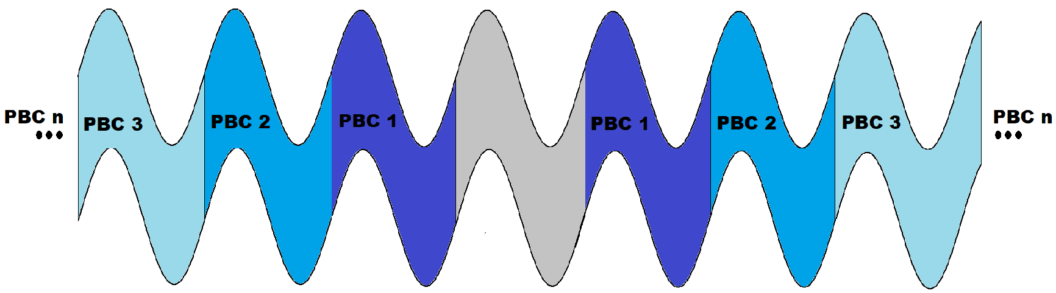

Figure S3.1: Cross-sectional view of the model structure of the quasi-infinite ripple film created using PBCs (top). Notice the unitary basic structure (grey) with all the relevant dimensions. Different blue copies of the primary structure (different PBC order) are shown in different blue colors (bottom).

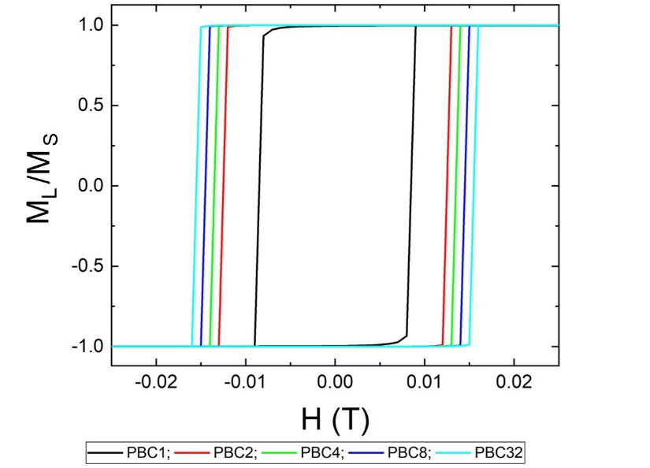

Figure S3.2: Normalized longitudinal magnetization loops with field applied along the ripple axis (easy axis) resulting from calculations with different PBC extension. The simulated structure is 20 nm thick film with 60 nm ripple amplitude and 200 nm of lateral periodicity. Notice the coercive field (Hc) for PBCs 2, 4, 8 and 32 differs only about 1 mT (near one field step), whilst the simulation space scales as [PBC order]2.

Crosscheck #2: An important method for the generation of model structures is antialiasing or *smoothing* of the structure contours with MuMax3. Specifically, these techniques seek to eliminate or, at least blur, as much as possible the "saw teeth" contour that is created at the model structure surfaces by the cubes partitioning. We have applied the maximum smoothing possible in the software to minimize the magnetostatic artifacts and have checked that the anisotropy fields are minimized for the actual choice of cell size and structure details.

Crosscheck #3: Angular studies prove complete coherent rotation in the thinnest ripple films: Modelling of ripple films proves uniaxial anisotropy with easy axis along the ripple crests regardless of film thickness (up to 100 nm). Also hard axis magnetization corresponds to undulated magnetic state at external fields around saturation. In case of very thin films (thickness comparable to exchange length) we expect hard axis magnetization quite uniform in the XY plane. Proof of a magnetization “rigidity” expected for the thinnest films is provided by simulations of reversal loops in a whole range of in-plane field angles αH (0º-360º) in comparison with the ideally-rigid (no exchange energy) theory of single domains. Dependence of normalized switching field (HS/HK) on field angle (αH) is shown in Figure S3.3(A). This left pannel is a polar plot of the switching field data (red curve) that closely resembles the famous astroid Stoner-Wohlfarth (SW) (blue line) analytically predicted for a small ellipsoid particle.[18]

$$H_{S}(α)=\frac{H_{K}}{{\left(\sin^{2/3}α+\cos^{2/3}α\right)}^{3/2}}$$

Minor differences between SW theory and the undulated state curves arise in the easy axis switching field [see Figure S3.3(A)], and these are not relevant as other processes set in for this configuration which were discussed above. The right pannel [Figure S3.3(B)] is a polar plot of normalized remanence magnetization (MR/MS) that matches a |cosαH| law characteristic of the Stoner-Wohlfarth model. All model films satisfy this remanence cosine law.

We thus see that the undulated magnetic state resembles the single-domain SW theory in many regards, e.g. the angle dependence of remanence. However important features are unique for the undulated state according to calculations of hard axis loops as is discussed in the main text. As the model thickness is made smaller such differences progressively vanish though.

**Figure S3.3**: (A) Red curve is polar diagram of normalized switching field (HS/HK) from the simulations of 10 nm thick film on a ripple pattern (amplitude 45 nm and wavelength 240 nm). Blue line is SW prediction (B) Polar diagram of normalized remanence (MR/MS) from the simulations of the same sample.

Crosscheck #4: Ripple crests and valleys act as nucleation sites for switching

To get more insight on the magnetic switching of thick film models (e.g. of thickness 30 nm) we have performed simulations of hard axis reversal loops at specific ripple zones. Transverse susceptibility of small zones at either ridge/valley or slopes (Figure S3.4) provides local information on switching events that is complementary to the demagnetizing field maps included in the main text (Figure 4). The local transverse susceptibility is calculated by differentation of MT curves similar to that of Figure 3C and 3F in the main text. For the 10 nm thin ripple model (Figure S3.4A-B) there are no big differences between both zones as the magnetization is quite uniform. Therefore, nucleation is equally likely at either ridges or central slopes. For the 30 nm thick film model (Figure S3.4C-D), at both ripple zones there are low-field and high-field contributions to MT(H) however, at the ridge/valley the high-field susceptibility peak (for H ~ HK) is clearly enhanced or, consequently, at central slopes the low-field susceptibility becomes comparatively larger. We can therefore expect nucleation initiated at the former zones.

**Figure S3.4**: Panels (A) and (C) display H.A. transverse susceptibility dMx/dHy as a function of reduced field for different zones of the 10 nm and 30 nm ripple film models respectively: blue dots are calculated at ridge or valley (with identical results) whereas red dots correspond to central parts of ripple structure i.e. where surface slope is maximum (central slope). Zones dimensions and positions are sketched in (B) and (D).

**References**

[1] M.A. Arranz, J.M. Colino, Angular tuning of the magnetic birefringence in rippled cobalt films, Appl. Phys. Lett. 106 (2015) 253102. doi:10.1063/1.4922807.

[2] M.A. Arranz, E.H. Sánchez, E. Rebollar, M. Castillejo, J.M. Colino, Form and magnetic birefringence in undulated Permalloy / PET films, Opt. Express. 27 (2019) 21285–21294. doi:10.1364/OE.27.021285.

[3] K. Zhang, F. Rotter, M. Uhrmacher, C. Ronning, J. Krauser, H. Hofsäss, Ion induced nanoscale surface ripples on ferromagnetic films with correlated magnetic texture, New J. Phys. 9 (2007) 29. doi:10.1088/1367-2630/9/2/029.

[4] M. Körner, F. Röder, K. Lenz, M. Fritzsche, J. Lindner, H. Lichte, J. Fassbender, Quantitative imaging of the magnetic configuration of modulated nanostructures by electron holography, Small. 10 (2014) 5161–5169. doi:10.1002/smll.201400377.

[5] S.A. Mollick, R. Singh, M. Kumar, S. Bhattacharyya, T. Som, Strong uniaxial magnetic anisotropy in Co films on highly ordered grating-like nanopatterned Ge surfaces, Nanotechnology. 29 (2018) 125302. doi:10.1088/1361-6528/aaaa74.

[6] J.M. Colino, M.A. Arranz, A.J. Barbero, A. Bollero, J. Camarero, Surface magnetization and the role of pattern defects in various types of ripple patterned films, J. Phys. D: Appl. Phys. 49 (2016) 135002. doi:10.1088/0022-3727/49/13/135002.

[7] M.O. Liedke, M. Körner, K. Lenz, M. Fritzsche, M. Ranjan, A. Keller, E. Čižmár, S.A. Zvyagin, S. Facsko, K. Potzger, J. Lindner, J. Fassbender, Crossover in the surface anisotropy contributions of ferromagnetic films on rippled Si surfaces, Phys. Rev. B: Condens. Matter Mater. Phys. 87 (2013) 024424. doi:10.1103/PhysRevB.87.024424.

[8] S. K.V., D. Kumar, V. Ganesan, A. Gupta, In-situ study of magnetic thin films on nanorippled Si (1 0 0) substrates, Appl. Surf. Sci. 258 (2012) 4116–4121. doi:10.1016/j.apsusc.2011.07.105.

[9] S. Zhang, Q. Zhan, Y. Yu, L. Liu, H. Li, H. Yang, Y. Xie, B. Wang, S. Xie, R.W. Li, Surface morphology and magnetic property of wrinkled FeGa thin films fabricated on elastic polydimethylsiloxane, Appl. Phys. Lett. 108 (2016) 102409. doi:10.1063/1.4943943.

[10] M.A. Arranz, J.M. Colino, F.J. Palomares, On the limits of uniaxial magnetic anisotropy tuning by a ripple surface pattern, J. Appl. Phys. 115 (2014) 183906. doi:10.1063/1.4876232.

[11] J.L.F. Cuñado, A. Bollero, T. Pérez-Castañeda, P. Perna, F. Ajejas, J. Pedrosa, A. Gudín, A. Maldonado, M.A. Niño, R. Guerrero, D. Cabrera, F.J. Terán, R. Miranda, J. Camarero, Emergence of the Stoner-Wohlfarth astroid in thin films at dynamic regime, Sci. Rep. 7 (2017) 13474. doi:10.1038/s41598-017-13854-7.

[12] S. Chikazumi, Magnetization rotation, in: Phys. Ferromagn., Oxford Science Publications, New York, 1997: p. 491.

[13] P. Perna, C. Rodrigo, E. Jiménez, F.J. Teran, N. Mikuszeit, L. Méchin, J. Camarero, R. Miranda, Tailoring magnetic anisotropy in epitaxial half metallic La0.7Sr0.3MnO3 thin films, J. Appl. Phys. 110 (2011) 013919. doi:10.1063/1.3605542.

[14] A. Vansteenkiste, J. Leliaert, M. Dvornik, M. Helsen, F. Garcia-Sanchez, B. Van Waeyenberge, The design and verification of MuMax3, AIP Adv. 4 (2014) 107133. doi:10.1063/1.4899186.

[15] A. Vansteenkiste, B. Van De Wiele, MUMAX: A new high-performance micromagnetic simulation tool, J. Magn. Magn. Mater. 323 (2011) 2585–2591. doi:10.1016/j.jmmm.2011.05.037.

[16] A.M. Abdelgawad, N. Nambiar, M. Bapna, H. Chen, S.A. Majetich, Magnetic vortices in nanocaps induced by curvature, AIP Adv. 8 (2018) 056321. doi:10.1063/1.5007213.

[17] G.S. Abo, Y.K. Hong, J. Park, J. Lee, W. Lee, B.C. Choi, Definition of magnetic exchange length, IEEE Trans. Magn. 49 (2013) 4937–4939. doi:10.1109/TMAG.2013.2258028.

[18] C. Tannous, J. Gieraltowski, A Stoner-Wohlfarth model Redux: Static properties, Phys. B: Condens. Matter. 403 (2008) 3563–3570. doi:10.1016/j.physb.2008.05.031.