Supporting Information

Bi-functional carbon-based catalysts for unitized regenerative fuel cells

L.M. Rivera-Gavidia¹, I. Fernández de la Puente¹, M.A. Hernández-Rodríguez², V. Celorrio^{3,Ϯ}, D. Sebastián³, M.J. Lázaro³, E. Pastor^{1*} and G. García^{1*}

¹Departamento de Química, IMN, Universidad de La Laguna, PO Box 456, E-38200, La Laguna, Santa Cruz de Tenerife, Spain
²Departamento de Física, MALTA Consolider Team, IMN, IUdEA, Universidad de La Laguna, PO Box 456, E-38200, La Laguna, Santa Cruz de Tenerife, Spain
³Instituto de Carboquímica, Miguel Luesma Castán 4, E-50018, Zaragoza, Spain.
^{Ϯ}Current address: Diamond Light Source Ltd, Diamond House, Harwell Campus, Didcot, United Kingdom

Corresponding authors:
*E-mail address: ggarcia@ull.edu.es
*E-mail address: epastor@ ull.edu.es

Figure S1. TEM image of CNFs.
Figure S2. TEM image of CNFs.

Figure S3. TEM image of gCMK-3.

Figure S4. TEM image of gCMK-3.

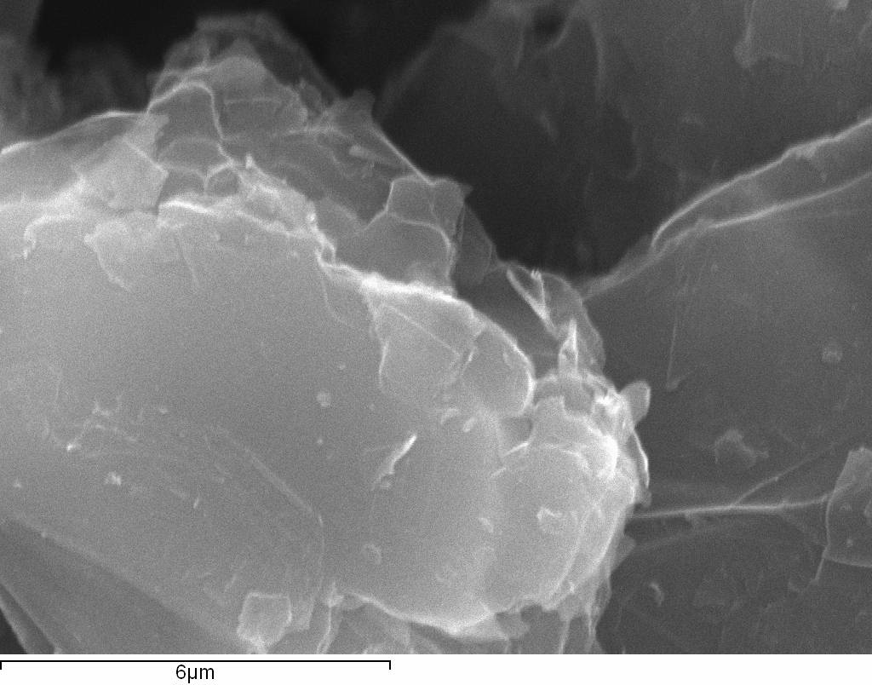
Figure S5. SEM image of Graphite.

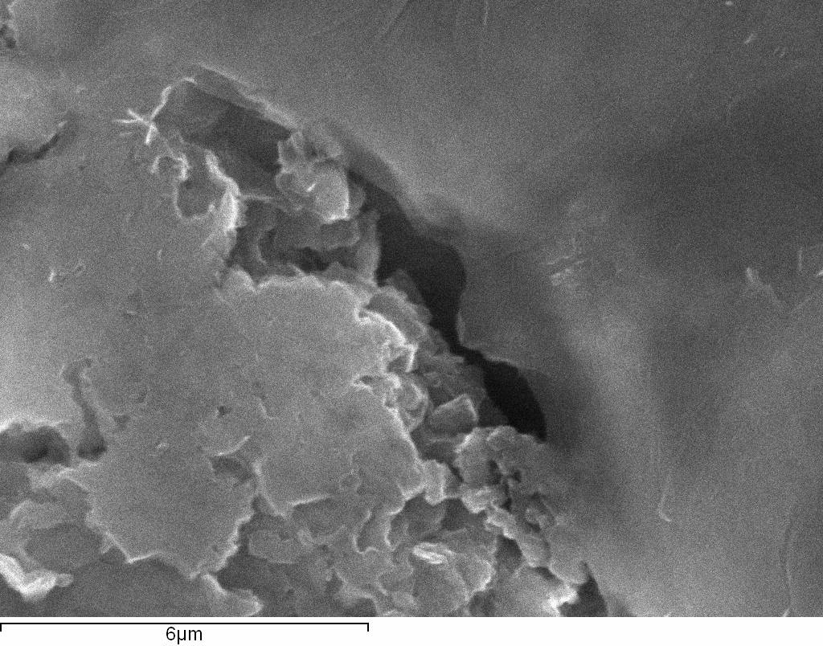
Figure S6. SEM image of GO.

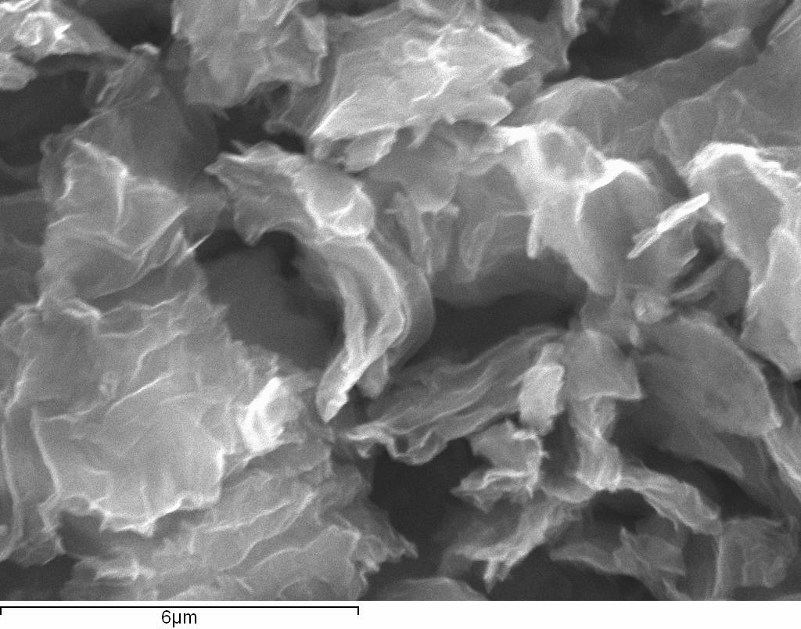
Figure S7. SEM image of H-rGO.

Table S1. BET analysis results.
Catalyst | BET surface Area (m² g⁻¹)
Graphite | ≈ 1
GO | ≈ 30
H-rGO | ≈ 350
CNFs | ≈ 100
gCMK-3 | ≈ 600

