Research article
Benefits for nurse and facilitated plants emerge when interactions are considered along the entire life-span
Alicia Montesinos-Navarroa,*, Isabelle Storerb, Rocío Perez-Barralesb
a Centro de Investigaciones sobre Desertificación (CIDE, CSIC-UV-GV), Carretera de Moncada-Náquera Km 4.5 46113 Moncada, Valencia, Spain
b School of Biological Sciences, King Henry Building, King Henry I Street, University of Portsmouth, Portsmouth, PO1 2DY, UK

A R T I C L E I N F O

Keywords:
Facilitative interactions Gypsum
Long-term interactions Nurse plants’ benefits Plant community Priority effects
A B S T R A C T

The structure of plant communities is often influenced by facilitative interactions where ‘facilitated’ plants benefit from growing associated with ‘nurse’ plants. Facilitation has been mostly studied from the facilitated plant’s perspective, and bidirectional effects between nurse and facilitated plants have received less attention. We hypothesized that reciprocal benefits in plant-plant interactions may emerge when interactions are con- sidered along the life-span of the plants involved. Over one spring, we selected five species with similar life-form and growth strategy, and using a full factorial design, we compared different fitness components along the plants’ life-span (seedling establishment, juvenile growth and reproductive investment in adult plants). We compared: a) plants growing in solitary stands and associated with other plants in vegetation patches; and b) plants that originally functioned as nurse plant (the largest plant of the vegetation patch) and as facilitated (not the largest plant of the vegetation patch). At an early developmental stage, facilitated plants growing in vege- tation patches displayed higher seedling establishment and juvenile growth compared to solitary conspecific plants. At a later developmental stage, nurse plants in vegetation patches experienced higher reproductive in- vestment (measured as flower production relative to plant size) compared to solitary plants, while the originally facilitated plants showed similar reproductive investment compared to their solitary pair of similar size. Facilitation is likely a complex interaction in which reciprocal benefits for both facilitated and nurse plants can be detected when interactions are considered along the plants’ life-span. Our results suggest that mutual benefits in plant-plant interactions could be important to sustain diversity in plant communities, but they appeared overlooked and deserve further attention.

Introduction
Community assembly processes strongly influence the relative abundance of species in communities and the spatial distribution of biodiversity (HilleRisLambers et al., 2012; Mittelbach and Schemske, 2015). Plant facilitative interactions occur if at least one of the inter- acting species gains some benefit (facilitated) from growing in asso- ciation with other (nurse) species, and no harm is caused to either (Callaway, 2007). During the period of establishment, plants commonly benefit from growing associated with a nurse plant, but this positive interaction can shift to competition when the facilitated plant reaches maturity (Miriti, 2006; Schiffers and Tielbӧrger, 2006; Armas and Pugnaire, 2009). A less explored component of facilitation is whether changes in the shared environment caused by adult facilitated plants may benefit the original nurse plant (i.e. the plant that arrived first to the shared environment). In stressful environments with limited
resources, this could result in positive feedbacks between plants, al- though detectable at different developmental stages for the nurse and the facilitated plants. Unfortunately, the dynamics of positive feedbacks along the entire life-span of plants (i.e. different developmental stages) remains largely unexplored.
Plant-plant facilitative interactions are commonly focused on the benefits gained by the facilitated species (Callaway, 2007), or the analysis of costs and benefits for both facilitated and nurse plants to identify shifts from facilitation to competition (Valiente-Banuet et al., 1991; Armas and Pugnaire, 2009). However, recent studies demon- strated that the benefits of plant-plant interactions can be mutual (Sortibrán et al., 2014; Tirado et al., 2015), which could be explained by a shift in the role of interacting plants, e.g. if the beneficiary species becomes benefactor when it becomes an adult plant. For example, during an early life stage, seedling establishment and growth of juvenile plants increases if plants grow under the stress-ameliorated micro-

⁎ Corresponding author.
E-mail addresses: ali.montesinos@gmail.com (A. Montesinos-Navarro), isabelle.storer@myport.ac.uk (I. Storer), rocio.barrales@port.ac.uk (R. Perez-Barrales).
https://doi.org/10.1016/j.ppees.2019.125483

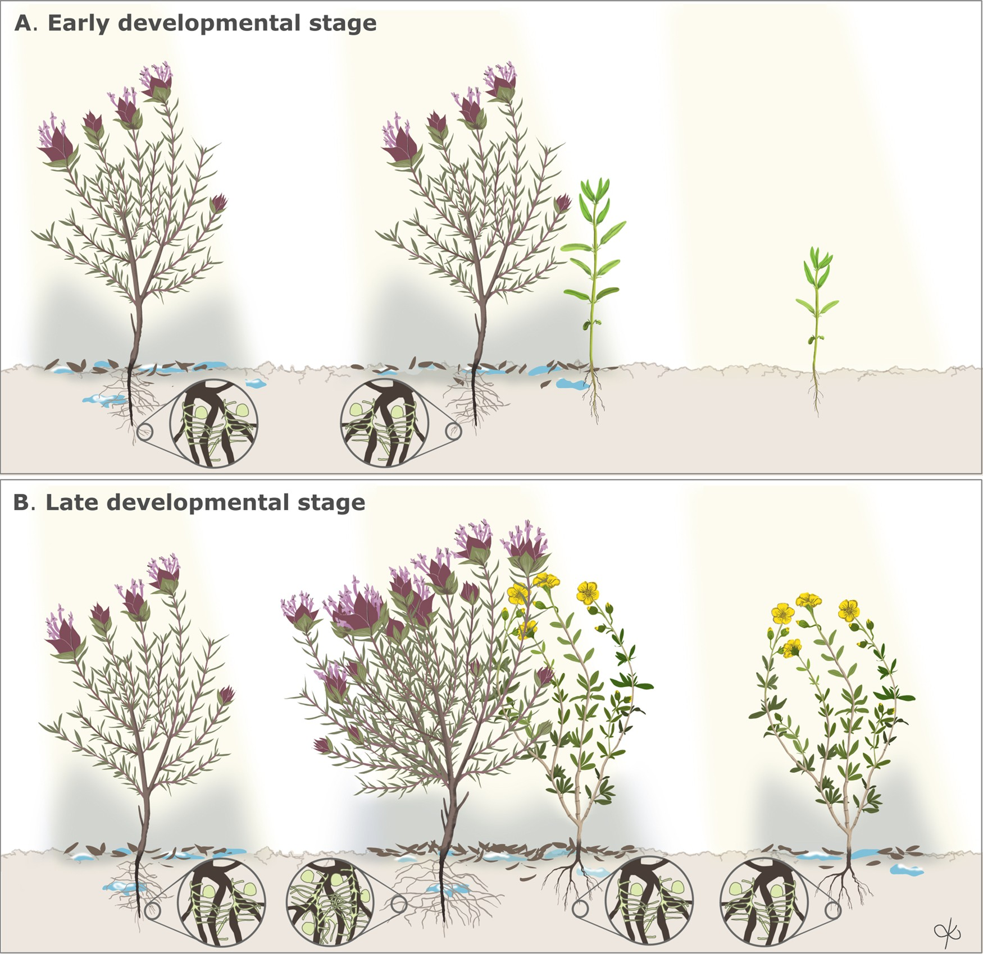
Fig. 1. Experimental design. Fitness components for seedling/juveniles and adults were compared between conspecific plants growing associated with other plants and solitary. In the field, two different situations were selected, vegetation patches where the focal species was the largest in the patch (i.e. originally acting as the nurse) and where it was an adult but not the largest of the patch (i.e. originally facilitated as a seedling). We expect that both the originally facilitated and nurse species will benefit from growing associated compared to solitary, the former at an early developmental stage, increasing its frequency of establishment and growth of juveniles - as a result of an amelioration of abiotic stress, such as water or nutrient limitation, and/or an enhancement of symbiotic interactions, when it is associated vs. solitary-(A), and the later at a later developmental stage, increasing flower production -as a result of a relevant contribution of the associated adult facilitated plant providing nutrients through litter or biotic symbionts such as mycorrhizal fungi-(B). Scientific Illustrations were created by “DharmaBeren Studio” (www.dharmaberen.com).

environment provided by the nurse plant (Pugnaire et al., 1996; Gómez- Aparicio et al., 2004; Callaway, 2007; Castillo et al., 2010); as plants become adults, they modify the micro-environment (Navarro-Cano et al., 2015), which in turn benefits those plants that share it. Adult plants can provide fungal mutualisms, increase nutrient turn over by altering soil microbiota, and accumulate nutrients, all of which benefit other plants (Montesinos-Navarro et al., 2012, 2016, Rodríguez- Echeverría et al., 2013; Lozano et al., 2014; Navarro-Cano et al., 2014; Sortibrán et al., 2014), including the original nurse. Therefore, as an adult plant, the originally facilitated plant can enrich the micro-en- vironment shared with the nurse plant, which might overall gain larger net benefits compared to the adult facilitated plant, since larger plants are more efficient at capturing resources (Goldberg and Landa, 1991; Keddy et al., 2002; Vogt et al., 2009). Nurse and adult facilitated plants might compete for resources during specific periods, but in the long term, the association between plants is likely to remain if the net effects are positive for both nurse and facilitated plant (Valiente-Banuet and
Verdú, 2007). Shifting roles from beneficiary to benefactor and vice versa might strengthen species coexistence, ultimately increasing the biodiversity of local communities.
In this study, we focus on a Mediterranean plant community growing on resource-poor gypsum soils to investigate whether mutual benefits for the nurse and the facilitated plants may emerge throughout the lifespan of plants. We compare the performance measures between isolated and aggregated plant species at different developmental stages (i.e., juveniles and adult plants) and expect that both the facilitated and the original nurse plant species can benefit from the interaction, the former at an early developmental stage and the later as an adult (Fig. 1). Overall, our approach contributes to a better understanding of the temporal dynamics of plant facilitative interactions, and provides insights into mutual benefits between nurse and facilitated plants, otherwise overlooked in the plant-plant facilitation literature.

Table 1
Trait values related to plant growth for the five focal species of our study compiled from BROT data base (Paula et al., 2009; Tavcsanouglu and Pausas, 2018): Helianthemum squamatum (H. squamatum), Helianthemum syriacum (H. syriacum), Helichrysum stoechas (He. stoechas), Teucrium libanitis (T. libanitis), Thymus moroderi (Th. moroderi). The similarity in trait values (number of in- dividuals (N), mean and standard deviation (sd)) across the plant species se- lected in the study, supports that they have similar growth strategies. All data comes from specimens collected in Eastern Spain.
Species traits N mean sd
Height (m)
H. squamatum 2 0.26 0.20
H. syriacum 5 0.46 0.24
He. stoechas 4 0.48 0.14
T. libanitis 1 0.12 –
Th. moroderi 1 0.10 – Leaf area (mm2)
H. squamatum 1 69.54 –
H. syriacum 2 44.80 14.42
He. stoechas 3 39.66 32.73
T. libanitis 1 23.44 –
differences in plant establishment, especially in gypsum soils, where secondary growth shows large inter-site and small interspecific differ- ences (Olano et al., 2011).
2.2. Sampling design
Over one spring, we studied five species with a similar life-form so that their size could be used as proxy of the sequence order of plant establishment in vegetation patches. We compared performance traits relevant to different life stages between plants that appeared growing in association with other species (i.e. in vegetation patches where ca- nopies overlapped) and solitary, in order to estimate the net benefits (or costs) of growing in vegetation patches. For seedlings and juvenile plants, we quantified the frequency of establishment and growth of juveniles respectively. In adult plants, we determined whether net flower production (relative to plant height) varied with the role that the species played in the interaction (nurse or facilitated) (Fig. 1). There- fore, we quantified the net benefit in pairs of species where the asso- ciated individual was the largest in the vegetation patch (assumed to be
the original nurse plant), and in pairs where it was not the largest

Th. moroderi
Leaf Nitrogen

content (mg/g)
1 4.50 –
(although frequency of establishment and juvenile growth might have

H. squamatum 1 13.39 –
H. syriacum 1 12.74 –
He. stoechas 3 12.82 0.79
Root depth (m)
H. squamatum 2 0.44 0.30
H. syriacum 2 0.39 0.39
He. stoechas 2 0.33 0.27
T. libanitis 1 0.17 –
Th. moroderi 1 0.13 – Specific leaf area (mm2/mg)
H. squamatum 1 4.56 –
H. syriacum 3 4.84 1.47
He. stoechas 3 10.15 2.04
T. libanitis 1 3.41
Th. moroderi 1 6.30 –

Materials and methods
  - Study site
The study was conducted in spring-summer 2016 in a semi-arid plant community in the SE of Spain, 2.21 km NE of Petrer in the pro- vince of Alicante (38°29'52.36"N, 0°44'37.62"W), in an area of 4708 m² with a 30% of vegetation cover (Delalandre and Montesinos-Navarro, 2018). The average annual temperature and precipitation of the region is 22.5 °C and 381 ml respectively (Cueva, 1994). The study site is an outcrop of gypsum soil surrounded by clay and loam. Gypsum soils are physically unstable due to lack of plasticity, cohesion, and aggregation (Romão and Escudero, 2005), properties that prevent roots from pe- netrating the surface crust after seed germination, and limit establish- ment of plant juveniles (Meyer, 1986). Gypsum soils generally lack important plant nutrients such as phosphorus, nitrate and potassium (Meyer, 1986). Altogether these physical and chemical properties make gypsum soils stressful environments for plants.
The most common plant species in the study site were chamae- phytes, including Teucrium libanitis Schreber, Thymus vulgaris, Th. moroderi, Fumana ericoides, Helianthemum squamatum (Jacq.) Dum. Cours., H. syriacum L., Helichrysum stoechas, Herniaria fruticosa, and Sedum sediforme. Shrubs such as Cistus clusii, Ononis tridentata and Rosmarinus officinalis were scattered and uncommon. We focused the study on the most abundant species, namely T. libanitis, Th. moroderi, H. squamatum, H. syriacum, and He. stoechas because they are all dwarf shrubs with similar size and similar traits related to growth strategies (trait values compiled from BROT data base, presented in Table 1; Paula et al., 2009; Tavcsanouglu and Pausas, 2018). Therefore, differences among these species are likely to emerge in relation to temporal
been facilitated by the nurse plant at an earlier life stage). We focused on key demographic parameters that influence population dynamics, namely survival, growth and reproduction (Caswell, 2001), and se- lected plant performance components that inform about these para- meters. We used plant height as proxy of either growth and/or survival, and flower production as a proxy of reproduction. Then, we followed a widely used approach to quantify the intensity of plant-plant interac- tions, which consists of comparing plant performance between treat- ments differing in the presence (e.g. associated) or absence (e.g. soli- tary) of neighbors (Goldberg et al., 1999; Holzapfel and Mahall, 1999; Pugnaire and Luque, 2001; Cavieres et al., 2008; Schӧb et al., 2014b; García-Cervigón et al., 2016; Pueyo et al., 2016; Llambí et al., 2017). We applied this general approach for the following fitness components along the plants’ life-span.
  - Frequency of juvenile recruitment
Recruitment and spatial distribution of juvenile plants (e.g. early life development stage) was studied by sampling 111 plots of
1.5 m × 1.5 m randomly distributed across the study site. We quanti- fied the number of juvenile plants growing in vegetation patches with other plants, and growing solitarily. We considered juvenile plants those with soft stems and without signs of stem lignification, and ve- getation patches as groups of plants with overlapping canopies. We calculated the percentage of the total area covered by plants by mea- suring the maximum and minimum diameter of the patch per plot, and approximated the patch area to an ellipse. We used binomial tests to compare the observed number of juveniles in the two conditions (i.e. growing in association with other plants in patches and solitarily), with those expected based on the proportion of area covered by plants, using the “binom.test” function implemented in R version 3.2.3 (R Core Team, 2013). The p-values were corrected for multiple testing through the false discovery rate (FDR) method, using the “p.adjust” function.
  - Juvenile growth
In an area of 30 m2, we compared height of juvenile plants growing in patches and isolated to test if performance increased in vegetation patches. Plant height was used as proxy of performance, driven either by an increase in growth rates and/or improved survival. We used a general linear mixed model and included height as dependent variable, growing condition (e.g. in association with other plants and in solitary stands) as fixed effect, and species identity as random effect. The ana- lysis was conducted using the “lme4” package (Bates et al., 2015), the significance of the fixed effect was assessed using “lmerTest” package

(Kuznetsova et al., 2017), and the mean estimate of the levels was re- trieved using “effects” package (Fox et al., 2003), all implemented in R version 3.2.1 (R Core Team, 2013).
  - Flower production of adult plants
We measured plant height and flower production in 200 adult in- dividuals. We selected plants distributed in a paired design (hereafter set) so that two plants of the same species appeared growing in each condition, i.e. in vegetation patches and in solitary stands within 1 m
distance from each other. In half of the sets, the plant growing in as-
Table 2
Binomial tests assessing differences in the establishment of juveniles in vege- tation patches and bare ground for the five focal species. The expected pro- portion of juveniles growing associated with other plants was 0.15, based on the percentage of cover of plants in the 30 m2 plot area sampled. For each species, the total number of juveniles observed (Total N. juveniles), the number of ju- veniles growing associated with other plants (N. juv. associated), the estimated probability of growing associated based on the binomial test (Estim. prob.), and the adjusted p-value corrected for multiple testing using the false discovery rate method (Adj. p-value) are presented. For all species, the proportion of juveniles growing associated with other plants is significantly greater than expected by
chance.

sociation was the largest of the vegetation patch (assumed to be ori-
ginally the nurse plant), whereas in the other half the adult plant was not the largest (assumed to be the originally facilitated plant as seed-
Species Total N. juveniles N. juv. associated
Estim. Prob. Adj. p-value

ling). For T. libanitis and Th. moroderi we counted the number of in- florescence rather than number of flowers because flowers of these species are too small to obtain accurate counts in the field. We targeted five species and selected 20 sets per species (40 plants per species), accumulating a total of 100 sets (sets included paired-individuals, one from the vegetation patch and one from solitary stands, of a similar size; 200 plants in total). In some cases, sets of different species shared the same vegetation patch, and this was incorporated in the analyses (see below).
Because plant size and/or age (both likely correlated with height) affects flower production, we conducted a linear regression for each species to predict flower production based on plant height. We ex- tracted the residuals and used them as measure of corrected flower production to remove plant size effects on the response variable. Within each set, we estimated the difference between the corrected flower production of plants growing in association and its solitary paired- plant. We used this measure as proxy of benefits gained (if positive) and costs (if negative) of growing associated with other plants in a vege- tation patch. Two conspecific plants within each set could slightly differ in height, but using the residuals of flower production regressed against plant height ensured that detectable differences between plants in as- sociation and its solitary paired-plant were independent of height. We used a general linear mixed model to test if differences in corrected flower production could be explained by the fixed factor “role”. “Role” indicated whether the associated plant was considered as originally nurse or facilitated plant (largest or not the largest plant of the patch respectively). In the analysis, plant species and vegetation patch were included as random factors. All statistical analyses were performed using the package “lme4” (Bates et al., 2015), the significance of the fixed effects was assessed using “lmerTest” package (Kuznetsova et al., 2017), and the mean estimates and standard error of the two levels of the fixed factor (largest and non-largest plant) were obtained using “effects” package (Fox et al., 2003), both implemented in R version
3.3.1 (R Core Team, 2013).

Results
  - Juvenile recruitment
In the 250 m2 area sampled, plants covered only 15% of the area surveyed, but the estimated probability of finding juveniles in vegeta- tion patches was threefold of the expected by chance for all plant species (0.52–0.59, Table 2). Therefore, the binomial test showed that the proportion of juveniles growing associated with vegetation patches was significantly larger than expected by chance (Table 2).
  - Juvenile growth
Height was recorded in 314 juvenile plants in 30 m2 (154 of H. syriacum, 82 of H. squamatum, 28 of Th. moroderi, 21 of T. libanitis and 19 of He. stoechas). The height of juvenile plants was significantly ex- plained by growing condition, whether the plants appeared growing
T. libanitis 203 120 0.591 < 0.001
H. squamatum 539 321 0.596 < 0.001
H. syriacim 201 106 0.527 < 0.001
T. moroderi 22 13 0.591 < 0.001
H. stoechas 23 12 0.522 < 0.001

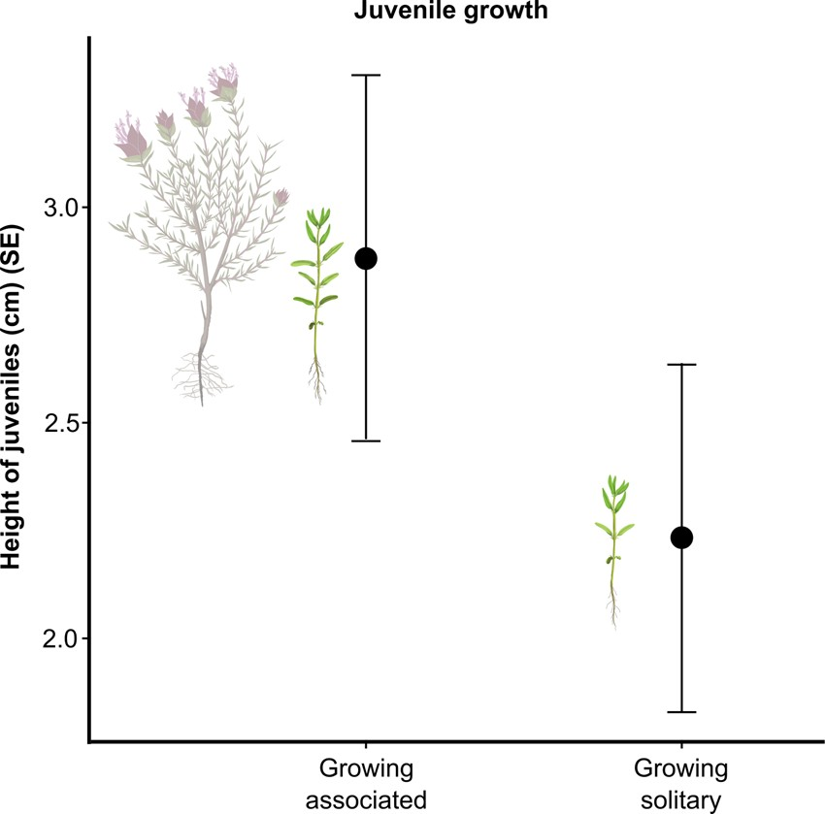
Fig. 2. Juveniles size when growing in association with other plants or isolated. Estimated means and standard errors of the height of juveniles (in cm) for plants growing in vegetation patches and solitary. Scientific Illustrations were created by “DharmaBeren Studio” (www.dharmaberen.com).

associated vs. in solitary stands (F-value = 6.071, 309, p-value = 0.01), with an average height (mean ± SE) of 2.88 ± 0.42 cm in vegetation patches and 2.23 ± 0.40 in solitary stands (Fig. 2). These differences represent an increase of 29% in height for juvenile plants in vegetation patches.

  - Flower production
We detected differences in corrected flower production in relation to the role assigned to plants. Nurse plants (i.e. the largest individuals in vegetation patches) showed significantly higher benefits than fa- cilitated conspecifics (not the largest) (N = 100, p-value = 0.003; Fig. 3). Specifically, differences in corrected flower production between the largest plant in the patch and its paired-solitary conspecific were positive and statistically significant (72.38 ± 25.22; p-value = 0.02). In contrast, when the associated plant was not the largest of the patch, flower production was similar between the plant in the vegetation patch and the paired-solitary conspecific (−11.02 ± 25.22; p- value = 0.67).

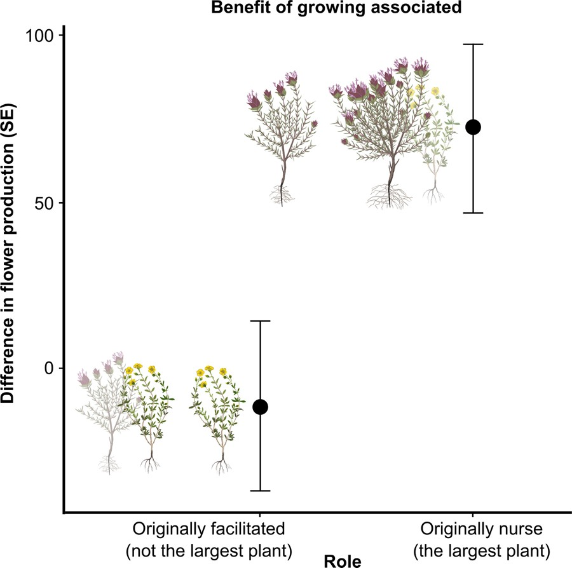
Fig. 3. Benefits of growing in association with other plants in vegetation pat- ches based on the role of the plant (largest plant of the patch assumed to function originally as nurse, and not the largest plant assumed to be originally facilitated as seedling, see Methods). Estimated means and standard errors of flower production are presented based on the residuals of the relationship be- tween flower production and height. Benefits were calculated as the difference in flower production between paired individuals growing associated with ve- getation patches and solitary. Scientific Illustrations were created by “DharmaBeren Studio” (www.dharmaberen.com).

Discussion
From its foundation, coexistence theory emphasized competitive interactions to predict species composition in communities (Chesson, 2000). More recently, facilitation has been incorporated to this fra- mework (Bulleri et al., 2016) under the view of being an unidirectional process with benefits for only one plant involved in the association (Callaway, 2007). The integration of a bidirectional and temporal perspective to plant-plant interactions has provided evidence of shifts from facilitation to competition, as facilitated plants became adults (Armas and Pugnaire, 2009). However, it remains untested whether adult facilitated plants could change their role and become benefactors, providing benefits to other plants, including the original nurse plant. Our study suggests that facilitation is likely a complex process main- tained throughout the life cycle of the plants involved in the interac- tion. Here we propose that as facilitated plants grow and become adults, both plants involved in the interaction could benefit from being asso- ciated with each other. It is therefore important to investigate the po- tential benefits gained at different developmental stages by identifying meaningful performance measures relevant to those life stages (e.g. survival and growth in juvenile vs. flower production as proxy of re- productive investment in adults). Previous research on plant-plant fa- cilitation quantified changes in the magnitude and sign of interactions along the ontogeny of facilitated plant (Armas and Pugnaire, 2005) and the effect of neighbours on its population dynamics (Miriti et al., 2001; Butterfield et al., 2010). However, to our knowledge, the proposed conceptual frame of mutual benefits for facilitated and nurse species along their life span has not been integrated in previous studies, and therefore the potential (delayed) benefits for nurse plants may have been overseen.
We investigated plant-plant interactions by testing whether plants growing in vegetation patches gained benefits compared to those growing in solitary stands. Our analysis revealed that more juveniles recruited associated with other plants in vegetation patches compared to solitary, while at a later developmental stage, the original nurse plant
showed an increased flower production compared to solitary con- specifics of similar size. In similar systems, vegetation patches provide a microenvironment richer in nutrients and with greater diversity of microbiota compared to bare ground (Navarro-Cano et al., 2014). However, further research is required to assess whether an improve- ment of soil properties (e.g. moisture, fertility, enriched microbiota, among others) could be the underlying mechanism of an enhacement of flower production in the nurse plants.
From a theoretical perspective, while experimental manipulations (i.e. plant removal, addition of nutrients) seem appropriate to evaluate mechanisms for plant facilitation, it might not be feasible to conduct them in unique edaphic islands with endemic plant species (Escudero et al., 2015). In addition, manipulations do not necessarily guarantee the removal of all the effects induced by the association. Hence, non- experimental approaches like ours seem appropriate to study plant- plant interactions under realistic conditions, although in non-experi- mental approaches multiple biotic or abiotic factors can influenced the performance measurements. Micro-environmental features of the landscape might affect soil nutrient content or water availability, con- ditioning the growth and reproduction of plants stablishing in different microsites (Lundholm, 2009; Stover and Henry, 2018). The relatively small area (0.5 Ha) and low slope of the study site selected should have minimized this potential micro-environmental variation. In addition, the paired experimental design to compare flower production between associated and solitary plants, where each pair is no more than one meter apart, should also account for potential micro-environmental variation present within our study site. In the case of early-stages per- formance measurements, other factors such as a seed-trap effect might influenced recruitment of juveniles in vegetation patches. However, it is unlikely that juvenile growth in vegetation patches could be attributed to seed-trap effects. Hence, other benefits, such as higher moisture or nutrient availability influenced by the presence of other plants, are likely in these environments. We identified some large individuals growing solitary, maybe reflecting a limited seed dispersal and colo- nization of all suitable micro-environments, as well as variability in the plant-plant interactions outcomes as a balance between competition and facilitation.
Facilitative priority effects occur when the establishment of a spe- cies modifies the biotic or abiotic environment in ways that favour the establishment of subsequently arriving species (Fukami et al., 2005). The time of arrival of different species can in turn affect performance of later arriving species, which is often reflected in the community structure (von Gillhaussen et al., 2014). Although the stage-dependent responses to plant-plant interactions studied are not equivalent to documenting temporal dynamics, our results describe a pattern that might support the presence of different effects of facilitative interac- tions based on the arrival time of the species involved. In our study, this is supported by the fact that the same species showed different re- sponses to growing associated vs. solitary, depending on whether they were the largest plant in the vegetation patch. Although larger size relative to other plant species in the vegetation patch may not ne- cessarily imply an earlier arrival time, this might be likely considering that the plant species selected share similar traits related to growth strategies.
Plants that establish first can influence recruitment, growth or re- productive success of subsequently arriving species (Fukami, 2015), and the mechanisms commonly invoked include niche pre-emption (e.g. a reduction of available niche for plants with similar require- ments), or niche modification (i.e. soil legacies) (Weiner, 1990; Grman and Suding, 2010; Cuddington, 2011; van der Putten et al., 2013; Helsen et al., 2016). Different mechanisms of soil modification can give rise to beneficial effects, for example, by increasing nutrient availability or soil mutualisms (Burkle and Belote, 2015), but this modification might depend on the size of the established plants. Our study suggests that adult plants, particularly when they are the largest of the vegeta- tion patch, could benefit from the association with other plants showing

a higher flower production. Flower production like other reproductive traits are often sensitive to nutrient availability particularly in stressful environments (Munoz et al., 2005; Burkle and Irwin, 2009). It is pos- sible that plants established in a vegetation patch modify soil properties
improving the microenvironment and resource availability of the patch

References

Armas, C., Pugnaire, F.I., 2005. Plant interactions govern population dynamics in a semi- arid plant community. J. Ecol. 93, 978–989.
Armas, C., Pugnaire, F.I., 2009. Ontogenetic shifts in interactions of two dominant shrub

(Navarro-Cano et al., 2014). While this can benefit all plants in the patch, the original nurse plant (i.e. the largest in the patch), which
species in a semi-arid coastal sand dune system. J. Veg. Sci. 20, 535–546.
Bates, D., Mächler, M., Bolker, B., Walker, S., 2015. Fitting linear mixed-effects using lme4. J. Stat. Softw. 67, 1–48.

models

probably presents a more developed root system than other adult plants, may be more efficient at acquiring resources, and thus more likely to gain greater benefits than relatively smaller plants (Violle et al., 2009; Wang et al., 2010). Nevertheless, further research will help improving a mechanistic understanding of these interesting patterns.
Reciprocal benefits in plant facilitative interactions have received little attention, but the interest is increasingly growing (Pugnaire et al., 1996; Holzapfel and Mahall, 1999; Sortibrán et al., 2014; Tirado et al., 2015). Plants interact on a multidimensional scale, exerting positive and negative effects on their partners depending on the fitness com- ponent considered (i.e. germination, seed production, flower density, fruit set) (Maestre et al., 2003; Schӧb et al., 2014a). However, plant traits vary across the life-span, implying that the benefits of harbouring
complementary suites of traits might only be detectable when facil-
Bulleri, F., Bruno, J.F., Silliman, B.R., Stachowicz, J.J., 2016. Facilitation and the niche:
implications for coexistence, range shifts and ecosystem functioning. Funct. Ecol. 30, 70–78.
Burkle, L.A., Belote, R.T., 2015. Soil mutualists modify priority effects on plant pro- ductivity, diversity, and composition. Appl. Veg. Sci. 18, 332–342.
Burkle, L.A., Irwin, R.E., 2009. The effects of nutrient addition on floral characters and pollination in two subalpine plants, Ipomopsis aggregata and Linum lewisii. Plant Ecol. 203, 83–98.
Butterfield, B.J., Betancourt, J.L., Turner, R.M., Briggs, J.M., 2010. Facilitation drives 65 years of vegetation change in the Sonoran Desert. Ecology 91, 1132–1139.
Callaway, R.M., 2007. Positive Interactions and Interdependence in Plant Communities.
Springer.
Castillo, J.P., Verdú, M., Valiente-Banuet, A., 2010. Neighborhood phylodiversity affects plant performance. Ecology 91, 3656–3663.
Caswell, H., 2001. Matrix Population Models: Construction, Analysis, and Interpretation, 2nd ed. Sinauer Associates, Sunderland, Masssachusetts.
Cavieres, L., Quiroz, C., Molina-Montenegro, M., 2008. Facilitation of the non-native
Taraxacum officinale by native nurse cushion species in the high Andes of central

itative interactions are considered along the entire life-span of plants (Montesinos-Navarro et al., 2019). At earlier developmental stages,
Chile: are there differences between nurses? Funct. Ecol. 22, 148–156.
Chesson, P., 2000. Mechanisms of maintenance of species diversity. Annu. Rev.
31, 343–366.

Ecol. Syst.

seedlings or juvenile plants might be unable to substantially modify the
Cuddington, K., 2011. Legacy effects: the persistent impact of ecological interactions.

soil conditions in which they grow (Sortibrán et al., 2014), but their
Biol. Theory 6, 203–210.
Cueva, A.J.P., 1994. Atlas climático

de la Comunidad Valenciana (1961-1990).

capacity increases along the ontogeny of the plant (Navarro-Cano et al., 2015). In contrast, adult plants can reduce insolation, enhance nutrient cycling through litter leaching, alter microbial communities, and en-
hance the performance and reproductive success of neighbour plants
Consellería de vivienda, obras públicas y vertebración del territorio.
Delalandre, L., Montesinos-Navarro, A., 2018. Can co-occurrence networks predict plant- plant interactions in a semi-arid gypsum community? Perspect. Plant Ecol. Evol. Syst. 31, 36–43.
Escudero, A., Palacio, S., Maestre, F.T., Luzuriaga, A.L., 2015. Plant life on gypsum: a

(Vetaas, 1992; Pugnaire et al., 1996; Montesinos-Navarro et al., 2012; Navarro-Cano et al., 2014; Rodríguez-Echeverría et al., 2016). Future
review of its multiple facets. Biol. Rev. 90, 1–18. Fox, J., et al., 2003. Effect displays in R for generalised
1–27.

linear models. J. Stat. Softw. 8,

research should incorporate a wider and functional perspective of other reproductive estimates, such as fruit and seed production and quality, or probability of pollen delivery and arrival, all of which positively correlate with larger floral displays (Karron and Mitchell, 2011). Measuring performance at different life stages allows identifying ben-
efits that might be delayed and emerge only when plant-plant inter-
Fukami, T., 2015. Historical contingency in community assembly: integrating niches, species pools, and priority effects. Annu. Rev. Ecol. Evol. Syst. 46, 1–23.
Fukami, T., Martijn Bezemer, T., Mortimer, S.R., Putten, W.H., 2005. Species divergence and trait convergence in experimental plant community assembly. Ecol. Lett. 8, 1283–1290.
García-Cervigón, A.I., Iriondo, J.M., Linares, J.C., Olano, J.M., 2016. Disentangling fa-
cilitation along the life cycle: impacts of plant-plant interactions at vegetative and

actions are considered along the life-span of the species involved.
reproductive stages in a Mediterranean forb. Front. Plant Sci. 7, 129.
Von Gillhaussen, P., Rascher, U., Jablonowski, N.D., Plückers, C., Beierkuhnlein,

C.,

In conclusion, this study provides a novel view of the stage-depen- dent benefits that both nurse and facilitated plants can gain from fa-
Temperton, V.M., 2014. Priority effects of time of arrival of plant functional groups override sowing interval or density effects: a grassland experiment. PLoS One 9,

cilitative interactions. Mutual benefits in facilitative interactions might
e86906.
Goldberg, D.E.,
Landa, K., 1991. Competitive effect and response: hierarchies and cor-

promote long-term co-existence in plant communities, particularly in stressful environments, and create positive feedbacks in plant-plant interactions. Nevertheless, more research is required to provide a functional perspective and discover the underlying mechanisms that create positive feedbacks between plants, and how these structure plant diversity at the community level.

Acknowledgements
AMN was supported by a postdoctoral contract from the Spanish Ministry of Economy and Competitiveness (FPDI-2013-16266;
related traits in the early stages of competition. J. Ecol. 79, 1013–1030.
Goldberg, D.E., Rajaniemi, T., Gurevitch, J., StewartOaten, A., 1999. Empirical ap- proaches to quantifying interaction intensity: competition and facilitation along productivity gradients. Ecology 80, 1118–1131.
Gómez-Aparicio, L., Zamora, R., Gómez, J.M., Hódar, J.A., Castro, J., Baraza, E., 2004. Applying plant facilitation to forest restoration: a meta-analysis of the use of shrubs as nurse plants. Ecol. Appl. 14, 1128–1138.
Grman, E., Suding, K.N., 2010. Within-year soil legacies contribute to strong priority effects of exotics on native California Grassland communities. Restor. Ecol. 18, 664–670.
Helsen, K., Hermy, M., Honnay, O., 2016. A test of priority effect persistence in semi- natural grasslands through the removal of plant functional groups during community assembly. BMC Ecol. 16, 22.
HilleRisLambers, J., Adler, P., Harpole, W., Levine, J., Mayfield, M., 2012. Rethinking
community assembly through the lens of coexistence theory. Annu. Rev. Ecol. Evol.

IJCI‐2015‐23498). Financial support was also provided by the regional
Syst. 43, 227.
Holzapfel, C., Mahall,
B.E., 1999. Bidirectional facilitation and interference between

government Generalitat Valenciana (GV/2016/187) and the Spanish Ministry of Economy and Competitiveness (RTI2018-099672-J-I00). RPB was supported by a Percy Sladen Memorial Grant from The Linnean Society. IS was supported by Erasmus+ with a work placement fellowship to conduct her undergraduate dissertation project. We are especially grateful to DharmaBeren Studio (www.dharmaberen.com) who kindly created the scientific Illustrations, to W. S. Armbruster for his insightful comments on previous versions of the manuscrit, to Maya Zomer, who kindly read the manuscript and provided insightful com- ments, and to M. Verdú and P. García-Fayos, for the support and hosting provided to IS during the development of her project.
shrubs and annuals in the Mojave Desert. Ecology 80, 1747–1761.
Karron, J.D., Mitchell, R.J., 2011. Effects of floral display size on male and female re- productive success in Mimulus ringens. Ann. Bot. 109, 563–570.
Keddy, P., Nielsen, K., Weiher, E., Lawson, R., 2002. Relative competitive performance of 63 species of terrestrial herbaceous plants. J. Veg. Sci. 13, 5–16.
Kuznetsova, A., Brockhoff, P.B., Christensen, R.H., 2017. lmerTest package: tests in linear mixed effects models. J. Stat. Softw. 82, 1–26.
Llambí, L.D., Hupp, N., Saez, A., Callaway, R., 2017. Reciprocal interactions between a facilitator, natives, and exotics in tropical alpine plant communities. Perspect. Plant Ecol. Evol. Syst. 30, 82–88.
Lozano, Y.M., Hortal, S., Armas, C., Pugnaire, F.I., 2014. Interactions among soil, plants, and microorganisms drive secondary succession in a dry environment. Soil Biol.
Biochem. 78, 298–306.
Lundholm, J.T., 2009. Plant species diversity and environmental heterogeneity: spatial scale and competing hypotheses. J. Veg. Sci. 20, 377–391.

Maestre, F.T., Bautista, S., Cortina, J., 2003. Positive, negative, and net effects in grass- shrub interactions in Mediterranean semiarid grasslands. Ecology 84, 3186–3197.
Meyer, S.E., 1986. The ecology of gypsophile endemism in the eastern Mojave Desert.
Ecology 67, 1303–1313.
Miriti, M.N., 2006. Ontogenetic shift from facilitation to competition in a desert shrub. J. Ecol. 94, 973–979.
Miriti, M.N., Joseph Wright, S., Howe, H.F., 2001. The effects of neighbors on the de- mography of a dominant desert shrub (Ambrosia dumosa). Ecol. Monogr. 71, 491–509.
Mittelbach, G.G., Schemske, D.W., 2015. Ecological and evolutionary perspectives on community assembly. Trends Ecol. Evol. 30, 241–247.
Montesinos-Navarro, A., Segarra-Moragues, J.G., Valiente-Banuet, A., Verdú, M., 2012.
Plant facilitation occurs between species differing in their associated arbuscular mycorrhizal fungi. New Phytol. 196, 835–844.
Montesinos-Navarro, A., Verdú, M., Querejeta, J.I., Sortibrán, L., Valiente-Banuet, A., 2016. Soil fungi promote nitrogen transfer among plants involved in long-lasting facilitative interactions. Perspect. Plant Ecol. Evol. Syst. 18, 45–51.
Montesinos-Navarro, A., Verdú, M., Querejeta, J.I., Valiente-Banuet, A., 2019. Nurse shrubs can receive water stored in the parenchyma of their facilitated columnar cacti.
J. Arid Environ. 165, 10–15.
Munoz, A.A., Celedon-Neghme, C., Cavieres, L.A., Arroyo, M.T., 2005. Bottom-up effects of nutrient availability on flower production, pollinator visitation, and seed output in a high-Andean shrub. Oecologia 143, 126–135.
Navarro-Cano, J.A., Goberna, M., Valiente-Banuet, A., Montesinos-Navarro, A., García, C., Verdú, M., 2014. Plant phylodiversity enhances soil microbial productivity in facil- itation-driven communities. Oecologia 174, 909–920.
Navarro-Cano, J.A., Verdú, M., García, C., Goberna, M., 2015. What nurse shrubs can do for barren soils: rapid productivity shifts associated with a 40 years ontogenetic gradient. Plant Soil 388, 197–209.
Olano, J.M., Eugenio, M., Escudero, A., 2011. Site effect is stronger than species identity in driving demographic responses of Helianthemum (Cistaceae) shrubs in gypsum environments. Am. J. Bot. 98, 1016–1023.
Paula, S., Arianoutsou, M., Kazanis, D., Tavsanoglu, Ç., Lloret, F., Buhk, C., Ojeda, F., Luna, B., Moreno, J., Rodrigo, A., et al., 2009. Fire-related traits for plant species of the Mediterranean Basin. Ecology 90 1420–1420.
Pueyo, Y., Moret-Fernández, D., Arroyo, A.I., Frutos, A., Kéfi, S., Saiz, H., Charte, R., de la
L. Giner, M., Alados, C.L., 2016. Plant nurse effects rely on combined hydrological and ecological components in a semiarid ecosystem. Ecosphere 7.
Pugnaire, F., Haase, P., Puigdefábregas, J., Cueto, M., Clark, S., Incoll, L., 1996. Facilitation and succession under the canopy of a leguminous shrub, Retama sphaerocarpa, in a semi-arid environment in South-East Spain. Oikos 76, 455–464.
Pugnaire, F.I., Luque, M.T., 2001. Changes in plant interactions along a gradient of en- vironmental stress. Oikos 93, 42–49.
Van der Putten, W.H., Bardgett, R.D., Bever, J.D., Bezemer, T.M., Casper, B.B., Fukami, T., Kardol, P., Klironomos, J.N., Kulmatiski, A., Schweitzer, J.A., et al., 2013. Plant-soil

feedbacks: the past, the present and future challenges. J. Ecol. 101, 265–276. R Core Team, 2015. R: a Language and Environment for Statistical Computing. R
Foundation for Statistical Computing, Vienna, Austria 2013.
Rodríguez-Echeverría, S., Armas, C., Pistón, N., Hortal, S., Pugnaire, F.I., 2013. A role for below-ground biota in plant-plant facilitation. J. Ecol. 101, 1420–1428.
Rodríguez-Echeverría, S., Lozano, Y.M., Bardgett, R.D., 2016. Influence of soil microbiota in nurse plant systems. Funct. Ecol. 30, 30–40.
Romão, R.L., Escudero, A., 2005. Gypsum physical soil crusts and the existence of gyp- sophytes in semi-arid central Spain. Plant Ecol. 181, 127–137.
Schiffers, K., Tielbӧrger, K., 2006. Ontogenetic shifts in interactions among annual plants.
J. Ecol. 94, 336–341.
Schӧb, C., Michalet, R., Cavieres, L.A., Pugnaire, F.I., Brooker, R.W., Butterfield, B.J., Cook, B.J., Kikvidze, Z., Lortie, C.J., Xiao, S., et al., 2014a. A global analysis of bi- directional interactions in alpine plant communities shows facilitators experiencing strong reciprocal fitness costs. New Phytol. 202, 95–105.
Schӧb, C., Prieto, I., Armas, C., Pugnaire, F.I., 2014b. Consequences of facilitation: one plant’s benefit is another plant’s cost. Funct. Ecol. 28, 500–508.
Sortibrán, L., Verdú, M., Valiente-Banuet, A., 2014. Nurses experience reciprocal fitness benefits from their distantly related facilitated plants. Perspect. Plant Ecol. Evol. Syst. 16, 228–235.
Stover, H.J., Henry, H.A., 2018. Soil homogenization and microedges: perspectives on soil‐based drivers of plant diversity and ecosystem processes. Ecosphere 9 (6), e02289.
Tavcsanouglu, Ç., Pausas, J.G., 2018. A functional trait database for Mediterranean Basin plants. Sci. Data 5, 180135.
Tirado, R., Bråthen, K.A., Pugnaire, F.I., 2015. Mutual positive effects between shrubs in an arid ecosystem. Sci. Rep. 5.
Valiente-Banuet, A., Verdú, M., 2007. Facilitation can increase the phylogenetic diversity of plant communities. Ecol. Lett. 10, 1029–1036.
Valiente-Banuet, A., Vite, F., Zavala-Hurtado, J.A., 1991. Interaction between the cactus Neobuxbaumia tetetzo and the nurse shrub Mimosa luisana. J. Veg. Sci. 2, 11–14.
Vetaas, O.R., 1992. Micro-site effects of trees and shrubs in dry savannas. J. Veg. Sci. 3, 337–344.
Violle, C., Garnier, E., Lecoeur, J., Roumet, C., Podeur, C., Blanchard, A., Navas, M.-L., 2009. Competition, traits and resource depletion in plant communities. Oecologia 160, 747–755.
Vogt, D.R., Murrell, D.J., Stoll, P., 2009. Testing spatial theories of plant coexistence: no consistent differences in intra-and interspecific interaction distances. Am. Nat. 175, 73–84.
Wang, P., Stieglitz, T., Zhou, D.W., Cahill Jr., J.F., 2010. Are competitive effect and re- sponse two sides of the same coin, or fundamentally different? Funct. Ecol. 24, 196–207.
Weiner, J., 1990. Asymmetric competition in plant populations. Trends Ecol. Evol. 5, 360–364.

