**Supplementary Material**

**Time-dependent transcriptomic responses of *Daphnia magna* exposed to metabolic disruptors that enhanced storage lipid accumulation.**

Inmaculada Fuertes, Rita Jordão, Benjamín Piña, Carlos Barata

Department of Environmental Chemistry, Institute of Environmental Assessment and Water Research (IDAEA), Spanish Research Council (IDAEA, CSIC), Jordi Girona 18, 08034 Barcelona, Spain

**METHODS**

**RNA Extraction**. Total RNA was isolated from the samples using Trizol reagent (Invitrogen, USA) and following manufacturer protocols with slight modifications. After RNA isolation, DNAse treatment was performed according to manufacturer protocols, followed by a double phenol-chloroform and another chloroform extraction for further purification. RNA was precipitated using sodium acetate and 100% ethanol, being re-suspended in RNAse free water, and, lastly, quantified and quality checked in a NanoDrop D-1000 Spectrophotometer (NanoDrop Technologies, USA). Samples presenting a ratio 230/260-260/280 between 1.9-2.1 were selected. RNA integrity was checked using a Agilent 2100 Bioanalyzer (Agilent Technologies, USA). Only the samples showing RIN values above 9 were used for microarray analysis.

**Microarrays**. A 8 x 60 K Agilent array containing the full set of the 41317 gene models (Orsini et al., 2016) representing the full transcriptome of *Daphnia magna* was used. This platform was designed from a previous 4 x 180 K one that contained four probes per gene model and which was tested across seven life-stages (Campos et al., 2018). The 8 x 60 K new platform included 39000 probes belonging to unique genes scoring the max fluorescence signal in at least five stages and the two best probes having the highest signal for the remaining 2317 genes, which showed a less consistent signalling pattern across life-stages. Further e-array based quality controls were added, resulting in a microarray with 50,000 probes, as well as an extra 3500 negative probes computer generated. This was then printed on a 8 x 60 K format (Agilent 079797design;GPL23826).

A total of three replicates per treatment and sampling point were used. One μg of total RNA was used for all hybridizations. cDNA synthesis, cRNA labeling, amplification, and hybridizations were performed following the manufacturer’s kits and protocols (Quick Amp labeling kit; Agilent, Palo Alto, CA). The Agilent one-color Microarray Based Gene Expression Analysis v6.5 was used for microarray hybridizations according to the manufacturer’s recommendations. Microarray images were generated by an Agilent high-resolution C microarray scanner. Data was resolved from microarray images using Agilent Feature Extraction software v10.7. Raw microarray data from this study have been deposited at the Gene Expression Omnibus Web site (www.ncbi.nlm.nih.gov/geo/) with accession number GSE119329

**RESULTS**

**FIGURES**

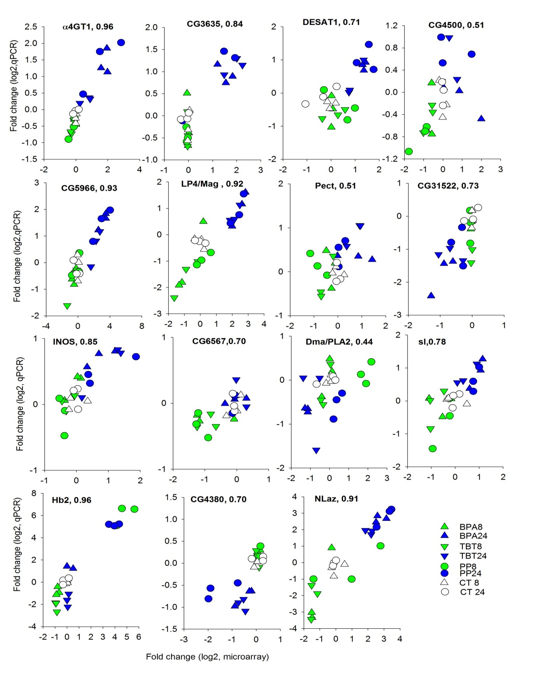

Fig S1. qPCR validation of microarray transcriptomic results for 15 selected de-regulated genes. Results are reported as log 2 normalized transcriptomic responses relative to the respective control time. Each symbol is a single observation. Numbers following gene name are Pearson correlation coefficients. All correlations were significant P<0.05.



Fig S2. Box plots of qPCR transcription patterns across treatments and time points of HR96. Data have been scaled to its time control.

Venn diagram.pdf

Fig S3. First two components of the medoid cluster analysis. Red, green and blue symbols represent genes belonging, respectively, to clusters A, B and C.

Figure S4. Transcription patterns across treatments and time points (Mean SE, N=3) of differentially transcribed genes (DEGs) belonging to the glycerolipid (A), fatty acid (B) , phosphoinositol (C) and glycerophospholipid (D) KEGG signalling pathways. Data has been scaled to its time control. Genes belonging to clusters A, B and C are depicted, respectively, in red, green and blue



Figure S5. Box plots of transcription patterns across treatments and time points of selected differentially transcribed genes (DEGs) belonging to clusters A, B, C and to KEGG or DAVID functional categories related to lipid metabolic signalling pathways. Data has been scaled to its time control.

TABLES

Table S1. Total number of genes and those present in the microarray and de-regulated (DE) belonging to the major KEGG pathways of lipid metabolism. The inositol phosphate metabolism is also included. The coverage (Cv) of the microarray respect to the total and that of the DE relative of the microarray are also reported.

|  |  |  |  |  |  |  |
| --- | --- | --- | --- | --- | --- | --- |
|  |  | Total | Array | | DE | |
| Code | Name | Genes | Genes | Cv (%) | Genes | Cv (%) |
| Lipid metabolism | |  |  |  |  |  |
| ec00564 | Glycerophospholipid metabolism | 110 | 73 | 66.4 | 5 | 6.8 |
| ec00561 | Glycerolipid metabolism | 86 | 58 | 67.4 | 15 | 25.9 |
| ec01212 | Fatty acid metabolism | 79 | 50 | 63.3 | 18 | 36 |
| ec00071 | Fatty acid degradation | 58 | 53 | 91.4 | 16 | 30.2 |
| ec00590 | Arachidonic acid metabolism | 44 | 31 | 70.5 | 3 | 9.7 |
| ec00600 | Sphingolipid metabolism | 41 | 26 | 63.4 | 3 | 11.5 |
| ec00061 | Fatty acid biosynthesis | 33 | 16 | 48.5 | 3 | 18.8 |
| ec01040 | Biosynthesis of unsaturated fatty acids | 32 | 10 | 31.3 | 2 | 20 |
| ec00072 | Synthesis and degradation of ketone bodies | 32 | 10 | 31.3 | 1 | 10 |
| ec00100 | Steroid biosynthesis | 31 | 9 | 29.0 | 3 | 33.3 |
| ec00565 | Ether lipid metabolism | 30 | 22 | 73.3 | 3 | 13.6 |
| ec00062 | Fatty acid elongation | 25 | 14 | 56.0 | 5 | 35.7 |
| ec00592 | alpha-Linolenic acid metabolism | 25 | 16 | 64.0 | 8 | 50 |
| ec00591 | Linoleic acid metabolism | 25 | 14 | 56.0 | 3 | 21.4 |
| Carbohydrate metabolism | |  |  |  |  |  |
| ec00562 | Inositol phosphate metabolism | 74 | 45 | 60.8 | 9 | 20 |

Table S2. Primer pairs designed from existing sequences used for amplification of selected *D. magna* partial gene sequences.

|  |  |  |  |  |  |
| --- | --- | --- | --- | --- | --- |
| **Official gene symbol** | **Name/function** | **Acc. Number** | **Forward** | **Reverse** | **Amplicon size (bp)** |
| ALPHA4GT1 | α1,4-galactosyltransferase1 | KZS12650.1 | GCACCGACTCATCGACGAA | CGTGCCACATGTAATCGTCC | 71 |
| CG31522 | Fatty acid elongase | KZS21395 | ACTGAGCCAGCCGAAACG | CAGCCTTCAAACTACGCGGA | 101 |
| CG3635 | Putative lipase 3 | KZS16640.1 | CTGGCTTCTGACTCAACTTGGA | GGAAATCTCCGTGGTTGTAAGTTT | 71 |
| CG4500 | Fatty-acid-CoA ligase | KZS06643 | CAATACGACACGAGAACGCCTA | CGGCATCAGTTCATTCTCTTGAT | 71 |
| CG5966 | Triacylglycerol lipase | KZS12532 | GTTGACCAATGATACGGTGACG | GATTTGCTAGATCCCAGTTGCTTT | 81 |
| CG6567 | Lysophospholipase | KZS14236 | AATGGGAGTTTCCGTGTTGC | GGTGTTGTGGCTCTGTCTTGC | 81 |
| DESAT1 | Desaturase | KZS17645.1 | GTTTGCAAGGGCCGTATTCA | ACGGGAAACGATAAGGAAATTTC | 71 |
| G3PDH | HK glyceraldehyde-3-phosphate dehydrogenase | AJ292555 | GACCATTACGCTGCTGAATACG | CCTTTGCTGACGCCGATAGG | 100 |
| HB2 | Hemoglobin 2 | AB021136 | CCCAGGTTCTTTTCCGCCTTC | CGGATTGAGGAACATCGGC | 81 |
| HR96 | Hormone receptor-like in 96 (but characterized) | JAM35624 | CTTCCGTTAATGGTGCCAGG | ATTGTCACCCGTACGCAC |  |
| INOS | Myo-inositol-1-phosphate synthase | KZS15705 | CGTGACGTGCAGTAATCGTAATC | GACTAAATTCCAAGTTGACAGCCC | 81 |
| LIP4 | Gastric triacylglycerol lipase | KZS21232.1 | TGTTCAAGTAACTCGAGAGGAAACG | CTTCTTGCTTTCTACCATTAAAACACA | 71 |
| NLAZ | Neural Lazarillo | KZS14940.1 | TCTATAGACACCATAAAAGTTTGGCAA | CACTTTCCCACTTTAAACTAAAACGA | 71 |
| Pect | Phosphocholine/ethanolamine cytidylyltransferase | KZS13222 | ATGAGCAGGCAGTTGCAGCT | TGCCTGTATCATTTTGGGCC | 81 |
| PLA2 | Phospholipase A2 | KZS08312. | TGCTCGTCGTCGTTCTTCG | TCCCTGTCGTTGTTGGCTG | 81 |
| RXR | Retinoid X Receptor | DQ530508 | GTGTCGAGTGCAAGGACGAG | CCCATTCAACCAACTGGAAAA | 100 |
| SL | Small wing; 1-phosphatidylinositol-4,5-bisphosphate phosphodiesterase | KZS14804 | TCGACCAGCCTATACCACAGC | CGCCTGTGTTTTGGTAGGATG | 71 |

Table S3. De-regulated *D. magna* genes homologous to *D. melanogaster* involved in lipid and related metabolic signaling pathways.

|  |  |  |  |  |  |  |
| --- | --- | --- | --- | --- | --- | --- |
| **Official gene symbol** | **Drosophila Accession Number**  **/Dapma7 geneID** | | **Gene Name/Description** | | **KEGG/GO** | |
| Brn | AAF45918 | | Brainiac, Beta-1,3-galactosyltransferase | | GlySL | |
| C1GalTA | NP_609258 | | Core 1 Galactosyltransferase A | | GlyL | |
| CDase | NP_651797 | | Ceramidase | | SL | |
| CG10849 | AAF47807 | | Very-long-chain enoyl-CoA reductase | | SD | |
| CG11162 | AAF48301.1 | | Fatty acid hydroxylase | | FA | |
| CG12262 | NP_648149 | | Acyl-CoA dehydrogenase | | FAβOx | |
| CG13282 | AAF53578 | | Triacylglycerol lipase | | LC | |
| CG1632 | NP_572467 | | Low-density lipoprotein | | LDL | |
| CG31522 | NP_730841 | | Fatty acid elongase | | FA | |
| CG33671 | NP_001027412 | | Mevalonate kinase | | TB | |
| CG3635 | NP_610138 | | Putative lipase 3 | | LC | |
| CG3699 | NP_569875 | | Acyl-CoA dehydrogenase | | FAβOx | |
| CG4380 (RXR) | NP_476781 | | Retinoid X receptor | | TG | |
| CG4500 | NP_609696 | | Fatty-acid-CoA ligase | | FA | |
| **CG5966** | NP_001284922 | | Triacylglycerol lipase | | GL | |
| CG6472 | NP_611166 | | Triacylglycerol lipase | | LC | |
| CG6567 | AAF54564 | | Lysophospholipase | | GPL | |
| **CG6847** | NP_573259 | | Triacylglycerol lipase | | GL, GPL | |
| ChLD3 | NP_609806 | | ChLD3-Low density lipoprotein | | LDL | |
| CRAT | NP_649650 | | Carnitine O-Acetyl-Transferase | | FaβOx | |
| Dark | NP_725637 | | Death-associated APAF1-related killer | | TG | |
| DESAT1 | NP_652731 | | Desaturase | | TG | |
| **Dma/LPGAT** | | Dapma7bEVm006286 | | Acyl-CoA:lysophosphatidylglycerol acyltransferase | | GPL | |
| **Dma/PLA2** | | Dapma7bEVm011274 | | Phospholipase A2 | | GPL | |
| Glaz | AAF58418 | | Glial Lazarillo | | LC | |
| HR96 | NP_524493 | | Hormone receptor-like in 96 (but characterized) | | TG | |
| Inos | NP_477405 | | Myo-inositol-1-phosphate synthase | | IP, TB | |
| **LIP4, Mag** | NP_001188785, NP_649229 | | Magro (Gastric triacylglycerol lipase), Sterol esterase | | GL, SB | |
| LRP1 | NP_788284 | | LDL receptor protein 1 | | LDL | |
| Mcr | AAF52601 | | Macroglobulin complement-related | | LDL | |
| MGL | NP_001096924 | | Megalin | | LDL | |
| NLaz | NP_001259867 | | Neural Lazarillo | | TG, LC | |
| norpA | NP_525069 | | No receptor potencial A, Phosphatidylinositol phospholipase C activity | | IP | |
| Pect | NP_723790 | | Phosphocholine/ethanolamine cytidylyltransferase | | GPL | |
| Pi3K21B | NP_001259815 | | Phosphatidylinositol 3-kinase | | IP | |
| Sc2 | AAF47807 | | 3-oxo-5-alpha-steroid 4-dehydrogenase | | SB | |
| SERCA | AAF47102 | | Sarco/endoplasmic reticulum Ca(2+)-ATPase | | FAβOx | |
| Sl | NP_476726 | | Small wing; 1-phosphatidylinositol-4,5-bisphosphate phosphodiesterase | | IP | |
| Teq | NP_001163393 | | Tequila-Low density Lipoprotein | | LDL | |
| **Thiolase** | AAF47083 | | Acetyl-CoA -acyltransferase | | FA, TB | |
| TROL | NP_001245496 | | Terribly reduced optic lobes-Low density Lipoprotein | | LDL | |
| α4GT1 | NP_608737 | | α1,4-galactosyltransferase 1 | | GlySL | |
| β4GalNAcTB | AAF56843 | | β1,4-N-acetylgalactosaminyltransferase B | | GlySL | |
| **CG4729** | AAF4947**3** | | Acylglycerol-3-phosphate O-acyltransferase 4 | | GLP | |
| CdsA | AAF50483 | | CDP-diacylglycerol synthase | | GLP | |
| **CG8552** | NP_609185 | | Triglyceride lipase | | GL | |

FA, fatty acid metabolism (ec0061, ec00062, ec00071, ec00592, ec01040); FAβOx, GO:0006635~fatty acid beta-oxidation; GL, Glycerolipid metabolism (ec00561); GLP, Glycerophospholipid metabolism (ec00564); GlySL, GO:0006688~glycosphingolipid biosynthetic process; IP, Inositol phosphate metabolism (ec00562); LC, GO:0016042~lipid catabolic process; LDL, IPR002172:Low-density lipoprotein (LDL) receptor class A; SB, Steroid biosynthesis  (ec00100 ); SD, Steroid degradation (ec00984); SL, Sphingolipid metabolism (ec00600 ); TB, Terpenoid backbone biosynthesis (ec00900); TG, GO:0070328~triglyceride homeostasis. Bold gene names belong to de novo synthesis pathway of neutral lipids according to Pol et al. (2014).

Table S4. Non de-regulated genes present in the microarray belonging to the lipid droplet-based storage fat metabolism in *Drosophila sensu* Pol et al. (2014).

|  |  |  |  |
| --- | --- | --- | --- |
| Official Drosophila gene symbol | Dapma7 geneID | Probe | Gene description |
| CG4920 | Dapma7bEVm004832 | CUST_1748_PI429715507 | Ethanolamine kinase |
| Bbc | Dapma7bEVm000746 | CUST_73232_PI429715507 | CDP-ethanolamine phosphotransferase |
| CG5508 | Dapma7bEVm001798 | CUST_133998_PI429715507 | glycerol-3- phosphate acyltransferase 1 or 2 (GPAT1 or 2) |
| CG3209 | Dapma7bEVm015513 | CUST_156291_PI429715507 | glycerol-3- phosphate acyltransferase 3 (GPAT 3) |
| Fu12/CG3812 | Dapma7bEVm005324 | CUST_27420_PI429715507 | 1-acyl-sn-glycerol-3-phosphate *O* –acyltransferases (AGPAT 1,2) |
| CG4729/CG4753 | Dapma7bEVm006286 | CUST_64377_PI429715507 | 1-acyl-sn-glycerol-3-phosphate *O* –acyltransferases (AGPAT 3,4) |
| CG8709 | Dapma7bEVm000171 | CUST_132216_PI429715507 | Mg 2+ -dependent PA phosphatase (lipin) |
| midway | Dapma7bEVm001874 | CUST_139290_PI429715507 | diacylglycerol *O* –acyltransferase (DGAT1) |
| CG1941/GC1942/GC1946 | Dapma7bEVm004344 | CUST_133645_PI429715507 | Di or mono- acylglycerol *O* –acyltransferases (DGAT or MGAT) |
| Brummer | Dapma7bEVm003238 | CUST_1139_PI429715507 | Brummer lipase |
| CG11055 | Dapma7bEVm005082 | CUST_45471_PI429715507 | Hormone-sensitive lipase |
| Lsd-1, Lsd-2 | Dapma7bEVm009909 | CUST_143643_PI429715507 | Perilipin family of Lipid droplet associated proteins |