Supplementary material

**Antibiotic Resistance Gene distribution in agricultural fields and crops. A soil-to-food analysis**

Francisco Cerqueira1, Víctor Matamoros1, Josep M. Bayona1, Thomas U. Berendonk2, Goffe Elsinga3, Luc M. Hornstra3, Benjamin Piña1,*

1) Department of Environmental Chemistry, IDAEA-CSIC, c/Jordi Girona, 18-26, 08034 Barcelona, Spain

2) [Department of Hydrosciences](https://www.researchgate.net/profile/institution/Technische_Universitaet_Dresden/department/Fachrichtung_Hydrowissenschaften), [Technische Universität Dresden](https://www.researchgate.net/profile/institution/Technische_Universitaet_Dresden), Dresden, Germany

3)KWR Watercycle Research Institute, Groningenhaven 7, 3433 PE, Nieuwegein, the Netherlands

*) Corresponding author: [bpcbmc@cid.csic.es](mailto:bpcbmc@cid.csic.es)



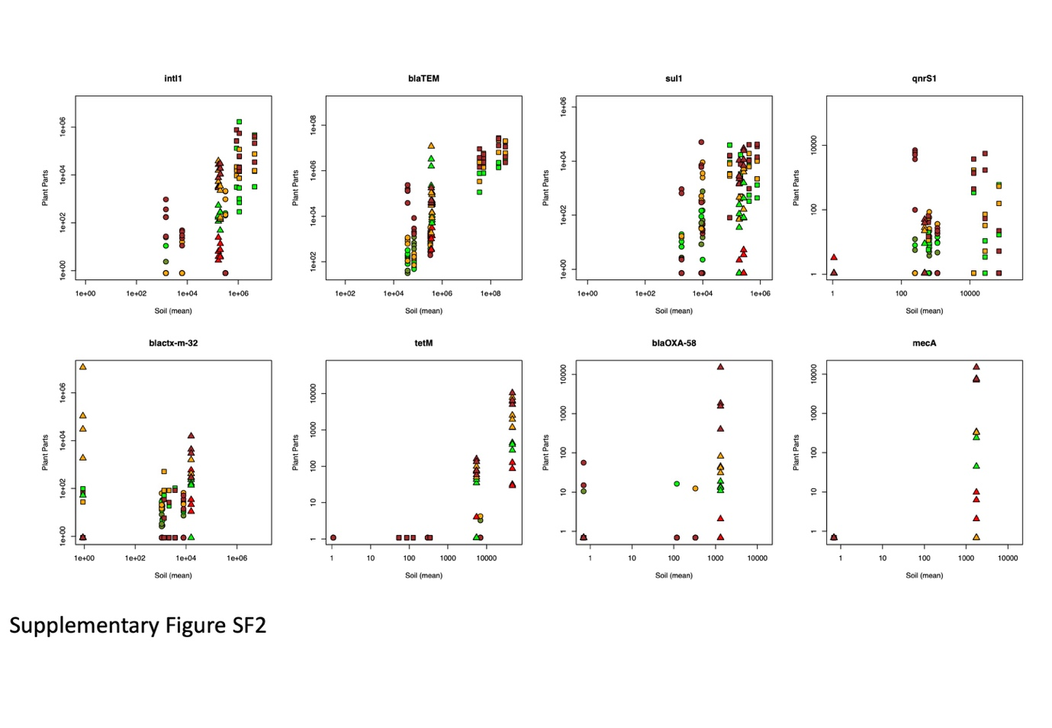

Correlations between ARG abundance in the different plant parts (Y-axis) and in the soil samples from the same plots (X-axis). Values are represented as copies per gram of sample. Soil abundances represent averages from four (Tomatoes and beans plots) or five (lettuces plots) samples, taken in the vicinity of the sampled plants. Circles, squares and triangles represent data from beans, lettuces and tomatoes, respectively; brown, orange, green, dark green and red symbols correspond to rhizospheric soil, roots, leaves, beans and tomatoes, respectively.

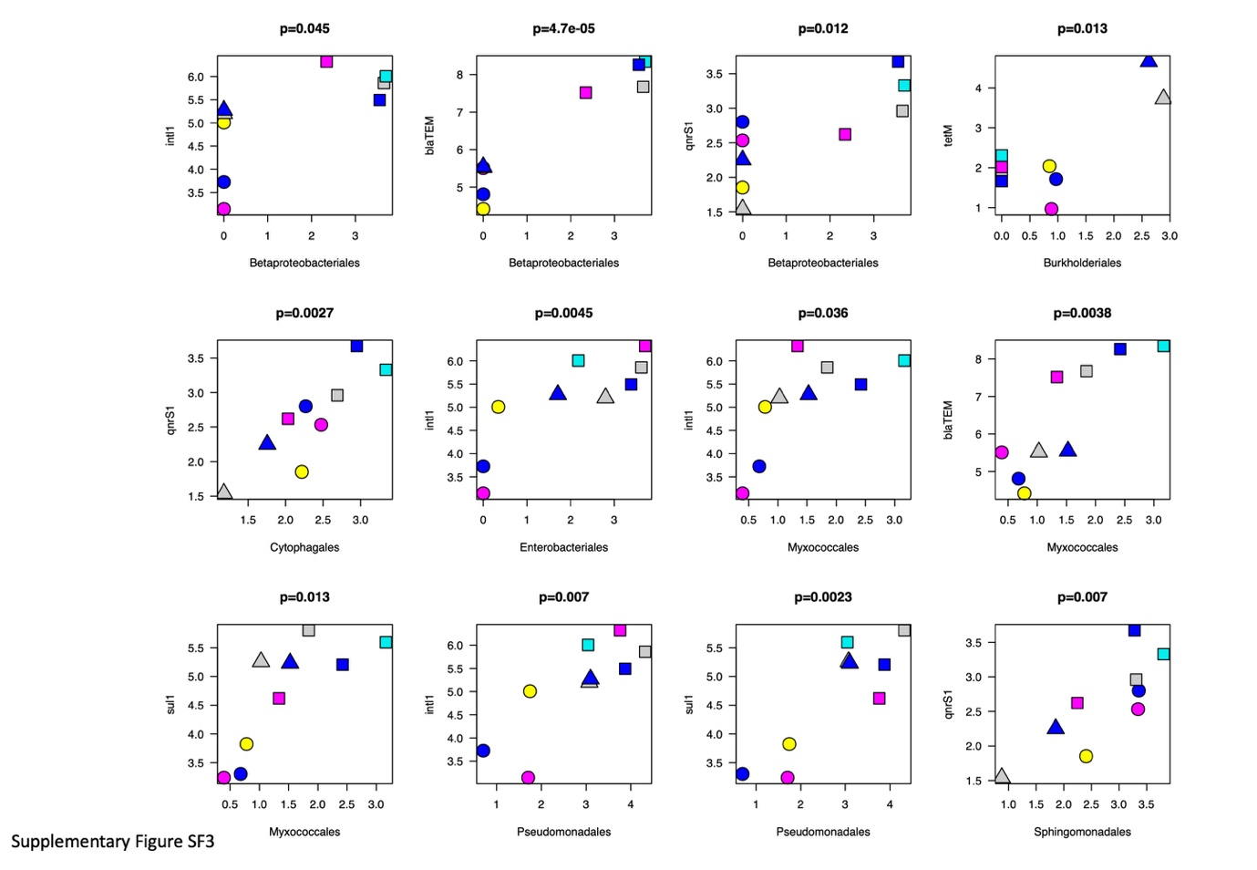

Correlations between the prevalence of different bacterial groups (at the taxonomic Order level, X-axis, log values of total counts) and the abundance of different ARGs or *intl1* (Y-axis, copies per gram of sample) in soil samples. Data are represented as averaged values form all samples from each plot, log-transformed. Circles, squares and triangles represent data from beans, lettuces and tomatoes, respectively. Grey, cyan, blue, magenta and yellow symbols correspond to samples from Z1, Z2, Z3, Z4, and Z5, respectively. Pearson's correlation *p*-values are represented at the top of each graph.

Supplementary Table ST1

Minimum, maximum and average levels of quality parameters measured in the waters used for sampling fields’ irrigation. Adapted from Margenat et al., 2017.

|  |  |  |  |  |
| --- | --- | --- | --- | --- |
|  | Z1 | Z2 | Z3 | Z4 |
| Conductivity (μS cm−1) | (968–1211) 1049 | (1490–2148) 1944 | (1255–1707) 1482 | (1272–2370) 1663 |
| NH4+–N(mg L−1) | (0.002–0.167) 0.05 | (3–47) 14 | (0.1–0.6) 0.2 | (0.1–12.8) 4.2 |
| Nitrates (mg L−1) | (2.8–4.6) 3.9 | (3.4–7.4) 5.4 | (1.5–2.5) 2.0 | (4–175) 55 |
| Total Phosphorous (mg L−1) | (0.03–3.0) 0.6 | (0.6–2.5) 1.5 | (0.2–0.7) 0.3 | (0.6–6.2) 2.5 |
| Total suspended solids (mg L−1) | (10–55) 21 | (14–94) 46 | (13–90) 63 | (2–40) 18 |
| pH | (7.5–8.6) 8.1 | (7.7–8.1) 7.9 | (6.7–8.6) 8.1 | (6.8–7.8) 7.4 |

|  |  |  |  |  |
| --- | --- | --- | --- | --- |
| Supplementary Table ST2. Statistics of soil sample microbiome sequencing | | | | |
|  | Number of OTUs | Median Sequencing Depth | Minimum number of sequences in a sample | Maximum number of Sequences in a Sample |
| Lettuces | 4165 | 243,095 | 141,607 | 301,036 |
| Tomato | 840 | 168,507 | 119,344 | 202,409 |
| Broad Beans | 588 | 19,047 | 3,607 | 56,524 |

|  |  |  |  |  |  |  |  |
| --- | --- | --- | --- | --- | --- | --- | --- |
| Supplementary Table ST3. Statistical analysis of ARG and intI1 abundances in soil samples from the three crops analysed in this work | | | | | | | |
|  | Copies per g of soil (1) | | | | |  |  |
| Gene | Broad Beans | | Lettuce | | Tomato | | *p* value(2) |
| *intl*1 | 1.06E+05 | b | 1.85E+06 | a | 1.80E+05 | b | 0.002 |
| *bla*TEM | 1.44E+05 | b | 1.75E+08 | a | 3.69E+05 | b | 3.56E-05 |
| *sul*1 | 6898 | b | 3.68E+05 | a | 2.25E+05 | a | 9.46E-06 |
| *qnrS*1 | 676 | a | 2.79E+04 | a | 239 |  | 0.067 |
| *bla*ctx-m-32 | 3403 |  | 1802 |  | 7943 |  | 0.757 |
| *tet*M | 2410 | b | 153 | b | 2.59E+04 | a | 0.001 |
| *bla*OXA-58 | 149 |  | 1 |  | 657 |  | NA |
| *mec*A | 1 |  | 1 |  | 879 |  | NA |
| (1) Average values. Small-case letters indicate statistically different subsets of data (ANOVA+Tukey's B) | | | | | | | |
| (2) ANOVA, square-root transformed values. NA indicates that the structure of data was not adequate for the test | | | | | | | |