Ultrafine particles and PM_{2.5} in the air of cities around the world: Are they representative of each other?

1. Instrumentation

PNCs were measured using various instruments. A Condensation Particle Counter (CPC) has been commonly used to measure the total ambient PNC. This instrument uses laser scattering to detect and count particles after enlarging them by condensation of a liquid on their surfaces. Different models mean different concentration range windows (cut-offs) of this instrument. CPCs can be stand-alone counters or integrated in a sizing system such as SMPS (Scanning Mobility Particle Sizer) and DMPS (Differential Mobility Particle Sizer), if size distribution is of interest. Both SMPS and DMPS classify the aerosols according to electrical mobility; SMPS does the voltage scanning continuously while DMPS does it stepwise. A more recent particle sizer is the FMPS (Fast Mobility Particle Sizer), which uses multiple electrometers for particle detection instead of a CPC.

PM_{2.5} was measured using four different types of instruments. One was the Dichotomous Tapered Element Oscillating Microbalance (TEOM) fitted with Filter Dynamics Measurement System (FDMS). TEOM collects and weighs the particles using a sensitive balance while the FDMS compensates for the loss of semi-volatile components from the collected particles. Another method used for particle mass measurement was based on optical light scattering (GRIMM instruments – Optical Particle Counter). The optical count is converted to mass distribution by an established density factor according to the US Environmental Protection Agency (EPA) Federal Reference Method (FRM). The Beta Attenuation Monitor (BAM), which collects particles on a filter tape and measures the reduction in beta rays travelling through the particles, was also a device used for PM_{2.5} measurements. Lastly, the Synchronized Hybrid Ambient Real-Time Particulate Monitor (SHARP) was used, which is an equivalent PM_{2.5} monitor utilising both light scattering photometry and beta attenuation.

- Effects of varying size window to PNC

Table 1. Particle number concentration (particles.cm⁻³) of varying upper size range. Numbers in brackets indicate the percentage of the total value of PNC, considered to be the largest range.
Particle size (nm) | Mean (%) | Median (%)
AUGSBURGª (hourly average from Oct 2012 – Sep 2013)
10–100 | 5882 (77.12) | 4465 (75.73)
10–800 | 7257 (95.15) | 5699 (96.67)
10–2000 | 7627 (100.0) | 5896 (100.0)
LOS ANGELES^{b} (hourly size distribution from Aug 2014 – Mar 2015)
13.6–101.8 | 6251 (85.13) | 4917 (86.78)
13.6–532.8 | 7331 (99.84) | 5661 (99.91)
13.6–736.5 | 7343 (100.0) | 5666 (100.0)
SHANGHAI^{c} (seasonal size distribution from Jan – Dec 2012 except spring data)
13.6–101.8 | 12952 (73.13) | NA
13.6–532.8 | 17640 (99.60) | NA
13.6–723 | 17698 (99.93) | NA
13.6–965 | 17707 (99.98) | NA
13.6–2458 | 17710 (100.0) | NA
Instruments used were ªTDMPS + APS, ^{b}SMPS/CPC TSI 3022 and ^{c}SMPS TSI 3936L87 + APS
Table 2. Particle number concentration (particles.cm⁻³) of varying lower size range. Numbers in brackets indicate the percentage of the total value of PNC, considered to be the largest range.
Particle size (nm) | Mean (%) | Median (%)
BRISBANE (hourly size distribution from Jul – Nov 2014)
9.5–445 | 5503 (100.0) | 3663 (100.0)
10.6–445 | 5479 (99.56) | 3654 (99.75)
11.8–445 | 5424 (98.56) | 3627 (99.02)
12.6–445 | 5374 (96.66) | 3600 (98.28)
13.6–445 | 5312 (96.53) | 3564 (97.30)
Instrument used was EC3071A/CPC3781

Note: hourly average means count for every hour in the given size range while hourly size distribution means count for every hour in a given size cut-off.

3. Factors affecting PNC and PM_{2.5} per city
As the investigated cities are located in different regions having distinct climate type, the variation in concentrations and trends among them is described and explained below.

Augsburg
AGB is a traffic influenced background site, located around 1 km north of the city centre. The nearest road with a density of approximately 500 vehicles.d⁻¹ is 110 m away then a major road (~1950 vehicles.d⁻¹) is just 152 m away. Thus, fresh and aged traffic emissions dominated the PNC while transported secondary (nitrate and sulphate) aerosols contributed to the PM_{2.5} (Gu et al., 2011). In a study done by Schäfer et al. (2014), although based on organic matter, meteorological influences are far more important than the role of the different emission sources in the PM_{2.5} of Augsburg; low temperature and high relative humidity drive both the primary and secondary pollutants together with wind speed and mixing layer height (MLH) (i.e. determined by wind direction). Nucleation was also observed but contribution was insignificant. In the diurnal plot, the observed high PNC (Fig. S1a) coincides with the morning rush traffic while the PM_{2.5} is relatively stable. The PM concentrations in the afternoon are lower due to a better atmospheric convection conditions.

High PNC is observed during late-spring (Fig. S2a), similar to the results reported by Cyrys et al. (2008), as AGB turned out to be at the downwind (south-westerly) of the major road during this season. No such effect is observed in the seasonal plot for PM_{2.5}, and that in fact PM_{2.5} is low during this time. Emissions from residential heating facilities is substantial to PM concentration in Augsburg especially at night time during the winter. Although minimum contribution to Augsburg’s ambient PM, additional source that may affect seasonal concentration is the long-range transported Sahara dust. Moulin et al. (1998) has discussed the mechanism how the dust can be transported northward (i.e. May – June towards the western basin and January to July towards the eastern basin) contributing significant amount of PM in the Mediterranean region and over long distances up to northern Europe. Although most of the particles are in the coarse mode, but since suspension is the mode of transport, it is expected to get finer with increasing distance from the source (Karanasiou et al., 2012).

Barcelona
BCN is one of the urban background stations in the city of Barcelona and is at 79 masl. Although a background station, the high PNC in BCN can be attributed to the dense road traffic emissions. The diurnal PNC plot showed that concentrations are high from 07:00 to 21:00 LT, with three peaks similar to the results of Reche et al. (2011). The morning and night time PNC peaks coincide with intense vehicular activities in the area while the midday peak can be attributed to NPF coinciding with the highest solar radiation activity and the shallow MLH brought about by the sea-breeze front that usually develops at 12:00 – 14:00 LT (Jorba et al., 2013). On the other hand, no distinct diurnal trend is observed for PM_{2.5}. The non-exhaust contribution from traffic is a significant source of PM_{2.5} in Barcelona, particularly resuspended road dust (about 2.2 µg.m⁻³ of PM_{2.5}, which is 15% of total traffic emissions), since the Western Mediterranean is a dry region (Amato et al., 2009). In addition, for PM_{2.5}, the port, which is about 6 km south-east of BCN contributes about 11 – 15%, mainly linked to primary emissions from fuel combustion and secondary aerosol formation (i.e. in particular secondary ammonium sulphate transported by the sea breeze after the reaction of SO₂/H₂SO₄ and NH₃, which is abundant in Barcelona) (Pérez et al., 2016).

Barcelona is situated in north-eastern Spain, on the Mediterranean coast with surrounding valleys and mountains, hence protected from the cold winds. However, the interaction of this topography with coastal circulations consequently lead to atmospheric layering causing polluted air masses to recirculate. Gangoiti et al. (2001) has provided a detailed study on wind patterns during the warm season (March – September) in the Western Mediterranean Basin; elevated concentration of O₃ originating regionally affects the whole metropolitan area. Spring and summer atmospheric conditions enhance NPF contributing to the high PNC in these seasons but not much variation for PM_{2.5} (Fig. S2a and Fig. S2b). Brines et al. (2014) has also reported the occurrence of both traffic tailpipe NPF and non-traffic NPF during autumn in BCN. The low PM concentrations in April can be attributed to higher wind velocities and more frequent precipitation while the reduced traffic emission due to annual summer vacation may have caused the low PM concentration in August (Pey et al., 2008). The PM_{2.5}, but especially PM_{2.5-10} concentration, may be affected by the Sahara dust episodes (as discussed above) that mostly occur during mid spring to early autumn (Forastiere et al., 2013). Nonetheless, it has been observed that the MLH progressively reduced with increasing intensity of dust outbreaks thus causing a progressive accumulation of anthropogenic pollutants and favouring the formation of new fine particles or specific relevant species likely from condensation of accumulated gaseous precursors on dust particles surface (Pandolfi et al., 2014).

Brisbane
Brisbane is hilly in the north-west, west, and south area with a coastline on the eastern region extending to the north and south, but the central business district (CBD) is a low-lying floodplain. At night time, the south-westerly drainage wind blows towards the city, then at day time, the north-easterly sea breeze occurs. This is the daily wind cycle throughout the year. Occasionally, when the gradient winds flow from the north-west, the combination with the south-westerlies delay the onset of the sea breeze causing recirculation of emissions in the city resulting to a photochemical smog event. (Morawska et al., 1998).

However, within the CBD, being situated at the curve of the Brisbane River, the general meteorological trend is the reversal of wind direction between the morning and afternoon. Thus, the morning PNC diurnal peak is due traffic emissions from the South East Freeway (aka M3 Pacific Motorway, which is <100 m away from BNE1). while the afternoon is a mixed emissions from the CBD (Mejía et al., 2007). Also, the higher midday PNC peak, can be attributed to NPF (Rahman et al., 2017). Further, the measured PM_{2.5} can also be linked to traffic emissions (non-exhaust) since BNE2 is a roadside station located at the boundary of major traffic corridors also adjacent to the South East Freeway. But for PM_{2.5}, secondary sulphate coming from a power plant is a major component (Friend & Ayoko, 2009). Aside from traffic and industrial emissions, aircrafts and ships also affect PM concentrations (Cheung, Morawska, & Ristovski, 2011). Both the Brisbane airport and port are located approximately 17 km NE of the city, thus emissions are carried by the sea breeze blowing towards the city. Given these conditions, not much variation was observed from the diurnal PM_{2.5} plot (Fig. S1b)

Similarly, seasonal PM_{2.5} did not vary much unlike PNC (Fig. S2a and Fig. S2b). Although, January (peak of summer) and July (peak of winter) showed high PM_{2.5} concentration. This can be explained by sea salts from the river and ocean carried by the strong winds from the Pacific Ocean during summer in addition to the above mentioned sources and the biomass burning as a land management practice in the nearby forest and agricultural areas during winter. The seasonal variability in PNC can also be attributed the prevailing winds and partly to local sources. From May to August, the high PNC in Brisbane is essentially due to the more stable continental air and in the absence of precipitation; pollutants can persist in longer times. Having a subtropical climate, though temperatures can go low during the cold months, not much building or home heating required but can still affect particle emissions.

Helsinki
The urban area of Helsinki has a fairly flat terrain adjacent to the Baltic Sea. Mäkelänkatu supersite station (HEL) is situated in a busy street canyon (28,000 vehicles.d⁻¹ on weekdays) around 6 km northeast of the city centre. UFP in Helsinki originate mainly from local traffic exhaust emissions and wood burning emissions during winter while PM_{2.5} concentrations are dominated by regionally and long-range transported aerosols (Pirjola et al., 2017; Soares et al., 2014). Being a street canyon, PM concentrations may vary significantly mainly based on wind direction due to the formation of wind vortices that influence dispersion (Dos Santos-Juusela et al., 2013). The obtained diurnal plot for PNC with two peak concentrations (Fig. S1a) agreed with those presented by Hussein et al. (2004) and Dos Santos-Juusela et al. (2013) especially on weekdays. However, the seasonal plot (Fig. S2a) is slightly different that the minimum concentration is observed in April (spring) and the maximum in October (autumn) which may be linked to prevailing wind direction and temperature during these months; aerosol particles from sources along the wind path may contribute while low ambient temperature is related to stable atmospheric stratification (Hussein et al., 2006). Although, the variation in concentration is essentially not apparent.

For PM_{2.5}, Karppinen et al. (2004) has estimated the transboundary air pollution in Helsinki to be >50%. Similarly, Vallius et al. (2003) and Pakkanen et al. (2001), reported same value for PM_{2.5} fraction originating from long-range transport then accounted around 30% for local traffic. The recent studies have shown that most important local sources affecting PM_{2.5} in the Helsinki centre are as follows: vehicle exhausts, street dust, wood burning emissions from suburban small house areas in winter as well as emissions from power and heat plants and harbors. Further, emissions from the power plants and the harbor, located in the downtown area may contribute to PM_{2.5} as well as particles originating from local street dust, are especially high in spring (March-May) when dusts accumulated in winter (icy, snowy and moist street surfaces) are released into the air when streets dry out. In winter, studded tires are commonly used (~80%) in cars and vans (i.e. light duty vehicles) and traction sand is also used to prevent slippery and to increase traffic safety. Although, not much change in concentration can be observed in the diurnal and seasonal PM_{2.5} plots (Fig. S1b and Fig. S2b), the trend is the same as the PNC. There is a slight increase in the morning, starting at 05:00 LT and sustained until midnight, similar to the plot presented by Hietikko et al. (2018) related to fresh and aged traffic emissions. PM_{2.5} are a little higher during the cold months, also comparable to PNC.

London
The city of London is situated along the River Thames, a relatively flat terrain surrounded by gently rolling hills. The predominant westerly winds with the frequent cold front and depression, movement of air masses are favoured with resulting rain. Episodes of exceedances are usually linked to transboundary pollution or when low wind speed occurs and an absence of the southerly vortex during peak traffic times (Charron, Harrison, & Quincey, 2007). LON1 is in a residential area with the nearest road in 5 m and 4 km to the west of Marylebone road, a busy six-lane road. Thus, contributions to PM_{2.5} are from wood smoke, vehicle emissions and secondary particles with some fresh sea salt fraction in summer (Crilley et al., 2017). However, road traffic is the major contributor to UFP in London, though NPF is also observed (i.e. with significant contribution during summer) and PNC is found to be correlated with BC and NO_{x} (Hofman et al., 2016; Reche et al., 2011). Emissions from shipping and coal combustion forming secondary inorganic aerosols contributed more to PM₁₀. The study of Ryall et al. (2002) has presented that England can also experience dust episodes via long range transport from the Sahara region. Although, this is true but it is a fairly rare occurrence (on average about once a year) and hence the effect on annual average concentrations is very small.

Both PNC and PM_{2.5} did not show much change in the diurnal plot, only a slight increase in PNC in the morning around 06:00 LT with the highest concentration around 20:00 LT. The observed fluctuations are due to traffic patterns (Reche et al., 2011). The seasonal variations in both PNC and PM_{2.5} agreed with the findings of Charron et al. (2007); high concentration during early spring/autumn and low concentration during early summer/winter due to air masses coming from the European mainland carrying PM load and meteorological conditions (e.g. temperature and MLH).

Los Angeles
Los Angeles is located in a coastal basin surrounded by mountain ranges experiencing frequent hot, dry and dusty days due to the Santa Ana winds. East of downtown Los Angeles is the Los Angeles River and a major Interstate freeway (I-110) including the entire Commuters Complex (four-level interchange connecting six freeways) is in the west. LA site is located a few kilometres south of downtown Los Angeles and about 150 m downwind of the I-110 (3790 LDV.h⁻¹ and 153 HDV.h⁻¹). Contributors to LA’s PM concentration include vehicle exhaust and non-exhaust emissions (both diesel and gasoline-powered), road dust, wood smoke and secondary aerosols (sulphates, nitrates and organics) (Schauer et al., 1996). According to Hasheminassab et al. (2014), the elevated PM_{2.5} in Los Angeles is mostly due to formation of secondary aerosols influenced by the area’s meteorological characteristics

Additionally, Sowlat, Hasheminassab, and Sioutas (2016) reported that wind speed in LA peaks at around 15:00 to 18:00 LT, hence the PNC and PM_{2.5} are low during these times based on the diurnal plots (Fig. S1a and Fig. S1b). Nucleation is a major contributor to the PNC of LA, especially in the early afternoon hours when O₃ concentration is high. The early morning peak in diurnal PNC coincides with traffic rush while the peak concentration in the diurnal PM_{2.5} in the late morning hours is due to secondary aerosols. The precursors of secondary aerosols, dominated by ammonium nitrate, ammonium sulphate and those forming secondary organic aerosol (SOA), come from major primary sources in the area, including traffic, LAX international airport (14 km away from LA), and the Ports of Los Angeles and Long Beach (30 km away from LA). Further, the PNC in winter could be attributed to vehicular emissions when temperature, wind speed and solar radiation were low, causing increased atmospheric stability and low MLH. For PM_{2.5}, vehicular emissions including non-exhaust in winter and aged sea salt in summer can also contribute (Hasheminassab et al., 2014; Saffari et al., 2015).

Milan
The largest urban area in Italy and being located in the north-western section of the Po valley, high PM concentration in Milan is predictable and meteorology has an impact on the diurnal and seasonal variability of PM concentration. The valley is enclosed by the Alps and the Apennines, two extensive mountain ranges, thus favours stagnant atmospheric conditions. This can explain why Milan, although classified as having a ‘marine west coast’ climate, the aerosol behaviour and chemistry typically resembles that of a continental; influenced greatly by local conditions and thermal inversions especially in winter. Based on the aerosol vertical profile reported by Curci et al. (2015), a plume of fresh emissions is dispersed in the morning, then an enhanced aerosol layer is formed in the upper mixing layer in the afternoon while the bottom part is cleansed by the mountain breeze in the evening. However, the daily wind pattern causes local circulation of the air within the valley leading to pollution build up. MIL, a background aerosol site, is located between two local roads, Viale dell’Innovazione and Via Roberto Cozzi. Viale dell’Innovazione is characterized by a total annual traffic of 4.2 million vehicles (480 vehicles.h⁻¹ with a peak of 870 vehicles.h⁻¹ during the morning rush hour) while Via Roberto Cozzi is characterized by a total annual traffic of 1.68 million vehicles (191 vehicles.h⁻¹ with a peak of 323 vehicles.h⁻¹ during the morning rush hour). Both account for <0.01% of the traffic vehicles circulating in the whole Milan municipality.

Further, secondary aerosol formation within the Po Valley is very imperative, as air masses from the Mediterranean Sea (occurring at midnight when northerly flow persist) are rich in sulphates. The high PM_{2.5} concentration in Milan is due mainly to local traffic (17 – 24%) as primary source with regional contribution from biomass burning (25 – 30%) during autumn and winter while secondary organic and inorganic aerosol (50 – 65%) during spring and summer. In autumn and winter, atmospheric stability with low mixing layer causes very high concentration at ground level while increased wind velocity and a broader mixing layer improves dispersion in summer. (Bernardoni et al., 2017; Carbone et al., 2010; Ferrero et al., 2010; Lonati et al., 2005; Perrone et al., 2012). The morning and night peak in the PNC diurnal pattern coincides with traffic and with low concentrations in the afternoon due to increased wind speed. On the other hand, no diurnal variation was observed for PM_{2.5}. For the seasonal variation, PNC and PM_{2.5} had a similar pattern (i.e. low concentration during late spring and early autumn) but the magnitude of increase was more prominent for PM_{2.5}.

Nanjing
Nanjing is situated in the lower region of the Yangtze River and NKG has been set-up mainly to measure the background air at the western end of the Yangtze River Delta. The station sits atop of a hill with 40 m elevation. Easterly winds prevail all year round. The nearest road is about 600 m from the station. However, as Nanjing is the most important gateway for the development of the central and western regions in China, air quality is continuously deteriorating due to urbanization and industrialization (An et al., 2015). Identified sources of PM_{2.5} were coal combustion, vehicular emissions, secondary organic and inorganic aerosols and road/sea salt (Yang et al., 2005).

The diurnal plots of the PNC and PM_{2.5} did not show much variation though concentration for both parameters are elevated. PNC started to increase at around 05:00 LT, the start time of the traffic hours. The most notable difference is that they had the opposite trend; from midnight until 05:00 LT, PNC is low while PM_{2.5} remained constant then from 12:00 to 18:00 LT, PM_{2.5} slightly decreased while PNC remained high. According to Nie et al. (2018), the decreased concentration in PM_{2.5} at noon is caused mainly by increased MLH and reduced anthropogenic emission. For the seasonal plots, both PNC and PM_{2.5} noticeably decreased during the summer possibly due to frequent precipitation. The high PNC during spring as explained by Zhu et al. (2013) is because of enhanced NPF (i.e. low aerosol surface area due to strong winds with increased solar radiation) while the high PM_{2.5} is due to the high contributions from soil and dust aerosols from local and long-range transport. In autumn and winter, the elevated PM_{2.5} as presented by Li et al. (2015) is due to biomass (straw) burning for harvest season in autumn and from small residential stoves for heating in winter. Moreover, winter has a more stable atmospheric condition (low wind speed and less precipitation), which promotes longer residence time for pollutants and enhance condensation of SOA.

Shanghai
Located in the Yangtze Delta, Shanghai, has a humid subtropical climate with no dry season; characterized by unpleasant hot summers with occasional thunderstorms and mild winters with precipitation. It is the largest city in the People’s Republic of China, equipped with two airports, operates the world’s fastest trains, has a huge network of highways and has the busiest port. SHA is located on the rooftop of a five-storey building (about 15 m above ground). An urban main road and a main overhead highway lie about 150 m to the south and 450 m to the east of the site, respectively. Although local sources also contribute significantly in the PNC and PM_{2.5}, the stable wind speed in Shanghai lessen the likelihood of accumulation. However, with the prevailing north-westerly, regional transport from the North China Plain (i.e. where the capital city, Beijing, is located) dominated the PM_{2.5} in Shanghai (Lv et al., 2017). The emissions from the Pearl River Delta characterized by high organic matter and from the seas having high SO₂⁴⁻ and NH₄⁺ are found to contribute to the high PM_{2.5} in Shanghai (Qiao et al., 2016).

Similar to Nanjing, the diurnal plots for both PNC and PM_{2.5} did not vary and with PNC peaks coinciding with traffic. However, the difference is that both parameters decreased in the afternoon around 12:00 to 16:00 LT. This is associated with daily variation of the MLH and anthropogenic emissions as mentioned above. The elevated PM_{2.5} even at night, similar to Nanjing, may be explained by the emissions from diesel truck traffic, which is only allowed at night time (Liu et al., 2018). For the seasonal, variability both PNC and PM_{2.5} were low during autumn (i.e. due to high frequency of precipitation in September) and high in winter (i.e. due to domestic heating and bad diffusion condition). The data for spring was not included in the analysis.

Toronto
Toronto is the largest and most populous city in Canada. Mostly flat to sloping terrain, the city of Toronto is along the north-western shore of Lake Ontario. The public transportation system in the downtown area includes subways, trams and buses. Summer in Toronto has low wind speeds compared to winter. YYZ is located in the downtown area, north of a four-lane major arterial roadway that experiences traffic volumes ranging from 16,000 to 25,000 vehicles.d⁻¹ but no major point source within 15 km. The PNC measurement was done 3 m above the ground while PM_{2.5} was approximately 20 m above the ground, on the rooftop of the station.
Combustion sources (industrial and transport) and secondary aerosols were the identified major sources for Toronto and both originated from the south and southwest part of Toronto (i.e. Pennsylvania, Indiana and Ohio where the largest coal-fired power plants are located for long-range transported secondary aerosols). Biomass burning for heating and road dust also contributed. Further, secondary sulphate was the dominant component for PM_{2.5} followed by secondary nitrate. The fluctuations in their concentrations gave the diurnal and seasonal variation. The temporal variation in the secondary nitrate concentration was well correlated with other emissions from traffic such as CO and VOCs suggesting association with gasoline and diesel combustion as source. Further, nitrate dominated the winter PM_{2.5} and sulphate for the rest of the year with summer concentration being higher than the winter concentration since formation was correlated with temperature (i.e. low temperature favoured secondary nitrate formation while high temperature drove secondary sulphate production). The high summer concentration was also affected by SOA. (Jeong et al., 2011; Lee et al., 2003; Tsai et al., 2004).
PM_{2.5} did not show a clear diurnal trend unlike the PNC in which concentration started to increase around 06:00 LT and this elevated concentration lasted until midnight due to emissions from cars at daytime and trucks at night time (Sabaliauskas et al., 2011). Further, the seasonality in the PNC and PM_{2.5} is similar; concentration is low during spring and high during winter. Although the changes in concentration are more prominent for PNC. This obtained trend coincides with those presented in studies mentioned earlier.

Table S1a. Pairwise Comparison of the Mean Difference and KS Test of the hourly PNC.
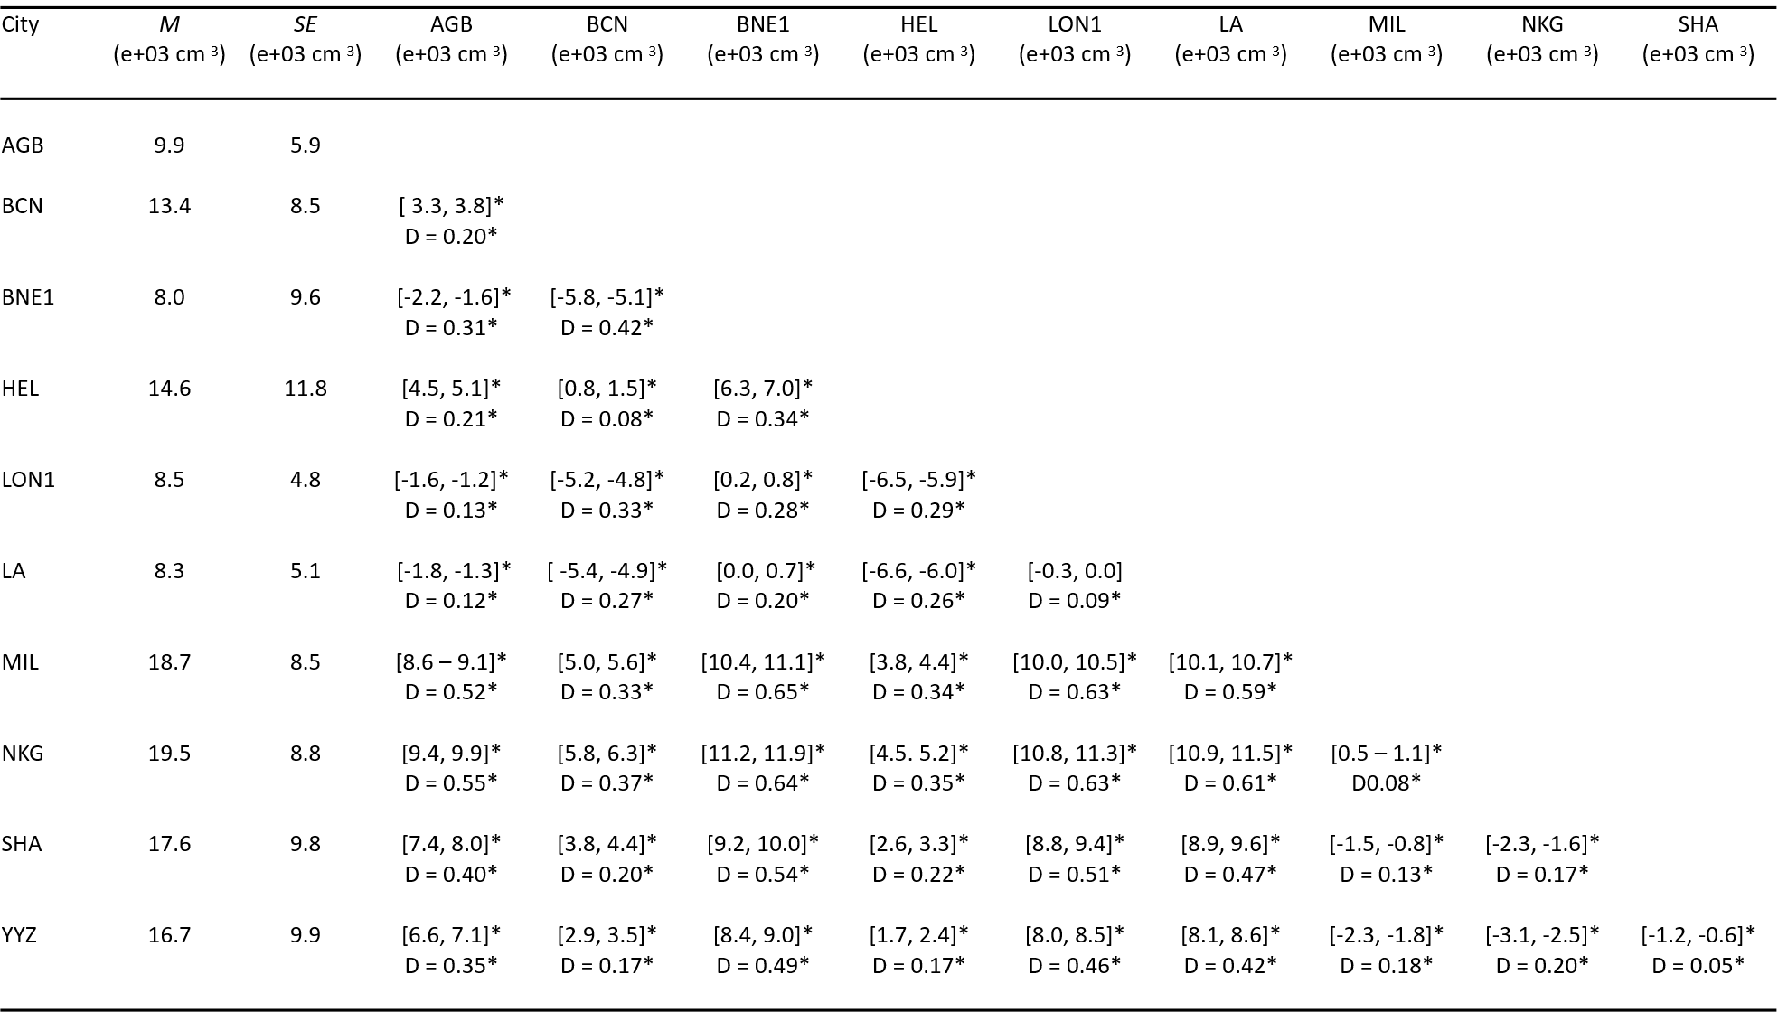
Note: M and SE are means and standard errors, respectively; Values in brackets indicate the 95% confidence interval of the mean difference after bootstrapping; D is the test statistic for the Kolmogorov-Smirnov; * indicates p<0.05 (bootstrapped p-value).
Table S1b. Pairwise Comparison of the Mean Difference and KS Test of the hourly PM_{2.5}.
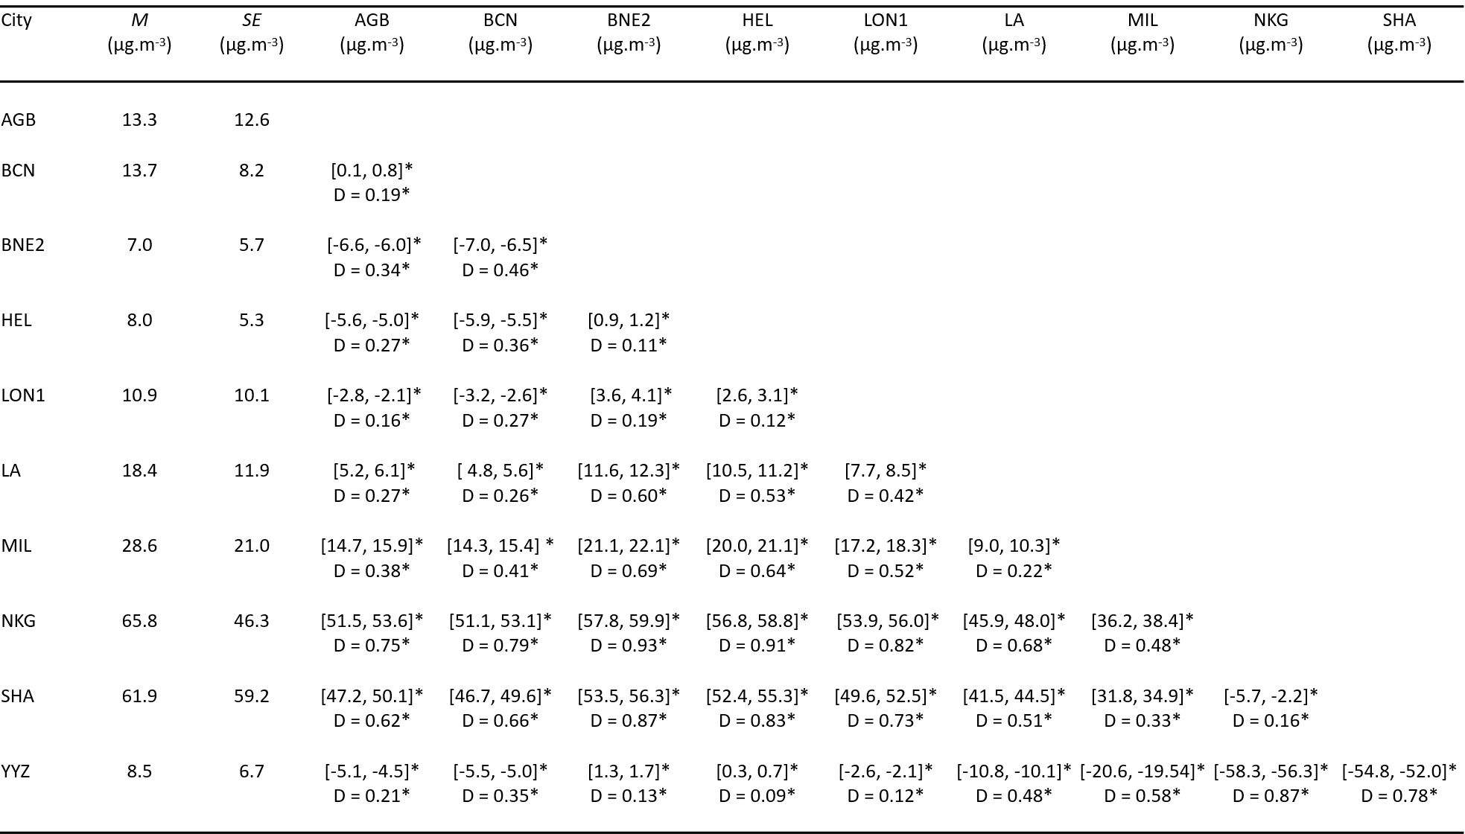
Note: M and SE are means and standard errors, respectively; Values in brackets indicate the 95% confidence interval of the mean difference after bootstrapping; D is the test statistic for the Kolmogorov-Smirnov; * indicates p<0.05 (bootstrapped p-value).

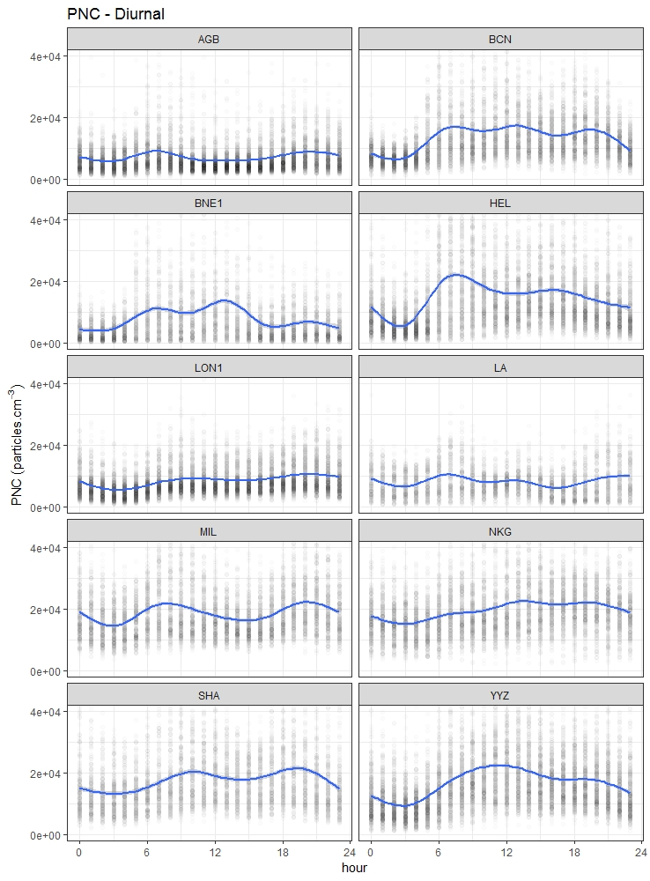
Figure S1a. Diurnal trend based on GAM for the hourly PNC.

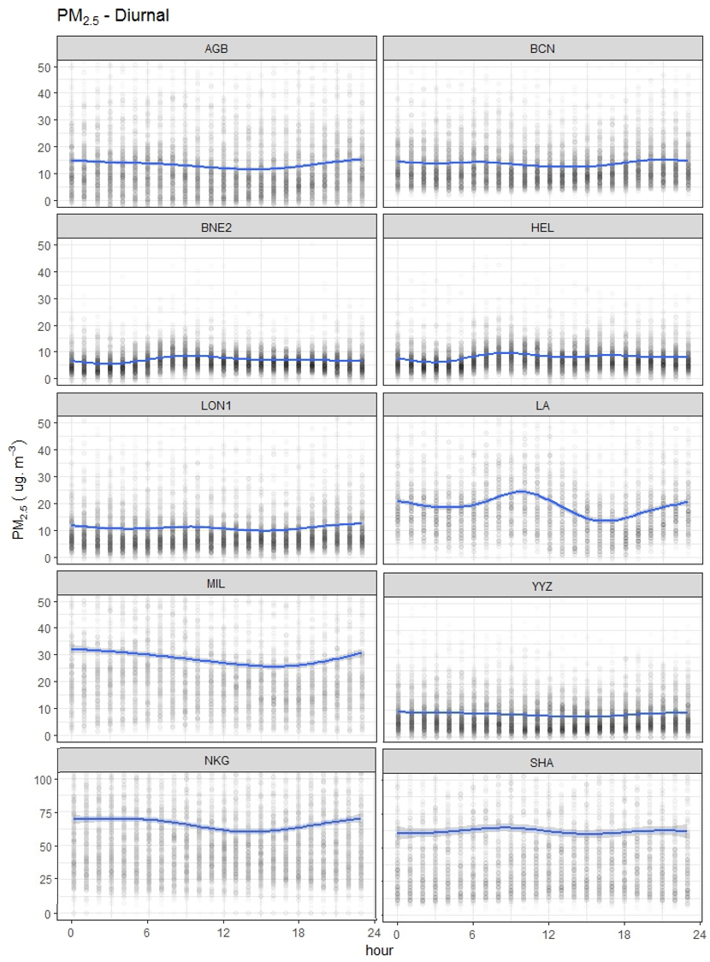
Note: Nanjing and Shanghai are presented on a different scale due to high concentrations.

Figure S1b. Diurnal trend based on GAM for the hourly PM_{2.5}

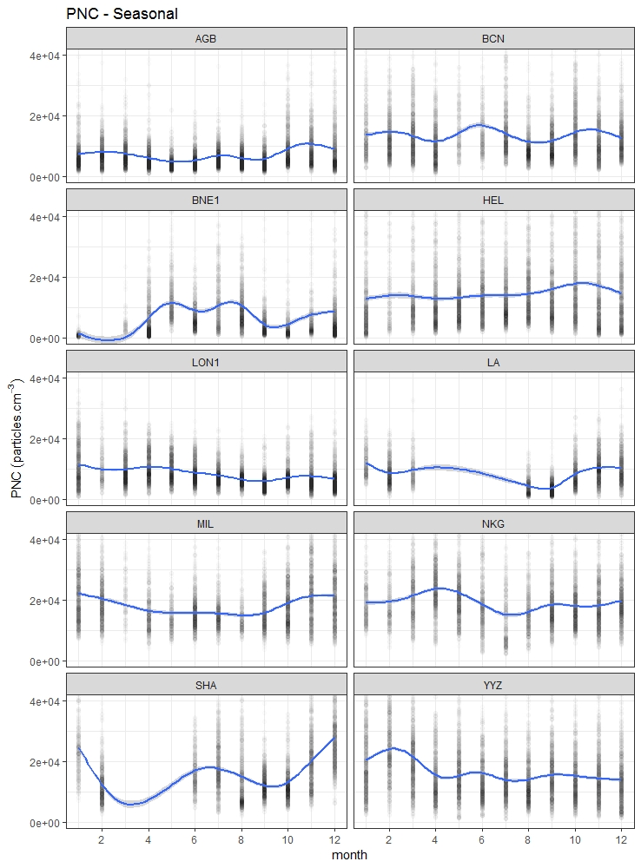
Figure S2a. Seasonal trend based on GAM for the hourly PNC.

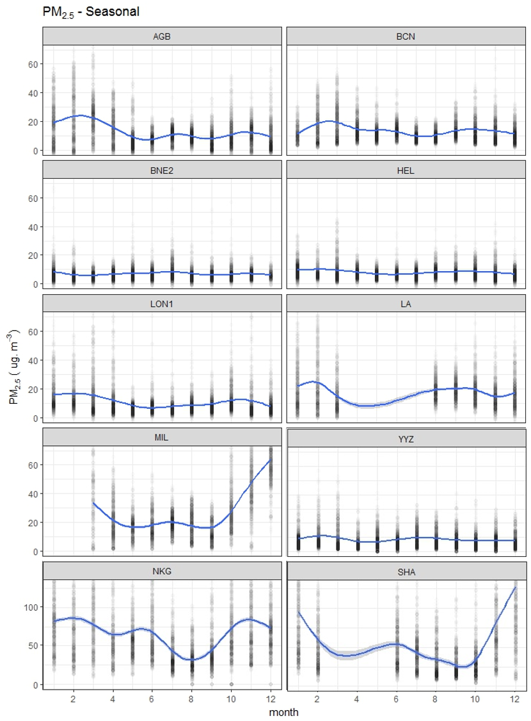
Note: Nanjing and Shanghai are presented on a different scale due to high concentrations.

Figure S2b. Seasonal trend based on GAM for the hourly PM_{2.5}.

Table S2. Particle number-to-mass concentration (PNC:PM_{2.5}) ratio of the annual medians.
City | PNC  (x 10³ particles.cm⁻³) |  | PM_{2.5}  (µg.m⁻³) |  | Ratio  (x 10⁹ particles.µg⁻¹)
 | median | IQR | median | IQR
AGB | 8.5 | 5.7 – 12.5 | 10.2 | 5.0 – 17.9 | 0.83
BCN | 11.3 | 7.6 – 16.9 | 11.6 | 8.1 – 17.2 | 0.97
BNE | 5.2 | 2.4 – 5.2 | 6.0 | 4.0 – 8.6 | 0.87
HEL | 11.2 | 6.5 – 19.0 | 6.9 | 4.8 – 10.1 | 1.6
LON | 7.2 | 5.2 – 10.5 | 7.8 | 5.0 – 12.8 | 0.92
LA | 7.3 | 4.4 – 11.2 | 16.0 | 10.0 – 24.0 | 0.46
MIL | 16.8 | 12.5 – 23.0 | 22.4 | 13.7 – 37.6 | 0.75
NKG | 18.2 | 13.5 – 24.2 | 53.9 | 34.5 – 83.2 | 0.34
SHA | 15.3 | 10.4 – 22.6 | 43.5 | 24.0 – 77.0 | 0.35
YYZ | 14.5 | 9.6 – 21.5 | 6.6 | 3.8 – 11.3 | 2.2

Table S3. Hourly PNC and PM_{2.5} Pearson’s Correlation (r) with bootstrapped p-value for all cities.
City | n | Raw data |  | Log transformed data
 |  | r | p | r | p
AGB | 6895 | 0.30 | 0.56 | 0.46 | 0.49
BCN | 6868 | 0.08 | 0.49 | 0.12 | 0.53
BNE | 4419 | 0.14 | 0.52 | 0.23 | 0.51
HEL | 7715 | 0.39 | 0.53 | 0.39 | 0.52
LON | 7990 | 0.35 | 0.49 | 0.35 | 0.52
LA | 3773 | 0.07 | 0.50 | 0.09 | 0.49
MIL | 4658 | 0.31 | 0.51 | 0.24 | 0.49
NKG | 6353 | 0.19 | 0.49 | 0.25 | 0.53
SHA | 5258 | 0.53 | 0.53 | 0.64 | 0.47
YYZ | 8592 | 0.16 | 0.49 | 0.24 | 0.50

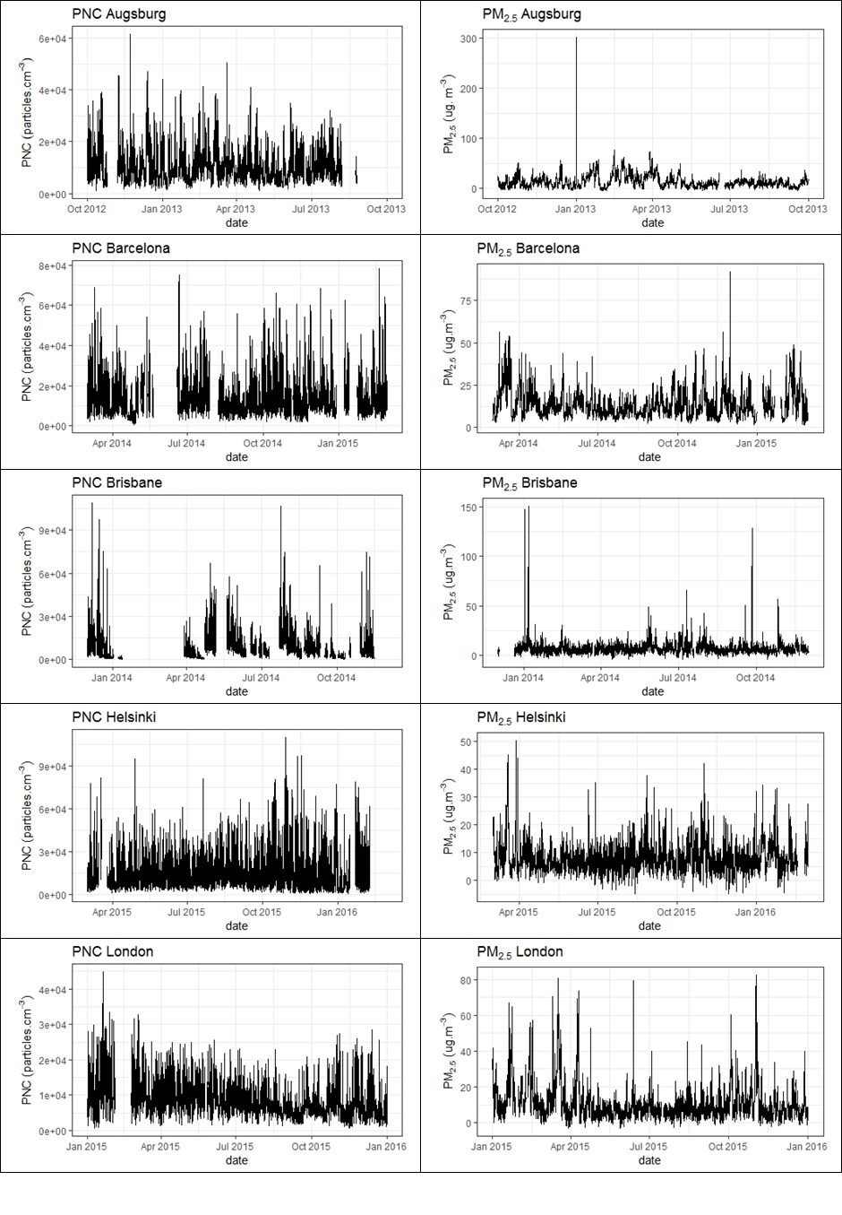
Note: Graphs are presented on different scales.

Figure S3. Time series of the hourly PNC and PM_{2.5} by city
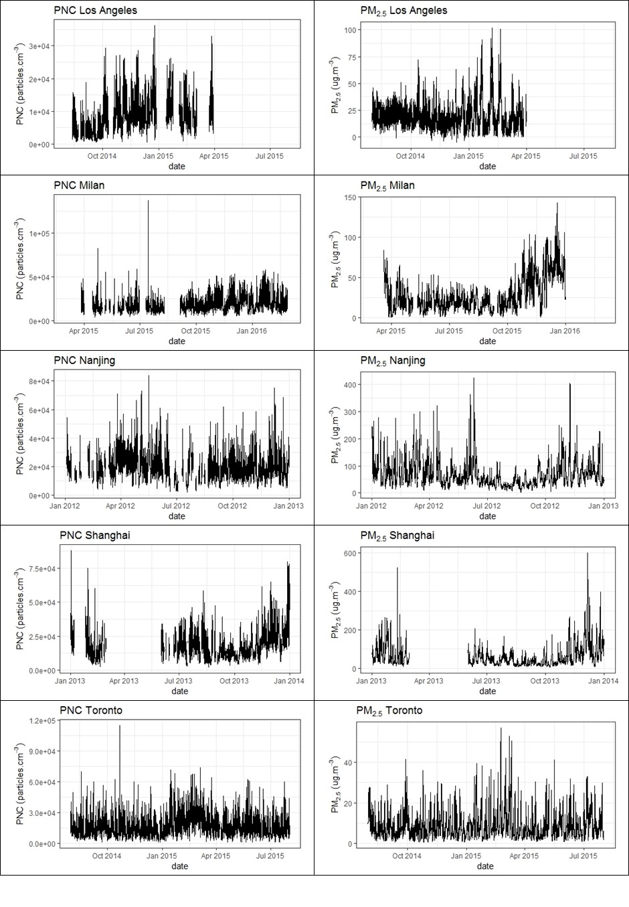
Note: Graphs are presented on different scales.

Figure S3. (Continued)

References
Amato, F., Pandolfi, M., Escrig, A., Querol, X., Alastuey, A., Pey, J., . . . Hopke, P. K. (2009). Quantifying road dust resuspension in urban environment by Multilinear Engine: A comparison with PMF2. Atmospheric Environment, 43(17), 2770-2780. doi:http://dx.doi.org/10.1016/j.atmosenv.2009.02.039
An, J., Duan, Q., Wang, H., Miao, Q., Shao, P., Wang, J., & Zou, J. (2015). Fine particulate pollution in the Nanjing northern suburb during summer: composition and sources. Environmental Monitoring and Assessment, 187(9), 561. doi:10.1007/s10661-015-4765-2
Bernardoni, V., Elser, M., Valli, G., Valentini, S., Bigi, A., Fermo, P., . . . Vecchi, R. (2017). Size-segregated aerosol in a hot-spot pollution urban area: Chemical composition and three-way source apportionment. Environmental Pollution, 231, 601-611. doi:https://doi.org/10.1016/j.envpol.2017.08.040
Brines, M., Dall'Osto, M., Beddows, D. C. S., Harrison, R. M., & Querol, X. (2014). Simplifying aerosol size distributions modes simultaneously detected at four monitoring sites during SAPUSS. Atmospheric Chemistry and Physics, 14(6), 2973-2986. doi:10.5194/acp-14-2973-2014
Carbone, C., Decesari, S., Mircea, M., Giulianelli, L., Finessi, E., Rinaldi, M., . . . Facchini, M. C. (2010). Size-resolved aerosol chemical composition over the Italian Peninsula during typical summer and winter conditions. Atmospheric Environment, 44(39), 5269-5278. doi:10.1016/j.atmosenv.2010.08.008
Charron, A., Harrison, R. M., & Quincey, P. (2007). What are the sources and conditions responsible for exceedences of the 24 h PM 10 limit value (50 μg m −3) at a heavily trafficked London site? Atmospheric Environment, 41(9), 1960-1975. doi:10.1016/j.atmosenv.2006.10.041
Cheung, H. C., Morawska, L., & Ristovski, Z. D. (2011). Observation of new particle formation in subtropical urban environment. Atmospheric Chemistry and Physics, 11(8), 3823.
Crilley, L. R., Lucarelli, F., Bloss, W. J., Harrison, R. M., Beddows, D. C., Calzolai, G., . . . Vecchi, R. (2017). Source apportionment of fine and coarse particles at a roadside and urban background site in London during the 2012 summer ClearfLo campaign. Environmental Pollution, 220, Part B, 766-778. doi:https://doi.org/10.1016/j.envpol.2016.06.002
Curci, G., Ferrero, L., Tuccella, P., Barnaba, F., Angelini, F., Bolzacchini, E., . . . Stocchi, P. (2015). How much is particulate matter near the ground influenced by upper-level processes within and above the PBL? A summertime case study in Milan (Italy) evidences the distinctive role of nitrate. Atmospheric Chemistry and Physics, 15(5), 2629-2649. doi:10.5194/acp-15-2629-2015
Cyrys, J., Pitz, M., Heinrich, J., Wichmann, H. E., & Peters, A. (2008). Spatial and temporal variation of particle number concentration in Augsburg, Germany. Science of The Total Environment, 401(1), 168-175. doi:10.1016/j.scitotenv.2008.03.043
Dos Santos-Juusela, V., Petäjä, T., Kousa, A., & Hämeri, K. (2013). Spatial-temporal variations of particle number concentrations between a busy street and the urban background. Atmospheric Environment, 79, 324-333. doi:10.1016/j.atmosenv.2013.05.077
Ferrero, L., Perrone, M. G., Petraccone, S., Sangiorgi, G., Ferrini, B. S., Porto, C. L., . . . Bolzacchini, E. (2010). Vertically-resolved particle size distribution within and above the mixing layer over the Milan metropolitan area. Atmospheric Chemistry and Physics, 10(8), 3915-3932. doi:10.5194/acp-10-3915-2010
Forastiere, F., Alastuey, A., Querol, X., Pey, J., & Stafoggia, M. (2013). African dust outbreaks over the Mediterranean Basin during 2001-2011: PM10 concentrations, phenomenology and trends, and its relation with synoptic and mesoscale meteorology. Atmospheric Chemistry and Physics, 13(3), 1395-1410. doi:10.5194/acp-13-1395-2013
Friend, A. J., & Ayoko, G. A. (2009). Multi-criteria ranking and source apportionment of fine particulate matter in Brisbane, Australia. Environmental Chemistry, 6(5), 398-406. doi:http://dx.doi.org/10.1071/EN09035
Gangoiti, G., Millán, M. M., Salvador, R., & Mantilla, E. (2001). Long-range transport and re-circulation of pollutants in the western Mediterranean during the project Regional Cycles of Air Pollution in the West-Central Mediterranean Area. Atmospheric Environment, 35(36), 6267-6276. doi:10.1016/S1352-2310(01)00440-X
Gu, J., Pitz, M., Schnelle-Kreis, J., Diemer, J., Reller, A., Zimmermann, R., . . . Cyrys, J. (2011). Source apportionment of ambient particles: Comparison of positive matrix factorization analysis applied to particle size distribution and chemical composition data. Atmospheric Environment, 45(10), 1849-1857. doi:http://dx.doi.org/10.1016/j.atmosenv.2011.01.009
Hasheminassab, S., Daher, N., Saffari, A., Wang, D., Ostro, B. D., & Sioutas, C. (2014). Spatial and temporal variability of sources of ambient fine particulate matter (PM2.5) in California. Atmospheric Chemistry and Physics, 14(22), 12085. doi:http://dx.doi.org/10.5194/acp-14-12085-2014
Hietikko, R., Kuuluvainen, H., Harrison, R. M., Portin, H., Timonen, H., Niemi, J. V., & Rönkkö, T. (2018). Diurnal variation of nanocluster aerosol concentrations and emission factors in a street canyon. Atmospheric Environment, 189, 98-106. doi:10.1016/j.atmosenv.2018.06.031
Hofman, J., Staelens, J., Cordell, R., Stroobants, C., Zikova, N., Hama, S. M. L., . . . Roekens, E. (2016). Ultrafine particles in four European urban environments: Results from a new continuous long-term monitoring network. Atmospheric Environment, 136, 68-81. doi:http://dx.doi.org/10.1016/j.atmosenv.2016.04.010
Hussein, T., Karppinen, A., Kukkonen, J., Härkönen, J., Aalto, P. P., Hämeri, K., . . . Kulmala, M. (2006). Meteorological dependence of size-fractionated number concentrations of urban aerosol particles. Atmospheric Environment, 40(8), 1427-1440. doi:10.1016/j.atmosenv.2005.10.061
Hussein, T., Puustinen, A., Aalto, P. P., Mäkelä, J. M., Hämeri, K., & Kulmala, M. (2004). Urban aerosol number size distributions. Atmospheric Chemistry and Physics, 4(2), 391-411. doi:10.5194/acp-4-391-2004
Jeong, C. H., McGuire, M. L., Herod, D., Dann, T., Dabek–Zlotorzynska, E., Wang, D., . . . Evans, G. (2011). Receptor model based identification of PM2.5 sources in Canadian cities. Atmospheric Pollution Research, 2(2), 158-171. doi:http://dx.doi.org/10.5094/APR.2011.021
Jorba, O., Pandolfi, M., Spada, M., Baldasano, J. M., Pey, J., Alastuey, A., . . . Querol, X. (2013). Overview of the meteorology and transport patterns during the DAURE field campaign and their impact to PM observations. Atmospheric Environment, 77(C), 607-620. doi:10.1016/j.atmosenv.2013.05.040
Karanasiou, A., Moreno, N., Moreno, T., Viana, M., de Leeuw, F., & Querol, X. (2012). Health effects from Sahara dust episodes in Europe: Literature review and research gaps. Environment International, 47, 107-114. doi:10.1016/j.envint.2012.06.012
Karppinen, A., Härkönen, J., Kukkonen, J., Aarnio, P., & Koskentalo, T. (2004). Statistical model for assessing the portion of fine particulate matter transported regionally and long range to urban air. Scandinavian Journal of Work, Environment & Health(2), 47-53.
Lee, P. K. H., Brook, J. R., Dabek-Zlotorzynska, E., & Mabury, S. A. (2003). Identification of the Major Sources Contributing to PM2.5 Observed in Toronto. Environmental Science & Technology, 37(21), 4831-4840. doi:10.1021/es026473i
Li, B., Zhang, J., Zhao, Y., Yuan, S., Zhao, Q., Shen, G., & Wu, H. (2015). Seasonal variation of urban carbonaceous aerosols in a typical city Nanjing in Yangtze River Delta, China. Atmospheric Environment, 106(C), 223-231. doi:10.1016/j.atmosenv.2015.01.064
Liu, Z., Gao, W., Yu, Y., Hu, B., Xin, J., Sun, Y., . . . Wang, Y. (2018). Characteristics of PM2.5 mass concentrations and chemical species in urban and background areas of China: emerging results from the CARE-China network. Atmos. Chem. Phys., 18, 8849 - 8871.
Lonati, G., Giugliano, M., Butelli, P., Romele, L., & Tardivo, R. (2005). Major chemical components of PM2.5 in Milan (Italy). Atmospheric Environment, 39(10), 1925-1934. doi:https://doi.org/10.1016/j.atmosenv.2004.12.012
Lv, B., Cai, J., Xu, B., & Bai, Y. (2017). Understanding the Rising Phase of the PM Concentration Evolution in Large China Cities. Scientific reports, 7, 46456. doi:10.1038/srep46456
Mejía, J. F., Wraith, D., Mengersen, K., & Morawska, L. (2007). Trends in size classified particle number concentration in subtropical Brisbane, Australia, based on a 5 year study. Atmospheric Environment, 41(5), 1064-1079. doi:http://doi.org/10.1016/j.atmosenv.2006.09.020
Morawska, L., Thomas, S., Bofinger, N., Wainwright, D., & Neale, D. (1998). Comprehensive characterization of aerosols in a subtropical urban atmosphere: particle size distribution and correlation with gaseous pollutants. Atmospheric Environment, 32(14), 2467-2478. doi:10.1016/S1352-2310(98)00023-5
Moulin, C., Lambert, C., Dayan, U., Masson, V., Ramonet, M., Bousquet, P., . . . Marticorena, B. (1998). Satellite climatology of African dust transport in the Mediterranean atmosphere. Journal of Geophysical Research: Atmospheres, 103(D11), 13137-13144. doi:10.1029/98JD00171
Nie, D., Chen, M., Wu, Y., Ge, X., Hu, J., Zhang, K., & Ge, P. (2018). Characterization of Fine Particulate Matter and Associated Health Burden in Nanjing. International Journal of Environmental Research and Public Health, 15(4), 602. doi:http://dx.doi.org/10.3390/ijerph15040602
Pakkanen, T. A., Loukkola, K., Korhonen, C. H., Aurela, M., Mäkelä, T., Hillamo, R. E., . . . Maenhaut, W. (2001). Sources and chemical composition of atmospheric fine and coarse particles in the Helsinki area. Atmospheric Environment, 35(32), 5381-5391. doi:10.1016/S1352-2310(01)00307-7
Pandolfi, M., Tobias, A., Alastuey, A., Sunyer, J., Schwartz, J., Lorente, J., . . . Querol, X. (2014). Effect of atmospheric mixing layer depth variations on urban air quality and daily mortality during Saharan dust outbreaks. Science of The Total Environment, 494-495, 283-289. doi:10.1016/j.scitotenv.2014.07.004
Pérez, N., Pey, J., Reche, C., Cortés, J., Alastuey, A., & Querol, X. (2016). Impact of harbour emissions on ambient PM10 and PM2.5 in Barcelona (Spain): Evidences of secondary aerosol formation within the urban area. Science of The Total Environment, 571, 237-250. doi:10.1016/j.scitotenv.2016.07.025
Perrone, M. G., Larsen, B. R., Ferrero, L., Sangiorgi, G., De Gennaro, G., Udisti, R., . . . Bolzacchini, E. (2012). Sources of high PM2.5 concentrations in Milan, Northern Italy: Molecular marker data and CMB modelling. Science of The Total Environment, 414, 343-355. doi:https://doi.org/10.1016/j.scitotenv.2011.11.026
Pey, J., Rodríguez, S., Querol, X., Alastuey, A., Moreno, T., Putaud, J. P., & Van Dingenen, R. (2008). Variations of urban aerosols in the western Mediterranean. Atmospheric Environment, 42(40), 9052-9062. doi:10.1016/j.atmosenv.2008.09.049
Pirjola, L., Niemi, J. V., Saarikoski, S., Aurela, M., Enroth, J., Carbone, S., . . . Hillamo, R. (2017). Physical and chemical characterization of urban winter-time aerosols by mobile measurements in Helsinki, Finland. Atmospheric Environment, 158, 60-75. doi:10.1016/j.atmosenv.2017.03.028
Qiao, T., Zhao, M., Xiu, G., & Yu, J. (2016). Simultaneous monitoring and compositions analysis of PM1 and PM2.5 in Shanghai: Implications for characterization of haze pollution and source apportionment. Science of The Total Environment, 557, 386-394. doi:http://dx.doi.org/10.1016/j.scitotenv.2016.03.095
Rahman, M. M., Mazaheri, M., Clifford, S., & Morawska, L. (2017). Estimate of main local sources to ambient ultrafine particle number concentrations in an urban area. Atmospheric Research, 194, 178-189. doi:https://doi.org/10.1016/j.atmosres.2017.04.036
Reche, C., Querol, X., Alastuey, A., Viana, M., Pey, J., Moreno, T., . . . Quincey, P. (2011). New considerations for PM, Black Carbon and particle number concentration for air quality monitoring across different European cities. Atmos. Chem. Phys., 11(13), 6207-6227. doi:10.5194/acp-11-6207-2011
Ryall, D. B., Derwent, R. G., Manning, A. J., Redington, A. L., Corden, J., Millington, W., . . . Fuller, G. W. (2002). The origin of high particulate concentrations over the United Kingdom, March 2000. Atmospheric Environment, 36(8), 1363-1378. doi:10.1016/S1352-2310(01)00522-2
Sabaliauskas, K., Jeong, C.-H., Yao, X., Jun, Y.-S., Jadidian, P., & Evans, G. J. (2011). Five-year roadside measurements of ultrafine particles in a major Canadian city. Atmospheric Environment, 49(C). doi:10.1016/j.atmosenv.2011.11.052
Saffari, A., Hasheminassab, S., Wang, D., Shafer, M. M., Schauer, J. J., & Sioutas, C. (2015). Impact of primary and secondary organic sources on the oxidative potential of quasi-ultrafine particles (PM0.25) at three contrasting locations in the Los Angeles Basin. Atmospheric Environment, 120, 286-296. doi:https://doi.org/10.1016/j.atmosenv.2015.09.022
Schäfer, K., Elsasser, M., Arteaga-Salas, J. M., Gu, J., Pitz, M., Schnelle-Kreis, J., . . . Zimmermann, R. (2014). Source apportionment and the role of meteorological conditions in the assessment of air pollution exposure due to urban emissions. Atmos. Chem. Phys. Discuss., 2014, 2235-2275. doi:10.5194/acpd-14-2235-2014
Schauer, J. J., Rogge, W. F., Hildemann, L. M., Mazurek, M. A., Cass, G. R., & Simoneit, B. R. T. (1996). Source apportionment of airborne particulate matter using organic compounds as tracers. Atmospheric Environment, 30(22), 3837-3855. doi:https://doi.org/10.1016/1352-2310(96)00085-4
Soares, J., Kousa, A., Kukkonen, J., Matilainen, L., Kangas, L., Kauhaniemi, M., . . . Karppinen, A. (2014). Refinement of a model for evaluating the population exposure in an urban area. Geoscientific Model Development, 7(5), 1855. doi:10.5194/gmd-7-1855-2014
Sowlat, M. H., Hasheminassab, S., & Sioutas, C. (2016). Source apportionment of ambient particle number concentrations in central Los Angeles using positive matrix factorization (PMF). Atmos. Chem. Phys., 16(8), 4849-4866. doi:10.5194/acp-16-4849-2016
Tsai, J., Owega, S., Evans, G., Jervis, R., Fila, M., Tan, P., & Malpica, O. (2004). Chemical composition and source apportionment of Toronto summertime urban fine aerosol (PM2.5). Journal of Radioanalytical and Nuclear Chemistry, 259(1), 193-197. doi:10.1023/B:JRNC.0000015828.93105.ac
Vallius, M., Lanki, T., Tiittanen, P., Koistinen, K., Ruuskanen, J., & Pekkanen, J. (2003). Source apportionment of urban ambient PM2.5 in two successive measurement campaigns in Helsinki, Finland. Atmospheric Environment, 37(5), 615-623. doi:https://doi.org/10.1016/S1352-2310(02)00925-1
Yang, H., Yu, J. Z., Ho, S. S. H., Xu, J., Wu, W.-S., Wan, C. H., . . . Wang, L. (2005). The chemical composition of inorganic and carbonaceous materials in PM2.5 in Nanjing, China. Atmospheric Environment, 39(20), 3735-3749. doi:http://dx.doi.org/10.1016/j.atmosenv.2005.03.010
Zhu, B., Wang, H., Shen, L., Kang, H., & Yu, X. (2013). Aerosol spectra and new particle formation observed in various seasons in Nanjing. Advances in Atmospheric Sciences, 30(6), 1632-1644. doi:10.1007/s00376-013-2202-4

