A COMBINED two-stage PROCESS OF PYROLYSIS and CATALYTIC CRACKING OF MUNICIPAL SOLID WASTE for the PRODUCTION OF SYNGAS AND SOLID REFUSE-DERIVED FUELS

Alberto Veses*, Olga Sanahuja-Parejo, María Soledad Callén, Ramón Murillo, Tomás García

Instituto de Carboquímica (ICB-CSIC), C/ Miguel Luesma Castán, 50018 Zaragoza, Spain.
*Corresponding author: Alberto Veses. Email: a.veses@icb.csic.es. Phone: +34 976 733977, Fax: +34 976733318

SUPPLEMENTARY DATA
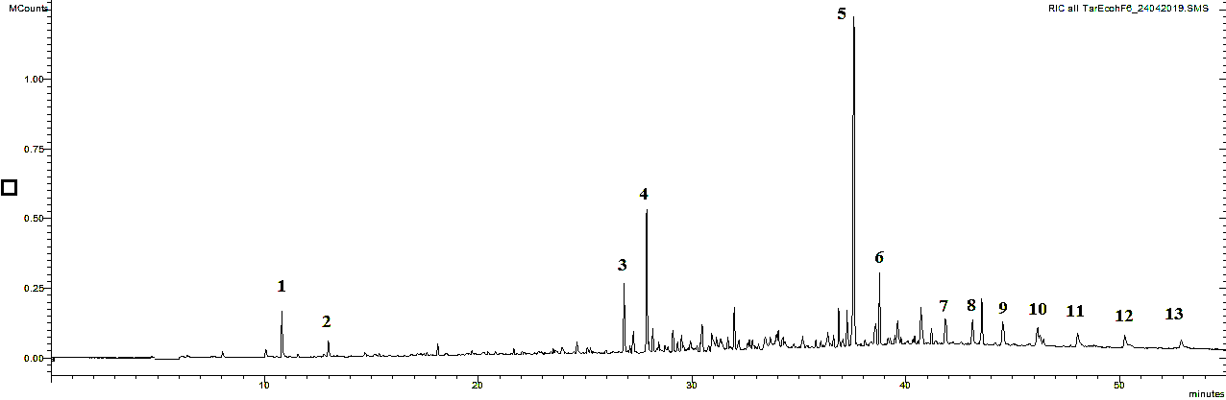
Figure S.1. GC/MS chromatogram of Tar fraction produced after catalytic experiment corresponding to 550 ºC-900 ºC-Dolomite. Main components (1-13) were identified as: 1= Styrene, 2= .alpha.- Methylstyrene, 3= Benzene,1,1´-(1,3-propanediyl)bis-, 4= Benzene, 1,1´-(2-butene,1,4-diyl)bis-, 5= Benzene,1,1´-(3-methyl-1-propene-1,3-diyl)bis-, 6= 1-Propene,3-(2-cyclopentenyl)-2-methyl-1,1-diphenyl-, 7-13= Linear straight-chain alkanes with base peak at m/z=57.

