Can differential predation of native and alien corixids explain the success of Trichocorixa verticalis verticalis in the Iberian Peninsula?

Cristina Coccia¹*, Luz Boyero^{1,2,3,4} and Andy J. Green¹

¹ Wetland Ecology Department, Estación Biológica de Doñana-CSIC, Seville, Spain
²School of Marine and Tropical Biology, James Cook University, Townsville, Qld, Australia
³Current address: Faculty of Science and Technology, University of the Basque Country (UPV/EHU), Bilbao, Spain
⁴Current address: IKERBASQUE, Basque Foundation for Science, Bilbao, Spain

*Corresponding author: coccia@ebd.csic.es; telephone (+34) 954 232 340; fax (+34) 954 621 125

Abstract
Invasive species represent an increasing fraction of aquatic biota. However, studies on the role and consequences of facilitative interactions among aliens remain scarce. Here we investigated whether the spread of the alien water boatman Trichocorixa verticalis verticalis in the Iberian Peninsula is related to reduced mortality from predation compared with native Corixidae, especially since Trichocorixa co-occurs with the invasive fishes Gambusia holbrooki and Fundulus heteroclitus. All three invaders have a common native range in North America and are widespread in and around Doñana in SW Spain. Using laboratory experiments, we compared the predation rates by the two exotic fish and native Odonata larvae on Trichocorixa and the native Sigara lateralis. We found no evidence to suggest that Trichocorixa suffers lower predation rates. However, when both corixids were mixed together, predation of Trichocorixa by Odonata larvae was higher. Odonata larvae were size-limited predators and the proportion of corixids ingested was positively correlated with mask length. Since Trichocorixa is smaller than its native competitors, this may explain their higher susceptibility to predation by Odonata. This may be one of various factors explaining why Trichocorixa is particularly dominant in saline habitats where Odonata are rare, while it is still scarce in fresh waters.

Key words: Corixidae, Trichocorixa, Sigara, Invasive species, Predation, Doñana

Introduction
Freshwater habitats have been subjected to massive species introductions from multiple sources for decades (Gherardi et al., 2008). As a consequence, in many of these systems, alien organisms are now a significant part of their biota (Cohen, 2002). Iberian inland waters, for example, host ca 73 non-indigenous freshwater species (Garcia-Berthou et al., 2007), belonging to a variety of taxa such as molluscs, crustaceans and fishes (Cobo et al., 2010).
Although negative interactions between species have been considered to be among the major drivers of biological invasions, only recently have studies highlighted the role of facilitative interactions among exotic species (Simberloff & Holle, 1999; Richardson et al., 2000). According to Courchamp et al. (2000), the co-occurrence of exotic predators and exotic prey can heavily impact native prey by hyperpredation. Adams et al. (2003) demonstrated how the invasion of the bullfrog Lithobates catesbeianus in North America was facilitated by the invasive bluegill sunfish Lepomis macrochirus, as the latter preys on macroinvertebrates that in turn prey on bullfrog tadpoles. Such positive interactions are thought to be widespread and important in exacerbating the problem of invasion (Simberloff & Holle, 1999), but studies that evaluate these interactions are still scarce (Richardson et al., 2000; Tecco et al., 2006), particularly for vertebrates (but see Adams et al., 2003).
In this study we experimentally investigated the role of predation by exotic predators (the eastern mosquitofish Gambusia holbrooki and the mummichog Fundulus heteroclitus; hereafter Gambusia and Fundulus, respectively) and native predators (dragonfly larvae) on the invasive boatman Trichocorixa verticalis verticalis (hereafter Trichocorixa) and the native, co-occurring boatman, Sigara lateralis (hereafter Sigara), in the Iberian Peninsula. Trichocorixa (Fieber 1851) (Heteroptera: Corixidae) is native to North American saline and freshwater habitats but now also occurs in South Africa, Iberia and Morocco (Jansson & Reavell, 1999; Kment, 2006; L’Mohdi et al., 2010). In Europe, following its initial detection in the Algarve in Portugal (Iberian Peninsula) in 1997, the species has spread along the Iberian Atlantic coast (Sala & Boix, 2005) and into the Guadalquivir delta and surrounding parts of SW Spain. Bio-climatic models predict future spread across Europe and the Mediterranean region (Guareschi et al., 2013). Established populations of Trichocorixa have been found at several sites in and around Doñana in the Guadalquivir delta, where it is the most abundant corixid in saline wetlands (Rodríguez-Pérez et al., 2009; Van de Meutter et al., 2010a). Despite their dominance at higher salinities, they do not show higher halotolerance as adults than native corixids (Van de Meutter et al., 2010a; Coccia et al., 2013).
In its native area, Trichocorixa co-occurs in rivers, brackish pools, potholes, and salt marshes with the above two euryhaline fish species (Gambusia along the east coast of USA from New Jersey to Florida and Fundulus along the North American Atlantic coast from Canada to Florida, see Sala & Boix, 2005). Various studies illustrate the coexistence of this corixid species with one of these fish species in the same waterbody within the native range (e.g. Harrington & Harrington, 1972; Cherry et al., 1979; MacKenzie, 2005; Rochlin et al., 2011; J. Simonis, pers. comm. 2014). These fishes were introduced to the Iberian Peninsula from North America around 1921 and 1970 respectively (Cobo et al., 2010). They now occur in a multitude of aquatic habitats during all the hydrological cycle in Doñana, where they are far more abundant than any native freshwater fish (Moreno-Valcárcel et al., 2013). Both species have been shown by gut content analysis to include corixids in their diet in permanent saline fish ponds in Doñana, where Odonata are absent or only recorded at low densities (Pyke, 2005; Dreamer-John, 2012; Rodríguez-Pérez & Green, 2012). In contrast, Odonata larvae represent the most important predators of corixids in temporary ponds in Doñana, where the invasive and native corixids co-exist but fishes rarely occur (Florencio et al., 2009; Rodríguez-Pérez et al., 2009).
As exotic predators can have dramatic effects on both invasive and native prey (Lodge, 1993; Knapp et al., 2001), only organisms with specific and effective anti-predatory mechanisms are likely to coexist with them (Sih et al., 2010). Although some studies have shown native prey to possess better defenses against native than alien predators (Gomez-Mestre & Díaz-Paniagua, 2011), prey species may also undergo rapid evolutionary change to counter a novel predation pressure (Griffin, 2004; Boyero, 2011). However, predator detection has a cost and performance can be lost with similar speed if the predator is removed (Strauss et al., 2006).
We hypothesized that alien predators (fish) and those native to Doñana (Odonata larvae) would have different interactions with the alien (Trichocorixa) and native (Sigara) corixids. Specifically, we tested the following hypotheses: i) predator responses to different prey depend on co-evolutionary history; thus, the exotic predators Fundulus and Gambusia are more successful at detecting and catching Trichocorixa, while Odonata are more successful at detecting and catching Sigara; and ii) differences in predation also depend on predator and prey size. We discuss the evidence that facilitative interactions can account for Trichocorixa success in southern Iberia and whether the scarcity of Odonata larvae in permanent, saline habitats in Doñana could be a factor promoting its dominance in this area (Rodríguez-Pérez et al., 2009; Van de Muetter et al., 2010b).

Material and methods

Methods
Adults of Fundulus and Gambusia were collected during spring 2012 using either minnow traps or a D-framed pond net (500 μm mesh; 16 × 16 cm), respectively. Native Odonata larvae and adults of Trichocorixa and Sigara were sampled using the same D-framed pond net. Experiments were run from 28 March to 16 May 2012. Fundulus and Trichocorixa were obtained from Veta la Palma fish ponds within Doñana Natural Park, Gambusia from an artificial pond called “pozo salinas” located in the stabilized sands (a system of stable dunes formed by marine drift during the Holocene period) in the west part of Doñana Biological Reserve and Sigara were sampled in two artificial ponds within the garden of the Cartuja Monastery (within the city of Seville). Finally, Odonata larvae were collected in artificial ponds either within Doñana National Park (FAO pond) or the Cartuja Monastery (see Serrano et al., 2006 for position of the Doñana sites).
Water conductivity varied between sites, being 32-36 mS cm⁻¹ in Veta la Palma, and 1.8-5 mS cm⁻¹ in the other ponds.
After collection, predators and prey were placed separately in plastic bags (a maximum of 4 fishes per bag) filled with water from the collection site and transported to the laboratory within thermally insulated polystyrene boxes to minimise thermal fluctuations. Once in the laboratory, each predator was transferred to its own 6-L aquarium (27x17x18 cm), containing water at conductivities that resembled those of sites from which they were collected [17 mS cm⁻¹for Fundulus; 5 mS cm⁻¹ for Gambusia (ca. 11 cm depth); and 2 mS cm⁻¹, for Odonata larvae (ca. 6 cm depth)]. Water from the collection point was used for the treatments of 5 and 2 mS cm⁻¹, whereas for high conductivity treatments, water was prepared by mixing pond water (32-36 mS cm⁻¹) with dechlorinated tap water until the required conductivity of 17 mS cm⁻¹ was obtained. As we did not test for turbidity effects, all treatments were conducted in clear water. Aquaria were provided with sand and were aerated for the fish treatments. Predators were acclimated for 24 h before predation experiments; this period is considered sufficient to allow fishes to explore the aquaria (Primavera, 1997). No food was provided to predators during these 24 h.
Experiments were conducted in a climatic chamber set at 15ºC under a 12 h: 12 h D:L regime. Ten corixids (balanced for sex when possible) were added to each aquarium containing a predator individual. When fishes were used as predators, six treatments were created by crossing corixid species (Trichocorixa alone, Sigara alone and both species together) and refuges (with and without an artificial plant, Online Resource 1a,b). In the case of Odonata larvae, only three treatments were employed (the three corixid combinations) as aquaria were always provided with artificial plants to provide a perch for the larvae. Five replicates of each treatment were used for each fish species and 10 replicates for dragonflies. The first check for surviving corixids was made after 6 h. Thereafter, aquaria were checked every 24 h. At each check, live corixids were retrieved using a hand net, counted, identified to species and visually sexed. After that, the corixids were returned to their aquarium. Consumed corixids were not replaced. After a maximum of 72 h, predators were retrieved from each aquarium. Each predator was used only once and sacrificed under licence after the experiment, using anaesthetic. Fishes were weighed using a ALC_2100.1 balance (Sartorious Ltd, U.K.) and the length of each individual was measured using a plastic millimeter sheet. Mean predator sizes (± SE) were as follows: 6.9±0.13 cm for Fundulus and 3.8±0.04 cm for Gambusia. The mean lengths (± SE) of masks of Odonata larvae (4.03±0.14 mm) were measured on images taken with a digital camera (AxioCam Icc1) connected to a Zeiss microscope (Discovery V8) (Online Resources 2-3). Odonata larvae were mainly (70%) final instars, and the remaining 30% were mid instars (according to Askew 1998). Prey size was not measured, as it would have involved a strong handling stress that may have altered corixid behaviour. The typical lengths were 5-6 mm for Sigara (Nieser et al., 1994) and 3.5-5.4 mm for Trichocorixa (authors’unpublished data).

Data analysis
We quantified the proportion of corixids (either Sigara or Trichocorixa) that were eaten by predators (Proportion of Corixids Eaten, PCE = 1 – final/initial number of corixid individuals), for each predator (Fundulus, Gambusia, and Odonata) and for each corixid treatment (single species vs. both species together). Although we used larvae of several dragonfly genera of the families Libellulidae and Aeshnidae [Orthetrum spp. (n=10); Aeshna spp. (n= 19); Sympetrum spp. (n= 10); and Crocothemis spp. (n=1)], we pooled the data for final analyses presented because results were the same as when using only the most frequent genus (Aeshna spp., other taxa could not be analysed separately because there were not enough individuals, see Online Resource 4). Initial models showed that there were no significant differences in PCE for fish between treatments with and without an artificial plant (results not shown). Thus, these treatments were pooled for further analyses comparing PCE between predator and prey species.
We used general linear models (GLMs) followed by Tukey tests to compare, for each corixid species separately, the effect of predator identity, corixid treatment and their interaction on PCE, which was arcsin square root transformed to improve normality and homogeneity of variances (tested with Shapiro-Wilk’s and Levene’s tests, respectively). Given the differential consumption rates between Fundulus (the most voracious), Gambusia and dragonflies, we initially calculated PCE for several experimental time intervals (6 and 24h for Fundulus; 6, 24, 48 and 72h for Gambusia and dragonflies), but we present results only for the final time (24h for Fundulus and 72h for Gambusia and dragonflies) because (1) Gambusia and dragonflies started eating after 24h and (2) results of analyses were the same between 6 and 24h for Fundulus and between 48 and 72h for Gambusia and dragonflies.
As the interaction between predator identity and corixid treatment was significant for Trichocorixa, we then used separate GLMs for each predator species to further explore effects of corixid treatment on PCE, for each corixid species separately. In these analyses we included the log (x+1) transformed predator size (for Fundulus and Gambusia) or dragonfly mask length as a covariate. Finally, we compared PCE between corixid species for the ‘both species together’ treatment with one-way ANOVA for each predator separately.

Results
Predator identity had a significant effect on PCE (Table 1), although results differed slightly for each corixid species. For Sigara, Fundulus showed the highest predation rate followed by Odonata larvae and Gambusia. For Trichocorixa, Fundulus and Odonata were equally efficient, and Gambusia was again the least efficient predator (Fig. 1). Corixid treatment had no effect on PCE, but the interaction between predator identity and corixid treatment was significant for Trichocorixa (Table 1); differences between corixid treatments were significant for Odonata (P < 0.05), which consumed significantly more Trichocorixa when Sigara was also present, but not for the other predators (Fig. 1).
When the effect of different predators was analyzed separately, there was no significant effect of either corixid treatment or predator body length for Fundulus and Gambusia (results not shown). For Odonata larvae, corixid treatment had no effect for Sigara; however, corixid treatment did have a significant effect for Trichocorixa. Mask length had a positive effect on PCE for both species (Table 2): dragonflies with larger masks ate more corixids (Fig. 2). When both corixid species were together, there were no significant differences between the number of Sigara and Trichocorixa eaten by any predator (Fundulus: F_{1,42} = 0.06, P = 0.78; Gambusia: F_{1,38} = 1.28, P = 0.27; dragonflies: F_{1,38} = 3.50, P = 0.069); however, the marginal result for dragonflies shows they tended to eat more Trichocorixa individuals (Fig. 3). Hence, the predation efficiency of Odonata larvae increased with their size, and was marginally influenced by prey size.

Discussion
In a multiple invasion context, where invaders at different trophic levels co-exist, several scenarios are possible. For example, alien predators may prefer native prey, native predators may prefer alien prey, or predators may easily detect/recognize prey because they share a co-evolutionary history (Sih et al., 2010).
Our results indicate that the invasive Fundulus and the native Odonata larvae are considerably more efficient than the invasive Gambusia in the rate of consumption of corixids. However, the only evidence to suggest that predators distinguish between alien and native corixids was on the basis of body size. Trichocorixa body mass is 35% lower than that of Sigara (Coccia et al., 2013), and our results suggest that for that reason they suffer higher predation by Odonata, and that this may help explain Trichocorixa dominance in saline waters in SW-Spain.
We found no evidence to suggest that corixids show different predator avoidance behaviour depending on whether they encountered predators sharing a common native range or predators of a different origin. However, our study did not allow us to distinguish between the existence of anti-predator responses in corixids vs. prey detection/capture mechanisms in predators, and we did not collect behavioural data. The absence of an efficient anti-predator response can lead to species decline (Courchamp et al., 2000), and the apparent inefficiency of anti-predator responses contradict field data confirming the co-occurrence of both exotic fishes and corixids in Doñana (Van de Meutter et al., 2010b; authors' unpublished data). Under confined laboratory conditions and high water clarity, it is likely that predator efficiency was greater than that in the field, where habitats are more diverse with reduced spatial or temporal overlap in habitat use between predator and prey, and turbidity can be high. For example, Kelts (1979) showed an increased rate of consumption of T.verticalis var sellaris by Fundulus when algae were removed from aquaria. The plastic plant we used as a refuge had no similar effect and was probably insufficient to hinder prey detection (Online Resource 1a,b).
In Doñana, Fundulus and Gambusia occur in different types of habitat (see Online Resource 5), however Fundulus prefers saline waters, and is generally absent in fresh or brackish ponds, which are inhabited mainly by Gambusia (Moreno-Valcárcel et al., 2013). Trichocorixa and Sigara often co-occur in sites of 3-15 mS cm⁻¹ (Van de Meutter at al., 2010a), whereas Trichocorixa is the dominant corixid at higher salinities and Sigara at lower salinities. Thus, we might expect a strong effect of Fundulus for both corixids at salinities between 9-23 mS cm⁻¹ where Fundulus dominates (Moreno-Valcárcel et al., 2013). However, in most of the sites were Trichocorixa was found with native corixids within the Doñana area, Gambusia was the only fish present (Van de Meutter et al., 2010b). At low conductivities (0.3-8.5 mS cm⁻¹), Moreno-Valcárcel et al. (2013) also found Gambusia to be the dominant species. The low observed predation rate by Gambusia in our experiments suggests that the predator-prey interaction between Gambusia and both the corixids is less important than that of Fundulus, a finding in agreement with field data showing that Gambusia ate mainly copepods and relatively few corixids (Dreamer-John 2012). In contrast, our results suggest that Fundulus and Odonata larvae may have a major impact on the invasive corixids in permanent saline waters and low salinity ponds respectively.
Permanent saline waters in SW Spain are often inhabited by both Fundulus and Trichocorixa (Sala & Boix, 2005). It has been suggested that the unpalatability of Trichocorixa late instars and adults may reduce predation by Fundulus in North America (Campbell & Denno, 1978; Kelts, 1979), but our observations do not support this. The extent of predation on Trichocorixa by Fundulus is likely to partly depend on the availability of alternative prey such as copepoda, isopoda and decapod shrimps (Dreamer-John, 2012). Furthermore, the distribution and abundance of Fundulus is likely to be limited by its own predators, such as larger fish and piscivorous birds, both of which are present at high density in saline parts of Doñana where Trichocorixa is dominant (Rendón et al., 2008, Rodríguez-Pérez & Green 2012). Additionally, co-occurrence with Fundulus may also be related to Trichocorixa preferences for shallow, vegetated waters (authors personal observation) avoided by fish (Kelts, 1979; Lewin et al., 2004). At the same time, the osmoregulatory ability of the invasive corixid at the egg and nymph stage together with its high fecundity and the absence of parasitic infections might be some important determinants of its success at higher salinities (authors’ unpublished data).
In temporary ponds, corixids arrive en masse in spring to reproduce, and the absence of fish maximises nymphal survival (Brown, 1951). Odonata larvae and both corixid species are often found together in Doñana ponds, especially during late spring (Florencio et al., 2009; Rodríguez-Pérez et al., 2009). Odonata larvae are top predators in temporary aquatic habitats, able to feed on different prey ranging from invertebrates (Hopper, 2001) to small fishes (Walker, 1953). Our results illustrate how Odonata larvae are size-limited predators, and suggest that predation of Trichocorixa by these major pond predators is increased by their smaller size compared to native Sigara spp. (including S. scripta, S. stagnalis and S. selecta, Rodríguez-Pérez et al. 2009, Van de Meutter et al., 2010b). The predator size-prey size relationship is one of many factors that can lead to greater use of exotic species as prey by native predators (Anholt & Werner, 1998). There are many previous example of native predators consuming exotic prey (King et al., 2006; Bulté & Blouin-Demers, 2008), sometimes as the dominant food items (Carlsson et al., 2009). In temporary ponds, predation by Odonata larvae may provide biotic resistance to invasion (Levine et al., 2004), limiting the abundance of Trichocorixa which frequently reproduces in temporary ponds in the native range (Brown, 1951). Selective predation can often mediate similar co-existence of similar prey (Ciros-Pérez et al., 2004).

Conclusion
Trichocorixa is a successful invader in SW Spain and is particularly dominant over native corixid species in saline wetlands (Rodríguez et al., 2009, Van de Meutter et al., 2010b). Our findings provide no support for the hypothesis that the Trichocorixa invasion has been promoted by lower predation rates compared to native corixids. On the other hand, Trichocorixa may suffer particularly higher predation rates from native Odonata larvae, which may partly explain why this species is particularly successful in saline habitats where Odonata are rare. Further studies are required to compare the life histories of the alien and native corixids. Priorities for future research include direct interactions (aggression, predation) between Trichocorixa and native heteropterans, as well the trophic ecology of Trichocorixa and its role in invaded food webs.

Acknowledgements
This research was funded by project P10- RNM-6262 financed by the Consejería de Innovación, Ciencia y Empresa, Junta de Andalucía (including FEDER funds), and by a JAE predoctoral grant from CSIC. Research permits were provided by Doñana National and Natural Park, Regional Andalusian Government (Consejería de Medio Ambiente). Fish capture and handling was approved by the CSIC Animal Bioethics Committee. We are grateful to Raquel Lopez and Carmen Diz-Salgado for laboratory and field assistance.

References
Adams, M. J., C. A. Pearl & R. B. Bury, 2003. Indirect facilitation of an anuran invasion by non-native fishes. Ecology Letters 6: 343–351.
Anholt, B. R. & E. E. Werner, 1998. Predictable changes in predation mortality as a consequence of changes in food availability and predation risk. Evolutionary Ecology 12: 729–738.
Askew, R. R., 1998. The dragonflies of Europe. Harley Books, Colchester, 291 pp.
Boyero, L., 2011. Expression of a behaviourally mediated morphology in response to different predators. Ecological Research 26: 1065–1070.
Brown, E. S., 1951. The relation between migration rate and type of aquatic insect with special reference to certain species of Corixidae. Proceedings of the Zoological Society of London 121: 539–545.
Bulté, G. & G. Blouin-Demers, 2008. Northern map turtles (Graptemys geographica) derive energy from the pelagic pathway through predation on zebra mussels (Dreissena polymorpha). Freshwater Biology 53: 497–508.
Campbell, D. C. & R. F. Denno, 1978. The structure of the aquatic insect community associated with intertidal pools on a New Jersey salt marsh. Ecological Entomology 181–187.
Carlsson, N. O., O. Sarnelle & D. L. Strayer, 2009. Native predators and exotic prey –an acquired taste? Frontiers in Ecology and the Environment 7: 525–532.
Cherry, D. S., R. K. Guthrie, F. F. Sherberger & S. R. Larrick, 1979. The influence of coal and thermal discharges upon the distribution and bioaccumulation of aquatic invertebrates. Hydrobiologia 62: 257–267.
Ciros-Pérez, J., M. J. Carmona, S. Lapesa & M. Serra, 2004. Predation as a factor mediating resource competition among Rotifer Sibling species. Limnology and Oceanography 49: 40–50.
Cobo, F., R. Vieira-Lanero, E. Rego & M. J. Servia, 2010. Temporal trends in non-indigenous freshwater species records during the 20th century: a case study in the Iberian Peninsula. Biodiversity and Conservation 19: 3471–3487.
Coccia, C., P. Calosi, L. Boyero, A. J. Green & D. T. Bilton, 2013. Does ecophysiology determine invasion success? A comparison between the invasive boatman Trichocorixa verticalis verticalis and the native Sigara lateralis (Hemiptera, Corixidae) in South-West Spain. PloS one 8: e63105.
Cohen, A. N., 2002. Success factors in the establishment of human-dispersed organisms Establishment of Human dispersed organism. In Bullock, J. M., Kenward, R. E. & Hails, R. S., (eds) Dispersal Ecology. London, Blackwell: 374–394.
Courchamp, F., M. Langlais & G. Sugihara, 2000. Rabbits killing birds: modelling the hyperpredation process. Journal of Animal Ecology 69: 154–164.
Dreamer- John, A., 2012. Ecological aspects of trophic niche width. MSc. thesis. School of Ocean Sciences, Bangor University.
Florencio, M., L. Serrano, P. Gomez-Rodriguez, A. Millan & C. Diaz-Paniagua, 2009. Inter- and intra-annual variations of macroinvertebrate assemblages are related to the hydroperiod in Mediterranean temporary ponds. Hydrobiologia 167–183.
Garcia-Berthou, E., D. Boix & M. Clavero, 2007. Non-indigenous animal species naturalized in Iberian inland waters. In Gherardi F. (ed.) Biological invaders in inland waters: Profiles, distribution and threats. Springer, Dordrecht, Netherland: 123–140.
Gherardi, F., S. Bertolino, M. Bodon, S. Casellato, S. Cianfanelli, M. Ferraguti, E. Lori, G. Mura, A. Nocita, N. Riccardi, G. Rossetti, E. Rota, R. Scalera, S. Zerunian & E. Tricarico, 2008. Animal xenodiversity in Italian inland waters: distribution, modes of arrival, and pathways. Biological Invasions 10: 435–454.
Gomez-Mestre, I. & C. Díaz-Paniagua, 2011. Invasive predatory crayfish do not trigger inducible defences in tadpoles. Proceedings of the Royal Royal Society of London B 278: 3364–3370.
Griffin, A. S., 2004. Social learning about predators: a review and prospectus. Learning & Behavior 32: 131–140.
Guareschi, S., C. Coccia, D. Sánchez-Fernández, J. A. Carbonell, J. Velasco, L. Boyero, A. J. Green & A. Millán, 2013. How Far Could the alien boatman Trichocorixa verticalis verticalis spread? Worldwide estimation of its current and future potential distribution. PloS one 8: e59757.
Harrington, R. W. & E. S. Harrington, 1972. Food of female marsh killifish, Fundulus confluentus goode and bean, in Florida. The American Midland Naturalist 87: 492–502.
Hopper, K. R., 2001. Flexible antipredator behavior in a dragonfly species that coexists with different predator types. Oikos 93: 470–476.
Jansson, A. & P. E. Reavell, 1999. North American species of Trichocorixa (Heteroptera: Corixidae) introduced into Africa. African Entomology 7: 295–297.
Kelts, L. J., 1979. Ecology of a tidal marsh corixid, Trichocorixa verticalis (Insecta, Hemiptera). Hydrobiologia 64: 37–57.
King, R. B., J. M. Ray & K. M. Stanford, 2006. Gorging on gobies: beneficial effects of alien prey on a threatened vertebrate. Canadian Journal of Zoology 84: 108–115.
Kment, P., 2006. A contribution to the faunistics of aquatic and semiaquatic Bugs (Heteroptera: Nepomorpha, Gerromorpha) in Portugal, with the review of biology of the Neartic corixid Trichocorixa verticalis (Fieber, 1851). Boletin de la Sociedad Entomológica Aragonesa 38: 359–361.
Knapp, R. A., K. R. Matthews & O. Sarnelli, 2001. Resistance and resilence of alpine lake fauna to fish introductions. Ecological Monograph 71: 401–421.
L’Mohdi, O., N. Bennas, O. Himmi, K. Hajji, M. El Haissoufi, C. Hernando, J. A. Carbonell & A. Millán, 2010. Trichocorixa verticalis verticalis (Fieber, 1851) (Hemiptera, Corixidae): une nouvelle especies exotique au Maroc. Boletin de la Sociedad Entomológica Aragonesa 46: 395–400.
Levine, J. M., P. B. Adler & S. G. Yelenik, 2004. A meta-analysis of biotic resistance to exotic plant invasions. Ecology Letters 7: 975–989.
Lewin, W. C., N. Okun & T. Mehner, 2004. Determinants of the distribution of juvenile fish in the littoral area of a shallow lake. Freshwater Biology 49: 410–424.
Lodge, D. M., 1993. Biological Invasions : lessons for Ecology. Trends in Ecology & Evolution 8: 133–137.
MacKenzie, R., 2005. Spatial and temporal patterns in insect emergence from a southern Maine salt marsh. The American Midland naturalist 153: 257–269.
Moreno-Valcárcel, R., F. J. Oliva-Paterna, C. Arribas & C. Fernández-Delgado, 2013. Fish composition and assemblage in the anthropogenic-modified tidally-restricted Doñana (Spain) marshlands. Estuarine, Coastal and Shelf Science 119: 54–63.
Nieser, N., M. Baena, J. Martínez-Avilés & A. Millán, 1994. Claves para la identificación de los heterópteros acuáticos (Nepomorpha y Gerromorpha) de la Península Ibérica- Con notas sobre las especies de las Islas Azores, Baleares, Canarias y Madeira , 112 pp.
Primavera, J. H., 1997. Fish predation on mangrove-associated penaeids. The role of structures and substrate. Journal of Experimental Marine Biology and Ecology 215: 205–216.
Pyke, G. H., 2005. A Review of the Biology of Gambusia affinis and G. holbrooki. Reviews in Fish Biology and Fisheries 15: 339–365.
Rendón, M. A., A. J. Green, E. Aguilera & P. Almaraz, 2008. Status, distribution and long-term changes in the waterbird community wintering in Doñana, south–west Spain. Biological Conservation 141: 1371–1388.
Richardson, D. M., N. Allsopp, C. M. D’Antonio, S. J. Milton & M. Rejmánek, 2000. Plant invasions-the role of mutualisms. Biological Reviews of the Cambridge Philosophical Society 75: 65–93.
Rochlin, I., M. E. Dempsey, T. Iwanejko & D. V. Ninivaggi, 2011. Aquatic insects of New York salt marsh associated with mosquito larval habitat and their potential utility as bioindicators. Journal of Insect Science (Online) 11: 1–17.
Rodríguez-Pérez, H., M. Florencio, C. Gómez-Rodríguez, A. J. Green, C. Díaz-Paniagua & L. Serrano, 2009. Monitoring the invasion of the aquatic bug Trichocorixa verticalis verticalis (Hemiptera: Corixidae) in the wetlands of Doñana National Park (SW Spain). Hydrobiologia 634: 209–217.
Rodríguez-Pérez, H. & A. J. Green, 2012. Strong seasonal effects of waterbirds on benthic communities in shallow lakes. Freshwater Science 31: 1273–1288.
Sala, J. & D. Boix, 2005. Presence of the nearctic water boatman Trichocorixa verticalis verticalis (Fieber, 1851) (Heteroptera, Corixidae) in the Algarve region (S Portugal). Graellsia 61: 31–36
Serrano, L., M. Reina, G. Martín, I. Reyes, A. Arechederra, D. León & J. Toja, 2006. The aquatic systems of Doñana (SW Spain ): watersheds and frontiers. Limnética 25: 11–32.
Sih, A., D. I. Bolnick, B. Luttbeg, J. L. Orrock, S. D. Peacor, L. M. Pintor, E. Preisser, J. S. Rehage & J. R. Vonesh, 2010. Predator-prey naïveté, antipredator behavior, and the ecology of predator invasions. Oikos 119: 610–621.
Simberloff, D. & B. Von Holle, 1999. Positive interactions of nonindigenous species : invasional meltdown? Biological Invasions 1: 21–32.
Strauss, S. Y., J. A. Lau & S. P. Carroll, 2006. Evolutionary responses of natives to introduced species: what do introductions tell us about natural communities? Ecology Letters 9: 357–374.
Tecco, P. A., D. E. Gurvich, S. Diaz, N. Perez-Harguindeguy & M. Cabido, 2006. Positive interaction between invasive plants: The influence of Pyracantha angustifolia on the recruitment of native and exotic woody species. Austral Ecology 31: 293–300.
Van de Meutter, F., H. Trekels, A. J. Green & R. Stoks, 2010a. Is salinity tolerance the key to success for the invasive water bug Trichocorixa verticalis? Hydrobiologia 649: 231–238.
Van de Meutter, F., H. Trekels & A. J. Green, 2010b. The impact of the North American waterbug Trichocorixa verticalis (Fieber) on aquatic macroinvertebrate communities in southern Europe. Fundamental and Applied Limnology / Archiv für Hydrobiologie 177: 283–292.
Walker, E. M., 1953. The Odonata of Canada and Alaska. Vol I. University of Toronto Press, Toronto, ON.

Table 1 Results (degrees of freedom, sum of squares, F-statistic and p-value) of GLMs showing the effects of predator identity (Fundulus heteroclitus, Gambusia hoolbroki or dragonflies larvae), corixid treatment (single species or both species together), and their interaction, on the proportion (arcsin sqrt transformed) of corixids eaten by predators.

Source of variation | df | SS | F | P
Sigara lateralis
Predator | 2 | 14.51 | 36.93 | <0.0001
Corixid | 1 | 0.01 | 0.03 | 0.87
Predator × Corixid | 2 | 0.54 | 1.38 | 0.26
Error | 85 | 16.70
Trichocorixa v. verticalis
Predator | 2 | 17.14 | 41.17 | <0.0001
Corixid | 1 | 0.12 | 0.60 | 0.44
Predator × Corixid | 2 | 1.49 | 3.58 | 0.032
Error | 85 | 17.69

Table 2 Results of GLMs showing the effects of corixid treatment (single species or both species together) and log (x+1) transformed mask length of the arcsin sqrt transformed proportion of corixids eaten by Odonata larvae.

Source of variation | df | SS | F | P
Sigara lateralis
Corixid | 1 | 0.48 | 2.82 | 0.10
Dragonfly mask length | 1 | 0.93 | 5.47 | 0.027
Error | 27 | 4.57
Trichocorixa v.verticalis
Corixid | 1 | 1.50 | 10.95 | 0.003
Dragonfly mask length | 1 | 1.41 | 10.36 | 0.003
Error | 27 | 3.69

Figure

Fig. 1 Arcsin sqrt-transformed mean ± SE proportion of corixids eaten (PCE = 1 - final/initial number of corixid individuals) for each corixid species (SL, Sigara lateralis; TV, Trichocorixa v. verticalis), by different predators (Fundulus heteroclitus, Gambusia holbrooki, and Dragonflies), and in two different corixid treatments (single species vs. both species together). Asterisks indicate significant differences in the PCE of TV by Dragonflies compared to the other predators when SL was also present.

Fig. 2 Linear regression (+ 95% confidence interval) between log-transformed dragonfly larva mask length and arcsin sqrt-transformed proportion of corixids eaten (PCE); SL, Sigara lateralis (P =0.11, R²=0.13); TV, Trichocorixa v. verticalis (P = 0.001; R² =0.46).

Fig. 3 Arcsin sqrt-transformed mean ± SE proportion of corixids eaten (PCE) of each species (SL, Sigara lateralis; TV, Trichocorixa v. verticalis) in the ‘both species together’ treatment.

Online Resource 1 Artificial plant used in the experiment

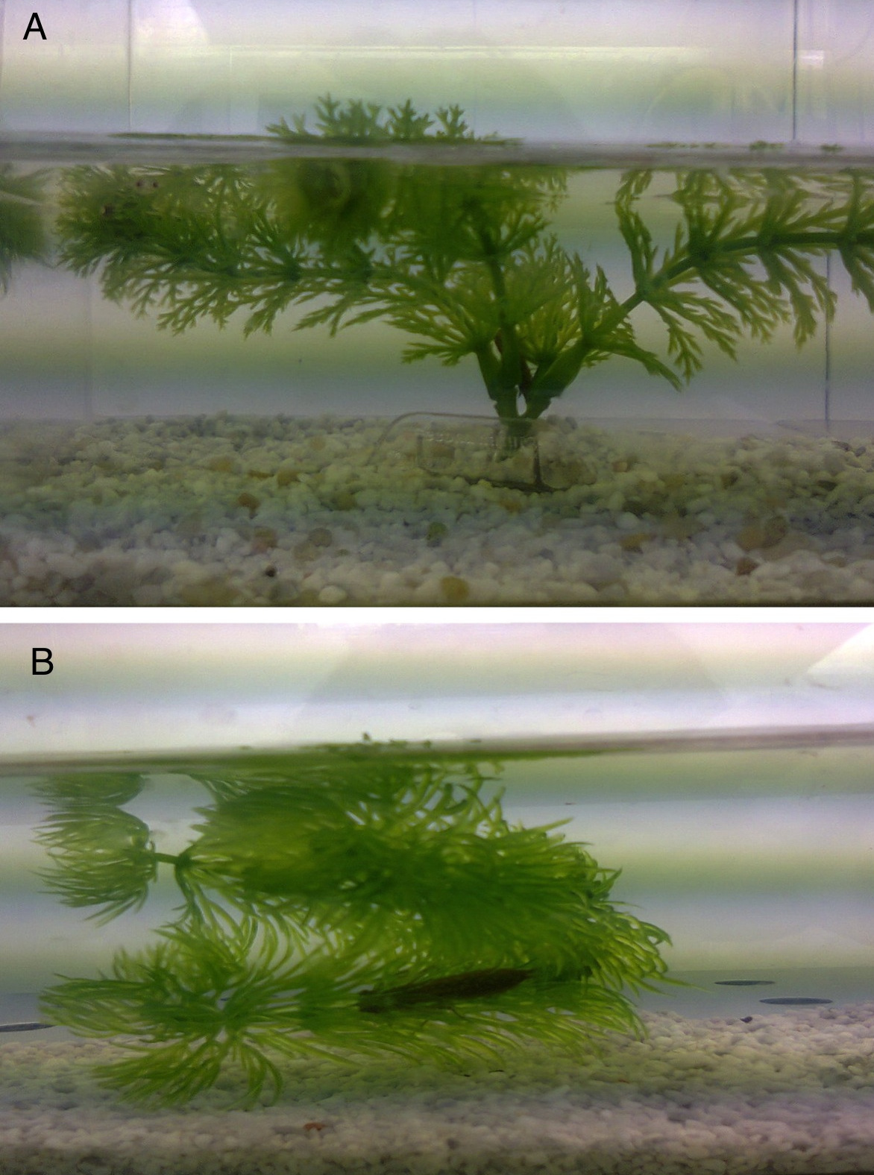

Online Resource 2 Dragonflies mask length.

N | Origen | Genus | Mask Length (mm) | Treatment
1 | Cartuja M. | Orthetrum spp | 3.5 | SL+TV
2 | Cartuja M. | Orthetrum spp | 3.6 | SL+TV
3 | Cartuja M. | Orthetrum spp | 3.0 | SL+TV
4 | Cartuja M. | Orthetrum spp | 3.3 | SL+TV
5 | Cartuja M. | Orthetrum spp | 3.1 | SL+TV
6 | Cartuja M. | Orthetrum spp | 3.3 | SL+TV
7 | Cartuja M. | Orthetrum spp | 2.8 | SL+TV
8 | Cartuja M. | Orthetrum spp | 3.2 | SL+TV
9 | Cartuja M. | Orthetrum spp | 2.6 | SL+TV
10 | Cartuja M. | Orthetrum spp | 1.9 | SL+TV
1 | FAO | Aesha spp | 5.6 | SL+TV
2 | FAO | Aesha spp | 4.7 | SL+TV
3 | FAO | Aesha spp | 5.5 | SL+TV
4 | FAO | Aesha spp | 5.6 | SL+TV
5 | FAO | Aesha spp | 4.3 | SL+TV
6 | FAO | Aesha spp | 4.8 | SL+TV
7 | FAO | Aesha spp | 4.3 | SL+TV
8 | FAO | Aesha spp | 4.5 | SL+TV
9 | FAO | Aesha spp | 4.6 | SL+TV
10 | FAO | Aesha spp | 4.8 | SL+TV
1 | FAO | Aesha spp | 4.9 | SL
2 | FAO | Aesha spp | 5.6 | SL
3 | FAO | Aesha spp | 4.7 | SL
4 | FAO | Aesha spp | 3.5 | SL
5 | FAO | Sympetrum spp | 3.5 | SL
6 | FAO | Sympetrum spp | 3.5 | SL
7 | FAO | Sympetrum spp | 3.4 | SL
8 | FAO | Sympetrum spp | 3.4 | SL
9 | FAO | Sympetrum spp | 3.7 | SL
10 | FAO | Sympetrum spp | 3.6 | SL
1 | FAO | Aesha spp | 4.7 | TV
2 | FAO | Aesha spp | 4.1 | TV
3 | FAO | Aesha spp | 4.7 | TV
4 | FAO | Aesha spp | 4.6 | TV
5 | FAO | Aesha spp | 5.6 | TV
6 | FAO | Crocothemis spp | 3.4 | TV
7 | FAO | Sympetrum spp | 3.6 | TV
8 | FAO | Sympetrum spp | 3.6 | TV
9 | FAO | Sympetrum spp | 3.7 | TV
10 | FAO | Sympetrum spp | 3.9 | TV

Online Resource 3 Example of stereomicroscope photograph of Odonata larvae mask

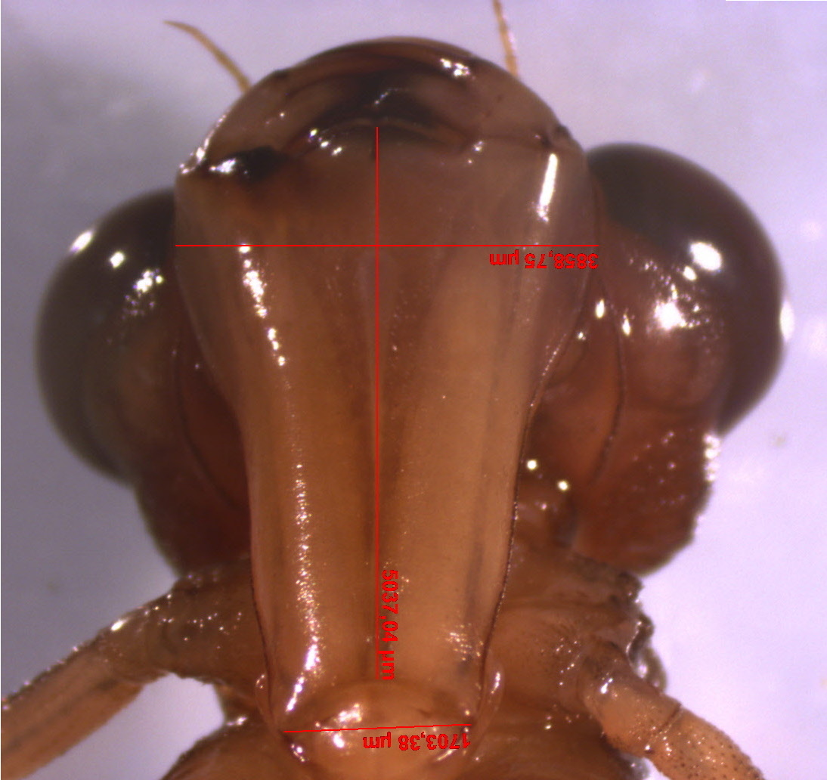

Source of variation | df | SS | F | P
Aeshna spp.
Sigara lateralis
Predator | 2 | 16.132 | 43.737 | <0.001
Corixid | 1 | 0.041 | 0.221 | 0.639
Predator x Corixid | 2 | 0.044 | 0.120 | 0.886
Error | 69 | 12.72
Trichocorixa v. verticalis
Predator | 2 | 18.294 | 44.132 | <0.001
Corixid | 1 | 0.208 | 1.003 | 0.319
Predator x Corixid | 2 | 1.416 | 3.416 | 0.038
Error | 70 | 14.51
All Odonata
Sigara lateralis
Predator | 2 | 14.510 | 36.929 | <0.001
Corixid | 1 | 0.005 | 0.027 | 0. 868
Predator x Corixid | 2 | 0.543 | 1.382 | 0.256
Error | 85 | 16.70
Trichocorixa v. verticalis
Predator | 2 | 17.138 | 41.167 | <0.001
Corixid | 1 | 0.124 | 0.597 | 0.442
Predator x Corixid | 2 | 1.491 | 3.581 | 0.032
Error | 85 | 17.69
Online Resource 4 Comparison of the results (degrees of freedom, sum of squares, F-statistic and p-value) of GLMs performed with all Odonata genera with those including only the most frequent genus Aeshna spp. on the proportion (arcsin sqrt transformed) of corixids eaten by them.
Online Resource 5 Types of habitat where Fundulus heterolictus, Gambusia holbrooki, Odonata larvae and Corixids (Sigara lateralis and Trichocorixa v.verticalis) occur in Doñana.

Habitat occurrence | Fundulus heteroclitus | Gambusia holbrooki | Odonata  larvae | Sigara lateralis | Trichocorixa v.  verticalis
Temporary ponds |  | x* | x | x | x
Permanent fresh ponds |  | x | x | x | x
Small streams | x | x | x | x | x
Seasonal lakes | x | x | x | x | x
Saline fish ponds | x | x | x |  | x
Solar saltworks | x |  |  |  | x
Waterholes |  | x | x | x | x
Ditches | x | x | x | x | x

* indicates that temporary presence of the species depends on hydrological connections defined by the flooding regime.

