TECHNICAL ADVANCE

A procedure for the transient expression of genes by agroinfiltration above the 28 °C permissive threshold, to study temperature-sensitive processes in plant-pathogen interactions

FRANCISCO DEL TORO¹, FRANCISCO TENLLADO¹, BONG-NAM CHUNG^{2,+} AND TOMAS CANTO^{1,+}
¹Environmental Biology Department. Centro de Investigaciones Biológicas, CIB-CSIC. Ramiro de Maeztu 9, 28040 Madrid, Spain.
²National Institute of Horticultural & Herbal Science. Agricultural Research Center for Climate Change. 281, Ayeon-ro, Jeju, 690-150, Jeju Island, Republic of Korea

Running Head: gene expression at high temperatures by agroinfiltration

Word Count Breakdown: Manuscript including Summary (6506); Summary (250); Table Content (112); References (1022); Supporting Information (378)

*: correspondence: E-mails: tomas.canto@cib.csic.es; chbn7567@korea.kr
SUMMARY
Localized expression of genes in plants from T-DNAs delivered into plant cells by Agrobacterium tumefaciens is an important tool in plant research. The technique, known as agroinfiltration, provides fast, efficient ways to transiently express or silence a desired gene without resorting to the time-consuming, challenging stable transformation of the host, use of less efficient means of delivery, such as bombardment, or use of viral vectors, which multiply and spread within the host causing themselves physiological alterations. A drawback of the agroinfiltration technique is its temperature dependency: early works had shown that temperatures above 29 °C were non-permissive to tumor induction by the bacterium as result of failure in pilus formation. However, research in plant sciences has interest in studying processes at those temperatures, above the 25 °C experimental standard, common to many host-environment and host-pathogen interactions in nature, and agroinfiltration would be an excellent tool for this purpose. Here we have measured the efficiency of agroinfiltration for expressing reporter genes in plants from T-DNAs at non-permissive 30 °C, either transiently or as part of viral amplicons, and envisaged procedures that allow and optimize its use for gene expression at that temperature. We have applied this technical advance to assess the performance at 30 °C of two viral suppressors of silencing in agropatch assays: Potato virus Y HCPro and Cucumber mosaic virus 2b protein, and within the context of infection by a PVX vector, indirectly assessed also their effect on the overall response of the host Nicotiana benthamiana to the virus.
INTRODUCTION
Agrobacterium tumafeciens is one of few bacteria capable of delivering DNAs into plant cells. In nature, the transferred DNA fragment (T-DNA) of the tumor-inducing (Ti) plasmids delivered by agrobacterium into plant nuclei encodes genes required for crown gall tumor formation as part of the bacterial life cycle. However, laboratory modifications have created versatile binary vector systems in which the T-DNA, free of tumor-inducing genes, can express any desired gene or sequence fragment under the control of a eukaryotic promoter, the most common of which for research purposes is the Cauliflower mosaic virus 35S promoter. Some of the T-DNA molecules delivered into a plant cell can integrate stably by recombination into the plant genome, thus becoming inheritable. This constitutes the basis of current techniques for plant transformation (Gelvin, 2003). More recently, transient, localized expression of genes and their products in plants from the bulk of non-integrated T-DNAS delivered into the plant cell by the bacterium has become a widely used tool in plant pathology and cell biology studies. This technique is commonly known as agroinfiltration or agroinjection, and ways to enhance the levels of expression or its large-scale use have been envisaged using a variety of approaches (Voinnet et al., 2003; Chen et al., 2013).
Transient, steady-state levels of gene products expressed from T-DNAs delivered into the agroinfiltrated leaf patch (agropatch) are influenced by several factors: one of them is their being recognized as foreign by the host, which elicits a silencing response that depresses both, transcript messenger RNA (mRNA) levels and those of the protein products they may encode (Johansen and Carrington, 2001). The trigger of this silencing response is probably the presence of double-stranded transcripts derived from sense and antisense transcription of the T-DNA sequences, causing the generation of small interfering RNAs to even promoter sequences, or to promoterless T-DNAs, in theory expected not to be transcribed (Canto et al., 2002). Co-expression of viral suppressors of gene silencing that prevent the targeting and degradation of T-DNA-derived transcripts arose as an strategy to counteract this partial silencing of T-DNA gene expression (Johansen and Carrington, 2001; Canto et al., 2002; Voinnet et al., 2003).
Another important factor to agroinfiltration efficiency is the type of plant host. Some plant species are just not physically amenable to the efficient infiltration of their leaves with agrobacterium cultures. The experimental plant species Arabidopsis thaliana, Nicotiana tabacum, or Nicotiana benthamiana can all three be readily infiltrated, but differences in the respective transient levels of the gene products achieved can be large: the latter host expresses higher levels of transcript mRNAs and their products than the other two ones . (Andrews and Curtis, 2005) This may be related to the fact that in N. benthamiana the salycilic acid and virus-inducible RNA-dependent RNA polymerase 1 (RdRP1) involved in antiviral defenses is naturally truncated, possibly causing its hypersusceptibility to many different plant viruses (Yang et al., 2004; Ying et al., 2010). Thus, unless a study requires a specific plant species, N. benthamiana is a usual host of choice for agroinfiltration assays in experimental studies.
Temperature is another factor affecting the efficiency of agroinfiltration as a tool for gene expression in plants. Optimal temperatures for transient gene expression through agroinfiltration appear to be in the 25 °C +-0.5 °C range in N. benthamiana (Lai and Chen, 2012; Chen et al., 2013) even though the bacterium tumor induction optimum may be lower, 22 °C in other hosts (Fullner and Nester, 1996). Transfer of T-DNAs into plant cells involves a complex set of bacterial genes and the physical formation of a pilus structure to allow for the physical transfer of bacterial DNA into the plant. Temperatures of 29°C and above completely prevent development of tumors as certain proteins involved in the transfer machine are not functional and critically, pilus formation does not take place either (Fullner and Nester, 1996; Gelvin et al., 2003). In addition, it has been shown that the strength of the plant silencing defense response that targets both viruses and also T-DNA transcripts steadily increases with temperature (Szittya et al., 2003; Qu et al., 2005; Velázquez et al., 2010; Chellappan et al., 2005). Thus, additionally to failure in the T-DNA transfer process, a stronger silencing defense response could have a further negative effect on any expression from agrodelivered T-DNAs. Therefore, agroinfiltration as a technique to transiently express genes in plants at temperatures above 29 °C would appear as a non-viable option.
In this work we have first assessed the actual efficiency and viability of agroinfiltration for expressing genes from T-DNAs at 30 °C, either transiently or as part of a viral Potato virus X (PVX)-based amplicon. We have then devised and optimized a procedure that allows its use for gene expression at that temperature and characterized its properties and parameters. With this procedure we have assessed the performance at 30 °C of two viral suppressors of silencing in agropatch assays: Potato virus Y HCPro and Cucumber mosaic virus 2b protein, and found that at least for HCPro, its suppressor of silencing activity in agropatch assays is as strong at 30 °C as it is at 25 °C. Within the context of infection by a PVX vector, we have also found that the strength of the overall response of the host Nicotiana benthamiana to the virus at high temperatures overcomes the effect that either 2b or HCPro may have on neutralising host defenses.

RESULTS
Poor steady-state levels of a reporter expressed at 30 °C from agroinfiltrated T-DNAs
A green fluorescent protein (GFP) reporter was agroinfiltrated at standard (25 °C) temperature into N. benthamiana leaf patches together with: empty construct pROK2, or pROK2 constructs expressing P1-Hexahistidine-tagged HCPro (P1-6x-HCPro) from Potato virus Y (PVY), 2b protein from Cucumber mosaic virus (CMV) or P19 from Tomato bushy stunt virus viral suppressors of silencing (Fig. 1A, agropatches labeled C, 1, 2 and 3, respectively). Within a few minutes after infiltration, plants were moved to growth cabinets at either 25 °C or 30 °C. After three days at standard temperature, GFP-derived fluorescence in the patches where the viral suppressors of silencing were present was much more intense than in the patch where GFP was being expressed alone under the UV lamp (Fig. 1A, left side leaf, patches 1, 2, and 3 vs. patch C) as partial silencing of the T-DNA-derived GFP transcript was relieved by the viral factors. Both, visual intensity of the fluorescence and amounts of GFP detected by western blot in the presence of the three different viral suppressors were similar (Fig. 1A, left leaf, and 1B, upper left western blot, compare 1, 2 and 3), indicating that 6x-HCPro (P1 and 6x-HCPro separate by proteolytic cleavage) and 2b displayed suppressor strengths comparable to that shown by tombusviral P19, usually considered a strong suppressor of silencing in this type of assays. Both HCPro and 2b were also detected serologically by western blot in their corresponding patches (Fig. 1B, lower left and right panels, respectively).
By contrast, in those plants kept three days at 30 °C GFP-derived fluorescence in infiltrated patches visualized very poorly and unevenly (Fig. 1A, right side leaf). Western blot analysis of the infiltrated patches showed the presence of very low, comparable amounts of GFP in all four patches, with independence of whether a viral suppressor had been co-infiltrated or not (Fig. 1B, upper right western blot panel). GFP levels in the C patch in this leaf were lower than in the left leaf that had been kept at 25 °C (Fig. 1B, lanes labeled C in upper western blot panels). Interestingly also, neither HCPro nor 2b could be detected serologically (Fig. 1B, lower left and right panels, respectively).
We concluded that in leaves kept at 30 °C after infiltration, transient GFP and suppressor expression as well as suppressor function were compromised. Given published literature, a likely cause for this outcome would be an inefficient transfer of T-DNA. However, it could also be the case that other factors, such as host processes affecting negatively at that temperature the steady-state levels of T-DNA transcripts or their protein products could also influence this outcome. In this regard, we also tested whether transfer of plants from 25 °C to 30 °C after their infiltration could have affected negatively their efficiency in agropatch assays as a consequence of a heat shock. To do this we compared those plants with plants that had been placed at 30 °C 3 days prior to their agroinfiltration and found no difference in their performance (data not shown).
24 hour at 25 °C after infiltration allow T-DNA transfer into plant cells and restores transient gene expression at 30 °C
We hypothesized that if T-DNA transfer into plant cell nuclei was being prevented by a temperature of 30 °C, providing a window of time after infiltration at standard temperature, long enough to allow for the transfer to occur but short enough that most T-DNA-derived protein accumulation and functional action took place at 30 °C, would let us perform studies on protein function at high temperatures using the agroinfiltration technique. For this reason we tested keeping plants 24 hours (24h) at 25 °C after infiltration, followed by 48h at 30 °C (Fig. 1A, center leaf). With this procedure we obtained at 72h post infiltration (hpi) levels of expression of the GFP reporter that were in the order of those seen in leaves kept all the time at 25 °C (Fig. 1A, central vs. left leaf; Fig. 1B upper left western blot panel). As an example, quantitation of the GFP band density corresponding to patch 2 showed that in the central leaf patch there was 83.7% of the protein found in the left leaf. This was in contrast to the meager 9% obtained at 30 °C in the equivalent sample (Fig. 1B upper western blot panels). Both HCPro and 2b proteins were also detected serologically in their corresponding patch samples in the central leaf, although in lesser proportion, relative to the protein found in the equivalent patch in the left (25 °C) leaf than for the GFP reporter (Fig. 1B; lower western blot panel). As an example, quantification of the 2b protein band density corresponding to patch 2 in left and central leaves showed that the latter accumulated 1/3rd (32.9%) of the suppressor found in the former. The reason behind this disparity between the accumulation of the reporter and those of the two suppressors could lie in the existence of host processes that specifically target the suppressor but not the reporter (Nakahara et al., 2012).
Thus, as expected T-DNA transfer was critically affected by the 30 °C temperature and providing a 24h 25 °C window after infiltration overcame this obstacle. We tested a window of only 12h but results were unsatisfactory (Supplemental Fig. S1A).
We then determined the maximum proportion of protein found at 72hpi that could have accumulated in the initial 24h. For this purpose, we made a time course experiment to analyze protein accumulation at 24, 48 and 72hpi of GFP reporter co-infiltrated with empty vector or with vectors expressing either 6x-HCPro or 2b protein, for which we had means of serological detection (Fig. 2). We tested protein accumulation in plants kept all the time at 25 °C (Fig. 2A) or in plants kept the first 24h at 25 °C and the following 48h at 30 °C (Fig. 2B). In both cases, we detected at 24h accumulation of GFP reporter and of 2b suppressor, but failed to detect accumulation of 6x-HCPro using two separate antibodies. For the GFP reporter, accumulation in the first 24h at 25 °C was limited to 15% or less of the total found at 72hpi (Fig. 2A and B, upper right panels). The same pattern was found for the 2b suppressor in plants kept all the time at 25 °C: 2b accumulation at 24hpi was also less than 12% of the protein found at 72hpi (Fig. 2A). However, in the case of plants kept 24h at 25 °C and the following 48h at 30 °C, 2b accumulation declined after the initial 24h and at 72hpi it was only 35.6% of that found at 24h (Fig. 2B, lower right panel). We found the same pattern in a modified 2b tagged with 6x-histidines and an HA peptide at its N- and C- terminus, respectively (construct 6x-2b-HA; Supplemental Fig. S1B) By contrast, 6x-HCPro accumulation followed a similar pattern in plants kept all the time at 25 °C or in plants kept the first 24h at 25 °C and the following 48h at 30 °C. No clear decline from 48 to 72h was observed either, in contrast to what happened to the 2b protein (Fig. 2B). These data clearly indicate differences between 2b and 6x-HCPro in their speed of expression and maturation, stability and turnover in a similar cellular environment.
Thus, in both situations most of the accumulation of our GFP reporter (over 85%) and of 6x-HCPro took place at 30 °C, as did whatever functionality the latter might have had at that temperature. This allowed us to conclude that in our particular experiment, HCPro displayed suppressor of silencing activities at 30 °C that were at least as strong as those displayed at 25 °C in the agropatch assay system. The case of 2b protein, native or tagged, was different, as its accumulation declined substantially after the initial 24h if plants were transferred to 30 °C. Remarkably even those lower levels of suppressor sufficed to suppress the silencing on the GFP reporter efficiently (Fig. 1; Figs 2A vs. 2B, upper GFP western blot panels; Supplemental Fig. S1A).
Viable expression of viral amplicons at 30 °C through agroinfiltration
We tested how binary constructs expressing viral amplicons would perform in our system. For that we used a construct expressing a PVX vector, and PVX vectors expressing either PVY P1-6x-HCPro (construct PVX-P1-6x-HCPro) or CMV 6x-2b-HA protein (construct PVX-6x-2b-HA). After agroinfiltration at 25 °C plants were either kept at 25 °C for seven days, or at 25 °C for 24h and then transferred to 30 °C for the remaining six days. Plants were monitored daily for the appearance of systemic infection symptoms during this period (Table I) and at the end of the seventh day samples were taken from systemic tissue to monitor viral coat protein (CP) levels. In plants kept at 25 °C symptoms appeared on the fifth day in all three cases, and became stronger with time. Symptoms were more severe in the case of PVX-P1-6x-HCPro and PVX-6x-2b-HA, and particularly stronger in the case of PVX-6x-2b-HA, leading on the seventh day to the start of necrosis in apical leaves (Table I and Fig. 3A). By contrast, in all three cases plants kept at 30 °C remained visually symptomless (Table I and Fig. 3A). Western blot analysis of systemic tissue revealed that regardless of the absence of symptoms all plants were infected with the virus. Densitometric analysis of the western blot CP bands revealed that at 25 °C, tissue infected with PVX or PVX-6x-2b-HA contained comparable levels of protein, and more than in tissue infected with PVX-P1-6x-HCPro (Fig. 3B, upper panels). In the symptomless plants kept at 30 °C CP levels were in the three viruses lower, and differences among them were less marked (Fig. 3B, upper panels). This is somewhat surprising as it happened despite the fact that two of the constructs expressed P1-6x-HCPro and 6x-2b-HA, both strong suppressors of gene silencing in agropatch assays as shown previously (Tena et al., 2013; González et al., 2012, respectively), and at least for 6x-HCPro functionally as active at 30 °C as at 25 °C (this work). That both suppressors accumulated at 30 °C in virus-infected tissue was confirmed serologically (Fig. 3B, lower panels).
As even a very low transfer of T-DNA by the agrobacterium could be sufficient to allow the viral amplicon to independently replicate, and given that we had observed some low level of expression of the GFP reporter even in plants transferred to 30 °C immediately after agroinfiltration (Fig. 1. Right leaf and right western blot panel) we tested whether infiltration of the viral amplicons would cause plants to become infected. At seven days after agroinfiltration plants remained symptomless (data not shown), but western blot analysis of the viral CP in systemic tissue revealed that they were infected, although CP levels were again lower than those found in plants kept at 25 °C (Fig. 3C). Furthermore, the levels of CP in all cases were very similar to those found in plants kept the first 24 hours after infiltration at 25 °C prior to their transfer to 30 °C for six days (Fig. 3C vs. 3B). However, repeated tests showed that in some instances PVX infection failed to occur in plants transferred to 30 °C immediately after agroinfiltration (Supplemental Fig. S1C). Therefore, even for T-DNAs expressing viral amplicons, a 24h window at 25 °C is advisable.
DISCUSSION
Most research in laboratories investigating mechanisms and processes underlying plant/virus interactions takes place at the standard room temperature, usually 25 °C. One of the main tools in plant pathology for functional studies is agroinfiltration, a technique that has its optimal working temperature precisely at 25 °C (Chen et al., 2013). At temperatures of 29 °C and above it is non-functional (Fullner and Nester, 1996; Gelvin et al., 2003). However, plants interact with their environment under seasonal and daily changes in temperature that within a crop growing season could span from lows of 10 °C or less, to highs in the upper 30s. Thus, there is interest in studying plant processes at 30 °C and above. ,Use of agroinfiltration as a fast and versatile tool to express proteins in native or modified form or to transiently silence any gene at elevated temperatures would be most useful.
On the other hand, in plant/virus interactions, increased temperature leads in general to weaker infection symptoms (Hull, 2002). In this regard, there is documented evidence that gene silencing-based defense processes that are key to the infection outcome show a positive correlation with temperature: it has been reported that antiviral silencing gets progressively stronger against RNA viruses and agroinfiltrated T-DNAs from 15 to 24 °C (Szyttia et al., 2003), against positive-sense RNA viruses from 21 to 27 °C (Qu et al., 2005), against negative RNA viruses from 26/18 °C to 32/26 °C (day/night; Velázquez et al., 2010), or against DNA geminiviruses from 25 to 30 °C (Chellappan et al., 2005). In all cases, this coincides with a decrease in the accumulation of corresponding viral titres, their mRNAs, or the products they encode, and with an increase in the levels of siRNAs to those sequences. This fact has been taken to advantage to transform plants at higher temperature to constitutively express a potyvirus-based viral amplicon vector avoiding its pathological effects. When transformation, regeneration and plant growth took place at high temperature, the amplicon failed to replicate and plants avoided virus-derived pathology effects during their regeneration and development. Lowering the temperature in full-grown, symptomless plants allowed the amplicon vector to express any potential product at high levels in some of the transgenic lines (Dujovny et al., 2009).
In contrast to gene silencing, less is known on the effect of temperature on other defense processes targeting viruses, such as proteasome or autophagy routes. Temperature can on the other hand also affect the biological activities of viral factors involved in processes such as movement (Boyko et al., 2000) or replication (Ohsato et al., 2003) although for the latter to discriminate it from that of gene silencing is problematic. As to the date, there is not much evidence regarding temperature-dependency on the activity of viral suppressors of silencing, but as this takes place through binding to nucleic acids or to host factors, within and/or interacting with physical subcellular structures/compartments, it could likely be the case.
Here we have developed a procedure that allows the use of the agroinfiltration technique for the expression of genes at 30 °C in virus-plant interaction studies. We first characterized the actual efficiency of agroinfiltration to express proteins at 30 °C and found that at that temperature accumulation of a GFP reporter and of the viral proteins tested was either very poor or undetectable (Fig. 1). By providing a 24h period post infiltration at 25 °C before placing the plants at 30 °C we allowed sufficient time for T-DNA transfer and subsequent gene expression to occur, while a shorter window of 12 hours was found to be inefficient (Fig. 1 and Supplemental Fig. S1). In this way, and by co-expressing our reporter with any of three viral suppressors of silencing we were able to achieve levels of accumulation that were over 83% those obtained in similarly agroinfiltrated plants, kept at 25 °C (Fig. 1B).
In contrast to our GFP reporter, accumulation of both viral HCPro and 2b suppressor proteins was lower than that found in plants kept all the time at 25 °C (33 % in the case of 2b protein; visually lower but not quantified in the case of 6x-HCPro; Fig. 1B). The reason for this disparity with the reporter could reside on their intrinsic stability or in the fact that unlike the reporter, the viral suppressors may be differentially targeted by host processes that affect negatively their steady-state levels, such as the proteasome (Ballut et al., 2005; Jien et al., 2007; Dielen et al., 2011; Sahana et al., 2012), or in the case of both HCPro and 2b protein through their binding to a calmodulin-related protein that may direct them to degradation via autophagy (Nakahara et al., 2012).
Even though it is usual wisdom that 24h is hardly enough time for protein accumulation after agroinfiltration (Voinnet et al., 2003) we tested in a time course the levels of accumulation of proteins in our system from 24 to 72hpi. We found that we could detect both GFP reporter and 2b suppressor at 24hpi. They are small proteins of 25 and 16 kilodalton (kDa), respectively. By contrast, we failed to detect 24h accumulation of the much larger (50 kDa) 6x-HCPro, which was in addition expressed as a polyprotein dowstream of the self-cleaving potyviral P1 factor. In any case, the levels of accumulation of GFP and 2b protein at 24hpi were less than 12 % of those found at 72hpi (Fig. 2). So the vast majority of proteins were actually expressed at 30 °C, and so would their biological activities, if any. Our data from 6x-HCPro and 2b (or 6x-2b-HA) show that the former requires more time to be translated and accumulate than the latter (Fig. 2B), and suggest also that its stability is greater than that of the 2b protein and its turnover slower. It could also be possible that the latter is targeted for degradation in a more efficient way than HCPro is by autophagy. These results also suggest that not all “strong” suppressors may perform the same for our agroinfiltration procedure to express proteins at high temperatures, even though in our conditions (30 °C and 72hpi) we saw no difference on suppressor effect on a GFP reporter levels using either 6x-HCPro or 2b protein, or P19 (Fig. 1). The fact that the steady-state levels of 2b protein dropped much faster than those of 6x-HCPro (Fig. 2B) suggests that perhaps if the experiment was performed at higher temperatures or for a longer period of time (4-5 days) differences on suppressor activity may arise, and then the more stable suppressor could be preferable.
We also tested how our procedure would help express viral PVX amplicons from binary vectors. We found that in this case, no 24h window at 25 °C was required before placing the plants at 30 °C to achieve infection (Fig. 3C). However, we also found that some infiltrated plants failed to become infected (Supplemental Fig. S1C). Therefore, although the 24h window at 25 °C is not a strict necessity for the amplicon to successfully take hold in a plant, it was nevertheless necessary to ensure that all plants became infected. When we tested PVX and PVX expressing either 6x-HCPro or 6x-2b-HA protein we found that regardless of differences between the three of them in the symptoms they induced and in their CP titers in plants kept at 25 °C, at 30 °C all plants were asymptomatic and CP levels were more uniform in the three cases, roughly between 25 and 50% of those found in systemic tissue of PVX-infected plants kept at 25 °C (table I and Fig. 3A, 3B). This may indicate that defense responses against PVX are stronger at 30 °C than at 25 °C or alternatively that viral replication is negatively affected by the higher temperature. Neither of the suppressors expressed by PVX-P1-6x-HCPro and PVX-6x-2b-HA increased CP levels from those found in tissue infected by PVX at 25 or 30 °C (Fig. 3b and 3C), despite of at least 6x-HCPro being a strong suppressor at 30 °C. This is in agreement with observations that PVX RNA did not increase in plants infected with a PVX recombinant virus expressing the Plum pox virus HCPro compared with plants infected with the PVX vector (González-Jara et al., 2005).
In conclusion, we have designed a procedure that allows the use of the agroinfiltration technique for an efficient expression of genes in plants for scientific studies at 30 °C. This technical advance allows studies in vivo at those temperatures of for example, fluorescently tagged proteins and their interactions with either subcellular structures or with other proteins, and their dynamics; or to perform biological assays with them, such as we did here with suppression of the silencing of a reporter by viral factors, or to comparatively study their synthesis and turnover. We have also shown the viability of agroinfiltration of binary vectors to express viral amplicons at 30 °C. With this tool we were able to monitor the effect of heterologous viral suppressors of silencing, whose activities we previously assessed at high temperatures, on the overall response of the host to the virus.
EXPERIMENTAL PROCEDURES
Binary vector constructs
Reporter and viral proteins were transiently expressed in plants from corresponding gene sequences expressed from caulimovirus 35SP-driven, pROK2-based binary vectors: vectors expressing the free GFP reporter and CMV (Fny) 2b protein were described in González et al., (2010); the binary vector expressing PVY P1-6x-HCPro (construct P1-6x-HCPro) was described in Tena et al., (2013). The binary vector expressing TBSV P19 suppressor was described in Canto et al., (2006). To generate the pROK2 binary vector that expressed 2b protein with six histidines fused at its N- terminus and an HA peptide (Tyr-Pro-Tyr-Asp-Val-Pro-Asp-Tyr-Ala) fused to its C-terminus used in supplemental Figure S1 (construct 6x-2b-HA), the 2b coding sequence was amplified in sequential PCR events with flanking oligos that contained the HA peptide and 6x-histidines sequences, resulting in a 2b sequence that had attached at its 3´end an AscI site plus that of the HA peptide in frame and a SacI site plus a stop codon at its end, and at its 5´end an XbaI site followed by an ATG, the sequence coding for 6x-His, and a BamHI site in frame with following sequence coding for 5´end nucleotides of the 2b sequence. The fragment was cloned between the XbaI and SacI sites of pROK2.
With regard to the three PVX viral amplicons, binary vector pgR 107 was used to express infectious PVX that contains an additional CP promoter and a polylinker for the insertion and expression of foreign genes (Lu et al., 2003). PVX expressing PVY P1-6x-HCPro has been already described (Tena et al., 2013). To create PVX expressing 6x-2b-HA the tagged 2b protein was amplified by PCR with appropriate oligos and cloned into ClaI/SalI-linearized construct pgR 107.
All PCRs were performed with PhusionTM DNA polymerase (Finnzymes, Keilaranta, Finland). All constructs were confirmed by sequencing of the inserted fragments and of the vector flanking regions.
Transient expression of genes in plants and local suppression of silencing in agroinfiltration patch assays
For transient expression assays (patch assays) of single proteins expressed from binary vectors, the latter were transferred to non-oncogenic electrocompetent Agrobacterium tumefaciens strain C58C1 derived from a single colony, to prevent bacterial variability. Cultures were grown to exponential phase in LB medium with antibiotics at 28 °C. For infiltration, each bacterial culture was diluted to a final optical density of 0.3 at 600 nm. Different cultures harbouring different T-DNAs were then combined and infiltration of the mixtures was performed as described (Canto and Palukaitis, 2002). In silencing suppression assays, a free GFP reporter gene expressed from a binary vector under the control of the 35S promoter was expressed transiently in a N. benthamiana leaf, either co-infiltrated with the empty binary vector pROK2, or with another vector expressing a protein to be tested for suppression of silencing activity. Leaves were then illuminated at 72 hpi with a Blak Ray® long wave UV lamp (UVP, Upland, CA, USA) to visualize the fluorescence derived from the transiently expressed free eGFP as described (González et al., 2010).
In the case of PVX amplicons, the binary vectors expressing them were electroporated into electrocompetent Agrobacterium tumefaciens strain GV3101 already containing a pJIC SA_Rep that conferred tetracycline resistance kindly provided by Prof. D. C. Baulcombe group (University of Cambridge, UK). For infiltration, agrobacterium cultures were grown as described in the previous paragraph.
Agroinfiltrations were performed on the laboratory bench at 25 °C. Immediately after infiltrations (no more than 15 minutes on the bench) plants were transferred to Controlled Environment Plant Growth chambers (SANYO Electronic Co.; Panasonic Corp., Japan) were they were maintained in 16/8 hour day/night photoperiod, and at temperatures of either 25 °C or 30 °C, or combinations thereof, depending on the experiment. In addition to the chamber own temperature controls temperature accuracy was independently monitored with a PCE HT-71 datalogger sensor (PCE Instruments Ltd. Southamptom, UK).
Immunoblot detection of proteins and densitometric analysis
Infiltrated fresh leaf tissue disks of 25 mm diameter were separated from the leaf with a borer (0.05 to 0.1 μg of fresh leaf tissue). Total proteins were extracted by grounding the nitrogen-frozen disks with a pestle in 400 μl of extraction buffer (0,1 M Tris-HCl PH 8, 10 mM EDTA, 0.1 M LiCl, 1% β-mercaptoethanol and 1% SDS), and the samples were boiled and fractionated by SDS-PAGE in 10 % (for HCPro detection) or 15 % (for GFP and 2b protein detection) gels. Gels were wet-blotted in tris-glycine buffer onto Hybond-P PVDF membranes (Amersham, GE Healthcare, Buckinghamshire, UK). For immunological detection of GFP, a rabbit anti-GFP, N-terminal antibody was used (SIGMA Aldrich, Saint Louis, Missouri, USA. Cat. G1544). For detection of 6x-HCPro a mouse monoclonal antiserum to six histidines was used (SIGMA Aldrich, Saint Louis, Missouri, USA. Cat. H1029). In addition, a mouse monoclonal antibody to PVY HCPro (Ab 1A11; Canto et al., 1996) was also used for its detection in the panels shown in Fig. 2 indicated as α-HCPro. For the detection of 2b protein, a mouse polyclonal serum was used (González et al., 2010). For the detection of PVX by western blot, a commercial rabbit antibody was used (No. 070375/500; Loewe Biochemica GmbH, Germany). Blotted proteins were detected using commercial secondary antibodies and SigmaFastTM BICP/NBT substrate tablets (SIGMA Aldrich, Saint Louis, Missouri, USA). Comparative Protein densitometric analysis of blotted proteins was made with the Quantity One 4.6.3 1-D analysis software (Bio-Rad laboratories, Hercules, CA, USA). Numbers shown in the Figures represent the quantification of protein amounts in individual western blot bands, and the values given are percentages to the value found in the internal control within the same blot. Densitometric comparisons were only made between bands within the same membrane and not between bands that corresponded to different blots or antibodies, unless internal controls were taken into account.

ACKNOWLEDGEMENTS
This work was funded by a grant from the Rural Development Administration (RDA) of the Republic of Korea, in cooperation with the Spanish Council for Scientific Research (CSIC). Authors wish to thank Prof. D.C. Baulcombe, University of Cambridge, for the kind provision from his laboratory to our group of binary construct pgR107 and helper plasmid pJIC SA_Rep.
REFERENCES

Andrews, L.B., and Curtis, W.R. (2005) Comparison of transient protein expression in tobacco leaves and plant suspension culture. Biotechnol Prog. 21, 946–952.

Ballut, L., Drucker, M., Pugniére, M., Cambon, F., Blanc, S., Roquet, F., Candresse, T., Schmid, H-P., Nicolas, P., Le Gall, O. and Badaoui, S. (2005) HcPro, a multifunctional protein encoded by a plant RNA virus, targets the 20S proteasome and affects its enzymatic activities. J. Gen. Virol. 88, 2595-2603.

Boyko, V., Ferralli, J., and Heinlein, M. (2000) Cell-to-Cell movement of TMV RNA is temperature-dependent and corresponds to the association of movement protein with microtubules. Plant J. 22, 315-325.

Canto, T., Ellis, P., Bowler, G., and López-Abella, D. (1996) Production of monoclonal antibodies to Potato virus Y helper component-protease and their use for strain differentiation. Plant Disease 79, 234-237.
Canto, T., Cillo, F., and Palukaitis, P. (2002) Generation of siRNAs by T-DNA sequences does not require active transcription nor homology to sequences in the plant. Mol. Plant-Microbe Interac. 15, 1137-1146.

Canto, T., Uhrig, J., Swanson, M., Wright, K. and MacFarlane, S. (2006) Traslocation of Tomato bushy stunt virus P19 protein inot the nucleus by ALY proteins compromises its suppressor of silencing activity. J. Virol. 80, 9064-9072.
Chellappan, P., Vanitharani, R., Ogbe, F., and Fauquet, C.M (2005) Effect of temperature on geminivirus-induced RNA silencing in plants. Plant Physiol. 138, 1828-1841.
Chen, Q., Lai, H., Hurtado, J., Stahnke, J., Leuzinger, K., and Dent, M. (2013) Agroinfiltration as an effective and scalable strategy of gene delivery for production of pharmaceutical proteins. Adv. Tech. Biol. Med 1: 103. DOI. 104172/atbm.1000103.
Dielen, A-S., Sassaki, F.T., Walter, J., Michon, T., Menard, G., Pagny, G., Krause-Sakate, R., Maia, I., Badaoui, S., Le Gall, O., Candresse, T. and German-Retama, S. (2011) The 20S proteasome α₅ subunit of Arabidopsis thaliana carries and RNAse activity and interacts in planta with the Lettuce mosaic potyvirus HcPro protein. Mol. Plant Pathol. 12, 137-150.
Dujovny, G., Valli, A., Calvo, M., and García, J.A (2009) A temperature-controlled amplicon system derived from Plum pos potyvirus. Plant Biotech. J. 7, 49-58.
Fullner, K.J., and Nester, E.W. (1996) Temperature affects the T-DNA transfer machinery of Agrobacterium tumefaciens. J. Bacteriol. 178, 1498-1504.
Gelvin, S. (2003) Agrobacterium-mediated plant transformation: the biology behind “gene-jockeying” tool. Microbiol. Mol. Biol. Reviews Mar 2003. P. 16-37.
González-Jara, P., Atencio, F. A., Martínez-García, B., Barajas, D., Tenllado, F. and Díaz-Ruíz, J. R. (2005) A single nucleotide mutation in the Plum pox virus HC-Pro gene abolishes both synergistic and silencing suppression activities. Phytopathology 95, 894-901.
González, I., Martínez, Ll., Rakitina, D., Lewsey, M.G., Atienzo, F.A., Llave, C., Kalinina, N., Carr, J.P., Palukaitis, P., and Canto, T. (2010) Cucumber Mosaic Virus 2b Protein Subcellular Targets and Interactions: Their Significance to its RNA Silencing Suppressor Activity. Mol. Plant-Microbe Interac. 23, 294-303.
González, I., Rakitina, D., Semashko, M., Taliansky, M., Praveen, S., Plaukaitis, P., Carr, J., Kalinina, N., and Canto, T. (2012) RNA binding is more critical to the suppression of silencing function of Cucumber mosaic virus 2b protein than nuclear localization. RNA 18, 771-782.
Hull, R. (2002) Matthews Plant Virology. Academic Press, San Diego CA USA.
Jin, Y., Ma, D., Dong, J., Jin, J., Li, D., Deng, C. and Wang, T. (2007) HC-Pro protein of Potato virus Y can interact with three Arabidopsis thaliana 20S proteasome subunits in planta. J. Virol. 81, 12881-12888.
Johansen, L.K. and Carrington, J.C. (2001) Silencing on the spot. Induction and suppression of RNA silencing in the Agrobacterium-mediated transient expression system. Plant Physiol. 126, 930-938.
Lai, H., and Chen, Q. (2012) Bioprocessing of plant-derived virus-like particles of norwalk virus capsid protein under current good manufacture practice regulations. Plant Cell Reports 31, 573-584.
Lu, R., Malcuit, I., Moffett, P., Ruíz, M.T., Peart, J., Wu, A.J., Rathjen, J.P., Bendahmane, A., Day, L. and Baulcombe, D.C. (2003) High throughput virus-induced gene silencing implicates heat shock protein 90 in plant disease resistance. EMBO J. 22, 5690-5699.

Nakahara, K.S., Masuta, C., Yamada, S., Shimura, H., Kashihara, Y., Wada, T.S., Meguro, A., Goto, K., Tadamura, K., Sueda, K., Sekiguchi, T., Shao, J., Itchoda, N., Matsumara, T, Igarashi, M., Ito, K., Carthew, R.W., y Uyeda, I. (2012) Tobacco calmodulin-like protein provides secondary defense by binding to and directing degradation of virus RNA silencing suppressors. Proc. Natl. Acad. Sci. USA 109, 10113-10118.
Ohsato, S., Miyanishi, M., and Shirako, Y. (2003) The optimal temperature for RNA replication in cells infected by Soil-borne wheat mosaic virus is 17 °C. J. Gen. Virol. 84, 995-1000.
Qu, F., Ye, X., Hou, G., Sato, S., Clemente, T.E., and Morris, T.J. (2005) RDR6 has a broad-spectrum by temperature-dependent antiviral defense role in Nicotiana benthamiana. J. Virol. 79, 15209-15217.
Sahana, N., Kaur, H.,Raj, B., Tena, F., Kumar, R.J., Palukaitis, P., Canto, T., and Praveen, S. (2012) Inhibition of the Host Proteasome Facilitates Papaya Ringspot Virus Accumulation and Proteosomal Catalytic Activity Is Modulated by Viral Factor HcPro PLoS ONE 7(12): e52546. doi:10.1371/journal.pone.0052546
Szyttia, G., Silhavy, D., Molnár, A., Havelda, Z., Lovas, A., Lakatos, L., Bánfaldi, Z., and Burgyán, J. (2003) Low temperature inhibits RNA silencing-mediated defence by the control of siRNA generation. EMBO J. 22, 633-640.
Tena, F., González, I., Doblas, P., Rodríguez, C., Sahana, N., Kaur, H., Tenllado, F., Praveen, S., and Canto, T. (2013) The influence of cis-acting P1 protein and translational elements on the expression of Potato virus Y HCPro in heterologous systems and its suppression of silencing activity. Mol. Plant Pathol. 14, 530-541.
Velázquez, K., Renovell, A., Comellas, M., Serra, P., García, M.L., Pina, J.A., Navarro, L., Moreno, P., and Guerri, J. (2010) Effects of temperature on RNA silencing of a negative-stranded RNA plant virus: Citrus psorosis virus. Plant Pathol. 59, 982-990.
Voinnet, O., Rivas, S., Mestre, P., and Baulcombe, D. (2003) An enhanced transient expression system in plants based on suppression of gene silencing by the P19 protein of tomato bushy stunt virus. Plant J. 33, 949-956.
Yang, S-J., Carter, S.A., Cole, A.B., Cheng, N-H., and Nelson, R.S. (2004) A natural variant of a host RNA-dependent RNA polymerase is associated with increased susceptibility to viruses by Nicotiana benthamiana. Proc. Natl. Acad. Sci. USA 101, 6297-6302.
Ying, X-B., Dong, L., Zhu, H., Duan, C-H., Du, Q-S., Lv, D-Q, Fang, Y-Y., García, J.A., Fang, R-X., and Guo, H-S. (2010) RNA-dependent polymerase 1 from Nicotiana tabacum suppresses RNA silencing and enhances viral infection in Nicotiana benthamiana. Plant Cell 22, 1358-1372.
SUPPORTING INFORMATION LEGENDS

SUPPLEMENTAL FIGURE S1. A, Assessment of the efficiency of agroinfiltration to express transiently a green fluorescent protein (GFP) reporter in infiltrated Nicotiana benthamiana patches at different temperatures. The GFP vector was co-infiltrated together with an empty vector (patches labeled C), or together with vectors expressing Potato virus Y P1-6x-HCPro (patch labeled 1), Cucumber mosaic virus (CMV) 2b protein, or a modified 2b protein with both, a hexahistidine tag and an HA peptide tag at its N- and C- termini (6x-2b-HA), patches labeled 2 and 3, respectively. The upper panel shows the visualization of GFP-derived fluorescence under the UV lamp in a leaf kept at 25 °C during 72 hours post infiltration (72hpi; left side leaf), in a leaf kept the 72hpi at 30 °C (right side leaf), or in a leaf kept the first 24hpi at 25 °C and the following 48hpi at 30 °C (central leaf). Note the similarity in fluorescence between left and central leaves. The lower panel show the visualization of GFP-derived fluorescence under the UV lamp in a leaf kept at 25 °C during 60hpi (left side leaf), in a leaf kept the 60hpi at 30 °C (right side leaf), or in a leaf kept the first 12hpi at 25 °C and the following 48hpi at 30 °C (central leaf). Note that in this case fluorescence in the central leaf is much weaker than in the left leaf. B, Time-course accumulation of 6x-2b-HA protein at 24, 48 and 72hpi, by western blot analysis using an antibody against the 2b protein. During the first 24h the plant was kept at 25 °C, and afterwards transferred to 30 °C. Note that the highest accumulation of 6x-2b-HA occurred at 24hpi. C, detection of virus presence in plant tissues agroinfiltrated with binary vectors that expressed three Potato virus X (PVX) amplicons by western blot analysis using an antibody against PVX coat protein (CP). Immediately after infiltration plants were either kept at 25 °C or at 30 °C. Note that in one case (PVX-P1-6x-HCPro) infiltration on leaves transferred to 30 °C failed to initiate infection. Lane M in blots shows molecular weight markers in kilodalton (kDa), and the small panels below the western blots show the membranes stained with Ponceau-S after blotting, as controls of loading.
FIGURE LEGENDS
FIGURE 1. Assessment of the efficiency of agroinfiltration to express transiently a green fluorescent protein (GFP) reporter in infiltrated Nicotiana benthamiana patches, at different temperatures, at 72 hours post infiltration (hpi). The GFP reporter vector was co-infiltrated together with empty vector (patches and western blot lanes labeled C), or together with vectors expressing P1-6x-HCPro, 2b protein, or P19 suppressors of silencing (patches and western blot lanes labeled 1, 2 and 3, respectively). A, visualization of GFP-derived fluorescence under the UV lamp in a leaf kept at 25 °C during the 72hpi (left side leaf), in a leaf kept the 72hpi at 30 °C (right side leaf), or in a leaf kept the first 24hpi at 25 °C and the following 48hpi at 30 °C (central leaf). B, western blot analysis using total extracts of the accumulation in the infiltrated patches of the GFP reporter (upper panels) and of the suppressors 6x-HCPro and 2b protein (lower panels) using antbodies against GFP and 6x-Histidine tags, respectively. Below selected lanes appears a densitometric analysis of protein bands (protein levels in leaf samples kept 72hpi at 25 °C are given the arbitrary value of 100%). Note that the same samples from the central leaf patches appear duplicated in both left and right upper western blots. This is because densitometric analysis requires bands to be in the same membrane, to eliminate the effect of differences between membranes in blotting efficiency or in antibody binding. Lane M in blots shows molecular weight markers in kilodalton (kDa), and the small panels below the western blot ones show the membranes stained with Ponceau-S after blotting as controls of loading.
FIGURE 2. Time-course analysis by western blot of green fluorescent protein (GFP) reporter and of suppressor accumulation in infiltrated patches at 24, 48 and 72 hours post infiltration (hpi). In A, agroinfiltrated Nicotiana benthamiana leaves were kept at 25 °C for the whole 72hpi. In B, agroinfiltrated leaves were kept at 25 °C the first 24 hours and then at 30 °C the following 48h. The GFP reporter construct was co-infiltrated together with empty vector or with Potato virus Y (PVY) P1-6x-HCPro, or Cucumber mosaic virus (CMV) 2b protein suppressors of silencing. Total patch extracts were analyzed by western blot for GFP (upper panels, using an antibody against GFP), 6x-HCPro (lower left panels, using antibodies against 6xhistidines or against HCPro) and 2b protein (lower right panel, using an antibody against 2b protein). Below selected lanes appear densitometric analysis of protein bands (protein levels in leaf samples collected at 72 hpi are given the value of 100%. Lane M in blots shows molecular weight marker values in kilodalton (kDa), and the small panels below the western blots show the membranes stained with Ponceau-S after blotting, as controls of loading.
FIGURE 3. Assessment of the efficiency of agroinfiltration to deliver Potato virus X (PVX)-based amplicons to Nicotiana benthamiana plants, and their accumulation at different temperatures, at seven days post infiltration. A, symptoms found in systemic leaves of plants infiltrated with a PVX amplicon, or with PVX amplicons expressing either P1-6x-HCPro, or 6x-2b-HA protein (PVX-P1-6x-HCPro and PVX-6x-2b-HA, respectively). At 25 °C plants showed systemic symptoms in the three cases (1st, 3rd and 5th images from the left). Symptoms were more severe if a suppressor was expressed, in particular 6x-2b-HA (3rd and 5th images vs. 1st image from the left). Plants kept at 30 ° after an initial 24h at 25 °C appeared symptomless (2nd, 4th and 6th images from the left). B, western blot analysis of viral coat protein (CP; upper panels) 6x-HCPro (lower left panel) and 6x-2b-HA (lower right panel) accumulation in systemic tissue (fifth leaf above infiltrated ones) of plants shown in A using antibodies against PVX CP, 6x-histidines and 2b protein, respectively. CP and suppressor accumulation were lower in samples kept at 30 ° after an initial 24 hours at 25 °C than in plants kept all the time at 25 °C. C, western blot analysis of viral CP accumulation in systemic tissue (fifth leaf above infiltrated ones) in plants kept all the seven days after infiltration at 30 °C vs. plants kept all the time at 25 °C. In both B and C, CP protein accumulation was similar between virus treatments but lower in the plants kept at 30 °C than in plants kept at 25 °C. Below selected lanes appear densitometric analysis of CP bands as a measure of virus titres. Protein levels in plants kept at 25 °C infected with the PVX construct are given the value of 100%. Lane M in blots shows molecular weight markers in kilodalton (kDa), and the small panels below the western blots show the membranes stained with Ponceau-S after blotting, as controls of loading.

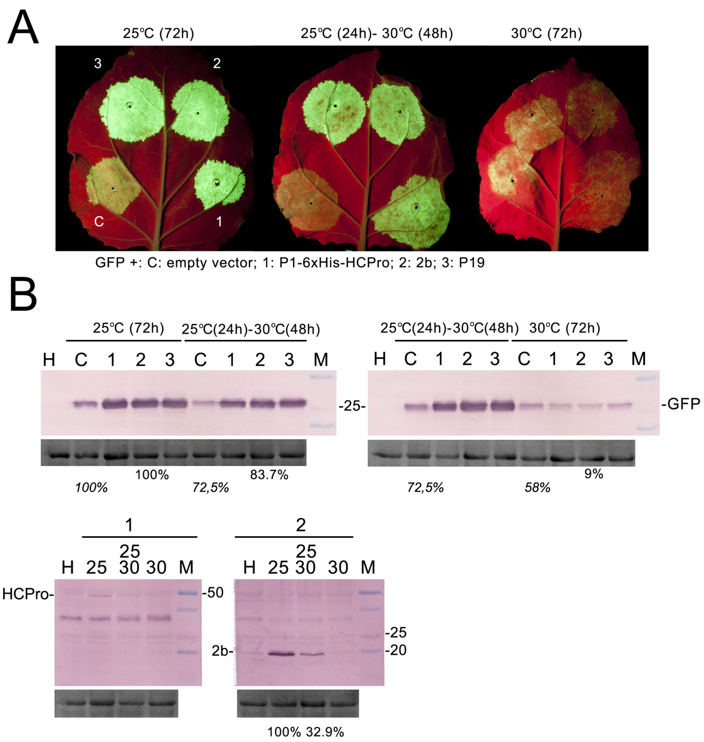
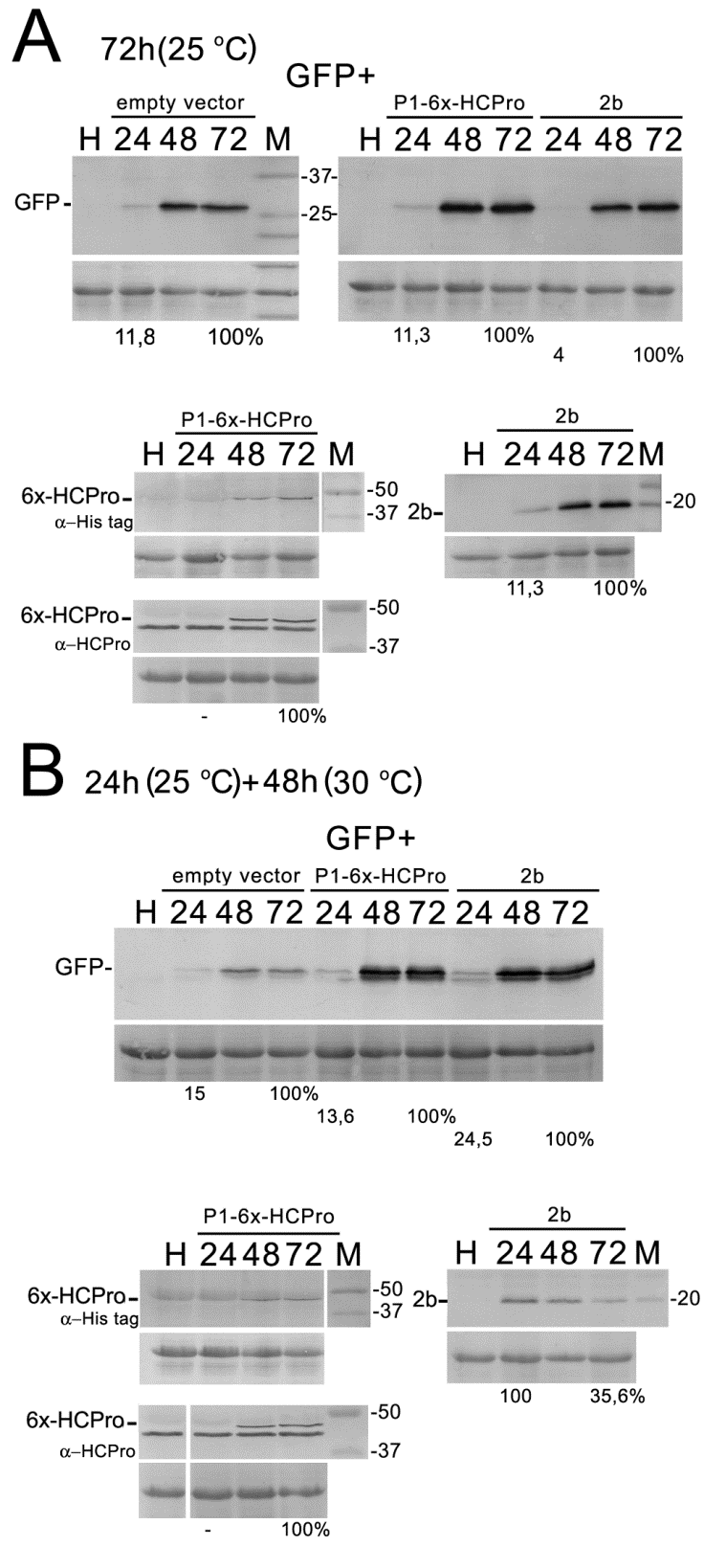

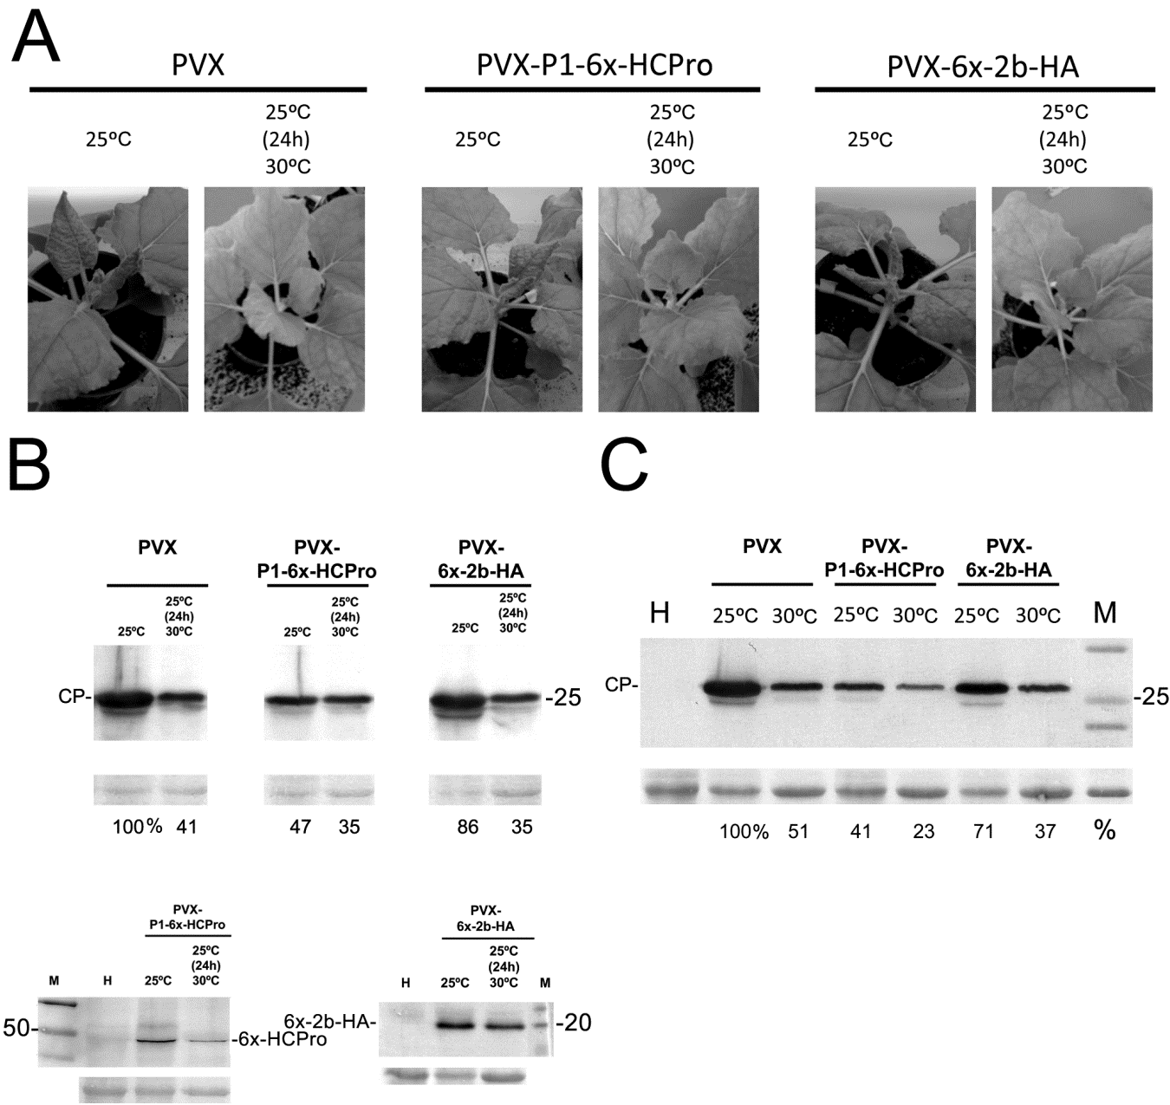

TABLE I. Visual assessment of systemic infection symptoms in plants infected with Potato virus X (PVX)-based vectors: PVX, PVX-P1-6x-HCPro or PVX-6x-2b-HA at 4 to 7 days post-infiltration.

 | 4 dpi |  | 5 dpi |  | 6 dpi |  | 7 dpi
 | 25ºC | 25ºC(24h) > 30ºC(48h) | 25ºC | 25ºC(24h) > 30ºC(48h) | 25ºC | 25ºC(24h)> 30ºC(48h) | 25ºC | 25ºC(24h) > 30ºC(48h)
PVX | no symptoms | no symptoms | curling in apical leaves, mosaic | no symptoms | curling in apical  leaves increased | no symptoms | curling in apical  leaves increased | no  symptoms
PVX-P1-6x-HCPro | no symptoms | no symptoms | curling in apical leaves, mosaic | no symptoms | curling in apical  leaves increased | no symptoms | curling in apical  leaves increased | no  symptoms
PVX-6x-2b-HA | no symptoms | no symptoms | curling in apical leaves, mosaic | no symptoms | curling in apical  leaves increased | no symptoms | curling in apical  leaves increased Start of necrosis in leaves 3 to  6 above infiltrated | no  symptoms

