**Solvent free epoxidation of vernonia oil using Ti-SBA-15 with tailor made particle morphology and pore size**

*Yaregal Awoke,1,2 Yonas Chebude,2 Carlos Márquez-Álvarez1 and Isabel Díaz1\**

*1Instituto de Catálisis y Petroleoquímica, CSIC, C/Marie Curie 2, Madrid, Spain*

*2Department of Chemistry, Addis Ababa University, Addis Ababa, Ethiopia*

**ABSTRACT**

*Vernonia galamensis* is a native weed of Ethiopia containing high concentration of naturally epoxidized oil (glyceryl trivernolate) in its seeds, which could be used as a potential substitute for currently used epoxy oils. Apart from an epoxy group, vernolic acid contains a double bond that could be further epoxidized yielding a low viscosity, high oxirane, non-edible oil. Epoxidized vegetable oils are usually produced at industrial scale mainly by the peracid process. Soluble mineral acids are essential for this process but these acidic components lead to several drawbacks. Our study deals with a solvent free epoxidation of vernonia oil using heterogeneous catalysts. Ordered mesoporous materials are good candidates as catalysts for epoxidation reactions of large molecules such as vernonia oil (MW = 926 g/mol). The aim of this work is to obtain titanium containing SBA-15 catalysts with tunable pore size and convenient particle morphology to avoid diffusion problems. Titanium was incorporated in SBA-15 catalysts by co-condensation as well as grafting methods in order to compare their catalytic performance. Ti-SBA-15 materials with hexagonal symmetry, surface area between 368 and 888 m2/g, high pore volume (0.75-1.41 cm3/g) and average pore diameter ranging from 7.2 to 14.3 nm have been successfully synthesized. The long fibers commonly observed in SBA-15 could be avoided obtaining small crystals with plate morphology having the channels running along the short axis of the crystal. DR UV-Vis and ICP-OES studies revealed that Ti has been successfully incorporated as isolated Ti(IV) species in SBA-15 while maintaining good textural properties. Ti was also incorporated in hydrophobic PMO supports by co-condensation and grafting for comparative purposes. Epoxidation of vernonia oil was carried out using anhydrous TBHP as an oxidant without any organic solvent at 70 oC. Titanium-grafted, large-pore size SBA-15 (TiCgESBAL) yielded 71 % conversion with more than 80 % selectivity, while short-channel Ti-SBA-15 and Ti-PMO showed the highest selectivity towards epoxide.

**Keywords:** Ti-SBA-15, Ti-PMO, vegetable oil epoxidation, vernonia oil

1. **Introduction**

Plant oils are frequently utilized as renewable raw materials in the chemical industry. These oils are often modified to increase their reactivity and therefore facilitate further conversion to higher value products [1]. Bio-based epoxy resins are promising alternatives to petroleum-based epoxies, due to their lower toxicity and their availability from renewable resources. Epoxy oils are widely used as raw materials for manufacturing of plastic formulations, protective coatings, lubricants, production of surfactants, polyurethanes and various types of composite materials [2]. Seeds from crops, such as soybean and linseed, are currently used as major sources of unsaturated oils for the synthesis of epoxy oils. However, these oils are edible and the chemical epoxidation process is expensive. In the mid-50s, United States Department of Agriculture conducted extensive research to identify plants not competing with existing crops as new sources of industrial raw materials. Among the many species examined, *Vernonia galamensis*, native to East Africa, received much attention due to the high concentration of naturally epoxidized oil in its seeds, which could be used as a potential substitute for currently used epoxy oils. These seeds contain more than 40 % oil, composed of vernolic (72 - 80%), oleic (4 - 6 %) and linoleic (12 - 14%) esters. Full epoxidation of vernonia oil may lead to an oxirane value of about 10% [3, 4].

Although there are several methods available to epoxidize double bonds of unsaturated fatty acids, epoxy fatty acid compounds are obtained at industrial scale mainly by the peracid process. The peracid oxidant acts as the catalytic species *in situ* when a carboxylic acid (usually formic acid) reacts with hydrogen peroxide [5, 6]. However, soluble mineral acids are essential for this process and these acidic components have several drawbacks: i) side reactions because of acid-catalyzed epoxide ring opening; ii) difficult separation of acidic by-products; iii) production of abundant neutralized salts that have to be disposed; iv) corrosion problems due to the strong acids present in the process. For these reasons, selectivity to the desired products is low. Additionally, the process does not comply with the principles and processes underlying green chemistry[7]. Due to these disadvantages, several recent studies have been undertaken paving the way to large scale, catalysis-based sustainable processes to be applied to the epoxidation of unsaturated fatty acid derivatives [8]. Herein we report our results on the selective epoxidation of vernonia oil in a solvent free medium, using Ti-incorporated ordered mesoporous materials (OMM) as catalysts.

Heterogeneous solid catalysts that can generate desired products selectively and effectively are both economical and sustainable. Metallosilicate catalysts such as zeolites and mesoporous silica with tetrahedrally coordinated transition metal species covalently linked into silica frameworks have attracted attention as oxidation catalysts because of the specific nature of the active sites and the relative natural abundance of their composition elements [9-11]. Siliceous mesoporous materials of SBA-15 type possess a regular two-dimensional array of tubular meso-channels that may be connected by micropores. In comparison with other regular mesoporous materials, SBA-15 can be prepared with larger pores, resulting in a more stable structure due to the thicker pore walls [12, 13]. Titanium containing and organically modified SBA-15 mesoporous materials attracted our attention because of their promising application as selective oxidation catalysts for unsaturated organic compounds [14]. Their catalytic activity is highly affected by their composition, structure, and method of preparation. Functionalization of SBA-15 with isolated titanium sites either through co-condensation [15, 16] or grafting [17] has been an active area in the last decade. However, the loading amount and the dispersion of Ti greatly affect its reactivity [18]. The reactivity of the Ti source in the strong acidic media required to prepare SBA-15 is the key parameters analyzed in the literature. Titanocene dichloride seems to be an efficient source to incorporate isolated Ti (IV) centers preventing from TiO2 oligomerization [19, 20]. Moreover, following the same approach and aiming at enhancing the hydrophobicity of the pore surface, the same authors incorporated Cp2TiCl2 successfully via direct synthesis in Periodic Mesoporous Organosilicas (PMO) with ethane groups forming the pore walls [21]. These works inspired us to proceed with the direct synthesis of Ti-OMM using Cp2TiCl2 in the presence of non-ionic surfactants while developing tunable oxidation catalysts for bulkier molecules that may imply both larger pore size and short diffusion paths. Limited number of papers has been published on controlling the pore size and particle morphology during functionalization of Ti active sites in SBA-15 materials. The morphology of OMM particles plays a significant role in diffusion and adsorption of molecules. [22]. Thus our aim is to synthesize Ti containing SBA-15 and PMO materials by either direct hydrothermal synthesis or grafting procedure with different pore sizes and particle morphology and to evaluate their catalytic activity in epoxidation of vernonia oil.

In this paper, we report a synthesis strategy developed to obtain well-ordered short channels SBA-15 and PMO materials bearing Ti(IV) species by using titanocene dichloride in direct synthesis. Ti incorporated ordered mesoporous material with short channels, synthesized with and without micelle expanders is reported here for the first time. The best catalysts were employed in the epoxidation of vernonia oil using tert-butyl hydroperoxide (TBHP) as an oxidant. Epoxidized vernonia oil (EVO) was successfully synthesized without solvent leading to a more sustainable and efficient synthetic method to produce epoxides of other long-chain unsaturated organic compounds.

1. **Experimental**
   1. *Reactants*

Triblock co-polymer poly(ethylene oxide)-poly(propylene oxide)-poly(ethylene oxide) Pluronic P123 (PEO20PPO70PEO20) (Sigma-Aldrich, USA) and Pluronic PE10400 or P104 (PEO27PPO62PEO27) (BASF, USA), used as structure directing agents, tetraethoxysilane (TEOS) (Merck, USA) and tetramethoxysilane (TMOS) (Alfa Aesar, Germany), ammonium fluoride (NH4F), 1,3,5-triisopropylbenzene (TIPB) (Alfa Aesar, Germany), and titanocene dichloride (Cp2TiCl2) (Sigma- Aldrich, USA), were used as purchased.

* 1. *Co-condensation or direct synthesis of Ti-SBA-15 with short channels*

The synthesis of Ti-SBA-15 with different particle morphologies and different pore sizes was optimized by varying the structure building agent, concentration of hydrochloric acid, temperature and type of swelling agents. Therefore, short channel SBA-15 with plate like particle morphology (SBA-S) were synthesized by using Pluronic PE10400 (P104) as structure building agent [23], and conventional pore size and fiber like particles (SBA-L, for “long channel”) were synthesized in the presence of Pluronic P123 [12, 24]. The materials with expanded pores (ESBA) were synthesized by using 1,3,5-triisopropylbenzene (TIPB) as a swelling agent and the above mentioned structure building agents [25, 26].

Ti incorporated ordered mesoporous material with short channels with and without expander is reported here for the first time (Ti-SBA-S and Ti-ESBA-S) using different Ti/Si ratios (0.01, 0.05 and 0.1). Typically, 1.6 g (0.271 mmol) of Pluronic PE10400 and 0.016 g NH4F were dissolved in 65.0 mL of 1.1 M aqueous HCl solution at room temperature in a closed Pyrex container, using a magnetic stirrer. Then calculated amounts of Cp2TiCl2 (0.04 g (0.16 mmol), 0.174 g (0.7 mmol) or 0.335 g (1.34 mmol)) were added and prehydrolyzed for 3 h. The container was transferred to an incubator at 15 °C and the solution was gently stirred for 1 hour to allow for temperature equilibration. Then, 0.8 mL of micelle expander TIPB was added and mixed for 30 min before adding a calculated amount of TMOS (2.21 g (14.51 mmol), 2.13 g (14 mmol) or 2.03 g (13.33 mmol) under vigorous stirring. The white gel obtained was vigorously stirred for 24 h at 15 °C and subsequently heated at 80 °C in the closed container under static conditions for 2 days. The mixture was then filtered and the solid product was washed with water and dried at room temperature. Finally, the samples were calcined in a furnace at 350 °C for 5 h (heating ramp rate: 2 °C/min).

The same procedure was repeated by changing only the structure building agent to P123 to synthesize conventional Ti-SBA-15-L materials with fiber-like particles [27].

* 1. *Co-condensation or direct synthesis of Ti-PMO with short channels*

Pluronic PE10400 (1.9 g) and NH4F (0.01 g) were dissolved at room temperature in 85.24 mL of 0.12 M HCl aqueous solution, in a closed container with slow stirring. Once the surfactant was dissolved, 5.63 g KCl were added, the container transferred to an incubator at 40ºC and the mixture kept under gentle stirring for 1 h. Then, 0.05 g of Cl2TiCp2 were added and prehydrolyzed for 3 h, followed by addition of 3.4 g of 1,2-bistriethoxysilylethane (BTESE) under vigorous stirring while heating at 40 °C for 24 h. Finally, the gel was aged at 80 °C under static conditions for 48 h. Subsequently, the solid product was recovered by filtration, washed with ethanol, dried at room temperature for 24 h, and then calcined in a furnace at 350 °C for 5 h (heating ramp rate: 2 °C/min).

* 1. *Grafting procedure TiG-SBA-15 and TiG-PMO*

For comparison purposes, Ti was incorporated via grafting of Cl2TiCp2 allowing higher loadings of Ti(IV) in the final solids. For grafting, calcined pure silica ESBA-S, ESBA-L and SBA-L and organosilica PMO-L, synthesized as indicated above but without addition of titanocene, were employed. The final samples were labeled TiG for “grafted” (TiG-SBA-15 and TiG-PMO). 1 g of the vacuum dried mesoporous support was loaded into a two necked flask and degassed at 120 ºC under vacuum for 12 h and then dispersed in a solution containing 0.274 g of Cp2TiCl2 in 100 mL of toluene. The mixture was refluxed under N2 at 140 oC for 24 h. The suspension was filtered and washed with ethanol and air dried at room temperature. After filtering, Ti(IV) active centers were obtained after calcination at 350 ºC for 5 h [28].

* 1. *Characterization of the catalysts*

Powder X ray diffraction (XRD) patterns were collected with a Philips XˊPERT diffractometer using CuKα radiation. Thermogravimetric analyses were carried out using a Perkin Elmer TGA 7 instrument in air atmosphere from 25 to 900 °C at a heating rate of 20 °C/min. Nitrogen adsorption-desorption isotherms were measured at -196 °C using a Micrometrics ASAP 2420 sorptometer to determine textural properties. All samples were pretreated at 350 °C for 16 h. Total pore volume, Vp, was determined from the amount of nitrogen adsorbed at a relative pressure of 0.97. Pore size distributions were determined from the adsorption branches of isotherms using the Barrett-Joyner-Halenda (BJH) model with cylindrical geometry of the pores. Scanning electron microscopy (SEM) micrographs were collected with a FE-SEM FEI Nova Nanosem 230 microscope with vCD detector. The samples were coated with chromium to enhance resolution. Transmission electron microscopy (TEM) images were taken using a JEOL 2100 electron microscope operating at 200 kV. The samples for TEM analyses were prepared by suspending a small amount of solid in ethanol, and dropping this suspension onto a holey carbon film on a copper grid. UV–visible diffuse reflectance spectra were registered on a Cary 5000 Varian spectrophotometer equipped with an integrating sphere and the obtained data were converted to corresponding spectra expressed according to the Kubelka–Munk function. The titanium content in the final solid products was determined by inductively coupled plasma optical emission spectroscopy (ICP-OES) Optima 3300 DV Perkin Elmer instrument. Calcined samples were previously dissolved and digested in strong acids (HNO3/HClO4).

* 1. *Epoxidation of Vernonia Oil*

Vernonia oil was obtained by supercritical carbon dioxide extraction [29] and used as a starting material for epoxidation reaction. The oil was composed of a mixture of triacylglycerols containing on average 2.0 epoxy functionalities and 3.0 olefinic groups per molecule, as determined by 1H-NMR analysis (see below for details on groups quantification). The low viscosity of vernonia oil [30] motivated us to run the epoxidation reaction without any organic solvent. The experimental conditions were developed from the work by Rios et al. [31] with some necessary modifications. Epoxidation of vernonia oil was carried out in the liquid phase at 70 °C in a 50 mL round-bottom flask equipped with a septum. Vernonia oil was used as a substrate and TBHP (5.5 M in decane solution) as the oxidant. In a typical experiment, 1.0 g (1.08 mmol) of vernonia oil and 0.32 g (3.56 mmol) of TBHP were mixed at room temperature (1:1.1 oxidant to olefinic groups molar ratio [32]). The reaction was started by adding the reaction mixture into the flask containing the catalyst (0.1 g) dried at 110 °C overnight in air prior to the experiment. The suspension was kept under magnetic stirring (400 rpm), and samples were taken periodically from the reaction mixture and analyzed by attenuated total reflection FT-IR (ATR-FTIR) spectroscopy to follow conversion of olefinic groups with time. ATR-FTIR spectra of oil samples were recorded using a Thermo Nicolet Nexus 670 FTIR spectrometer equipped with a PIKE GladiATR single-bounce monolithic diamond ATR accessory and a liquid nitrogen-cooled MCT detector. Each spectrum was obtained as the average of 128 scans recorded at room temperature with 4 cm-1 resolution in the 4000 – 650 cm-1 wavenumber. Conversion at any given reaction time was calculated as the fractional loss of absorbance of the C-H stretching band of olefinic groups (at ca. 3010 cm-1) respect to the initial reaction mixture. Products obtained after 24 h reaction were characterized by 1H and 13C NMR to evaluate selectivities. A few drops of the oil were added to CDCl3 and the solution analyzed using a Bruker AVANCE 300 MHz spectrometer with a 5 mm 1H/13C dual probe. 1H-NMR spectra were used to quantify epoxide and olefinic groups in the oil. For quantitative analysis, methylene hydrogens of glyceryl groups (sn1 and sn3 positions) were used as internal standard, as they are unaffected during epoxidation and oxidation reactions in the absence of water [33]. Conversion of olefinic groups and selectivities to epoxide were calculated from epoxide to glyceryl (EP/GL) and olefinic to glyceryl (OL/GL) molar ratios determined by 1H-NMR, using the method of Hong, et al. [34] with some modifications. The integrated intensities of all protons were normalized by assigning to the signal of the 4 protons of the glyceryl methylene groups (δ 4.0 – 4.4 ppm) a value of 4. Thus, the number of glyceryl groups, which corresponds to ¼ of this later value is assigned a value of 1. In this way, the integrated intensity of the protons in epoxide (‑CHOCH-) groups (δ 2.7 – 3.0 ppm) is equivalent to twice the number of epoxide groups per glyceryl moiety (EP/GL). The signals of olefinic (‑CH=CH-) protons (δ 5.2 – 5.6 ppm) overlap with that of the methine hydrogen of the glyceryl moiety (sn2 position). Therefore, to determine the concentration of olefinic groups, the integrated signal in the 5.2 – 5.6 ppm chemical shift range was first corrected by subtracting 1 unit (one methine proton per glyceryl group). Thus, the resulting value, divided by 2, corresponds to the number of olefinic groups per glyceryl moiety (OL/GL). The conversion of olefinic groups and the selectivity to epoxide were then determined according to:

$$Conversion \left(\%\right)=\left[\frac{{(OL/GL)}_{i}-{(OL/GL)}_{p}}{{(OL/GL)}_{i}}\right]*100$$

$$Epoxide selectivity\left(\%\right)=\left[\frac{{(OL/GL)}_{p}+ {(EP/GL)}_{p}}{{(OL/GL)}_{i}+{(EP/GL)}_{i}}\right]*100$$

where the subscripts *i* and *p* refer to the initial reaction mixture and the product after 24 h reaction, respectively.

1. **Results and discussion**
   1. *Ti-SBA-15 and Ti-PMO synthesis and characterization*

The use of titanocene as a source of Ti in the direct synthesis of Ti-SBA-15 afforded highly ordered hexagonal SBA-15 using Pluronic P104 and P123 surfactants. Figure 1 shows the XRD profiles of two sets of samples after calcination at 350ºC to remove the Cp groups. Figure 1A shows the profiles of the three samples obtained in the presence of P104 (Ti-SBA-S*n*) and Figure 1B, those of the three samples prepared using P123 (Ti-SBA-L*n*), using *n* = 1, 5 and 10 mol Ti per 100 mol Si in the synthesis gel, The patterns exhibit a strong 100 diffraction peak at very low angle followed by 110 and 200 weaker peaks in the *p*6mm symmetry characteristic of SBA-15 [12]. The unit cell parameters (a0) obtained from the d100 spacing are included in Table 1. It can be observed how the nature of the surfactant seems to affect the unit cell size obtaining larger unit cell parameters when P104 is used. The higher ratio of hydrophilic branch of the surfactant seems to provoke the growth of the crystals in the *ab* plane, rather than along the *c*-direction, the direction of the channels producing thicker pore walls as a consequence of the different crystal growth mechanism [35]. The incorporation of Ti in the presence of this surfactant is not straightforward due to the hydrophobic nature of the Cp groups [15]. As the content of Cl2TiCp2 increases in the synthesis gel, the segregation of Ti takes place, forming anatase separate phases as observed in high angle XRD profiles (Figure 2A). These phases were further observed by SEM and TEM as it will be discussed later. This phase segregation does not occur in the presence of P123, were no diffraction peaks of anatase were observed at high angle XRD (Figure 2B), indicating that in this case the Cp has more affinity for the P123 micelles as it has been reported previously [21].

When the swelling agent (tri-isopropylbenzene) is incorporated to the synthesis gel (samples labeled with “E”: Ti-ESBA-S*n* and Ti-ESBA-L*n*), the tendency for structuring versus Ti-incorporation follows inverse tendency. When P123 is used as surfactant, TIPB together with Cl2TiCp2 provoke a segregation of phases leading to high amount of anatase crystals as the Ti content increases (as shown in XRD patterns of Figure 2B), whereas P104 incorporates Ti homogeneously into the pore surface as a result of the affinity between the Cp and the TIPB (showing no anatase peaks in the XRD patterns plotted in Figure 2A). This trend seems to indicate that the expander does not act as a micelle swelling agent. Instead, it seems to be located at the interface of the wall and the micelles. In the presence of TIPB, the higher incorporation of Ti in the P123 system (see Ti-ESBA-L samples in Table 1) results in a poorly ordered SBA-15 hexagonal structure. On the other hand, the successful incorporation of Ti into well-ordered SBA-15 structure using P104, is accompanied by a rather low amount of final Ti content in the solid (samples Ti-ESBA-S, Table 1). As it can be observed in the XRD profiles of Figure 1, both systems incorporate the swelling agent, leading to a systematic shift of the d100 diffraction peak to lower angles due to the larger unit cell parameter. The pore increment occurs regardless of the amount of Ti incorporated in the gel with an average value of 5 nm larger unit cell dimensions. The aimed swelling effect was achieved obtaining pore sizes up to 14 nm (see below).

The same attempts were tried for an organically modified ordered mesoporous solid, PMO, aiming to prepare short channels in more hydrophobic catalysts in order to enhance diffusion of the bulky molecules of vernonia oil. Due to the hydrophobic nature of the silica source (1,2-bistriethoxysilylethane), in this case, only the lowest content of Cl2TiCp2 in the synthesis gel (0.01 Ti/Si ratio; sample Ti-PMO-S1) yielded a well-structured 2D hexagonal type of structure (according to the XRD pattern shown in Figure 1A), with Si–CH2-CH2-Si groups forming the pore walls. Any attempt to obtain higher loading of Ti, or to expand pores by adding TIPB to the synthesis gel, resulted in disordered mesoporous materials with foam type of porous structure having hindered access to the pore cavities. Most probably, the larger amount of hydrophobic species in the presence of a rather hydrophilic surfactant creates a large corona in the interface of the wall and the micelles, leading to the formation of spheres instead of rod-like aggregates [21]. The pore size in this case is 6 nm, like an average PMO [21].

The morphology of the catalysts was evaluated systematically by scanning electron microscopy. Figure 3 shows the SEM micrographs of selected catalysts obtained with short channels. Samples with 5 and 10% Ti ((A) Ti-SBA-S5 and (B) Ti-SBA-S10) are formed by uniform hexagonal plates. Ti-SBA-S5 shows 2 µm width hexagonal faces, while the thickness of the particles, containing the axis of the channels, is as short as 0.3 µm, corroborating the desired morphology; however, small particles of anatase could be observed as brighter small spots, more abundant in the case of 10%Ti (Ti-SBA-S10,). On the other hand, when the synthesis is conducted in the presence of expanders (Ti-ESBA-S5, Figure 3C), the size of the crystals is much smaller having the shape of small cylinders. The length of the channels remains at around 0.3 µm, while the diameter of this rods (0.5 µm) is much smaller compared to Ti-SBA-S5. No phase segregation was observed in the pore-expanded sample. Finally, Figure 3D shows the large hexagonal platelets forming the Ti-PMO-S1 sample. Samples prepared using P123 were formed in all cases by fibers, typical of SBA-15 type of materials (Figures 3E and F). The orientation of the channels within the crystals was corroborated by TEM. Interestingly, the TEM observations revealed that anatase crystals (previously detected by XRD) are systematically formed by oval shaped mesoporous anatase. Figure 4A shows a typical image of sample Ti-SBA-S5 with hexagonal arrangement of mesopores, and oval shaped 200 nm particles (marked with a circle), which at high magnification (Figure 4B) reveals the mesoporosity seen as diffuse lighter contrast areas within the crystalline structure of anatase (indexed in the electron diffraction pattern of the inset). These mesoporous anatase particles are observed in all the samples for which XRD and SEM show phase segregation.

Looking into the nature of the Ti species incorporated in the different systems, all the samples were calcined at 350ºC in order to promote condensation of the remaining defects of condensation in the Ti species while removing the Cp groups but avoiding burial of the Ti species in the pore walls [36]. The calcination process was followed by thermogravimetric analysis (Figure 5). In the plot, it can be observed that the sharp weight loss centered at ca. 300ºC in as-made samples, due to the release of the surfactant, disappears after calcination for 5h at 350ºC. In the case of PMO, calcination was employed instead of solvent extraction in order to ensure the full condensation of the titanocene groups avoiging leaching during the catalytic reaction [21]. Similarly, the surfactant is lost after calcination at 350ºC, while the weight loss due to the -CH2-CH2- groups in the pore walls remains stable at around 600ºC.

Regardless of the presence of anatase, the UV-Vis spectra of all the samples show a band at 200-220 nm (Figure 6). This absorption band could be assigned to a charge transfer between the oxygen ligands and a central Ti (IV) ion with tetrahedral coordination in isolated species [37]. Figure 6A shows the UV-Vis of the samples obtained in the presence of P104, including PMO, and Figure 6B shows the samples prepared using P123. At low titanium loading, the observed absorption band at 210 nm is very weak. When the Ti loading increases, the intensity of the absorption band in this wavelength range increases due to the incorporation of high amount of Ti (IV) isolated sites, shifting the band towards λ ≥ 230 nm indicates extension of the coordination number to 5- or 6- but still for single Ti atom species. The shoulders observed in the curves extending up to 370 nm, showed the presence of TiO2-like clusters as observed before [38]. In the case of expanded-pore samples, the little amount of Ti incorporated when using the P104 surfactant led to very weak yet clearly defined 210 nm band in Ti-ESBA-S5 and -S10 due to isolated Ti(IV) species. On the other hand, the use of expander in the presence of P123 allowed incorporating higher amount of Ti (see Table 1) although in a very broad range of coordination stages (210 to 260-290 nm) and incipient oligomerization (λ ≥ 300 nm) as it can be observed by the broad plateau extended from 210 to 340 nm. In our opinion, samples prepared with P104 follow a regular distribution of more isolated Ti(IV) species probably due to the presence of the cyclopentadienyl ligands that assist the incorporation of titanium on the surface of the material minimizing the agglomeration of titanium clusters due to hydrophobic interaction of cyclopentadienyl with the center of the micelle. This scenario is not equally occurring in the presence of P123.

The N2 adsorption-desorption isotherms of all materials are type IV and show steeply sloped isotherms and large hysteresis at high relative pressures (Figure 7). This feature is typical of mesoporous materials that have large pore sizes. They show type H1 hysteresis loop, which is often associated with porous materials consisting of well-defined cylindrical-like pore channels or agglomerates of approximately uniform spheres [39]. The small extra step observed in the desorption branch in some of the samples, could be due to a possible partial blockage of few pore mouths. The actual pore size in each sample (Table 1) varies upon the purity and degree of structuring of the samples without a clear tendency, in particular the incorporation of Ti in large pore well-ordered SBA-15 structure was successfully achieved in the Ti-ESBA-S system. Although more titanium is incorporated to the channel walls of the samples prepared with P123 (“L” series) those catalysts were ignored due to the heterogeneity of the sample in terms of Ti species that produced catalysts with limited accessibility, or even due to the covering up of Ti within the thick amorphous wall of SBA-15 and therefore in active for oxidation reaction [15].

Finally, in order to compare the effect of the synthesis method on the efficiency of the catalysts, four Ti-Grafted samples were prepared with different pore size, particle morphology and surface chemistry. Hexagonally arranged pure silica SBA-15 materials with short, wide pore channels, ESBA-S (plate-like particle shape, synthesized with micelle swelling agent), and with long pore channels (fiber type of particles), synthesized without and with micelle swelling agent (SBA-L and ESBA-L, respectively), were grafted with Ti(IV) species and calcined at 350ºC yielding TiG-ESBA-S, TiG-SBA-L and TiG-ESBA-L samples, with pore diameters, 12.0 nm, 8.4 nm and 10.5 nm, respectively. Organically modified PMO with short channels was also grafted obtaining TiG-PMO-S with pore diameter less than 6 nm. The chemical, structural and textural properties are included in Table 1. As it can be observed in the XRD profiles shown in Figure 8A, the symmetry and arrangement of pores was not affected by the grafting procedure. All the materials have high Ti content (Table 1) with no significant presence of anatase phase according to XRD analysis (Figure 8B). The pore diameter has decreased in all cases from the starting material before grafting yet the isotherms remain those of typical ordered mesoporous materials (Figure 8C). The UV-Vis spectra show a broad band at around 210 nm that extends to 240 nm owing to the presence of isolated Ti(IV) Td species at 4- and probably higher coordination stages indicating that the grafting produces one type of Ti species population [40], in contrast with the direct synthesis. However, in this grafted samples, the Ti active sites might be mainly anchored to the surface of the particles and to the pore openings of the channels instead of incorporated to the channel walls.

* 1. *Epoxidation of vernonia oil using Ti-SBA-15 and Ti-PMO*

Epoxidation of vernonia oil (Figure 9) would require large pore sizes and active Ti(IV) species to proceed. Our aim was initially to work with solvents and at low temperature to avoid viscosity increase. In our first attempts we tried to epoxidize vernonia oil using acetonitrile and heptane as solvents at 50, 60 and 70 oC. However, in all cases, the ATR-FTIR spectra of the reaction mixture showed no significant changes with time, indicating that negligible conversion levels were attained [41, 42]. This is probably due to the fact that both solvents are not suitable for mixing the oil, oxidant and catalyst. Therefore, we tried to follow the epoxidation reaction at 70 oC, acting the TBHP (10% in decane) as solvent. In all catalytic runs, the reaction was monitored by FTIR (Figure S1). The disappearance of the bands at 3010 cm-1 (νCH of unsaturated carbon) and 1650 cm-1 (νC=C) was an evidence of the conversion of the olefinic carbon of the vernonia oil, while the increase of peak intensity at ca. 824 cm-1 supported the formation of epoxide groups [41]. These spectra allowed determining conversion of olefinic carbon groups along the reaction time by following the decrease of intensity of the C-H stretching band at ca. 3010 cm-1. Figure 10 shows the conversion versus time of the reaction conducted with selected catalysts followed by FTIR (initial reaction rates calculated from these curves are also included in Table 2). As it can be observed, TiG-ESBA-L shows the highest initial reaction rate, probably due to the large pore diameter that allowed easy diffusion of reagents and products. The high content of isolated Ti sites in this sample, together with the large pore size justifies the highest conversion obtained for this catalyst. When we compare the catalysts with short channels, a slight difference in the initial reaction rate is observed in favour of Ti-PMO-S over Ti-SBA-S5 and Ti-ESBA-S5, probably due to a higher affinity of the vernonia oil with the hydrophobic surface of the pores in this case, despite the very low amount of Ti (0.62wt%) in this catalyst. In this group of catalysts, the highest conversion is achieved by the Ti-Grafted sample (TiG-ESBA-S), justified once again by the higher content of Ti active sites (3.43wt%). However, the activity of this later sample is not as high as would be expected when compared with those of the catalysts prepared by direct synthesis, which contain less than 1wt % Ti. In the case of Ti-SBA-S5, the presence of anatase crystals in the sample represents an inactive share of titanium in the sample, whereas in the Ti-ESBA-S5, the low activity values are due to the presence of only 0.22wt% Ti. In summary, what seems to be clear from this plot is that large pore, and a Ti content in the range of 2-3% yield high conversion in this reaction regardless of the length of the channels, although a hydrophobic surface seems to have a major effect on the adsorption of the vernonia oil making the Ti sites more efficient.

Upon stabilization (24 h of reaction), conversion, selectivity and yield to EVO were quantified using 1H NMR. Identification of the different functional groups was also supported by 13C NMR (full 1H and 13C NMR spectra of vernonia oil and its epoxidation product are included in Figure S2). The epoxidation of olefinic groups present in the oil is evidenced by the development of 1H resonances in the 2.9-3.1 ppm range and 13C peaks at ca. 68-69 ppm, with a concomitant depletion of the olefinic protons signals at δ 5.3 – 5.6 ppm and olefinic carbon signals in the range 123-134 ppm. Downfield shifts of 13C atoms in epoxy groups were observed when the number of epoxy groups increased in the fatty acid chain. The NMR spectra showed that, for all catalysts testes, the major product of reaction at 70 oC was epoxidized vernonia oil, while very small amount of polyols were produced due to ring opening. 13C-NMR confirms the absence of other side products like ketone and enone esters (absence of peaks at around 200 ppm). Furthermore, NMR results showed that the triglyceride structure remained intact after epoxidation.

Conversion, selectivity and epoxide yield determined by 1H NMR analysis of the products obtained after 24 h of reaction are collected in Table 2, along with turnover number calculated as mol EVO/mol Ti for each catalyst. One has to bear in mind that we are working with the pure oil, with relatively high viscosity, and without solvent, which explains the lower conversion values as compared to epoxidation of fatty acid methyl esters [40]. The conversions obtained do not follow any trend respect to Ti content of the catalysts, although values around 2 wt% Ti seem to be optimum to reach conversions above 40%. However, it is remarkable the result given by the catalyst Ti-PMO-S which with only 0.62% of Ti, gives a conversion of 41% at 24 h. If we compare only the “S” family (catalysts containing short pore channels), the increase of conversion follows the increase of Ti content, maintaining in all cases selectivities > 90%. The effect of the pore size is difficult to isolate because the catalysts do not contain the same amount of actve Ti sites. However, pore size does not seem to be crucial for the diffusion of VO since Ti-SBA-S5 with relatively narrow pores (8 nm) converts 41% with 88% selectivity, while Ti-ESBA-S5, with 12 nm pore size, only converts 26% of VO with 94% selectivity, and Ti-PMO-S is the most efficient catalyst (41% conversion, 92% selectivity) despite its narrow pore size of 6.1 nm. This indicates that the surface chemistry is more important than the actual pore size. The efficiency of the small amounts of Ti in Ti-ESBA-S (0.22 wt%) and Ti-PMO-S (0.62 wt%), as indicated by the highest TON, corroborates the presence of isolated Ti(IV) sites in these samples, against the mixture of several types of populations in Ti-SBA-S5 which contained small crystals of anatase. On the other hand, when Ti-ESBA-S and Ti-PMO-S catalysts are compared with their Ti-grafted counterparts, TiG-ESBA-S and TiG-PMO-S, it can be seen a significant drop of catalytic activity of the later samples despite the successful increment of Ti content (3.43 and 2.39 wt%, respectively). This is probably due to the fact that grafting produces mainly external surface sites, or maybe less condensed sites, with pending OH groups, less efficient in this reaction [21], besides the decrement in pore size in the case of PMO (5.4 nm). For the “L” group of catalysts, with pore sizes around 8 nm but with fiber-like particle morphology (long pore channels), conversion decreases to 39% despite the Ti contents are higher (1.2 5wt% for Ti-SBA-L5 and 2.97 wt% for Ti-SBA-L10) demonstrating that the fiber-like particle morphology hinders the diffusion of VO and EVO and, therefore, decrease the efficiency of the catalyst (lower TON values). Finally, for Ti-grafted catalysts, the notable increase in Ti content achieved in these catalyst (4.65 wt% in TiG-SBA-L and 3.31 wt% in TiG-ESBA-L), does not produce a proportional increase of activity, which results in lower TON values. However, the highest conversion (71%) is achieved for TiG-ESBA-L, probably due to its large pore size (10.5 nm) together with the large amount of Ti sites. These results, in our opinion, indicate that 2 wt% of Ti(IV) isolated sites is a good value for this reaction, in a hydrophobic pore surface such as PMO, with pore sizes between 6 and 10 nm, and with a short-channel particle morphology.

1. **Conclusions**

Surfactant Pluronic PE10400 has been used to obtain hexagonal platelets with short-channels of Ti-SBA-15 using titanocene as Ti source and triisopropylbencene as pore expander. The same surfactant was employed to incorporate Ti in PMO pore walls obtaining also hexagonal platelets with short channels. Solvent free epoxidation of vernonia oil with anhydrous tert-butyl hydroperoxide (5.5 M TBHP in decane solution) in the presence of titanium containing SBA-15 and PMO catalysts was investigated. Ti-grafted large-pore conventional SBA-15 shows the highest conversion showing no restriction to diffusion, although Ti-SBA-15 and Ti-PMO materials with hexagonal platelet morphologies having short pore channels gave better yields in epoxidation of vernonia oil than those with conventional rod like morphologies possessing longer channels. These catalysts show promising epoxidation properties due to the short diffusion path obtained which could be further improved by achieving higher Ti loading as well as increased pore size.

**Acknowledgments**

The authors acknowledge the funding by the Spanish Ministry of Science, Innovation and Universities (formerly the Ministry of Economy and Competitiveness), Project MAT2016-77496-R (AEI/FEDER, UE), and CSIC, Project iCOOP+2016 COOPA20136, and the School of Chemistry, University of Nottingham, for supplying scCO2-extracted VO. We thank Chemistry Department, Addis Ababa University, and BETAQUIMICA for their support. YA also acknowledges Assosa University for financial support.

**References**

[1] F. Haitz, S. Radloff, S. Rupp, M. Frohling, T. Hirth, S. Zibek, Appl. Biochem. Biotechnol. 185 (2018) 13-33.

[2] S.G. Tan, W.S. Chow, Polym.-Plast. Technol. Eng. 49 (2010) 1581-1590.

[3] K.D. Carlson, S.P. Chang, JAOCS 62 (1985) 934-939.

[4] T. Baye, H.C. Becker, S.v. Witzke-Ehbrecht, Ind. Crop. Prod. 21 (2005) 257-261.

[5] S. Dinda, A.V. Patwardhan, V.V. Goud, N.C. Pradhan, Bioresour. Technol. 99 (2008) 3737–3744.

[6] E. Milchert, A. Smagowicz, G. Lewandowski, J. Chem. Technol. Biotechnol. 85 (2010) 1099-1107.

[7] N. Asfaw, Y. Chebude, A. Ejigu, B.B. Hurisso, P. Licence, R.L. Smith, S.L.Y. Tang, M. Poliakoff, Green Chem. 13 (2011) 1059–1060.

[8] S.M. Danov, O.A. Kazantsev, A.L. Esipovich, A.S. Belousov, A.E. Rogozhin, E.A. Kanakov, Catal. Sci. Technol. 7 (2017) 3659-3675.

[9] K.M. Choi, T. Yokoi, T. Tatsumi, K. Kuroda, J. Mater. Chem. A 1 (2013) 2485–2494.

[10] N. Wilde, J. Přech, M. Pelz, M. Kubů, J. Čejka, R. Gläser, Catal. Sci. Technol. 6 (2016) 7280-7288.

[11] J. Přech (2018) Catal. Rev. 60 (2018) 71-131.

[12] D. Zhao, J. Feng, Q. Huo, N. Melosh, G.H. Fredrickson, B.F. Chmelka, G.D. Stucky, Science 279 (1998) 548-552.

[13] D. Zhao, Q. Huo, J. Feng, B. F. Chmelka, G. D. Stucky, J. Am. Chem. Soc. 120 (1998) 6024-6036.

[14] J. Iglesias, J. A. Melero, J. Sainz-Pardo, J. Mol. Catal. A-Chem 291 (2008) 75-84.

[15] Y. Chen, Y. Huang, J. Xiu, X. Han, X. Bao, Appl. Catal. A-Gen 273 (2004) 185-191.

[16] H. Chu, Y. Wan, D. Zhao, Catal. Today, 148 (2009) 19-27.

[17] E. Gianotti, C. Bisio, L. Marchese, M. Guidotti, N. Ravasio, R. Psaro, S. Coluccia, J. Phys. Chem. C 111 (2007) 5083-5089.

[18] W. Zhan, J. Yao, Z. Xiao, Y. Guo, Y. Wang, Y. Guo, G. Lu, Micropor. Mesopor. Mater., 183 (2014) 150-155.

[19] T. Maschmeyer, F. Rey, G. Sankar, J. M. Thomas, Nature 378 (1995) 159.

[20] J. A. Melero, J. M. Arsuaga, P. Frutos, J. Iglesias, J. Sainz, S. Blázquez Micropor. Mesopor. Mater. 86 (2005) 364-373

[21] J. A. Melero, J. Iglesias, J. M. Arsuaga, J. Sainz-Pardo, P. de Frutos, S. Blazquez, J. Mater. Chem. 17 (2007) 377-385.

[22] V. Gascon, I. Diaz, C. Marquez-Alvarez, R.M. Blanco, Molecules, 19 (2014) 7057-7071.

[23] P. Linton, V. Alfredsson, Chem. Mater. 20 (2008) 2878-2880.

[24] G. Gómez, J. A. Botas, D. P. Serrano, P. Pizarro, Catal. Today 277 (2016) 152-160.

[25] L. Cao, T. Man, M. Kruk, Chem. Mater. 21 (2009) 1144-1153.

[26] L. Cao, M. Kruk, Colloid. Surface A 357 (2010) 91-96.

[27] W.-H. Zhang, J. Lu, B. Han, M. Li, J. Xiu, P. Ying, C. Li, Chem. Mater. 14 (2002) 3413-3421.

[28] M. Guidotti, N. Ravasio, R. Psaro, E. Gianotti, L. Marchese, S. Coluccia, Green Chem. 5 (2003) 421-424.

[29] J.W. King, A. Mohamed, S.L. Taylor, T. Mebrahtu, C. Paul, Ind. Crop Prod. 14 (2001) 241-249.

[30] P. Muturi, D. Wang, S. Dirlikov, Prog. Org. Coat. 25 (1994) 85-94.

[31] L. Rios, P. Weckes, H. Schuster, W. Hoelderich, J. Catal. 232 (2005) 19-26.

[32] A. Campanella, M. A. Baltanás, M. C. Capel-Sánchez, J. M. Campos-Martín, J. L. G. Fierro, Green Chem. 6 (2004) 330-334.

[33] W. Xia, S.M. Budge, M.D. Lumsden, J. Agric. Food Chem. 63 (2015) 5780-5786.

[34] M. Hong, M.-Y. Yao, H. Pan, RSC Adv. 5 (2015) 91558–91563.

[35] P. Linton, H. Wennerstrom, V. Alfredsson, Phys. Chem. Chem. Phys. 12 (2010) 3852-3858.

[36] E. Gianotti, V. Dellarocca, L. Marchese, G. Martra, S. Coluccia, T. Maschmeyer, Phys. Chem. Chem. Phys. 4 (2002) 6109-6115.

[37] [P. Ratnasamy,](https://www.sciencedirect.com/science/article/pii/S0360056404480018" \l "!) [D. Srinivas,](https://www.sciencedirect.com/science/article/pii/S0360056404480018" \l "!) [H. Knözinger,](https://www.sciencedirect.com/science/article/pii/S0360056404480018" \l "!) Adv. Catal. 48 (2004) 1-169.

[38] M. Guidotti, N. Ravasio, R. Psaro, E. Gianotti, S. Coluccia, L. Marchese, J. Mol. Catal. A-Chem. 250 (2006) 218-225.

[39] Z. Alothman, Materials 5 (2012) 2874-2902.

[40] M. Guidotti, R. Psaro, N. Ravasio, M. Sgobba, E. Gianotti, S. Grinberg, Catal. Lett. 122 (2008) 53-56.

[41] T.D. Zeleke, Y.M. Ayana, Am. J. App. Chem. 5(2017) 1-6.

[42] A. Sammaiah, K.V. Padmaja, R.B. Narayna Prasad, J. Oleo Sci. 63 (2014) 637-643.

**Table 1. Structural, chemical and textural properties of the Ti-containing catalysts**

|  |  |  |  |  |  |  |  |  |  |
| --- | --- | --- | --- | --- | --- | --- | --- | --- | --- |
| **Catalyst** | **a0**  **(nm)** | **Pore size**  **(nm)** | **Pore wall**  **(nm)** | **Ti**  **(wt%)** | | **Vp**  **(cm3/g)** | | **SBET**  **(m2g-1)** | |
| Ti-SBA-S10 | 12.1 | 7.2 | 4.9 | | 5.51 | | 0.76 | | 731 | |
| Ti-SBA-S5 | 12.1 | 8 | 4.1 | | 2.83 | | 0.93 | | 842 | |
| Ti-SBA-S1 | 13.4 | 9.6 | 3.8 | | 0.26 | | 0.76 | | 888 | |
| Ti-ESBA-S10 | 17.2 | 14.3 | 2.9 | | 0.52 | | 1.14 | | 830 | |
| Ti-ESBA-S5 | 15.9 | 12 | 3.9 | | 0.22 | | 1.17 | | 776 | |
| Ti-ESBA-S1 | 17.2 | 14 | 3.2 | | 0.12 | | 0.81 | | 675 | |
| Ti-PMO-S1 | 12.1 | 6.1 | 6.0 | | 0.62 | | 0.59 | | 640 | |
| Ti-SBA-L10 | 11.4 | 7.3 | 4.1 | | 2.97 | | 0.83 | | 763 | |
| Ti-SBA-L5 | 11.6 | 8 | 3.6 | | 1.25 | | 0.98 | | 849 | |
| Ti-SBA-L1 | 11.8 | 8.6 | 3.2 | | 0.22 | | 1.08 | | 869 | |
| Ti-ESBA-L10 | 16.3 | 14.4 | 1.9 | | 4.72 | | 1.41 | | 598 | |
| Ti-ESBA-L5 | 14.4 | 13.2 | 1.2 | | 2.25 | | 1.34 | | 589 | |
| Ti-ESBA-L1 | 15 | 14.1 | 0.9 | | 0.08 | | 1.25 | | 556 | |
| TiG-ESBA-S | 15.9 | 12.0 | - | | 3.43 | | 1.08 | | 681 | |
| TiG-PMO-S | 12.1 | 5.4 | - | | 2.39 | | 0.43 | | 446 | |
| TiG-SBA-L | 11.0 | 8.4 | - | | 4.65 | | 0.98 | | 630 | |
| TiG-ESBA-L | 13.7 | 10.5 | - | | 3.31 | | 0.75 | | 368 | |

Table 2. Results of epoxidation of vernonia oil by using selected catalysts (10% weight of catalyst) at 70ºC for 24h.

|  |  |  |  |  |  |  |  |
| --- | --- | --- | --- | --- | --- | --- | --- |
| **Catalyst** | **Ti**  **(wt%)** | **Pore size**  **(nm)** | **Initial reaction rate**  **(mmol/h) a** | **Conversion (%)** | **Selectivity (%)** | **Yield (%)** | **TON** |
| Ti-SBA-S5 | 2.83 | 8 | 0.10 | 41 | 88 | 36 | 7.4 |
| Ti-ESBA-S5 | 0.22 | 12 | 0.07 | 26 | 94 | 24 | 64.8 |
| Ti-ESBA-S10 | 0.52 | 14.3 | 0.11 | 32 | 93 | 30 | 34.2 |
| Ti-PMO-S1 | 0.62 | 6.1 | 0.13 | 41 | 92 | 37 | 35 |
| Ti-SBA-L10 | 2.97 | 7.3 | 0.09 | 39 | 93 | 36 | 7.2 |
| Ti-SBA-L5 | 1.25 | 8 | 0.09 | 39 | 92 | 36 | 16.8 |
| TiG-ESBA-S | 3.43 | 12 | 0.12 | 45 | 83 | 37.6 | 6.4 |
| TiG-PMO-S | 2.39 | 5.4 | 0.07 | 28 | 90 | 25 | 6.15 |
| TiG-SBA-L | 4.65 | 8.4 | 0.05 | 49 | 84 | 41 | 5.06 |
| TiG-ESBA-L | 3.31 | 10.5 | 0.27 | 71 | 80 | 57 | 10 |
| SBA-15 |  |  |  | 5.41 | 92 | 5.6 | - |
| BLANK |  |  |  | 5.41 | 91 | 5.5 | - |

a Estimated from the vernonia oil conversion level measured within the first 2 h of reaction.

Figures

Figure 1. Low-angle X-ray diffraction patters of the samples prepared by co-condensation using three different Ti/Si ratios, (A) in the presence of P10400 (Ti-SBA-S) and (B) in the presence of P123 (Ti-SBA-L).



**A**

**B**

**Ti-SBA-S10**

**Ti-SBA-S5**

**Ti-SBA-S1**

**Ti-PMO-S1**

**Ti-ESBA-S10**

**Ti-ESBA-S5**

**Ti-ESBA-S1**

**Ti-ESBA-L10**

**Ti-ESBA-L5**

**Ti-ESBA-L1**

**Ti-SBA-L1**

**Ti-SBA-L5**

**Ti-SBA-L10**



Figure 2. High angle X ray diffraction patters of the samples prepared by co-condensation using three ratios of Cp2TiCl2: (A) in the presence of P10400 (Ti-SBA-S) and (B) in the presence of P123 (Ti-SBA-L). Sharp diffraction peaks correspond to anatase phase.



**Ti-SBA-S10**

**Ti-SBA-S5**

**Ti-SBA-S1**

**Ti-PMO-S1**

**Ti-ESBA-S1**

**Ti-ESBA-S5**

**Ti-ESBA-S10**

**Ti-ESBA-L10**

**Ti-ESBA-L5**

**Ti-ESBA-L1**

**Ti-SBA-L1**

**Ti-SBA-L5**

**Ti-SBA-L10**



**A**

**B**

Figure 3. SEM micrographs of selected catalysts: (A) Ti-SBA-S5, (B) Ti-SBA-S10, (C) Ti-ESBA-S5, (D) Ti-PMO-S1, (E) Ti-SBA-L5 and (F) Ti-SBA-L10.

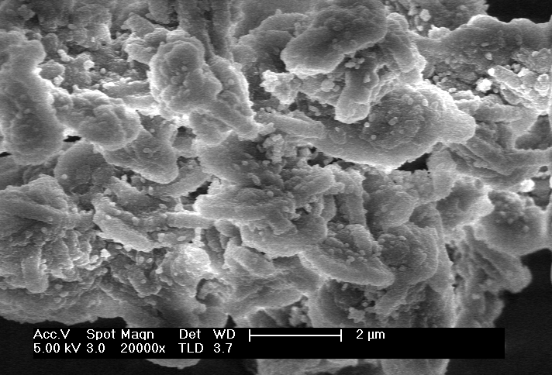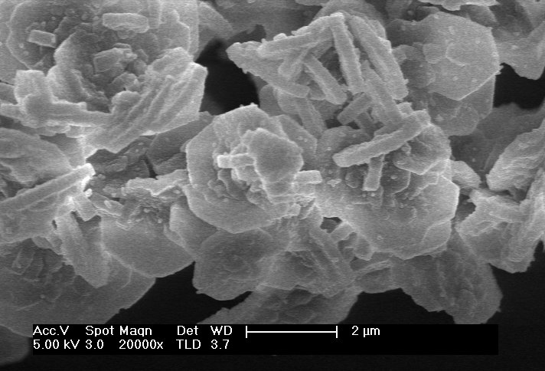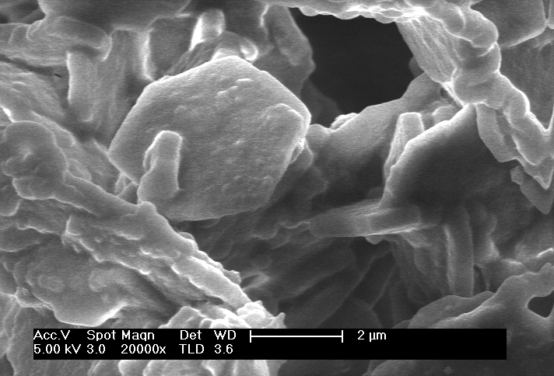

**2 µm**

**2 µm**

**2 µm**

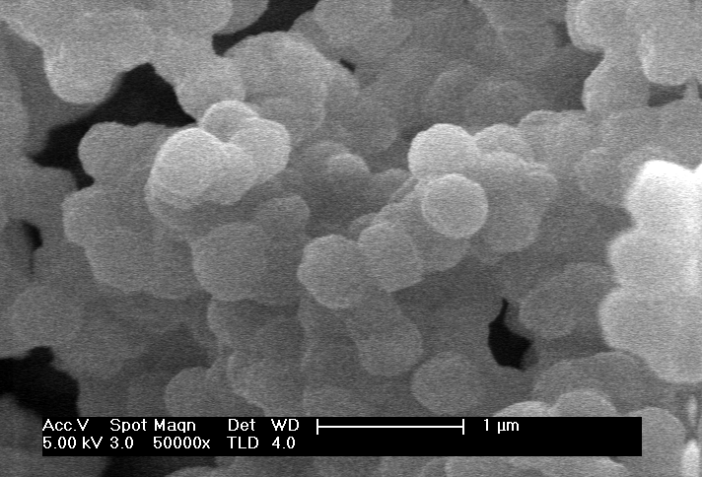

**1 µm**

**A**

**B**

**C**

**D**

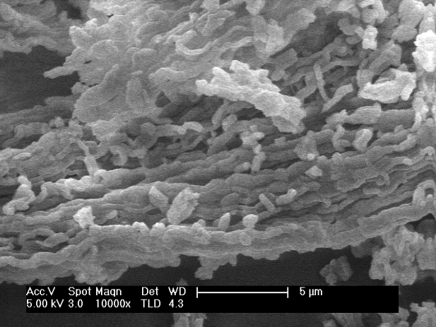

**E**

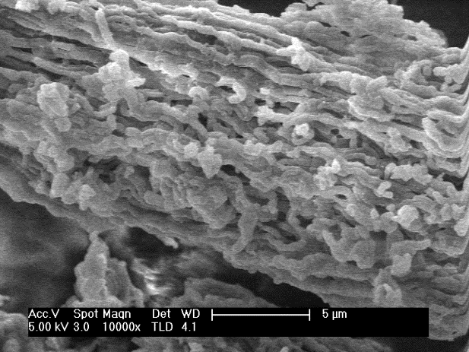

**F**

**5 µm**

**5 µm**

Figure 4. TEM Images of selected catalysts: (A) Ti-SBA-S5, (B) High magnification image of the anatase crystals in Ti-SBA-S5, with the electron diffraction pattern in the inset. (C) Ti-ESBA-S5 showing large pores along the cylinders.

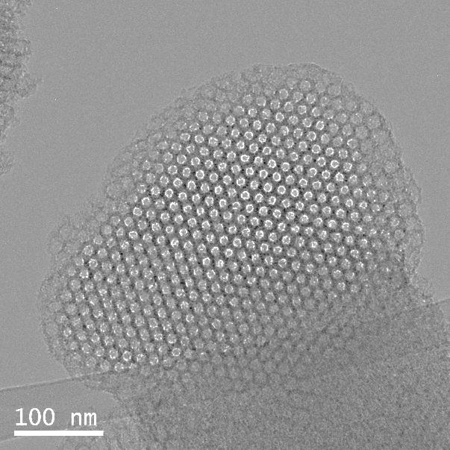

**C**

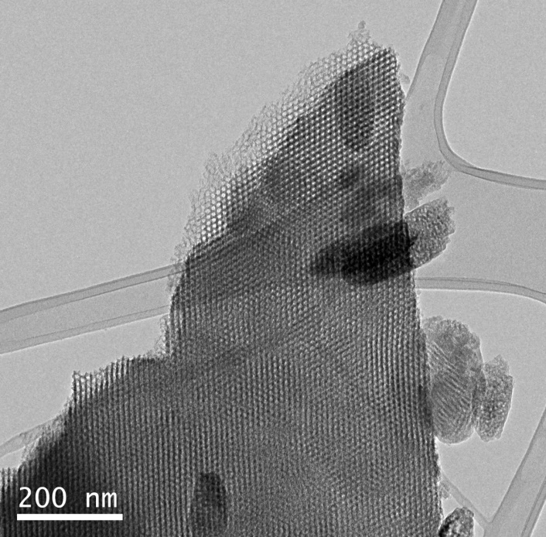

**A**

**100 nm**

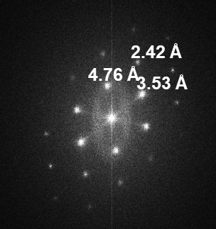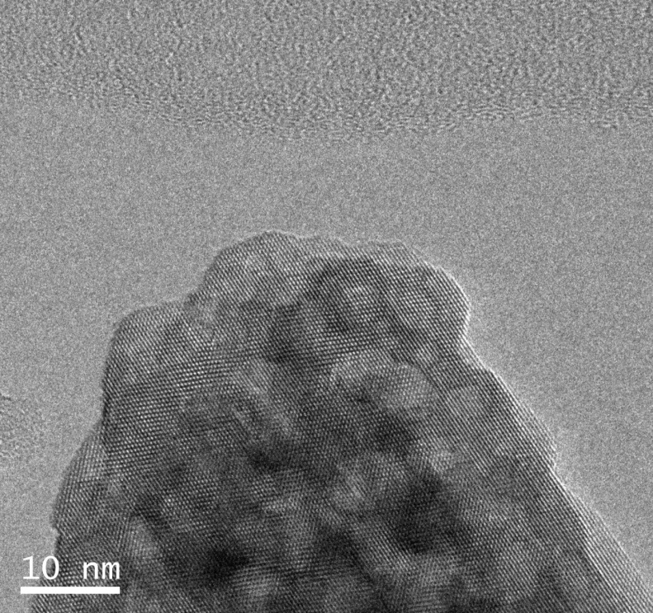

**B**

Figure 5. Thermograms of two samples before (dashed line) and after (solid line) calcination at 350ºC for 5h.



**Ti-PMO-S1calc**

**Ti-ESBA-S5calc**

**Ti-PMO-S1**

**Ti-ESBA-S5**

Figure 6. UV-Vis of the samples prepared by co-condensation (A) in the presence of P104 (Ti-SBA-S) and (B) in the presence of P123 (Ti-SBA-L).



**Ti-SBA-L10**

**Ti-SBA-L5**

**Ti-SBA-L1**

**Ti-ESBA-L1**

**Ti-ESBA-L10**

**Ti-ESBA-L5**

**Ti-ESBA-S10**

**Ti-ESBA-S5**

**Ti-ESBA-S1**

**Ti-PMO-S1**

**Ti-SBA-S10**

**Ti-SBA-S5**

**Ti-SBA-S1**

**A**

**B**

Figure 7. N2 isotherms of the samples prepared by co-condensation in the presence of (A) P104 (Ti-SBA-S), (B) P123 (Ti-SBA-L), (C) P104 with expander (Ti-ESBA-S) and (D) P123 with expander (Ti-ESBA-S).



**D**

**C**

**B**

**A**

Figure 8. Characterization of the samples prepared by grafting of Cl2TiCp2. (A) Low angle XRD, (B) high angle XRD, (C) UV-Vis and (D) N2 adsorption-desorption isotherms.



**A**

**B**

**C**

**D**

**TiG-SBA-L**

**TiG-ESBA-L**

**TiG-PMO-S**

**TiG-ESBA-S**

**TiG-SBA-L**

**TiG-ESBA-L**

**TiG-PMO-S**

**TiG-ESBA-S**

**TiG-SBA-L**

**TiG-ESBA-L**

**TiG-PMO-S**

**TiG-ESBA-S**

**TiG-SBA-L**

**TiG-ESBA-L**

**TiG-ESBA-S**

**TiG-PMO-S**

Figure 9. Scheme of the epoxidation of vernonia oil using Ti-containing SBA-15.

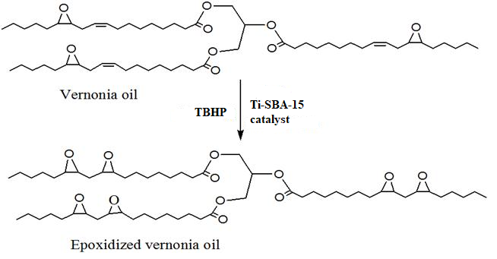

Figure 10. Vernonia oil conversion determined by ATR-FTIR analysis for selected catalysts.

