**Magnetic** **spent coffee biochar (Fe-BC) activated** **peroxymonosulfate system for humic acid removal from water and membrane fouling mitigation**

Yatong Lia,b, Xinbo Zhanga,b,*, Huu Hao Ngoc,a*, Wenshan Guoc,a, Dan Zhanga,b, Huizhong Wanga,b, Tianwei Longa,b

a*Joint Research Centre for Protective Infrastructure Technology and Environmental Green Bioprocess, School of Environmental and Municipal Engineering, Tianjin Chengjian University, Tianjin 300384, China*

*bTianjin Key Laboratory of Aquatic Science and Technology, Tianjin Chengjian University, Jinjing Road 26, Tianjin 300384, China*

*cCentre for Technology in Water and Wastewater, School of Civil and Environmental Engineering, University of Technology Sydney, Sydney, NSW 2007, Australia*

*Correspondence authors: Email: zxbcj2006@126.com (X. B. Zhang);

ngohuuhao121@gmail.com (H. H. Ngo)



**Fig. S1.** Water contact angle of UF membrane



**Fig. S2.** FTIR spectra of BC and Fe-BC.

 

 

**Fig. S3.** XPS spectra of Fe-BC (up) and BC (down).

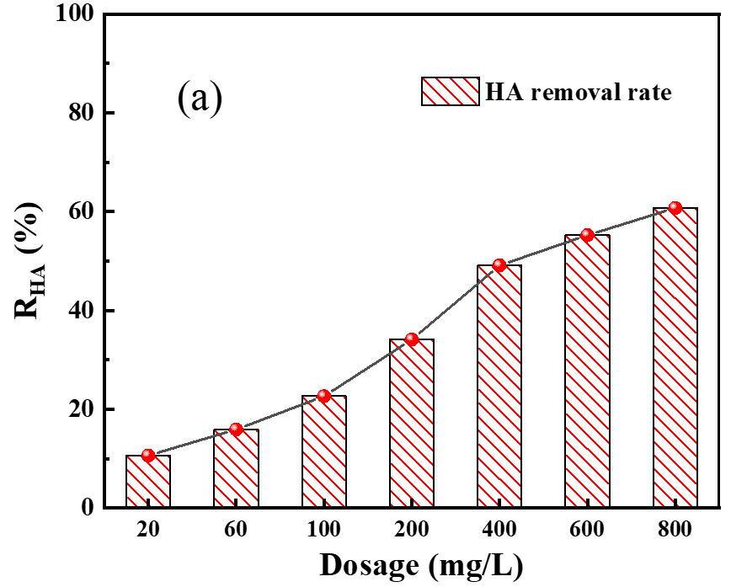 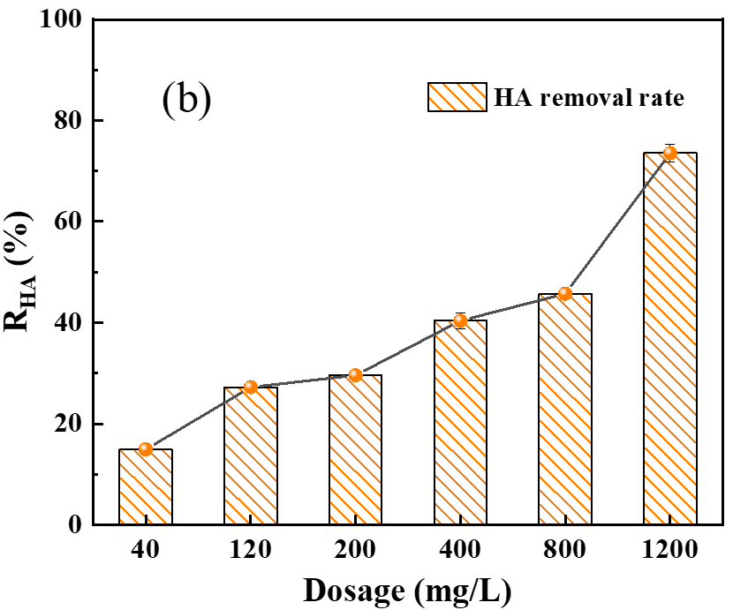

**Fig. S4.** The dosage is the sum of Fe-BC and PMS, mFe-BC: mPMS=1:1(a), mFe-BC: mPMS=1:3(b).

Project Path: C:\画图1\四种体系去除HA效果对比.opju
PE Folder: /四种体系去除HA效果对比/Folder1/
Short Name: Graph3

**Fig. S5.** Effect of different catalysts on HA removal.

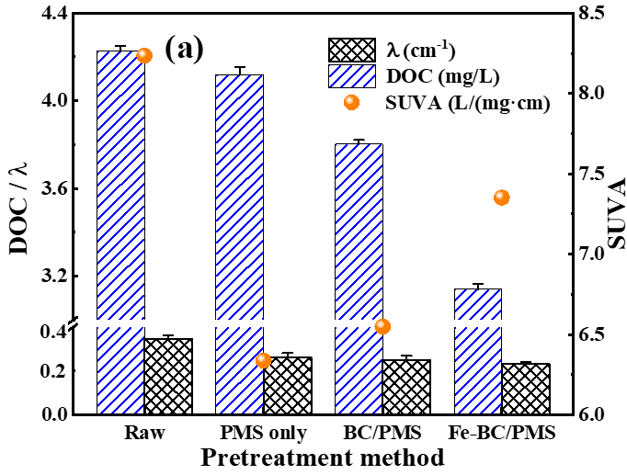 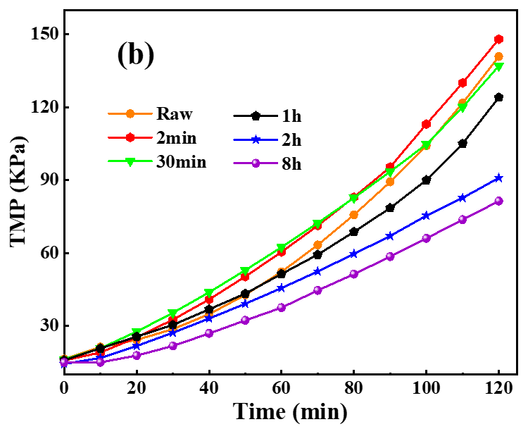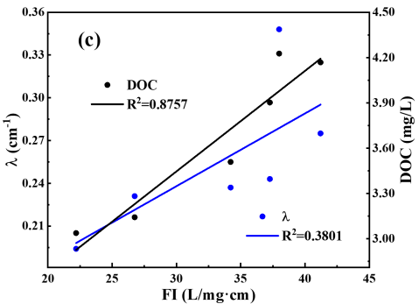

**Fig. S6.** SUVA changes (a), HA TMP curve (b) and FI fitting under different reaction time (c). ((a). PMS, BC, Fe-BC:100mg/L, t: 2h; (b). PMS, Fe-BC:100mg/L.)

**Table S1**

**Five combined blocking models.**

|  |  |
| --- | --- |
| **Blocking models** | **Fitting equation** |
| cake-complete |  |
| complete-standard |  |
| cake-standard |  |
| Cake-intermediate |  |
| intermediate-standard |  |

where: V is the filtration volume, P is the transmembrane pressure, J is the filtration flux, t is the filtration time and K is the model fitting constant.

**Table S2**

**Reaction process of radicals with coexisting ions.**

|  |  |  |
| --- | --- | --- |
| **Anion species** | **Reaction process** | |
| **Equation** | **Reaction rate constant** |
| Cl- |  | |
| HCO3- |  |  |
| CO32- |  |  |
| H2PO4- |  |  |
| NO3- |  |  |

**Table S3**

**Kb and Ks of the complete-standard blocking model in each reaction system.**

|  |  |  |  |  |
| --- | --- | --- | --- | --- |
| **Constant** | **System** | | | |
| **Raw** | **PMS** **only** | **BC/PMS** | **Fe-BC/PMS** |
| Kb | 5.67E-05 | 5.97E-05 | 5.82E-05 | 5.28E-05 |
| Ks | 8.94E-07 | 1.91E-06 | 1.31E-06 | 1.59E-06 |
| Kb/Ks | 63.42 | 31.25 | 44.4 | 33.20 |