 | Mortality (%) |  | Fertilization success (%)
 | Control | Fenoxycarb | Control | Fenoxycarb
G. fossarum | 78 | 82 | 72 | 56
G. roeseli | 72 | 58 | 50 | 65
E. longisetosus | 98 | 97 | 77 | 90
Supplementary material

Table S1. Mortality and fertilization success in the three study species in response to 5 µg L⁻¹ fenoxycarb exposure

Molecular analysis
Mitochondrial DNA was extracted from ethanol preserved tissue. For each individual, first gnathopod was added to 150 µL of Chelex 7% (Walsh et al. 1991) and to 10 µL of proteinase K. The tissue fragments were then incubated according to the following cycle: 2 hours at 50°C, 15 minutes at 90°C and then 5 min at 15°C.
An approximately 600 nucleotide fragments of the mitochondrial cytochrome c oxidase subunit 1 (CO1) was amplified using Folmer’s universal primers (Folmer et al. 1994). A standard PCR mix included per sample an amount of 2 µL genomic DNA, 17 µL of H₂O, 2.5 µL of Standard Buffer 10X (Biolabs B9014S) with 30 mM MgCl2, 1 µL of each primers at 10 µM, 0.25 µL of BSA 100X at 10 mg/mL, 1 µL of dNTP at 20 mM and 0.25 µL of Taq polymerase at 5 U/µL (EUROBIOTAQ). The polymerase chain reaction conditions were as follows. After an initial step of 95°C for 3 min, 40 cycles of 20 s at 95°C, 30 s at 51°C and 45 s at 72°C was proceeded. Reaction was terminated after a final step at 72°C for 5 min.
PCR results were checked on a 1.3% agarose gel with TAE 1X. Both strands were sequenced by using the Sanger method (Sanger et al. 1977) by Biofidal. Sequence chromatograms were edited manually for all individuals using FinchTV (version 1.4.0 Geospiza, Inc., Seattle, WA, USA; http://www.geospiza.com). CO1 fragments alignment was done using Prank (Löytynoja 2005). In order to compare these sequences, the CO1 of 11 species belonging to the Echinogammarus genus was extracted from the genetic database NCBI (see accession number on phylogenetic tree). A sequence of Gammarus roeseli was added in order to root the tree. The tree building was processed in PhyML with the Neighbor Joining method and the robustness of nodes was assessed by a non-parametric bootstrap test (100) (Felsenstein 1985).
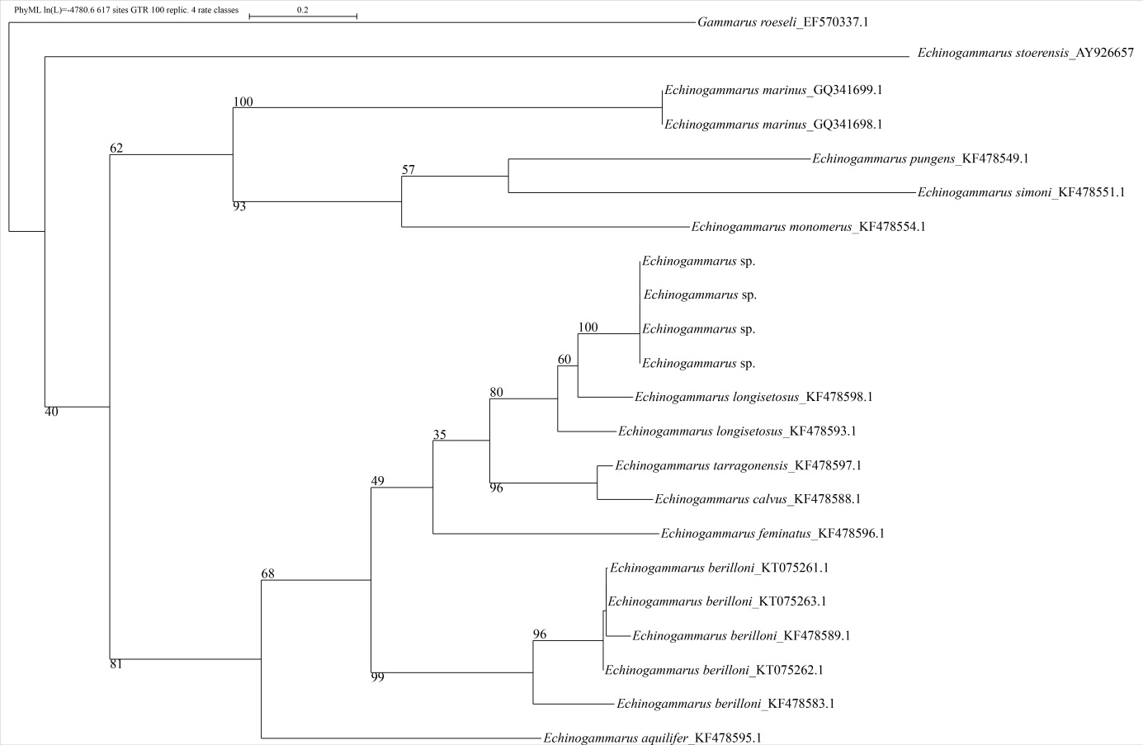
Figure1: Maximum likelihood phylogenetic tree run with 100 bootstraps based on 617 base pairs of the CO1 mitochondrial marker.

References

Felsenstein J (1985) Confidence limits on phylogenies: an approach using the bootstrap. Evolution 39:783-791.

Folmer O, Hoeh WR, Black MB, Vrijenhoek RC (1994) Conserved primers for PCR amplification of mitochondrial DNA from different invertebrate phyla. Mol Mar Biol Biotechnol 3:294-299.
Löytynoja A, Goldman N (2005) An algorithm for progressive multiple alignment of sequences with insertions. PNAS 102:10557-10562.
Sanger F, Nicklen S, Coulson AR (1977) DNA sequencing with chain-terminating inhibitorsPNAS 74:5463-5467.
Walsh PS, Metzger DA, Higuchi R (1991) Chelex 100 as a medium for simple extraction of DNA for PCR-based typing from forensic material. Biotechniques 10:506–513.

