Conflicting selection on Cneorum tricoccon (Rutaceae) seed size caused by native and alien seed dispersers

The disappearance of native seed dispersers due to anthropogenic activities is often accompanied by the introduction of alien species, which may to some extent replace the ecological service provided by the extinct ones. Yet, little empirical evidence exists demonstrating the evolutionary consequences of such alien ‘replacement’. Here, we document the conflicting selection exerted on seed size by two native lizards (Podarcis lilfordi and P. pityusensis) and an alien mammal species (Martes martes), all acting as legitimate seed dispersers of the Mediterranean relict Cneorum tricoccon. While lizards mostly exerted a negative directional selection on seed diameter, especially P. pityusensis, the much larger pine marten exerted positive selection on seed size. Our findings suggest that this among-disperser variation in the selection regimes, together with the occurrence of spatial variation in the presence of each of seed disperser, help to create the geographical variation observed for seed size of C. tricoccon. To our knowledge, this is the first empirical evidence showing opposing selective pressures between native and alien species in the seed dispersal process in an invaded ecosystem.

KEY WORDS: functional replacement, frugivory, Lacertidae, phenotypic selection, seed dispersal interactions, seed size

Evidence accumulated in the last few years shows that biological invasions have profound effects on many ecological processes involved in ecosystem functioning (Richardson 2011). Mutualistic interactions between species are included in such processes, with a great potential to be altered by the arrival of alien invaders into native communities (Kiers et al. 2010; Traveset and Richardson 2014). Introduced vertebrates, specifically, have had very harmful impacts, often leading to species extinctions (mainly animals but also plants; e.g. Humphreys et al. 2019), with possible collateral effects on their mutualist partners; thus, for instance, the introduction of vertebrates has disrupted the interactions between pollinators and seed dispersers influencing, indirectly, plant reproductive success (Kelly et al. 2010; Anderson et al. 2011; Traveset et al. 2012; Pérez-Méndez et al. 2016; Rogers et al. 2017). Such impacts have been documented mostly on oceanic islands (e. g. Sax and Gaines 2008) but also on mainland areas (e.g. Ceballos et al. 2017). Not all alien species, however, result in negative consequences for native biodiversity and ecosystem functioning. In some cases, alien species act as beneficial partners of native species, and to some extent can be functionally adequate replacements of native counterparts (Kawakami et al. 2009; Burns 2012; García et al. 2014; Pejchar 2018). In fact, in some cases, these alien species may be the only available partners acting as “rescuers” of mutualistic interactions and the derived ecosystem functions (Foster and Robinson 2007; Muñoz-Gallego et al. 2019), despite having an overall negative effect on the native community by, for instance, enhancing further invasions (e.g. Kawakami et al. 2009; Pejchar 2015; Wotton and McAlpine 2015; MacFarlane et al. 2016; Kaushik et al. 2018).
Conversely to such increasing information on ecological consequences of mutualistic disruptions due to alien invasions, there is a lack of knowledge on the potential evolutionary consequences of such disruptions. In the same way that invaders evolve specific traits when arriving to an ecosystem (Colautti and Lau 2015; Hendry et al. 2016; Rudman et al. 2017), they may directly or indirectly modify the selective scenarios for the native ones, promoting the evolution of some phenotypic traits adapted to the new conditions of the invaded environment (Mooney and Cleland 2001; Strauss et al. 2006; Shine 2012). Illustrative examples of traits evolved after an invasion –sometimes in the scale of a few generations- is the increased beak length of North American and Australian soapberry bugs in response to the larger fruits of introduced hosts (Carroll et al. 2005) or the larger toepads and more abundant lamella evolved in Anolis lizards to exploit taller perches and avoid competition with an invader congener (Stuart et al. 2014). Similar examples involving mutualistic interactions are scarcer in the literature - but see Rowles and O’Dowd (2009) for seed dispersal eco-evolutionary consequences of dispersal disruption by ant invaders. Switches to novel mutualist partners are increasingly common in current ecosystems (Kiers et al. 2010). However, we lack data on the evolutionary consequences of such shifts for the species involved in the new interaction. In the particular case of animal-mediated seed dispersal, larger frugivores are known to ingest larger seeds in greater number, and transport them to larger distances (e.g. Wotton and Kelly 2012; Pérez-Méndez et al. 2016). Hence, the introduction of a new frugivore differing in size from the native/s one/s might involve a different spatial distribution of seed sizes, which in turn might have implications for the plants, both at the population and community level (Kaushik et al. 2018).
The aim of this study is to delve into the evolutionary consequences of the arrival of an alien invader for its native mutualistic partner, and provide empirical evidence on the different selective pressures resulting from the shift of native to alien seed dispersers. We focus on the dispersal system of a shrub, Cneorum tricoccon L. (Rutaceae), that has a restricted distribution to the western Mediterranean area, and whose main populations are currently found in the Balearic Islands (Riera et al. 2002). The only native seed dispersers of this plant species on this archipelago are two endemic lacertid lizards: the Balearic lizard Podarcis lilfordi in the eastern Balearic Islands and the Eivissa wall lizard P. pityusensis in the southwestern Balearic Islands (Traveset 1995; Riera et al. 2002; Traveset et al. 2012) (Fig. 1). Podarcis lifordi has disappeared from the two larger islands of the Balearic Islands, Mallorca and Menorca, presumably after the anthropic introduction of predators, mainly carnivorous mammals but also snakes (Cooper and Pérez-Mellado 2012; Mencía et al. 2017). This lizard species is currently present only in islets surrounding Mallorca and Menorca, playing an important role as a legitimate disperser of different plant species (Traveset and Riera 2005). By contrast, P. pityusensis has survived the introduction of carnivores (e.g. genets, cats) in two islands, Eivissa and Formentera, possibly due to the lower tameness of this lizard as it was exposed to greater natural predation pressure before human introduction of predators (Cooper and Pérez-Mellado 2012). Three species of carnivores have been introduced to the Balearic islands: the least weasel (Mustela nivalis) presumably by Romans (1st century BCE – 5th century CE), the common genet (Genetta genetta) presumably by Muslims (8th -13th century CE) and the pine marten (Martes martes) probably during Modern times (since 15th century AD) –given its absence from the archaeological record (Valenzuela and Alcover 2013). There is good evidence that all these carnivores prey upon lizards either in the Balearics (Alcover 1984, Clevenger 1993) or in other archipelagos (e.g. King 2017). Nevertheles, pine martens feed not only on animal preys but also on fruits (Clevenger 1993, 1996), acting as effective seed dispersers of C. tricoccon (Traveset et al. 2012; Celedón-Neghme et al. 2013).
Given the large differences in body size and gape width between pine martens and lizards, we might expect a different selection pattern on fruit size, which should translate into differences in the size of seeds dispersed by them (Woodward et al. 2005, Wotton and Kelly 2012). Lizards are possibly constrained by gape width to consume large fruits/seeds, and the presence of large seeds in their guts might well decelerate food processing, as found in frugivorous birds (Levey and Grajal 1991). Rapid seed processing allows greater fruit consumption as well as higher assimilation of pulp nutrients. On the contrary, pine martens, with a much larger body size, higher energy requirement, and a gape width easily able to consume C. tricoccon fruits of any size, are expected to select larger fruits as these offer larger pulp reward. Moreover, we might also predict that seeds dispersed by mammals had greater germinability (i.e. final germination percentage) than those dispersed by lizards owing to the larger seed size and also to a possible stronger gut passage effect (Traveset and Verdú 2002; Moles and Westoby 2004). This, in the long-term, might result in the evolution of a greater seed size of the populations in which this alien mammal acts as seed disperser.
Hence, the specific objectives of this work are: (1) to assess whether native lizards and the alien seed disperser exert different selection pressures on seed size, and (2) to evaluate if such phenotypic selection affects the subsequent stage of seed germination. Seed size is also known to be influenced by abiotic conditions (e.g. Larios and Venable 2018; Sobral et al. 2019 and references therein); thus, we further wanted to test to what extent climatic variation might explain the differences observed across populations of C. tricoccon.

Methods

STUDY SYSTEM
Cneorum tricoccon L. (Rutaceae) is an evergreen shrub that can reach 1 m in height, although on average it is about 40 cm (n = 2542) (Fig. S1). The species is considered a relict of the Mediterranean flora that evolved during the early Tertiary (Traveset et al. 2012 and references therein). It inhabits southeastern Spain, southeastern France, and western Italy (Sardinia, Giannutri and Tuscany), with the main populations in the Balearic Islands (Traveset et al. 2012; Lázaro-Nogal et al. 2017). It produces fleshy fruits consisting of three or (more rarely) four cocci (locules of a syncarpous ovary) (Fig. S1) which ripen from about mid-March to mid-July. Each coccus is functionally a drupe with a cross diameter of 5.70 ± 0.05 mm (n = 315). Fruit and seed size are strongly correlated (Fruit diameter = 1.23 ± 0.91 x Seed diameter, R² = 0.63, P < 0.001). As mentioned above, in the Balearic Islands this plant is dispersed mainly by two native lizards (Podarcis lilfordi and P. pityusensis) and one alien carnivore, the pine marten (Martes martes), which has even influenced the plant distribution in Mallorca, where this mammal is very abundant (Rotllàn-Puig and Traveset 2016). A closely related species to C. tricoccon, Neochamaelea pulverulenta (Vent.) Erdtman, endemic to the Canary Islands, is also dispersed –in this case exclusively– by endemic lizards in the Gallotia genus (Pérez-Méndez et al. 2016, 2018). Although the fruits of both species are of the size and color of those typically consumed by frugivorous birds, these animals do not consume them. For example, we have made direct observations (>30 h) on C. tricoccon fruiting individuals but never saw a bird consuming its fruits (Fuster and Traveset, under review). Moreover, we have collected abundant bird feces during different studies in these islands but never detected a C. tricoccon seed in them (Traveset, unpub. data). Only anecdotically, some seeds have been observed in seagulls’ regurgitations, in islets where they nest (Calviño-Cancela 2011). Genets also consume the fruits of C. tricoccon, although this carnivore is not considered an effective seed disperser as it defecates most seeds in latrines on rocky places in which they will unlikely germinate (Traveset 1995; Clevenger 1996). The alien mammal on which we focused in this study is thus the pine marten. This species has an important frugivorous diet throughout the year in the Balearics, but with highest levels during June-August and December-February (Clevenger 1996). The pine marten is much larger (1,100-2,500 g; Barja 2008) than the native lizards. Also, P. pityusensis is slightly bigger and heavier than P. lilfordi [maximum snout vent length: 96 vs. 81 mm (Cooper and Pérez-Mellado 2012); body mass range: 7.70-11.90 g (Avery et al. 1987) vs. 4.78-7.80 g (Castilla and Bauwens 2000)].

STUDY POPULATIONS
We gathered data from 15 populations differing in the type of disperser: Podarcis pityusensis was the only seed disperser in nine populations, P. lilfordi in three, and pine martens in the other three populations (Fig. 1; Table S1 shows the geographical coordinates and the mean annual precipitation and temperature of each population). In most of these populations, C. tricoccon inhabits coastal maquis or shrublands, dominated by species such as Pistacia lentiscus (Anacardiaceae), Olea europea (Oleaceae), Rhamnus alaternus (Rhamnaceae), Cistus monspeliensis (Cistaceae) and Rosmarinus officinalis (Lamiaceae), usually in calcareous soils. In Mallorca, however, the species has also colonized the interior, being often found in the understory of oak forests (Quercus ilex L.) up to an altitude of around 1000 m a.s.l. (Traveset 1995).

SEED SAMPLING AND FRUGIVORES’ MORPHOLOGICAL MEASUREMENTS
For each plant population, we measured seeds directly collected from plants (i.e. controls) as well as seeds collected from animals’ feces (i.e. dispersed). All seeds were gathered during the late fruiting peak, i.e. June-July. Between 10-15 ripe fruits were collected from each of 15-19 individuals in each population and manually depulped. Seeds dispersed by lizards were gathered directly from their droppings by randomly walking through the study areas. The density of droppings with seeds varied among populations depending upon lizard density, but it was relatively easy in most of them to find a minimum of 50 at each site. Seeds dispersed by pine martens were recovered from droppings sampled along linear transects of at least one kilometer in each population. Such droppings are easily distinguishable from those of other carnivores as they usually contain fruit pulp, and are often found on trails. Cneorum seeds are spherical, thus for all collected seeds (control and dispersed) we measured their diameter as a proxy of seed size. A total of 11,353 seeds were collected pooling all populations and seed dispersers; 9,738 were control seeds, and the rest were recovered in droppings: 300 from P. lilfordi, 952 from P. pytiusensis, and 363 from pine martens.
Lizards’ gape width measurements were recorded from live-captured animals, whereas pine martens’ gape width was measured in skulls (Smith 1984) from the collection “IMEDEA Col·lecció de Cordats, Institut Mediterrani d’Estudis Avançats”. All measures were conducted with a digital caliper with a resolution of 0.001mm.

SELECTION ANALYSES
Because only one seed disperser species (either lizard species or the pine marten) is found in each plant population, we assumed that if phenotypic selection occurs it is exerted by the local seed disperser. The magnitude of selection was first estimated in each population by means of the selection differential, calculated as the change in seed diameter mean before (i.e. control) and after selection by frugivorous animals (Falconer 1989). We estimated the directional selection differential (S_{i}) by fitting a linear regression, and the non-linear selection differential (C_{ii}) by fitting a quadratic regression, using in both cases logit as link functions (Morrisey 2014). The fitness functions were visualized in generalized additive models relating the probability of dispersal to seed diameter. These analyses were performed by means of the gsg R package (Morrissey and Sakrejda 2014).
The possible occurrence of conflicting selection between pine martens and the two lizard species was explored by testing the interaction between the identity of dispersers and seed size. If dispersers exert divergent selection on seed size, the interaction must be significant. This analysis was performed using a GLMM with a binomial distribution of errors and logit as link function. The model included thus the two main effects (disperser identity, seed size) and their interaction; the population of origin was nested within each corresponding island group (Gymnesic and Pityusic islands), i.e. both population and island group were included as random effects.
We further evaluated whether the strength of selection increases with dispersers’ gape width by means of linear regression. However, this model showed heteroscedasticity in the residual variance, and thus we had to modify the assumption of residual variance and multiply it by the power of the absolute value of the variance of gape width, fitting the linear model with the generalized least squares method (GLS) (Zuur et al. 2009) implemented in the nlme R package (Pinheiro et al. 2016).
Finally, we evaluated whether among-population differences in seed diameter were associated to differences in the identity of the three seed disperser species. For this, we controlled for climatic variation among populations, which is known to affect seed size in many species (e.g. Larios and Venable 2018). Because mean annual precipitation and temperature were strongly correlated (r = -0.79, P < 0.001), we used temperature and the residuals of a regression model between precipitation and temperature. A linear mixed model (LMM) was fitted using seed size as response variable, the identity of dispersers in each population as a fixed factor, and temperature and precipitation residuals as covariates. We included as random factors the individual plant from which seeds were collected, to control for maternal effects, and the population of origin, again nested within island group.

SEED GERMINATION
Dispersed seeds were sown in a greenhouse to test for differences in germination rates when compared to control seeds from their respective plant populations. A total of 1,296 seeds (control = 670; dispersed by P. lilfordi =134; dispersed by P. pityusensis =415; dispersed by pine martens = 77) were planted in potting soil across different germination trays (with 60 alveoli in each), filled with universal substrate, randomly placed on the greenhouse benches, and watered every 2-3 days. Apex emergence (germination hereafter) was recorded every 2-3 days until the germination stopped (460 days after planting). Each sown seed was previously weighed as this trait is known to influence seed germination. Seed weight and diameter are strongly correlated in this species (R²= 0.82, P<0.001, N= 157).
To evaluate how germinability (proportion of seeds that germinate) was affected by seed size and disperser identity, we used either a general linear model (GLM) or a generalized linear mixed model (GLMM), depending on whether the dispersed and control seeds were collected from one population (in the case of pine marten) or several populations (in the case of lizards). In both cases, binomial distribution of errors and logit family were used to fit the models. These analyses were performed using the lme4 R package (Douglas et al. 2015), and the main effects (and their interaction) in these models were evaluated by means of the Anova function in the car R package (Fox and Weisberg 2011). In addition to the parameter estimates, a goodness of fit measure, the pseudo-R², was calculated by means of the function sem.model.fits implemented in piecewiseSEM R package (Lefcheck 2016).

Results
The probability of being dispersed by pine martens increased with seed size whilst the opposite occurred for seeds dispersed by P. pityusensis (Fig. 2, Fig. S2). This contrasting result was supported by the significant interaction found between disperser identity and seed size (Table 1). Pine martens dispersed the largest seeds (4.58 ± 0.03 mm), followed by P. lifordi (4.19 ± 0.02) and P. pityusensis (3.67 ± 0.01) (Table S2). These results are directly related to differences in body size between pine martens and lizards. However, we also found differences when comparing the two lizards: P. pityusensis (with bigger gape width) selected seeds smaller in size than those selected by P. lilfordi (with smaller gape width) (Table S2 and Fig. S3).

Both the magnitude and direction of selection varied according to the identity of the seed disperser (Fig. 3, Table S2). Pine martens exerted positive directional selection on seed diameter in all studied populations, dispersing larger seeds than the average within each population (Fig. 4 and Fig. S3). On the contrary, the two lizard species exerted negative directional selection in all populations except one in the case of P. lilfordi and two in the case of P. pityusensis. Interestingly, the populations where lizard selection was significantly positive were characterized by displaying the smallest seeds of the studied populations (Table S2, Fig. 2).
Dispersers’ gape width was positively and significantly associated to the strength of selection (Si = -1.03+0.06*gape width; P < 0.01 _{pseudo}R² = 0.3, Fig. 5), a result concordant with the overall positive directional selection in the populations in which the pine marten is the only seed disperser (Fig. 2 and 4).
Seeds dispersed by pine martens tended to show higher germinability than control seeds (Table 2), although the difference was only marginally significant (X² = 3.037, df = 1, P = 0.081). Contrary to expectation, however, the variation in germinability was not related to seed weight (X² = 1.1, df = 1, P = 0.30). The germinability of seeds ingested by lizards was quite similar to that of control seeds, for both P. lilfordi (X² = 1.03, df =1, P = 0.31) and P. pityusensis (X² = 1.96, df =1, P = 0.16) (Tables 2 and 3). There were differences, however, between lizard species in the effect of seed size: for seeds dispersed by P. lilfordi, seed weight did not influence germinability (X² = 0.03, df = 1, P = 0.86) whereas for those dispersed by P. pityusensis it did (X² = 29.5, df = 1, P < 0.001, Table 3), heavier seeds germinating better than lighter ones.
The strong variation in seed diameter found across populations (X² = 9,74, df = 2, P = 0.007) did not seem to respond to the climatic variables considered (Table 4).
However, the identity of dispersers was significantly associated with seed size differences across populations, with larger seeds occurring in the populations with pine martens. The predicted value of mean seed size (± SE) for the populations with pine martens was 4.27 (±0.01), for those with P. lilfordi it was 3.64 (± 0.02), and for those with P. pityusensis it was 4.02 (±0.006).

Discussion

Our study demonstrates that non-native frugivores can exert different selection pressures than native species. The alien pine marten modified the selection regime on seed size compared to that exerted by the native lizard species. Such effect is likely be long-lasting and lead to evolutionary changes. In fact, we found that seeds tend to be larger in those populations in which the pine marten acts as seed disperser, with climatic factors playing only a minor role explaining the spatial variation in seed size. The phenotypic selection regimes exerted by pine martens appeared to also influence the subsequent stage on the plant recruitment process, i.e. germination, although such effect was rather small. A previous study (Galetti et al. 2013) showed that the functional extinction of large-gape seed dispersers in the Brazilian Atlantic forest was associated with a consistent reduction in seed size of a keystone palm species. A recent phylogenetic analysis including more than 400 species across the Indo-Malayan archipelago has also revealed that average fruit size tracts the taxonomic and functional diversity of frugivores (Brodie 2017). We foresee that more evolutionary changes will be increasingly documented as mutualistic disruptions take place as a result of global change.

DRIVERS OF CONFLICTING SELECTION: DISPERSER MORPHOLOGY, FOOD REWARD AND PREDATION RISK
Native and alien seed dispersers differed in the direction of their phenotypic selection regimes. Native lizards consumed smaller fruits and thus dispersed smaller seeds whereas the alien pine marten consumed the largest fruits and hence dispersed larger seeds. Pine martens’ gape is much wider than the largest fruits of C. tricoccon and, thus, this trait does not represent any morphological constraint to swallow whole fruits; in fact, pine martens probably eat simultaneously several fruits in a single feeding bout given the usually high number (>10) of C. tricoccon seeds found in their droppings (Traveset, pers. obs.). Compared to their small-bodied counterparts, larger bodied frugivores are known to ingest larger seeds in greater numbers, and are also capable of transporting seeds to greater distances (Sobral et al. 2010; Wotton and Kelly 2012; Pérez-Méndez et al. 2016; DeSoto et al. 2017). It is thus not surprising that pine martens choose among the largest, more rewarding, fruits. Due to their wide foraging ranges (up to 1,400m) (González-Varo et al. 2013) and longer seed retention times, they probably transport seeds to much longer distances than the native lizards whose territories are usually within the range of 100 m (Rodríguez-Pérez et al. 2012).
Compared to pine martens, both lizard species are probably constrained by their morphology and/or digestive physiology and either cannot ingest large fruits (and seeds) or have to defecate them rapidly to accelerate fruit processing and increase pulp assimilation, as happens with birds (Levey and Grajal 1991). This was especially evident for P. pityusensis, which mostly consumed fruits smaller in size than those available in their respective populations regardless of their gape width. Alternatively, the preference of lizards for smaller fruits - which is a suboptimal foraging decision as smaller fruits are less rewarding; e.g. Rey et al. (1997) - may be related to the tradeoff between reward acquisition, seed volume within the digestive track, but also the predation risk in each population. A suboptimal selection from the nutritional perspective is expected in scenarios of increased predation risk, as smaller food pieces are handled more rapidly reducing the time spent exposed to predators (Perea et al. 2011). In the case of P. lilfordi, a significantly negative selection for seed size was found in only one population. By contrast, P. pityusensis selected for smaller seeds in c. 80% of the populations, exerting positive selection only in those populations with the smallest seeds (BB and LM; Table S2). One possible explanation for the differences between the two lizard species might be the different history of predation regime between the Gymnesic and the Pityusic subarchipelagos where P. lilfordi and P. piytusensis evolved, respectively. The latter, when the common ancestor of these lizards began to diverge (Alcover et al. 1981; Alcover 2010), was far richer in avian predators. Such historic divergence in predation pressure has indeed been hypothesized to modify the capacity of adaptation of both species to the presence of predators (Cooper and Pérez-Mellado 2012). Podarcis pityusensis shows much stronger anti-predatory strategies such as escape response (Cooper and Pérez-Mellado 2012) and tail loss capacity (e.g. Pérez-Mellado et al. 1997) than P. lilfordi, which shows a reduced escape behavior according to the so-called “island tameness” phenomenon. We therefore suggest that between-lizard differences in the sign and magnitude of selection on seed size might result, to some extent, from their evolutionary interaction with predators.

LONG-TERM CONSEQUENCES FOR PLANT FITNESS OF THE CONFLICTING SELECTIVE PRESSURES ON SEED SIZE
As expected from previous studies (e.g. Norden et al. 2009, Kolodziejek 2017), we found that seed size was positively associated with germinability, i.e. germination percentage. Interestingly, however, such effect is contingent upon disperser identity. On the one hand, seeds dispersed by pine martens appeared to germinate better than controls, although there was a high variation within each group of seeds and so differences were only marginal, while seed weight showed a small influence on final germination percentage. Although results need to be interpreted with caution due to the low germination rates, the ingestion of seeds by the alien mammal tends to have a positive, albeit small, effect regardless of the size of the fruits they have consumed, which agrees with findings for the seed dispersal effect of other meso- carnivores on other plant species (Escribano-Avila et al. 2013). On the other hand, differences in the influence of seed size on germination were detected between the two lizard species. Seeds passed through P. lilfordi germinated similarly to controls, regardless of seed size. We could thus infer from this that the benefit of this lizard species for the plant has more to do with moving the seeds away from the parent plant than with a possible scarification effect of the seed testa (Traveset 1998; Traveset et al. 2001). Moving seeds away from the mother plant seems indeed to be advantageous, as found in a parallel study in which we monitored C. tricoccon seedlings from different microhabitats in one of the populations; seedling mortality over the summer was higher below the mother plant (24%) than far from it in other microhabitats (11%) (Traveset, unpubl. data). By contrast, seeds ingested by P. pityusensis germinated better than controls but only when seeds were large enough. Considering that this lizard tends to select the smallest seeds, the overall effect on this component of plant fitness is thus probably similar to that of P. lilfordi. Thus, for populations with P. pityusensis, opposing selective pressures act on seed size across the stages of seed dispersal and seed germination; small seeds are moved more frequently, but larger seeds benefit more by gut passage (Alcántara and Rey 2003; Gómez 2004, 2008).
The wide among-population variation in seed size that we found was associated with differences in the identity of dispersers once we controlled for plant maternal effects and climatic conditions. When examining the overall differences among populations with different disperser species, the striking result was the greater seed size in the populations of plants dispersed by pine martens. We argue that this finding might be explained by the positive directional selection of this alien disperser on seed size at the stage of seed dispersal. Despite the apparently low effect at the germination stage, the odds for larger seeds to be recruited in the population are still higher than for smaller seeds that are less frequently dispersed. Hence, considering that seed size is an heritable trait (e.g. Wheelwright 1993; Gómez 2008; Galetti et al. 2013; Zas and Sampedro 2015), we might expect long-lasting evolutionary effects of the selection of large seeds by the alien pine martens at the plant population level. Even if pine martens had been introduced only 500 years ago (Valenzuela and Alcover 2013), the time that these animals have coexisted with C. tricoccon in Mallorca island might be enough for them to promote phenotypic evolution on seed size (see also Galetti et al. 2013).

In short, our study shows that phenotypic selection on seed size seems to be driven by the mutualistic interaction with their frugivores, with abiotic variables not playing a relevant role. Such effect of frugivores on seed size has probably persisted along the evolutionary history of the plant. Mounting evidence in the last few years actually suggests that such top-down control in plant’s phenotypic evolutionary response may be more frequent and relevant than previously thought (e.g. Galetti et al. 2013, Pérez-Méndez et al. 2016). Our study also highlights how alien species, especially those that spread rapidly and become very abundant, may change the evolutionary trajectories of native interaction partner/s, with consequences still unknown both at the population and community level.

REFERENCES

Alcover, J. A., S. Moyá-Solà, and J. Pons-Moyá. 1981. Les quimeres del Passat. Els Vertebrats fossils del Plio-Quaternari de les Belears i Pitiüses. Editorial Moll, Palma de Mallorca.
Alcover, J.A. 1984. Über die Nahrung der Ginsterkatze Genetta genetta (Linnaeus, 1758) auf den Inseln Mallorca, Ibiza und Cabrera. Säugetierkundliche Mitteilungen 31:189-195.

Alcover, J. A. 2010. A century of insular vertebrate palaeontology research on the Balearic Islands. In: Pérez-Mellado, V., and M. Ramon, eds. Islands and evolution. Mao: Institut Menorqui d'Estudis, 59–83.
Alcántara, J. M. and P. J. Rey. 2003. Conflicting selection pressures on seed size: evolutionary ecology of fruit size in a bird‐dispersed tree, Olea europaea. J. Evol. Biol. 16:1168-1176.
Anderson, S. H., D. Kelly, J. J. Ladly, S. Molloy, and J. Terry. 2011 Cascading effects of bird functional extinction reduce pollination and plant density. Science 31:1068–1071.
Avery, R. A., Mueller, C. F., Jones, S. M., Smith, A., and D. J. Bond. 1987. Speeds and movement patterns of European lacertid lizards: A comparative study. J. Herpetol. 21:324- 329.
Barja, I. (2008) Marta – Martes martes. In: Enciclopedia Virtual de los Vertebrados Españoles. Carrascal, L. M., Salvador, A. (Eds.). Museo Nacional de Ciencias Naturales, Madrid. http://www.vertebradosibericos.org/
Brodie, J. F. 2017. Evolutionary cascades induced by large frugivores. Proc. Natl. Acad. Sci. USA 114:11998-12002.
Burns, K. C. 2012. Are introduced birds unimportant mutualists? A case study of frugivory in European blackbirds (Turdus merula). New Zealand J. Ecol. 36:171-176.
Calviño-Cancela, M. 2011. Gulls (Laridae) as frugivores and seed dispersers. Plant Ecol. 212:1149–1157.
Carroll, S. P, J. E. Loye, H. Dingle, M. Mathieson, T. R. Famula, and M. P. Zalucki 2005. And the beak shall inherit –evolution in response to invasion. Ecol. Lett. 8:944-951.
Castilla, A.M. and D. Bauwens. 2000. Reproductive characteristics of the island lacertid lizard Podarcis lilfordi. J. Herpetol. 34:390-396.
Ceballos, G., P. R. Ehrlich, and R. Dirzo. 2017. Biological annihilation via the ongoing sixth mass extinction signaled by vertebrate population losses and declines. Proc. Natl. Acad. Sci. USA 114:E6089-E6096.
Celedón-Neghme, C., A. Traveset, and M. Calviño-Cancel. 2013. Contrasting patterns of seed dispersal between alien mammals and native lizards in a declining plant. Plant Ecol. 214:657–667.
Clevenger, A.P. 1996. Frugivory of Martes martes and Genetta genetta in an insular mediterranean habitat. Rev. d’Ecol. (Terre et Vie) 51:19–28.
Colautti, R. I. and J. A. Lau. 2015. Contemporary evolution during invasion: evidence for differentiation, natural selection, and local adaptation. Mol. Ecol. 24:1999–2017.
Cooper, W. E. Jr. and V. Peréz-Mellado. 2004. Tradeoffs between escape behavior and foraging opportunity by the Balearic lizard (Podarcis lilfordi). Herpetologica 60:321-324.
Cooper, W. E. Jr. and V. Peréz-Mellado. 2012. Historical influence of predation pressure on escape by Podarcis lizards in the Balearic Islands. Biol. J. Linn. Soc. 107:254-268.
DeSoto, L., R. Torices, S. Rodríguez-Echeverría, and C. Nabais. 2017. Variation in seed packaging of a fleshy-fruited conifer provides insights into the ecology and evolution of multi-seeded fruits. Plant Biol. 19:533-541.
Douglas, B., M. Maechler, B. Bolker, and S. Walker. 2015. Fitting Linear Mixed-Effects Models Using lme4. J. Stat. Soft. 67:1-48.
Escribano-Ávila, G., B. Pías, V. Sanz-Perez, A. Escudero, and F. Valladares. 2013. Spanish juniper gain expansion opportunities by counting on a functionally diverse dispersal assemblage community. Ecol. Evol. 3:3751-3763.
Falconer D. S. 1989. Introduction to quantitative genetics. 3rd ed. Longman, Harlow, UK.

Foster, J. T. and S. K. Robinson. 2007. Introduced birds and the fate of Hawaiian rainforests. Cons. Biol. 21:1248-1257.

Fox, J. and S. Weisberg. 2011. An {R} Companion to Applied Regression, Second Edition. Thousand Oaks CA: Sage. Thousand Oaks, CA.

Galetti, M., R. Guevara, M. C. Cortes, R. Fadini, S. Von Matter, A. B. Leite, F. Labecca, T. Ribeiro, C. S. Carvalho, R. G. Collevatti, M. M. Pires, P. R. Guimarães Jr., P. H. Brancalion, M. C. Ribeiro, and Pedro Jordano. 2013. Functional extinction of birds drives rapid evolutionary changes in seed size. Science 340:1086–1090.

García, D., D. Martínez, D. B. Stouffer, and J. M. Tylianakis. 2014. Exotic birds increase generalization and compensate for native bird decline in plant-frugivore assemblages. J. Anim. Ecol. 83:1441-1450.
Gómez, J. M. 2004. Bigger is not always better: Conflicting selective pressures on seed size in Quercus ilex. Evolution 58:71-80.
Gómez, J. M. 2008. Sequential conflicting selection due to multispecific interactions triggers evolutionary trade-offs in a monocarpic herb. Evolution 62:668-679.
González-Varo, J. P, J. V. López-Bao, and J. Guitián. 2013 Functional diversity among seed dispersal kernels generated by carnivorous mammals. J. Anim. Ecol. 82:562–571.
Hendry, A. P., K. M. Gotand, and I. Svensson. 2016. Human influences on evolution, and the ecological and societal consequences. Phil. Trans. R. Soc. B 372:20160028
Kaushik, M., L. Pejchar, and L. H. Crampton. 2018. Potential disruption of seed dispersal in the absence of a native Kauai thrush. PLoS ONE 13:e0191992.
Humphreys, A. M, R. Govaerts, S.Z. Ficinski, E. N. Lughadha, and M. S. Vorontsova. 2019. Global dataset shows geography and life form predict modern plant extinction and rediscovery. Nature Ecol. Evol. https://doi.org/10.1038/s41559-019-0906-2
Kawakami, K., L. Mizusawa, and H. Higuchi. 2009, Re-established mutualism in a seed-dispersal system consisting of native and introduced birds and plants on the Boning Islands, Japan. Ecol. Res. 24:741-748.
Kelly, D., J. J. Ladley, D. M. Wotton, A. W. Robertson, S. H. Anderson, and S. K. Wiser. 2010. Mutualisms with the wreckage of an avifauna: the status of bird pollination and fruit dispersal in New Zealand. New Zealand J. Ecol. 34:66–85.
Kiers, E.T., T. M. Palmer, A. R. Ives, J. F. Bruno, and J. L. Bronstein. 2010. Mutualisms in a changing world: an evolutionary perspective. Ecol. Lett. 13:1459-1474.
King, C.M. 2017. Liberation and spread of stoats (Mustela erminea) and weasels (M. nivalis) in New Zealand, 1883-1920. New Zealand J. Ecol. 41:163- 177.
Kolodziejek, J. 2017. Effect of seed position and soil nutrients on seed mass, germination and seedling growth in Peucedanum oreoselinum (Apiaceae). Sci. Rep. 1959. doi: 10.1038/s41598-017-02035-1
Larios, E. and D. L. Venable. 2018. Selection for seed size: the unexpected effects of water availability and density. Funct. Ecol. 32:2216-2224.
Lázaro-Nogal, A., S. Matesanz, A. García-Fernández, A. Traveset, and F. Valladares. 2017. Population size, center–periphery, and seed dispersers’ effects on the genetic diversity and population structure of the Mediterranean relict shrub Cneorum tricoccon. Ecol. Evol. 7:7231-7242.
Lefcheck, J.S. 2016. piecewiseSEM: Piecewise structural equation modeling in R for ecology, evolution, and systematics. Methods Ecol. Evol. 7: 573-579.
Levey, D.J. and A. Grajal. 1991. Evolutionary implications of fruit-processing limitations in cedar waxwings. The American Naturalist 138: 171-189.
MacFarlane, A. E. T., D. Kelly, and J. V. Briskie. 2016. Introduced blackbirds and song thrushes: useful substitutes for lost mid-sized native frugivores, or weed vectors? New Zealand J. Ecol. 40:80-87.
Mencía, A., Z. Ortega, and V. Pérez-Mellado. 2017. From tameness to wariness: chemical recognition of snake predators by lizards in a Mediterranean island. PeerJ 5:e2828; DOI 10.7717/peerj.2828
Moles, A. T. and M. Westoby. 2004. Seedling survival and seed size: a synthesis of the literature. J. Ecol. 92:372-383.
Mooney, H. A. and E. E. Cleland. 2001. The evolutionary impact of invasive species. Proc. Natl. Acad. Sci. USA 98:5446-5451.
Morrissey, M. and K. Sakrejda. 2014. gsg: Calculation of selection coefficients. R package version 2.0. https://CRAN.R-project.org/package=gsg
Morrissey, M. B. 2014. In search of the best methods for multivariate selection analysis. Methods Ecol. and Evol. 5:1095-1109.
Muñoz-Gallego, R., J. M. Fedriani, and A. Traveset. 2019. Non-native mammals are the main seed dispersers of the ancient Mediterranean palm Chamaerops humilis L. in the Balearic Islands: rescuers of a lost seed dispersal Service? Frontiers Ecol. Evol. 7, article 161. doi: 10.3389/fevo.2019.00161
Norden, N., M. I. Daws, C. Antoine, M. A. González, N. C. Garwood, and J. Chave. 2009. The relationship between seed mass and mean time to germination for 1037 tree species across five tropical forests. Funct. Ecol. 23: 203–210.
Pejchar, L. 2015. Introduced birds incompletely replace seed dispersal by a native frugivore. AoB PLANTS 7:plv072.
Perea, R., R. González, A. San Miguel, and Gil, L. 2011. Moonlight and shelter cause differential seed selection and removal by rodents. Anim. Behav. 82:717-723.
Pérez-Mellado, V., C. Corti, and P. Lo Cascio. 1997. Tail autotomy and extinction in Mediterranean lizards. A preliminary study of continental and island populations. J. Zool. 243:533–541.
Pérez-Méndez, N., P. Jordano, García, C. and A. Valido. 2016. The signatures of Anthropocene defaunation: cascading effects of the seed dispersal collapse. Sci. Rep. 6:24820.
Pérez-Méndez, N., P. Jordano, and A. Valido. 2018. Persisting in defaunated landscapes: reduced plant population connectivity after seed dispersal collapse. J. Ecol.106:936–947.
Pinheiro, J., D. Bates, S. DebRoy, D. Sarkar, and R Core Team (2016). nlme: Linear and Nonlinear Mixed Effects Models. R package version 3.1-128. http://CRAN.R-project.org/package=nlme.
Rey, P. J., J. E. Gutiérrez, J. Alcántara, and F. Valera. 1997. Fruit size in wild olives:
implications for avian seed dispersal. Funct. Ecol.11:611-618.
Richardson, D.M. (ed) (2011). Fifty years of invasion ecology. The legacy of Charles Elton. Wiley-Blackwell, Oxford.
Riera, N., A. Traveset, and O. García. 2002 Breakage of mutualisms by alien species: the case of Cneorum tricoccon L. in the Balearic Islands (western Mediterranean Sea). J. Biog. 29:713–719.
Rodríguez-Pérez, J., A. R. Larrinaga, and L. Santamaría. 2012 Effects of frugivore preferences and habitat heterogeneity on seed rain: a multi-scale analysis. Plos One 7:e33246.
Rogers, H.S., E. R. Buhle, J. HilleRisLambers, E. C. Fricke, R. H. Miller, and J. J. Tewksbury. 2017. Effects of an invasive predator cascade to plants via mutualism disruption. Nat. Com. 8:14557
Rotllàn-Puig, X. and Traveset, A. 2016. Declining relict plants: climate effect or seed dispersal disruption? A landscape-scale approach. Basic Appl. Ecol. 17:81–91.
Rowles, A. D. and D. J. O’Dowd. 2009. New mutualism for old: indirect disruption and direct facilitation of seed dispersal following Argentine ant invasion. Oecologia 158:709-716.
Rudman, S.M., M. Kreitzman, K. M. A. Chan, and D. Schluter. 2017. Ecosystem services: rapid evolution and the provision of ecosystem services. Trends Ecol. Evol. 32:403–415.
Sax, D. F. and S. D. Gaines. 2008. Species invasions and extinction: The future of native biodiversity on islands. Proc. Natl. Acad. Sci. USA 105:11490-11497.
Shine, R. 2012. Invasive species as drivers of evolutionary change: cane toads in tropical Australia. Evol. Appl. 5:107–116.
Sobral, M., A. R. Larrinaga, and J. Guitián. 2010. Fruit-size preferences in wild and naive Eurasian blackbirds (Turdus merula) feeding on hawthorn (Crataegus monogyna). The Auk 127:532-539.
Sobral, M., Guitián, J., Guitián, P., Violle, C. and Larrinaga, A.R. 2019. Exploring subindividual variability: role of ontogeny, abiotic environment, and seed-dispersing birds. Plant Biology 21:688-694.
Strauss, S. Y., J. A. Lau, S. P. Carroll. 2006. Evolutionary responses of natives to introduced species: what do introductions tell us about natural communities? Ecol. Lett. 9:357–374.
Stuart, Y. E, T. S. Campbell, P. A. Hohnelohe, R. G. Reynolds, L. J. Revell, and J. B. Losos. 2014. Rapid evolution of a native species following invasion by a congener. Science 346:463-466.
Traveset, A. 1995. Seed dispersal of Cneorum tricoccon by lizards and mammals in the Balearic Archipelago. Acta Oecol. 16:171–178.
Traveset, A. 1998. Effect of seed passage through vertebrate frugivores’ guts on germination: a review. Persp. Plant Ecol. Evol. Syst.1-2:151–190.
Traveset, A., N. Riera, and R. E. Mas. 2001. Passage through bird guts causes interspecific differences in seed germination characteristics. Funct. Ecol. 15:669-675.

Traveset, A. and M. Verdú. 2002. A Meta-analysis of the Effect of gut Treatment on Seed Germination. In: Seed Dispersal and Frugivory: Ecology, Evolution and Conservation. Eds: Levey, D. F., W. R. Silva, and M. Galetti CAB International, Wallingford, UK.
Traveset, A. and N. Riera. 2005 Disruption of a plant–lizard seed dispersal system and its ecological effects on a threatened endemic plant in the Balearic Islands. Conserv. Biol. 19:421–431.
Traveset, A. and D. M. Richardson. 2014. Mutualistic interactions and biological invasions. Annual Rev. Ecol. Evol. Syst. 45:89-113.
Traveset, A., J. P. González-Varo, and A. Valido. 2012. Long-term demographic consequences of a seed dispersal disruption. Proc. R. S. Biol Sci. 279:3298-3303.
Valenzuela, A. and Alcover, J. A. 2013. Radiocarbon evidence for a prehistoric deliberate translocation: the weasel (Mustela nivalis) of Mallorca. Biol. Inv. 15:717-722.
Wheelwright, N. T. 1993. Fruit size in a tropical tree species: variation, preference by birds, and heritability. Vegetatio 107/108:163-174.
Woodward, G., B. Ebenman, M. Emmerson, J. M. Montoya, J. M. Olesen, A. Valido A, et al. 2005. Body size in ecological networks. Trends Ecol Evol. 20:402-409.
Wotton, D. M. and K. G. McAlpine. 2015 Seed dispersal of fleshy-fruited environmental weeds in New Zealand. New Zealand J. Ecol. 39:155-169.
Wotton, D. M. and D. Kelly D. 2012. Do larger frugivores move seeds further? Body size, seed dispersal distance, and a case study of a large, sedentary pigeon. J Biogeogr. 39:1973-1983.
Zas, R. and L. Sampedro. 2015. Heritability of seed weight in Maritime pine, a relevant trait in the transmission of environmental maternal effects. Heredity 114:116-124.
Zuur, A., E. N. Leno, N. Walker, A. A. Saveliev, and G. M. Smith. 2009. Mixed Eﬀects Models and Extensions in Ecology with R. Springer, New York, NY.
FIGURE LEGENDS

Figure 1. Geographical distribution of the study populations of Cneorum tricoccon (Rutaceae) in the Gymnesic islands (Northeast) and the Pityusic islands (Southwest) in the Balearic Islands. The unique seed dispersers for each population are pine martens (Martes martes) in Mallorca (TN: Tramuntana North, TC: Tramuntana Centre, TS: Tramuntana South), Podarcis lilfordi in three minor islands (DR: Dragonera, CA: Cabrera, CC: Conillera de Cabrera), and Podarcis pityusensis in Eivissa and Formentera islands, and surrounding islets (ES: S’Espartar; IB: Illa d’en Bosch, CE: Conillera d’Eivissa, TG: Tagomago; SC: Sa Canal; SE: S’Espalmador; SP: Espardell, BB: Cap de Barbaria, LM: La Mola). Latitude and longitude reference axes are also indicated.

Figure 2. Mean seed size for each study population before and after selection (i.e. control vs defecated seeds) by each disperser species. Bars indicate standard error of the means.

Figure 3. Fitness landscapes for the seed dispersal probability in relation to seed size (diameter) for the 15 study populations. From top to bottom, the seed disperser is represented: Martes martes (TN, TC, TS), Podarcis lilfordi (CA, CC, DR), Podarcis pityusensis (SP, CE, EP, IB, SC, SE, LM, BB, TG). Note that x and y axes are independent for each fitness landscape. Corresponding selection differential estimates and significance are shown in Table S2.

Figure 4. Density plots denoting the distribution of seed size (diameter) before and after selection (i.e. control vs defecated seeds) by each seed disperser species. Vertical dashed lines represent the mean seed size for each category.

Figure 5. Relationship between the coefficient of selection (S_{i}) and gape width of seed dispersers in each study population. The widespread distribution of points corresponding to lizards implies that further factors beyond morphology may explain fruit and seed size selection by these species. Much less variation in S_{i} is observed for the three pine marten populations. Given that the assumption of homocesdaticity was not satisfied for the linear relationship, we fitted this linear model with generalized least squares. For further details see the methods’ section.

Table 1. Main effects and estimated parameters for the conflictive selection model. The dispersal probability for a seed of a given diameter changes with the disperser identity. Large seeds are more likely dispersed by M. martes whereas small seeds are more likely dispersed by P. pityusensis.

ANOVA Table
 | X² |  | df | P ( > X²)
Disperser | 36.58 |  | 2 | < 0.0001
Seed diameter | 93.8 |  | 1 | < 0.0001
Disperser x Seed diameter | 232.62 |  | 2 | < 0.0001
Parameter estimates (GLMM)
Random Effects | Variance |  | SD
Population | 0.403 |  | 0.635
Fixed Effects | Estimate |  | SE | z | P ( > |z|)
intercept | -2.29 |  | 0.685 | -3.34 | <0.0001
Disperser: M. martes | -7.38 |  | 1.41 | -5.24 | <0.0001
Disperser: P. pityusensis | 5.66 |  | 0.79 | 7.18 | <0.0001
Seed diameter | 0.23 |  | 0.14 | 1.69 | 0,09
M. martes x seed diameter | 2.16 |  | 0.31 | 7.02 | <0.0001
P. pityusensis x seed diameter |  | -1.62 | 0.16 | -9.83 | <0.0001
R² marginal: 0.19 | R² conditional: 0.28

Table 2. Mean (± SE) of the germinability, i.e. proportion of seeds germinating, and weight (g) of control and dispersed seeds by the three frugivorous species.

 | Dispersed |  |  | Control
 | Germinability | Weight | n | Germinability | Weight | n
M. martes | 0.13 ± 0.34 | 0.072±0.015 | 77 | 0.025 ± 0.16 | 0.055±0.013 | 80
P. lilfordi | 0.40 ± 0.5 | 0.056±0.013 | 134 | 0.33 ± 0.47 | 0.049±0.023 | 139
P. pityusensis | 0.47 ± 0.5 | 0.04±0.012 | 415 | 0.47 ± 0.5 | 0.047±0.013 | 451

Table 3. Main effects and estimated parameters for the germination experiment with P. pityusensis.

Anova Table
 | X² | df | P ( > X²)
Gut passage | 1.96 | 1 | 0.16
Seed weight | 29.5 | 1 | < 0.0001
Gut passage x Seed Weight | 1.41 | 1 | 0.235
Parameter estimates

GLMM
Random Effects | Variance | SD
Population | 0.3 | 0.55
Fixed Effects | Estimate | SE | z | P ( > |z|)
Intercept | -1.46 | 0.44 | -3.3 | 0.0009
Gut passed seeds | -0.42 | 0.55 | -0.76 | 0.44
Seed weight | 27.76 | 8.16 | 3.4 | 0.0006
Gut passed seeds x Seed weight | 14.52 | 12.21 | 1.19 | 0.23
R² marginal: 0.05 | R² conditional: 0.13

Table 4. Main effects and estimated parameters for the factors influencing seed diameter at the population level.

Anova Table
 | X² | df | P ( > X²)
Temperature | 1.89 | 1 | 0.17
Precipitation Residuals | 2.05 | 1 | 0.15
Disperser | 9.74 | 2 | 0.007
Parameter estimates LMM
Random Effects | Variance | SD
Plant | 0.105 | 0.32
Population | 0.037 | 0.19
Residuals | 0.010 | 0.31
Fixed Effects | Estimate | SE | df | t value | P ( > |t|)
Intercept | 1.421 | 1.707 | 12.32 | 0.833 | 0.421
Temperature | 0.14 | 0.101 | 12.62 | 1.376 | 0.193
Precipitation Residuals | 0.001 | 0.0006 | 11.67 | 1.432 | 0.178
Disp: M. martes | 0.859 | 0.28 | 11.33 | 3.018 | 0.011
Disp: P. pityusensis | 0.07 | 0.19 | 16.11 | 0.376 | 0.71
R² marginal: 0.134 | R² conditional: 0.64

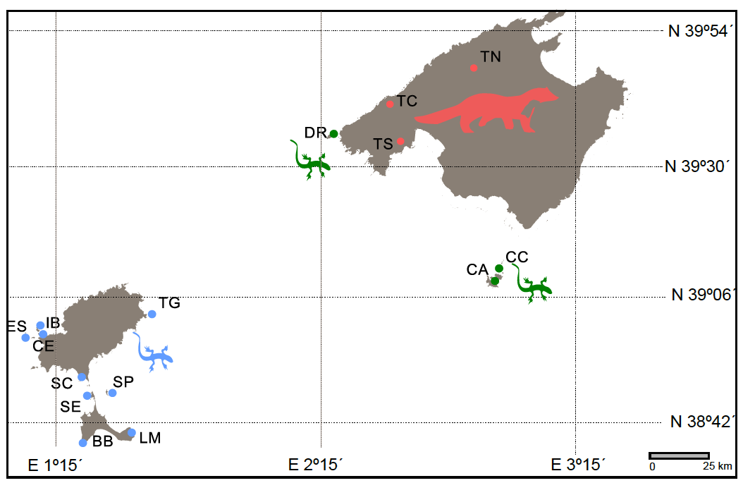

Figure 1

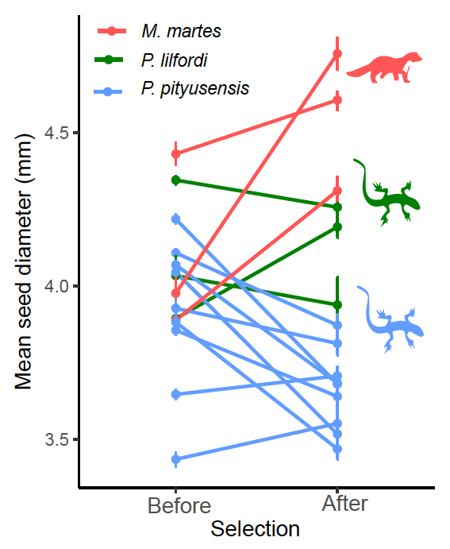

Figure 2

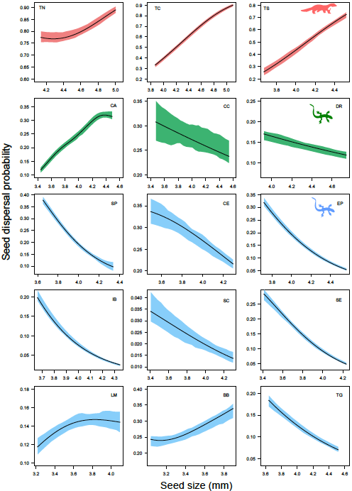

Figure 3

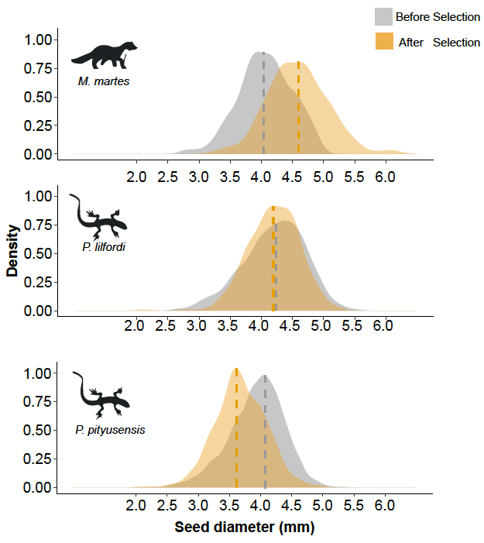

Figure 4

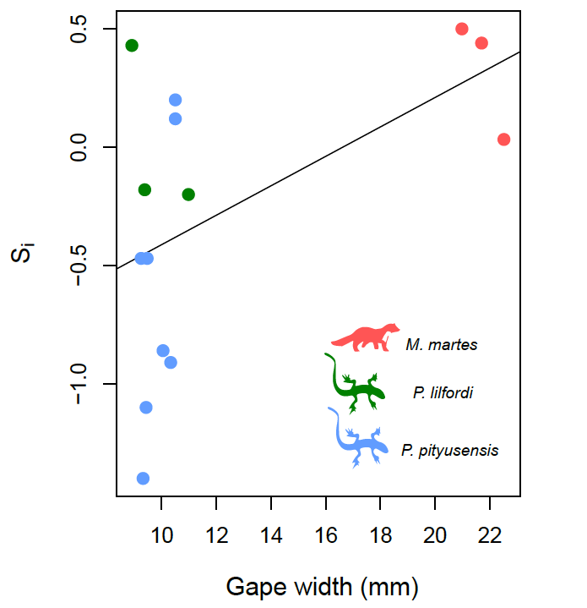

Figure 5

