How does micromorphology reflect taxonomy within the Xeranthemum group (Cardueae-Asteraceae)?

Milan Gavrilović^{1*}, Núria Garcia Jacas², Alfonso Susanna², Petar D. Marin¹, Pedja Janaćković¹

¹University of Belgrade - Faculty of Biology, Institute of Botany and Botanical Garden “Jevremovac”, Studentski trg 16, 11000 Belgrade, Serbia
²Botanic Institute of Barcelona (IBB,CSIC-ICUB), Pg. del Migdia s. n., 08038 Barcelona, Spain

*Corresponding author: mgavrilovic@bio.bg.ac.rs
Studentski trg 16, 11000, Belgrade, Serbia, phone +381(0)638889696/+381(0)113342114, fax +381(0)113243603, ORCID ID: https://orcid.org/0000-0002-1325-9658
e-mail addresses: ngarciajacas@ibb.csic.es, asusanna@ibb.csic.es, pdmarin@bio.bg.ac.rs, pjanackovic@bio.bg.ac.rs

Abstract

Comparative micromorphological analyses were conducted on five members of the Xeranthemum group, both perennial (Amphoricarpos exsul and Shangwua masarica) and annual (Chardinia orientalis, Siebera pungens and Xeranthemum inapertum), using scanning electron microscopy (SEM) and SEM coupled with energy dispersive spectrometer (SEM-EDS), with the purpose to describe and investigate whether micromorphological characters correlate with current phylogenies. Smooth outer periclinal upper leaf epidermal cell walls, slightly sinuate anticlinal upper leaf epidermal cell walls, “puzzle-like” fashion of the leaf upper epidermal cells and absence of weddellite crystals on the involucral bracts are shared by A. exsul and Sh. masarica, while sinuate anticlinal upper leaf epidermal cell walls, weddellite crystals on the involucral bracts and aristato-paleaceous pappus link together Ch. orientalis, S. pungens and X. inapertum. The following traits are likely species-specific: a) glabrous upper leaf epidermis and cypsela surface, and plumose-setose pappus in Sh. masarica; b) barbato-aristate pappus in A. exsul; c) very irregular cell shape of upper leaf epidermis with cuticle corrugations and papillose cypsela surface in Ch. orientalis; d) channeled anticlinal borders of upper leaf epidermal cells and wax deposition on the involucral bracts surface in X. inapertum; and e) strongly ribbed thickenings (striation) of outer periclinal upper leaf epidermal cell walls and involucral bracts with a whitish patch of appressed hairs in the central surface in S. pungens. All examined species shared the following characters: vermiform hairs on stems and on the abaxial leaf surfaces, adaxial detachment area, asymmetrical carpopodium and direct insertion of the pappus to the pericarp. Results revealed valuable qualitative characters that help species identification and contribute to a better understanding of relationships between genera. Phylogenetic analyses suggest that some characters found on leaves and involucral bracts are likely due to adaptations of perennial ancestors to xeric habitats.

Keywords: cypsela, involucral bract, trichomes, weddellite crystals

1. Introduction

One of the largest families of Embryophyta, Asteraceae comprises around 24000-30000 species in 1600-2000 genera (Anderberg et al., 2007; Funk et al., 2005; Funk and Robinson, 2005; Hind, 2007;). Members of the family are mostly annual or perennial herbaceous species with global distribution (Anderberg et al., 2007). According to Funk et al. (2009), the family consists of 12 subfamilies and 43 tribes. The subfamily Carduoideae comprises at least 93 genera and 2600 species, mostly from the Old World. This subfamily includes four tribes: Cardueae, Dicomeae, Oldenburgieae and Tarchonantheae (Funk et al., 2009). The tribe Cardueae is one of the largest in Asteraceae, with around 2400 species in 73 genera (Susanna and Garcia-Jacas, 2007). Given that some of the largest genera of the family Asteraceae belong to this tribe and because of their great morphological diversity, tribe Cardueae is one of the most complex (Susanna and Garcia-Jacas, 2007). The most important characters of Cardueae are: leaves with spiny apices, coriaceous phyllaries with spiny tips and cypselae obconical or broadly cylindrical, often with pericarp reinforced with strips of sclerenchyma and apical groove below insertion of the pappus (Ortiz et al., 2009). According to the latest molecular analysis (Susanna et al., 2006), the tribe Cardueae is monophyletic and comprises five subtribes (Cardopatiinae, Carduinae, Carlininae, Centaureinae and Echinopsinae). The subtribe Carduinae includes perennial, biennial or annual spiny herbs or subshrubs, rarely unarmed, characterized by bracts usually spiny with the innermost exappendiculate or with rudimentary appendages; cypselae with radially sclerified pericarp, sometimes absent, often with apical caruncle, insertion areole straight or lateral-abaxial, andpappus deciduous, inserted on a ring in the apical plate, simple or in many undifferentiated rows. Carduinae are paraphyletic (Susanna and Garcia-Jacas, 2007), but several informal groups are relatively well characterized based on morphological and molecular characters (Susanna and Garcia-Jacas, 2007). However, the taxonomy and phylogenetic relationships of these groups remain to be resolved. The most noticeable of these groups are: the Arctium-Cousinia group, the Carduus-Cirsium group, the Cynara group, the Jurinea-Saussurea group, the Onopordum group and the Xeranthemum group, together with two remarkable isolates: Berardia and Staehelina.
The Xeranthemum group includes unarmed annual or perennial herbs, rarely dwarf shrubs with entire leaves. The cypselae are often dimorphic, with pappus of long-tapering or subulate scales, rarely reduced to a corona in Chardinia Desf. (Susanna and Garcia-Jacas, 2009). This group comprises five genera and 15 species: Amphoricarpos Vis. (A. autariatus Blečič & E. Mayer, A. elegans Albov, A. exsul O. Schwarz, A. neumayerianus (Vis.) Greuter and A. praedictus Ayasligil & Grierson), the monotypic Chardinia (Ch. orientalis (L.) Kuntze) and Siebera J. Gay (S. pungens (Lam.) J. Gay) (Shishkin and Bobrov, 1997; Susanna and Garcia-Jacas, 2009), the newly described genus Shangwua Yu J. Wang, Raab-Straube, Susanna & J. Quan Liu (Sh. denticulata (DC.) Raab-Straube & Yu J. Wang, Sh. jacea (Klotzsch) Yu J. Wang & Raab-Straube and Sh. masarica (Lipsky) Yu J. Wang & Raab-Straube) (Wang et al., 2013) and Xeranthemum L. (X. annuum L., X. cylindraceum Sm., X. inapertum (L.) Mill, X. longepapposum Fisch. & C. A. Mey. and X. squarrosum Boiss.) (Susanna and Garcia-Jacas, 2009). Phylogenies based on molecular markers confirm that it is a natural group (e.g., Barres et al., 2013; Susanna et al., 2006; Wang et al., 2013), which was recognized even as a different tribe “Xeranthemées” (Cassini, 1819). Chardinia, Siebera and Xeranthemum comprise primarily annual plants, most often colonizers of wasteland throughout the Mediterranean and Irano-Turanian arid regions, while species of Amphoricarpos and Shangwua are perennial plants from the Eastern Mediterranean (Susanna et al., 2006; Susanna and Garcia-Jacas, 2007) and the Himalayas (Wang et al., 2013), respectively. Previous studies suggested that the ancestors of annuals are perennials growing on conservative habitats (mountains) (Barres et al., 2013; Gavrilović et al., 2018c). In the molecular phylogenies of the group, Amphoricarpos was sister to the rest of genera, , while Chardinia was placed as sister to Siebera and Xeranthemum (Susanna et al., 2006).
Micromorphological characters are of crucial importance in detecting taxonomic and phylogenetic relationships of particular plant groups and have been successfully used in plant systematic studies for decades (Endress et al., 2000). The anatomical characteristics that could be observed in Asteraceae are: (a) presence of various types of glandular or non-glandular trichomes; (b) papillae on the abaxial epidermis; (c) anomocytic, anisocytic and rarely heliocytic stomata types; (d) presence of hydathodes; (e) presence of hypodermis; (f) homogeneous or heterogeneous mesophyll; and (g) vascular bundles with parenchymatic sheath composed by large cells (Metcalfe and Chalk, 1979). The systematic value of leaf epidermal characters in Asteraceae has been proven by numerous studies, as leaf surface is under strong genetic control (Adedeji and Jewoola, 2008; Karanović et al., 2015). Some leaf blade characters (e. g., epidermal anticlinal cell walls, epicuticular wax and trichome type) were diagnostic for separating Aster L., Galatella Cass. and Tripolium Nees (Karanović et al., 2015). A comparative study of the leaf epidermis of twelve species (Ageratum conyzoides L., Aspilia africana (Pers.) C.D. Adams, Bidens pilosa L., Chromolaena odorata (L.) R.M. King and Robinson, Emilia coccinea (Sims) G. Don, E. praetermissa Milne-Redhead, Launaea taraxacifolia (Willd.) Amin ex C. Jeffrey., Synedrella nodiflora (L.) Gaertn., Tithonia diversifolia (Hemsl.) A. Gray, Tridax procumbens L., Vernonia amygdalina Del. and V. cinerea L.), all of them members of the Asteraceae, showed that type and shape of trichomes, cuticular striations and stomatal type are taxonomically important characters that may be used for the delimitation of the species (Adedeji and Jewoola, 2008). Also, microcharacters of involucral bracts are considered very helpful in delimitation in certain taxonomic groups in Asteraceae (e.g., for subtribes of Cardueae: with spiny pectinate-fimbriate appendages in Cardopatiinae; usually spiny, innermost exappendiculate or with rudimentary appendages in Carduinae; inner often conspicuous and colored in Carlininae; often with a diversely scarious, fimbriate, pectinate, spiny or unarmed appendage in Centaureinae; and in many rows in Echinopsinae (Robinson, 2009; Susanna and Garcia-Jacas, 2009). Petit (1997), studying generic interrelationships of the Cardueae, mentioned that reproductive parts are more valid and reliable at the intergeneric level comparing with vegetative parts because the latter exhibit morphological changes more quickly during evolution. In addition, morphological features of fruit surface sculpturing are considered to be less affected by environmental conditions (Barthlott, 1984). Cypselae micromorphological characteristics have provided useful information for the taxonomy of many Asteraceae (Barthlott, 1984; Blanca and Díaz de la Guardia, 1997; Garg and Sharma, 2007; Abid and Ali, 2010; Abid and Qaiser, 2009; Inceer et al., 2012; Singh and Pandey, 1984; Stebbins, 1953, Zhu et al., 2006), especially in the tribe Cardueae (Dittrich, 1977, 1985; Häffner, 2000; Petit, 1997; Zarembo and Boyko, 2008). Size, body shape, number of ribs, prickles, ornamentation of the intercostal gaps, type of tapering (sharp or gradual) body/beak junction, shape of beak and degree of swelling at the apex, and pubescence of the annulus are features that characterize the species of Tragopogon L. (Blanca and Díaz de la Guardia, 1997). Micromorphological characters of cypselae (shape, surface, colour, size), pappus (stucture, shape, number, colour, size) and carpopodium (shape, position, diameter) of 26 species of 9 genera of the tribe Senecioneae, as well as of 44 species of 15 genera of the tribe Anthemidae are useful for assessing relationship and delimitation of almost all taxa at the generic and specific levels (Abid and Ali, 2010; Abid and Qaiser, 2009). As a result of morphological and anatomical structure investigations of cypselae in the East Asian species of Rhaponticum Vaill., Klasea Cass., Serratula L. and Synurus Iljin. in the tribe Cardueae s.l., authors found the following diagnostic traits at species level: 1) topography of epidermal cells of pericarp, 2) presence of phlobaphenes, 3) occurrence, topography and localization of calcium oxalate crystals 4) occurrence and location of secretory ducts in mesocarp (Zarembo and Boyko, 2008). Another diagnostic character at the generic level is the structure of epidermal cells of testa (size, form, orientation, wall thickness).

Calcium oxalate crystals in Asteraceae were documented in previous studies (Dormer, 1961, 1962; Horner, 1977; Kartal, 2016; Meric, 2008, 2009a, 2009b; Meric and Dane, 2004). Crystal formation within the cell is consider to be under genetic control and species-specific (Horner et al., 2009; Ilarslan et al., 2001).
Species from the Xeranthemum group are insufficiently investigated from micromorphological point of view, because most of them are growing at very unaccessible habitats. Dittrich (1996) studied cypselae micromorphology and anatomy of Amphoricarpos autariatus, A. elegans, A. neumayerianus, Chardinia orientalis, Siebera pungens and all off Xeranthemum species and claimed that genera within the group are related, based on the shape and surface structure of the cypselae, morphology of the pappus and pericarp anatomy, and the arrangement of the vascular bundles. In our previous works, we examined involucral bracts micromorphology of X. annuum and X. cylindraceum and documented weddellite crystals on its surfaces (Gavrilović et al., 2017). Also, comparative anatomical and micromorphological studies of roots, stems, peduncles, leaves and inflorescences have been conducted on X. annuum and X. cylindraceum where well defined qualitative anatomical characters (e.g., shape of the young stem and peduncle cross-sections, type of glandular trichomes, cortical vascular bundles occurrence) have been shown useful in delimitation of the studied species (Gavrilović et al., 2018c). Also, some of the characters found (secondary growth in roots and dorsiventral leaves) points towards an adaptation from mesophytic to xeric habitats (Gavrilović et al., 2018c). In our previous investigation of X. cylindraceum cypselae, we found that cypsela micromorphology was in agreement with earlier investigations (Dittrich, 1996), as well as that presence of twin hairs on the cypselae surface link the Xeranthemum group with the basal subtribes of the Cardueae (Gavrilović et al., 2018a). Micromorphological investigation of leaf blade of A. elegans showed occurence of densely distributed non-glandular curly and rare glandular capitate type trichomes and epidermal cells with sinuous anticlinal walls (Gavrilović et al., 2018b).
The objectives of the present study were: (1) to conduct comparative micromorphological analysis of stems, leaves, involucral bracts and cypselae of Amphoricarpos exsul, Chardinia orientalis, Siebera pungens, Shangwua masarica, Sh. denticulata, and Xeranthemum inapertum in order to evaluate their systematic value; (2) to describe and examine taxonomically useful micromorphological features, and provide characters for better identification of the species; (3) to examine whether weddellite crystals are present on the involucral bracts surfaces of the studied species and whether they have taxonomic importance; and (4) to test whether the micromorphological characters examined support molecular-based phylogenetic analyses.

2. Material and methods

2.1. Plant Material

We have chosen five representatives for the investigation, one from each genus: Amphoricarpos exsul, Chardinia orientalis, Shangwua masarica (only leaves were investigated from Sh. denticulata), Siebera pungens and Xeranthemum inapertum. Mature leaves, stems, involucral bracts and cypselae were collected during flowering period from plants growing in their natural habitats in Spain, Turkey and China (Table 1). Voucher specimens were deposited in the herbaria of the Botanical Institute of Barcelona (BC), Spain, Moscow State University (MW), Russia and Lanzhou University (LZU), Gansu, Lanzhou, People's Republic of China.

2.2. Micromorphological methods (SEM and SEM-EDS)

Micromorphological analyses were carried out using scanning electron microscopy (SEM). Dry middle region of the leaves and stems, middle involucral bracts and mature cypselae (one sample per species) were sputter-coated with gold for 180 s at 30 mA (BAL-TEC SCD 005), and viewed using a JEOL JSM-6460LV electron microscope at an acceleration voltage of 20 kV. Mineral precipitation of some samples (involucral bracts) was detected using scanning electron microscopy coupled with energy dispersive spectrometer (SEM-EDS). Air-dried samples were mounted on aluminium stubs using double-sided carbon adhesive tape. Detection limits for most elements were 0.1%. Given that the samples were not polished, chemical analyses can be regarded as qualitative. To describe the three-dimensional model of the crystals the Miller indices method was used (Miller, 1839). Hair morphology follows Wurdack (1986), pappus description follows Small (1819), and detachment area of cypsela follows Häffner (2000).

3. Results

3.1. Stem micromorphology

Densely distributed, non-glandular, curly, trichomes, especially on the ribbed stem surface, are morphologically the same in all investigated species (Fig. 1A-C). These trichomes are vermiform (lanate) hairs. Capitate type glandular trichomes, seen as glandular dots, were found only in the surface of Shangwua masarica (Fig. 1A). Glandular trichomes are not recorded on the stem surface of the other species.

3.2. Leaf micromorphology

The adaxial leaf surface of Shangwua denticulata (Fig. 2A) lacks trichomes, whereas in the remaining studied species it is densely covered with non-glandular, curly trichomes (Fig. 2B-E). Glandular trichomes of the capitate type are evident on the adaxial surface (Fig. 2B, D). The cells of the adaxial epidermis are polygonal in shape (Fig. 2A, B, E), except in Chardinia orientalis (Fig. 2C) and Xeranthemum inapertum (Fig. 2D) in which adaxial epidermal cells are very irregular and polygonal irregular in shape, respectively. Outer periclinal cell walls of all investigated species are convex (Fig. 2A-E), although they are slightly concave (artifact) in Sh. denticulata (Fig. 2A). Outer periclinal cell walls are smooth in Sh. denticulata (Fig. 2A) and in Amphoricarpos exsul (Fig. 2B). The epidermal cells of Ch. orientalis show cuticle corrugations (Fig. 2C). The outer periclinal cell walls in X. inapertum (Fig. 2D) have slightly ribbed thickenings, while outer periclinal cell walls in Siebera pungens (Fig. 2E) have strongly ribbed thickenings (striation). Slightly sinuate anticlinal cell walls are found in Sh. denticulata (Fig. 2A) and A. exsul (Fig. 2B), while sinuate anticlinal cell walls are present in the other studied species (Fig. 2C-E). The epidermal cells of the adaxial surface in Sh. denticulata (Fig. 2A) and A. exsul (Fig. 2B) are arranged in a "puzzle-like" way. Adaxial leaf surface is wrinkled in Ch. orientalis (Fig. 2C), with channeled anticlinal borders in X. inapertum (Fig. 2D) and striated in S. pungens (Fig. 2E). Actinocytic, slightly sunken stomata were observed on the adaxial surface of A. exsul (Fig. 2B) and S. pungens (Fig. 2E). The abaxial leaf surface in all investigated species is densely covered with non-glandular, curly trichomes, forming a velvety indumentum (Fig. 2F-J). These trichomes are also vermiform (lanate) hairs. Glandular trichomes of the capitate type are evident on the abaxial surface of all the studied species (Fig. 2F-H), but much more so in Sh. denticulata (Fig. 2F).

3.3. Involucral bract micromorphology

The involucral bracts of Amphoricarpos exsul and Shangwua masarica are almost glabrous, with vermiform (lanate) hairs sparsely distributed near margins (Fig. 3A, B, respectively), while involucral bracts of Chardinia orientalis (Fig. 3C-D) and Xeranthemum inapertum (Fig. 3E-F) are glabrous. In contrast, the involucral bract of Siebera pungens possess a whitish patch of appressed vermiform (lanate) hairs in the central surface (Fig. 3G). The epidermal cells of the involucral bracts of X. inapertum are densely covered with epicuticular wax in form of platelets with even or irregular edges (Fig. 3E-F).
On the surface of the involucral bracts of Chardinia orientalis, Siebera pungens and Xeranthemum inapertum a large number of extracellular, densely packed crystals were observed (Fig. 3C-D, E-F, G-H, respectively). Crystals are more or less the same size, ranging from 8 to 20µm, evenly distributed on the epidermal surface (Fig. 3C-H). They rarely occur in combination of tetragonal bipyramide and tetragonal prism - Miller index (100) (Fig. 3D), but much often in the form of tetragonal bipyramide - Miller index (101) (Fig. 3F). According to the chemical composition and morphology, these crystals correspond to weddellite (CaC₂O₄∙2H₂O).

3.4. Cypsela micromorphology

The surface of the cypselae of Shangwua masarica is glabrous (Fig. 4A), and sericeous in all the other investigated species (Fig. 4B-E). Numerous elongated non-glandular, twin hairs shortly-forked on the top, are evident all over the surface of the cypselae of Amphoricarpos exsul, Chardinia orientalis, Xeranthemum inapertum and Siebera pungens (Fig. 4B-E, respectively). The apical ends of the shortly-forked hairs are more or less equal (Fig. 4C). Regarding the dimorphic cypselae of A. exsul, the surface of the inner cypselae is much more covered with trichomes (Fig. 4B, left), while the surface of the outer cypsela are sparsely covered, more on the central part and near the pappus (Fig. 4B, right). Although Ch. orientalis possesses dimorphic cypselae, we were only able to examine inner cypselae. Surface of Ch. orientalis is papillose with very large papillae and shows visible striations (Fig. 4F).
A homomorphic, uniseriate, persistent pappus, directly attached on the upper edge of the cypsela, with its elements more or less connate at the base (Fig. 4B, G-J) is a feature shared by all studied species. The pappus is plumose-setose in Shangwua masarica (Fig. 4K), barbato-aristate in Amphoricarpos exsul (Fig. 4L-M) and aristato-paleaceous in Chardinia orientalis (Fig. 4N-O), Xeranthemum inapertum (Fig. 4I, P) and Siebera pungens (Fig. 4Q-R). Pappus elements in Sh. masarica consist of numerous plumose bristles (Fig. 4K), whereas in A. exsul they are formed by subulate, basally smooth and apically barbellate bristels (Fig. 4L-M). The inner cypselae of A. exsul (Fig. 4B, left) possess much more bristles that the outer cypselae; bristles in the latter possess more small pinnules on the its surface (Fig. 4M) than bristles of the inner one (Fig. 4L). Pappus of Ch. orientalis consists of wide, scarious, subulate scales, more or less of equal length (Fig. 4N-O). Scales are serrulate (Fig. 4N-O), basally smooth, with small pinnules, over the external side, arising from central narrow part continuing to the top (Fig. 4N); apically pinnulate (Fig. 4O). X. inapertum possesses pappus which is formed by wide, scarious, subulate scales, variable in length (Fig. 4I). Scales are serrulate, basally scabrid, with pinnules all over the surface (Fig. 4I) and apically pinnulate (Fig. 4P). Pappus of S. pungens consists of wide, scarious, subulate scales spreading in all directions, more or less equal in length (Fig. 4J). Scales are serrulate, basally almost smooth (Fig. 4Q), apically scabrid, barbellate or plumose (Fig. 4R). The detachment area of all investigated species is adaxial (Fig. 4S-T). At the basal part of the fruit of all studied species, the abscission zone is surrounded by a carpopodium (Fig. 4S-T). The carpopodium constitutes the abscission zone. The carpopodium is asymmetrical and forms a horseshoe cup. The cell walls are poorly visible giving the carpopodium a smooth appearance (Fig. 4S-T).
Selected above-mentioned qualitative characters of stem, leaf, involucral bract and cypsela of examined species are outlined in Table 2.

4. Discussion

Indument. We showed here that all studied taxa possess hairy stems and woolly indumentum on both leaf surfaces, but much more densely on the abaxial side. Exception was the glabrous adaxial leaf surface of Shangwua denticulata. On the vegetative parts of the species belonging to the subtribe Carduinae a wide range of hair types are present (Häffner, 2000). Most Carduinae species possess a woolly indumentum either on the abaxial or on both leaf surfaces (Häffner, 2000). Trichomes are unicellular or formed by one to few basal cells and a long filiform terminal cell; more rarely, trichomes are large, uniseriate and multicellular (Häffner, 2000). Unicellular branched trichomes are seldom detected in the Carduinae, e.g., Onopordum L. (Häffner 2000). Capitate trichomes are found on the leaves of all studied species, but much more on the abaxial surface of Sh. denticulata, as well as on the stem surface of Sh. masarica. In Asteraceae, a widely distributed microcharacter on stems and leaves are glandular trichomes of short-stalked capitate type, seen as glandular dots (Robinson, 2009). According to Häffner (2000), glandular trichomes are formed by two cell rows: the lower pair form the stalk, and the apical pair represent the gland. However, in some genera of Carduinae, viz Alfredia Cass., Ancathia DC., Carduus L., Cirsium Mill., Lamyropappus Knorring & Tamams., Olgaea Iljin, Synurus Iljin and Xanthopappus C. Winkler, glands are absent (Häffner 2000). Persistence of traits associated to the adaptation to extreme habitats is a well-documented phenomenon in Asteraceae. The genus Phalacrachena Iljin from Siberia shows a dense glandular indument that was interpreted as an ancient adaptation to xeric habitats (Susanna et al., 2011). Likewise, non-glandular trichomes together with rare capitate glandular ones are present on the leaves surfaces of the limestone stenoendemic species Amphoricarpos elegans from Georgia (Gavrilović et al, 2018b). These glandular trichomes are the major sites of biosynthesis and accumulation of sesquiterpene lactones, very important compounds, which play significant role in ecology; possess biological activity; and are valuable in chemotaxonomy of the family (Appezzato-da-Glória et al., 2012; Gavrilović et al., 2018b).
Leaves. We found cuticle ribbed thickenings on the upper leaf epidermis surface of Xeranthemum inapertum and especially in Siebera pungens which is, according to Pătruţ et al. (2005), an adaptation aiming to reduce evapotranspiration. The same character was found in X. annuum and X. cylindraceum (Gavrilović et al., 2018c). Epidermal cells in Amphoricarpos exsul and Shangwua denticulata do not have ribbed thickenings of outer periclinal cell walls, because these species inhabit mesophytic habitats in mountain regions. The systematic value of leaf epidermal characters is very well documented in Asteraceae (Adedeji and Jewoola, 2008; Karanović et al., 2015). Also, cuticle ornamentation could provide additional taxonomical features (Stenglein et al., 2005). Four stomata types have been observed in the Asteraceae: anomocytic, brachyparacytic, anisocytic and diacytic (Adedeji and Jewoola, 2008). We observed actinocytic stomata type on the adaxial surface in A. exsul and S. pungens, in contrast to anomocytic found in X. annuum and X. cylindraceum (Gavrilović et al., 2018c). In all examined species, epidermal cells are polygonal in shape, except in Chardinia orientalis and X. inapertum which are very irregular and polygonal irregular, respectively. Anticlinal epidermal cell walls of studied species are sinuate, except in A. exsul and Sh. denticulata, where they are slightly sinuate. Sinuate anticlinal cell walls are also found in A. elegans (Gavrilović et al, 2018b) and X. annum and X. cylindraceum (Gavrilović et al., 2018c). Cuticle corrugations in Ch. orientalis, channeled anticlinal borders of upper leaf epidermal cells in X. inapertum and very visible striations in S. pungens, are likely unique features for these species. On the other hand, “puzzle-like” arrangement of upper leaf epidermal cells connected A. exsul and Sh. denticulata. The comparison between epidermal structures of the investigated species show the tendency of developing xeromorphic features (hairy stems and leaves). We can deduce a trend from glabrous upper epidermis in Sh. denticulata and smooth upper epidermis in A. exsul and Sh. denticulata to thick hairy covering and ribbed cuticle thickenings in S. pungens and X. inapertum, which grow in open, arid habitats. Moreover, a space remains between the leaf surface and trichomes which protects the epidermis from extreme evaporation (Uzunova et al, 2007). Thus, micromorphological features of the leaf epidermis, such as the nature of outer periclinal and anticlinal cell walls or presence of hairs, are taxonomically important in delimitation of the certain species and even at the generic level, as stated by Barthlott (1981).
Involucral bracts. Our results showed that the middle involucral bract differ between studied species. Regarding the presence of hairs, we could make some conclusions: Amphoricarpos exsul and Shangwua masarica similarly possess hairs on the margins; Chardinia orientalis and Xeranthemum inapertum lack hairs; and Siebera pungens is most distinctive with a whitish patch of appressed hairs in the central surface. Many characters of capitula are useful in systematics of Asteraceae, e.g., shape and size or condensation of the capitulum; the nature and number of involucral bracts and paleae; and the number of florets (Häffner, 2000). Wax platelets of irregular shape and different sizes are only found on the involucral bract epidermis in X. inapertum. Wax type is a genetically determined characteristic (Baker, 1982). In this regard,The X. inapertum is the only species in this study that presents wax on the involucral bract surface. Involucral bracts surface of X. annuum and X. cylindraceum lacks wax platelets (Gavrilović et al., 2017). Thus, the presence of wax depositions could serve as additional character for separating Xeranthemum species. In addition, epicuticular wax composition is helpful in taxonomy (Stenglein et al., 2005). The main role of wax depositions on the leaves of species inhabiting sunny and dry places is in the control of evaporation (Mika and Bumerl, 1984).
Weddellite crystals were observed on the surface of involucral bracts in Chardinia orientalis, Siebera pungens and Xeranthemum inapertum, whereas Amphoricarpos exsul and Shangwua masarica completely lack crystals. Observed crystals do not correspond to chemically similar whewellite (CaC₂O₄∙H₂O) because they do not form monoclinic crystals. The same extracellular crystals are found in X. annum and X. cylindraceum involucral bracts surfaces (Gavrilović et al., 2017). Extracellular deposition of crystals is surely caused by intracellular crystal formation, thus all epidermal cells are secretory (Franceschi and Nakata, 2005). According to our results and previous studies (Bárcenas-Argüello et al., 2015; De Yoreo and Dove, 2004), the type of crystal formation and crystallite morphology is correlated to the chemical composition of the crystals, as well as to the edaphic conditions in which certain species grow. The structural characteristics of each crystal phase also depend on the type of chemical bond, the size of ions or atoms, temperature of crystallization etc. Moreover, modifications in the shape of different crystals could depend on the presence of small inorganic molecules and moderate to large size organic molecules (De Yoreo and Dove, 2004). Nevertheless, from taxonomical point of view, the morphological diversity of the crystals in plants may be a source of phylogenetic characters (Bárcenas-Argüello et al., 2015). In this regard, A. exsul and Sh. masarica are separated from the remaining investigated species. An obvious logical question is why these crystals are not formed on the involucral bracts surfaces in A. exsul and Sh. masarica. Is this in relation with genetics, edaphic conditions, or life form? In the Xeranthemum group, Amphoricarpos and Shangwua species grow in mountain and alpine regions, while the species from the other annual genera, Chardinia, Siebera and Xeranthemum, grow in open arid habitats, which might influence crystal formation.
Cypselae. Results obtained in this study showed that cypselae of all studied species are sericeous, except in Shangwua masarica. Twin hairs on the fruit surface usually occur in genera of Asteraceae (Robinson, 2009). These hairs, specific of the cypsela epidermis (Hess, 1938), consist of two elongated, parallel cells, originated from an epidermal mother cell which undergoes anticlinal division (Bremer, 1987; Cron et al., 1993; Hess, 1938). The function of these hairs is still unclear. According to Hess (1938), the main function might be water absorption. In this regard, myxogenic twin hairs would keep the moisture around the cypselae surface and thus facilitate the germination and probably contribute to the seed dispersal (Hess, 1938). In Cardueae, cypselae are glabrous in most of Carduinae and Centaureinae, and usually hirsute or densely sericeous in Carlininae, Cardopatiinae and Echinopsinae (Susanna and Garcia-Jacas, 2009). The only exception in Carduinae is the Xeranthemum group (Dittrich, 1977). Ozcan (2017) also did not found twin hairs in Cirsium, while cypselae of X. cylindraceum are densely hairy (Gavrilović et al., 2018a). Thus, Xeranthemum group shares a significant character, presence of twin hairs, with the basal Cardueae subtribes (Carlininae, Cardopatiinae and Echinopsinae). The lack of twin hairs in Shangwua could be interpreted as a loss (Petit, 1997). Also, cypsela surface of Chardinia orientalis is papillose, with very visible striations. This character separate Ch. orientalis from the remaining studied species. A character which is evident in some natural groups within Carduinae (Cousinia group, Dolomiaea DC, Jurinea Cass. and some genera of the Onopordum group) is a rugose pericarp, while smooth pericarp is constant in Carduus, Cirsium and some other Central Asian Carduinae (Häffner, 2000; Ozcan, 2017). Carpological features such as morphology and microsculpturing of the cypselae are significant conservative characters in Asteraceae, as also showed Inceer et al. (2012), Karanović et al. (2016) and Ozcan (2017).
All investigated species share an adaxial detachment area. It was also found in Xeranthemum cylindraceum (Gavrilović et al., 2018a). Our finding is in agreement with Dittrich (1977) who pointed out that the detachment area of the Cardueae members is straight and basal, or lateral in some genera, e.g., Cardopatium Juss., Chardinia, Siebera and Xeranthemum. However, Häffner (2000) found strictly basal detachment area in Cousinia group, Cynara L., Dolomiaea and Pilostemon Cass., as well as Ozcan (2017) in Cirsium.
Another feature which connect examined species is an asymmetrical carpopodium. A carpopodium is a zone with visible sclerified pericarp epidermis (Haque and Godward, 1984; Mattfeld, 1923), facilitating the abscission from the receptacle (John, 1921). Carpopodium occurs within many tribes of the Asteraceae (Haque and Godward, 1984). Moreover, it was suggested that the hairy pappus and the occurrence of the carpopodium are correlated, as these structures play a role in wind dispersal (Haque and Godward, 1984). The carpopodium may be symmetrical or it is more often asymmetrical, indistinct to prominent, or even absent (Funk et al., 2009; Haque and Godward, 1984). Its shape mainly depends on the cypsela position on the receptacle (Sundberg, 1985). An important note is that shape and cellular structure of carpopodium are used in systematic studies (King and Robinson, 1966; Sundberg, 1985). In addition, Ozcan (2017) reported undeveloped carpopodium in Cirsium taxa, whereas it is asymmetrical in Xeranthemum cylindraceum (Gavrilović et al., 2018a).
Pappus formed by bristles is present in A. exsul and Sh. masarica, while pappus formed by scales is present in the other examined species, in agreement with Dittrich (1996). These findings also show close relation of annual genera of the group, and separate perrenial ones. Deciduous pappus is present in most of the Carduinae, while persistent pappus is found in most Jurinea and related genera (Häffner, 2000). In Cardueae, pinnules of the pappus bristles are shorter than the width of the bristle (scabrate); as long as width of the bristle (pinnulate); or much longer and capillar (plumose; cf. Susanna and Garcia-Jacas, 2009). Within Carduinae, the pappus bristles exhibit structural features which help in the genera delimitation (Häffner, 2000; Mukherjee and Nordenstam, 2008); e.g., the pappus is formed by scabrid cylindrical bristles in Berardia and Staehelina; plumose or barbellate bristles in Carduus-Cirsium; plumose with very long bristles in the Cynara group; plumose with very long, conspicuous bristles in the Jurinea-Saussurea group; and plumose in the Onopordum group (Susanna and Garcia-Jacas, 2009).
Our results confirmed that pappus is directly united to the pericarp in all investigated species. In Cardueae, the pappus is directly attached to the pericarp wall in the basal subtribes Cardopatiinae, Carlininae and Echinopsinae, as well as in the genera Berardia Vill., Staehelina and in the Xeranthemum group of Carduinae. Thus, members of the Xeranthemum group share this pappus feature with all the basal Cardueae subtribes. This is also in agreement with Dittrich (1970, 1977): the pappus in Xeranthemum is fixed to the edge of the vertical wall on the apex of the cypsela. Contrarily, in remaining Carduinae and in all Centaureinae, the pappus is fixed to a parenchymatous ring on the cypselae apical plate.
Distribution of the studied characters (shared and specific), as well as characters found in literature (appearance of involucral bract apex and margin and color of the pappus; cf. Dittrich, 1996; Bremer 1994; Wang et al., 2013) represented as numbers, are shown on the phylogenetic tree of the Xeranthemum group (redrawn from Wang et al., 2013) (Fig. 5). It could be concluded that some features such as smooth outer periclinal upper leaf epidermal cell walls, slightly sinuate anticlinal upper leaf epidermal cell walls, “puzzle-like” shape of the leaf upper epidermal cells, very short terminal point of the involucral bracts, black fringe of the involucral bracts and absence of weddellite crystals on the involucral bracts surfaces are shared by Amphoricarpos exsul and Shangwua masarica, perennial members of the group, while sinuate anticlinal upper leaf epidermal cell walls, mucronate involucral bracts, presence of weddellite crystals on the involucral bracts surfaces and aristato-paleaceous pappus link together Chardinia orientalis, Siebera pungens and Xeranthemum inapertum, annual members of the group. Involucral bracts in the Xeranthemum group are scarious and often colored (Wang et al., 2013). All examined species possess scarious bracts, more or less chartaceous, ending in a point of different size: relatively short in A. exsul and Sh. masarica, longer in Ch. orientalis and X. inapertum, and very long, erect in S. pungens (Bremer, 1994). According to herbarium samples, bracts of both Amphoricarpos and Shangwua species often share a very important character - a black fringe. Dimorphic cypselae are found in A. exsul and Ch. orientalis (Bremer, 1994). Petit (1997) suggested that sterile cypselae in Siebera and Xeranthemum probably derived from the Amphoricarpos type, which possesses flattened and winged outer cypselae. Color of the pappus also served as additional taxonomic character (Häffner, 2000). Most members of Carduinae have white to cream-colored or even brownish pappus (Häffner, 2000). Color of the pappus varies between studied species, with S. pungens being the most distinctive by having translucent pappus with a brown stripe in the middle of the scales (Wang et al., 2013).
Some traits are likely species-specific: a) glabrous upper leaf epidermis and cypsela surface and plumose-setose pappus in Sh. masarica; b) barbato-aristate pappus in A. exsul; c) very irregular cell shape of upper leaf epidermis with cuticle corrugations and papillose cypsela surface in Ch. orientalis; d) channeled anticlinal borders on the upper leaf epidermis and wax deposition on the involucral bract surface in X. inapertum; and e) strongly ribbed thickenings (striation) of outer periclinal upper leaf epidermal cell walls and involucral bracts with a whitish patch of appressed hairs in the central surface in S. pungens. However, some features are common for all species: vermiform hairs on stems and on the abaxial leaf surface, adaxial detachment area, asymmetrical carpopodium and direct insertion of the pappus to the pericarp.
Finally, we could consider that micromorphology significantly correlated with current phylogeny (Wang et al., 2013) of the group. Our findings favor hypothesis of previous work (Gavrilović et al., 2018c; Wang et al., 2013) which suggested that the perennial ancestors from conservative habitats (mountains) adapted to xeric habitats. According to Barres et al. (2013), the separation of Xeranthemum from Amphoricarpos occurred in the Oligocene (ca. 27 million years ago). Molecular phylogenies (Barres et al., 2013; Susanna et al., 2006) indicated a close relationiship of Amphoricarpos and Chardinia, which were succesive sisters to the other genera of the group. This could be observed also in their micromorphology, as Chardinia shares some features with Amphoricarpos (dimorphic cypselae) and some features only with Xeranthemum (mucronate and glabrous involucral bracts). Close relation of Xeranthemum and Chardinia is also confirmed by the same ornamentation of pollen grains (verrucoid and prolate–spheroidal) (Garnatje and Martín, 2007).
The short generation time and the sexual allogamous reproduction of the annuals in the Xeranthemum group may lead to the accumulation of many changes in a relatively short period of time, which could result in genome changes (chromosome number, DNA content; Garnatje et al., 2004a). This mechanism would provide a rapid adaptation to arid conditions at ruderal places, where these plants often live. Regarding leaf and cypsela characteristics, Shangwua species exhibit some unique features (glabrous upper epidermis and cypsela surface, plumose-setose pappus) which could indicate an intermediate position of this genus between the other species of the Xeranthemum group and the subtribe Carlininae, in agreement with Dittrich (1996) and Wang et al. (2013).
The relevance of these analyses in the Xeranthemum group is particularly remarkable, since this complex comprises annual and perennial species. where their micromorphological characters, consider as conservative, could throw light on their taxonomy and evolution. Moreover, some of the additional characters obtained could be useful in the delimitation of other Cardueae taxa. Finally, a comprehensive micromorphological analysis, combined with anatomical, phytochemical and molecular data, of the remaining species from the Xeranthemum group will certainly help in resolving their phylogenetic and taxonomic relationships.
Finally, extracellular crystal formation is still an unclear phenomenon. Anatomical and embryological studies of Chardinia, Siebera and Xeranthemum species are needed to truly understand the extracellular crystal deposition. Further anatomical study of the inflorescences of related species could reveal new cases where extracellular crystals occur, the way of its deposition and their function.

5. Conclusions

This first detailed comparative micromorphological study of five representatives of the Xeranthemum group revealed many qualitative characters which have taxonomic and phylogenetic importance. Some selected qualitative characters of leaf, involucral bract and cypsela provide valuable features for better species identification and help in better understanding the relationships between the genera. Our results favor hypothesis of previous works which suggested that the ancestors of annual genera are perennials from conservative habitats. Microcharacters also confirm that these annual genera are adapted to arid conditions at ruderal places.

Acknowledgments
Financial support was provided by the Ministry of Education, Science and Technological Development of the Republic of Serbia (Project No. 173029). SEM and SEM-EDS analysis has been carried out at SEM laboratory, Faculty of Mining and Geology, University of Belgrade and at University Centre for Electron Microscopy, Novi Sad. Many thanks to Mr Milos Bokorov from University Center for Electron Microscopy, Novi Sad, for his technical assistance and contribution in SEM analysis.

Declarations of interest: none

References

Abid, R., Ali, N., 2010. Cypsela morphology and its taxonomic significance for the tribe Senecioneae (Asteraceae) from Pakistan. Pak. J. Bot. 42, 117–133.
Abid, R.D., Qaiser, M., 2009. Taxonomic significance of the cypsela morphology in the tribe Anthemideae (Asteraceae) from Pakistan and Kashmir. Pak. J. Bot. 41, 555–579.
Adedeji, O., Jewoola, O.A., 2008. Importance of leaf epidermal characters in the Asteraceae family. Not. Bot. Horticult. Agrobot. 36, 7–16.
Anderberg, A.A., Baldwin, B.G., Bayer, R.J., Breitwieser, I., Jeffrey, C., Dillon, M.O., Eldenäs, P., Funk, V.A., Garcia-Jacas, N., Hind, D.J.N., Karis, P.O., Lack, H.W., Nesom, G., Nordenstam, B., Oberprieler, C., Panero, J.L., Puttock, C., Robinson, H., Stuessy, T.F., Susanna, A., Urtubey, E., Vogt, R., Ward, J., Watson, L.E., 2007. Compositae, in: J. W. Kadereit, and C. Jeffrey [eds.], Flowering Plants. Eudicots. Asterales, vol. VIII, in K. Kubitzki [ed.], The families and genera of vascular plants, 123–146. Springer Verlag, Berlin.
Appezzato-da-Glória, B., Da Costa, F.B., Silva, V.C., Gobbo-Neto, L., Rehder, V.L.G., Hayashi, A.H., 2012. Glandular trichomes on aerial and underground organs in Chrysolaena species (Vernonieae – Asteraceae): structure, ultrastructure and chemical composition. Flora 207, 878–887.
Baker, E.A., 1982. Chemistry and morphology of plant epicuticular waxes, in: Cutler, D.F., Alvin, K.L., Price, C.E. (Eds.), The plant cuticle. Academic Press, London, pp. 139–166.
Bárcenas-Argüello, M.L., Gutiérrez-Castorena, M.C.D.C., Terrazas, T., 2015. The polymorphic weddellite crystals in three species of Cephalocereus (Cactaceae). Micron 77, 1–8.
Barres, L., Sanmartín, I., Anderson, C.L., Susanna, A., Buerki, S., Galbany‐Casals, M., Vilatersana, R., 2013. Reconstructing the evolution and biogeographic history of tribe Cardueae (Compositae). Am. J. Bot. 100, 867–882.
Barthlott, W., 1981. Epidermal and seed surface characteristics of plants: systematic applicability and some evolutionary aspects. Nord. J. Bot. 1, 345–354.
Barthlott, W., 1984. Microstructural features of seed surfaces, in: Heywood, V.H., Moore, D.M. (Eds.), Current concepts in plant taxonomy. Academic Press, Cambridge, pp. 95–105.
Blanca, G., Díaz de la Guardia, C., 1997. Fruit morphology in Tragopogon L. (Compositae: Lactuceae) from the Iberian Peninsula. Bot. J. Linn. Soc. 125, 319–329.
Bremer, K., 1987. Tribal interrelationships of the Asteraceae. Cladistics 3, 210–253.
Bremer, K., 1994. Asteraceae: Cladistics & Classification. Timber Press, Portland.
Cassini, H., 1819. Sur la famille des Synanthérées: contenant les caractéres des tribus. J. Phys. Chim. Hist. Nat. Arts. 88, 189–204.
Cron, G.V., Robbertse, P.J., Vincent, P.L.D., 1993. The anatomy of the cypselae of species of Cineraria L. (Asteraceae-Senecioneae) and its taxonomic significance. Bot. J. Linn. Soc. 112, 319–334.
De Yoreo, J.J., Dove, P.M., 2004. Shaping crystals with biomolecules. Science 306, 1301–1302.
Dittrich, M., 1966. Karpologische Untersuchungen zur Systematik von Centaurea und verwandten Gattungen. Bot. Jahrb. Syst. 88, 70–162.
Dittrich, M., 1970. Morphologische und anatomische Untersuchungen an Früchten der Carduinae (Compositae). I. Morphologischer Teil. Candollea 25, 45–67.
Dittrich, M., 1977. Cynareae – systematic review, in: Heywood, V.H., Harborne, J.B., Turner, B.L. (Eds.), The Biology and Chemistry of the Compositae 2. Academic Press, London, New York, San Francisco, pp. 999–1015
Dittrich, M., 1985. Morphologische und anatomische Untersuchungen an Blüten und Früchten der Gattung Carlina (Compositae). Bot. Jahrb. Syst. 107, 591–609.
Dittrich, M., 1996. Die Bedeutung morphologischer und anatomischer Achänen-Merkmale für die Systematik der Tribus Echinopeae Cass. und Carlineae Cass. Boissiera 51, 9–102.
Dormer, K.J., 1961. The crystals in the ovaries of certain Compositae. Ann. Bot., London 25, 241–254.
Dormer, K.J., 1962. The taxonomic significance of crystal forms in Centaurea. New Phytol. 61, 32–35.
Endress, P.K., Baas, P., Gregory, M., 2000. Systematic plant morphology and anatomy: 50 years of progress. Taxon 49, 401–434.
Franceschi, V.R., Nakata, P.A., 2005. Calcium oxalate in plants: formation and function. Annu. Rev. Plant. Biol. 56, 41–71.
Funk, V.A., Bayer, R.J., Keeley, S., Chan, R., Watson, L., Gemeinholzer, B., Schilling, E., Panero, J.L., Baldwin, B.G., Garcia-Jacas, N., Susanna, A., Jansen, R.K., 2005. Everywhere but Antarctica: using a supertree to understand the diversity and distribution of the Compositae. Biol. Skrif. 55, 343–374.
Funk, V.A., Robinson, H.E., 2005. Daisies and sunflowers: family Asteraceae, in: Krupnick, G.A., Kress, W.J. (Eds.), Plant Conservation. A Natural History Approach. University of Chicago Press, Chicago and London, pp. 115-137.
Funk, V.A., Susanna, A., Stuessy, T.F., Robinson, H., 2009. Classification of Compositae, in: Funk, V.A., Susanna, A., Stuessy, T.F., Bayer, R.J. (Eds.), Systematics, Evolution, and Geography of Compositae, IAPT, Vienna, pp. 171–189.
Garg, S.K., Sharma, K.C., 2007. Taxonomical significance of the micromorphological and scanning electron microscopic surface patterns of cypselas in some members of the tribe Heliantheae (Asteraceae). Feddes Repert. 118, 165–191.
Garnatje, T., Vallès, J., Garcia, S., Hidalgo, O., Sanz, M., Canela, M.Á., Siljak-Yakovlev, S., 2004a. Genome size in Echinops L. and related genera (Asteraceae, Cardueae): karyological, ecological and phylogenetic implications. Biol. Cell 96, 117–124.
Garnatje, T., Vallès, J., Vilatersana, R., Garcia‐Jacas, N., Susanna, A., Siljak‐Yakovlev S., 2004b. Molecular cytogenetics of Xeranthemum L. and related genera (Asteraceae, Cardueae). Plant Biol 6, 140–146.
Garnatje, T., Martín, J., 2007. Pollen studies in the genus Echinops L. and Xeranthemum group (Asteraceae). Bot. J. Linn. Soc. 154, 549–557.
Gavrilović, M., Erić, S., Marin, P.D., Garcia-Jacas, N., Susanna, A., Janaćković, P., 2017. Scanning electron microscopy coupled with energy dispersive spectrometric analysis reveals for the first time weddellite and sylvite crystals on the surface of involucral bracts and petals of two Xeranthemum L. (Compositae) species. Microsc. Microanal. 23, 679–686.
Gavrilović, M., De Oliveira, A.F.M., Barbosa, M.O., Garcia-Jacas N., Susanna, A., Marin P.D., Janaćković, P., 2018a. Cypselae micromorphology and fatty acid composition of Xeranthemum cylindraceum Sm. (Asteraceae, Cardueae). Bot. Serb. 42, 241–250.
Gavrilović, M., Tešević, V., Đorđević, I., Rajčević, N., Bakhia, A., Garcia-Jacas, N., Susanna, A., Marin, P.D., Janaćković, P., 2018b. Leaf micromorphology, antioxidative activity and a new record of 3-deoxyamphoricarpolide of relict and limestone endemic Amphoricarpos elegans Albov (Compositae) from Georgia. Arch. Biol. Sci. https://doi.org/10.2298/ABS180309022G.
Gavrilović, M., Rančić, D., Škundrić, T., Dajić-Stevanović, Z., Marin, P.D., Garcia-Jacas, N., Susanna, A., Janaćković, P., 2018c. Anatomical characteristics of Xeranthemum L. (Compositae) species: taxonomical insights and evolution of life form. Pak. J. Bot. in press.
Hacioğlu, B.T., Arslan, Y., Subasi, I., Katar, D., Bulbul, A.S., Çeter, T., 2012. Achene morphology of Turkish Carthamus species. Aust. J. Crop Sci. 6, 1260–1264.
Häffner, E., 2000. On the phylogeny of the subtribe Carduinae (tribe Cardueae, Compositae). Englera 21, 1–208.
Haque, M.Z., Godward, M.B.E., 1984. New records of the carpopodium in Compositae and its taxonomic use. Bot. J. Linn. Soc. 89, 321–340.
Hess, R., 1938. Vergleichende Untersuchungen über die Zwillingshaare der Compositen. Bot. Jahrb. Syst. 68, 435–496.
Hind, D.J.N. 2007. Asteraceae, in: Heywood, V.H., Brummitt, R.K., Culham, A.C., Seberg, O. (Eds.), Flowering Plant Families of the World. Kew Publications, Richmond; Firefly Books, Ontario and Buffalo, New York. pp. 46–52
Horner, H.T., 1977. A comparative light and electron-microscopic study of microsporogenesis in male-fertile and cytoplasmic male-sterile sunflower (Helianthus annuus). Am. J. Bot. 64, 745–759.
Horner, H.T., Wanke, S., Samain, M.S., 2009. Evolution and systematic value of leaf crystal macropatterns: a phylogenetic approach in the genus Peperomia (Piperaceae). Int. J. Plant Sci. 170, 343–354.
Ilarslan, H., Palmer, R.G., Horner, H.T., 2001. Calcium oxalate crystals in developing seeds of soybean. Ann. Bot., London 88, 243–257.
Inceer, H., Bal, M., Ceter, T., Pinar, N.M., 2012. Fruit structure of 12 Turkish endemic Tripleurospermum Sch. Bip. (Asteraceae) taxa and its taxonomic implications. Plant Syst. Evol. 298, 845–855.
John, A., 1921. Beiträge zur Kenntnis der Ablösungseinrichtungen der Kompositenfrüchte. Beihefte zum Botanischen Centralblatt, Abteilung I, 38, 182–203.
Karanović, D., Luković, J., Zorić, L., Anačkov, G., Boža, P., 2015. Taxonomic status of Aster, Galatella and Tripolium (Asteraceae) in view of anatomical and micro‐morphological evidence. Nord. J. Bot. 33, 484–497.
Karanović, D., Zorić, L., Zlatković, B., Boža, P., Luković, J., 2016. Carpological and receptacular morpho-anatomical characters of Inula, Dittrichia, Limbarda and Pulicaria species (Compositae, Inuleae): taxonomic implications. Flora 219, 48–61.
Kartal, C., 2016. Calcium oxalate crystals in some species of the tribe Cardueae (Asteraceae). Bot. Sci. 94, 107–119.
King, R.M., Robinson, H., 1966. Generic limitations in the Hofmeisteria complex (Compositae-Eupatorieae). Phytologia 12, 465–476.
Mattfeld, J., 1923. Compositae, in: Pilger, R., (Ed.), Plantae Ltitzelburgianae brasilienses: 8, Notizblatt des Botanischen Gartens, Berlin-Dahlem, pp. 425–451.
Meric, C., Dane, F., 2004. Calcium oxalate crystals in floral organs of Helianthus annuus L. and H. tuberosus L. (Asteraceae). Acta Biol. Szeged. 48, 19–23.
Meric, C., 2008. Calcium oxalate crystals in Conyza canadensis (L.) Cronq. and Conyza bonariensis (L.) Cronq. (Asteraceae: Astereae). Acta Biol. Szeged. 52, 295–299.
Meric, C., 2009a. Calcium oxalate crystals in some species of the tribe Inuleae (Asteraceae). Acta Biol. Crac. Ser. Bot. 51, 105–110.
Meric, C., 2009b. Calcium oxalate crystals in Aster squamatus and Bellis perennis (Asteraceae: Astereae). Phytol. Balc. 15, 255–259.
Metcalfe, C.R. and Chalk, L., 1979. Anatomy of the Dicotyledons, 2nd Edition. Clarendon Press, Oxford.
Mika, V., Bumerl, J., 1984. Variability of the secretion of epicuticular waxes in the plants of Red Clover (Trifolium pratense L) and their relation to infection with Erysiphe trifolii Grev. Rostl. Vyroba 30, 193–199.
Miller, W.H., 1839. A treatise on crystallography. J. & J. J. Deighton, Cambridge.
Mukherjee, S.K., Nordenstam, B., 2008. Diversity of pappus structure in some tribes of the Asteraceae. Phytotaxonomy 8, 32–46.
Ortiz, S., Bonifacino, M.J., Crisci, V.J., Funk, A.V., Hansen, V.H., Hind, N.J.D., Katinas, L., Roque, N., Sancho, G., Susanna, A., Telleria, S.M. 2009. The basal grade of the Compositae: Mutisieae (sensu Cabrera) and Carduoideae, in: Funk, V.A., Susanna, A., Stuessy, T.F.., Bayer, R.J. (Eds.), Systematics, Evolution and Biogeography of Compositae. IAPT, Vienna, pp. 194–213.
Ozcan, M., 2017. Cypsela micromorphology and anatomy in Cirsium sect. Epitrachys (Asteraceae, Carduoideae) and its taxonomic implications. Nordic J. Bot. 35, 653–668.
Pătruţ, D.I., Pop, A., Coste, I., 2005. Biodiversitatea halofitelor din Câmpia Banatului. Eurobit, Timişoara.
Petit, D.P., 1997. Generic interrelationships of the Cardueae (Compositae): a cladistic analysis of morphological data. Plant Syst. Evol. 207, 173–203.
Robinson, H., 2009. An introduction to micro-characters of Compositae, in: Funk, V.A., Susanna, A., Stuessy, T.F., Bayer, R.J. (Eds.), Systematics, Evolution and Biogeography of Compositae. IAPT, Vienna, pp. 89–100.
Roy, S., Mondal, T., Mukherjee, S.K., 2013. Diversity of cypselar characters in some members of tribe Inuleae (Asteraceae). IJPRBS 2, 82–98.
Shishkin, B.K., Bobrov, E.G., 1997. Flora of the USSR. Dehra Dun: Bishen Singh Mahendra Pal Singh and Koeltz Scientific Books.
Singh, R.P., Pandey, A.K., 1984. Development and structure of seeds and fruits in Compositae - Cynareae. Phytomorphology 34, 1–10.
Small, J., 1919. The origin and development of the Compositae. New Phytologist Reprint, No. 11. William Wesley & Son, London.
Stebbins, G.L., 1953. A new classification of the tribe Cichoriae, family Compositae. Madroño 12, 65–81.
Stenglein, S.A., Arambarri, A.M., Menendez Sevillano, M.C., Balatti, P.A., 2005. Leaf epidermal characters related with plant’s passive resistance to pathogens vary among accessions of wild beans Phaseolus vulgaris var. aborigineus (Leguminosae–Phaseoleae). Flora 200, 285–295.
Sundberg, S., 1985. Micromorphological characters as generic markers in the Asteraceae. Taxon 34, 31–37.
Susanna, A., Galbany-Casals, M., Romashchenko, K., Barres, L., Martín, J., Garcia-Jacas, N., 2011. Lessons from Plectocephalus (Compositae, Cardueae-Centaureinae): ITS disorientation in annuals and Beringian dispersal as revealed by molecular analyses. Ann. Bot., London 108, 263–277.
Susanna, A., Garcia-Jacas, N., Hidalgo, O., Vilatersana, R., Garnatje, T., 2006. The Cardueae (Compositae) revisited: insights from ITS, trnL-trnF, and matK nuclear and chloroplast DNA analysis. Ann. Mo. Bot. Gard. 93, 150–171.
Susanna, A., Garcia-Jacas, N., 2007. Tribe Cardueae Cass. (1819), in: Kubitzki, K. (Ed.), The Families and Genera of Vascular Plants. VIII Flowering Plants-Eudicots. Springer Verlag, Berlin & Heidelberg, pp. 123–146.
Susanna, A., Garcia-Jacas, N., 2009. Cardueae (Carduoideae), in: Funk, V.A., Susanna, A., Stuessy, T.F.., Bayer, R.J. (Eds.), Systematics, Evolution and Biogeography of Compositae. IAPT, Vienna, pp. 293–313.
Turner, B.L., 2007. The Comps of México: a systematic account of the family Asteraceae (Vol. 8). Liabeae and Vernonieae. Phytologia Memoirs 12, 35–14
Uzunova, K., Bancheva, S., Raimondo, F.M., 2007. Studies on the leaf epidermal structure of genus Cyanus, sect. Napuliferae (Compositae). Bocconea 21, 249–256.
Wang, Y.J., Raab-Straube, E., Susanna, A., Liu, J.Q., 2013. Shangwua (Compositae), a new genus from the Qinghai-Tibetan Plateau and Himalayas. Taxon 62, 984–996.
Wurdack, J.J. 1986. Atlas of hairs for Neotropical Melastomataceae. Smithsonian Contrib. Bot.
Zarembo, E.V., Boyko, E.V., 2008. Carpology of some east Asian Cardueae (Asteraceae). Anales Jard. Bot. Madrid 65, 129–134.
Zhu, S.X., Qin, H.N., Shih, C., 2006. Achene wall anatomy and surface sculpturing of Lactuca L. and related genera (Compositae: Lactuceae) with notes on their systematic significance. J. Integr. Plant. Biol. 48, 390–399.
Table 1. List of the investigated species with voucher numbers

Species | Locality | Coordinates | Date | Voucher number
Shangwua masarica (Lipsky) Yu J. Wang & Raab-Straube | Tadjikistan | 38°58’10’’N 70°39’53’’E | 17/8/1975 | Pimenov 1222 et al. (MW)
Shangwua denticulata (DC.) Raab-Straube & Yu J. Wang | China | 28°08’53’’N, 85°58’55’’E | 8/2012 | Liu 7150 (LZU)
Amphoricarpos exsul Schwarz | Turkey | 36°50’06’’N, 29°24’46’’E | 29/7/2002 | Susanna 2256 et al. (BC)
Chardinia orientalis Kuntze | Iran | 34°43’02’’N 46°53’35’’E | 11/8/1996 | Susanna 1715 et al. (BC)
Xeranthemum inapertum Mill. | Spain | 41°23’02’’N 3°8’11’’W | 12/8/2015 | Garcia-Jacas & Susanna 2797 (BC)
Siebera pungens J. Gay | Turkey | 37°03’N 37°21’’E | 4/8/2002 | Susanna 2316 et al (BC)

Table 2. Diagnostic micromorphological qualitative characters of stem, leaf, involucral bract and cypsela of studied species of the Xeranhemum group

Plant parts | Character | Shangwua masarica | Shangwua denticulata | Amphoricarpos exsul | Chardinia orientalis | Xeranthemum inapertum | Siebera pungens
Stem | Indument | vermiform (lanate) hairs |  | vermiform (lanate) hairs | vermiform (lanate) hairs | vermiform (lanate) hairs | vermiform (lanate) hairs
Leaf (adaxial surface) | Indument |  | glabrous | vermiform (lanate) hairs, capitate glandular trichomes | vermiform (lanate) hairs, capitate glandular trichomes | vermiform (lanate) hairs, capitate glandular trichomes | vermiform (lanate) hairs, capitate glandular trichomes
 | Cell shape |  | polygonal | polygonal | very irregular | polygonal and irregular | polygonal
 | Outer periclinal wall |  | convex, smooth | convex, smooth | convex, cuticle corrugations | convex, slightly ribbed thickenings | convex, very ribbed thickenings
 | Anticlinall walls |  | slightly sinuate | slightly sinuate | sinuate | sinuate | sinuate
 | Appearance |  | “puzzle”-like | “puzzle”-like | wrinkly | channeled anticlinal borders | striation
Leaf (abaxial surface) | Indument |  | vermiform (lanate) hairs, capitate glandular trichomes | vermiform (lanate) hairs, capitate glandular trichomes | vermiform (lanate) hairs, capitate glandular trichomes | vermiform (lanate) hairs, capitate glandular trichomes | vermiform (lanate) hairs, capitate glandular trichomes
Involucral bract | Surface | almost glabrous, hairy sparsely distributed near margins |  | almost glabrous, hairy on margins | scarious, glabrous | scarious, glabrous | scarious, with a whitish patch of appressed hairs in the central surface
 | Wax depositions | not recorded |  | not recorded | not recorded | platelets with even or irregular edges | not recorded
 | Weddellite crystals | absent |  | absent | present | present | present
Cypsela | Surface | glabrous |  | sericeous | sericeous, papillose with visible striations | sericeous | sericeous
 | Indument | absent twin hairs |  | non-glandular, twin hairs | non-glandular, twin hairs | non-glandular, twin hairs | non-glandular, twin hairs
 | Detachment area | adaxial |  | adaxial | adaxial | adaxial | adaxial
 | Carpopodium | asymmetrical, forms a horseshoe cup with smooth outermost walls |  | asymmetrical, forms a horseshoe cup with smooth outermost walls | asymmetrical, forms a horseshoe cup with smooth outermost walls | asymmetrical, forms a horseshoe cup with smooth outermost walls | asymmetrical, forms a horseshoe cup with smooth outermost walls
Pappus | Structure | plumose-setose, homomorphic, uniseriate, persistent |  | barbato-aristate, homomorphic, uniseriate, persistent | aristato-paleaceous, homomorphic, uniseriate, persistent | aristato-paleaceous, homomorphic, uniseriate, persistent | aristato-paleaceous, homomorphic, uniseriate, persistent
 | Insertion | directly attached on the upper edge of the cypsela |  | directly attached on the upper edge of the cypsela | directly attached on the upper edge of the cypsela | directly attached on the upper edge of the cypsela | directly attached on the upper edge of the cypsela
 | Pappus elements | plumose bristles, more or less connate at the base |  | subulate, basally smooth and apically barbellate bristles; inner cypsela with many more bristles, outher cypsela with more small pinnules on the bristle surface | wide, scarious, subulate, serrulate, basally smooth, with small pinnules arising from central narrow part and continuing to the end, apically pinnulate scales, more or less the same in length and more or less connate at the base | wide, scarious, subulate, serrulate, basally scabrid,apically pinnulate scales, variable in length and more or less connate at the base. | wide, scarious, subulate, serrulate, basally almost smooth, apically scabrid, barbellate or plumose scales, more or less the same in length and more or less connate at the base

Fig. 1. Scanning electron micrographs of stems. (A) Sh. masarica. (B) Ch. orientalis. (C) X. inapertum. A glandular trichomes (capitate type) in (A) Sh. masarica.
Fig. 2. Scanning electron micrographs of leaves. Adaxial leaf surface of (A) Sh. denticulata, (B) A. exsul, (C) Ch. orientalis, (D) X. inapertum and (E) S. pungens. Abaxial leaf surface of (F) Sh. denticulata, (G) A. exsul, (H) Ch. orientalis, (I) X. inapertum and (J) S. pungens.
Fig. 3. Scanning electron micrographs of middle involucral bracts. (A) Sh. masarica, (B) A. exsul, (C) and (D) Ch. orientalis, (E) and (F) X. inapertum, (G) and (H) S. pungens. (C-H) densely packed extracellular weddellite crystals (CaC₂O₄∙2H₂O).

Fig. 4. Scanning electron micrographs of cypselae. (A) cypsela surface of the Sh. masarica, (B) A. exsul, (C) Ch. orientalis, (D) X. inapertum and (E) S. pungens. (F) papillose surface, with visible striations in Ch. orientalis. (G) plumose-setose pappus in Sh. masarica, (H), (I) and (J) aristato-paleaceous pappus in Ch. orientalis, X. inapertum and S. pungens, respectively. (K) numerous plumose bristles in Sh. masarica. (L) and (M) subulate, basally smooth and apically barbellate bristels in A. exsul. (N) and (O) serrulate, basally smooth, apically pinnulate bristles in Ch. orientalis. (P) apically pinnulate bristles in X. inapertum. (Q) and (R) scarious, subulate, serrulate, basally almost smooth, apically scabrid, barbellate or plumose scales in S. pungens. (S) and (T) adaxial detachment area and asymmetrical carpopodium in Sh. masarica and Ch. orientalis, respectively.

Fig. 5. Phylogenetic tree of the Xeranthemum group (redrawn from Wang et al., 2013) showing the distribution of the studied characters. (1 = “puzzle-like” fashion of the leaf upper epidermal cells; 2 = very short terminal point of the involucral bracts; 3 = black fringe of the involucral bract; 4 = smooth outer periclinal upper leaf epidermal cell walls; 5 = slightly sinuate anticlinal upper leaf epidermal cell walls; 6 = glabrous cypsela surface; 7 = glabrous upper leaf epidermis; 8 = plumose-setose pappus; 9 = dimorphic cypselae; 10 = sinuate anticlinal upper leaf epidermal cell walls; 11 = mucronate involucral bracts; 12 = glabrous involucral bracts surface; 13 = weddelite crystals on the involucral bracts surface; 14 = aristato-paleaceous pappus; 15 = barbato-aristate pappus; 16 = cuticle corrugations of upper leaf epidermal cells; 17 = papillose cypsela surface; 18 = channeled anticlinal borders of upper leaf epidermal cells; 19 = wax depositions on the involucral bracts surface; 20 = very ribbed thickenings of outer periclinal upper leaf epidermal cell walls ; 21 = long, pungent, erect, subulate spine of involucral bracts; ; 22 = translucid with brown stripe in the middle). 1, 4, 5, 6, 7, 8, 10, 12, 13, 14, 15, 16, 17, 18, 19 = our results and 2, 3, 9, 11, 21, 22 = results obtained from the literature (Dittrich, 1996; Bremer 1994; Wang et al., 2013).
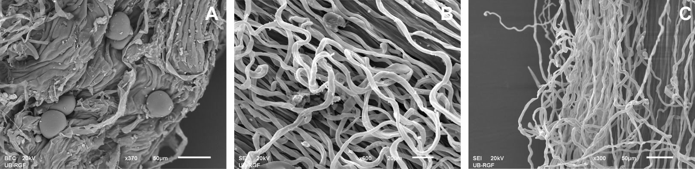
Fig. 1.

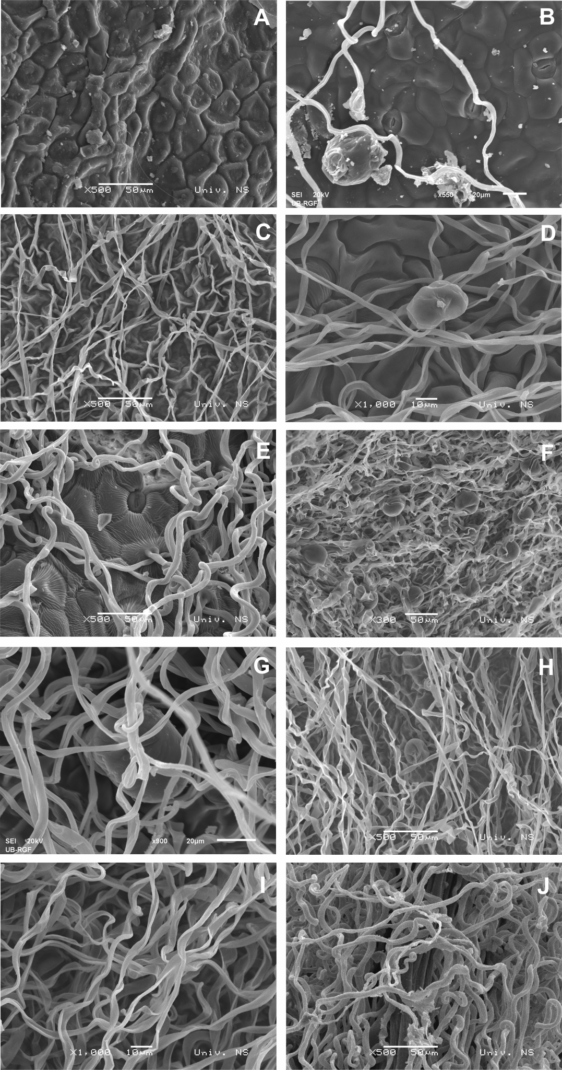
Fig. 2

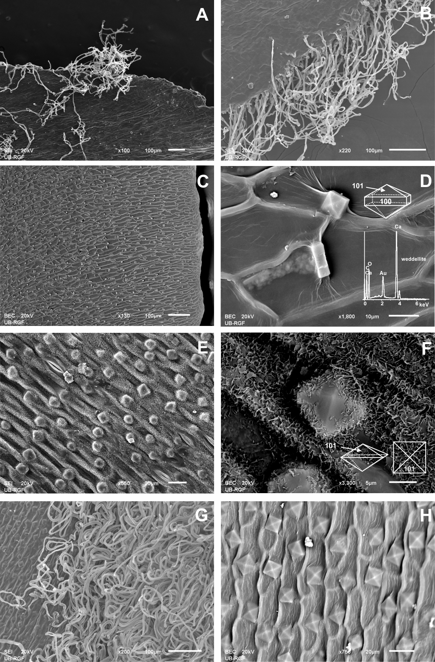
Fig. 3

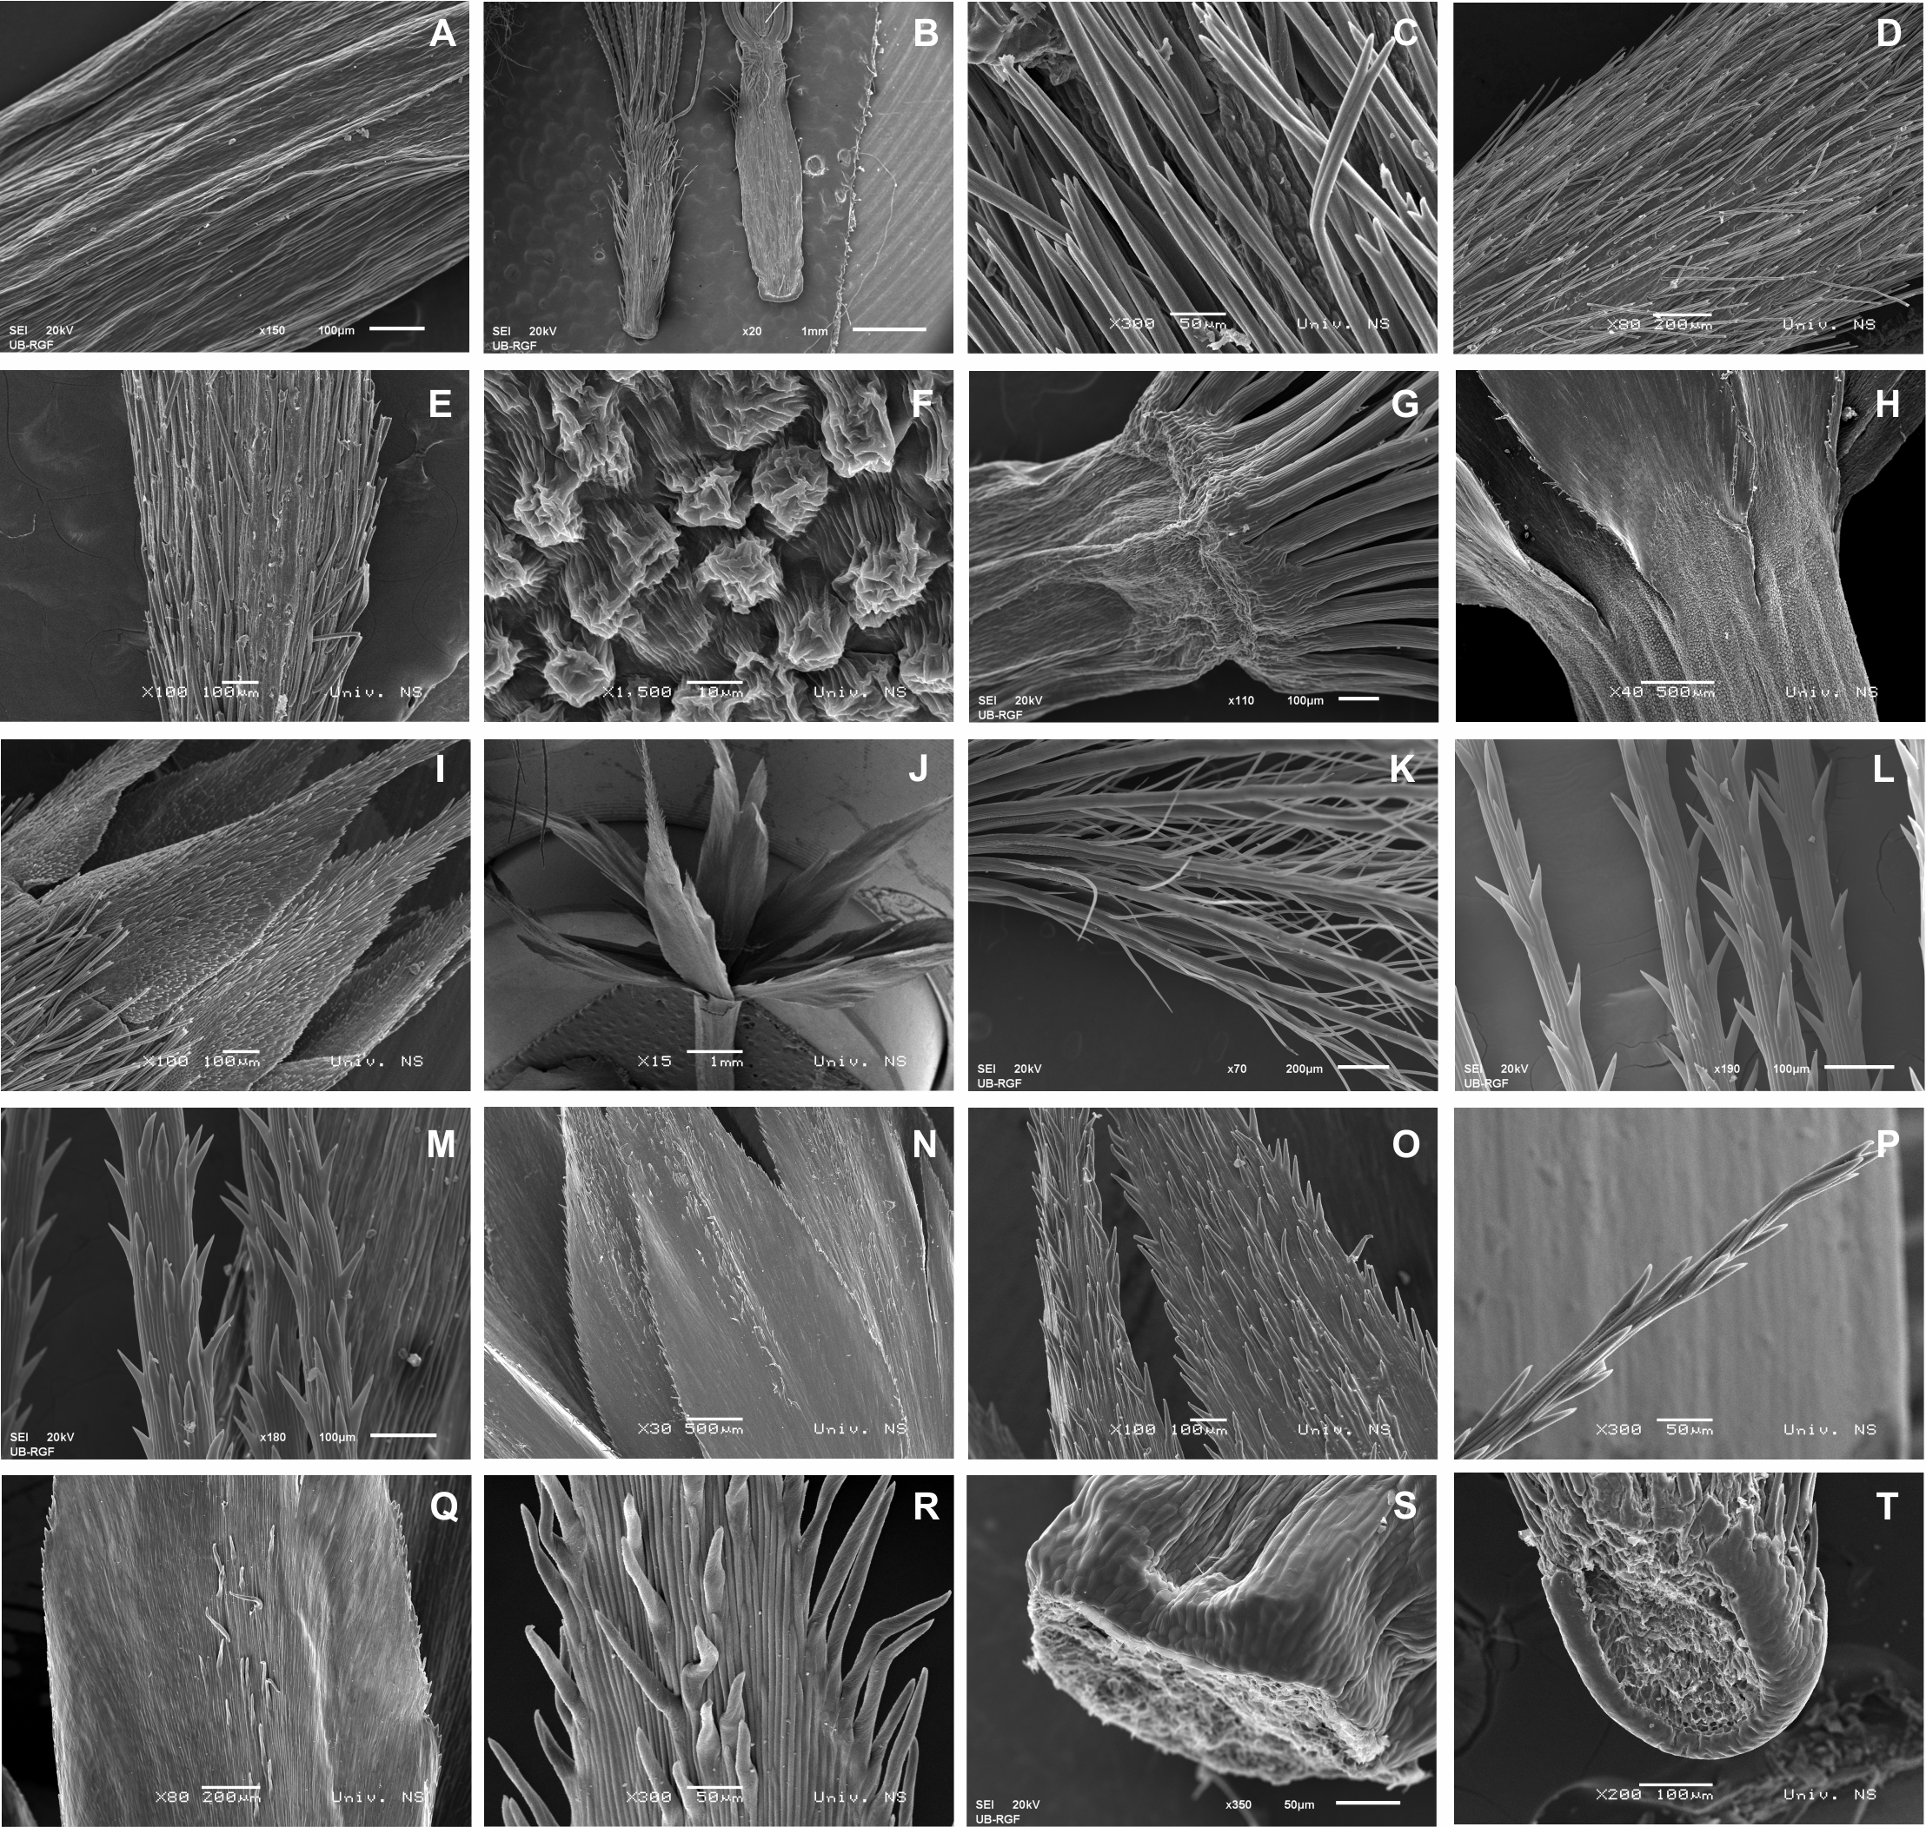
Fig. 4

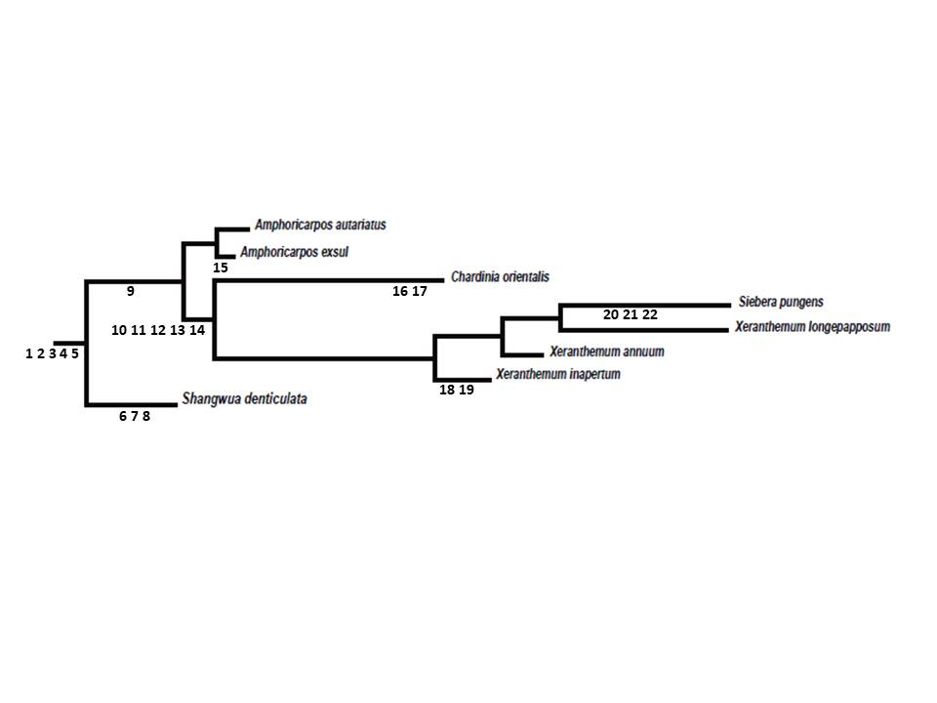
Fig. 5

