Supporting Information

Table S1. Pearson correlation matrix for trace metal and physicochemical parameters in soil samples.

 |  | Cu
Cu | 1 |  | Ni
Ni | 0.605** |  | 1 |  | Pb
Pb | 0.411** |  | 0.045 |  | 1 |  | Cd
Cd | 0.091 |  | 0.269** |  | 0.089 |  | 1 |  | Hg
Hg | 0.413** |  | 0.130 |  | 0.391** |  | -0.075 |  | 1 |  | Zn
Zn | 0.541** |  | 0.294** |  | 0.455** |  | 0.081 |  | 0.264** |  | 1 |  | Mn
Mn | 0.256** |  | 0.036 |  | 0.137* |  | -0.053 |  | 0.090 |  | 0.178** |  | 1 |  | Fe
Fe | 0.461** |  | 0.689** |  | 0.039 |  | 0.150* |  | 0.175** |  | 0.265** |  | 0.081 |  | 1 |  | P
P | -0.020 |  | 0.086 |  | -0.061 |  | 0.188** |  | -0.005 |  | -0.049 |  | -0.075 |  | 0.027 |  | 1 |  | OM
OM | 0.092 |  | 0.090 |  | 0.082 |  | 0.163* |  | -0.043 |  | 0.150* |  | 0.107 |  | 0.116 |  | 0.109 |  | 1 |  | CEC
CEC | 0.257** |  | 0.134* |  | 0.102 |  | 0.178** |  | 0.121 |  | 0.234** |  | 0.233** |  | 0.041 |  | 0.030 |  | 0.219** |  | 1 |  | pH
pH | -0.011 |  | -0.009 |  | -0.001 |  | 0.044 |  | -0.025 |  | 0.017 |  | 0.060 |  | -0.101 |  | 0.083 |  | -0.320** |  | 0.233** |  | 1

* Correlation is significant at the 0.05 level. ** Correlation is significant at the 0.01 level.

Table S2. Rotated component matrix of five-factor model with moderate to strong loadings in bold typeface.

Parameter | PC1 | PC2 | PC3 | PC4 | PC5
Cu | 0.619 | 0.573 | 0.247 | 0.002 | -0.028
Zn | 0.283 | 0.631 | 0.282 | 0.085 | 0.020
Ni | 0.904 | 0.084 | 0.052 | -0.012 | 0.179
Pb | -0.085 | 0.846 | 0.078 | 0.072 | 0.053
Cd | 0.189 | -0.009 | 0.122 | 0.080 | 0.712
Mn | 0.078 | 0.078 | 0.700 | 0.057 | -0.325
Hg | 0.112 | 0.733 | -0.075 | -0.086 | -0.086
Fe | 0.879 | 0.062 | -0.015 | 0.092 | 0.017
P | -0.018 | -0.014 | -0.102 | -0.036 | 0.720
OM | 0.018 | 0.011 | 0.328 | 0.790 | 0.257
CEC | 0.032 | 0.118 | 0.769 | -0.069 | 0.245
pH | -0.076 | -0.026 | 0.324 | -0.818 | 0.190
Eigenvalues | 3.018 | 1.564 | 1.348 | 1.283 | 1.070
% variance | 25.148 | 13.031 | 11.237 | 10.689 | 8.919
Cumulative % | 25.148 | 38.179 | 49.416 | 60.105 | 69.025

Figure S1. Spatial distribution of Zn, Ni, Mn and Cu in surface soils of the study area.
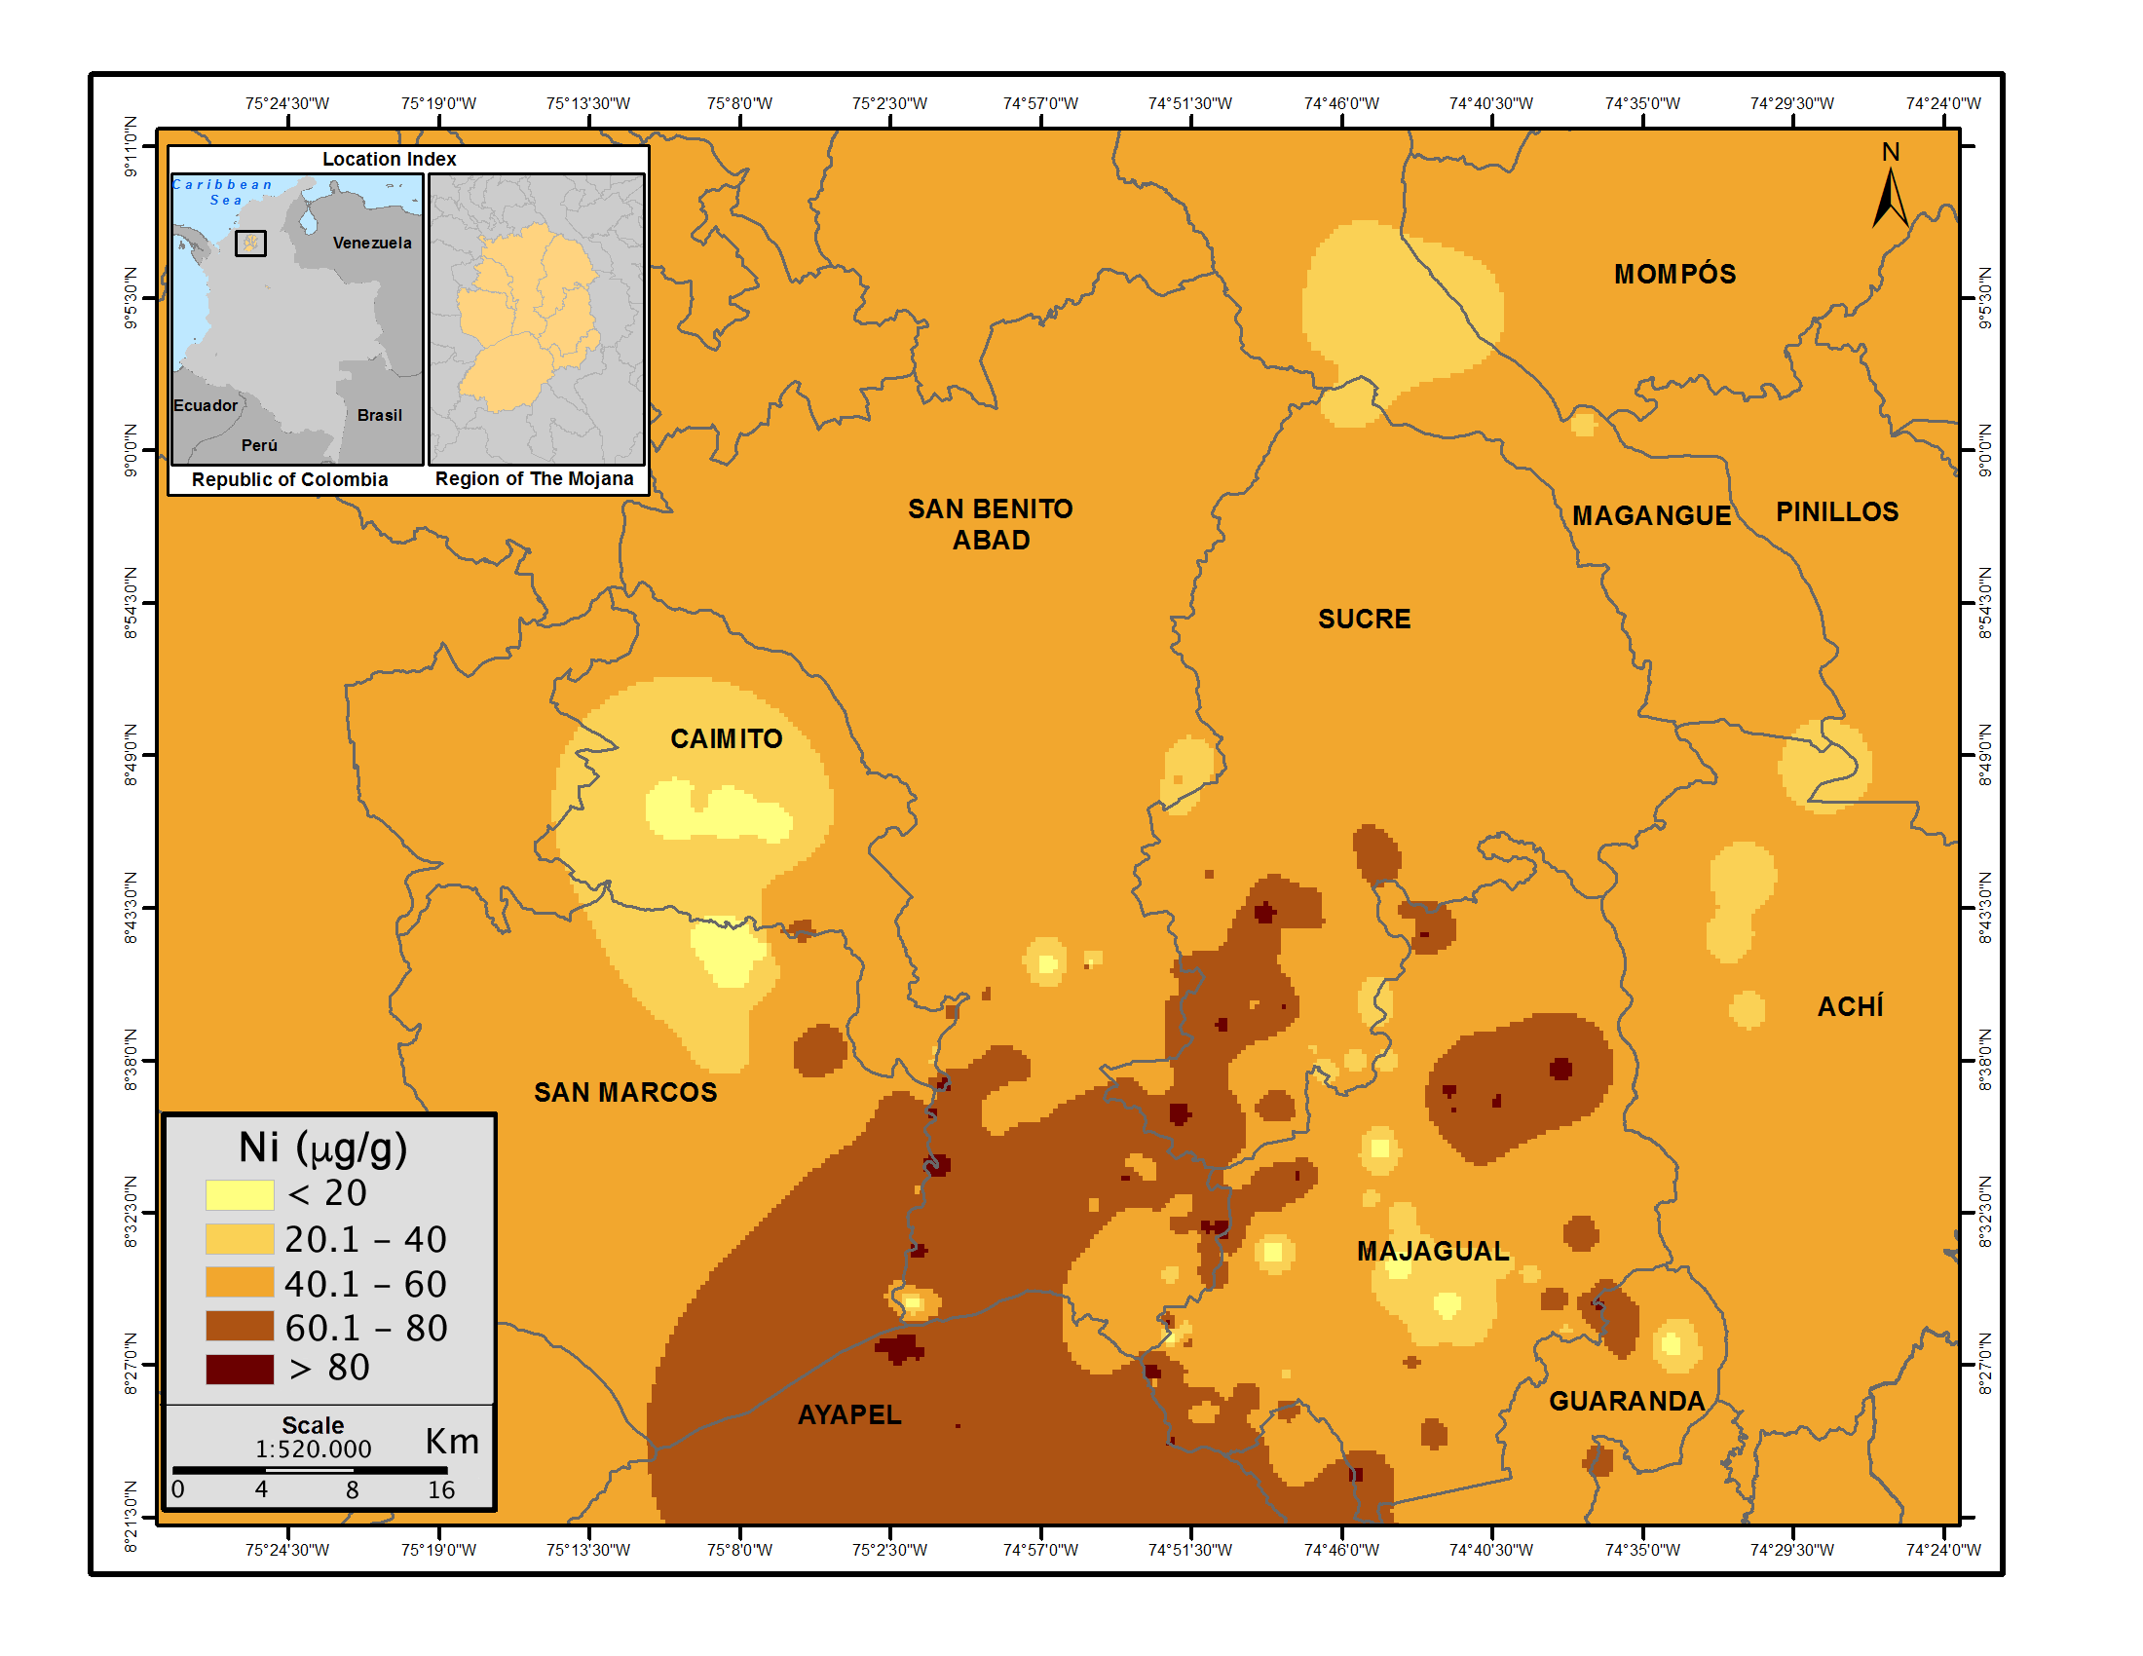
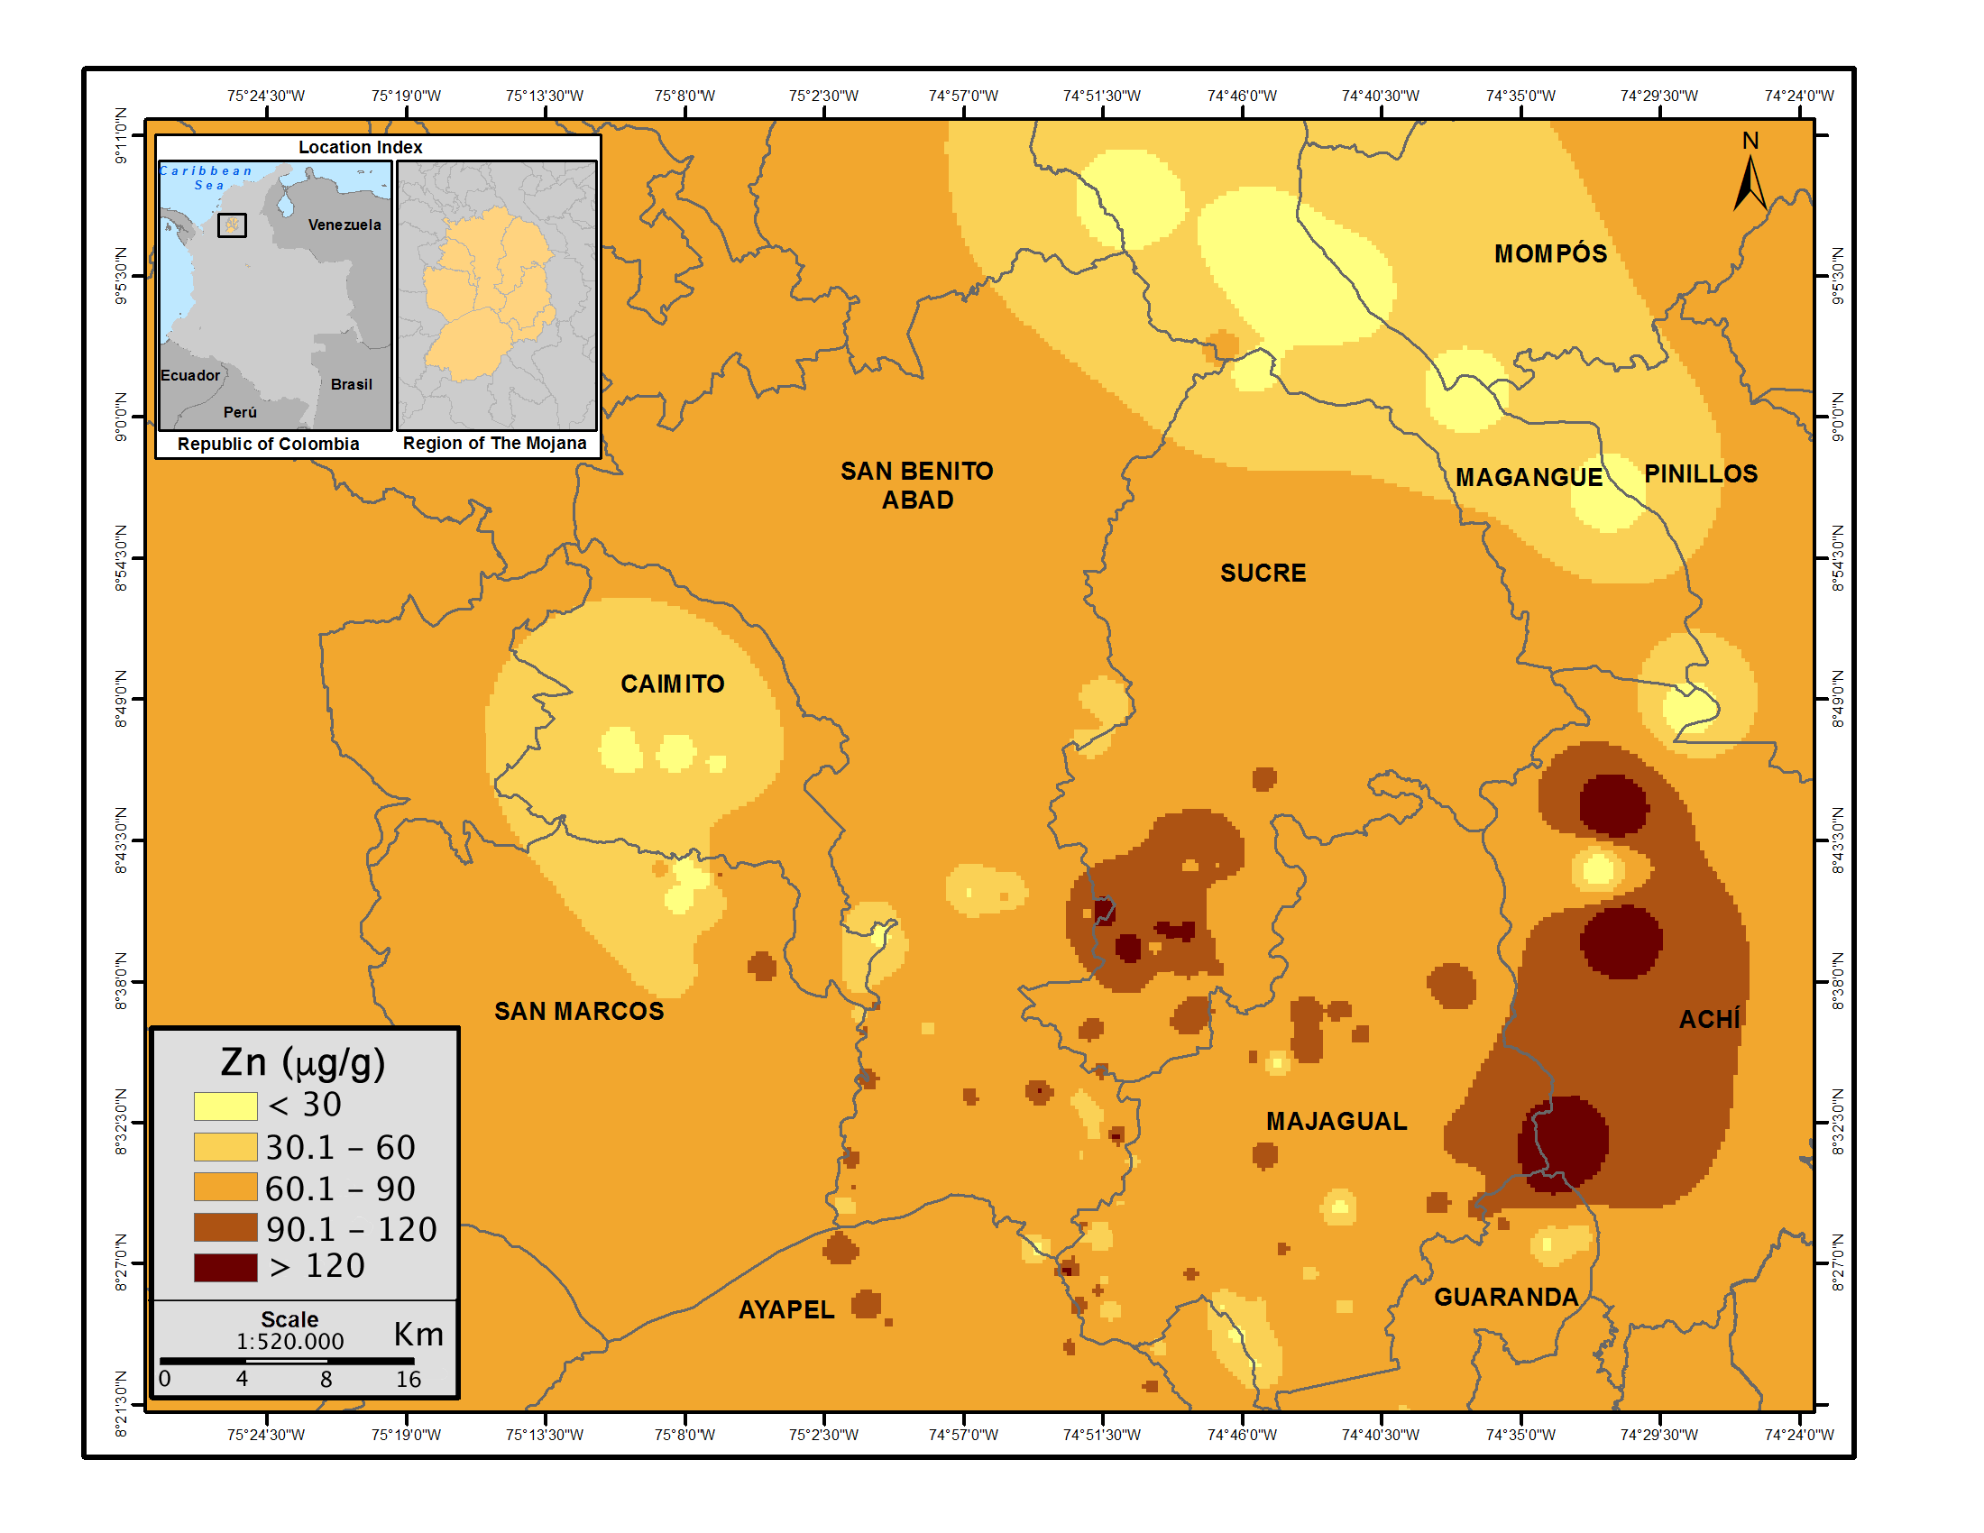

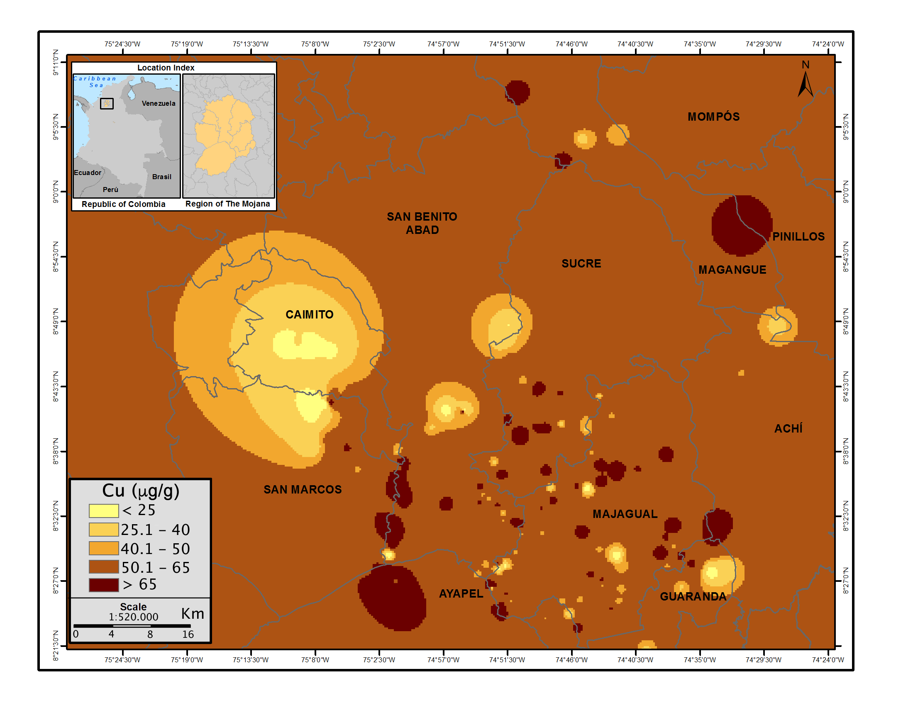
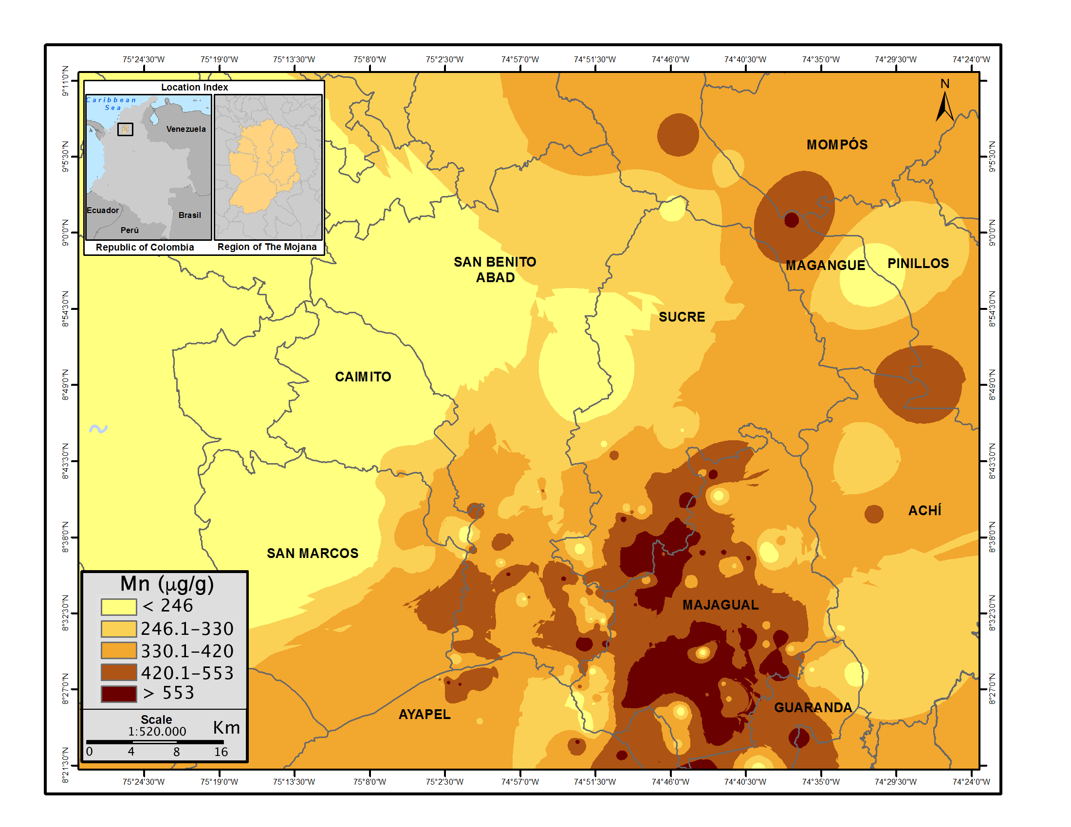

Figure S2. Loading plot of PC1, PC2 and PC3

