**Mapping stress in polycrystals with sub-10 nm spatial resolution**

**C. Polop,a* E. Vasco,b A. P. Perrinob and R. Garciab**

a *Departamento de Física de la Materia Condensada and Instituto Nicolás Cabrera, Universidad Autónoma de Madrid, 28049 Madrid, Spain.* b *Instituto de Ciencia de Materiales de Madrid, CSIC, Sor Juana Inés de la Cruz 3, 28049 Madrid, Spain*

**Abstract**

From aircraft to electronic devices, and even in Formula One cars, stress is the main cause of degraded material performance and mechanical failure in applications incorporating thin films and coatings. Over the last two decades, the scientific community has searched for the mechanisms responsible for stress generation in films, with no consensus in sight. The main difficulty is that most current models of stress generation, while atomistic in nature, are based on macroscopic measurements. Here, we demonstrate a novel method for mapping the stress at the surface of polycrystals with sub-10 nm spatial resolution. This method consists of transforming elastic modulus maps measured by atomic force microscopy techniques into stress maps via the local stress-stiffening effect. The validity of this approach is supported by Finite Element Modeling simulations. Our study reveals a strongly heterogeneous distribution of intrinsic stress in polycrystalline Au films, with gradients as intense as 100 MPa/nm near the grain boundaries. Consequently, our study discloses the limited capacity of macroscopic stress assessments and standard tests to discriminate among models, and the great potential of nanometer-scale stress mapping.

**Introduction**

The intrinsic stress generated during the preparation and processing of polycrystalline solids is a persistent problem and common source of failure in present-day technology. This stress is originated from imperfections such as defects, interfaces and free surfaces in the lattice, and significantly reduces material performance. The polycrystalline coatings are particularly susceptible because their shapes with high surface-to-bulk ratios are mechanically stabilized by moderated cohesion and adhesion forces. Intrinsic stress in the order of those forces can cause mechanical failures such as film fracture, delamination/peel-off, crack propagation, and premature thermo-mechanical fatigue1-4.

Three features make the intrinsic stress particularly harmful for these systems. (*i*) It is unavoidable: even a single-crystal solid has non-zero defect density in its lattice due to entropy, under conditions of thermodynamic equilibrium. The defect density is higher in films due to kinetic limitations caused by the deposition conditions and substrate constraints. (*ii*) It is reversible and cumulative: intrinsic stress can be regenerated by residual stress in the system (the unreleased fraction under normal temperature and pressure - NTP), and can accumulate under conditions of heating, overpressure, and periodic loads. (*iii*) It exhibits a non-uniform spatial distribution at the scale of the solid lattice defects. In polycrystals, this scale (~10-100 nm) is far below the resolution of standard stress tests. Macroscopic assessments are ineffective at detecting these intense stress gradients, which can be higher than the mechanical strengths required for commercial use (including safety margins). Consequently, stress mapping at the nanoscale is an irreplaceable tool for the study of material resistance and nanomechanics.

The failure of current technology to investigate stress at the inherent spatial scales of polycrystals is mirrored in the academic world, where the mechanisms responsible for stress generation during film deposition and processing have generated intense conjecture and scientific activity5-12. However, no consensus has been reached so far. The main difficulty is that current models of stress generation, most of which are atomistic in nature, are only supported by data with at best sub-micron resolutions. For example, techniques such as curvature-based measurements, Raman spectroscopy, and x-ray diffraction cannot reveal the stress distribution in films on nanometer scales.

Atomic force microscopy (AFM) is a suitable tool for determining the mechanical properties of solids at the nanoscale13-15. In this work, we develop a method to map the stress on the surface of polycrystals with sub-10 nm spatial resolution. Our method maps the elastic modulus of the surface by two AFM techniques (Force Modulation Microscopy and bimodal AFM), then transforms these data into a stress map via the local stress-stiffening effect. The validity of our method is supported by Finite Element Modeling (FEM) simulations. Applying this method to Au films reveals a highly heterogeneous distribution of intrinsic stress along grain diameters, with stress gradients as intense as 100 MPa/nm near the grain boundaries (GBs). Consequently, our results call into question the validity of stress assessments based on standard tests and micrometer-scale characterization techniques.

**Results and discussion**

**Elastic modulus maps**

As a benchmark for the application of Force Modulation Microscopy (FMM) on materials with low stiffness contrast, we first studied isolated Cu grains evaporated on Si(100) substrates (Figure 1). Figs. 1a and 1b respectively show simultaneously taken topography and FMM amplitude images of several Cu grains. The profiles (Fig. 1c) are measured along the dashed-blue and continuous-red lines plotted in the images. In this example, the Cu grains are about 20 nm in diameter and 2 nm high. The cantilever vibration amplitude  is lower over the Cu grains than over Si, consistent with the fact that Cu has a lower Young’s modulus (=130 GPa while =170 GPa). This FMM amplitude contrast is consistent for all excitation frequencies < 0.7, where  is the resonance frequency of the first mode of the cantilever. The fact that we can observe variations in  as small as 0.2 Å, due solely to minute differences in the indentation amplitudes , demonstrates both the high sensitivity of FMM and its suitability for imaging systems with low stiffness contrasts(see Methods for details).

Figure 2 shows the results of the FMM experiments measured at dissimilar modulation voltage  on Au films with two different thicknesses (600 nm in the left column and 1200 nm in the right column). For each experiment, we try three different modulation voltages  driving the probe vibration. The Methods section describes how we estimate the corresponding force modulation . Comparing the topography of both films (Figs. 2a and 2b), we see that grain size increases with film thickness as expected (note the different length scales). The grains with flat tops are surrounded by deeper regions where GBs intercept the surface16. The overlapping height distributions for different values of  (the histograms of Figs. 2a and 2b) demonstrate that the topography measurements are independent of , and hence that the average tip-sample contact geometry is preserved.

Figs. 2c and 2d show the corresponding FMM amplitude maps, together with their -normalized histograms. The meaning of  is discussed below. In general, we observed only slight variations in  within grains (light areas). However, the amplitude  decreases dramatically near the GBs (dark areas) and peaks inside the GBs (white areas). The FMM amplitude images also reveal some small-scale morphological features such as vicinal surfaces (arrows in Figs. 2c and 2d) with better resolution than the topography images. A possible explanation for this enhanced FMM resolution is provided in the Methods.

Once the FMM amplitude was measured, we mapped the effective elastic modulus  using the following novel procedure. For an FMM probe excited by a piezoelectric actuator coupled to the cantilever base, the *AFMM* response is described by the equation:17-21

 (1)

where  is the amplitude of the cantilever vibration on an infinitely stiff sample,  is the force constant of the first mode of the cantilever, and  denotes the effective force constant of the tip-sample contact.  is defined by a Taylor expansion of the Hertz equation:

 (2)

where  is the static load,  is the effective elastic modulus taking into account deformations of both the tip and sample ( is the Poisson ratio of each material), and  is the effective radius of contact expressing the competition between the tip radius  and the local curvature 22 of the sample. To estimate , we can either measure a reference FMM amplitude on a much stiffer sample or measure the amplitude on a region whose  is known exactly. Since the samples are mostly relaxed at NTP, as measured by a multi-beam optical stress sensor (MOSS, see the Supplementary Material), we use the latter method and assume that ==78 GPa on the flat regions interior to the grains (the light areas in Figs. 2c and 2d). Such regions comprise the majority of the imaged morphological features by area, corresponding to the mode of the histograms, . Consequently, in these regions, the effective elastic modulus is63 GPa, the effective radius is =, and the effective force constant is . Eq. 1 then becomes , which allows us to estimate an *in situ* value for . We discarded the alternative approach, where  is measured on a much stiffer sample, because swapping samples would create unavoidable changes in the experiment geometry.

At this point, we need to remove the topography contribution from the FMM amplitude maps, because the rough surface of the samples has a significant impact on the FMM images (by changing the contact area of the probe). If we assume that the intrinsic mechanical properties of the sample are independent of its morphology (i.e., we reject potential finite-size effects), the spatial dependence of  can be described as a perturbation  around its bulk value , thus . By substituting this form of  into Eq. 2, we can express  in terms of separable functions: . Here,  describes exclusively the morphology dependence of  due to the local curvature  of the surface. Thus, the effective elastic modulus at each point on the image is calculated as follows:

 (3)

where  is computed by Eq. 1 from the FMM amplitudes (raw FMM data) and  is calculated from the simultaneously measured topography (see above).

Figs. 2e and 2f show the  maps for the Au samples together with their histograms. Fig. 2h plots typical profiles across a GB for the three mapped magnitudes (topography,  and ). The profile paths are the solid straight lines overlaid on the maps. The  maps reveal that the inner-grain regions do have homogeneous mechanical properties, with  variations no more than 10% (region Z1 in Fig. 2h). The regions near a GB are softer than the grain interior, with  decreasing to 48% of  (region Z2). The values of  inside the GBs (where  peaks) are influenced by the difficulty of accessing these narrow gaps with the probe tip and we do not analyze them. The decrease in  near GBs is significant and reproducible for different  (we used both standard and ultrasharp tips, with nominal = 10 and 2 nm) and different scanning angles.

Comparing the profiles in Fig. 2h, we see that the  and  profiles (middle and bottom) do not follow the shape of the height profile (top) around the GB. Note that, for example, the positions where the topography slope changes (as those marked by red dashed lines) do not coincide with the major variations in . The fact that both profiles are scanned simultaneously rules out the possibility that this shift is caused by potential artifacts of the measurement or topographic effects. Additionally, we have calculated the normalized topography contribution to the FMM amplitude as  and compared it with the experimental  maps. The corresponding histograms are shown in Fig. 2g. An overlapping of both histograms would mean that the contrast in the  maps is originated mostly by topography effects. If this were the case, we would additionally obtain flat  maps (fixed to the value ) after removing the topography contribution. Fig. 2g reveals that both histograms differ; the  histogram is wider and is shifted to lower (i.e., softer) values. The following conclusions can be drawn from these differences: (i) the topography contribution predicts a more homogeneous mechanical response of the sample than that actually measured; (ii) the surface measured by FMM seems to be more compliant than expected from the topography contribution. The partial overlapping of the two histograms around their maxima only indicates that the elastic modulus is roughly constant on the inner-grain regions. Consequently, we can conclude that the topography plays a minor role in the contrast of the  maps, which is removed in the maps.

Increasing  beyond a certain threshold, which is defined by the condition , causes an abnormal broadening of the  histograms (see arrows in Figs. 2e and 2f). We know that this broadening is not related to changes in the average contact geometry, such as tip deformation or plastic regime, because those would also be visible in the topographic images (note that the height histograms still overlap). Two possible explanations for the histogram broadening are anharmonic distortions in the mechanical response of the sample17 (probably responsible for the high- tail in the histogram of Fig. 2e) and/or small slips of the tip on steep regions18 (the low- tail in the histogram of Fig. 2f).

To validate our method, Figure 3 compares the inferred  results obtained by FMM (b) with  maps obtained independently by bimodal AFM (a), for different regions of the 1200 nm-thick Au film. The latter method determines the effective elastic modulus without any prior assumptions23-26. The general features of the  maps obtained by both techniques agree with regard to: (*i*) the low dispersion of mechanical properties within the grain interiors ( for bimodal AFM), (*ii*) the fact that regions close to a GB are softer ( decreases to 42 % of  in the bimodal AFM map) and (*iii*) the observed peak in  at the GBs. This qualitative agreement between the three types regions and their behaviors is supported by the two GB-crossing profiles depicted in Fig. 3c. Fig 3d compares the corresponding  histograms. The difference in the modes, which are 60 GPa and 63 GPa for bimodal AFM and FMM respectively, is within the error generated during calibration of the cantilever force constants. The good agreement between the results obtained by two different AFM techniques with dissimilar tip-sample interactions (while the FMM requires a strong continuous contact, bimodal AFM is based on weaker intermittent contact), using two different setups (see Methods) supports our proposed procedure for  mapping by FMM experiments on stiff polycrystalline films.

**Stress maps**

The fact that the elastic modulus  is a cooperative lattice property allows us to correlate its variation at the nanoscale with the strain field in a solid. The macroscopic elastic modulus of a material is highly sensitive to massive defects27 such as voids, incohesive grain bonds and involvement of non-crystallized particles. On the contrary, microscopic  varies only by a few percent even for heavy deformations, dramatic atomic rearrangement and intense field of intrinsic stress, which is due to that the lattice of a crystalline solid admits only small perturbations. For example, the lattice anharmonicity effect in fcc-metal films changes microscopic  by less than 5 % for equibiaxial intrinsic stresses as high as = ±1 GPa27. However, the  maps in Figs. 2 and 3 involve spatial variations of 20-50 % much higher than expected and higher than the intrinsic  values measured by contactless (optical) techniques. Large variations of microscopic  have been only reported in Au-Ni and Cu-Pd multilayers with composition modulation wavelengths lower than 3 nm (*supermodulus effect*)28. Conversely, in our study, the large variations of  are observed on the free surfaces of films with submicrometer thicknesses.

The high variability of  observed in our study suggests that the elastic moduli measured by FMM and bimodal AFM are affected by the tip-sample contact (note that this does not happen with optical techniques). In this case, the spatial variation of  is mostly due to a stress-stiffening effect (also known as geometric nonlinearity). This process is typical of stressed membranes when the deformation produced by a normal load generates out-of-plane contributions of the stress force that counteract such a load. In our case, the membrane corresponds to the outermost sublayer of the film, the normal load is , the out-of-plane deformation is the indentation depth  (as defined by the Hertz model), and the stress in the membrane corresponds to the biaxial intrinsic stress in the film . Thus, as sketched in Figures 4a and 4b, the indentation of a region under compression (with , dashed red arrows) creates a stress force  that strengthens . On the other hand, the indentation of a region under traction () creates a stress force  that counters . The fact that we calculate  from  instead of  implies an underestimation (overestimation) of the applied load, and means that the regions under compression (traction) are displayed as softer (stiffer): i.e.,  ().

Figure 4c (symbols) shows the load-indentation curves computed by FEM for -stressed isotropic Au films under a normal load  exerted by a Si tip29. The curves for different values of  follow a power law of the form , in agreement with the Hertz model. As previously discussed, the indentation depth for a given  increases as  decreases (considering the sign). The -dependence of  is calculated by fitting each curve to the Hertz model. This dependence is plotted in the inset of Fig. 3c (symbols), together with the  variations due to changing  expected from the lattice anharmonicity effect in Au(111) films30 (dashed curve). The FEM results show a stronger -dependence (e.g.,  changes up to 20 % for  GPa) than that estimated for the lattice anharmonicity effect, which predicts changes in  only up to 4%. Consequently, the  variation with  found by FEM appears to be consistent with the spatial dispersions in the  maps (Fig. 2), since local residual stress  of at most a few GPa are expected. It should be remembered that the Au films are macroscopically relaxed (as measured by MOSS, see the Supplementary Material). Therefore, the stresses causing the  dispersion correspond to local residual fractions of the growth intrinsic stress that survives at NTP.

By taking into account the -dependence of  found by FEM, we can now transform the  maps into  maps using the following analytical model of stress stiffening. The film indentation caused by the tip pressure breaks the in-plane film symmetry. The biaxial intrinsic stress  in the film therefore contributes an amount  to the normal pressure, where  is a factor describing the stress field geometry31 and  is the unit vector normal to the film plane. This contribution can be estimated as , where  is the radius of the contact surface  (shaped like a spherical cap).  generates a stress force on the tip:

 (4)

Hence, the resulting force becomes . Updating the Hertz model to take stress stiffening into consideration, we obtain . Now, if we interpret the spatial  variation due to the stress field  in terms of the *Eeff* variation, we get:

 (5)

where . From Eqs. 4 and 5, the regions under compression () seem to be softer () than they really are, while those under traction () seem to be stiffer (). The continuous lines in Fig. 3c and its inset show the load-indentation curves and the -dependence of  obtained from our analytical model. The good agreement between our model and the FEM simulations (the model overestimates  by 2-3%) supports the key role played by stress stiffening in the measured  dispersion.

Eq. 5 allows us to transform the  maps into . Then, by substituting  into the updated Hertz model, we can compute the  maps shown in Figures 5a and 5b for the 600 nm and 1200 nm-thick Au films, respectively. Since the  contribution to  (Eq. 4) depends on the indentation depth, deeper indentations induced by higher force modulations  of the tip load are required to sense lower stresses. However, increasing beyond a certain threshold also produces abnormal broadening of the  histograms, as discussed above. Thus, the practical  maximum determines the amount of uncertainty in the stress resolution **. This uncertainty is defined as the minimum  variation required to produce a change in  greater than the experimental error in determining the indentation depth  (see Methods).

Because the intrinsic stress modifies the indentation depth nonlinearly, the analytical model determines a series of uncertainties ** for different measurement ranges. The uncertainty varies with both the sign and the magnitude of the intrinsic stress. These uncertainties are used to determine the statistical properties of the  maps, and correspond to the bin widths of the histograms in Figs. 5c and 5d. As specified in Figs. 5c and 5d, the intrinsic stress measurements are grouped into five levels (colors): 0-green, A-dark red, A′-light red, B-dark blue and B′-light blue. The green bins represent the relaxed area, while the red (blue) bins collect measurements from areas under compression (traction). Dark (light) colors correspond to the areas under low (high) stress. Figs. 5e and 5f redraw the  maps using this discrete color scale, to improve the contrast between regions with different stress levels. In addition, these figures illustrate the GB mesh with white lines, calculated by applying a tessellation filter to the topography images32. The line thickness in the figure is similar to the diameter of the tip-sample contact area (≈5.5-5.7 nm), providing a visual estimation of the areas inaccessible to the AFM tip. We call this simplified representation a “compression-traction map” hereafter.

Typical values of ** obtained under our experimental conditions are a few hundred MPa. For example, the average uncertainties in the  maps around the relaxed state (level 0) in Figs. 5a and 5b are **170 and 158 MPa, respectively. This stress uncertainty also reduces the spatial (lateral) resolution of the  maps. The spatial resolution is theoretically limited by the diameter of the contact area (5.5-5.7 nm for both maps), but worsens to ** where ** is the magnitude of the stress gradient to resolve. For example, given the statistics of the  maps in Fig. 5a and 5b, we can estimate their average stress gradients as **=26.6 and 25.8 MPa/nm, respectively. This implies that the maps have average spatial resolutions of **≈6.4 and 6.1 nm, respectively. Since these resolutions (below 10 nm) are smaller than the inherent length scales of the lattice imperfections in polycrystals (~10-100 nm), the method of stress mapping proposed here is good enough to image residual stress gradients in polycrystalline films. In particular, the method is suitable to sense the stress within the outermost sublayer with thickness in the order of the indentation depth (~1 nm for  of few hundred nN). Note that this sublayer plays a key role in the mechanical properties of systems with high surface-to-volume ratio.

The compression-traction maps reveal that the stress distribution in polycrystals is highly heterogeneous: relaxed areas alternate with regions under compression and traction. Some regions exemplifying the different stress regimes are highlighted in Figs. 5e and 5f. While the inner vicinal surfaces of the grains are mostly relaxed (0–green areas), most of the regions near grain boundaries are under compression (A and A′−red areas). Annular areas with traction stress (B−blue areas) appear frequently in between the previous two regimes. Fig. 5g shows a typical stress profile measured across a GB, performed along the black line in Fig. 5a. The corresponding 1D gradient (right axis) demonstrates that residual stress gradients as intense as 100 MPa/nm persist along the grain diameters in macroscopically relaxed films.

These results are directly connected to the generation of compressive stress at the post-coalescence stage (i.e., once the GBs are formed) during the deposition of polycrystalline films, which is extensively discussed in the literature5-12. Although we are mapping residual stresses rather than *in situ* growth stresses, it is reasonable to assume that the two quantities are related in a straightforward way by stress-relaxation thermodynamics. Thus, after deposition stops, the accumulated growth stress relaxes progressively until it reaches a steady state (residual stress), wherein the strain energy generated by the residual stress is lower than the activation energy of the relaxation mechanism. Subsequently, two preliminary conclusions can be drawn from our results. (*i*) Neither force-dipole interactions between morphology features5 nor adatom insertion between ledges6 at vicinal surfaces are responsible for post-coalescence compression, since those areas are mostly relaxed. (*ii*) The fact that compression regions mostly decorate GB edges indicates that GBs are involved in the generation of the post-coalescence compression, as proposed in Refs [7, 10, 12]. We will address the physical origin of the stress gradients along the grain diameter in a forthcoming work.

Finally, note that the heterogeneous distribution of stress over the surface of polycrystalline films, as resolved here in the sub-10 nm stress maps, is undetectable by the standard techniques and tests used for stress analysis. Such techniques, which have sub-micron spatial resolutions at best, are only sensitive to the average stress over the entire displayed areas in Figs. 5a and 5b:  −33 MPa and −14 MPa, respectively. Besides, these values correspond to the macroscopically relaxed samples, as discussed above. Furthermore, average stresses hide the existence of intense gradients (as high as 100 MPa/nm in Au) which can be greater than the mechanical strengths required by many applications33. Consequently, we hope that stress mapping at the nanoscale becomes an irreplaceable tool for the study of material resistance. More generally, this and other nanomechanics technologies will change our perception about the atomistic nature of stress in crystalline solids.

**Methods**

**Sample Preparation**

The Au films were deposited by thermal evaporation on mica substrates at room temperature. Films with thicknesses within the range of 200-1200 nm were grown at 0.1 nm/s under a pressure of 10-7 mbar. The samples were *ex-situ* characterized by scanning electron microscopy, x-ray diffraction and AFM microscopy. All the films exhibited a [111]-textured columnar microstructure without in-plane order (see Supplementary Material).

**Force Modulation Microscopy**

**(Background)** FMM (also called ‘modulated nanoindentation’34) is an AFM technique used to study materials with intermediate stiffness (1 GPa << hundreds of GPa). Using a standard AFM set-up, FMM measures the amplitude of vibration in a cantilever whose tip held in continuous contact with the surface of the sample (see Fig. 1d). As it moves across the surface, the cantilever vibrates at a frequency  lower than its first resonance 17-21,34. This vibration is induced by applying a modulation voltage  to a piezoelectric element at the base of the cantilever or the sample (acoustic excitation). This process results in a load modulation  around the static load  used to hold the continuous contact. The amplitude of the cantilever vibration  is measured by a four-sector photodiode operating in a frequency-locked loop (FLL). Relatively high static load values (several hundred nN) are required to ensure that adhesion forces can be ruled out. The Hertz model predicts  for a spherical tip. From a Taylor expansion of the Hertz model for small force modulations, the force balance corresponding to harmonic FMM quasi-static vibration can be estimated as  for an indentation amplitude . Thus, a decrease (increase) in the measured value of  is expected on more compliant (stiffer) areas (see Fig. 1d).

The resulting FMM equation , as clarified in Eq. 1, relates the contrast in the vibration amplitude map  to the ratio between the force constants of the cantilever and the tip-sample contact. This ratio depends on the mechanical properties of the sample and tip. This equation offers a straightforward interpretation of the mechanical properties of soft materials with flat surfaces. In systems with stiffness much lower than that of the tip and negligible roughness,  is independent of the sample topography, and any deformation of the tip can be neglected. Consequently, contrast in the FMM images can be attributed almost exclusively to gradients in the mechanical properties of the sample, in particular variations of  since the spatial dependence of  is smoother.

However, when the target surface is a metal or ceramic polycrystalline film grown by the Volmer-Weber (V-W) mechanism, interpreting the FMM images is a more complex task. These films are composed of grains with non-negligible roughness, which implies high curvature gradients. Ceramic and metal grains may also have stiffnesses comparable to that of the tip. Therefore, the sample topography and tip deformation become non-negligible factors, as we describe in the main text. Our procedure to remove the topography contribution from the FMM amplitude maps and inferred material properties of the surface is related to other research35 with similar aims, in particular with respect to features with sizes in the order of the tip radius.

**(Experimental)** The FMM experiments were performed with a commercial AFM (Nanotec Electronica S.L.) in a dry N2(g) atmosphere. The environmental humidity was held below 10% in order to avoid capillary forces36. The modulation voltage  was applied to a piezoelectric element at the base of the cantilever. Silicon cantilevers (PPP-NCHR by Nanosensors) with =40 N/m, =10 nm and =300 kHz were used. Topographic images and FMM amplitude images were acquired simultaneously. In order to remain within the linear elastic regime of the material, the static load  and modulation voltage  were chosen to produce indentations of only a few Å. The relationship between  and  for each experiment was estimated from the static and dynamic calibrations of the photodiode (namely, photodiode response in nm/V and signal gain at the excitation frequencies). Specifically, for the 600 nm and 1200 nm-thick Au films, we obtain  and  respectively. The frequency-locked loop (FLL) fixed to the excitation frequencies (=47 kHz for 600 nm and 80.6 kHz for 1200 nm) allowed us to determinate the harmonic indentation amplitude  with an experimental error of =0.2 Å, as shown in Fig. 1 for systems with low stiffness contrast. The FLL mode improves the FMM resolution by attenuating inelastic responses to the tip-sample interactions. Also, in FLL mode, FMM exhibits enhanced resolution on abrupt hollow features18 (e.g., GBs and steps at vicinal surfaces) where the effective radius  of contact diverges for . The data were processed assuming the following mechanical properties: =78 GPa and =0.44 for the sample, =170 GPa and =0.28 for the tip material.

**Bimodal AFM**

Bimodal AFM is a nanomechanical spectroscopy method that enables simultaneous and accurate maps of material properties23-26. The bimodal AFM measurements were performed with a Cypher S microscope (Asylum Research, Oxford Instruments) operating in AM-FM configuration24,23. We used Si cantilevers PPP-NCH (Nanosensors) characterized by = 293 kHz,= 1848 kHz, = 40 N/m and = 2164 N/m 37-39. In the AM-FM configuration, the feedback acts on the amplitude of the first eigenmode and on the frequency shift of the resonant frequency of the second. Thus, the driving frequency of the first flexural mode  is fixed during imaging, while the oscillation amplitude  is used as the feedback parameter to track the topography of the sample. In the second mode, changes in the resonant frequency  are recorded while imaging. The oscillation amplitude of the second mode  is kept constant during this process. To keep track of changes in  over the surface, we keep the phase shift locked at 90º with a phase-locked loop (PLL). These feedback loops provide the experimental observables that are transformed into  for the Hertz model, through analytical expressionsref. The images were taken at *Asp*= 10 nm, with free amplitudes of =20 nm and= 0.4 nm.

**Conclusions**

We have presented a method to map mechanical stresses on the surface of polycrystals with sub-10 nm spatial resolution. The method directly observes spatial variations in the elastic properties of a crystalline solid over its surface, in particular the elastic modulus maps provided by AFM techniques. We transform these values into stress maps using an analytical model of stress-stiffening. The consistency of this model is supported by FEM simulations. The application of this method to the study of evaporated Au films up to 1 micron in thickness reveals a strongly heterogeneous distribution of the intrinsic stress, with gradients as high as 100 MPa/nm along the grain diameters. Such extreme values, which occur near grain boundaries, could compromise the mechanical reliability of polycrystalline films in many applications.

**Acknowledgements**

C. P. thanks P. Ares and I. Horcas for their help resolving doubts about the FMM setup. Financial support was provided by the Ministerio de Economía y Competitividad (grants MAT2014-52477-C5-5-P to CP and EV; CSD2010-00024 and MAT2013-44858-R to RG).

**References**

1 A. Witvrouw, H. A. C. Tilmans, & I. De Wolf, *Microelectronic Eng.*, 2004, **76**, 245.

2 S. Kim, *J. Electrochem. Soc.*, 2011, **158**, H904.

3 J.-H. Cho, T. James and D. H. Gracias, *Adv. Mater.*, 2010, **22**, 2320.

4 L. B. Freund and S. Suresh, *Thin Film Materials: Stress, Defect Formation and Surface Evolution*, Cambridge University Press, Cambridge, England, 2003.

5 C. Friesen and C. V. Thompson, *Phys. Rev. Lett.*, 2004,**93**, 056104.

6 F. Spaepen, *Acta. Mater.*, 2000, **48**, 31.

7 E. Chason, B. W. Sheldon, L. B. Freund, J. A. Floro and S. J. Hearne, *Phys. Rev. Lett.* 2002, **88**, 156103.

8 R. Koch, D. Hu and A. K. Das, *Phys. Rev. Lett.* 2005, **94**, 146101.

9 A. Gonzalez-Gonzalez, C. Polop and E. Vasco, *Phys. Rev. Lett.*, 2013,**110**, 056101.

10 H. Z. Yu and C. V. Thompson, *Appl. Phys. Lett.*, 2014,**194**, 141913.

11 B. Fu, W. An, C. H. Turner and G. B. Thompson, *Phys. Rev. Lett.*, 2010, **105**, 096101.

12 A. Saedi and M. J. Rost, *Nat. Commun.*, 2016,**7**, 10733.

13 A. Raman et al, *Nature Nanotech.* **6**, 809 (2011).

14 G. López-Polín et al, *Nature Physics* **11**, 26 (2015).

15 A. Perrino and R. García, *Nanoscale* **8**, 9023 (2016).

16 C. Polop, C. Rosiepen, S. Bleikamp, R. Drese, J. Mayer, A. Dimyati and T. Michely, *New J. of Phys.*, 2007, **9**, 74.

17 P. Maivald, H. J. Butt, S. A. C. Gould, C. B. Prater, B. Drake, J. A. Guriey, V. B. Elings and P. K. Hansma, *Nanotech*., 1991, **2**, 103.

18 F.B. Li, G. E. Thompson, R.C. Newman, *Appl. Surf. Sci.* 1998, **126**, 21

19 M. Radmacher, R. W. Tillmann and H. E. Gaub, *Biophys. J.*, 1993, **64**, 735.

20 X. Xu, M. Koslowski and A. Raman, *J. Appl. Phys.*, 2012, **111**, 54303.

21 R. Wagner and J. P. Killgore, *Appl. Phys. Lett.*, 2015, **107**, 203111.

22 The curvature of the rough surface was computed as follows:

where  is a polynomial interpolation of the AFM-imaged topography using Lagrange polynomials of degree 3. This choice ensures non-trivial and continuous second derivatives.

23 R. Garcia and E. T. Herruzo, *Nat. Nanotechnol.*, 2012, **7**, 217.

24 R. Garcia and R. Proksch, *Eur. Polym. J.*, 2013,**49**, 1897.

25 E. T. Herruzo, A. P. Perrino and R. Garcia, *Nat. Commun.*, 2014, **5**, 3126.

26 A. Labuda, M. Kocun, W. Meinhold, D. Walters and R. Proksch, *Beilstein J. of Nanotechnol.*, 2016, **7**,970.

27 H. Ogi, M. Fujii, N. Nakamura, T. Yasui and M. Hirao, *Phys. Rev. Lett.*, 2007, **98**, 195503.

## 28 W. M. C. Yang, T. Tsakalakos and J. E. Hillard, *J. Appl. Phys.*, 1977,**48**, 876.

29 Finite Element Modeling (FEM) simulations were performed with COMSOL Multiphysics 5.2. We designed a two-step solid mechanics study: the first step concerns the pre-stressed stage of the central grain, and the second step approximates the mechanical response of the pre-stressed grain to the load exerted by a conical Si tip with a spherical apex. The simulation geometry and the distribution of the contact pressure are included in the Supplementary Material.

30 The -dependence of  due to the lattice anharmonicity effect was estimated from the data in Table I of Ref. [27]. In the case of polycrystalline Au films (with <111>Au // z-axis), the anharmonic effect was estimated to be =4.53, with the in-plane strain being . Here  is the biaxial residual stress, and Young’s modulus is  for .

31 =4 for an equibiaxial stress field with , and =2 for an isotropic stress field with .

32 A. González-González, J. L. Sacedón, C. Polop, E. Rodríguez-Canas, J. A. Aznarez, and E. Vasco, J. Vac. Sci & Technol. A, 2009, **27**, 1012.

33 The stress variation in regions near a GB has the same order of magnitude as the mechanical strengths of many pure metals and alloys. For example, the representative ultimate strengths of Au, Ag, Fe, Ta, Ti, Sn, Cu alloys, Al alloys, and Zn alloys are all in the range of 100-500 MPa.

34 H.-C. Chiu, S. Kim, C. Klinke and E. Riedo, *Appl. Phys. Lett.*, 2012, **101**, 103109.

35 M. Stark, C. Möller, D. J. Müller, and R. Guckenberger, *Biophysical J.*, 2001, **80**, 3009.

36 I. Horcas, R. Fernández, J. M. Gómez-Rodriguez, J. Colchero, J. Gómez-Herrero, A. M. Baró, *Rev. Sci. Instrum.*, 2007, **78**, 013705.

37 H. J. Butt and M. Jaschke, *Nanotechnol.*, 1995, **6,** 1.

38 J. R. Lozano, D. Kiracofe, J. Melcher, R. García and A. Raman, *Nanotechnol.*, 2010, **21,** 465502.

39 A. Labuda, M. Kocun, M. Lysy, T. Walsh, J. Meinhold, T. Proksch, W. Meinhold, C. Anderson and R. Proksch, *Rev. Sci. Instrum.*, 2016, **87**, 73705.

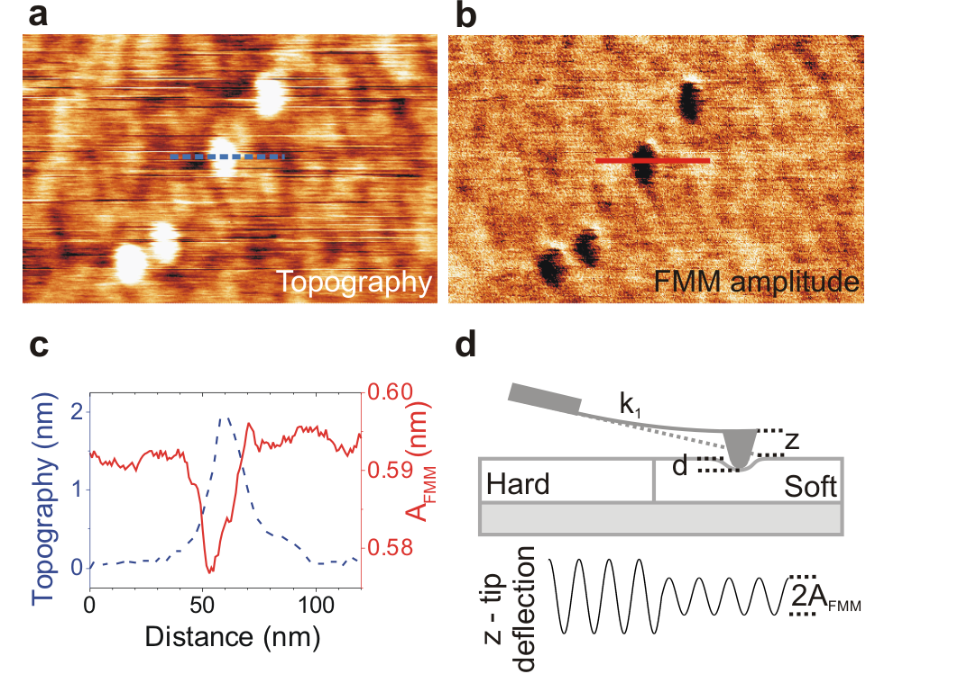

**Fig. 1** Working principle of FMM in systems with low mechanical contrast. Simultaneously taken topography (**a**) and FMM amplitude (**b**) images of isolated Cu grains deposited on Si(100). (**c**) Topography and FMM amplitude profiles across the lines marked in (a) and (b). (**d**) Schematic of the FMM setup (see Methods).

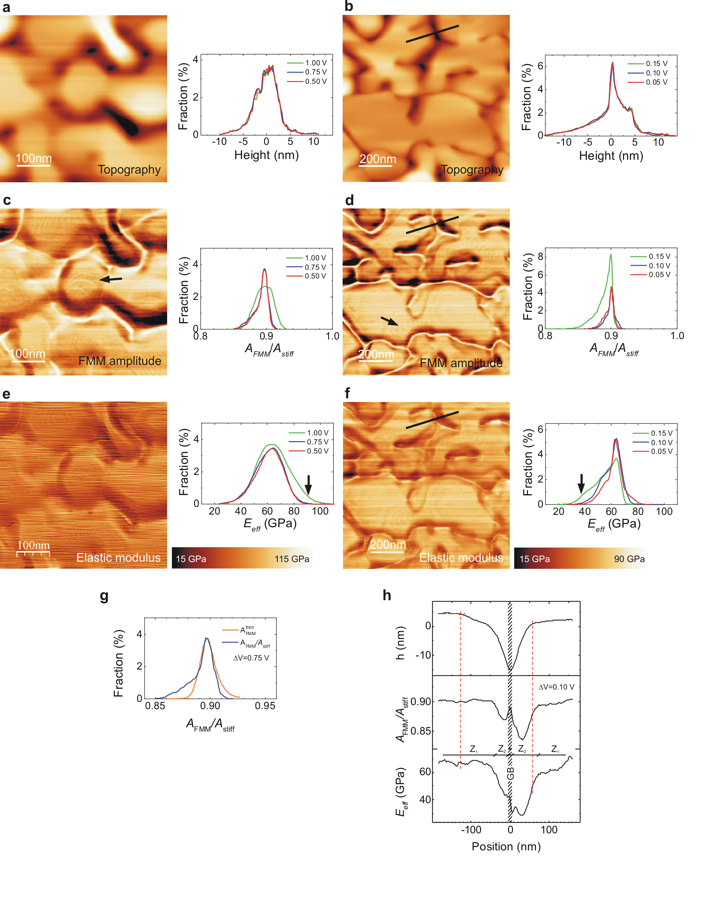

**Fig. 2** Mechanical characterization at the nanoscale by FMM. The left (**a**,**c**,**e,g**) and right (**b**,**d**,**f,h**) columns correspond to 600 nm and 1200 nm-thick Au films, respectively. The images are shown alongside histograms for the different . Figures (**a**,**b**), (**c**,**d**) and (**e**,**f**) correspond to the topography, FMM amplitude, and effective elastic modulus, respectively. The conversion of into force modulation  is described in Methods. The FMM amplitude images in (c,d) correspond to those acquired at =0.75 V (with =180 nN and =47 kHz) and =0.15 V(with =200 nN and=80.6 kHz), respectively. The arrows in (c,d) point out vicinal structures, while those in (e,f) indicate abnormal broadening of the  histograms. Figure (**g**) shows a comparison of the histogram of the FMM amplitude map in (c) with that calculated from considering only the topography contribution  to such a map.  is calculated from the topography imaged in (a) assuming . Figure (**h**) plots characteristic profiles of the mapped magnitudes along the lines depicted in (b,d,f). Dashed red lines identify the positions of some topography slope changes and labels  indicate regions with different mechanical behaviors as described in the text.

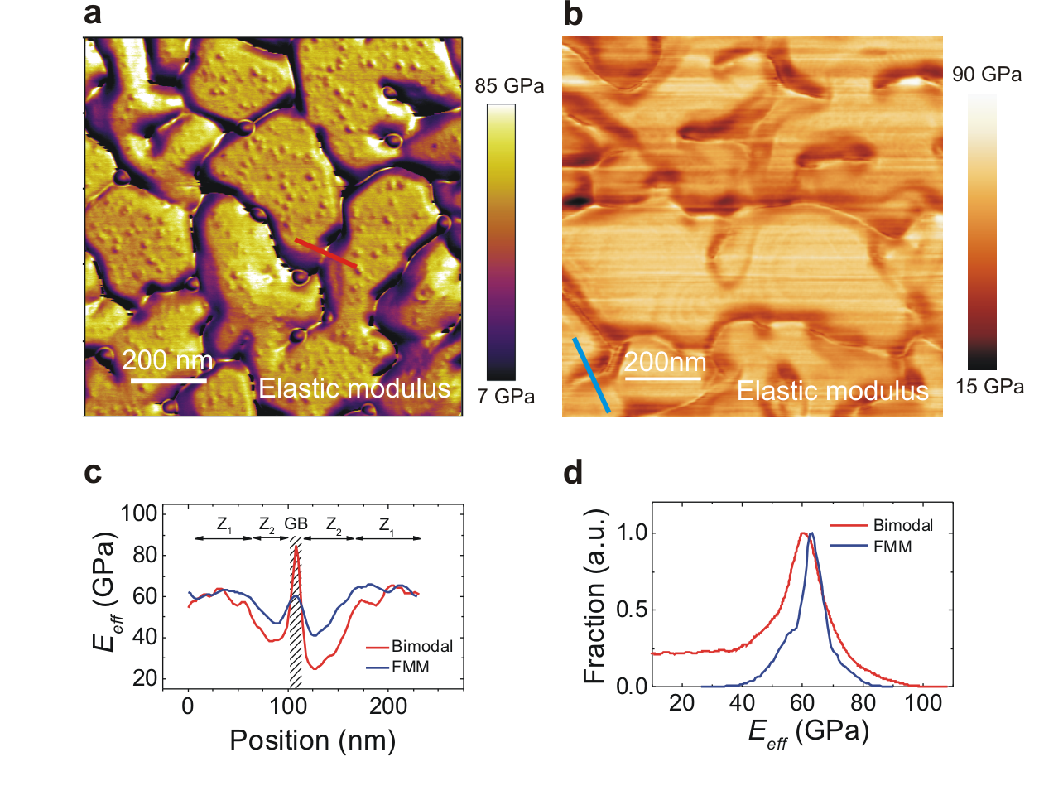

**Fig. 3** Comparison of bimodal AFM (**a**) and FMM (**b**) maps of the elastic modulus, taken from different regions of the same 1200 nm-thick Au film. (**c**) Comparison between the  profiles along the red and blue lines plotted in (a,b). (**d**) Comparison of the corresponding  histograms.

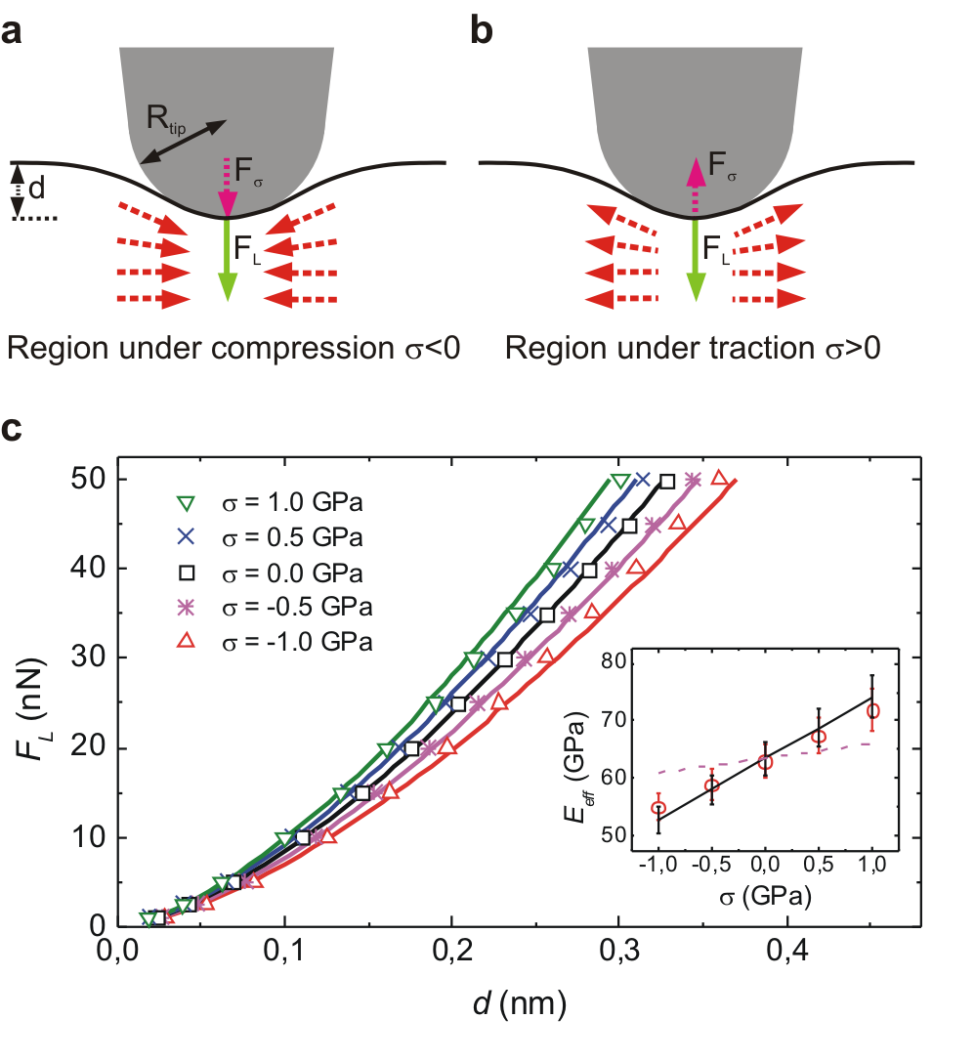

**Fig. 4** Stress-stiffening effect. (**a**,**b**) Diagrams of the tip-film contact geometry in regions under stress of compression and traction respectively, showing the parameters of the stress-stiffening model. (**c**) Load-indentation curves computed by FEM (symbols) and by the stress-stiffening model (continuous lines) for -stressed isotropic Au films under a load exerted by a Si tip29. The inset shows the -dependencies of  computed from the fit of the FEM results to the updated Hertz model (symbols), the stress-stiffening model (solid line), and the lattice anharmonicity effect estimated for Au <111> films (dashed curve).30

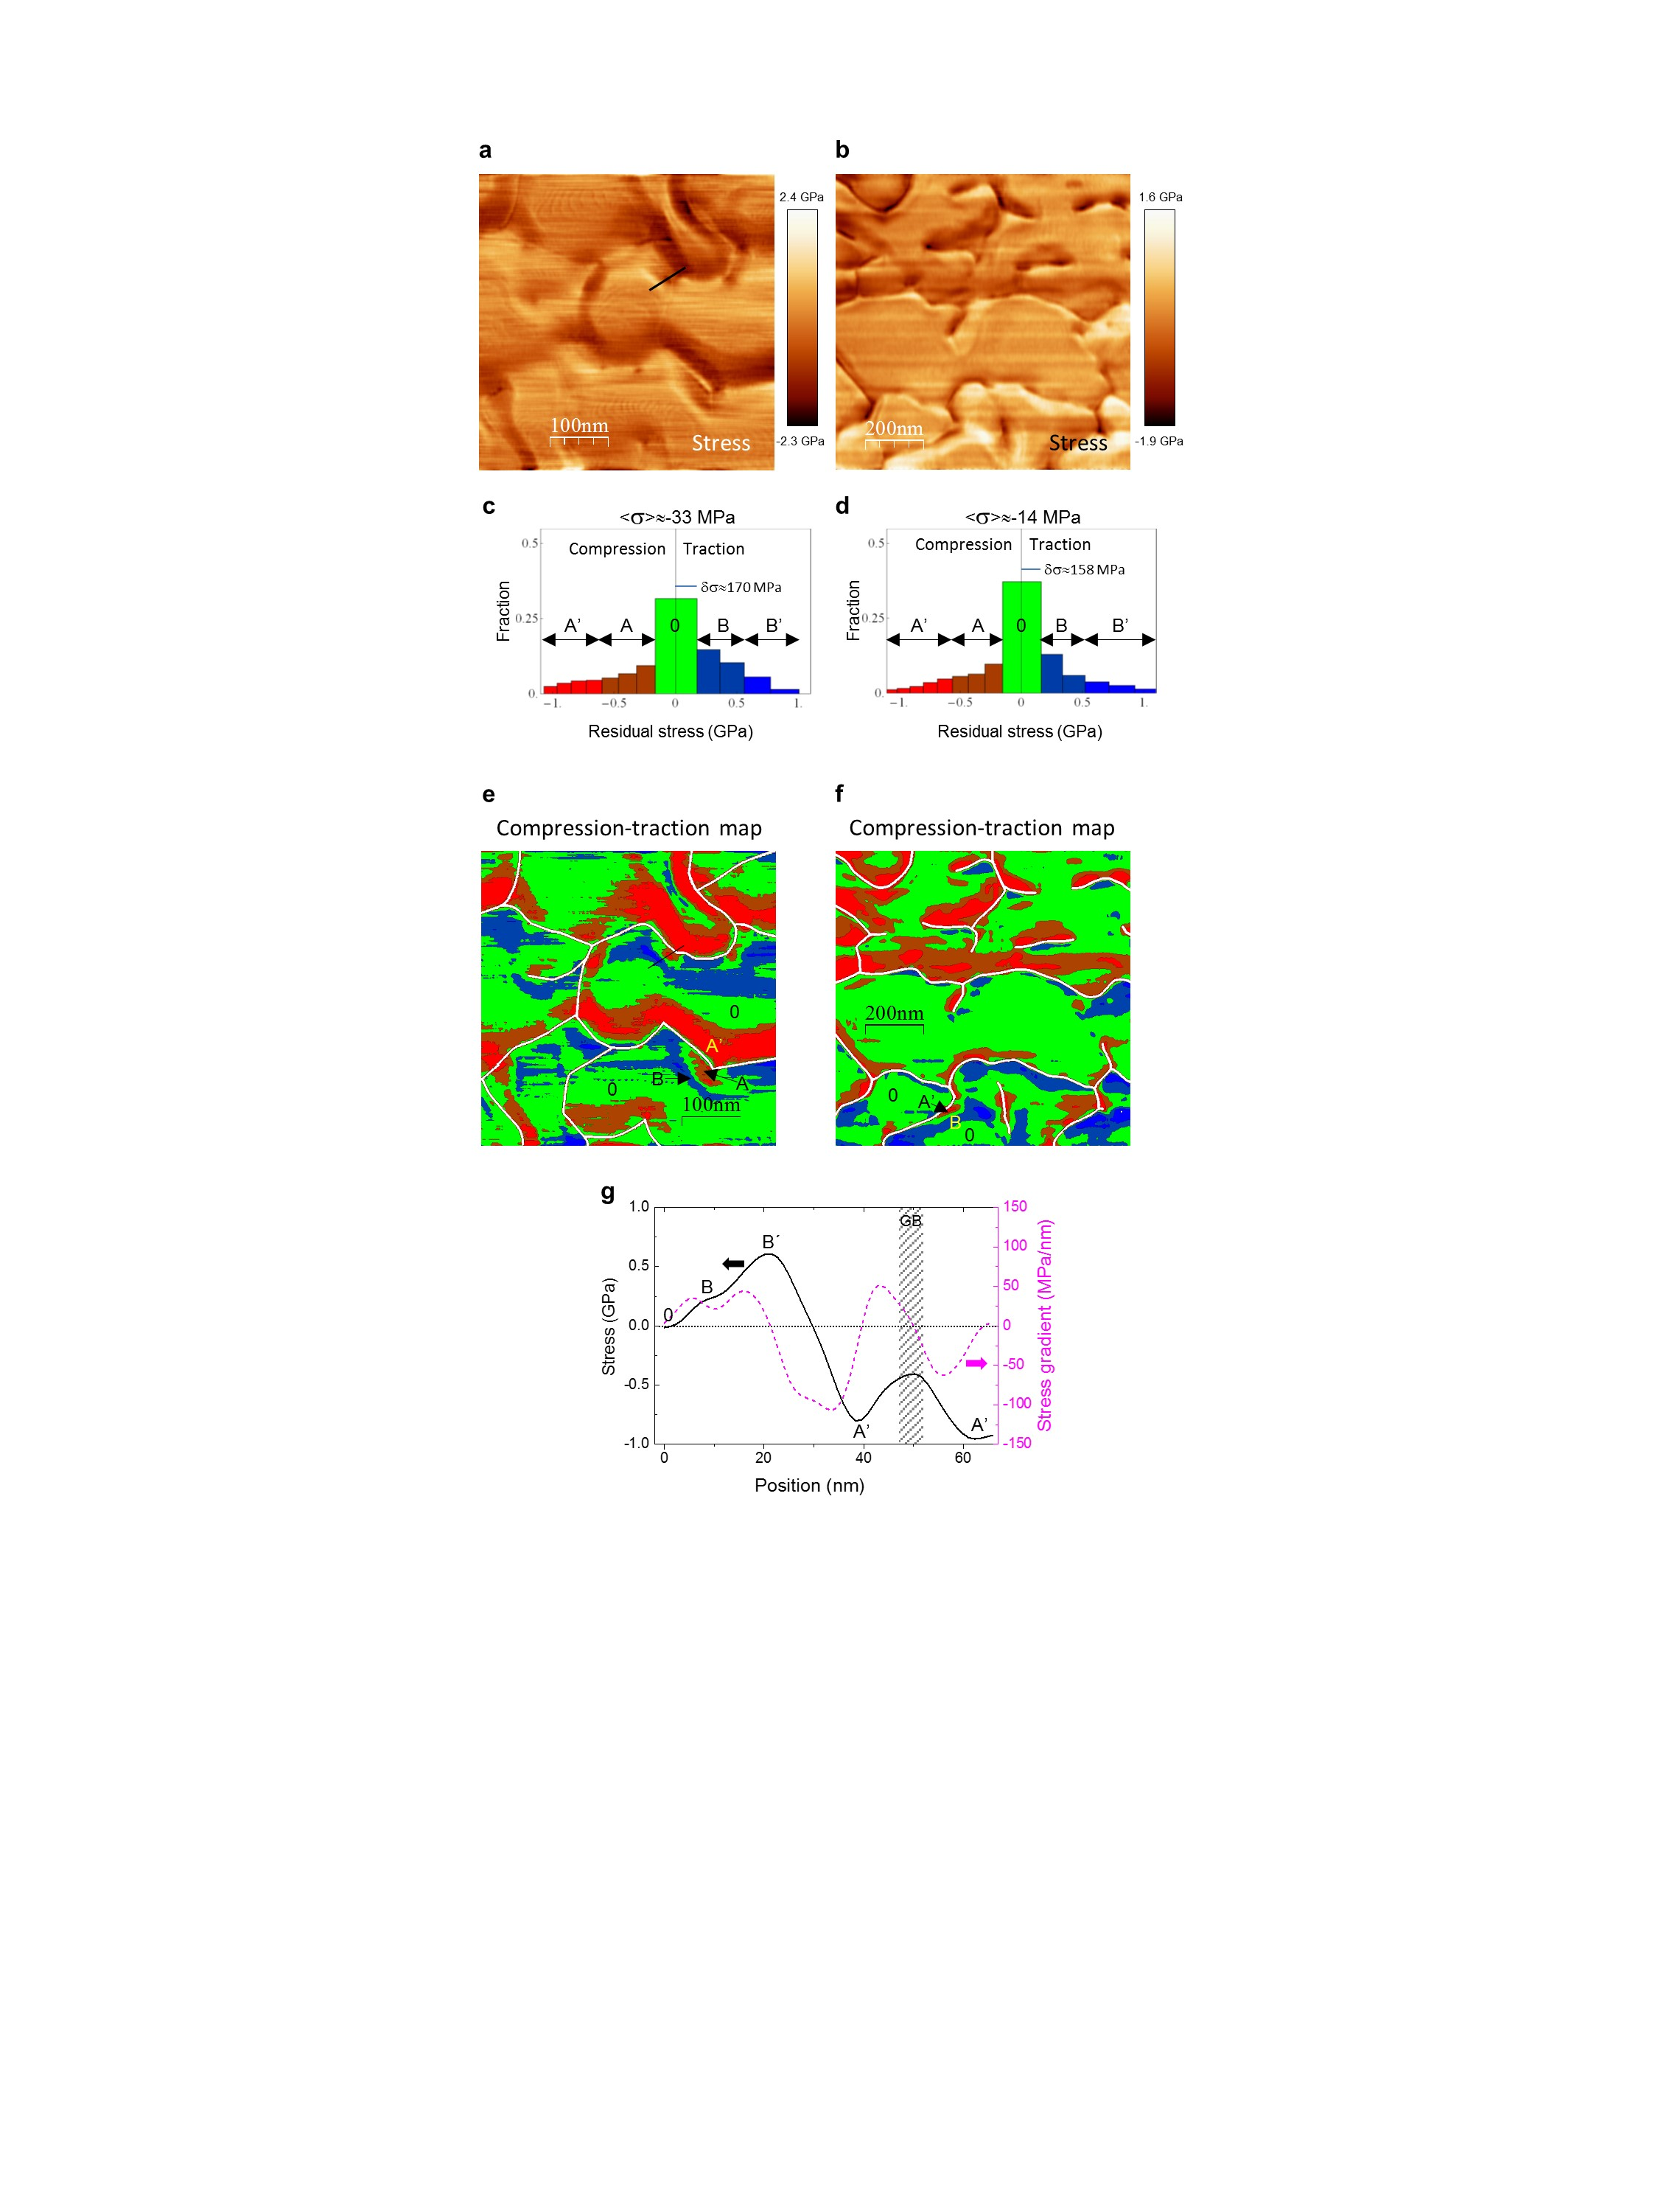

**Fig. 5** Residual stress () maps on the nanoscale. (**a**,**b)**  maps of 600 nm and 1200 nm thick Au films, calculated from FMM images obtained at =0.75 V and 0.10 V, respectively. (**c**,**d**) Histograms identifying the major stress levels in the two films, namely: relaxed regions (0, green), areas under low and high compression (A and A’, dark and light red), areas under low and high traction (B and B’, dark and light blue). The average stress  over each map is reported above the corresponding histogram together with the  uncertainties around the relaxed state **. Note that ** (width of the histogram bins)depends on the  magnitude as described in the text. (**e**,**f**) Compression-traction maps of the Au films, using the discrete color scale defined in the histograms (c) and (d). (**g**) Stress profile (continuous black line) along the line plotted in (a) and its corresponding 1D gradient (dashed magenta line referred to the right axes).