Tectonics
Supporting Information for
The crustal domains of the Alboran Basin (western Mediterranean)
L. Gómez de la Peña^{1,2}, C. R. Ranero¹,³ and E. Gràcia¹
¹B-CSI, Institut de Ciències del Mar, CSIC, Pg. Marítim de la Barceloneta 37-49, 08003 Barcelona, Spain
²Now at: GEOMAR Helmholtz Centre of Ocean Research, Wichhofst. 1-3, 24148 Kiel, Germany (lgomez@geomar.de)
³ICREA, Passeig Lluis Companys 23, 08010, Barcelona, Spain

Contents of this file

Text S1
Figures S1 to S5
Table S1

Introduction
A detailed description of the processing flow applied to the multichannel sections in time domain is performed. A comparison with the previous version of the reprocessed lines have been included.
Data processing: Multichannel Seismic processing flow in time domain
The processing flow in the time domain (Table S1) has been designed to increase the signal-to-noise ratio. It can be divided in six main steps: 1) Pre-processing, 2) Deconvolution, 3) Multiple attenuation and velocity analysis, 4) Dip Move Out correction, 5) Final stack, and 6) Post-stack time migration.
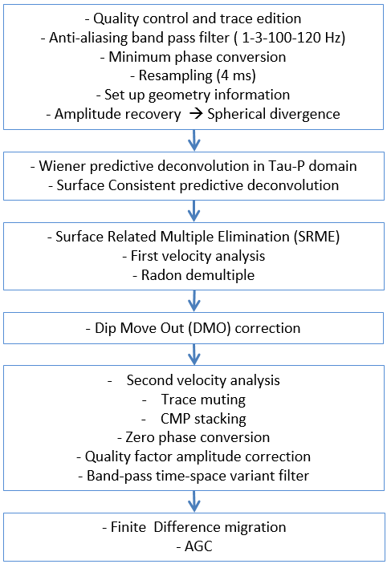 | Table S1: Processing flow used for processing the dataset in time domain.
1 Pre-processing
In this step, we describe analysis of data to design the proper time processing sequence. They consisted on a first data quality control, a broad band-pass filter, minimum phase conversion, a time resample of data, addition of the geometry information, and an amplitude recovery to balance amplitude which is convenient for several processing steps like deconvolution.
During quality control, checks are carried out for missing traces determined, and bad or noisy shots. Tests are done to filter, amplitude balance or even eliminate noisy input data early on in the process flow. A delay between trigger and the air-guns shot time, applying a positive time shift correction of 50 ms, was applied.
The band-pass filter consists on a Butterworth filter, designed to remove lower frequencies related to sea swell and human noises, and a high cut to prevent time aliasing of the signal. The values applied are 1-3-100-120 Hz. In the design of this filter, the Gibbs Phenomenon has been taken into account to avoid the generation of ringing.
To perform the minimum phase conversion, we have to determine the source wavelet. We carried out an autocorrelation of 100 seismic traces, starting at the seafloor time, with a window length of approximately 5 times the length of the generated signal (~500 ms). This parameter led to a 2500 ms window. The autocorrelation allowed us to find the wavelet because this generated wavelet is the same for all traces. Once we have determined the wavelet, we are able to convert it to minimum phase, and design the filter that allows converting all seismic traces to minimum phase. Through the convolution of our minimum phase filter with the mixed phased raw data, we are able to convert this raw data to minimum phase. After the data are minimum phase, they are resampled to 4 ms to reduce data volume without losing information.
Finally, we set up the geometry information in the seg-y file headers. A spherical divergent amplitude correction based on a geological velocity layers model has been applied.
2 Deconvolution
There are two types of deconvolution: deterministic and statistical. The deterministic deconvolution is carried out when the source waveform is known. When the source waveform is insufficiently known, then the solution to the deconvolution is statistical (Yilmaz, 1987). We applied two statistical deconvolutions, as the source waveform is insufficiently known.
To perform deconvolution, we need to design a filter, which will modify the wavelet of our data. The fundament of this filter is that the geology is random, so the impulse response is also random. This implies that if there is a pattern replicated along the seismic trace, it must be induced by the source wavelet. The filter can be obtained by autocorrelation of the signal, and the main objective is to convert the source wavelet in a spike (Yilmaz, 1987). In our case, we applied two pre-stack deconvolutions to the data, (2.1) a Wiener Predictive deconvolution in Tau-P domain, and (2.2) a Surface Consistent deconvolution.
2.1 Wiener predictive deconvolution in Tau-P domain
We have applied a Wiener predictive deconvolution in Tau-P domain to sharpen the source wavelet and attenuate short period multiples. This deconvolution process has been performed with a spatial variant filter, designed in the shots. The filter length was variable and corresponds to the water point at each point of the seismic section, as tests reveal that it is the most effective length. The gap length was the same as the time of the bubble (in our case, between 140 and 160 ms, depending on the profile and tested for each). The chosen designed window was from 100 ms below the seafloor till 7000 ms, because this window contains a representative section of the data and do not introduce noise in the deconvolution process. White noise percentage was 0.1%. The deconvolution has been applied in a single window over the whole trace, in the shot sorted data.
These parameters helped attenuate the source bubble and other short peg reverberations. It is more effective in depth water, although it also improves the seismic profiles in the shallower parts.
2.2 Surface Consistent deconvolution
We have performed two surface consistent deconvolution processes, the first one in shot-sorted data, and the second one in channel-sorted data (offset gathers). The chosen design and application windows are the same as for the Wiener predictive deconvolution in Tau-P domain (design window, from 100 ms below seafloor till 7000 ms, applied to the whole trace). For this deconvolution, the filter and gap lengths are fixed. The filter length was chosen to be half the length of the generated wavelet. In our case, it means values between 180 ms and 240 ms (parameters were tested for each profile specifically). The gap was defined as half the width of the source wavelet (24 ms).
Surface Consistent deconvolution makes data more coherent, reduces the bubble noise and attenuates residual swell and random noise that was not removed with the first band pass filter. It produces a good vertical signal compaction and improves lateral continuity of the reflections.
3 Multiple attenuation and velocity analysis
3.1 Surface Related Multiple Elimination (SRME)
SRME works on a multiple prediction model. This model has been constructed trace by trace, and it is subtracted from the original dataset in order to attenuate the multiple. As it works better with a zero offset configuration, we changed the geometry of our data in order to improve the results. After the SRME process, the original geometry is restored.
The subtraction of the model is done in receiver-sorted data. It is done in three steps, with two different methods applied. First, we performed a subtraction based on the publication of Y. Wang (2003). This part of the processing is comparatively very effective attenuating the multiple´s energy in complex seafloor geometries, where steep dips and diffractions are present. Second, we applied two more subtraction based in D. J. Monk adaptive subtractions (Monk, 1993). This is a trace-by-trace process, very useful in shallow waters and horizontal sedimentary layers, where dipping structures or diffraction are not present. We performed two Monk’s subtractions, in order to improve the accuracy of the final result.
The SRME is highly efficient, specially looking at near offsets (Figure S2). The multiple´s energy remaining at far offsets will be dealt with later, using Radon demultiple techniques.
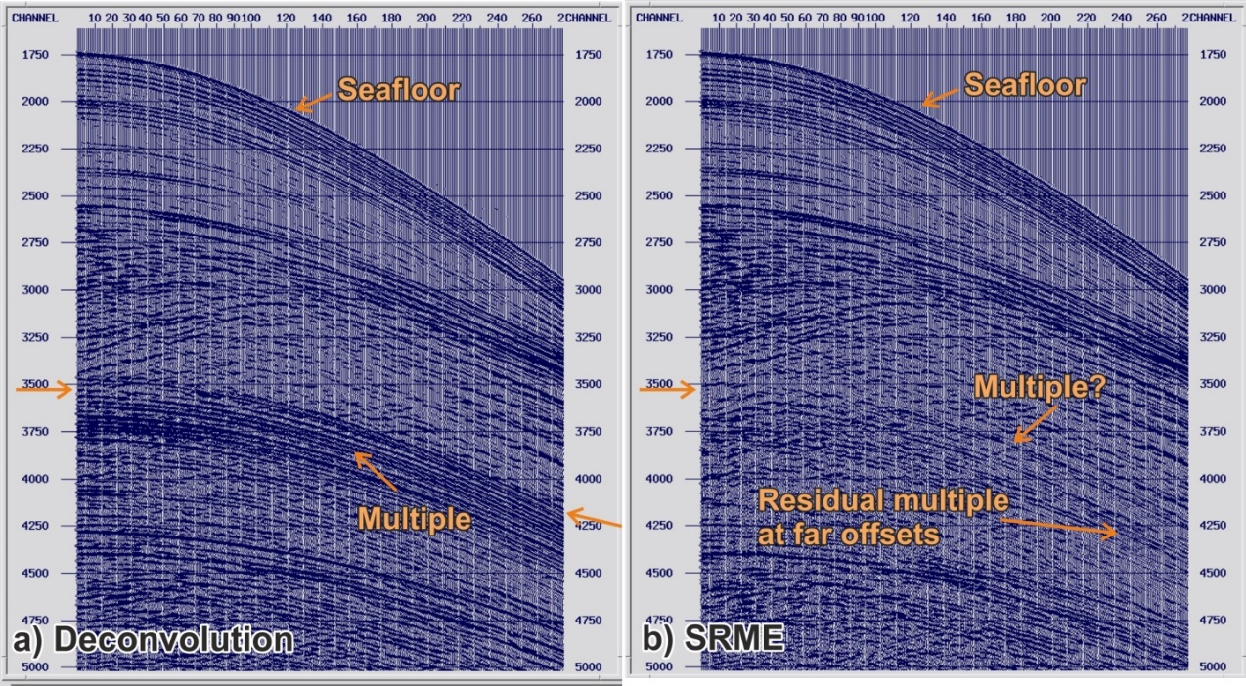
Figure S2: Shot 1360 (channels from 1 till 270, TWTT from 1.7 s to 5 s) before (a) and after (b) SRME is applied. Notice the effectiveness of the SRME process removing the surface related multiples. Orange arrow indicates the estimated time of arrival of the first seafloor multiple (2 times the TWTT at the seafloor, 3500 ms). Residual multiple energy will be removed with the Radon filter (see point 3.3) (vertical axis TWTT in ms).
3.2 Velocity analysis
To perform the first velocity analysis, we made a first approach on the basis of an interval velocity model, taking into account the geology of the area. We digitized a set of layers following geological criteria, and the velocities used coincide with average velocities of the region.
Once having a first gross regional velocity model, we started with the velocity analysis to achieve an accurate velocity model. In order to determine the NMO velocity, we performed the velocity spectrum analysis through the analysis of semblance panels.
3.3 Radon demultiple
We performed the Parabolic Radon demultiple process above the CMP sorted dataset, with the NMO correction applied. We reorganized CMP gathers (100 m inter-trace distance) in super-gathers (inter-trace distance 12.5 m) to have better spatial mapping per input gather, to avoid spatial aliasing and obtain better results. For each profile, a designed window of the Radon filter has been tested and chosen, taking into account the dips of the hyperbolic events (multiples). This filter is based on the residual move out values at the farther offset.
This method is more efficient in areas with different high-velocity between primary reflections and multiples. It works better in far offsets, and in long-period multiples found in deep waters. On the other hand, the method has problems dealing with the multiple´s energy in the near offset or with short period reverberations. In shallow waters (< 500 ms), this process may introduce some low frequency noise, but it is removed with a band pass filter.
The results show an attenuation of the multiple in far offsets that complements the improvement of the image obtained with the SRME, being complementary to the SRME process that removes the multiple´s energy in the near offsets (Figure S3).
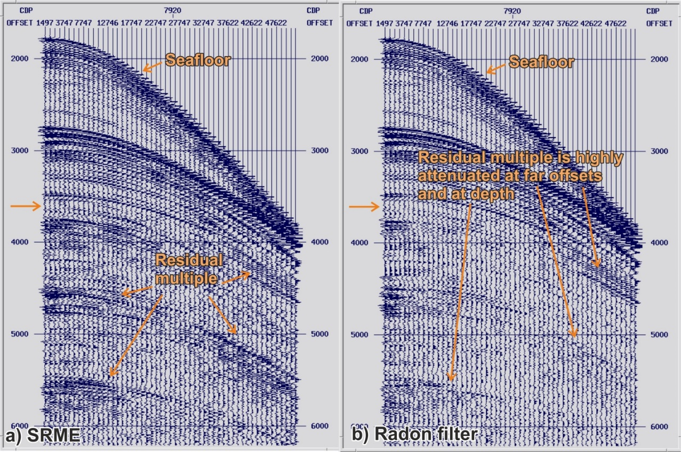
Figure S3: CMP 7920 processed till SRME step (a) and till Radon (b). X axis is offset in decimetres, Y axis, TWTT in miliseconds. Is worth noticed how the Radon filter efficiently removes the residual multiple energy remaining after the SRME modelling, especially at far offsets and at the deepest parts.
4 Dip Move Out correction
We performed a Kirchhoff DMO correction in time domain, in pre-stack data, sorted by offset and with the NMO correction applied. As a result, the level of random noise decreased, and side diffractions were partially removed. DMO is an efficient alternative to pre-stack migration as it corrects the dip effect in the NMO velocities. Combining NMO and DMO, we remove the offset and the dip effect for the pre-stack data, preserving the different dips and obtaining a dataset ready for post-stack migration.
5 Final stack
5.1 Final velocity analysis, trace muting and CMP stacking
To obtain the final stack section, we performed a second velocity analysis; with the same basic principles that the first one. This task has been achieved by systematically analysing the semblance panels each 300 CMP (1875 m), and closer in areas where local geology requires it. The aim of this analysis is to estimate an accurate NMO velocity.
We have designed an external mute, picked in our NMO corrected CMP, in order to remove the stretching deformation. With the aim of removing the remaining multiple energy, we picked an inner mute that helps to remove remnants multiple energy in very near offset.
With this final NMO velocity model and the mutes, the final stack is achieved.
5.2 Zero phase conversion
We performed a Zero phase conversion. This conversion has been done in similar way than the Minimum phase conversion. We designed a filter, on the basis of the auto-correlation of 1000 stacked traces. In that way, we found the source wavelet, and designed the Zero phase filter applied to the whole profile through a convolution module.
5.3 Quality factor amplitude correction
Quality factor has been estimated in a practical way performing tests with different Q values, and choosing the best result for correcting the amplitude decay.
5.4 Band-pass filtering
A time and space variant band-pass filter has been designed for each line, following geological criteria. It has been applied following a layer model, with five manually picked horizons, which define the main geological units in the area.
6 Post-Stack Time Migration
We performed a post-stack Finite Difference migration in time domain. The main input parameters are a smooth interval velocity model, a window for the time slices of 20 ms and a dip filter factor equal to the cosine of 0.65 degrees. The algorithm is supposed to be based on a X-T domain implicit 45-degree migration, but it offers reasonable results up to 60 degrees of dipping.
Finally, we applied a seafloor mute and a final amplitude balance. This balance is a time-variant scaling in which the scaling function follows the desired criterion. We choose an Automatic Gain Control (AGC), which goal is bringing up weak signals. In order to preserve some amplitudes variation, we have applied this AGC in two windows, one for the sedimentary basin and one for the basement. The final output has been exported in seg-y format.
We considered that this processing flow in Time domain is optimal for the data (Figure S4a-j). Tau-P deconvolution removed short-period multiples and the bubble noise, while long-period multiples were removed using the complementary SRME (especially effective in near offsets, horizontal layers, and irregular seafloor) and Radon demultiple processes (which works better in far offsets and is effective with dipping layers). The Surface Consistent deconvolution helps to increase the vertical resolution, as it compresses the signal wavelet in a unique spike, to make reflections more coherent. DMO is an approximation to a Pre-Stack Time Migration, which preserves velocity and dipping variations, collapsing part of the diffraction and filtering some incoherence noise. Finally, a more real image of the subsurface was obtained performing a Post-Stack Time Migration, which collapses diffractions and put the reflections in their true position. Remaining incoherent noises have been further attenuated with band-pass filtering variable in space and time. Final amplitude balance was applied to recover the energy lost by geometrical spreading.

Figure S4 (next pages): The evolution of a section of profile TM21 is shown as example. Brute-stack sections were performed with a preliminary initial velocity model, based on first velocity analysis, while stack sections were performed with the final velocity model. See following figures a, b, c, d, e, f, g, h, i and j. a) Initial brutestack. This section is the result of the data preparation for the processing in time domain, including quality control, a gentle band-pass Butterworth filter, minimum phase conversion, geometry insertion and spherical divergence correction to recover amplitudes in depth. Resolution of the image is very poor due to low signal to noise ratio, affected by the present of coherent noises (bubble, reverberations, multiple), incoherent noises and the inaccuracy of the velocity model. b) Brutestack with the Tau-P (TP) deconvolution applied. This deconvolution process is highly efficient removing the bubble noise and other short peg reverberations, which is important to obtain a clearly image of the sedimentary layer. c) Brutestack with Tau-P (TP) and Surface Consistent (SC) deconvolution. After the SC deconvolution, reflections gain in continuity and amplitudes of low energy reflections are enhanced over the surrounding noise. d) Brutestack after the SRME demultiple process. It points out the great potency of this technique removing the multiple´s energy without damaging the signal below it. e) Same section as d, but stacked with the final velocity model that results from the semblance analysis. Here is clear the importance of the velocity model to achieve a good seismic image. Reflections gain in resolution in the shallow and the deep parts of the profile, where registered signal is recovered, and incoherent noise level is decreased. f) In order to remove the remaining multiple energy we have applied a Radon filter. With this filter, we remove the dip events from the NMO corrected CMP gathers, where the primaries reflections are supposed to be horizontal. This technique reduces the multiple especially in the far offsets. It is important to check that there is no dip information loses in the stacked section. g) To reduce the remaining dipping coherent noise and reduce the diffraction hyperboles, we have performed a Dip Move Out correction before the final stack. The result is a section with a better definition of the reflections, which is especially noticed at irregular surfaces (where diffractions are generated) or in dipping reflections. h) Final stack section. This section includes muting, zero phase conversion, amplitudes recovery through the Q factor and a time and spatial variant band-pass filter. The result is a section with a high signal to noise ratio, with a low level of noise and no spike amplitudes that will be a properly input for the migration. i) Time migration. In the migrated section, dipping events are well defined and diffractions collapsed, allowing a good interpretation of sedimentary and tectonic structures. j) Time migration with and Automatic Gain Control (AGC) applied. The AGC allows recovering the amplitudes in depth. The result of the time domain processing flow is a high quality, clear and high-resolution image, in which sedimentary layers and tectonic structures can be satisfactorily identified and interpreted.
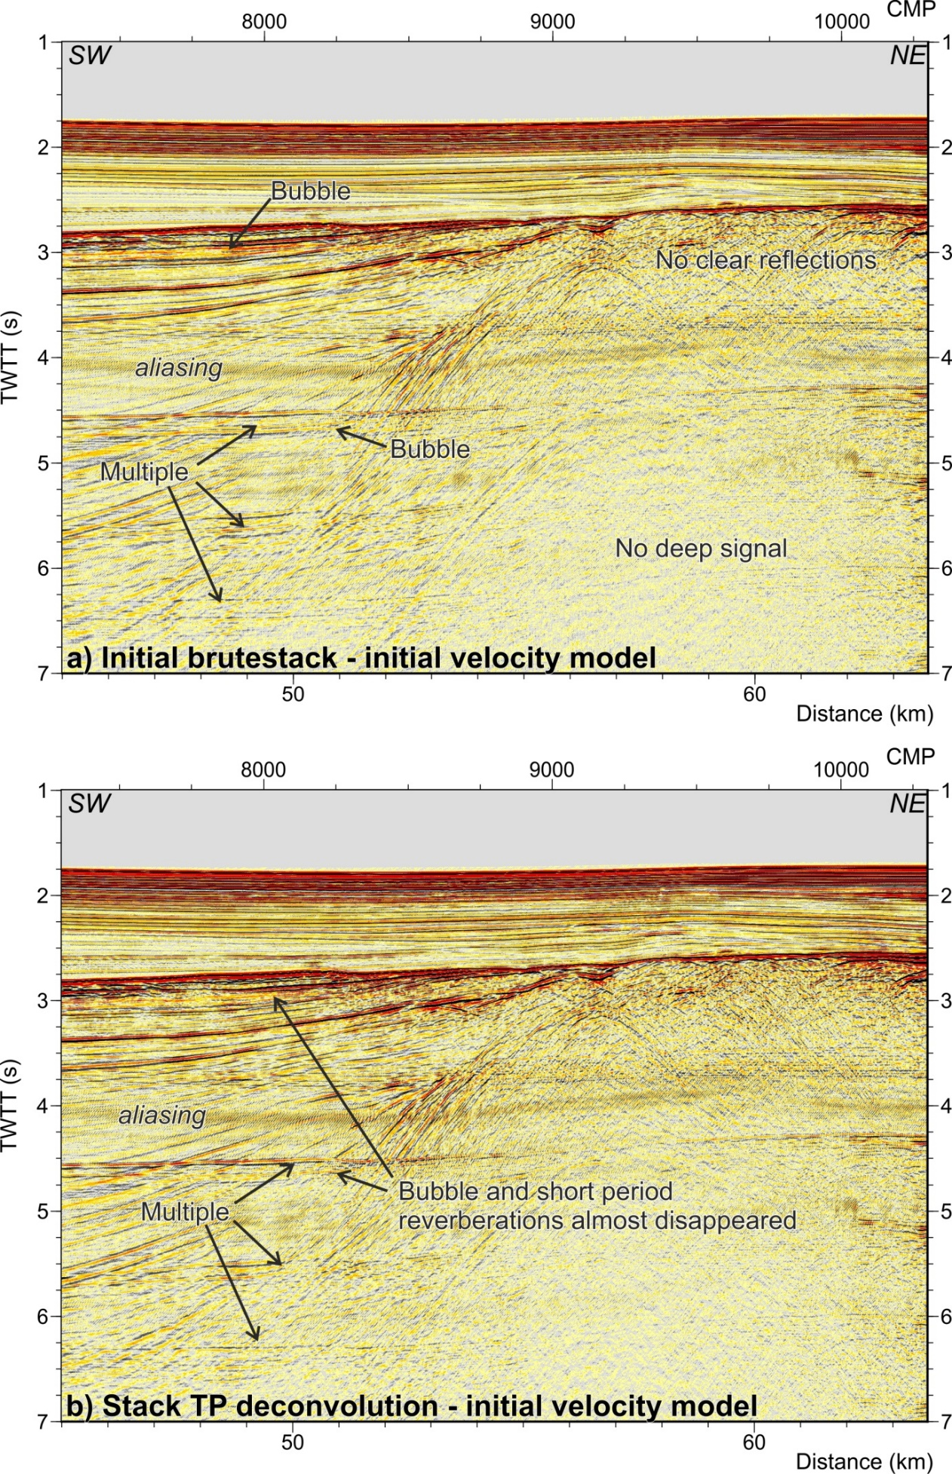
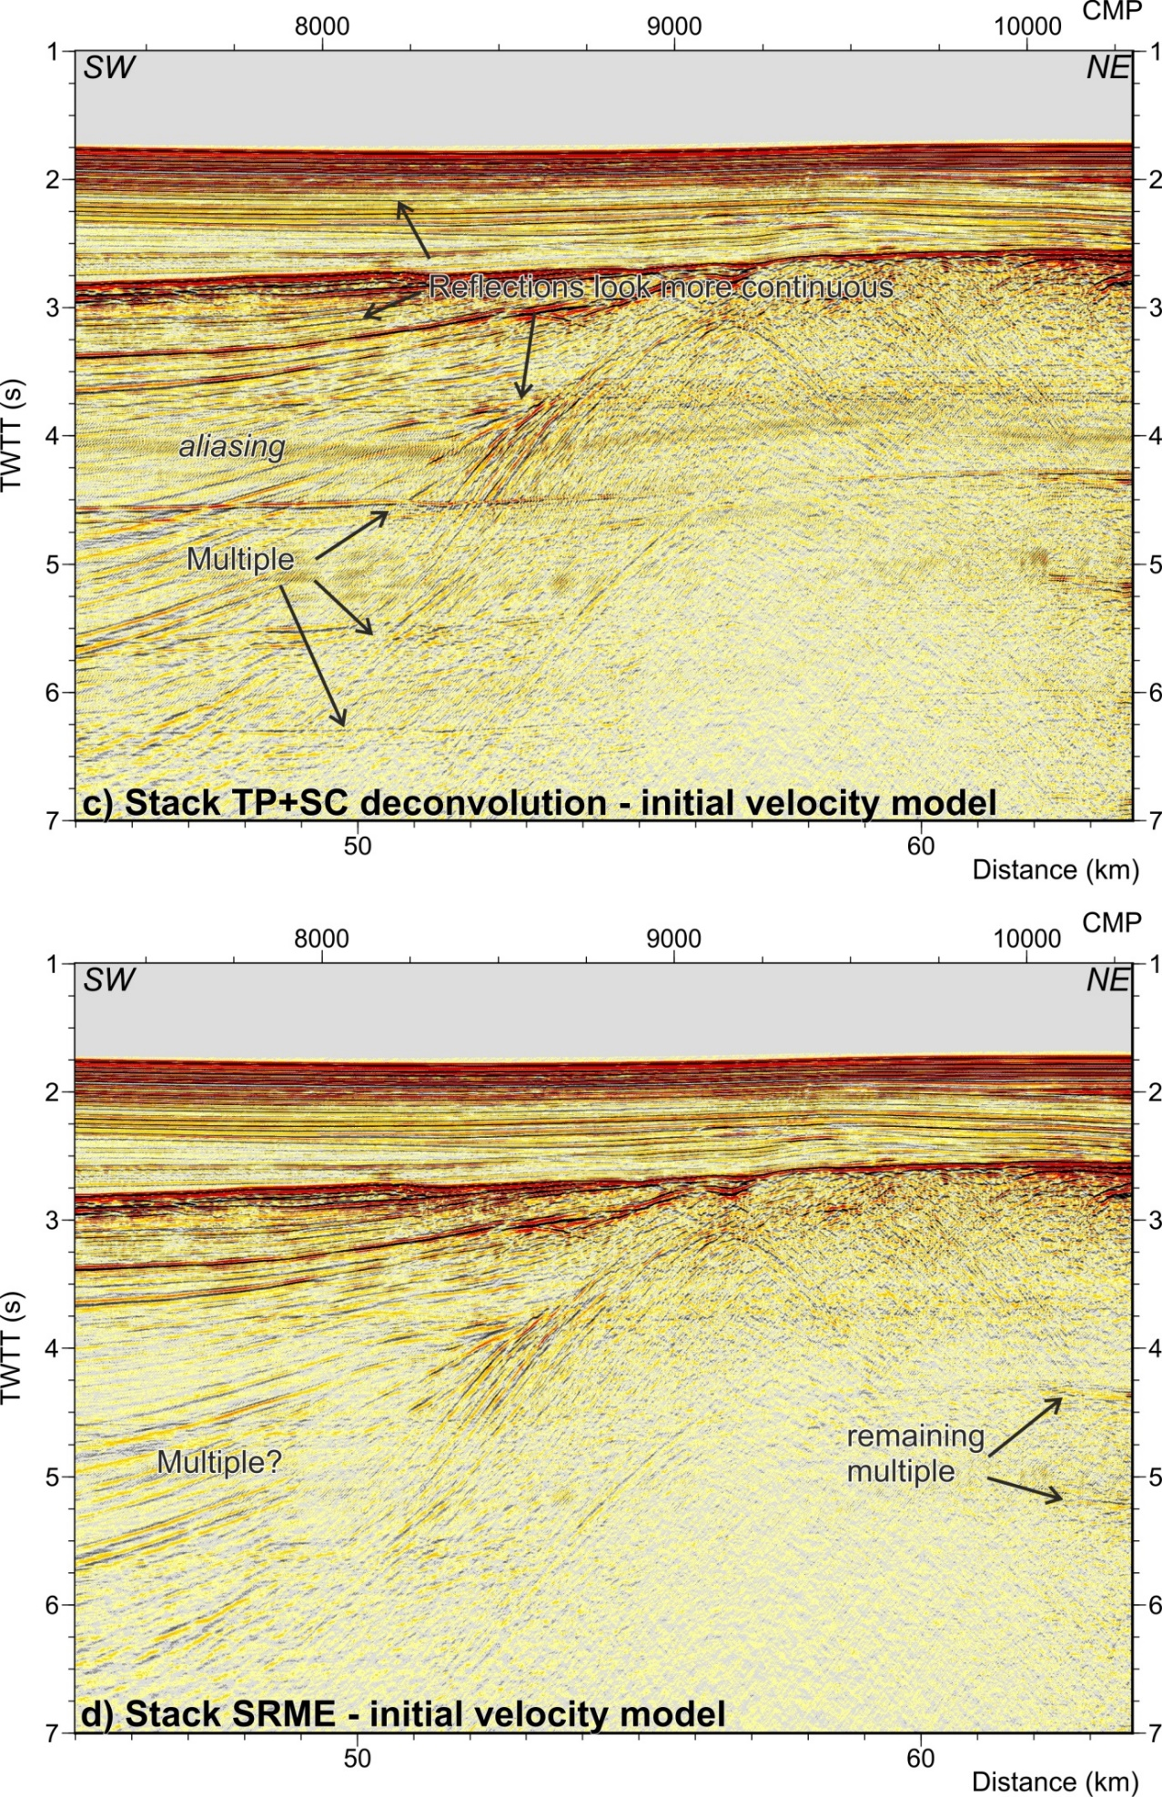
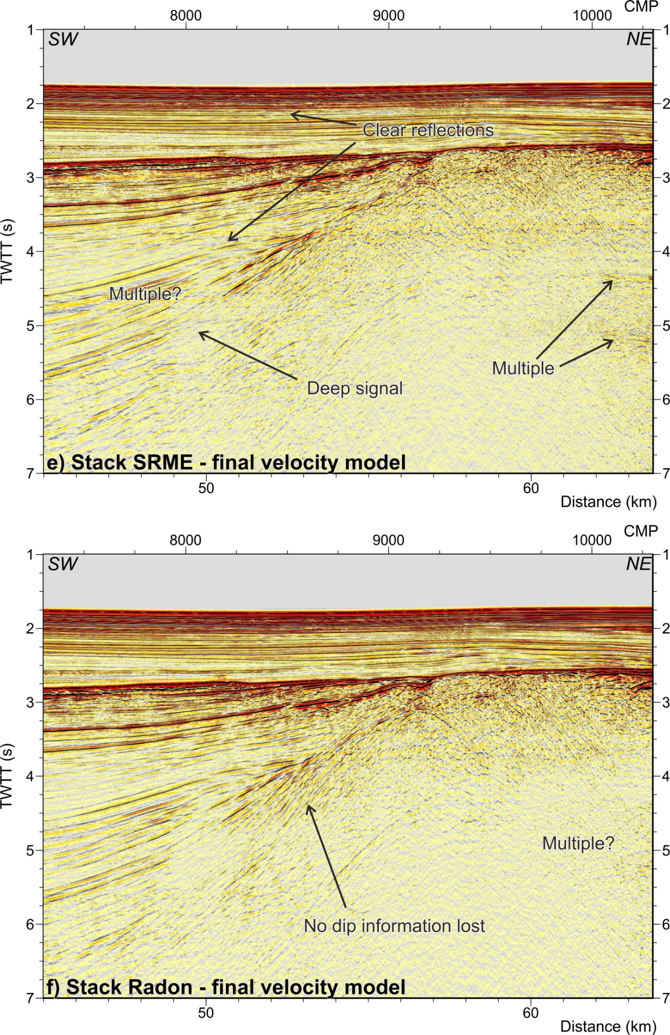
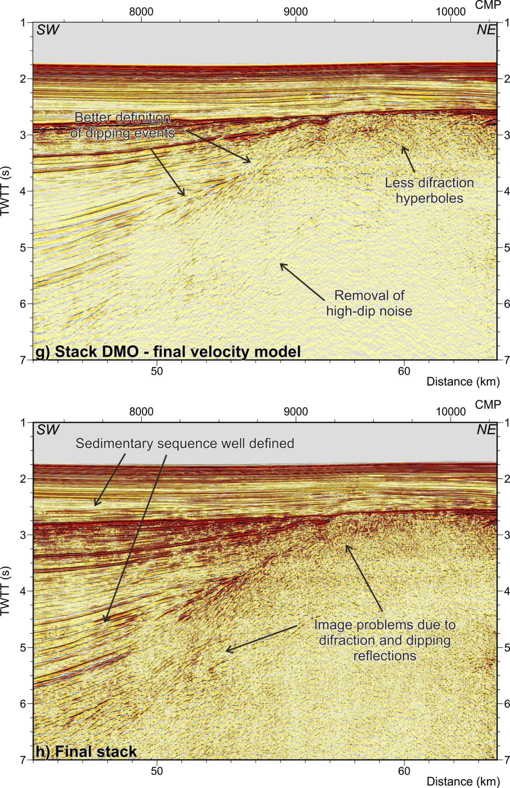
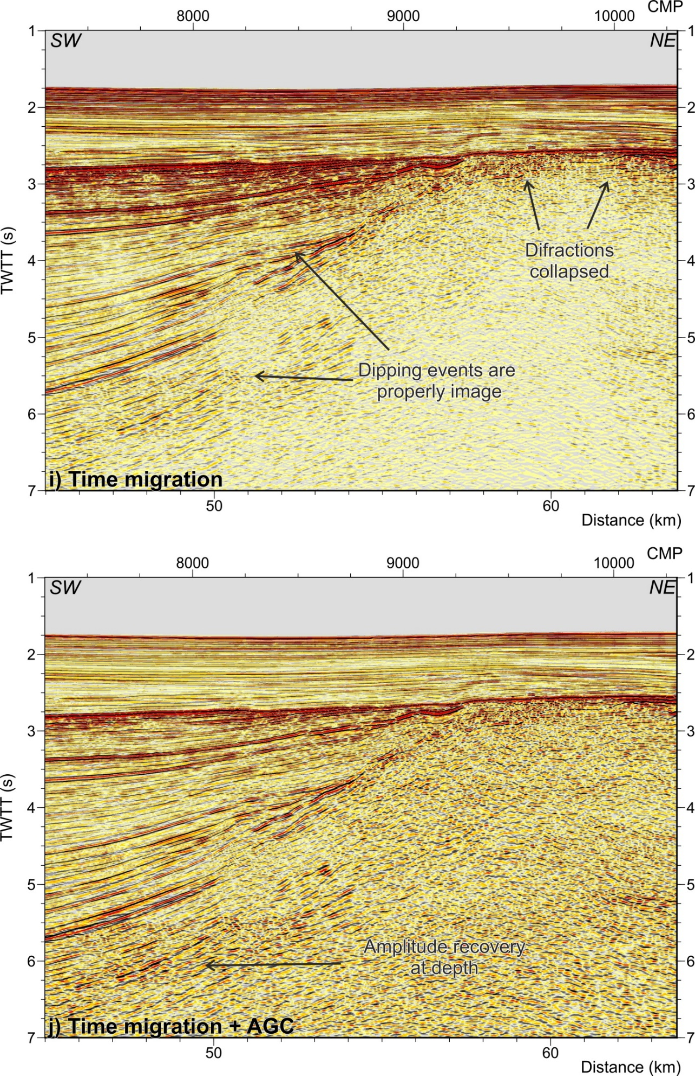

7 Comparison with previous processed profiles

The processing flow applied also allows us to improve the results of the reprocessed sections. As an example, we show profile ESCI-Alb1, as published by Comas et al., 1995 (stack section, Figure S5a) and after reprocessing (time migrated section, Figure S5b). Previous processing includes a post-stack deconvolution, a f-k filtering and a band pass filter (5-35 Hz), both applied to the stack section (Comas et al., 1995). Main improvements with the new processing flow applied for this study concern the multiple elimination, which reveals the deep structure, and the time migration. Notice how in the reprocessed section (Figure S5b) the resolution inside the sedimentary sequence increases, the top of the basement is better defined, and the multiple elimination allows the interpretation of the deep reflectivity, as the intracrustal features or the Moho reflections.

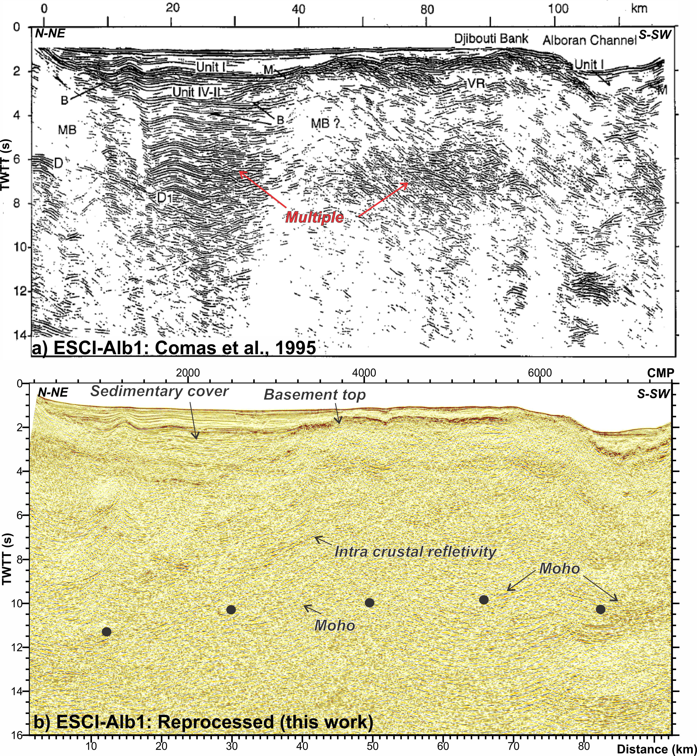

Figure S5: (a) Line ESCI-Alb1 as published by Comas et al., (1995) (stack section). Labels are Unit: Plio-Quaternary sedimentary unit, Unit IV-II: Late Miocene sedimentary units, M: Messinian top reflection, B: top of the basement, MB: Metamorphic basement, VR: volcanic rocks, D: intracrustal reflections. (b) Line ESCI-Alb1 with the seismic processing presented in this paper. Notice the improvement in the reflections definition and in the deeper section of the profile, due to the multiple elimination.

