OPEN ACCESS DOCUMENT

Information of the Journal in which the present paper is published:

- Ecotoxicology and environmental safety, 2017, 145, 583-590
- https://doi.org/10.1016/j.ecoenv.2017.08.013

Analysis of neurobehavioural data by chemometric methods in ecotoxicological studies
Cristian Gómez-Canelaa*, Eva Pratsb, Romà Taulera, Demetrio Raldúaa

aDepartment of Environmental Chemistry, IDAEA-CSIC, Jordi Girona 18-26, 08034 Barcelona, Catalonia, Spain.
bCentre d’Investigació i Desenvolupament, CID-CSIC, Jordi Girona 18-26, 08034 Barcelona, Catalonia, Spain.

*Corresponding author:
Email: cristian.gomez@cid.csic.es (C. Gómez-Canela)
Tel: +34 93 400 61 00
Fax: +34 93 204 59 04

Abstract
Incorporation of chemometric tools in behavioural data management workflows allows for the early identification of most relevant endpoints complementarily to statistical confirmatory approaches. In this work, the effects of two model neurotoxicants, chlorpyrifos (CPF) and nicotine, exposures on behavioural profiles of adult zebrafish at three different times (2, 6 and 24 h) were evaluated using open field test (OFT) paradigm experiments. Two chemometric methods like Principal Component Analysis (PCA) and Analysis of Variance-Simultaneous Component Analysis (ASCA) have been used to interpret the changes observed in the obtained behavioural data. A decreased of the locomotor activity, an anxiolytic effect and an altered exploratory behaviour were the most affected behavioural endpoints in the CPF exposures. However, an increase of the locomotor activity and an anxiogenic effect were observed in the nicotine exposures. Finally, an excellent correlation between the ASCA results and the results obtained using traditional statistical procedures for both compounds were encountered.

Keywords: zebrafish; open field test; behaviour; chemometric tools.

1. Introduction
Humans are routinely exposed to a wide range of environmental pollutants potentially inducing neurotoxicity (De Duffard and Duffard, 1996; Jones and Miller, 2008). Different animal models have been used in attempt to understand the neurobiological basis of the adverse effects induced by these neurotoxicants on the human central and peripheral nervous system. Zebrafish (Danio rerio) is a vertebrate model species increasingly used in biomedical research, drug discovery and safety pharmacology (Brittijn et al., 2009; Lieschke and Currie, 2007; Raldúa and Piña, 2014). Low cost, well-established molecular genetic tools and high conservation of the main physiological processes involved in nervous system morphogenesis and maintenance all combine to make zebrafish a promising animal model for neuroscience research, including neurobehavioural toxicology (Babin et al., 2014; Faria et al., 2015; Raldúa and Piña, 2014; Stewart et al., 2015). Until recently, the main criterion for determining the neurotoxicity of one chemical was the presence of neuropathological adverse effects. However, behavioural endpoints have been recently incorporated to the neurotoxicology screening protocols, and these functional endpoints are now used routinely to detect and characterize potential neurotoxicity of chemicals (De Duffard and Duffard, 1996).
A wide variety of behavioural methods and paradigms are currently available for using in laboratory animals, including zebrafish, for studying specific neurotoxic effects of environmental pollutants and drugs (Levin and Chen, 2004; Mora-Zamorano et al., 2016; Oliveri et al., 2015). The recent development of different video-tracking software in neuroscience research has enabled standardize and automate behavioural endpoints, promoting reproducibility and allowing for multiple endpoints to be recorded at once (Cachat et al., 2011). Specific video-tracking systems to automate behavioural studies in zebrafish are commercially available from companies such as Noldus Information Technology (Ethovision® XT) and Viewpoint (ZebraLab). These systems are able to analyse simultaneously dozens of dependent variables, including those related with movement, location, path or direction, for each sampling time (commonly 30 samples per second) and experimental condition. Once obtained all these data from the video-tracking systems, behavioural endpoints are usually compared between control and treated animals by using standard statistical analysis. Thus, after assessing the normality of the different distributions and the homoscedasticity of the groups, the most suitable parametric or non-parametric test are usually selected. This process, however, can become extremely time-consuming, as often hundreds of distributions need to be tested individually. Therefore, methodologies allowing the prioritization of those endpoints really relevant for a further statistical analysis and confirmation are urgently needed in the neurobehavioural toxicology field. Although multivariate data anlaysis chemometric techniques, including Principal Component Analysis, PCA (Farrés et al., 2015) and the Analysis of Variance and Simultaneous Component Analysis (ASCA) (Jansen et al., 2005; Smilde et al., 2005), could be extremely useful for this role, their use in zebrafish neurobehavioural research is still scarce.
Thus, our hypothesis in this work is that chemometric tools are useful to predict the most relevant behavioural endpoints altered by neurotoxicants. As a proof of principle of this new approach, adult zebrafish have been exposed to chlorpyrifos (CPF) and nicotine, two well-known neurotoxic compounds modulating anxiety-like behaviour in mammalian models (Lopez-Crespo et al., 2007). Adults were selected instead of embryos or larvae, as they exhibit a more complex behaviour (Cachat et al., 2011). The open field test (OFT) and the video tracking system Ethovision XT 11.5 (Noldus Technologies) was selected for the behavioural analyses, as this experimental paradigm evaluates the natural neophobic response, providing information on both locomotor and anxiety-related behaviour (Hall, 1934; Stewart et al., 2012). The obtained data were first analysed with the most time-consuming statistical procedures and then, the behavioural profiles obtained with the two chemometric methods (PCA and ASCA) were compared. Results of this study strongly supported that chemometric analysis of video-tracking data not only offers new possibilities to extract information, but also illustrates new effects obtained in behavioural assays, allowing for a save of time and for a reduction of the efforts in the statistical confirmatory analysis of the most relevant endpoints.

2. Material and methods
2.1. Animals and housing
Adult wild-type zebrafish, obtained from a local commercial distributor (Piscicultura Superior, Barcelona, Spain), were maintained in fish water [reverse-osmosis purified water containing 90 μg/mL of Instant Ocean (Aquarium Systems, Sarrebourg, France) and 0.58 mM CaSO₄·2H₂O] at 28 ± 1°C and a 12L:12D photoperiod in the Research and Development Centre of the Spanish Research Council (CID-CSIC) facilities for at least 5 weeks before the experiments. All procedures were conducted in accordance with the institutional guidelines under a license from the local government (DAMM 7964) and were approved by the Institutional Animal Care and Use Committee at the Spanish Research Council.

2.2. Experimental procedure
Chlorpyrifos (CPF; CAS♯2921-88-2, purity≥ 99.5%) and (-)-nicotine (nicotine; CAS♯54-11-5, purity≥ 99%) were purchased from Sigma-Aldrich (St. Louis, MO, USA). Stock solution 10 mM CPF was prepared in dimethyl sulfoxide (DMSO). A range finding test was conducted for each compound in order to find the maximum tolerated concentration (MTC), defined as the concentration for which no lethality was observed above that seen in vehicle treated siblings (Raldúa and Babin, 2009). The MTC for each compound, 5 μM CPF and 50 μM nicotine, was used in the exposure solutions for behavioural analyses.
On the day of the experiment, fresh exposure solutions were prepared. Whereas CPF exposure solution was prepared by dilution of the stock solution in fish water, with a final concentration of 0.05% DMSO, nicotine exposure solution was prepared by direct dilution of product in the fish water. Locomotor behaviour was tested in zebrafish simultaneously in control (0.05% DMSO in fish water for CPF and fish water only for nicotine samples) and treated (5 µM CPF and 50 µM nicotine) groups at 2, 6 or 24 h after CPF and nicotine exposures. Between 7 and 12 replicates of 2-3 independent experiments were analyzed depending on each condition. Exposures were performed at 28 ± 1°C in aerated glass beakers containing 4000 mL of exposure solution and four fish were conducted. All fishes used in this study were experimentally naïve, in order to avoid the inter-sessions habituation response in the behavioural tests.

2.3. Behavioural test
The zebrafish open field test was performed according to Grossman et al. (2010) (Grossman et al., 2010). An experimental setup for monitoring and recording 4 fish simultaneously was used (Supporting Information, Figure S1). OFT was performed in four circular trunked conical white plastic tanks (testing tanks; 22.5 cm lower diameter x 25.0 cm upper diameter x 26.0 cm height) containing 5 L of fish water at 28°C. Following the exposure to the carrier and 5 μM CPF or 50 μM nicotine for the selected times, fish were individually transferred to the testing tanks. The first 6 min of the trial were video-recorded (MPEG1 format, 30 fps at 640 x 480) with a video surveillance software (Security Monitor Pro; DeskShare Inc, Plainview, NY, USA) linked to USB 2.0 web-cameras (Microsoft LifeCam Studio; Microsoft Corporation, Redmon, WA, USA) placed on the top of the testing tanks. Two anti-flicker LED tubes (TUT8-ST28-NFL; AS de LED®, Valencia, Spain) mounted on both sides of the test tanks provided uniform illumination for the video-recording. After recording, videos were analysed by Ethovision XT 11.5 and the distance travelled (cm), average velocity (cm/s) and the duration and frequency of immobile (changed area ≤ 3%), mobile (changed area between 3.1 and 69.9%), and highly mobile (changed area ≥ 70%) states were determined. In order to assess any effect of the CPF and nicotine treatments on the thigmotaxism, OFT arena was virtually divided into periphery (area within 5 cm from the walls) and center. Moreover, as zebrafish exhibit a robust preferred loci (homebases) in the OFT (Cachat et al., 2013; Stewart et al., 2010), arena was divided in four virtual zones and identification of the homebase (HB) and non-homebase (NH) quadrants was based in the criteria described by Steward et al. (2010). Behavioural endpoints analysed in both HB and NH included the distance travelled and the cumulative time spent.

2.4. Statistical analysis
Statistical analyses were performed using SPSS software v22 (IBM, Chicago, IL, USA). The data were presented as the mean ± standard error of the mean (SEM) unless stated otherwise. Normal distribution (Kolmogorov-Smirnov test) and homoscedasticity (Levene’s test) of the data were analysed. Pairwise statistical significance was determined with Student’s t-test or Mann-Whitney U-test as appropriate. Differences were considered statistically significant at p < 0.05. For a simple experimental design like the one used here, 216 normality tests and 108 homoscedasticity tests were needed before any inference could be done about the most suitable statistical test. Student t-test was used to compare the different behavioural endpoints between control and treated fish when distributions fitted normality and homoscedasticity criteria. On the other hand, Mann-Whitney U-test was used when distributions were not normal and/or variances were unequal, even considering that some reports suggest that homoscedasticity is also needed for using this non-parametric test (Kasuya, 2001). In addition, the multiple comparison Tukey-Kramer test (Tukey, 1977) was applied for multiple testing correction in the univariate case. As stated recently (Saccenti et al., 2014), different situations can be encountered in practice depending on the correlation among variables, and it is better to confirm the results using both type of approaches, univariate (with the multicomparison test) and multivariate approaches.

2.5. Chemometric analyses
Chemometric data analysis included two different multivariate data analysis methods, Principal Component Analysis (PCA) and ANOVA-Simultaneous Component Analysis (ASCA). MATLAB R2016a (Mathworks Inc. Natick, MA, USA) and PLS Toolbox 8.2 (Eigenvector Research Inc., Wenatchee, WA, USA) were used as computer programming environments for all chemometric analyses.

2.5.1. Principal Component Analysis (PCA)
PCA is a commonly used method for reducing the dimensionality of complex data sets and it is frequently used for unsupervised pattern recognition of the dominant effects and clusters on a set of samples. PCA decomposes the experimental data matrix, D, into the product of two factor matrices using a bilinear orthogonal decomposition (Esbensen and Geladi, 2010; Wold et al., 1987). D=XYT+E, where principal component scores, X, and loadings, YT explain most of the data variance (information) of the original dataset, leaving the unexplained residual variance in E. Plots of scores and loadings of the first principal components display the main sources of variance in the original data and the interrelationships among samples and variables. In this work, PCA was performed on the autoscalled OFT matrix of both 54 and 55 zebrafish group of samples treated by the two studied neurotoxicants (CPF and nicotine) at three different exposure times (2h, 6h and 24h). The number of principal components was selected on the basis of scree plots (Jackson, 2004).

2.5.2. Analysis of Variance-Simultaneous Component Analysis (ASCA)
ASCA is a multivariate data analysis approach that combines the statistical advantages of ANOVA to separate the variance sources, and the advantages of PCA for eliminating the covariation among variables and to explain maximum variance. ASCA can be understood as a direct generalization of the analysis of variance (ANOVA) for univariate data to the multivariate case (Smilde et al., 2005). In this method, the information of the experimental design structure of datasets (i.e., underlying factors such as exposure time, dose or combinations thereof) is incorporated, enabling a better understanding of the underlying biological information of them. In the ASCA methodology, each PCA model is fitted to each ANOVA separated factor data matrix individually (Jansen et al., 2005). Assuming the general factor ANOVA model for balanced data, a permutation test is used to check the statistical significance of the effects of all factors and their interactions (Vis et al., 2007). This permutation test, assess whether there is no significant effect of the considered factor (H₀, null hypothesis), and it is performed by randomly permuting the original data matrix (i.e. 10,000 permutations) (Vis et al., 2007).
In this work, ASCA was applied to the OFT experimental data sets in the presence of CPF (Figure 1) and nicotine (Figure S2), to study the effects of two factors, treatment (controls and 5 µM CPF or 50 µM nicotine, respectively) and exposure time (2, 6 and 24 h), with a number of levels differing among experiments and their interaction. Statistical significances of the two factors and of their possible interaction were evaluated by the permutation test, using 10,000 permutations (Vis et al., 2007).

3. Results and discussion
3.1. Statistical univariate analysis results
As commented before, Student’s t-test or Mann-Whitney U-test were used to calculate statistically significant differences between control and exposed samples, considering p values< 0.05.
When the OFT was used to analyse the effect of CPF on zebrafish locomotor activity, a significant decrease in both the distance travelled and velocity was found at all selected time points (Figure 2A). Mobility states were also significantly altered by CPF exposure calculated through t-test (Figure 2A). Thus, in spite that the high mobility frequency increased after 2 and 24 h exposure to CPF, duration of this mobility state decreased at all the selected time points in CPF-treated fish. Moreover, both frequency and duration of mobile state significantly increased from 6 h CPF exposure onwards. Finally, both frequency and duration of the immobility state increased after 2 and 24 h of CPF exposure. Nicotine exhibited the opposite effect on locomotor activity (Figure 3A). Thus, a significant increase in both the distance travelled and velocity was found 6 and 24 h after exposure to nicotine (Figure 3A). Mobility states of zebrafish were also significantly altered by nicotine.On the other hand, high mobility and mobility frequencies significantly decreased 6 and 24 h after exposure. The duration of high mobility state, however, significantly increased 24 h after nicotine exposure. At this time point the frequency of the immobility state was significantly reduced by nicotine.
CPF and nicotine exhibited different effects on the zebrafish anxiety behaviour. Thus, a significant increase of the time spent in the centre with a concomitant decrease of the time spent in the periphery was found at the three selected time points after CPF exposure (Figure 2B). This decrease in the thigmotactic swimming found in the open field paradigm indicates a specific anxiolytic-like effect of CPF in adult zebrafish. Moreover, the relationship between CPF-exposure and the increase observed in the time spent in the immobility state found in our study is consistent with the reported increase in the number of animals undergoing freeze responses observed in adult zebrafish 24 h after CPF exposure (Tilton et al., 2011). Nicotine, on the contrary, exhibited an anxiogenic effect, increasing significantly the time spent in the periphery and reducing the time spent in the center of the arena 24 h after exposure (Figure 3B). While homebase formation represents an important aspect of animal exploration, data on the effect of environmental pollutants and drugs on homebase behaviour are still scarce (Cachat et al., 2013; Stewart et al., 2010). When the effect of CPF on the homebases formation was examined (Figure 2C), a mild but significant effect was found only 2 h after exposure. At this time CPF-treated zebrafish moved longer distances and spent more time in the HBs than control zebrafish. These results indicate that CPF modify also the zebrafish exploratory behaviour. Nicotine, in contrast, did not modify the exploratory behaviour of zebrafish at any selected time point (Figure 3C).
All these results were confirmed when the multiple comparison Tukey-Kramer test was applied (Tukey, 1977). In all cases, the results were similar than the student’s t-test and Mann-Whitney U-test applied to every one of the behaviour endpoint considered separately.

3.2. PCA results
PCA was applied to the video-tracking data results for exploratory analysis. Both CPF and nicotine treated samples were compared with their respective control samples. In the case of CPF, three principal components explained 67.1% of the data variance. PC1 explains 41.43% of the data variance and separates the samples in relation to the treatment factor (Figure S3A). Samples grouped in the negative side of PC1 axis were those exposed to CPF whereas samples grouped on the positive side of PC1 axis were the control samples. Variances explained by PC2 and PC3 were related to other variability sources non-dependent of treatment factor. In the case of nicotine, PCA with three principal components explained a 76.02% of the data variance. PC1 explains 36.47% of the data variance, but it does not describe the differences between control and nicotine-treated animals (Figure S3B). When data from both treatments were simultaneously analysed, no improvement in the interpretation was gained and the separation between control and treated samples was worse. To further investigate the possible effects of exposure time factor, the ASCA method was used to show the level of the significance of both factors, treatment and time, and their possible interaction.

3.3. ASCA results: evaluation of CPF and nicotine treatment and exposure time effects on behaviour of zebrafish
Statistical significances of the two categorical factors (i.e., treatment and exposure time) and of their interaction were evaluated by the ASCA method. Table 1 shows the ASCA results indicating the significance and partitioning of the total variance. For CPF treatment, natural variability was the dominant part (residuals ≥67%), and only a minor part could be assigned to factors and interaction (~33%), with a higher effect of the treatment (different CPF concentrations) factor (27.8%). Results of the permutation test confirmed the larger significance (p<0.01) of the treatment factor and in contrast, no significant p-values for the exposure time factor, neither for the interaction between factors were reported (Table 1). SCA PC1 scores (of the first component) of factor the treatment factor shown in Figure 4A indicate that control samples were different to samples exposed to CPF. SCA PC1 loadings (Figure 4B) indicated that the more affected variables by CPF exposure were related to highly mobile state frequency, mobile and immobile states frequency, duration, homebase distance and duration. In contrast, the rest of the variables studied (distance moved, velocity, entrance and velocity to periphery, time in periphery, entrance to center, highly mobile duration and non-homebase distances) did not show differences between CPF treated and control samples. On the other hand, SCA PC1 scores of the interaction data matrix did not show any specific pattern.
Table 1 also shows the ASCA results for nicotine. Natural variability was even more dominant in this case (residuals ≥83%) than for CPF (residuals ≥67%), and the factors and interaction accounted only for ~17% of the total observed variance. Permutation test showed statistical significance for the treatment factor (p<0.001) and also for the exposed time factor (p=0.0084). In contrast, the interaction between these two factors was not significant. SCA PC1 scores of the first component for the treatment factor separated control samples from samples exposed to nicotine (Figure 5A). Therefore, SCA PC1 loadings (Figure 5B) show that the endpoints distance moved, velocity, entrance to periphery, time in periphery, entrance to center and highly mobile duration are the variables more affected by exposure to nicotine. Conversely, the rest of the variables studied (latency in periphery, time in center, latency in center, highly mobile frequency, mobile frequency and duration, immobile frequency and duration, homebase distance and duration, and non-homebase distance and duration) had higher loadings for control untreated samples. On the other hand, there was no clear interpretation of the effects of exposure time and for this reason; the plot of SCA PC1 scores of exposure time factor data matrix is not shown. Finally, there was no systematic increasing or decreasing interaction trend in the sample scores between treatment factor regard to exposure time factor (Table 1).
PCA and ASCA results reported in this manuscript for the effects caused by the treatment with both compounds, CPF and nicotine, have shown a good agreement with the results obtained simultaneously with traditional statistical tests. In fact, SCA PC1 loadings presented in Figures 4B and 5B summarize perfectly the statistical results presented in Figures 2 and 3. Thus, SCA PC1 loadings identified the decrease in locomotor activity observed in animals exposed to CPF, with the exposed fish swimming less distance, at lower velocity, spending less time at highly mobility state and more time at mobile and immobile states. These results were also consistent with the reduction in locomotion observed in rats 2 days after a single high dose of CPF (Lopez-Crespo et al., 2007) and with the decrease in the swimming rates found in adult zebrafish exposed to 0.6 µM CPF for 24 h (Tilton et al., 2011). SCA PC1 loadings identified also a specific anxiolytic-like effect of CPF in adult zebrafish, characterized by a decrease in the thigmotactic swimming: CPF-exposed zebrafish spent significantly more time swimming in the center of the arena than the control fish. This effect was not only encountered in the statistical analysis but also is consistent with different reports on the behavioural effects of CPF on vertebrates (Lopez-Crespo et al., 2007); (Richendrfer et al., 2012).
The behavioural effects of nicotine identified by the SCA PC1 loading were also encountered in the statistical analysis of the locomotor activity data and with the concomitant anxiogenic-like effect. These behavioural effects of nicotine seem to be dependent on the route of administration, the behavioural state of the experimental subjects, the behavioural paradigm explored, the animal species, as well as on the strain (Picciotto et al., 2002). Although an anxiolytic-like effect of acute nicotine treatment has been described in different species, including adult zebrafish (Cachat et al., 2011; Levin et al., 2007; Sackerman et al., 2010), the anxiogenic-like effect nicotine found in the present study is consistent with a similar effect found in different studies on mice and rat using different paradigms (Elliott et al., 2004; Kenny et al., 2000; Picciotto et al., 2002; Trigo et al., 2009).

4. Conclusions
This study explores the possibility of using chemometric methods to reduce the heavy workload commonly associated to regular statistical analysis of data generated during the neurobehavioural protocols using video-tracking technologies. The hypothesis tested is that the application of principal component analysis (PCA) and analysis of variance-simultaneous component analysis (ASCA) as initial chemometric multivariate data analysis steps in behavioural data management workflow allows for an early fast identification of the most relevant endpoints altered by the different treatments. Then, these endpoints should be prioritized for further confirmatory statistical analyses. Adult zebrafish were exposed to chlorpyrifos (CPF) and nicotine and changes in behaviour have been analysed at three different times using the OFT paradigm. The most relevant behavioural effects induced by CPF (decreased locomotor activity, anxiolytic effect, altered exploratory behaviour) and nicotine (increased locomotor activity and anxiogenic effect) identified by a time-consuming statistical analyses were also successfully identified by using ASCA. The results presented in this manuscript support that the incorporation of the proposed chemometric methods in neurobehavioural assessment studies of neurotoxic effects of chemicals and drugs can be very useful as a preliminary fast screening step.

Acknowledgements
This study was funded by the European Research Council under European Union’s Seven Framework Programme (FP/2007-2013)/ERC Grant Agreement n.320737, the NATO SfP project MD.SFPP 984777 (D.R.), and the Spanish Government (CTM2014-51985-R; D.R.). The authors thank Mr. Marc Mañas for his valuable assistance building the Open Field Test setup. Marc F. Nuñez, Michele Celentano and Aurora Costa are gratefully thanked for their help in the OFT experiments.

Table 1. ASCA results: Statistical significances and partitioning of the total variance into the individual terms corresponding to factors and their interaction.
Neurotoxicant | Factor | Cum EigenValª | Percentage of variation^{b} | Significance (p-value)
Chlorpyrifos | Treatment | 5.01 | 27.8 | 0.001
 | Exposed time | 0.41 | 2.30 | 0.676
 | Treatment x Exposed time | 0.50 | 2.81 | 0.999
 | Residuals | 67.4
Nicotine | Treatment | 1.34 | 7.44 | 0.0001
 | Exposed time | 1.08 | 6.02 | 0.0084
 | Treatment x Exposed time | 0.72 | 3.98 | 0.9879
 | Residuals | 82.56
aCumulative EigenVal. bPercentage of variation expressed as sums of squared deviations from the overall mean. Treatment factor (control and 5 µM in the case of CPF; and control and 50 µM in the case of nicotine). Exposed time factor (2h, 6h and 24h levels). In bold, p-values≤ 0.001.

Figure Legends

Figure 1. Structure of the experimental data sets arranged for PCA and ASCA analyses in the CPF experiment (similar data arrangements for nicotine). Each rectangle represents a zebrafish sample. Data sets i at each exposure time are shown in different colours (green: 2h; blue: 6h and red: 24h). Data sets from control and treated zebrafish samples are further arranged into an augmented data matrix, as indicated in the right-hand side of the figure.

Figure 2. Time-course of behavioural effects induced by the acute exposure to 5 µM chlorpyrifos (CPF) in adult zebrafish. The 6-min open field test (OFT) was selected and different endpoints related with locomotion (A), anxiety (B) and exploratory (C) behaviours were analysed. Representative 2D traces of control- and CPF-treated fish 24 h after exposure generated by Ethovision XT11.5 are also shown. Data are reported as mean ± SEM. *p < 0.05, **p < 0.01, ***p < 0.001.

Figure 3. Time-course of behavioural effects induced by the acute exposure to 50 µM nicotine in adult zebrafish. The 6-min open field test (OFT) was selected and different endpoints related with locomotion (A), anxiety (B) and exploratory (C) behaviours were analysed. Representative 2D traces of control- and nicotine-treated fish 24 h after exposure generated by Ethovision XT11.5 are also shown. Data are reported as mean ± SEM. *p < 0.05, **p< 0.01, ***p < 0.001.

Figure 4. ASCA results of OFT data from control and CPF-treated adult zebrafish samples. (A) SCA scores plot for the “dose” factor matrix. Color symbols indicate the different samples studied: green diamonds are controls and red squares are the zebrafish samples at 5 µM CPF and (B) SCA PC1 loadings plot for the dose sample factor matrix with their variables in the x-axis.

Figure 5. ASCA results of the OFT data from s in control and nicotine-treated adult zebrafish samples. (A) SCA scores plot for the “dose” factor matrix. Color symbols indicate the different samples studied: green diamonds are controls and red squares are the zebrafish samples at 50 µM of nicotine and (B) SCA PC1 loadings plot of dose sample factor matrix with their variables in the x-axis.

Figure 1
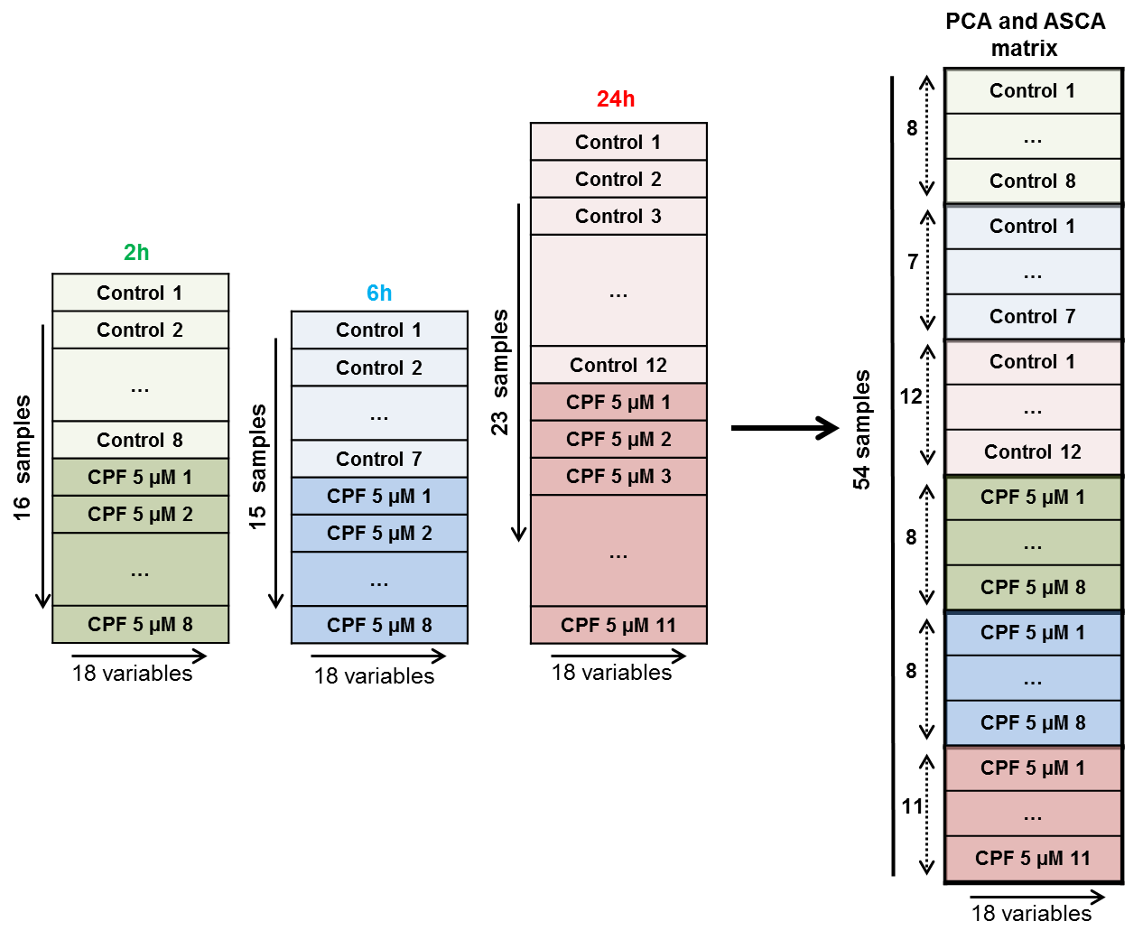

Figure 2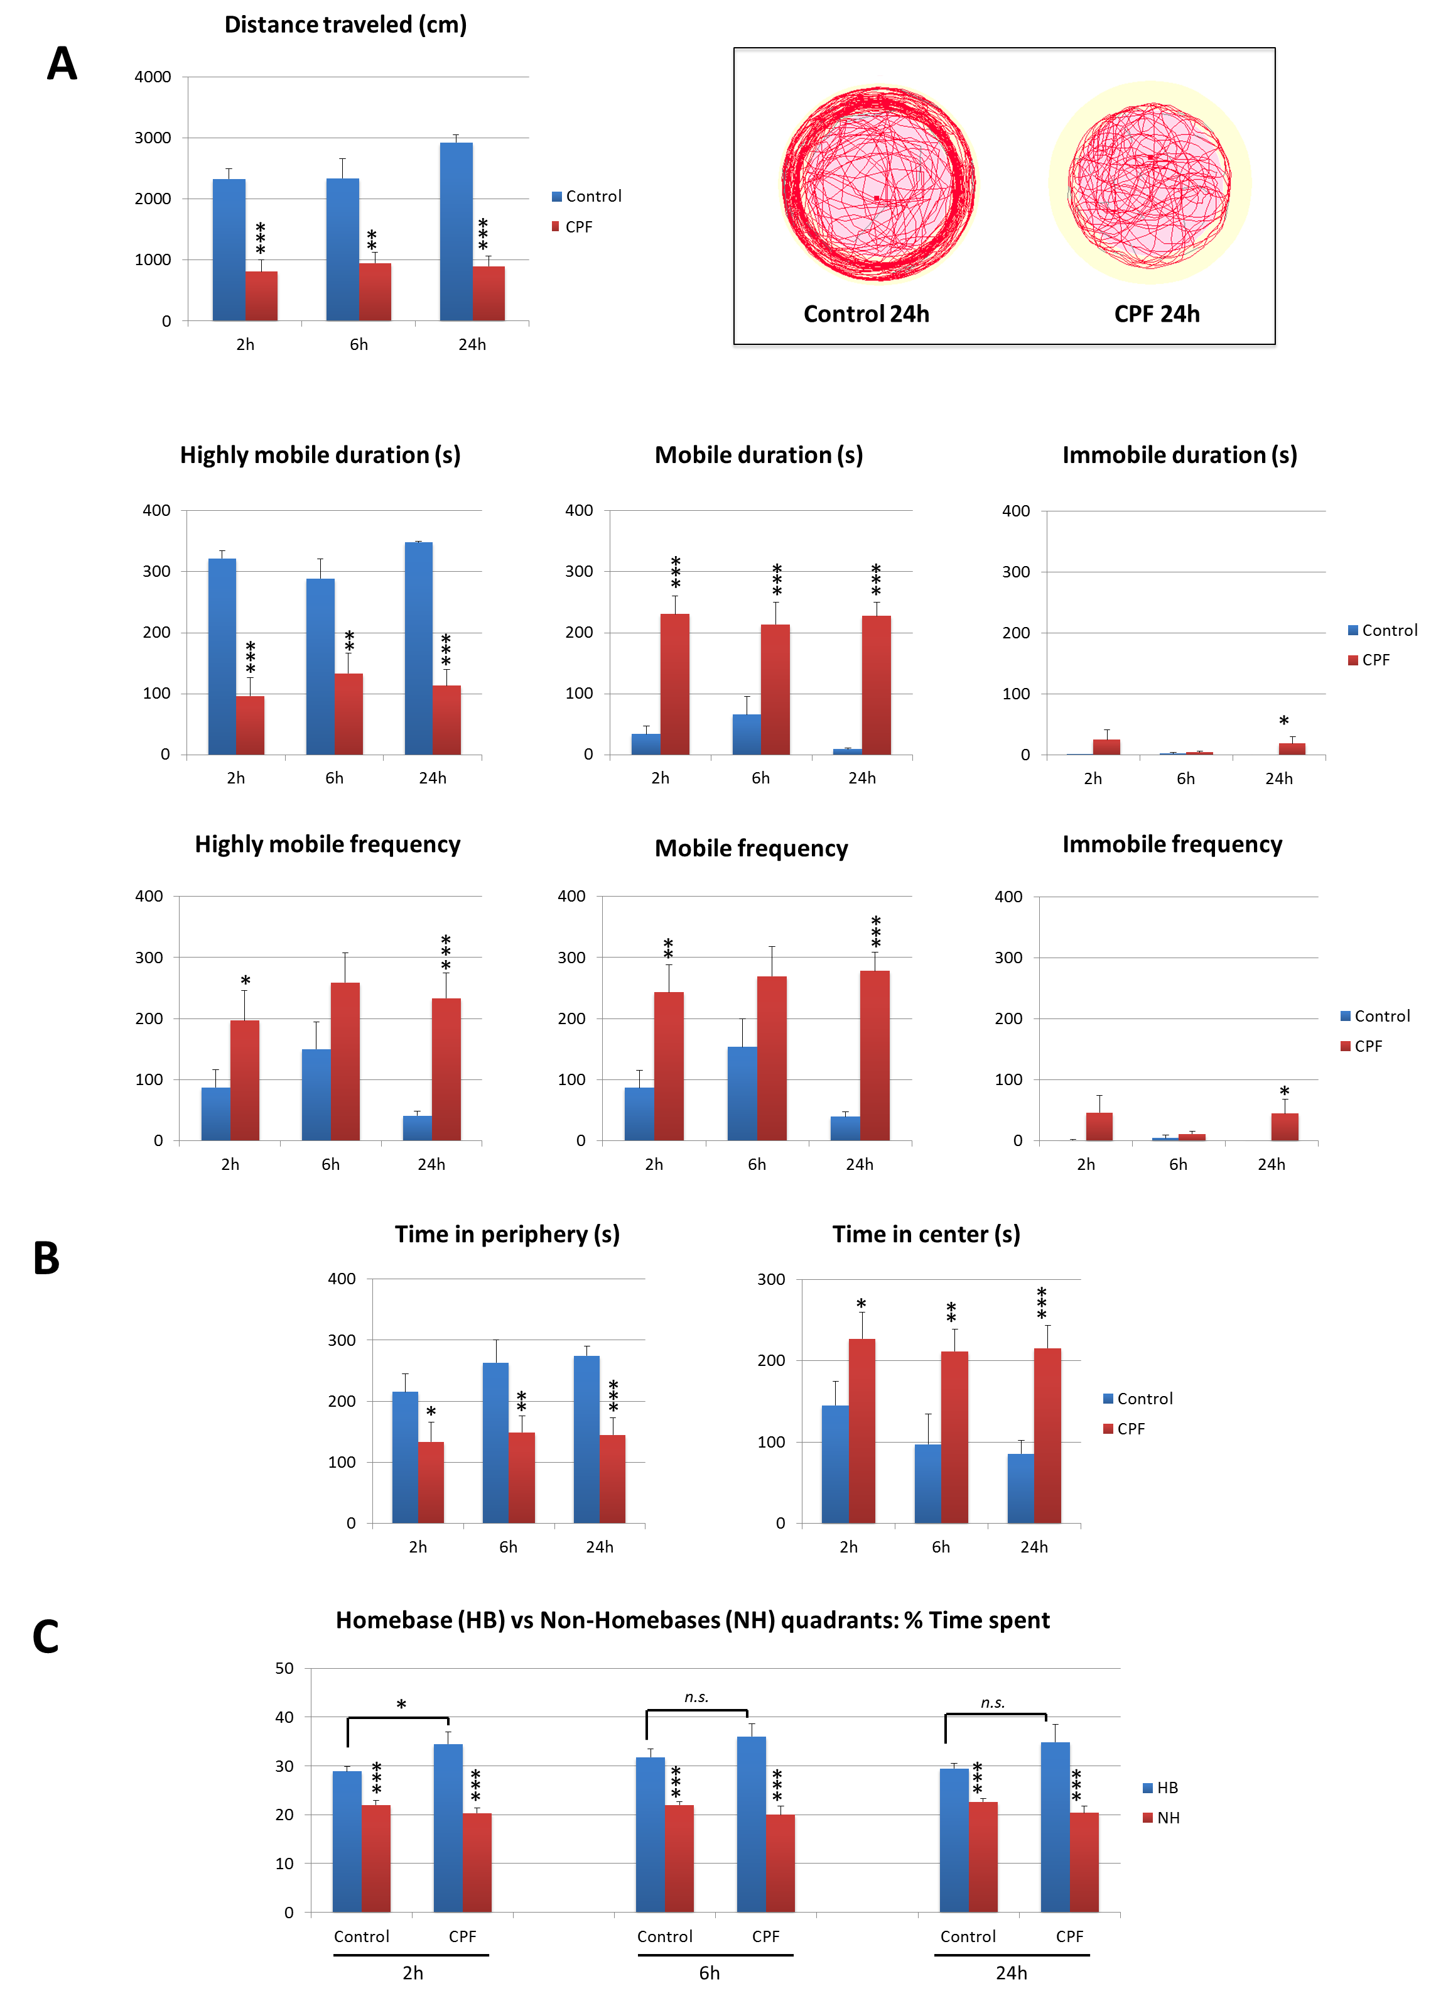

Figure 3
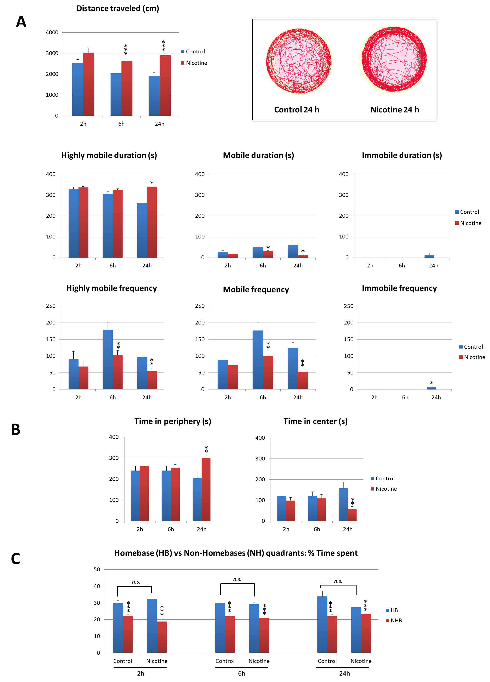

Figure 4
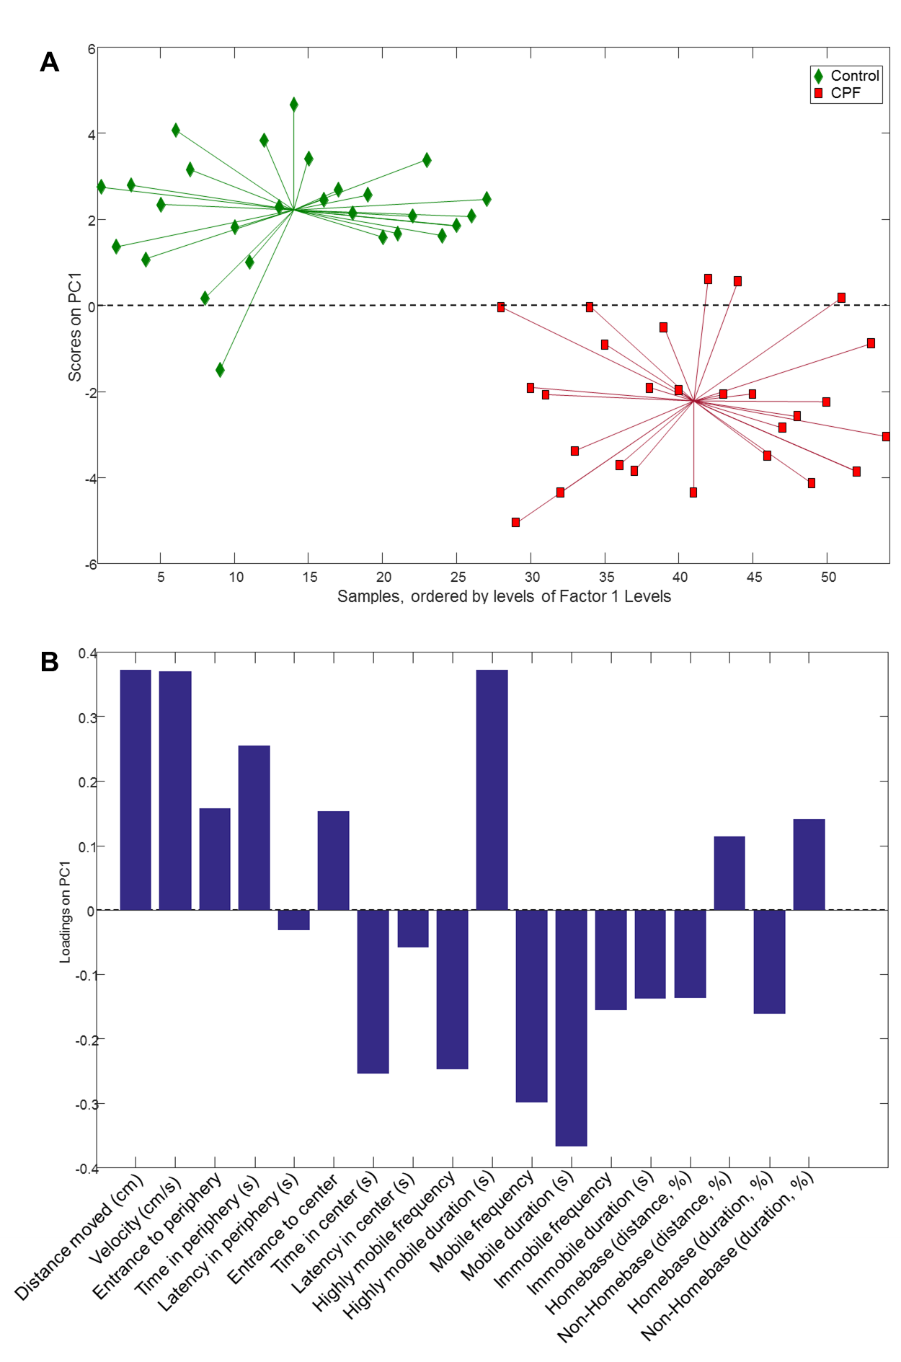

Figure 5
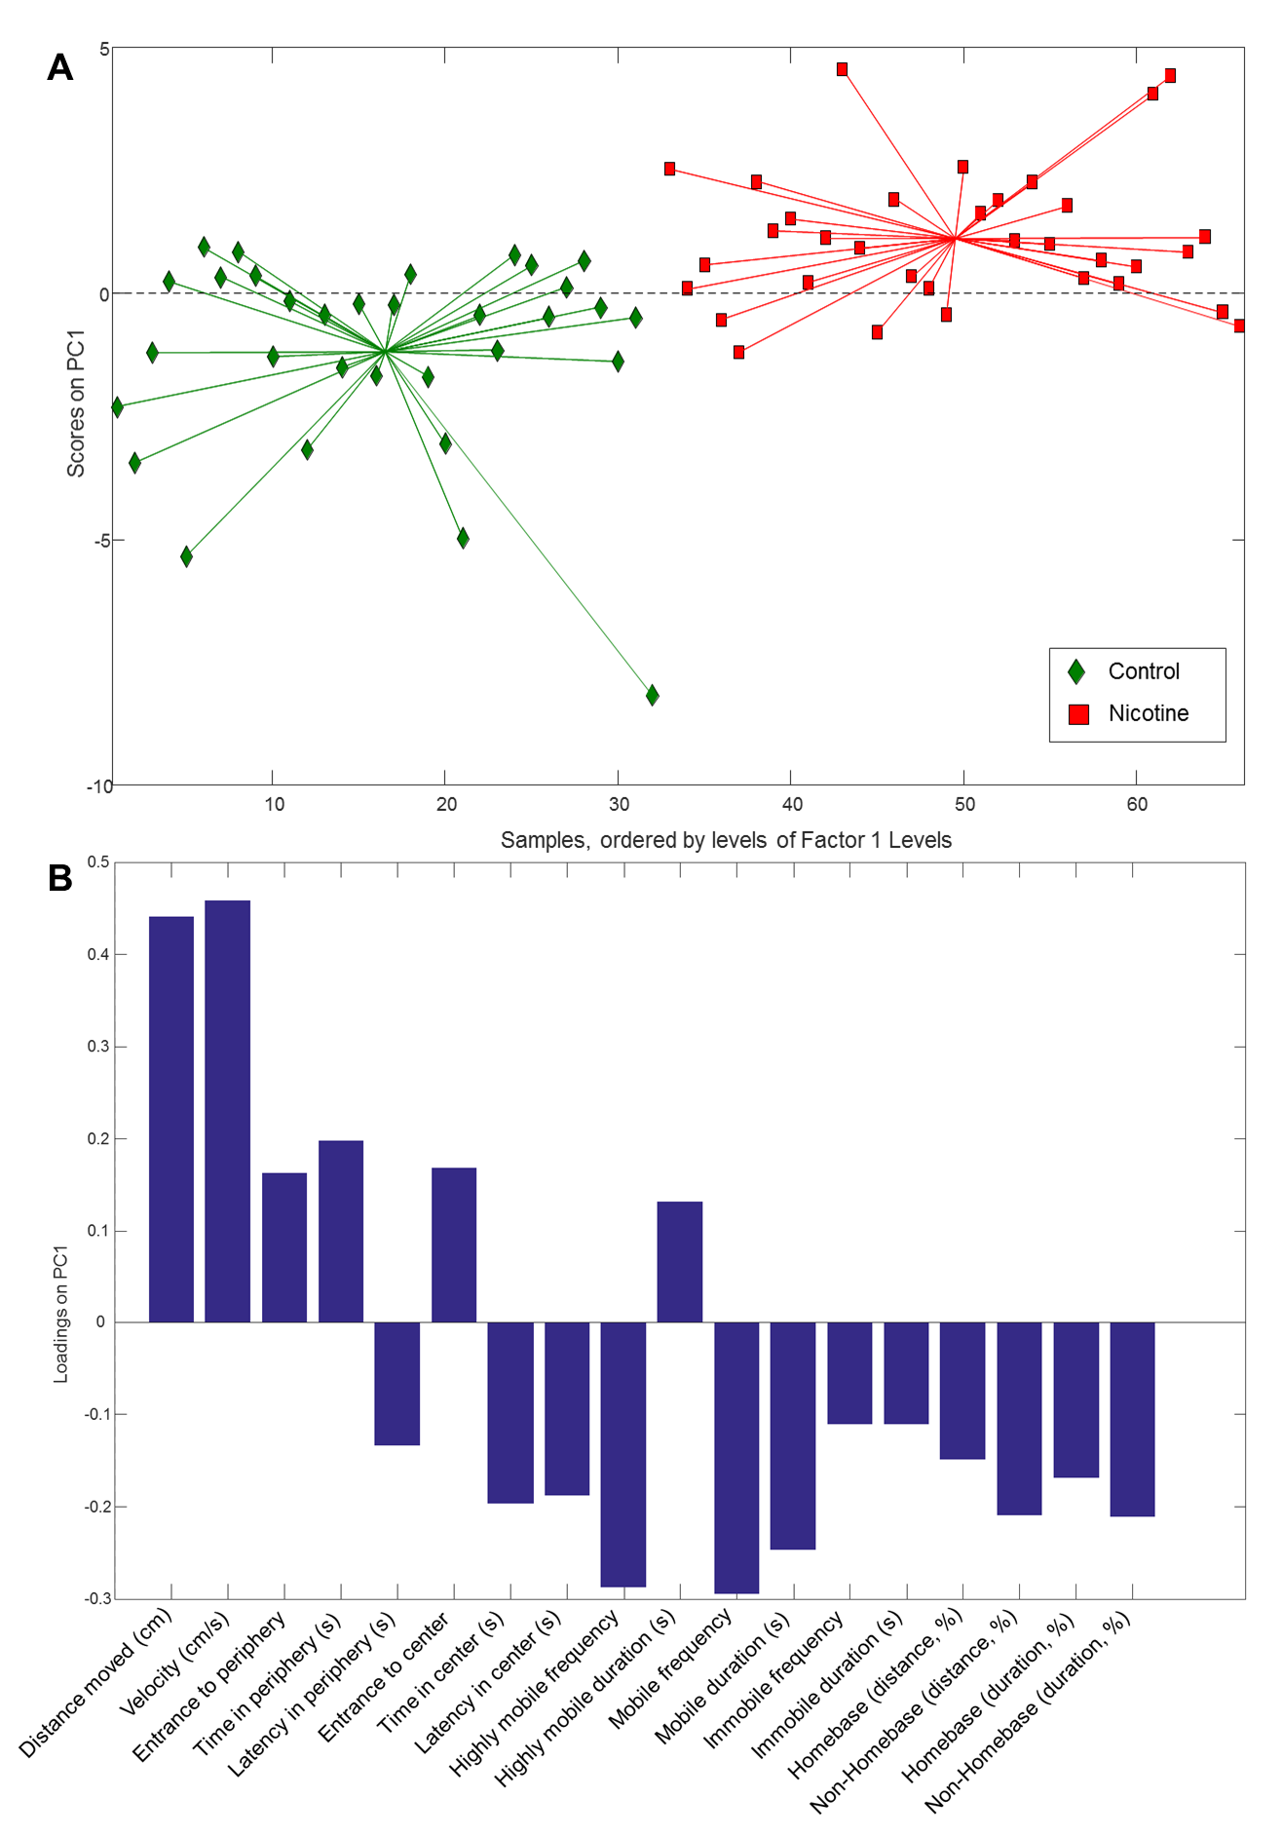

References
Babin, P. J., Goizet, C., Raldua, D., 2014. Zebrafish models of human motor neuron diseases: advantages and limitations. Progress in neurobiology. 118, 36-58.
Brittijn, S. A., Duivesteijn, S. J., Belmamoune, M., Bertens, L. F. M., Bitter, W., De Bruijn, J. D., Champagne, D. L., Cuppen, E., Flik, G., Vandenbroucke-Grauls, C. M., Janssen, R. A. J., De Jong, I. M. L., De Kloet, E. R., Kros, A., Meijer, A. H., Metz, J. R., Van Der Sar, A. M., Schaaf, M. J. M., Schulte-Merker, S., Spaink, H. P., Tak, P. P., Verbeek, F. J., Vervoordeldonk, M. J., Vonk, F. J., Witte, F., Yuan, H., Richardson, M. K., 2009. Zebrafish development and regeneration: New tools for biomedical research. International Journal of Developmental Biology. 53, 835-850.
Cachat, J., Kyzar, E. J., Collins, C., Gaikwad, S., Green, J., Roth, A., El-Ounsi, M., Davis, A., Pham, M., Landsman, S., 2013. Unique and potent effects of acute ibogaine on zebrafish: the developing utility of novel aquatic models for hallucinogenic drug research. Behavioural brain research. 236, 258-269.
Cachat, J. M., Stewart, A., Utterback, E., Kyzar, E., Hart, P. C., Carlos, D., Gaikwad, S., Hook, M., Rhymes, K., Kalueff, A. V., 2011. Deconstructing adult zebrafish behavior with swim trace visualizations. Zebrafish neurobehavioral protocols. 191-201.
De Duffard, A. E., Duffard, R., 1996. Behavioral toxicology, risk assessment, and chlorinated hydrocarbons. Environmental health perspectives. 104, 353.
Elliott, B. M., Faraday, M. M., Phillips, J. M., Grunberg, N. E., 2004. Effects of nicotine on elevated plus maze and locomotor activity in male and female adolescent and adult rats. Pharmacology Biochemistry and Behavior. 77, 21-28.
Esbensen, K. H., Geladi, P., Principal Component Analysis: Concept, Geometrical Interpretation, Mathematical Background, Algorithms, History, Practice. Comprehensive Chemometrics. Elsevier, 2010, pp. 211-226.
Faria, M., Garcia-Reyero, N., Padrós, F., Babin, P. J., Sebastián, D., Cachot, J., Prats, E., Arick II, M., Rial, E., Knoll-Gellida, A., 2015. Zebrafish Models for Human Acute Organophosphorus Poisoning. Scientific reports. 5.
Farrés, M., Piña, B., Tauler, R., 2015. Chemometric evaluation of Saccharomyces cerevisiae metabolic profiles using LC–MS. Metabolomics. 11, 210-224.
Grossman, L., Utterback, E., Stewart, A., Gaikwad, S., Chung, K. M., Suciu, C., Wong, K., Elegante, M., Elkhayat, S., Tan, J., 2010. Characterization of behavioral and endocrine effects of LSD on zebrafish. Behavioural brain research. 214, 277-284.
Jackson, J. E., Frontmatter. A User's Guide to Principal Components. John Wiley & Sons, Inc., 2004, pp. i-3.
Jansen, J. J., Hoefsloot, H. C., van der Greef, J., Timmerman, M. E., Westerhuis, J. A., Smilde, A. K., 2005. ASCA: analysis of multivariate data obtained from an experimental design. Journal of Chemometrics. 19, 469-481.
Jones, D. C., Miller, G. W., 2008. The effects of environmental neurotoxicants on the dopaminergic system: a possible role in drug addiction. Biochemical pharmacology. 76, 569-581.
Kasuya, E., 2001. Mann-Whitney U test when variances are unequal. Animal Behaviour. 61, 1247-1249.
Kenny, P. J., Cheeta, S., E. File, S., 2000. Anxiogenic effects of nicotine in the dorsal hippocampus are mediated by 5-HT(1A) and not by muscarinic M1 receptors. Neuropharmacology. 39, 300-307.
Levin, E. D., Bencan, Z., Cerutti, D. T., 2007. Anxiolytic effects of nicotine in zebrafish. Physiology and Behavior. 90, 54-58.
Levin, E. D., Chen, E., 2004. Nicotinic involvement in memory function in zebrafish. Neurotoxicology and teratology. 26, 731-735.
Lieschke, G. J., Currie, P. D., 2007. Animal models of human disease: Zebrafish swim into view. Nature Reviews Genetics. 8, 353-367.
Lopez-Crespo, G., Carvajal, F., Flores, P., Sánchez-Santed, F., Sánchez-Amate, M., 2007. Time course of biochemical and behavioural effects of a single high dose of chlorpyrifos. Neurotoxicology. 28, 541-547.
Mora-Zamorano, F. X., Svoboda, K. R., Carvan III, M. J., 2016. The Nicotine-Evoked Locomotor Response: A Behavioral Paradigm for Toxicity Screening in Zebrafish (Danio rerio) Embryos and Eleutheroembryos Exposed to Methylmercury. PloS one. 11, e0154570.
Oliveri, A., Bailey, J., Levin, E., 2015. Developmental exposure to organophosphate flame retardants causes behavioral effects in larval and adult zebrafish. Neurotoxicology and teratology. 52, 220-227.
Picciotto, M. R., Brunzell, D. H., Caldarone, B. J., 2002. Effect of nicotine and nicotinic receptors on anxiety and depression. NeuroReport. 13, 1097-1106.
Raldúa, D., Babin, P. J., 2009. Simple, rapid zebrafish larva bioassay for assessing the potential of chemical pollutants and drugs to disrupt thyroid gland function. Environmental science & technology. 43, 6844-6850.
Raldúa, D., Piña, B., 2014. In vivo zebrafish assays for analyzing drug toxicity. Expert opinion on drug metabolism & toxicology. 10, 685-697.
Richendrfer, H., Pelkowski, S. D., Colwill, R. M., Créton, R., 2012. Developmental sub-chronic exposure to chlorpyrifos reduces anxiety-related behavior in zebrafish larvae. Neurotoxicology and teratology. 34, 458-465.
Saccenti, E., Hoefsloot, H. C. J., Smilde, A. K., Westerhuis, J. A., Hendriks, M. M. W. B., 2014. Reflections on univariate and multivariate analysis of metabolomics data. Metabolomics. 10, 361-374.
Sackerman, J., Donegan, J. J., Cunningham, C. S., Nguyen, N. N., Lawless, K., Long, A., Benno, R. H., Gould, G. G., 2010. Zebrafish Behavior in Novel Environments: Effects of Acute Exposure to Anxiolytic Compounds and Choice of Danio rerio Line. International journal of comparative psychology / ISCP ; sponsored by the International Society for Comparative Psychology and the University of Calabria. 23, 43-61.
Smilde, A. K., Jansen, J. J., Hoefsloot, H. C., Lamers, R.-J. A., Van Der Greef, J., Timmerman, M. E., 2005. ANOVA-simultaneous component analysis (ASCA): a new tool for analyzing designed metabolomics data. Bioinformatics. 21, 3043-3048.
Stewart, A., Cachat, J., Wong, K., Gaikwad, S., Gilder, T., DiLeo, J., Chang, K., Utterback, E., Kalueff, A. V., 2010. Homebase behavior of zebrafish in novelty-based paradigms. Behavioural processes. 85, 198-203.
Stewart, A. M., Grieco, F., Tegelenbosch, R. A., Kyzar, E. J., Nguyen, M., Kaluyeva, A., Song, C., Noldus, L. P., Kalueff, A. V., 2015. A novel 3D method of locomotor analysis in adult zebrafish: Implications for automated detection of CNS drug-evoked phenotypes. Journal of neuroscience methods. 255, 66-74.
Tilton, F. A., Bammler, T. K., Gallagher, E. P., 2011. Swimming impairment and acetylcholinesterase inhibition in zebrafish exposed to copper or chlorpyrifos separately, or as mixtures. Comparative Biochemistry and Physiology Part C: Toxicology & Pharmacology. 153, 9-16.
Trigo, J. M., Zimmer, A., Maldonado, R., 2009. Nicotine anxiogenic and rewarding effects are decreased in mice lacking β-endorphin. Neuropharmacology. 56, 1147-1153.
Tukey, J. W., 1977. Some thoughts on clinical trials, especially problems of multiplicity. Science. 198, 679-684.
Vis, D. J., Westerhuis, J. A., Smilde, A. K., van der Greef, J., 2007. Statistical validation of megavariate effects in ASCA. BMC Bioinformatics. 8.
Wold, S., Esbensen, K., Geladi, P., 1987. Principal component analysis. Chemometrics and Intelligent Laboratory Systems. 2, 37-52.

