OPEN ACCESS DOCUMENT

Information of the Journal in which the present paper is published:

- Environ. Pollut. 231(2017) 22-36.
- DOI: 10.1016/j.envpol.2017.07.095.

Metabolic disruption of zebrafish (Danio rerio) embryos by bisphenol A. An integrated metabolomic and transcriptomic approach

Elena Ortiz-Villanueva¹, Laia Navarro-Martín ¹, Joaquim Jaumot¹, Fernando Benavente², Victoria Sanz-Nebot², Benjamín Piña¹, Romà Tauler^{1,*}

¹Department of Environmental Chemistry, IDAEA-CSIC, Jordi Girona 18-26, 08034 Barcelona, Spain.
²Department of Chemical Engineering and Analytical Chemistry, University of Barcelona, Diagonal 645, 08028 Barcelona, Spain.

Corresponding author: Prof. Dr. Romà Tauler

Postal address: Department of Environmental Chemistry, IDAEA-CSIC, Jordi Girona 18-26, 08034 Barcelona, Spain.
E-mail: roma.tauler@idaea.csic.es

Abstract
Although bisphenol A (BPA) is commonly recognized as an endocrine disruptor, the metabolic consequences of its exposure are still poorly understood. In this study, we present a non-targeted LC-MS based metabolomic analysis in combination with a full-genome, high-throughput RNA sequencing (RNA-Seq) to reveal the metabolic effects and the subjacent regulatory pathways of exposing zebrafish embryos to BPA during the first 120 hours post-fertilization. We applied multivariate data analysis methods to extract biochemical information from the LC-MS and RNA-Seq complex datasets and to perform testable predictions of the phenotypic adverse effects. Metabolomic and transcriptomic data revealed a similar subset of altered pathways, despite the large difference in the number of identified biomarkers (around 50 metabolites and more than 1000 genes). These results suggest that even a moderate coverage of zebrafish metabolome may be representative of the global metabolic changes. These multi-omic responses indicate a specific metabolic disruption by BPA affecting different signaling pathways, such as retinoid and prostaglandin metabolism. The combination of transcriptomic and metabolomic data allowed a dynamic interpretation of the results that could not be drawn from either single dataset. These results illustrate the utility of -omic integrative analyses for characterizing the physiological effects of toxicants beyond the mere indication of the affected pathways.

Capsule Abstract
Pathway-level integration of metabolomic and transcriptomic results after exposing zebrafish embryos to BPA confirmed the presence of metabolic disruption.

Keywords
Bisphenol A, Metabolic disruption, Non-targeted metabolomics, Transcriptomics, Zebrafish.

- Introduction
Bisphenol A (BPA) is a common industrial chemical amply used in the manufacture of polycarbonate plastics and epoxy resins [1]. Due to their unbeatable resistance and temperature tolerance, BPA-derived plastics are usually employed in the production of a broad range of goods, including containers, electronic products, and medical devices [2]. BPA leaks from the original plastics over time by the hydrolysis of the ester bonds linking it to plastic monomers. As a consequence, large amounts of BPA are continuously released into the environment, especially to surface and groundwater, ending up in wastewater treatment plants and being finally deposited in sediments [3,4]. According to the United States Environmental Protection Agency (EPA), the annual release of BPA into the environment exceeded 500 tons in 2012. The highest BPA levels (mg·L⁻¹) are usually found in landfill leachate and mill effluents, while usual concentrations in surface waters are at the µg·L⁻¹ levels [5,3,6]. Nevertheless, BPA is considered an important threat to the human health, wildlife and environment, owing to its estrogenic activity at environmentally relevant concentrations [7]. In addition to its assumed endocrine and reproductive toxicity [8-10], several authors have already described that BPA exposure disrupts hormone balances [11,12], alters gonadal functions [13-16], and affects hepatic vitellogenin production in fish and other organisms [17,18]. However, the mode of action of some of these effects is not entirely understood. The European Food Safety Authority fixed a temporary tolerable daily intake (t-(TDI)) of 4 µg kg⁻¹ body weight (BW) for humans, which could be reached in some cases even from exclusively environmental, non-dietary exposures [19,20].
Diverse organisms and biological systems have been used to evaluate the toxicological effects of BPA exposure, including rats [21-24], mice [25] and mammal cells [26]. However, aquatic model organisms confer the most valuable option for toxicological tests in environmental and biomedical research, especially crustaceans (Daphnia magna) [27,28] and zebrafish (Danio rerio) [29,30]. Zebrafish has been recognized as a privileged vertebrate model due to its relative genetic proximity to humans and the extensive characterization of its genome and transcriptome. Zebrafish embryos up to 120 hours post-fertilization (hpf) are considered as replacement method in toxicology according to the stringent European legislation on the protection of animals used for scientific purposes [31]. Other advantages, such as its small size, wide distribution, and easy growth conditions offer the possibility to perform small-scale and high-throughput analyses for -omic studies, including metabolic profiling [32,7]. Zebrafish has been deeply studied at least at four -omic levels: genomics, transcriptomics, proteomics and metabolomics [33]. In addition, several environmental studies have assessed BPA toxic effects in zebrafish [13,34-37].
At present, there is an increasing trend to use integration approaches in an attempt to obtain complementary information for better interpretation. For instance, information coming from the analysis of same samples at different -omic levels could be integrated [38-41], such as transcriptomics (mRNA) and metabolomics (metabolites) data. Alternatively, integration of the information from the analysis of same samples at the same -omic level using different analytical platforms is also common [42], such as the joint analysis of one-dimensional ¹H nuclear magnetic resonance (NMR) spectroscopy and liquid chromatography-mass spectrometry (LC-MS) data. In the environmental field, several studies dealing with the combination of multi-omic levels to evaluate the effects of toxicants by using quantitative real-time polymerase chain reaction (qPCR) or DNA microarrays (genomic or transcriptomics information) and NMR or targeted LC-MS (metabolomics information) have been reported [43,40,41,44]. To the best of our knowledge, only few studies focus on the pure integration of transcriptomics (qPCR) and metabolomics (targeted LC-MS) data [39]. Recently, the combination of information from other platforms has also been proposed [45,46]. These integration efforts aim to improve the abilities to identify and to connect the different molecular pathways affected by a particular stimulus or stressing condition [47,39].
The main aim of this paper is to study the effects of sub-lethal BPA exposures of early zebrafish embryos up to 120 hpf, particularly in metabolic pathways, by using a combination of metabolomic and transcriptomic data. On the one hand, a non-targeted metabolomic approach based on LC-MS was chosen for a more comprehensive evaluation of metabolic alterations at the metabolome level. This method is appropriated due to its great sensitivity and selectivity. On the other hand, mRNA abundances were investigated using high-performance RNA sequencing (RNA-Seq). Results from both assays were further analyzed using multivariate chemometric models and standard data analysis tools to assess the metabolomic and transcriptomic effects of BPA separately. Finally, integration of the results from both -omic levels was used both to characterize relevant molecular biomarkers with high reliability and to identify the subjacent regulatory pathways underlying the observed BPA toxicity-induced changes in zebrafish embryos.
2. Materials and methods
2.1. Chemicals and reagents
All chemicals used in the preparation of buffers and solutions were analytical reagent grade. Acetic acid (glacial), methanol (HPLC grade) and acetonitrile (HPLC and MS grade) were purchased from Merck (Darmstadt, Germany). Chloroform was supplied by Carlo Erba (Peypin, France). Ammonium acetate (MS grade), dimethyl sulfoxide (DMSO), water (HPLC and MS grade), calcium sulfate dihydrate (CaSO₄·2H₂O) and bisphenol A (BPA) were provided by Sigma-Aldrich (St. Louis, MO, USA). L-methionine sulfone and Piperazine-1,4-bis(2-ethanesulfonic acid) (PIPES), used as internal standards (IS), were also supplied by Sigma-Aldrich (St. Louis, MO, USA).
2.2. Animals and rearing conditions

Adult wild-type zebrafish were maintained under standard conditions in fish water, composed of reverse-osmosis purified water containing 90 μg·mL⁻¹ of Instant Ocean (Aquarium Systems, Sarrebourg, France) and 0.58 mM CaSO₄·2H₂O at a temperature of 28 (± 1°C). Adults were fed twice a day with dry flakes (TetraMin, Tetra, Germany). Zebrafish embryos were obtained by natural mating by placing 6 males and 3 females on 4-L mesh-bottom breeding tanks. At 2 hpf, eggs were collected and rinsed. Fertilized viable eggs were randomly distributed in 6-well multiplates (10 embryos/well). Embryos were raised at 28.5 °C with a 12 Light:12 Dark photoperiods in fish water (3mL/well). All procedures were conducted in accordance with the institutional guidelines under a license from the local government (DAMM 7669, 7964) and were approved by the Institutional Animal Care and Use Committees at the Research and Development Centre of the Spanish Research Council, CID-CSIC.

2.3. Zebrafish embryo BPA treatments and sample collection
BPA stock solutions were prepared in DMSO (carrier) on the day of the experiment. Dosing solutions with the same final concentration of DMSO (0.2% v/v) were obtained by dissolving the stocks with fish water. Zebrafish embryos were exposed to contaminated water samples at 2 hpf. A preliminary range-finding test was performed to select BPA concentrations. The highest selected BPA concentration (17.5 μM) corresponds to the lowest observed effect concentration (LOEC) of gross morphological effects calculated experimentally. The concentrations used in the present study were chosen to be below the LOEC, hardly even any phenotypic effect at the morphological level was observed at either life stage. This selection was done to avoid detecting molecular events directly related to alterations in development, malformations or larvae viability is coincident with previous data [48,49].
Zebrafish embryos were exposed to fish water (1.125 g·L⁻¹ Instant Ocean® + 250 μg·L⁻¹ CaSO₄) containing DMSO (0.2% v/v) as the control group, 4.4, 8.8 and 17.5 μM of BPA (using DMSO as a carrier). Anatomical development of embryos was followed daily during the exposure as described by Kimmel et al. [50] under a stereomicroscope Nikon SMZ1500 equipped with a Nikon digital sight DS-Ri1 digital camera. Mortality/survival (24, 48, 72, 96 and 120 hpf), hatching (72, 96 and 120 hpf) and inflated swim bladder (96 and 120 hpf) rates were recorded for each concentration (see Supplementary Material Figure S1). Mortality during the exposure protocol was negligible and sublethal endpoints such as coagulated embryos, lack of somite formation, non-detachment of the tail, lack of heartbeat were not observed. Non-hatched eggs were insignificant for either control and exposed groups. However, embryos exposed to 17.5 μM of BPA presented lower rates of inflated swim bladder at 120 hpf (56%) and slightly darker pigmentation. Continuous exposure to BPA was assured by preparing and renewing water solutions every day until embryo collection at 120 hpf. Chemical analysis of media water solutions was not performed in accordance to the high stability of BPA in water previously reported by Jordão et al. [27], where the measured concentration of BPA in old test solutions (after 48 h) resulted only 5% lower than freshly prepared ones.
Pools of 20 and 8 zebrafish embryos were gathered for each biological replicate to ensure sufficient amount of metabolites and RNA, respectively. A total number of six biological replicates per treatment were used for LC-MS analyses and three for RNA-Seq analyses. A rinsing step was included for the samples collected for metabolite extraction, which consisted in washing the embryos twice with 0.5 mL HPLC grade water. In both cases, embryo pools were snap-frozen in dry ice and stored at -80˚C until further analysis.
2.4. Sample preparation and analysis
2.4.1. Metabolite extraction and LC-MS analysis
Each pool of 20 zebrafish embryos was thawed in a water bath at room temperature. Metabolites were first extracted with 900 µL of methanol containing the internal standard (IS1) (L-methionine sulfone) at a final concentration of 5 µg·mL⁻¹. After vortexing 15 s, the mixture was sonicated for 15 min and vortexed again 15 s. Samples were then centrifuged at 23500g for 10 min at 4˚C to isolate the supernatant and subsequently 500 µL of water and 300 µL of chloroform were added. Samples were vortexed 15 s, placed on ice for 10 min and centrifuged again at 23500g for 10 min at 4˚C. Finally, the aqueous fractions were evaporated to dryness under nitrogen gas and reconstituted with 100 µL of 1:1 v/v acetonitrile:water containing PIPES (IS2) at a concentration of 5 µg·mL⁻¹. Prior to injection, zebrafish embryo extracts were filtered through 0.22 µm filters (Ultrafree®-MC, Millipore Bedford, MA, USA) at 11000g for 4 min and stored at -80˚C until their analysis. All centrifugations were performed at 4ºC in a Serie Digicen 21 centrifuge (Ortoalresa, Madrid, Spain).
LC-MS analyses were carried out using an Agilent Infinity 1200 series LC system coupled with an orthogonal G1385-44300 interface (Agilent Technologies, Waldbronn, Germany) to a 6220 oa-TOF LC/MS mass spectrometer (Agilent Technologies). LC control and separation data acquisition were performed using ChemStation software (Agilent Technologies) that was running in combination with the MassHunter workstation software (Agilent Technologies) for control and data acquisition of the TOF mass spectrometer. For the chromatographic separations, an HILIC TSK Gel Amide-80 column (250 mm length, 2.1 mm inner diameter and 5 µm particle size, Tosoh Bioscience, Tokyo, Japan) was used at 25ºC with gradient elution at a flow rate of 0.15 mL·min⁻¹. Elution gradient was performed using solvent A (acetonitrile) and solvent B (5 mM of ammonium acetate adjusted to pH 5.5 with acetic acid) as follows: 0-8 min, linear gradient from 25 to 30% B; 8-12 min, from 30 to 60% B; 12-17 min, 60% B; 17-20 min, back linearly from 60% to 25% B; and from 20 to 27 min, 25 % B. Solvents were degassed for 15 min by sonication before use. Sample injection was performed with an autosampler at 4˚C, and the injection volume was 5 μL. All samples (six replicates per treatment: control, 4.4 μM BPA, 8.8 μM BPA and 17.5 μM BPA) were randomly injected. Several blank samples and calibration standards were also randomly injected to further assess the stability of the instrument among runs.
The TOF mass spectrometer operated both in positive and negative mode using the following parameters: capillary voltage 4000 V, drying gas temperature 350˚C, drying gas flow rate 8 L·min⁻¹, nebulizer gas 32 psi, fragmentor voltage 150 V, skimmer voltage 65 V and OCT 1 RF Vpp voltage 300 V. Data were collected in profile mode at 1 spectrum/s (approximately 10000 transients/spectrum) with an m/z range of 85-1000 working in the extended dynamic range mode (2 GHz) with the mass range set to standard.
2.4.2. RNA extraction, library construction and sequencing
Total RNA was isolated from three pools of 8 zebrafish embryos using AllPrep DNA/RNA Mini Kit (Qiagen, CA, USA) as described by the manufacturer. Extracted RNA was reconstituted in RNase-free water. Then, total RNA was assayed for quantity and quality using Qubit® RNA BR Assay kit (Thermo Fisher Scientific) and RNA 6000 Nano Assay on a Bioanalyzer 2100 (Agilent Technologies). Given the monotonic response of the metabolome to BPA, we opted to focus the transcriptomic analysis comparing control and high dose (17.5 μM BPA) groups. High-quality RNA biological replicates were sent for sequencing to the National Center for Genomic Analysis (CNAG, Barcelona, Spain). In all cases, RNA concentrations ranged between 50-200 ng·µL ⁻¹, free of DNA and with RNA integrity (RIN) number >8.
The RNA-Seq libraries were prepared from total RNA using KAPA Stranded mRNA-Seq Kit Illumina® Platforms (Kapa Biosystems) with minor modifications. Briefly, after poly-A based mRNA enrichment with oligo-dT magnetic beads and 500 ng of total RNA as the input material, the mRNA was fragmented (resulting RNA fragment size was 80-250nt, with the major peak at 130nt). The second strand cDNA synthesis was performed in the presence of dUTP instead of dTTP, to achieve the strand specificity. The blunt-ended double-stranded cDNA was 3´adenylated and Illumina indexed adapters (Illumina) were ligated. The ligation product was enriched with 15 PCR cycles and the final library was validated on an Agilent 2100 Bioanalyzer with the DNA 7500 assay.
Each library was sequenced using TruSeq SBS Kit v3-HS, in the paired-end mode with a read length of 2x76bp. We generated on average 40 million paired-end reads for each sample in a fraction of a sequencing lane on HiSeq2000 (Illumina) following the manufacturer’s protocol. Images analysis, base calling and quality scoring of the run were processed using the manufacturer’s software Real Time Analysis (RTA 1.13.48) and followed by generation of FASTQ sequence files by CASAVA.
2.5. Data analysis
2.5.1. LC-MS metabolomics data analysis
LC-MS data were analyzed by a combination of multivariate analysis tools to evaluate the most significant metabolic changes caused by BPA treatment. The data analysis workflow used in this study was carried out as described in previous studies [51,52] with some modifications.
Total ion chromatograms (TIC) of the 24 samples were analyzed using data exploration chemometric tools implemented in the PLS Toolbox version 7.3.1 (Eigenvector Research Inc., Wenatchee, WA, USA). First, the intensity scale of every TIC was normalized by the area of PIPES (IS2). Chromatographic peaks were aligned in the time domain to correct the small variations in retention times of metabolites among different chromatographic runs using the correlation optimized warping (COW) method [53]. Chromatograms were also baseline corrected by automatic weighted least squares and mean-centered. Finally, unsupervised principal component analysis (PCA) was applied to differentiate between embryo samples according to BPA exposure and to detect possible outlier samples.
Non-targeted analysis of LC-MS raw data was performed using the multivariate curve resolution alternating least squares (MCR-ALS) method [54] following the same procedure as described in previous studies [55,52] (see details in Supplementary material). The application of this approach allowed the resolution of the chromatographic elution profiles of the metabolites present in every zebrafish embryo sample as well as of their corresponding mass spectra [55,52]. Prior to MCR-ALS analysis, blank samples were employed to estimate the noise threshold used as a low filter in the MinMax algorithm [52], used for peak normalization (see Supplementary material, MCR-ALS section). The threshold was set at 1e2 for negative ionization and 2e3 for positive ionization. The intensity scale of every chromatogram was also normalized dividing by the area of PIPES (IS2).
After applying MCR-ALS, the significance of the concentration changes upon BPA treatment of resolved elution profiles (detected metabolites) in the different zebrafish embryo samples was assessed using statistical tests. With this aim, the chromatographic peak areas of the resolved metabolites by MCR-ALS were calculated. The obtained peak area values from MassHunter software were normalized by the peak area of the IS2 (PIPES), for each sample. Then, changes in the normalized peak areas of control and exposed samples for each metabolite were individually evaluated applying one-way ANOVA, considering exposure level as a factor, and correcting p-values according to the Benjamini-Hochberg multiple comparison testing procedure [56]. Metabolites with an adjusted p-value lower than 0.05 were selected as possible markers of the investigated BPA exposure effects and considered for further analysis. These multiple comparison tests were performed using MATLAB Statistics and Machine Learning Toolbox™ and Benjamini-Hochberg FDR function described in [57]. Changes in metabolite areas among different groups of samples were also examined by hierarchical cluster analysis (HCA) [58] combined with the heatmap display of the auto-scaled metabolite concentrations in order to show groups (clusters) of metabolites with similar behavior after BPA exposure.
Only the metabolites that showed a statistically significant difference between means of groups were selected as potential markers of BPA exposure and were tentatively identified. This identification was based on the comparison of the accurate molecular mass measured by LC-MS with the corresponding values found in online database resources, such as METLIN Metabolite Database [59], Human Metabolome Database [60] and MetaCyc database [61].
2.5.2. RNA sequencing data analysis
RNA-Seq reads were aligned to the D. rerio reference genome (GRCz10) using STAR version 2.5.1b [62]. Genes annotated in GRCz10.84 were quantified using RSEM version 1.2.28 [63] with default parameters. Differential expression analysis between control and 17.5 μM BPA treatment was performed with the DESeq2 (v.1.10.1) R package with the default Walt test option that uses a variant of scaling factor normalization based on the assumption that most genes are not differentially expressed [64,65]. This normalization is performed dividing each sample by the median of each gene scaling ratio. Variability between replica batches was taken into account in the design matrix. Genes with an adjusted p-value lower than 0.05 (after Walt test with Benjamini-Hochberg multiple comparison testing) were selected for further study.
2.5.3. Functional analysis of integrated metabolomic and transcriptomic data
Pathway-based integration of metabolomic and transcriptomic datasets was performed through metabolic pathways’ knowledge defined by KEGG database. The joint list of identified markers from both metabolomic and transcriptomic data was introduced as input data into the KEGG database (D. rerio pathway dataset) to investigate common metabolic pathways and mechanisms affected by the BPA treatment. The analysis was limited to pathways related to metabolism (modules dre00001-dre01999). Identified pathways with at least two hits were included in the network analysis, using the reshape2 and igraph packages in R [66]. Bipartite graphs were drawn from an incidence table of metabolites (represented as KEGG C-codes) versus genes (represented by their official gene names, ZFIN.org). Any given metabolite was considered linked to a given gene if they share at least one common KEGG pathway. The general pathway dre01100 (Metabolic pathways) was excluded from the analysis as it essentially included all tested biomarkers (see Table S1).
3. Results and discussion
3.1. Metabolomics of BPA exposure
Preliminary exploration of the TIC data of the 24 embryos extracts (six replicates per condition: control, 4.4 µM BPA, 8.8 µM BPA and 17.5 µM BPA) by PCA allowed detecting general patterns and differentiating the samples according to BPA treatment. Examples of LC-MS chromatograms belonging to the embryos extract in negative and positive ESI (ESI- and ESI+) modes are given in Figure 1A and B, respectively. Chromatograms showed a complex profile with several coeluting compounds in the first 18 minutes. In ESI- data, the second component (PC2) separated the embryo samples in relation to the BPA exposure in the PCA scores plot (Figure 1C), showing noticeable BPA-dose effects. In ESI+ data, PCA also highlights differences in samples in accordance with the BPA exposure when considering the first two components, with control, 4.4 μM and 8.8 μM BPA samples partially overlapped (Figure 1D).
Figure 1 near here
Non-targeted analysis of full scan metabolomics LC-MS raw data is challenging due to the large number of multiple coeluted peaks [52]. To solve this problem and obtain more reliable metabolite profiling, the strategy based on the application of the MCR-ALS method was proposed [52]. The simultaneous MCR-ALS analysis of the 24 embryo extracts, allowed a fast systematic and reliable resolution of the chromatographic profiles (elution) and mass spectra of most of the sample metabolites. MCR-ALS resolved profiles explained most of the experimental data variance (R² higher than 96%). In MCR-ALS, the number of components is used to allow modeling possible solvent and background contributions, which are resolved (subtracted) from the metabolite contributions and not evaluated in the next steps of the data analysis workflow. For instance, components giving elution profiles with unreasonable chromatographic peak shapes or noisy mass spectra were not considered in the following steps of the data analysis workflow. Every MCR-ALS resolved component was defined by a dyad of elution and mass spectrum profiles, which could be associated with one single metabolite. Several ion features derived from the same metabolite were grouped in the same single MCR-ALS component. These ion features usually correspond to the different isotopic signals of an ion with a particular nominal m/z value, due to the hydrogen cations/anions and other adducts. More details about MCR-ALS method are described in the Supplementary Material.
Statistical assessment of the metabolite changes based on a comparison of peak areas identified 29 metabolites from ESI- and 30 metabolites from ESI+ ionization modes as significant contributions. These metabolites were tentatively identified based on the comparison of their accurate experimental molecular mass values with the corresponding molecular mass values reported in different online databases (mass error of the possible molecular formulas ≤ 10 ppm). Tables 1 and 2 show the lists of tentatively identified metabolites, which differentiate between control and BPA-exposed samples in ESI- and ESI+ mode, respectively. Metabolite identity, detected ion, measured molecular mass, relative mass error, elution time, adjusted p-value (only when p-value ≤ 0.05), fold-change, folding trend and KEGG C-code are included in the tables. Nine metabolites were detected in both ESI- and ESI+ mode. Fold changes were calculated dividing the mean of the peak areas of the metabolites in each dose-exposed group by the mean of the peak areas of the same metabolites in the control group, and the trend was determined taking as a reference the response of control samples.
Table 1and 2 near here
Hierarchical clustering analysis of the peak areas of these metabolites (biomarkers) grouped the samples that presented similar behavior according to the observed metabolite changes (heatmap in Figure 2). Four groups of samples were outlined, correctly reflecting BPA-dose effects (controls, 4.4 µM BPA, 8.8 µM BPA and 17.5 µM BPA) and revealing slight variations between biological replicates possibly due to natural biological variation. In Figure 2, the relative change in the metabolite concentrations is also depicted with colors in the heatmap. Up-regulation and down-regulation of metabolites are represented in red and blue, respectively. Hierarchical clustering of metabolites revealed two main clusters, one including metabolites whose concentrations increased upon BPA treatment (Cluster A in Figure 2), and the second one including metabolites that become depleted by the treatment. The heatmap also suggests a monotonic response, as samples treated with the lowest BPA concentration (4.4 µM) grouped with the untreated ones (similar patterns), whereas samples corresponding to the two highest concentrations tested clustered together (see the dendrogram on the top of Figure 2).
Figure 2 near here
Functional analysis revealed that most metabolites affected by BPA were related to amino acids or nucleotide/nucleosides metabolic pathways (Figure 2, Tables 1 and 2). Relevant changes in amino acid metabolism as a response to BPA treatment have been already reported in zebrafish embryos [67,39] and Daphnia [28], suggesting that this is a rather general effect. The observed decrease on nucleotide-related metabolites by BPA treatment, particularly hypoxanthine and uric acid, may be interpreted as changes in signaling pathways. For example, an imbalance in uric acid production associated with hypoxanthine concentration changes has been related to oxidative stress in zebrafish embryos [68]. Purine metabolism, which was mainly down-regulated upon BPA treatment, may be linked to the observed increase in glutamate levels (see Figure 2, Table 1 and 2), an effect already observed in the fish metabolome upon BPA exposure [68]. In addition to these two major groups, we observed changes in biochemical pathways related to lipids, sugars and their derivatives, and to steroid metabolism, in agreement with previous transcriptomic [69,10] and metabolomic studies [68]. Particularly, changes in glycerophospholipid metabolism suggest cell membrane damage by BPA [67,68]. Finally, and related to these primary cellular components, we observed changes in secondary metabolism, in pathways related to nicotinamide, linoleic and arachidonic acids, retinol metabolism, and cofactors and vitamins.
3.2. Transcriptomics of BPA exposure
Statistical assessment of changes in the mRNA levels between control and 17.5 μM BPA groups revealed 1381 differentially expressed genes (adjusted p-value <0.05), with 765 up-regulated and 616 down-regulated genes.
Figure 3 near here
Hierarchical clustering of differentially expressed mRNA levels identified two main clusters according to the expression changes upon BPA exposure (A and B, Figure 3). Cluster A comprises the expressed genes that were up-regulated by BPA exposure, whereas cluster B includes down-regulated genes. Genes with the highest differential expression (Top-twenty genes) are listed in Table 3. As it is shown, these top-twenty genes were related to response to different biological processes including estrogen stimulus and xenobiotics, oxidation-reduction process, metabolic process, fin regeneration, tissue development and cell proliferation.
Most of these altered biological processes by BPA were reported in previous literature. For instance, brain aromatase (cyp19a1b) is a well-known marker for estrogen exposure in fish embryos, and its increased expression in BPA-treated samples is consistent with the estrogenic activity of BPA in vertebrates [13]. BPA alters cytochrome P450 enzymes activities, which play a crucial role in oxidative metabolism [67]. BPA disruption on different cellular functions involved in cell proliferation and tissue development were also described [70,30]; we consider that the observed alterations in nucleotide and amino acid synthesis pathways may be at least partially related to these effects. Furthermore, up-regulation of gstp2 mRNA levels (see Table 3) may correlate to an increase in GST activity as a response to an increased oxidative stress and apoptosis [71]. In fact, changes in GST activity has been considered as a sign of contaminated aquatic ecosystems with BPA [72].
Table 3 near here
3.3. Identification of altered pathways with metabolomic and transcriptomic pathway-based integration
Integration of metabolomic and transcriptomic datasets improves understanding of underlying biological processes to gain insight into a system and its mechanism of action. However, this pathway-level integration and corresponding biological interpretation of data is not trivial [38]. In this work, datasets of statistically significant affected genes and metabolites were evaluated using the existing biological knowledge through the metabolic pathways defined by KEGG database. KEGG pathway analysis of the aggregated metabolite and gene biomarkers (1431 different entries in total) identified 70 functional modules related to metabolism that included at least two biomarkers, 38 of them with more than 4 hits (Table S1). All of these 38 functional modules included at least two genes and only two of them did not contain at least one metabolite, one related to drug metabolism (i.e. exogenous compounds, dre00982) and a second one related to N-glycan biosynthesis (dre00510), a pathway for which few detectable metabolites should be expected (Table S1). This result could be considered as indicative that results derived from both metabolomic and transcriptomic data revealed additional information [38], showing similar physiological effects that essentially affected the same set of metabolic pathways (dre01100 module). Among the less-represented pathways (four hits or less), those related to hydrophobic metabolites (lipids, steroids) or exogenous compounds were also mainly represented by genes. At this point, it is important to note that the experimental procedure for metabolite extraction did not favor the recovery of hydrophobic compounds; hence lipids and related metabolites were likely underrepresented in the LC-MS analysis. Further screening efforts would be required to cover this limitation and assess possible effects of BPA treatment on zebrafish embryos lipidome. Therefore, ascertainment of possible changes in lipid metabolism could be achieved maximizing the interpretation obtained at the transcriptome level. Nonetheless, non-targeted approaches used herein presented clear advantages regarding metabolite and gene coverage over targeted methods usually employed [39].
Figure 4 near here
3.4. Biological relevance of observed metabolic disruption
After screening out those biomarkers only present in the dre01100 module, 48 metabolites and 119 genes were used to construct the bipartite graph shown in Figure 4. The largest cluster of biomarkers corresponded to genes and metabolites related to amino acid metabolism (red oval in Figure 4), whereas a second, densely populated cluster included biomarkers related to purine metabolism (brown oval in Figure 4). Therefore, most metabolic changes were related to protein and amino acid synthesis, major components of the cells and likely related to proliferation/toxic effects of the BPA treatment [70,30]. In addition, pathway-based integration analysis revealed different clusters or biomarkers related to vitamin/cofactor biosynthesis (folate, ascorbate), to signaling pathways (retinol, glutamate, taurine, prostaglandins), and to lipid metabolism (glycerophospholipids, stearate, linoleate). At least some of these clusters may be reflecting the disruption of signaling/regulatory functions of the fish embryos by BPA, an activity linked to its potential as endocrine disruptor [73,74,49,75,76].
The physiological meaning of the observed changes in the levels of the different biomarkers can be inferred by detecting which genes or metabolites increased (red symbols) or decreased (blue symbols) upon treatment with BPA (Figure 4). Most metabolites related to purine, retinol, folate and lipid metabolism decreased their concentrations upon BPA treatment, whereas several amino acid concentrations increased (Figures 2 and 4). These variations can be correlated to the changes in mRNA levels of the genes included in the same metabolic pathways, although this correlation was not necessarily a direct one. Perturbation of aminoacyl-tRNA synthesis related to the increase in amino acid concentrations in BPA-treated embryos could be linked to the reduction of energy demand for maintaining homeostasis [39]. Amino acid concentration changes affect several downstream dependent metabolic and biosynthesis pathways. Potentially affected pathway of folate (folate deficiency) on embryo development could be related to the blocking process of BPA effects on the organism, probably associated with depressive symptoms [77]. Furthermore, dysregulation of linoleate has also been previously described that could be commonly related to several neurological disorders including depression [39].
On the other hand, total retinoid levels (9-cis, 11-cis, and all-trans retinal) decreased upon BPA treatment, whereas up to 7 genes related to their metabolic pathway (aldh1a2, bco1l, cyp26b1, si:ch1073-13h15.3, rdh12, ugt1a1, ugt5g1) appear overexpressed (Figures 4 and, in detail, in Figure 5A). Previous studies have shown that a general increase of the retinoid degradation pathway can be observed upon zebrafish embryo exposures to physiological retinoids [78]. In addition, a recent study carried out in mice indicates that retinoid acid enables transcriptional and post-transcriptional responses that are necessary for BPA biodegradation [79]. These results are consistent with a retinoid-mimicking effect of BPA, which in turn would trigger the feedback mechanisms that physiologically control the retinoid concentrations in the cells. The precise mode of action for this proposed retinoid-disrupting effect of BPA is still to be investigated but is well-known that retinoid levels exert relevant effects on embryonic development, cell growth, differentiation and apoptosis [80].
Similarly, the decrease in the concentrations of the prostaglandins (either PGG₂ or 6-keto-PGE₁) in BPA-treated embryo samples can be explained by the observed reduction of mRNA abundance of their producing enzyme ptgs2b. This effect is combined with the increase in expression of up to 7 enzymes catalyzing alternative pathways either from the common precursor, arachidonic acid, or the intermediate metabolite PGH₂ (Figures 4 and, in detail, in Figure 5B). The disruption of the prostaglandin pathway in BPA-treated organisms could be related to the inflammatory response, but the meaning of this observation is still unclear. Only few studies on the effects of BPA on prostaglandins synthesis have been up to now, and all of them are referred to adult tissues [81]. Although multiple roles of prostaglandins signaling pathway in reproduction have been described [81], the role of prostaglandins during early development is still unknown. BPA was shown to affect ovarian function via prostaglandin synthesis in mammalian granulosa cells [82], but it is difficult to find a relationship with our study using fish embryos. Our results suggest that further studies could be carried out to elucidate the mode of action of BPA on prostaglandin synthesis in early development.
Figure 5 near here
4. Conclusions
Non-targeted LC-MS metabolomic and RNA-Seq transcriptomic analyses reflected a defined metabolic disruption of exposing zebrafish embryos to BPA. These non-targeted approaches allowed identifying a complete disruption of BPA compared to the usually used targeted techniques with limited profiling capability. The application of multivariate chemometric models and other data analysis tools allowed extracting relevant biochemical information from these datasets and obtain the phenotypic adverse effects of BPA in zebrafish embryos. Integration of both transcriptomic and metabolomic results at the pathway-level revealed the presence of affected metabolic routes in zebrafish embryos after BPA exposure. Our results suggested a significant effect on several signaling pathways, with possible indicators of metabolic disruption by BPA. This conclusion is in agreement with different reports indicating a rather pleiotropic toxic effect of BPA and BPA-related compounds, affecting estrogenic, androgenic, thyroid, retinoid and prostaglandin signaling pathways and cholesterol and lipid homeostasis [69,83-85]. Several of these already recognized as BPA-affected pathways have also been directly (retinoid, estrogenic, lipids) or indirectly (arachidonic/prostaglandin metabolism) detected by our metabolomic or transcriptomic analyses, or by both. In addition, we observed effects in previously unexpected pathways, like the folate or ascorbate metabolism pathways, information that can help in further studies to understand the complexities of BPA toxicity. While clearly illustrating the utility of high-performance analytical procedures and the application of multivariate data analysis methods to interpret the complex experimental data, the conclusions of our work have also shown how metabolomic and transcriptomic results can be coupled to fully characterize the effects of toxicants beyond the simple indication of the affected pathways. For example, the interpretation of the changes in the retinoid metabolic pathway could only be done by combining results from both -omic analyses, as neither method allows predicting the activation of retinoids' degradation, rather than inhibition of their synthesis, by itself. Only a solid understanding of the organisms' metabolism will eventually allow the full interpretation of the observed changes, which is an absolute requirement to translate experimental data from laboratory assays to useful information for the protection of the environment and human health. Therefore, pathway-based integration of metabolomic and transcriptomic data offers evidence of BPA effects on the system highlighting the correlation between pathways behavior, despite the lack of observable phenotypic effects. Further analytical studies should be performed to correlate gene changes related to lipid metabolism upon BPA exposure, such as using LC-MS lipidomic analyses. Although it has been demonstrated the robustness of a pathway-based strategy for metabolomic and transcriptomic datasets integration, more efforts are pursued in multivariate-based integration [38].

Acknowledgements
This work was supported by the European Research Council under the European Union's Seventh Framework Programme (FP/2007-2013) / ERC Grant Agreement n. 320737. Some part of this study was also supported by a grant from the Spanish Ministry of Economy and Competitiveness (CTQ2014-56777-R). LNM was supported by a Beatriu de Pinos Postdoctoral Fellow (2013BP-B-00088) awarded by the Secretary for Universities and Research of the Ministry of Economy and Knowledge of the Government of Catalonia and the Cofund programme of the Marie Curie Actions of the 7th R&D Framework Programme of the European Union.

Conflict of interest statement
The authors declare that they have no competing interests.

References

[1] Wang, S., Wang, L., Hua, W., Zhou, M., Wang, Q., Zhou, Q., Huang, X., 2015. Effects of bisphenol A, an environmental endocrine disruptor, on the endogenous hormones of plants. Environmental Science and Pollution Research 22, 17653-17662.
[2] Huang, Y.Q., Wong, C.K.C., Zheng, J.S., Bouwman, H., Barra, R., Wahlström, B., Neretin, L., Wong, M.H., 2012. Bisphenol A (BPA) in China: A review of sources, environmental levels, and potential human health impacts. Environment International 42, 91-99.
[3] Flint, S., Markle, T., Thompson, S., Wallace, E., 2012. Bisphenol A exposure, effects, and policy: A wildlife perspective. Journal of Environmental Management 104, 19-34.
[4] Kang, J.-H., Kondo, F., Katayama, Y., 2006. Human exposure to bisphenol A. Toxicology 226, 79-89.
[5] Canesi, L., Fabbri, E., 2015. Environmental Effects of BPA: Focus on Aquatic Species. Dose-Response 13, 1559325815598304.
[6] Kolpin, D.W., Furlong, E.T., Meyer, M.T., Thurman, E.M., Zaugg, S.D., Barber, L.B., Buxton, H.T., 2002. Pharmaceuticals, Hormones, and Other Organic Wastewater Contaminants in U.S. Streams, 1999−2000: A National Reconnaissance. Environmental Science & Technology 36, 1202-1211.
[7] Xu, H., Yang, M., Qiu, W., Pan, C., Wu, M., 2013. The impact of endocrine-disrupting chemicals on oxidative stress and innate immune response in zebrafish embryos. Environmental Toxicology and Chemistry 32, 1793-1799.
[8] Crain, D.A., Eriksen, M., Iguchi, T., Jobling, S., Laufer, H., LeBlanc, G.A., Guillette Jr, L.J., 2007. An ecological assessment of bisphenol-A: Evidence from comparative biology. Reproductive Toxicology 24, 225-239.
[9] Kang, J.-H., Aasi, D., Katayama, Y., 2007. Bisphenol A in the Aquatic Environment and Its Endocrine-Disruptive Effects on Aquatic Organisms. Critical Reviews in Toxicology 37, 607-625.
[10] Villeneuve, D.L., Garcia-Reyero, N., Escalon, B.L., Jensen, K.M., Cavallin, J.E., Makynen, E.A., Durhan, E.J., Kahl, M.D., Thomas, L.M., Perkins, E.J., Ankley, G.T., 2012. Ecotoxicogenomics to Support Ecological Risk Assessment: A Case Study with Bisphenol A in Fish. Environmental Science & Technology 46, 51-59.
[11] Arase, S., Ishii, K., Igarashi, K., Aisaki, K., Yoshio, Y., Matsushima, A., Shimohigashi, Y., Arima, K., Kanno, J., Sugimura, Y., 2011. Endocrine Disrupter Bisphenol A Increases In Situ Estrogen Production in the Mouse Urogenital Sinus. Biology of Reproduction 84, 734-742.
[12] Careghini, A., Mastorgio, A.F., Saponaro, S., Sezenna, E., 2014. Bisphenol A, nonylphenols, benzophenones, and benzotriazoles in soils, groundwater, surface water, sediments, and food: a review. Environmental Science and Pollution Research 22, 5711-5741.
[13] Chen, J., Saili, K.S., Liu, Y., Li, L., Zhao, Y., Jia, Y., Bai, C., Tanguay, R.L., Dong, Q., Huang, C., 2017. Developmental bisphenol A exposure impairs sperm function and reproduction in zebrafish. Chemosphere 169, 262-270.
[14] Choi, B.-I., Harvey, A.J., Green, M.P., 2016. Bisphenol A affects early bovine embryo development and metabolism that is negated by an oestrogen receptor inhibitor. Scientific Reports 6, 29318.
[15] Ekman, D.R., Hartig, P.C., Cardon, M., Skelton, D.M., Teng, Q., Durhan, E.J., Jensen, K.M., Kahl, M.D., Villeneuve, D.L., Gray, L.E., Collette, T.W., Ankley, G.T., 2012. Metabolite Profiling and a Transcriptional Activation Assay Provide Direct Evidence of Androgen Receptor Antagonism by Bisphenol A in Fish. Environmental Science & Technology 46, 9673-9680.
[16] Lee, H.J., Chattopadhyay, S., Gong, E.-Y., Ahn, R.S., Lee, K., 2003. Antiandrogenic Effects of Bisphenol A and Nonylphenol on the Function of Androgen Receptor. Toxicological Sciences 75, 40-46.
[17] Lindholst, C., Pedersen, K.L., Pedersen, S.N., 2000. Estrogenic response of bisphenol A in rainbow trout (Oncorhynchus mykiss). Aquatic Toxicology 48, 87-94.
[18] Rankouhi, T.R., van Holsteijn, I., Letcher, R., Giesy, J.P., van den Berg, M., 2002. Effects of Primary Exposure to Environmental and Natural Estrogens on Vitellogenin Production in Carp (Cyprinus carpio) Hepatocytes. Toxicological Sciences 67, 75-80.
[19] European Food Safety, A., 2016. Overview of existing methodologies for the estimation of non-dietary exposure to chemicals from the use of consumer products and via the environment. EFSA Journal 14, e04525-n/a.
[20] Lejonklou, M.H., Dunder, L., Bladin, E., Pettersson, V., Ronn, M., Lind, L., Walden, T.B., Lind, P.M., 2017. Effects of Low-Dose Developmental Bisphenol A Exposure on Metabolic Parameters and Gene Expression in Male and Female Fischer 344 Rat Offspring. Environ Health Perspect 125, 067018.
[21] Chen, M., Zhou, K., Chen, X., Qiao, S., Hu, Y., Xu, B., Xu, B., Han, X., Tang, R., Mao, Z., Dong, C., Wu, D., Wang, Y., Wang, S., Zhou, Z., Xia, Y., Wang, X., 2014. Metabolomic Analysis Reveals Metabolic Changes Caused by Bisphenol A in Rats. Toxicological Sciences 138, 256-267.
[22] Geetharathan, T., Josthna, P., 2016. Effect of BPA on protein, lipid profile and immuno-histo chemical changes in placenta and uterine tissues of albino rat. International Journal of Pharmaceutical and Clinical Research 8, 260-268.
[23] Li, S., Jin, Y., Wang, J., Tang, Z., Xu, S., Wang, T., Cai, Z., 2016. Urinary profiling of cis-diol-containing metabolites in rats with bisphenol A exposure by liquid chromatography-mass spectrometry and isotope labeling. Analyst 141, 1144-1153.
[24] Tremblay-Franco, M., Cabaton, N.J., Canlet, C., Gautier, R., Schaeberle, C.M., Jourdan, F., Sonnenschein, C., Vinson, F., Soto, A.M., Zalko, D., 2015. Dynamic Metabolic Disruption in Rats Perinatally Exposed to Low Doses of Bisphenol-A. PLoS ONE 10, e0141698.
[25] Javurek, A.B., Spollen, W.G., Johnson, S.A., Bivens, N.J., Bromert, K.H., Givan, S.A., Rosenfeld, C.S., 2016. Effects of exposure to bisphenol A and ethinyl estradiol on the gut microbiota of parents and their offspring in a rodent model. Gut Microbes 7, 471-485.
[26] Stiefel, F., Paul, A.J., Jacopo, T., Sgueglia, A., Stützle, M., Herold, E.M., Hesse, F., 2016. The influence of bisphenol A on mammalian cell cultivation. Applied Microbiology and Biotechnology 100, 113-124.
[27] Jordão, R., Garreta, E., Campos, B., Lemos, M.F.L., Soares, A.M.V.M., Tauler, R., Barata, C., 2016. Compounds altering fat storage in Daphnia magna. Science of The Total Environment 545, 127-136.
[28] Nagato, E.G., Simpson, A.J., Simpson, M.J., 2016. Metabolomics reveals energetic impairments in Daphnia magna exposed to diazinon, malathion and bisphenol-A. Aquatic Toxicology 170, 175-186.
[29] Chen, X., Hang, X., Ke, W., Ma, Z., Sun, Y., 2012. Acute and subacute toxicity of Bisphenol A on zebrafish (Danio rerio), Advanced Materials Research, pp. 138-141.
[30] Lam, S.H., Hlaing, M.M., Zhang, X., Yan, C., Duan, Z., Zhu, L., Ung, C.Y., Mathavan, S., Ong, C.N., Gong, Z., 2011. Toxicogenomic and Phenotypic Analyses of Bisphenol-A Early-Life Exposure Toxicity in Zebrafish. PLoS ONE 6, e28273.
[31] Directive2010/63/EU, 2010. Directive 2010/63/EU Of The European Parliament and of the Council of 22 September 2010 on the protection of animals used for scientific purposes. Official Journal of the European Union L 276, 20 October 2010 33-79.
[32] Olivares, A., van Drooge, B.L., Casado, M., Prats, E., Serra, M., van der Ven, L.T., Kamstra, J.H., Hamers, T., Hermsen, S., Grimalt, J.O., Piña, B., 2013. Developmental effects of aerosols and coal burning particles in zebrafish embryos. Environmental Pollution 178, 72-79.
[33] Mushtaq, M.Y., Verpoorte, R., Kim, H.K., 2013. Zebrafish as a model for systems biology. Biotechnology and Genetic Engineering Reviews 29, 187-205.
[34] Chen, J., Xiao, Y., Gai, Z., Li, R., Zhu, Z., Bai, C., Tanguay, R.L., Xu, X., Huang, C., Dong, Q., 2015. Reproductive toxicity of low level bisphenol A exposures in a two-generation zebrafish assay: Evidence of male-specific effects. Aquatic Toxicology 169, 204-214.
[35] Laing, L.V., Viana, J., Dempster, E.L., Trznadel, M., Trunkfield, L.A., Uren Webster, T.M., van Aerle, R., Paull, G.C., Wilson, R.J., Mill, J., Santos, E.M., 2016. Bisphenol A causes reproductive toxicity, decreases dnmt1 transcription, and reduces global DNA methylation in breeding zebrafish (Danio rerio). Epigenetics 11, 526-538.
[36] Qiu, W., Zhao, Y., Yang, M., Farajzadeh, M., Pan, C., Wayne, N.L., 2015. Actions of Bisphenol A and Bisphenol S on the Reproductive Neuroendocrine System During Early Development in Zebrafish. Endocrinology 157, 636-647.
[37] Santangeli, S., Maradonna, F., Gioacchini, G., Cobellis, G., Piccinetti, C.C., Dalla Valle, L., Carnevali, O., 2016. BPA-Induced Deregulation Of Epigenetic Patterns: Effects On Female Zebrafish Reproduction. Scientific Reports 6, 21982.
[38] Cavill, R., Jennen, D., Kleinjans, J., Briedé, J.J., 2016. Transcriptomic and metabolomic data integration. Briefings in Bioinformatics 17, 891-901.
[39] Huang, S.S.Y., Benskin, J.P., Veldhoen, N., Chandramouli, B., Butler, H., Helbing, C.C., Cosgrove, J.R., 2017. A multi-omic approach to elucidate low-dose effects of xenobiotics in zebrafish (Danio rerio) larvae. Aquatic Toxicology 182, 102-112.
[40] Katsiadaki, I., Williams, T.D., Ball, J.S., Bean, T.P., Sanders, M.B., Wu, H., Santos, E.M., Brown, M.M., Baker, P., Ortega, F., Falciani, F., Craft, J.A., Tyler, C.R., Viant, M.R., Chipman, J.K., 2010. Hepatic transcriptomic and metabolomic responses in the Stickleback (Gasterosteus aculeatus) exposed to ethinyl-estradiol. Aquatic Toxicology 97, 174-187.
[41] Santos, E.M., Ball, J.S., Williams, T.D., Wu, H., Ortega, F., van Aerle, R., Katsiadaki, I., Falciani, F., Viant, M.R., Chipman, J.K., Tyler, C.R., 2010. Identifying Health Impacts of Exposure to Copper Using Transcriptomics and Metabolomics in a Fish Model. Environmental Science & Technology 44, 820-826.
[42] Soanes, K.H., Achenbach, J.C., Burton, I.W., Hui, J.P.M., Penny, S.L., Karakach, T.K., 2011. Molecular Characterization of Zebrafish Embryogenesis via DNA Microarrays and Multiplatform Time Course Metabolomics Studies. Journal of Proteome Research 10, 5102-5117.
[43] Benskin, J.P., Ikonomou, M.G., Liu, J., Veldhoen, N., Dubetz, C., Helbing, C.C., Cosgrove, J.R., 2014. Distinctive Metabolite Profiles in In-Migrating Sockeye Salmon Suggest Sex-Linked Endocrine Perturbation. Environmental Science & Technology 48, 11670-11678.
[44] Williams, T.D., Wu, H., Santos, E.M., Ball, J., Katsiadaki, I., Brown, M.M., Baker, P., Ortega, F., Falciani, F., Craft, J.A., Tyler, C.R., Chipman, J.K., Viant, M.R., 2009. Hepatic Transcriptomic and Metabolomic Responses in the Stickleback (Gasterosteus aculeatus) Exposed to Environmentally Relevant Concentrations of Dibenzanthracene. Environmental Science & Technology 43, 6341-6348.
[45] Song, Q., Chen, H., Li, Y., Zhou, H., Han, Q., Diao, X., 2016. Toxicological effects of benzo(a)pyrene, DDT and their mixture on the green mussel Perna viridis revealed by proteomic and metabolomic approaches. Chemosphere 144, 214-224.
[46] Yang, B., Guan, Q., Tian, J., Komatsu, S., 2017. Transcriptomic and proteomic analyses of leaves from Clematis terniflora DC. under high level of ultraviolet-B irradiation followed by dark treatment. Journal of Proteomics 150, 323-340.
[47] Gligorijević, V., Malod-Dognin, N., Pržulj, N., 2016. Integrative methods for analyzing big data in precision medicine. Proteomics 16, 741-758.
[48] Berghmans, S., Butler, P., Goldsmith, P., Waldron, G., Gardner, I., Golder, Z., Richards, F.M., Kimber, G., Roach, A., Alderton, W., Fleming, A., 2008. Zebrafish based assays for the assessment of cardiac, visual and gut function — potential safety screens for early drug discovery. Journal of Pharmacological and Toxicological Methods 58, 59-68.
[49] Pelayo, S., Oliveira, E., Thienpont, B., Babin, P.J., Raldúa, D., André, M., Piña, B., 2012. Triiodothyronine-induced changes in the zebrafish transcriptome during the eleutheroembryonic stage: Implications for bisphenol A developmental toxicity. Aquatic Toxicology 110–111, 114-122.
[50] Kimmel, C.B., Ballard, W.W., Kimmel, S.R., Ullmann, B., Schilling, T.F., 1995. Stages of embryonic development of the zebrafish. Developmental Dynamics 203, 253-310.
[51] Navarro-Reig, M., Jaumot, J., García-Reiriz, A., Tauler, R., 2015. Evaluation of changes induced in rice metabolome by Cd and Cu exposure using LC-MS with XCMS and MCR-ALS data analysis strategies. Analytical and Bioanalytical Chemistry 407, 8835-8847.
[52] Ortiz-Villanueva, E., Jaumot, J., Benavente, F., Piña, B., Sanz-Nebot, V., Tauler, R., 2015. Combination of CE-MS and advanced chemometric methods for high-throughput metabolic profiling. Electrophoresis 36, 2324-2335.
[53] Tomasi, G., van den Berg, F., Andersson, C., 2004. Correlation optimized warping and dynamic time warping as preprocessing methods for chromatographic data. J. Chemometr. 18, 231-241.
[54] Jaumot, J., de Juan, A., Tauler, R., 2015. MCR-ALS GUI 2.0: New features and applications. Chemometrics and Intelligent Laboratory Systems 140, 1-12.
[55] Farrés, M., Piña, B., Tauler, R., 2015. Chemometric evaluation of Saccharomyces cerevisiae metabolic profiles using LC–MS. Metabolomics 11, 210-224.
[56] Benjamini, Y., Hochberg, Y., 1995. Controlling the False Discovery Rate: A Practical and Powerful Approach to Multiple Testing. Journal of the Royal Statistical Society. Series B (Methodological) 57, 289-300.
[57] Groppe, D.M., Urbach, T.P., Kutas, M., 2011. Mass univariate analysis of event-related brain potentials/fields I: A critical tutorial review. Psychophysiology 48, 1711-1725.
[58] Schonlau, M., 2004. Visualizing non-hierarchical and hierarchical cluster analyses with clustergrams. Computational Statistics 19, 95-111.
[59] Smith, C.A., Maille, G.O., Want, E.J., Qin, C., Trauger, S.A., Brandon, T.R., Custodio, D.E., Abagyan, R., Siuzdak, G., 2005. METLIN: A Metabolite Mass Spectral Database. Ther. Drug Monit. 27, 747-751.
[60] Wishart, D.S., Tzur, D., Knox, C., Eisner, R., Guo, A.C., Young, N., Cheng, D., Jewell, K., Arndt, D., Sawhney, S., Fung, C., Nikolai, L., Lewis, M., Coutouly, M.-A., Forsythe, I., Tang, P., Shrivastava, S., Jeroncic, K., Stothard, P., Amegbey, G., Block, D., Hau, D.D., Wagner, J., Miniaci, J., Clements, M., Gebremedhin, M., Guo, N., Zhang, Y., Duggan, G.E., MacInnis, G.D., Weljie, A.M., Dowlatabadi, R., Bamforth, F., Clive, D., Greiner, R., Li, L., Marrie, T., Sykes, B.D., Vogel, H.J., Querengesser, L., 2007. HMDB: the Human Metabolome Database. Nucleic Acids Research 35, D521-D526.
[61] Caspi, R., Altman, T., Billington, R., Dreher, K., Foerster, H., Fulcher, C.A., Holland, T.A., Keseler, I.M., Kothari, A., Kubo, A., Krummenacker, M., Latendresse, M., Mueller, L.A., Ong, Q., Paley, S., Subhraveti, P., Weaver, D.S., Weerasinghe, D., Zhang, P., Karp, P.D., 2014. The MetaCyc database of metabolic pathways and enzymes and the BioCyc collection of Pathway/Genome Databases. Nucleic Acids Research 42, D459-D471.
[62] Dobin, A., Davis, C.A., Schlesinger, F., Drenkow, J., Zaleski, C., Jha, S., Batut, P., Chaisson, M., Gingeras, T.R., 2012. STAR: ultrafast universal RNA-seq aligner. Bioinformatics 29, 15-21.
[63] Li, B., Dewey, C.N., 2011. RSEM: accurate transcript quantification from RNA-Seq data with or without a reference genome. BMC Bioinformatics 12, 323.
[64] Anders, S., Huber, W., 2010. Differential expression analysis for sequence count data. Genome Biology 11, R106.
[65] Love, M.I., Huber, W., Anders, S., 2014. Moderated estimation of fold change and dispersion for RNA-seq data with DESeq2. Genome Biology 15, 550.
[66] RCoreTeam, 2014. R: A language and environment for statistical computing. R Foundation for Statistical Computing, Vienna, Austria
[67] Huang, S.S.Y., Benskin, J.P., Chandramouli, B., Butler, H., Helbing, C.C., Cosgrove, J.R., 2016. Xenobiotics Produce Distinct Metabolomic Responses in Zebrafish Larvae (Danio rerio). Environmental Science & Technology 50, 6526-6535.
[68] Yoon, C., Yoon, D., Cho, J., Kim, S., Lee, H., Choi, H., Kim, S., 2017. 1H-NMR-based metabolomic studies of bisphenol A in zebrafish (Danio rerio). Journal of Environmental Science and Health, Part B 52, 282-289.
[69] Boucher, J.G., Gagné, R., Rowan-Carroll, A., Boudreau, A., Yauk, C.L., Atlas, E., 2016. Bisphenol A and Bisphenol S Induce Distinct Transcriptional Profiles in Differentiating Human Primary Preadipocytes. PLoS ONE 11, e0163318.
[70] Lam, H.-M., Ho, S.-M., Chen, J., Medvedovic, M., Tam, N.N.C., 2016. Bisphenol A Disrupts HNF4α-Regulated Gene Networks Linking to Prostate Preneoplasia and Immune Disruption in Noble Rats. Endocrinology 157, 207-219.
[71] Hassan, Z.K., Elobeid, M.A., Virk, P., Omer, S.A., ElAmin, M., Daghestani, M.H., AlOlayan, E.M., 2012. Bisphenol A Induces Hepatotoxicity through Oxidative Stress in Rat Model. Oxidative Medicine and Cellular Longevity 2012, 194829.
[72] Li, X., Lin, L., Luan, T., Yang, L., Lan, C., 2008. Effects of landfill leachate effluent and bisphenol A on glutathione and glutathione-related enzymes in the gills and digestive glands of the freshwater snail Bellamya purificata. Chemosphere 70, 1903-1909.
[73] Chen, Y., Reese, D.H., 2013. A Screen for Disruptors of the Retinol (Vitamin A) Signaling Pathway. Birth Defects Research Part B: Developmental and Reproductive Toxicology 98, 276-282.
[74] LaKind, J.S., Goodman, M., Mattison, D.R., 2014. Bisphenol A and indicators of obesity, glucose metabolism/type 2 diabetes and cardiovascular disease: A systematic review of epidemiologic research. Critical Reviews in Toxicology 44, 121-150.
[75] Porreca, I., Ulloa-Severino, L., Almeida, P., Cuomo, D., Nardone, A., Falco, G., Mallardo, M., Ambrosino, C., 2017. Molecular targets of developmental exposure to bisphenol A in diabesity: a focus on endoderm-derived organs. Obesity Reviews 18, 99-108.
[76] Rochester, J.R., 2013. Bisphenol A and human health: A review of the literature. Reproductive Toxicology 42, 132-155.
[77] Geng, Y., Gao, R., Chen, X., Liu, X., Liao, X., Li, Y., Liu, S., Ding, Y., Wang, Y., He, J., 2015. Folate deficiency impairs decidualization and alters methylation patterns of the genome in mice. MHR: Basic science of reproductive medicine 21, 844-856.
[78] Oliveira, E., Casado, M., Raldúa, D., Soares, A., Barata, C., Piña, B., 2013. Retinoic acid receptors' expression and function during zebrafish early development. The Journal of steroid biochemistry and molecular biology 138, 143-151.
[79] Shmarakov, I.O., Borschovetska, V.L., Blaner, W.S., 2017. Hepatic Detoxification of Bisphenol A is Retinoid-Dependent. Toxicological Sciences 157, 141-155.
[80] Bushue, N., Wan, Y.-J.Y., 2010. Retinoid pathway and cancer therapeutics. Advanced Drug Delivery Reviews 62, 1285-1298.
[81] Rossitto, M., Ujjan, S., Poulat, F., Boizet-Bonhoure, B., 2015. Multiple roles of the prostaglandin D2 signaling pathway in reproduction. Reproduction 149, R49-R58.
[82] OVS, M., KHN, A., MAM, I., Kodithuwakku, L.S., 2016. Endocrine Disruptor Bisphenol-A (BPA) alters the Prostaglandins Synthesis Cascade Enzyme gene expression in Porcine Granulosa Cells in vitro, Wayamba University Sri Lanka International Conference 2016.
[83] Li, N., Jiang, W., Ma, M., Wang, D., Wang, Z., 2016. Chlorination by-products of bisphenol A enhanced retinoid X receptor disrupting effects. Journal of Hazardous Materials 320, 289-295.
[84] Thompson, P.A., Khatami, M., Baglole, C.J., Sun, J., Harris, S., Moon, E.-Y., Al-Mulla, F., Al-Temaimi, R., Brown, D., Colacci, A., Mondello, C., Raju, J., Ryan, E., Woodrick, J., Scovassi, I., Singh, N., Vaccari, M., Roy, R., Forte, S., Memeo, L., Salem, H.K., Amedei, A., Hamid, R.A., Lowe, L., Guarnieri, T., Bisson, W.H., 2015. Environmental immune disruptors, inflammation and cancer risk. Carcinogenesis 36, S232-S253.
[85] Wetherill, Y.B., Akingbemi, B.T., Kanno, J., McLachlan, J.A., Nadal, A., Sonnenschein, C., Watson, C.S., Zoeller, R.T., Belcher, S.M., 2007. In vitro molecular mechanisms of bisphenol A action. Reproductive Toxicology 24, 178-198.

Figure captions

Figure 1. Total ion chromatogram (TIC) of a control embryo extract analyzed by LC-MS using: (A) ESI- and (B) ESI+ mode. PCA scores plots of the TICs of the 24 embryo extracts: (C) in ESI- and (D) ESI+; green diamonds are control samples, blue squares are embryo samples exposed to BPA at 4.4 µM, purple triangles are samples exposed to BPA at 8.8 µM and red circles are samples exposed to BPA at 17.5 µM.
Figure 2. Heatmap of the statistically significant tentatively identified metabolites whose concentrations changed between control and BPA-exposed samples (4.4, 8.8 and 17.5 µM): (A) up-regulated metabolites; (B) down-regulated metabolites. Cells colors represent autoscaled relative abundances of each metabolite, going from less (blue) to more (red). Color codes are indicated in the color bar at the left side of the figure.
Figure 3. Heatmap of the differentially expressed genes after BPA exposure (17.5 µM). Cells colors are coded as in Figure 2.
Figure 4. Integrated network of functional interactions between metabolites (represented by their KEGG C-codes) and genes (represented by their ZFIN official names) whose levels were affected in zebrafish embryos by the BPA treatment. Metabolites and genes are connected if they share at least one common KEGG pathway, excluding the general dre01100 (Table S1). Increased or decreased metabolite or mRNA abundances (genes) in BPA-exposed samples are indicated by red and blue symbols, respectively. Standard names of some relevant metabolites are shown in green just beside their corresponding C-code.
Figure 5. Metabolic KEGG maps corresponding to (A) retinol and (B) arachidonic metabolism. Increased (red) or decreased (blue) metabolite concentrations are represented by dots, and enzymes/genes by boxes.
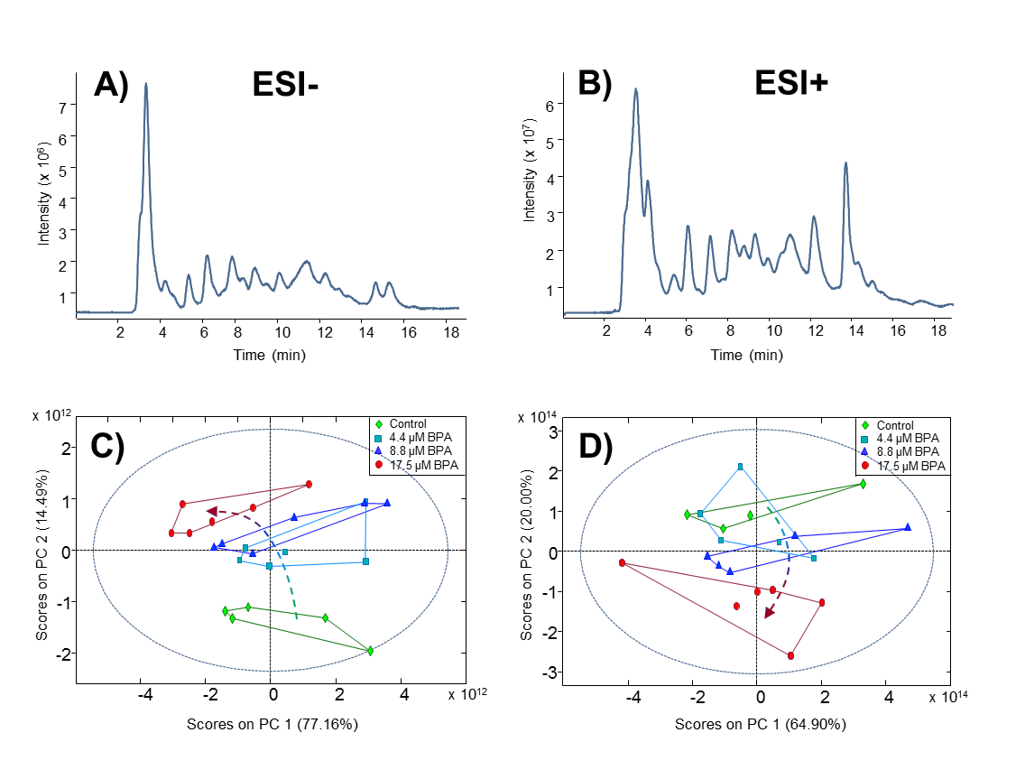
Figure 1
Black-and-white in print

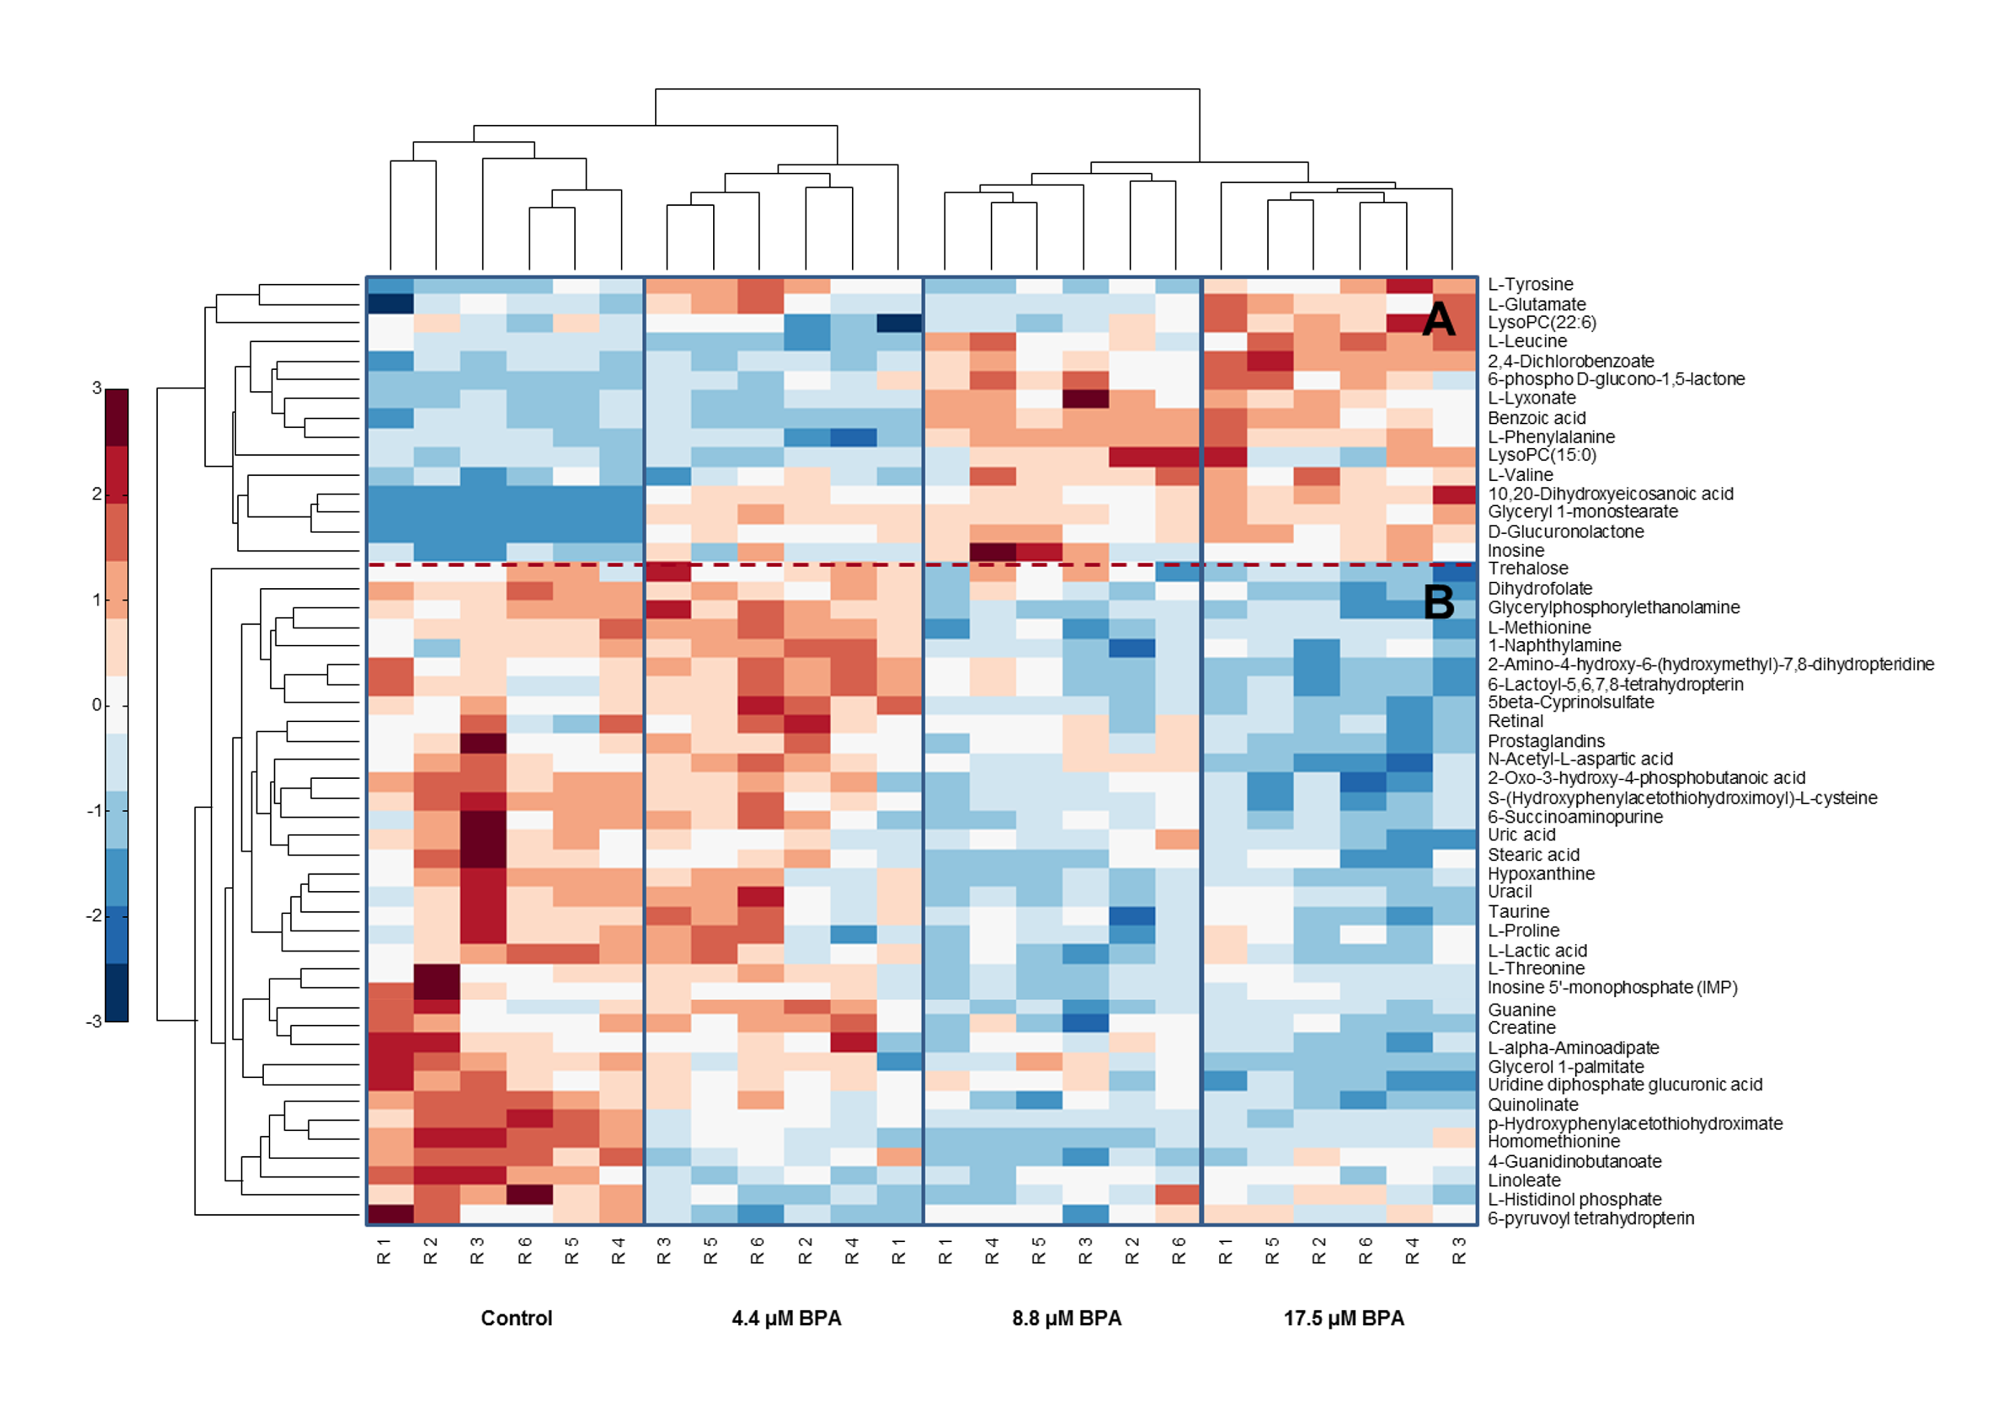
Figure 2

Black-and-white in print

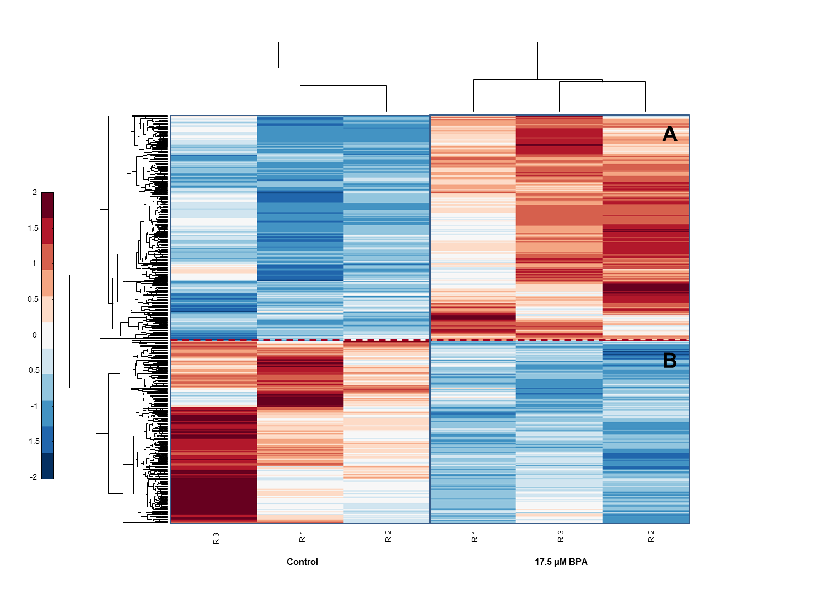
Figure 3
Black-and-white in print

Figure 4
Black-and-white in print

Figure 5

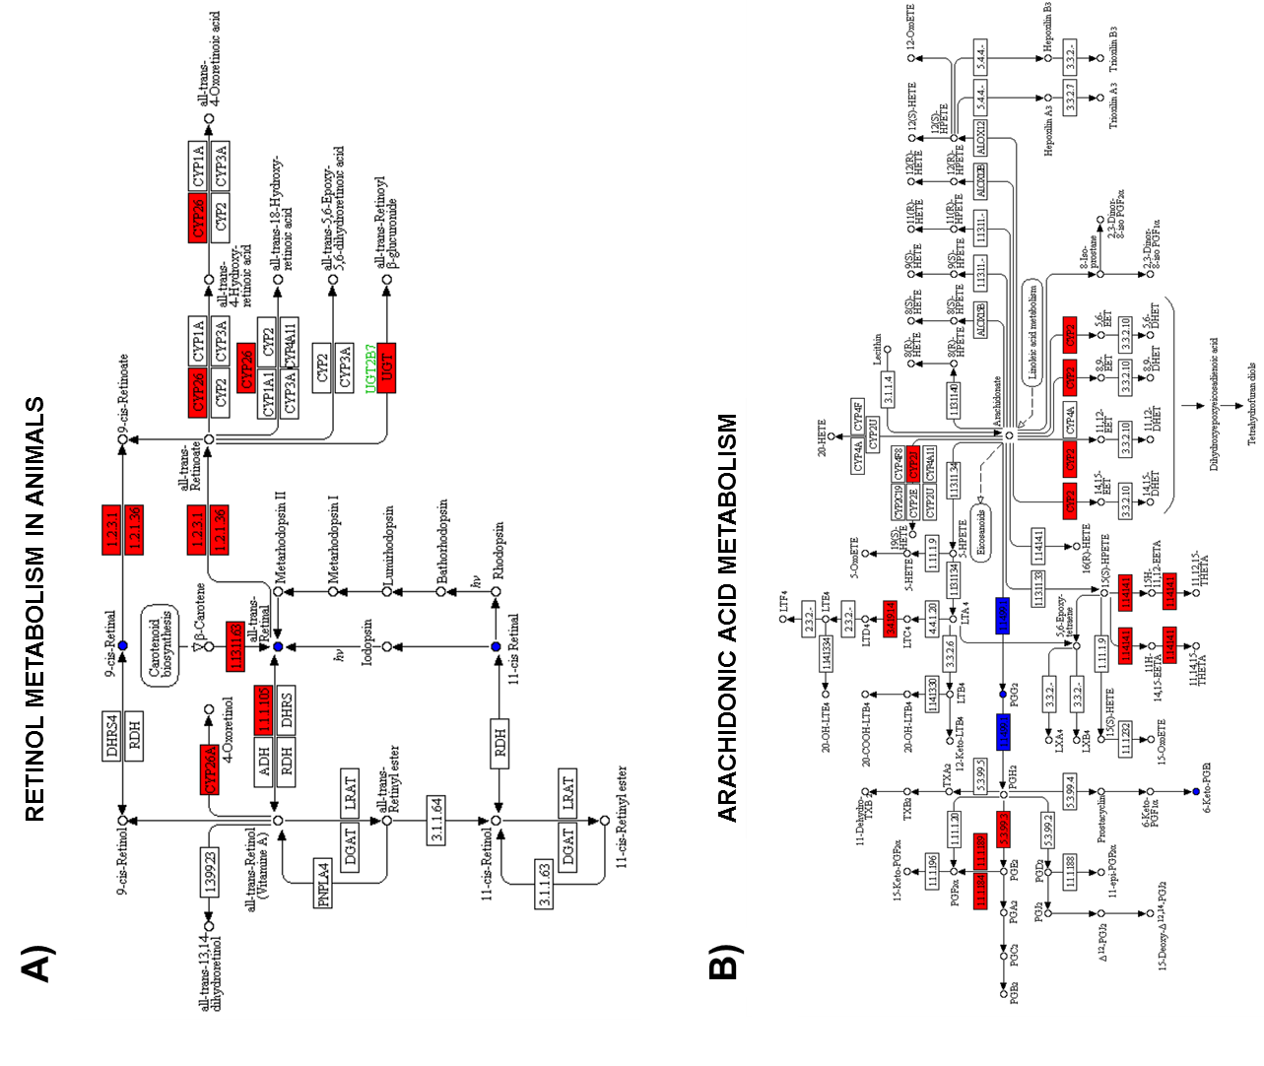

Black-and-white in print
Table 1. List of tentatively identified metabolites statistically significant to differentiate between control and BPA exposed zebrafish embryos samples in ESI-.
 | Compound | Molecular  formula | Ion  assignment | Measured molecular mass (Da) | ª Mass error (ppm) | Fold-change ctrl vs.  4.4 µM | Fold-change ctrl vs.  8.8 µM | Fold-change ctrl vs.  17.5 µM | Trend | t_{r} (min) | ^{b} p-adj | ^{c}KEGG
Cluster A | L-Valine | C5H11NO2 | [M-H]⁻ | 116.0707 | 6.9 | 1.1 | 1.2 | 1.3 | UP | 12.5 | 1.34E-03 | C00183
 | Benzoic acid | C7H6O2 | [M-H]⁻ | 121.0288 | 5.8 | 1 | 1.6 | 1.5 | UP | 3.8 | 1.74E-08 | C00180
 | ^{d} L-Leucine | C6H13NO2 | [M-H]⁻ | 130.0868 | 4.6 | 1.1 | 1.2 | 1.1 | UP | 9.5 | 3.42E-02 | C00123
 | ^{d} L-Glutamate | C5H9NO4 | [M-H]⁻ | 146.0450 | 6.2 | 1.2 | 1.1 | 1.3 | UP | 11 | 3.82E-03 | C00025
 | L-Lyxonate | C5H10O6 | [M-H]⁻ | 165.0404 | 0.6 | 1.2 | 2.5 | 2.3 | UP | 3.9 | 2.64E-06 | C05412
 | 2,4-Dichlorobenzoate | C7H4Cl2O2 | [M-H]⁻ | 188.9504 | 6.4 | 1.1 | 1.4 | 1.7 | UP | 3.5 | 1.28E-07 | C06670
 | ^{e} 10,20-Dihydroxyeicosanoic acid | C20H40O4 | [M-H+HAc]⁻ | 403.3052 | 3.2 | 300 | 308 | 414 | UP | 3.7 | 2.61E-10 | x
 | ^{e} Glyceryl 1-monostearate | C21H42O4 | [M-H+HAc]⁻ | 417.3217 | 1.7 | 139 | 129 | 142 | UP | 3.4 | 4.35E-13 | x
Cluster B | L-Lactic acid | C3H6O3 | [M-H]⁻ | 89.0238 | 6.7 | 0.9 | 0.7 | 0.8 | DOWN | 5.3 | 1.47E-04 | C00186
 | Uracil | C4H4N2O2 | [M-H]⁻ | 111.0195 | 4.5 | 1.0 | 0.7 | 0.7 | DOWN | 6.1 | 4.99E-04 | C00106
 | ^{d} L-Proline | C5H9NO2 | [M-H]⁻ | 114.0556 | 4.4 | 0.9 | 0.8 | 0.9 | DOWN | 12.8 | 3.70E-02 | C00148
 | ^{d} L-Threonine | C4H9NO3 | [M-H]⁻ | 118.0501 | 7.6 | 0.9 | 0.7 | 0.8 | DOWN | 14.5 | 2.45E-02 | C00188
 | ^{d} Taurine | C2H7NO3S | [M-H]⁻ | 124.0073 | 0.8 | 1.0 | 0.8 | 0.8 | DOWN | 11.3 | 1.34E-03 | C00245
 | ^{d} Creatine | C4H9N3O2 | [M-H]⁻ | 130.0618 | 3.1 | 1.0 | 0.8 | 0.8 | DOWN | 14.1 | 5.92E-03 | C00300
 | ^{d} Hypoxanthine | C5H4N4O | [M-H]⁻ | 135.0305 | 5.2 | 0.9 | 0.7 | 0.7 | DOWN | 7.3 | 1.74E-05 | C00262
 | Quinolinate | C7H5NO4 | [M-H]⁻ | 166.0141 | 3 | 0.7 | 0.5 | 0.4 | DOWN | 4.4 | 7.61E-07 | C03722
 | Uric acid | C5H4N4O3 | [M-H]⁻ | 167.0205 | 3.6 | 0.9 | 0.9 | 0.8 | DOWN | 6.5 | 1.21E-03 | C00366
 | N-Acetyl-L-aspartic acid | C6H9NO5 | [M-H]⁻ | 174.0405 | 1.7 | 1.0 | 0.9 | 0.8 | DOWN | 6.2 | 3.09E-05 | C01042
 | Homomethionine | C6H13NO2S | [M-H+HAc]⁻ | 222.0799 | 3.2 | 0.5 | 0.4 | 0.5 | DOWN | 3.5 | 7.98E-10 | C17213
 | p-Hydroxyphenylacetothiohydroximate | C8H9NO2S | [M-H+HAc]⁻ | 242.0489 | 1.7 | 0.4 | 0.2 | 0.2 | DOWN | 3.5 | 4.83E-10 | C17239
 | S-(Hydroxyphenylacetothiohydroximoyl)-L-cysteine | C11H14N2O4S | [M-H]⁻ | 269.0599 | 1.1 | 0.9 | 0.6 | 0.5 | DOWN | 3.6 | 4.48E-06 | C17238
 | ^{d} Linoleate | C18H32O2 | [M-H]⁻ | 279.2329 | 0.4 | 0.9 | 0.7 | 0.6 | DOWN | 3.4 | 5.92E-03 | C01595
 | Stearic acid | C18H36O2 | [M-H]⁻ | 283.2645 | 0.7 | 0.6 | 0.7 | 0.7 | DOWN | 3.2 | 3.09E-05 | C01530
 | ^{e} 6-Succinoaminopurine | C9H9N5O3 | [M-H+HAc]⁻ | 294.0833 | 3.7 | 0.9 | 0.8 | 0.8 | DOWN | 6.1 | 2.58E-02 | x
 | all-trans-Retinal | C20H28O | [M-H+HAc]⁻ | 343.2288 | 2.6 | 1.1 | 0.9 | 0.6 | DOWN | 3.3 | 5.04E-03 | C00376
 | 11-cis-Retinaldehyde |  |  | 343.2288 | 2.6 | 1.1 | 0.9 | 0.6 | DOWN | 3.3 |  | C02110
 | 9-cis-Retinal |  |  | 343.2288 | 2.6 | 1.1 | 0.9 | 0.6 | DOWN | 3.3 |  | C16681
 | Prostaglandin G2 | C20H32O6 | [M-H]⁻ | 367.2113 | 3.5 | 1.0 | 0.8 | 0.6 | DOWN | 3.8 | 4.95E-04 | C05956
 | 6-Ketoprostaglandin E1 |  |  | 367.2113 | 3.5 | 1.0 | 0.8 | 0.6 |  |  |  | C05962
 | 2-Oxo-3-hydroxy-4-phosphobutanoic acid | C4H7O8P | [2M-H]⁻ | 426.9688 | 0.9 | 0.9 | 0.7 | 0.6 | DOWN | 3 | 3.09E-05 | C06054
 | ^{d} 5β-Cyprinolsulfate | C27H48O8S | [M-H]⁻ | 531.2977 | 3.8 | 1.2 | 0.7 | 0.6 | DOWN | 3.3 | 1.28E-07 | C05468
 | Uridine diphosphate glucuronic acid | C15H22N2O18P2 | [M-H]⁻ | 579.0273 | 0.5 | 0.8 | 0.7 | 0.4 | DOWN | 16.7 | 1.77E-06 | C00167
ª Mass accuracy = [((exact mass-measured mass)/exact mass) × 10⁶] ≤10 ppm.
^{b} Obtained p-value using one-way ANOVA with Benjamini-Hochberg multiple testing correction.
^{c} Metabolite KEGG C-code.
^{d} Metabolites which were also detected in ESI+.
^{e} Metabolites without KEGG C-code.
Table 2. List of tentatively identified metabolites statistically significant to differentiate between control and BPA exposed zebrafish embryos samples in ESI+.
Compound |  |  | Molecular formula | Ion assignment | Measured molecular mass (Da) | ª Mass error (ppm) | Fold-change ctrl vs.  4.4 µM | Fold-change ctrl vs.  8.8 µM | Fold-change ctrl vs.  17.5 µM | Trend | t_{r} (min) | ^{b} p-adj | ^{c} KEGG
Cluster A | ^{d} L-Leucine | C6H13NO2 |  | [M+H]⁺ | 132.1012 | 5.3 | 0.9 | 1.1 | 1.3 | UP | 9.5 | 3.02E-06 |  | C00123
 | ^{d} L-Glutamate | C5H9NO4 |  | [M+H]⁺ | 148.0606 | 1.4 | 1.2 | 1.1 | 1.2 | UP | 11.0 | 3.53E-02 |  | C00025
 | L-Phenylalanine | C9H11NO2 |  | [M+H]⁺ | 166.0870 | 4.2 | 0.9 | 1.4 | 1.3 | UP | 9.0 | 5.58E-07 |  | C00079
 | L-Tyrosine | C9H11NO3 |  | [M+H]⁺ | 182.0821 | 4.9 | 1.3 | 1 | 1.3 | UP | 10.8 | 4.96E-05 |  | C00082
 | D-Glucuronolactone | C6H8O6 |  | [M+NH₄]⁺ | 194.0656 | 1.5 | 107 | 123 | 138 | UP | 3.7 | 3.10E-10 |  | C02670
 | 6-phospho D-glucono-1,5-lactone | C6H11O9P |  | [M+H]⁺ | 259.0212 | 0.4 | 1.5 | 2.5 | 2.4 | UP | 3.6 | 2.21E-04 |  | C01236
 | Inosine | C10H12N4O5 |  | [M+H]⁺ | 269.0884 | 1.5 | 1.1 | 1.2 | 1.3 | UP | 8.4 | 2.37E-03 |  | C00294
 | LysoPC(15:0) | C23H48NO7P |  | [M+H]⁺ | 482.3255 | 2.9 | 1 | 1.6 | 1.4 | UP | 4.1 | 1.36E-02 |  | C04230
 | LysoPC(22:6) | C30H50NO7P |  | [M+H]⁺ | 568.3373 | 4.4 | 0.9 | 1 | 1.3 | UP | 4.2 | 2.18E-02 |  | C04230
Cluster B | ^{d} L-Proline | C5H9NO2 |  | [M+H]⁺ | 116.0713 | 6.0 | 0.9 | 0.7 | 0.7 | DOWN | 12.8 | 3.70E-02 |  | C00148
 | ^{d} L-Threonine | C4H9NO3 |  | [M+H]⁺ | 120.0654 | 0.8 | 0.9 | 0.7 | 0.8 | DOWN | 14.5 | 1.55E-02 |  | C00188
 | ^{d} Taurine | C2H7NO3S |  | [M+H]⁺ | 126.0224 | 4.0 | 0.9 | 0.8 | 0.7 | DOWN | 11.3 | 3.10E-02 |  | C00245
 | ^{d} Creatine | C4H9N3O2 |  | [M+H]⁺ | 132.0775 | 5.3 | 1.0 | 0.8 | 0.8 | DOWN | 14.1 | 6.59E-04 |  | C00300
 | ^{d} Hypoxanthine | C5H4N4O |  | [M+H]⁺ | 137.0457 | 0.7 | 0.9 | 0.8 | 0.7 | DOWN | 7.3 | 3.62E-02 |  | C00262
 | 1-Naphthylamine | C10H9N |  | [M+H]⁺ | 144.0809 | 0.7 | 1.2 | 0.7 | 0.7 | DOWN | 8.6 | 2.21E-04 |  | C14790
 | 4-Guanidinobutanoate | C5H11N3O2 |  | [M+H]⁺ | 146.0926 | 1.4 | 0.7 | 0.5 | 0.6 | DOWN | 14.6 | 6.20E-06 |  | C01035
 | L-Methionine | C5H11NO2S |  | [M+H]⁺ | 150.0584 | 0.7 | 1.1 | 0.8 | 0.8 | DOWN | 10.7 | 1.20E-06 |  | C00073
 | Guanine | C5H5N5O |  | [M+H]⁺ | 152.0563 | 2.6 | 1.1 | 0.6 | 0.7 | DOWN | 8.7 | 1.80E-04 |  | C00242
 | L-alpha-Aminoadipate | C6H11NO4 |  | [M+H]⁺ | 162.0763 | 1.2 | 0.9 | 0.8 | 0.6 | DOWN | 12.0 | 5.46E-03 |  | C00956
 | 2-Amino-4-hydroxy-6-(hydroxymethyl)-7,8-dihydropteridine | C7H9N5O2 |  | [M+H]⁺ | 196.0832 | 1.5 | 1.3 | 0.8 | 0.4 | DOWN | 10.1 | 1.43E-05 |  | C01300
 | L-Histidinol phosphate | C6H12N3O4P |  | [M+H]⁺ | 222.0635 | 1.4 | 0.6 | 0.7 | 0.7 | DOWN | 5.5 | 5.43E-03 |  | C01100
 | 6-pyruvoyl tetrahydropterin | C9H11N5O3 |  | [M+H]⁺ | 238.0937 | 0.8 | 0.7 | 0.8 | 0.8 | DOWN | 7.2 | 2.76E-03 |  | C03684
 | 6-Lactoyl-5,6,7,8-tetrahydropterin | C9H13N5O3 |  | [M+H]⁺ | 240.1093 | 0.8 | 1.2 | 0.7 | 0.4 | DOWN | 10.2 | 3.10E-05 |  | C04244
 | ^{d} Linoleate | C18H32O2 |  | [M+NH₄]⁺ | 298.2740 | 0.3 | 0.9 | 0.8 | 0.7 | DOWN | 3.4 | 1.29E-02 |  | C01595
 | ^{e} Glycerol 1-palmitate | C19H38O4 |  | [M+H]⁺ | 331.2820 | 6.9 | 0.7 | 0.7 | 0.4 | DOWN | 3.5 | 2.21E-04 |  | x
 | Inosine 5'-monophosphate (IMP) | C10H13N4O8P |  | [M+H]⁺ | 349.0541 | 1.4 | 1.1 | 0.9 | 0.7 | DOWN | 10.2 | 8.60E-03 |  | C00130
 | Trehalose | C12H22O11 |  | [M+NH4]⁺ | 360.1487 | 3.6 | 1.1 | 0.9 | 0.7 | DOWN | 14.9 | 9.43E-03 |  | C01083
 | Dihydrofolate | C19H21N7O6 |  | [M+H-H₂O]⁺ | 426.1490 | 5.9 | 0.9 | 0.7 | 0.6 | DOWN | 3.4 | 6.20E-06 |  | C00415
 | Glycerylphosphorylethanolamine | C5H14NO6P |  | [2M+H]⁺ | 431.1192 | 0.5 | 1.1 | 0.5 | 0.4 | DOWN | 7.9 | 6.10E-07 |  | C01233
 | ^{d} 5β-Cyprinolsulfate | C27H48O8S |  | [M+NH₄]⁺ | 550.3409 | 0.2 | 1.3 | 0.9 | 0.7 | DOWN | 3.3 | 3.72E-04 |  | C05468
ª Mass accuracy = [((exact mass-measured mass)/exact mass) × 10⁶] ≤10 ppm.
^{b} Obtained p-value using one-way ANOVA with Benjamini-Hochberg multiple testing correction.
^{c} Metabolite KEGG C-code.
^{d} Metabolites which were also detected in ESI-.
^{e} Metabolites without KEGG C-code.
Table 3. Biological processes and molecular functions of the most differentially expressed genes (top-twenty) after BPA exposure.
ENSEMBL ID | ªZFIN ID | Gene name | ^{b}baseMean | ^{c}lfc | ^{d}lfcSE | ^{e}p-adj | Biological Process | Molecular Function
Up-regulated
ENSDARG00000098360 | cyp19a1b | Cytochrome P450, family 19, subfamily A, polypeptide 1b | 339.3 | 2.86 | 0.21 | 1.62E-36 | Response to estrogen stimulus | Heme binding
ENSDARG00000045453 | f13a1a.1 | Coagulation factor XIII, A1 polypeptide a, tandem duplicate 1 | 64.9 | 1.84 | 0.22 | 1.01E-13 | Peptide cross-linking | Protein-glutamine gamma-glutamyltransferase activity
ENSDARG00000104593 | cyp2k18 | Cytochrome P450, family 2, subfamily K, polypeptide 18 | 522.8 | 1.81 | 0.21 | 4.09E-15 | Oxidation-reduction process | Heme binding
ENSDARG00000011573 | abcb11a | ATP-binding cassette, sub-family B (MDR/TAP), member 11a | 397 | 1.72 | 0.19 | 2.07E-15 | Transmembrane transport | ATP binding
ENSDARG00000103019 | gstp2 | Glutathione S-transferase pi 2 | 555.3 | 1.68 | 0.21 | 5.90E-12 | Response to toxic substance | Glutathione transferase activity
ENSDARG00000019838 | ugdh | UDP-glucose 6-dehydrogenase | 1294.3 | 1.68 | 0.19 | 6.25E-16 | Atrioventricular valve formation | NAD binding
ENSDARG00000068493 | si:zfos-411a11.2 | Cytochrome family | 552.6 | 1.68 | 0.18 | 9.51E-18 | Oxidation-reduction process | Heme binding
ENSDARG00000087017 | ptgr1 | Prostaglandin reductase 1 | 258.2 | 1.6 | 0.2 | 7.41E-13 | Oxidation-reduction process | Oxidoreductase activity
ENSDARG00000099525 | si:ch1073-13h15.3 | Unknown | 1415.9 | 1.51 | 0.18 | 1.32E-13 | Oxidation-reduction process | GDP-dissociation inhibitor activity
ENSDARG00000002394 | ugt5d1 | UDP glucuronosyltransferase 5 family, polypeptide D1 | 216.1 | 1.46 | 0.21 | 4.76E-09 | Metabolic process | Glucuronosyltransferase activity
Down-regulated
ENSDARG00000041433 | si:dkey-7c18.24 | Unknown | 3990.1 | -2.06 | 0.18 | 1.29E-26 | Unknown | Unknown
ENSDARG00000094104 | si:ch211-213i16.3 | Linc RNA | 683.2 | -1.58 | 0.21 | 1.62E-11 | Unknown | Unknown
ENSDARG00000094041 | krt17 | Keratin 17 | 80473.8 | -1.45 | 0.14 | 5.59E-22 | Fin regeneration | Structural molecule activity
ENSDARG00000104359 | anxa1c | Annexin a1c | 3474.7 | -1.43 | 0.21 | 3.57E-09 | Unknown | Calcium ion binding
ENSDARG00000071216 | si:ch211-133n4.9 | Unknown | 44.3 | -1.25 | 0.22 | 2.54E-06 | Hydrolase activity | Unknown
ENSDARG00000102057 | si:ch73-329n5.2 | Unknown | 80.9 | -1.23 | 0.22 | 3.74E-06 | Cell-matrix adhesion | Unknown
ENSDARG00000093628 | s100a11 | S100 calcium binding protein A11 | 7171.6 | -1.21 | 0.17 | 1.71E-09 | Regulation of cell proliferation | Calcium ion binding
ENSDARG00000069293 | ahsg2 | Alpha-2-HS-glycoprotein 2 | 499.7 | -1.19 | 0.19 | 1.07E-07 | Negative regulation of biomineral tissue development | Cysteine-type endopeptidase inhibitor activity
ENSDARG00000076269 | zgc:172131 | Unknown | 61.9 | -1.16 | 0.21 | 1.15E-05 | Unknown | GTP binding
ENSDARG00000026726 | anxa1a | Annexin a1a | 12680.2 | -1.1 | 0.16 | 5.89E-09 | Fin regeneration | Calcium ion binding

ª ZFIN Gene official name. ^{b} Mean of normalized counts of all samples. ^{c} Log2 fold change. ^{d} Log2 fold change standard error. ^{e} Obtained p-value using Wald test with Benjamini-Hochberg multiple testing correction.

